Intro
This assignment will focus on using six sigma methodologies and lean principles in the Link department in the Cold Mill Port Talbot. It will also mention examples of other areas and projects in TATA steel.

Six sigma
Six Sigma is a method that provides organizations tools to improve the capability of their business processes. This increase in performance and decrease in process variation helps lead to defect reduction and improvement in profits, employee morale, and quality of products or services.
Using six sigma methodologies will aid the yield project as it focuses on lowering defects which in turn increases line yield and profit, less defects will result in less errors by operator which will boost morale and improving the quality will satisfy the customer.
Using the six sigma methodology of define, measure, analyse, improve and control (DMAIC) the correct steps will be followed to fully investigate the roots causes and create improvements to line yield percentage and other work place examples.

Define
The define process is the first phase of DMAIC, it outlines what exactly is the reason behind the project or improvement process. Here the problem statement is made clear. In a current projects case the problem statement is:-
‘A number of coils are below the yield target of 98%, there are a number of cuts taken by processes in the link entry (pickle line) some of which are uncontrolled’.
Coils being below 98% yield also affect value was removing material is a nonvalue adding activity.
Setting a problem statement allows goals to be set and a goal statement to be made in this project.
‘achieve or work towards improving and achieving 98% yield on all non-defective coils’
These goals can both be found within the project charter, where the roles and responsibilities are set out with the goals noted.
To aid defining the process , process mapping is essential and shows clearly where cuts are made in the pickle line entry allowing those areas to be investigated further.

Pickle line entry process map
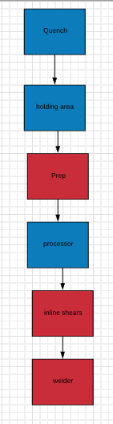

Quench – coils from the hotmill are quenched in water the cool the coils ready for processing

Holding area – coils selected for processing are held and numbered

Prep – the coil is loaded onto a walking beam and moved to the prep station where it is debanded and rotated into a shear where the ‘fish tail’ is removed. This is an automatic sequence, depending on the gage the prep will remove a set amount of ‘cuts’

Processor – this turns the coil onto a mandrel and the coil is fed up the line

Inline shears – the head end of the coil is removed (non-prime material) in order for clean welding

Before welding begins the shape of the two coils are inspected then the welder shear squares off a small amount both from the head and the tail end to ensure a clean weld (minimal yield loss)

*The processes in red highlight where cuts are made and yield is lost.

As seen from the process flow there are 3 processes in the pickle entry that effect yield, the prep, the inline shears and the welder. Using the define method and process flow allows these areas to be clearly defined and investigated further.
Another step from the first phase define is ensuring the customer requirements are met and the customer itself is defined. The requirements of the customer should be clearly defined, the type of product they require, the date they need the product and the level of quality of the product. This can be found by using the four step procedure of :-
- Identify
- Distribute
- Collect
- Create
Identifying the needs through research, distributing the information found to the stakeholders, creating features or content that adapts to the customer’s needs, and collecting feedback from customers to ensure they are satisfied.
It is also vital the have an open line of communication with the customer to ensure the demands are met. Once the customer needs are defined the scale of the problem can be found. These when related to TATA steel would be heavily revolved around cost. For general practice material certain levels of defects are acceptable. This is noted in the service agreement. For full finish material for the automotive sector the tolerances are extremely tight and defects are not acceptable. Before full finish can be processed through the line a line clean down and inspection must be carried out, to meet needs of the customer for the prime material and achieve the best product the line must stop. The line operates using a pull system where specific coil types are made on request of the customer.

Measure
This is a key phase of DMAIC as it sets out to gather key information and measures on how the process currently performs. Measurable data must be taken in order to compare with later results and view progress. The measure phase give a baseline of the process, where the current state can be analysed. It is important to focus on data and measures that only concern the customer.
In order to set out what data is needed a data collection plan must be made. This plan include all the details of where the data is found, by who and when. It also includes a time frame and regularity of the data collection. The person responsible is again included to ensure everyone involved is aware of their responsibilities.
Once that data collection plan is in place baseline data can be collected. Without this data the progress and assessment of its impact would not be very difficult. In other words baseline provides the historical point of reference for the next steps of project monitoring and evaluation. The baseline information also allows other information to be collected or show weakness in the collection methods.
As a baseline for yield TATA steel uses entry and exit weighers and compares the differences after the coil has been processed, the difference in the weight is calculated and line yield can be calculated. Below is a table attached analysing the number of coils below the 98% KPI of line yield.
Collecting data that is reliable is key, as projects and decisions may be set in place as an affect of the findings. The techniques that are used in data collection must be standardised to ensure there is no deviation.
Analyse
The third phase of DMAIC is analyse. This is the stage where root causes can be predicted before being investigated further. Root causes can be found by using brainstorming activities and analysing the baseline data found from the measure phase. To closely examine the process methods such as time analysis, value added analysis and value stream mapping can be used. Time analysis focusses on the time that work is being done compared to the time being idle, in the pickle line this is measured as availability. Value adding analyses focusses on whether the activity being carried out adds value from the customers perspective. Removing a length of coil is not a value adding process as this created a yield loss for TATA and the coil is will be lighter in weight, this weight is used as part of billing the customer. Value stream mapping can also be carried out so that waste can be removed.
After data collection from the measure phase the data can be looked at in depth, a data collection method that included the number of cuts that were carried out was created, HC (hardness class) and gauge was included this allows more information to be compared.

Looking at the data there isn’t much correlation between cuts and yield, the results are mixed but generally with coils with lower gauge more cuts are needed therefore lower yield is achieved.
Using a root cause activity and a fishbone diagram for the analyse phase allows for possible predictions to be made on what is the underlying root cause. The can be narrowed down into one or two possible root causes. For a yield project there are various underlying possible causes, for the machine branch the prep machine has a programmed setting depending on the gauge for heavier gauge it will make less cuts which are around 1m per cut, and for lighter gauge it will make up to 5 cuts again around 1m per cut. This is also related to method which too may cuts me be taken and also at the inline shears where the head end of the coil is cut. For the material branch defective material with bad shape and gauge deviation is a factor is yield loss as more material must be cut in order to achieve quality material that can be welded. The man power branch causes are related to training, judgment and storage by manned crane drivers who may damage coils whilst moving on the prep station. The last branch is money, as TATA is spending less money on line improvements which affect the changes that might be needed to achieve 98% on every coil.

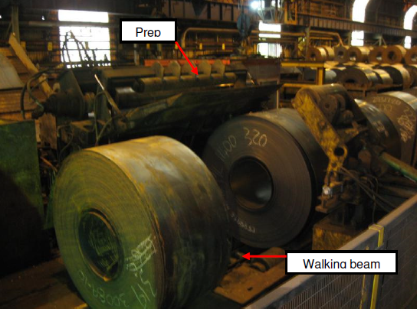
Picture of the prep station where the tail end is removed.

The inline shears which are another possible root cause but a different part of the process could be a potential root cause.
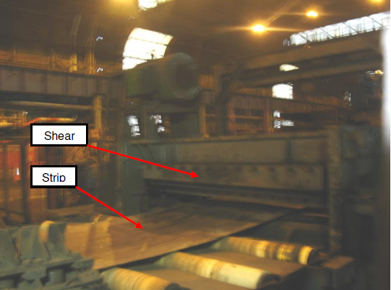

During a process observation there are no pre-programmed settings for operators at the inline shears, cuts are carried out using the shear at the control panel and all coils which are classed as ‘bad shape’ or ‘unfit for welding’ have material removed. This could also be related to training root cause and method root cause as there is no set written guidance on strip that has bad shape or unfit for welding. The waste taken from cuts is a lean waste and is over processing as it has unclear standards and specifications. Operators tend to over processes the strip at the inline shears as the same operator will then carry out the welding, therefore to avoid a strip break they tend to take more cuts than needed.
Another potential cause was found during an observation of the inline shears whilst on stop. The leveller rolls were worn by 6mm on the operative side of the shears, the leveller rolls are vital for shape and if they are worn the shape will be poorer as it reaches the inline shears resulting in more ‘bad shape’ and more cuts being made the shears impacting line yield.

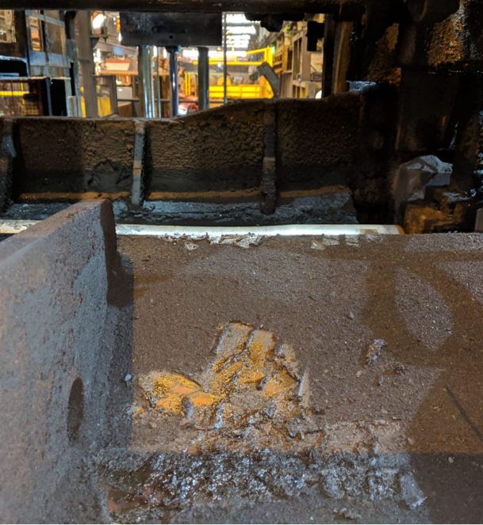

After analysing the prep and inline shears, the difference between cuts and yield at the prep is minimal and has no correlation. The inline shears have no tolerances and large amounts of cuts are taken due to a number of causes resulting in a loss of yield therefore the inline shears are the root cause.

Improve
The improve phase aims to identify and addresses the solutions to the root causes. This can only be done by first using the other phases and identifying the root causes then brainstorming solutions, selecting the most practical of the solutions then implementing those ideas. It is key that everyone involved in the project and further expertise have input. All ideas should be put forward but assessed with conformation and evidence.
The first step is to brainstorm a range of improvements that address the root causes, using the information already collected as a guide. Tools to support and provide reliable information should be used such as, cross-training TATA steel has a version of this known as competency assessments where operators carry out different tasks by the assessor until they are deemed demonstrable competent. Step up reduction where the changeover of one method to another is assessed can also be carried out in this phase.
Selecting the correct solution should be a step taken with everyone undertaking the project involved, the ideas after brainstorming activities should be evaluated and ranked on the difficulty and impact of implementation and cost of the improvements. Tools such as weighted criteria matrix which evaluates potential against a list of factors, this is usually displayed in a table which options such as cost, time and ease of implementation scored. A simpler tool that can be used is an impact effort matrix, with low impact, high impact, easy and hard in a 2x2 table this is useful to eliminate improvements that are less efficient.

Using impact effort matrix as an example, to improve the root causes of the inline shears the best option would be to make the operation fully automatic whereby operators would not be needed and lasers could be installed to make cuts at the correct position to allow a clean strong weld with the least impact on line yield. The machine and operator working together to detect defects, in lean manufacturing this is known as jidoka. It is classed as hard as it would take a large amount of investment research and time to implement. This would also be a safeguard for the operator or ‘poka-yoke’. The most practical high impact option would be to provide adequate training and set in place SOP’s specifically for the tolerances on how to judge non-prime material removal. The low impact and easy to do option of changing the leveller rolls more often should be considered as in spec rolls will level the strip and allow the operator to cut less resulting in less yield loss. The low impact and hard option is using two operators for the task allowing one to judge the nonprime and the other operator to perform the task. This is difficult as it is a one man job and the nearest operator should be preparing for the strip to be welded. This could have an impact on speed of work which is class as ‘waiting’ waste slowing the line and effecting performance. These solutions can be used to create maps of the improved process, using a tools such as ‘to be maps’. Once the practical ideas are selected they can be made into flow charts to see the impact on the process or other processes due to its implementation and implementation plans can be created by the engineering execution manager with responsibilities and dates in place to ensure completion. Data and analysis and process observation must be carried out to ensure the improvement is measured against the baseline. This is the only way its effectiveness can be measured.

Control
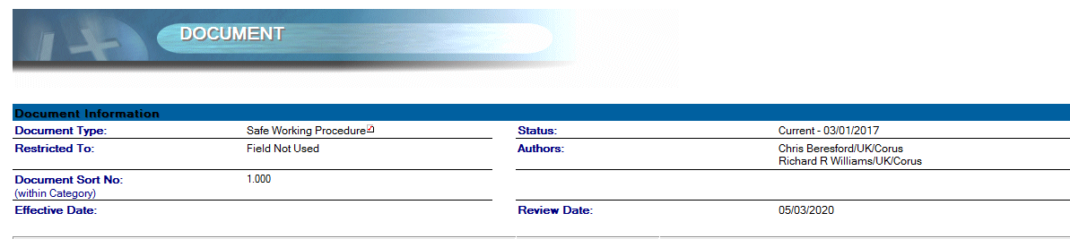
Once the root cause is found an steps taken to address the problems in the improve phase control measures can be set in place. This is to ensure the process continues to be an improved process when compared to the baseline on permanent basis. A monitoring plan is set up and an owner is set in place responsible for the process. The process can be monitored for its efficiency by creating a monitoring plan and a response plan in order to combat the problems that might arise, data before and after implantation should compared and the differences analysed for efficient of the DMAIC task. Using visual documentation and updating the process and SOP’s in line with the improvement is vital. The new SOP for the line yield project is part of the control process for reducing the yield loss therefore it must be correct and in line with other improvements and reviewed.
Depending on the risk rating of the safe working procedure will affect the review date. FMEA and control plans must be updated to fit the new improvements to ensure they are reliable. The improvements can be shared with other departments in TATA steel this may give others ideas or initiative to carry out their own six sigma exercises, reduce waste and optimise performance. The last step of DMAIC is to continuous improve (kaizen) the process by using lean principles and educating others.

Bibliography
Imageresume.com (website) https://www.imageresume.com/9-10-goal-statement-examples/ accessed April 30 2019
Projectmanager.com (website) https://www.projectmanager.com/blog/project-charter accessed April 30 2019
Sixgima daily.com (website) https://www.sixsigmadaily.com/customer-needs-and-requirements/ accessed May 2 2019
Conductor.com (website) https://www.conductor.com/learning-center/customer-needs/ accessed May 2 2019
Searchterp.techtarget.com (website) https://searcherp.techtarget.com/definition/operational-performance-management-OPM accessed May 3 2019
tasminrl.wordpress.com (website) https://tasminrl.wordpress.com/2011/09/30/why-is-reliability-important/ accessed May 3 2019
leanmanufacturingtools.org (website) http://leanmanufacturingtools.org/121/waste-of-overprocessing-causes-symptoms-examples-and-solutions/ accessed May 14 2019
Six sigma/ Heidi Wiesenfelder/ Project management (book) https://www.brighthubpm.com/six-sigma/25328-dmaic-phase-four-the-improve-phase/ Accessed May 16 2019
Tata steel CRP Safe Working Procedure database

Asq.org (website) https://asq.org/quality-resources/six-sigma accessed April 29th 2019
Lucidchart.com (website) https://www.lucidchart.com/documents/edit/e4be4462-166a-4b0c-aea3-3f2c3669a8ee/0# accessed April 30 2019
Conductor.com (website) https://www.conductor.com/learning-center/customer-needs/ accessed May 2 2019
Trustconsultancy.org (website) https://trustconsultancy.org/baseline-data/ accessed May 3 2019

