Essay Topic: The Politics of Desire- Post-capitalism and Platform Culture
Title: Transformative Ready-mades, From Duchamps Fountain to Weiwei’s Activism
Essay Question:
Has the commodification of the human experience and the parallel relationship that exists with the symbolism associated with objects of mass production and the media, inadvertently made of people, consumer goods and technology, a far more powerful collection of ‘ready-mades’ than Marcel Duchamp could of conceived of, when he introduced the concept in 1917.

Name: Leigh Sinclair
Student Number: 2313952
Course: M.A Contemporary Dialogues
Abstract
Western society at the beginning of the 20th century witnessed the development of a technological ontology, transforming the way we see our world and ourselves in It. During this time, significant changes also occurred within art and design. One such being the appropriation of mass-produced objects by artists as a new medium and mode of expression. Beginning with the work of contemporary artist Ai Weiwei, the intention of this research was to answer the question, ‘has the commodification of the human experience and the parallel relationship that exists with the symbolism associated with objects of mass production and the media, inadvertently made of people, consumer goods and technology, a far more powerful collection of ‘ready-mades’ than Marcel Duchamp could of conceived of, when he introduced the concept in 1917.
Continuing with the Dadaist Manifesto and the work of Marcel Duchamp, the research then focused upon the development of art in this era of growing mechanisation, exploring as such the socioeconomic context of the time. Informed by the critical theories of thinkers such as, Gilles Delueze, Felix Gutarri and Herbert Marcuse, the essay charts the familiarity and growing obsession with material wealth at the expense of spirituality and the erosion of established ideological structures.
Within the secular conditions of contemporary western life, what the research revealed, was that through the objectification and reduction of our lived experience into images, a new symbolic framework has been erected around the spectacle of our lives, which is populated by products and social media posts, managed by a sophisticated media apparatus which dominates the political and social narrative. Artists in this era have found ways and means to subvert or circumnavigate this apparatus, finding new modes of communication to affect change and challenge institutional convention and bias, through the constant evolution of the ‘readymade’ and the appropriation of methods established by media and advertising.

Meaning Beyond Function
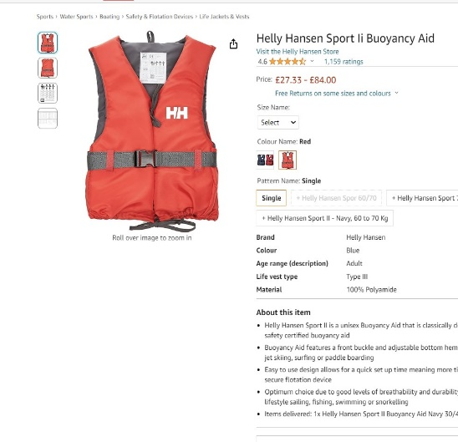


Figure. 1. Unisex Buoyancy Aid
Figure. 2. Automatic Harness Lifejacket
Figure 1 and Figure 2 are typical of two types of life jacket available to purchase online. Figure 1 ‘Unisex Buoyancy Aid’, describes the type of life jacket that you may be requested to wear, were you involved in the relative safety of a risk assessed organised water sport activity, such as paddle boarding or canoeing. Figure 2 ‘Automatic Harness Life Jacket,’ describes a far more serious piece of equipment, reflected in its price, this would be necessary for individuals, who enjoyed ocean sailing, who would be exposed to harsher, more dangerous conditions.
Considerations of appropriateness or difference between types of life jackets are absent from our general concern. For Migrants attempting the perilous journeys across the Mediterranean, factors surrounding a life jackets function and suitability are far more nuanced, influenced by contrasting concerns to that of individuals not exposed to similar circumstances.
On the beaches of Lesbos in Greece, where enormous volumes of life jackets are discarded by migrants, what is being discovered is that many of the life jackets that are being found are fakes, One migrant reported “such life jackets can be found. Digging through piles of plastic and foam, the occasional vest is stuffed with nylon, paper or other fillings.” (Strickland, P. (n.d.)
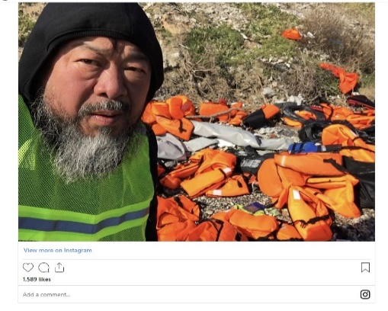
The nuance expressed in the descriptions of these lifejackets illustrate the subjective nature of an object, even one possessive of binary functions such as this. Meaning is contingent upon context, this was exemplified and examined in 1917 through the introduction of the ‘readymade’ in art by Marcel Duchamp. In 2016 Ai Weiwei, an artist who himself has explored and developed the concept of the readymade, spent a month on the Greek island of Lesbos. Having set up a studio to create work in response to the growing wave of migration into Europe, his intention, was to humanise the phenomena and the unfolding of an incomprehensible human tragedy. According to Reuters, No fewer than 20,000 deaths have been recorded of migrants crossing the Mediterranean since 2014.” (Reuters, 2023). In 2023, lifejackets have also come to represent, exploitation, need, fear and in far too many instances, death.

Figure. 3. Ai Weiwei Instagram post
Having used his platform to bring attention to the plight of the migrants, bear witness to what was happening and use his social media platforms to share what he was seeing. Weiwei installed a large installation at the konzerthaus in Berlin, where he wrapped the six columns that support the entrance in thousands of orange life jackets along with an enormous inflatable boat hanging between the middle columns, bearing the message #safepassage, the work, an enormous collection of ‘readymade’ objects representing the daily flow of asylum seekers onto European shores.
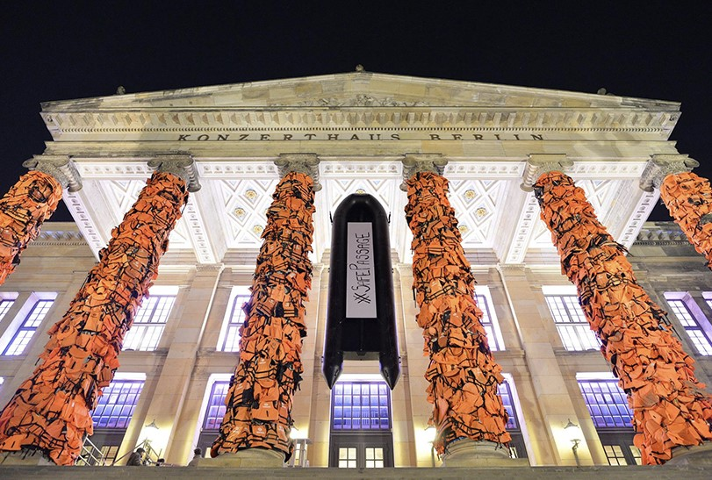
Figure. 4. Weiwei. A, Safe Passage, 2017

This essay will examine the factors which have provided the artist the opportunity to present a very potent message through a simple object that until recently, was demonstrative of, apart from in extreme scenarios a precautionary measure. The research undertaken will examine the conception and evolution of the ‘Ready-made’ and subversive tactics within art and design, tactics that have been used to change the cultural paradigm. It will also be necessary to examine the role that consumerism has played in creating new meanings for everyday objects and images. Additionally, it will be essential to examine the significance that space and place play within culture as well as the implication of social media platforms in mediating a third space for artists to operate in.
Transformative Ready-mades, From Duchamps Fountain to Weiwei’s Activism
“The higher culture of the West-whose moral, aesthetic, and intellectual values industrial society still profess- was a pre- technological culture in a functional as well as chronological sense. Its validity derived from the theoretical of a world that no longer exists and which cannot be recaptured because it is in a strict sense invalidated by technological society.” (Marcuse, 1964 p.61)
It was to this backdrop of growing technology, the development of the industrial war machine and an expanding middle class, that in 1917 Marcel Duchamp attempted to display a urinal titled ‘Fountain’ in a group exhibition under the pseudonym; ‘R Mutt’.(the work was included, but hidden from view). This artistic subversion was a direct challenge to arts function and the role of the artist and also where agency resided in the making and exhibiting of art. For Duchamp, the venerated status of an artist had been inflated to serve the needs of the establishment, “The word “artist” was invented when the painter became an individual, first in monarchical society” (Cabanne and Duchamp, 1987 p. 16) The proliferation of this status functioned in order to maintain the hierarchical distance between the so called elite and the rest of the public. By the late 19th and early 20th century, this system neither represented the general public’s mood or relationship with their material world which was, through the drive of capitalism and industry shifting more of its attention towards the middle classes. 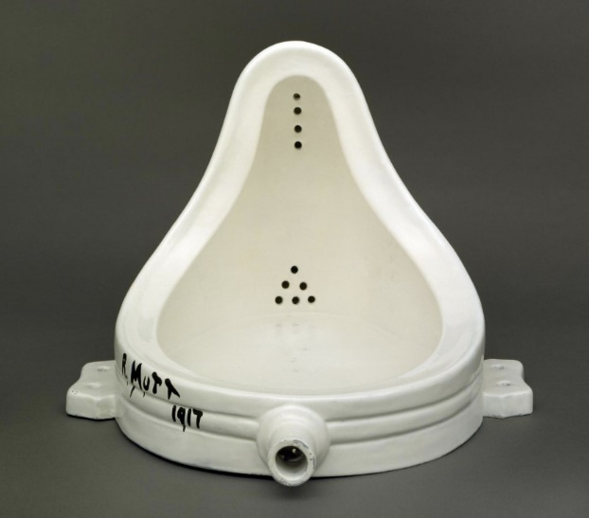
Figure.5 Duchamp. M, Fountain, 1917

In 2023 The growth of technology and the fracturing of an artist’s function in society has reached an apex, Ai Weiwei subverts and amplifies what he perceives to be the most significant narratives of the day, using everyday objects and the internet. Where artists formerly operated at a distance from the public, Weiwei functions at a tweet’s length from his audience: “It’s a wonderful thing, the internet. People who don’t know me can see exactly what I’ve been doing” (Smith et al, 2009 p.19). Through the immediacy of the medium he can witness and share his experiences directly, his role, oscillating between journalist and artist, through this duality he can operate beyond censored institutions that curtail genuine expression and freedom of speech.
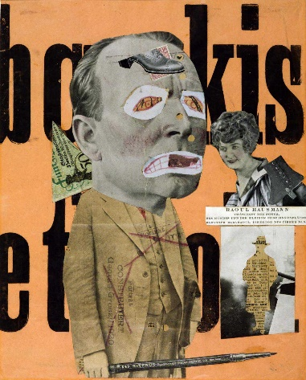
Weiwei’s disrubition of public space as exemplified in #safepassage, interrupts the familial nature of the city, in this case Berlin, and creates an opportunity for an intimate experiene of a place. Yi Fu Tuan said “intimate occasions are often those on which we become passive and allow ourselves to be vulnerable.” (Tuan, 1977. P137). Through subverting the expected appearance of an existing place, Weiwei creates a liminal space allowing, certain perceptions to become suspended, thus enabling visitors time to re-evaluate their preconceived beliefs. Through this deterritorialization and reterritorialization of space and place, Weiwei transforms and subverts to challenge our perceptions and prejudices.

Figure 6.Hausmann, R. (1919-20) The Art Critic
This type of breakdown between what an artist’s role should be in society, has its origins firmly in the attitudes promoted by the Dadaists. Formed to the backdrop of World War 1, and the absurdity that they witnessed orchestrated by the ruling elite, the Dada group sought to subvert all known conventions, being opposed as they were to all established institutions, they dissolved all notions attached to tradition, empirical knowledge and social norms in favour of a carnival of insane performance. Initially focused around the Cabaret Voltaire in Zurich which according to Hans Arp in his 1927 diary was, “total pandemonium.” (Hage, 2016). The movement quickly became international with Dada groups being established in a number of European cities.
Tristan Tzara’s ‘Dada Manifesto’ declared that “Dada Means Nothing.” (Tzara. T 1917 p.1) But it is clear the spirit of Dada was firmly a spirit of revolution. For Tzara also stated, “The new artist protests: he no longer paints (symbolic and illusionist reproduction) but creates directly in stone, wood, iron, tin, boulders—locomotive organisms capable of being turned in all directions by the limpid wind of momentary sensation.” (Tzara. T 1917 p.2) This was a call to arms, an organised revolt against the structures and institutions which had inflicted untold misery upon the people of Europe. Like Ai Weiwei’s use of Technology, bearing witness to the unfolding tragedy of the migrant crisis, Dada performed as a mirror, holding up and reflecting the insanity of what it had witnessed during World War 1.
Through the subversive nature of Dada, what has resulted is a rhizomatic approach to arts practice, which has had a transformative impact on how artists engage with materials, notions of space and place and an understanding of how reductive objectivity can be, often exploited through institutions and political establishment, to promote binary ideologies and belief structures. In the Dada Manifesto, Tzara also stated “A work of art is never beautiful by decree, objectively and for all. Hence criticism is useless, it exists only subjectively, for each man separately,) without the slightest character of universality.” (Tzara. T 1917 p.2 ) Later in the century, Post-Structuralist philosophy would come to reflect upon the reductive nature of institutional objectivity and the transitory nature of subjectivity. Initially, through the work of Jacques Lacan and the developments of his theories based on the ‘mirror phase’ and then through thinkers such as Gilles Deleuze and Felix Guattari. In their account of what a book is and how it operates in the world. They begin by describing a book as a multitude, that it is neither objective nor subjective. “The book is not an image of the world. It forms a rhizome with the world, there is a parallel evolution of the book and the world ; the book assures the deterritorialization of the world, but the world effects a reterritorialization of the book. (Deleuze and Guattari, 2023 p.10)
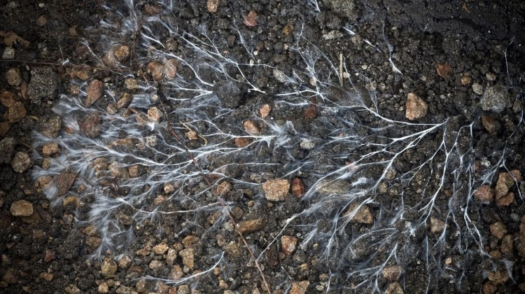
Figure. 7. Mycelium Network
For Deleuze and Guattari, a rhizomatic approach to the systems that govern society is preferential over an arborescent model. This way of understanding is demonstrative of how post-structuralists perceives our phenomenological experience of the world. For post structuralists, meaning is contingent upon the context that we experience any given phenomena. Therefore, when an artist puts something out into the world, meaning naturally evolves beyond the original intentions of the artist, affected as it is by, sociological and temporal forces. Thus understood, enforcing a didactic universality and meaning onto the performative nature of a work of art is an oppressive exercise which excludes interpretation through experience and difference, presenting a narrow view of the world which only serves to imprison subjectivity in a reality reminiscent of Plato’s cave.
For Duchamp, his most significant impact on art was elevating the ‘idea’ as an accepted medium for the artist. Beginning with the ‘readymade,’ the subsequent reframing of what a work of art is, how it should function and who is it for, allowed artists to circumvent representation and use materials which most explicitly expressed their concepts.
Weiwei’s ‘Safe Passage,’ Uses a very tangible public space as his ‘plinth’ to share an idea and participate in a conversation on an incredibly contentious topic, which engages all levels of society. Displaying real life jackets in this context rather than artistic representations, forces the public to perceive new significance and meaning within the objects, affecting a response that induces debate, and keeps the issues present in the mind of the public. Weiwei clearly has his position, but the work is not didactic, it simply presents the facts of the situation and allows time and space for conversation.
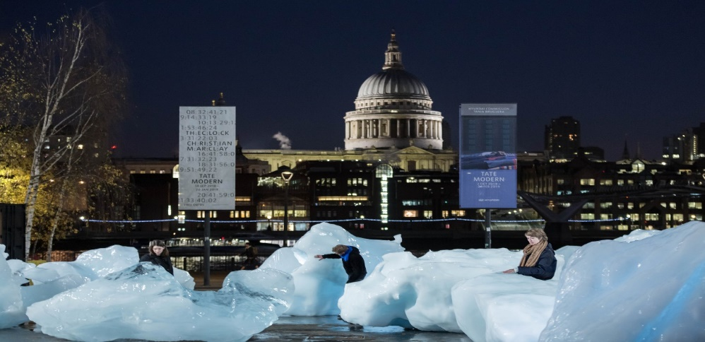
Similarly, using the same sort of appropriation of public space to create a spectacle, Olafur Eliasson, utilised the concept of the ‘ready-made,’ when, in 2018 he exhibited ‘Ice Watch’, an instillation which Consisted of 30 glaziers that had broken away from the Greenland ice sheet.

Figure 8. Eilasson, O. Ice Watch 2018
Massive ice boulders placed in situ outside of the Tate Modern. As an installation, ‘Ice Watch’, presented several themes, primarily, it laid down a challenge to the viewers who engaged with it to consider the impact of climate change in a very stark interplay of space and place. “Eliasson has called these kinds of experiences ‘frictional encounters’ interactions between viewers and artworks or subjects and objects, that are always riven with tension’. (Olafur Eliasson and Engberg-Pedersen, 2018)
The aesthetic simplicity and clear message that Eliasson expresses through ‘Ice Watch,’ demonstrates a complex understanding of space. In a Thousand Plateaus, Deleuze and Guattari discuss the essence of the nomadic qualities that exist within smooth space, which they see as being, defined through experiences at close range. Striated space is on the other hand defined by horizons and fixed points. “When we invoke a primordial duality between the smooth and the striated, it is in order to subordinate the differences between “haptic” and “optic,” “close vision” and “distant vision”. (Deleuze and Guattari, 2023 p. 576) Through ‘Ice Watch’, Eliasson attempts to create an interplay with these different spaces and materials, drawing the public into proximity, to engage in a primal haptic experience of the glaciers whilst simultaneously being drawn back into the overwhelmingly stark contrast of the contemporary forms of the cityscape, symbolic as they are of the very reason behind the works existence. For both Weiwei and Eliasson, the notional diversity that ‘ready-mades’ provide, create an opportunity to utilise a symbolism through a form of creative shorthand, using materials which have cultural universality which resonate despite the apparent economy of creative labour.

Multiples, Capitalism, consumerism
For ‘Safe Passage,’ Weiwei gathered 14000 life jackets. In the first instance they represent the ‘many.’ The garment, reflecting as it does human form, makes the symbol even more poignant. Simultaneously true, is that surplus of a mass-produced object is also suggestive of commerce. In the 1999 movie Fight Club, Tyler Durden, the nihilistic antagonist, engages Edward Nortons character, ‘Narrator,’ in a benign question, “what is a duvet?” Narrator replies, “a comforter,” Durden answers plainly in response, “It’s a blanket, just a blanket.” (Fincher. D. fight club, 1999) What the movie attempts to exemplify, is that as we arrived at late capitalism, symbolic meaning, appropriated by commerce had firmly transferred onto objects of mass production in a way which had become entirely normal to society.
This adaptation of symbology to the new materialisms of Western culture, subverts a notion by the German philosopher Walter Benjamin, who developed a theory regarding an atmosphere or ambience that exists solely in relation to an object that was one of a kind. Through his influential 1935 essay ‘The Work of Art in the age of Mechanical Reproduction.’ (Benjamin, 1935) Using a work of art as his example, he associated the term, ‘Aura’ in relation to a unique work, for Benjamin, aura was absent from any form of reproduction. His pre WW2 perspective clearly had no concept what was to come during the boom years of the 1950’s and the subsequent amplification and distribution of mass produced domestic goods and how in this new atomised era, where spirituality and traditional values were in decline across western societies, and places of worship and religion were being supplanted by shops and brands, new significance and meaning was being seen in mass produced objects, replicated in their millions, ‘Aura’ it seemed was being found, not in the uniqueness of an object but in the lifestyle choices of the day, and what they represented for an individual. Art was not exempt from this commodification of everyday life, and artists began to absorb this new materialist aesthetic into their work.
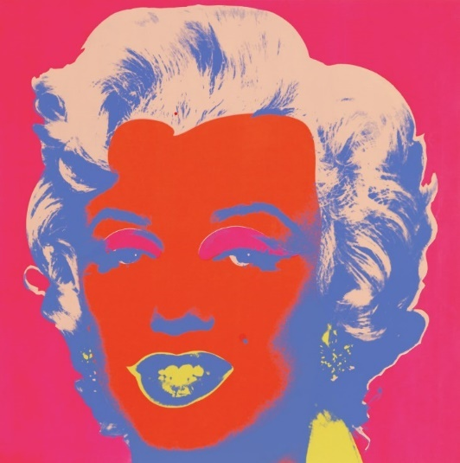
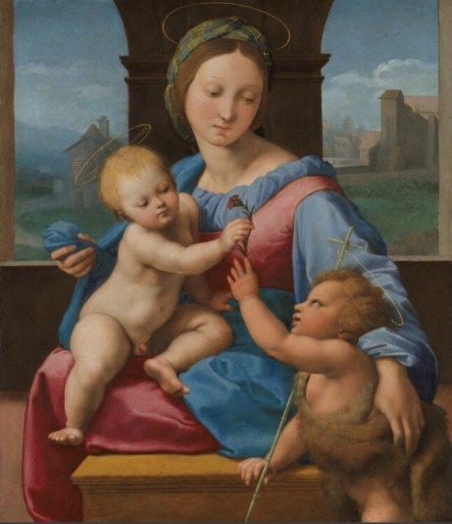
When Andy Warhol first began to explore multiples, broader society struggled with the notion of how something perceived as, ‘culturally low,’ could be rendered ‘high art.’ What Warhol and other artists of the 1960’s had begun to understand was that cultural iconography, formerly dominated by religious symbolism, had been supplanted with commercial icons, crassly put, western society and the blooming secular attitudes of the age, had replaced the Madonna with Marilyn.

Figure. 10. Warhol. A. Untitled from Marilyn Monroe. 1967
Fig.9. Raphael. The Garvagh Madonna. 1510

What Warhol observed through magazines, movies and television, was that via photography, our phenomenological experience of the world had become mediated through images. Guy Debord observed, “The Spectacle is not a collection of images; it is a social relation between people that is mediated by images.” (Debord, 1977 p. 7) The objectification and proliferation of commercial images had achieved more than entertainment, advertising had sold them to us as opportunities to realise better versions of ourselves, “The first stage of the economy’s domination of social life brought about an evident degradation of being into having, human fulfilment was no longer equated with what one was, but with what one possessed.” (Debord, 1977 p. 7) Through buying a new toaster or watching the latest Elvis movie, you could achieve greater fulfilment and like a certain washing up liquid brand, longer lasting happiness.
Jean Baudrillard said of Pop Art “The object ceases to be banal as soon as it signifies. Now, we have seen that the ‘truth’ of the contemporary object is no longer to be manipulated as an instrument, but as a sign. And it is the success of pop at its best to show it to us as such.” (Baudrillard, 1970 p118) During 2016, Ai Weiwei exhibited alongside a curated collection of Andy Warhol’s work in his hometown of Pittsburgh. Warhol’s work and concepts have always resonated with Weiwei, especially through his use of repetition. During an interview for the exhibition, Weiwei reflected upon this mutual appreciation for the multiple and repetition “Repetition gives work a stronger position, and it makes the impression double and triple ... Because we live in a post-industrial information age, information is repeatedly re-used to establish a ground for communication.” (carnegiemuseums.org, n.d.)
An observation such as this succinctly links Weiwei’s absorption of media techniques and communication strategies to subvert the narrative in the direction of his choosing, tactics usually associated with marketing and the media. On the surface this pairing is something of a contradiction. Considering the work in isolation though, both of their praxis reverberates with a hawkish social narrative which operates both overtly and covertly.
Herbert Marcuse’s asserted that “The artist along with his role must be understood in terms of the society in which he lives.” (Pippin, Feenberg and Webel, 1988. P.109) In the case of the Pop artists, their reflections on a mass-produced consumer society, can only be assessed in relation to the fact they were unaware to the extent that consumerism and surplus would irreparably damage the planet and the social and mental health of the people it purported it was liberating through commerce. Through their work, they expressed a naïve curiosity like that of a toddler experiencing something for the first time. “The reason these works leave us thoroughly dissatisfied lies not in their means but in the end: most of them have nothing to say” (Madoff, etal,1997. P. 85) Today, Questioning the narrative has become in contemporary art, an expectation. Pop Arts most vital legacy was the appropriation of the commercial industries own tools and devices in the making of art that questions and challenges the existing paradigm.
Advertising, marketing, public relations, or, as originally conceived, ‘peace time propaganda’ (Curtis, A. The Century of the Self 2002) has been on the offensive since it recognised the commercial opportunities available through manipulating the choices of the masses. Ever since, Industries and governments have sought to identify and objectify swathes of people to manipulate consent and subvert the notion of ‘free choice.’ In 1964 Herbert Marcuse released One-Dimensional Man, a book that captured the zeitgeist, scrutinizing as it did, evidence that capitalism was creating a docile unquestioning and disconnected society that was subjectively and spiritually bereft. “Our society distinguishes itself by conquering the centrifugal social forces with technology rather than Terror, on the dual basis of an overwhelming efficiency and increasing standard of living”. (Marcuse, 1964. p xl) Marcuse had observed that Western companies had set about the business of reducing their populations to objectified subjects of mass production, financial opportunism has produced a populous, divided and isolated into smaller and smaller social groups, our differences exaggerated through our consumer choices, has made us more vulnerable to marketing from commercial business and social division by government, exemplified by the 2016 Brexit vote and the scandal surrounding Cambridge Analytica and the gathering of Facebook data to subvert online media content in favour of the pro- Brexit Campaign (Terziyski, 2019)


Figure. 11. Brexit Bus. 2016

Control Through Consent
Despite the complex nature of an individual’s identity, social media companies in the 21st century are spending millions of pounds attempting to objectify populations and reduce communities into measurable units. In 2016 remain voters sat comfortably, unaware of the silent 51.9% who had voted to leave. This silence engineered through algorithms that kept voters entrenched in polarised communities believing that their opinion was a universal truth. Through his book Capitalist Realism Mark Fisher Cites Adam Curtis, who believes that the internet, “in his view, facilitates communities of solipsists, interpassive networks of like-minds who confirm, rather than challenge, each other’s assumptions, and prejudices. Instead of having to confront other points of view in a contested public space, these communities retreat into closed circuits.” (Fisher, 2007 p35) Within these striated spaces, animosity and resentment create division and become resistant to different perspectives.
Through this objectification and reduction of our phenomenological experiences into images, capitalism has stripped bare any sense of mystique from the world and replaced it with a sedentary nihilism, where fulfilment is achieved through engaging in mindless screen based entertainment, that we generally consume individually rather than collectively. Zizek observed “today’s society must appear post-ideological: the prevailing ideology is that of cynicism; people no longer believe in ideological truth; they do not take ideological propositions seriously.” (Fisher, 2022. p.11 ) The ensuing paralysis has therefore manifested through an absolute fear of what an alternative could be and set loose destructive human qualities which are affecting our ethical and moral judgment, devastating our planet as well as the unifying social fabric that formerly held communities together, be they local or global.
So it is, that the average western citizen has seen themselves objectified, and treated in the same way that an item is valued on a production line, our decisions and opinions manipulated to keep us in place. Governments, commercial industry, and social media do not see people, they see measurable data and profit.
Our sense of community and social identity finds itself in a choke hold of radical individualism, above anything else, we value our accumulative individual wealth, clothes. houses, cars, our mobile phones, these objects as such, become symbolic of ourselves, our identity, elevating these products of commerce above their inherent function, and thus obtaining a powerful representation of our very selves. Conversely the very tools through which this has been achieved have produced opportunities for artists from Duchamp, Warhol and Weiwei to manipulate and subvert this new iconography, and challenge our political, cultural, and individual values and ideologies.
Reterritorialization
On November 24th, 2023, a glacier known as, ‘A23a,’ the size of greater London began the process of calving, which is to break off from a larger glacier. Despite our current association with glaciers and the Anthropocene,
this process is entirely natural. Significant is what then happens during the thawing process. As a glacier melts the mineral dust it collected from the Antarctic floor, releases and goes on to nourish organisms that are critical to ocean food chains. Describing this little-known function of icebergs, Dr Catherine Walker reveals a hidden nature inherent within glaciers. "In many ways these icebergs are life-giving; they are the origin point for a lot of biological activity," (A23a: World’s biggest iceberg on the move after 30 years, 2023)
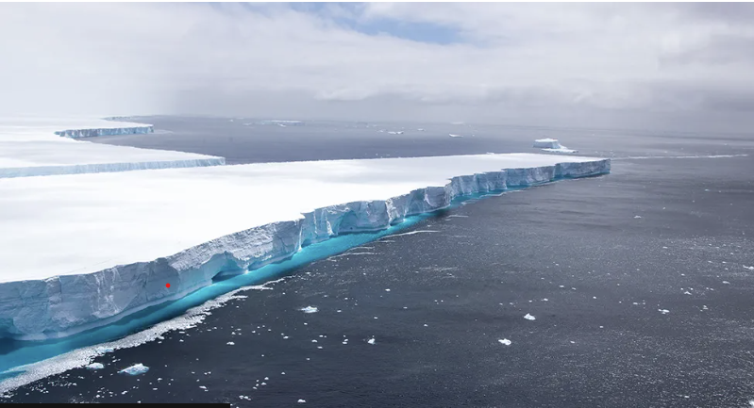
Figure 13. A23a. 2023

This is interesting, in metaphorizing the glacier, Walker humanises the object and gives it a new context. Removed as we are from these natural phenomena, this process makes it more relational to us on a human scale we can comprehend. This illustrates how language and symbols can develop and evolve, beyond our accepted perception.
Consumerism and Western capitalist ideologies, as evidenced, has had extremely damaging effects on society, simultaneously allowing space for freedom of speech, these same ideologies have sought to install technologies which have suppressed that same freedom, and marginalised radical thinking whilst dividing communities. There is however a flipside to this apparent irretractable situation. Through the essay, it has been demonstrated that in the early 20th century, the radical changes observed in society were being challenged by artists, rather than being in the service of the ruling elite, arts function began to operate as a mirror. This spirit of activism began with Duchamp and the Dada group, established as a reactive gathering of liberal creative thinkers. In the late 20st century many artists began to establish practices that seek to heal the corrosive impacts of neo liberal and capitalist ideologies. This has been accomplished through once again, examining the performative function of the artist and the curatorial role of the gallery or museum.
In his book ‘Relational Aesthetics.’ Nicolas Bourriaud set out to define the rise of what he describes as relational art “An art taking as its theoretical horizon, the realm of human interactions and its social context, rather than the assertion of an independent and private space.” (Bourriaud, 2002 P.10)
According to Bourriaud, relational art can instead of presenting an image depicting possible ways of living, he proclaims that art can embody that now, “within in the existing real” (Bourriaud, 2002 P.9) central to this approach is a fundamental change of role for an artist who in this context, performs more as a curator than a maker. An artists function in this setting is to manage an interaction between the visitors or participants within the given space, rather than manage the interaction between visitors and the art work. In this context the ready-made for an artist is the participant.
Through collaboration a vast number of contemporary art groups have become established, reflecting the spirit of dada through a transdisciplinary approach to making, naming but a few, Array in Northen Ireland, Cooking Sections, and Black Obsidian in London. Gentle Radical, a collective based in Cardiff operate within their small community, with an ethos which sets out an ambitious but powerful position.

Figure. 14. Gentle Radical. Imagination Forum

“From culture we connect community, politics, spirituality, and social justice, building projects from the ground up. We live in Wales, we believe in the power of small nations, and we want to create art from spaces of equity and solidarity These are lofty ideals, easy to speak and harder to uphold in practice, the gaps between ideals and practice – is also the work” (Anon, n.d.)
Society endured radical changes throughout the last century, we find ourselves overwhelmed by the materialistic surge of consumerism, too often our lives, dog eared by purchases and acquisitions rather than experiences with others. However, what this essay has demonstrated is the resourcefulness of people, to gather, create, question and use the systems and objects that have been manufactured and designed to suppress us and turn something as banal as a life jacket into an object of mass- subversion or use an individual’s story as a medium for social justice and change.

Bibliography‌
Baudrillard, J. (1970). The consumer society : myths and structures. London: Sage.
Benjamin, W. (1935). The Work of Art in the Age of Mechanical Reproduction. London: Penguin Books.

Bishop, C. (2010). Participation. London: Whitechapel.
Bourriaud, N. (2002). Relational Aesthetics. Paris: Les Presses Du Réel.
Cabanne, P. and Duchamp, M. (1987). Dialogues with Marcel Duchamp. New York, N.Y.: Da Capo Press.
Coole, D.H. and Frost, S. (2010). New materialisms : ontology, agency, and politics. Durham Nc ; London: Duke University Press.
Debord, G. (1977). Society of the spectacle. Detroit: Black & Red. ‌
Deleuze, G. Guattari, F. Foucault, M., Hurley, R., Seem, M. and Lane, H.R. (2012). Anti-Oedipus : capitalism and schizophrenia. London ; New York: Continuum.
Deleuze, G. and Guattari, F. (2017). A thousand plateaus : capitalism and schizophrenia. Translated by B.
Eliasson, O. (2021) ON ART AND ACTIVISM.
Fisher, M. (2022). Capitalist Realism. John Hunt Publishing.
Homer, S. (2010). Jacques Lacan. London Routledge.
‌Madan Sarup (1993). An introductory guide to post-structuralism and postmodernism. New York: Harvester Wheatsheaf.
Marcuse, H. (1964). One-dimensional man : studies in the ideology of advanced industrial society. London: Routledge.
Massumi. London [U.A.] Bloomsbury.
Olafur Eliasson and Engberg-Pedersen, A. (2018). Olafur Eliasson: Experience. Berlin Phaidon.
Pippin, R., Feenberg, A. and Webel, C.P. (1988). Marcuse. critical theory and the promise of utopia. Houndmills.
Ramazzotto, N. (2022) Heidegger and Dewey Art and the Horizons of Meaning.
Smith, K., Hans Ulrich Obrist, Fibicher, B. and Ai, W. (2009). Ai Weiwei. Ediz. Inglese. Phaidon Press Limited.
Steven Henry Madoff (1997). Pop Art: A Critical History. Press.

Tuan, Y.-F. (1977). Space and place: the Perspective of Experience. Minneapolis, Mn: University of Minnesota Press.

Websites
A23a: World’s biggest iceberg on the move after 30 years. (2023). BBC News. [online] 24 Nov. Available at: https://www.bbc.co.uk/news/science-environment-67507558 [Accessed 29 Nov. 2023].
Anon, (n.d.). Who – Gentle Radical. [online] Available at: http://gentleradical.org/who/.
carnegiemuseums.org. (n.d.). Carnegie Magazine | Summer 2016 | Ai Weiwei at The Warhol - By Cristina Rouvalis. [online] Available at: https://carnegiemuseums.org/magazine-archive/2016/summer/feature-557.html [Accessed 20 Nov. 2023].

Hage, E. (2016). A ‘Living Magazine’: Hugo Ball’s Cabaret Voltaire. The Germanic Review: Literature, Culture, Theory, 91(4), pp.395–414. doi:https://doi.org/10.1080/00168890.2016.1224912. [Accessed 11 December 2023]
‌Reuters (2023). Over 400 migrants died crossing Mediterranean early in 2023 -UN agency. Reuters. [online] 12 Apr. Available at: https://www.reuters.com/world/europe/over-400-migrants-died-crossing-mediterranean-early-2023-un-agency-2023-04-12/. [Accessed on 11 December 2023]
Strickland, P. (n.d.). Life-jacket mountain a metaphor for Greece’s refugees. [online] Al Jazeera. Available at: https://www.aljazeera.com/features/2015/12/29/life-jacket-mountain-a-metaphor-for-greeces-refugees/ [Accessed 27 Nov. 2023].
The Century of the Self, There is a Policeman Inside All Our Heads - He Must Be Destroyed, 20:00 31/03/2002, BBC2 England, 60 mins. https://learningonscreen.ac.uk/ondemand/index.php/prog/00180FD8?bcast=977997 (Accessed 09 Dec 2023)
Terziyski, M. (2019). The Political Elite and the Scandal with ,,Cambridge Analytica” and ,,Facebook”. Проблеми на постмодерността, [online] 9(2). Available at: https://doaj.org/article/9f967df3a619459298b5b0428cebb419. [Accessed on 11 December 2023]

‌

‌

Illustration List
Figure 1. Amazon. Unisex Buoyancy Aid. (Image) Available at: https://amzn.eu/d/2gZMK2g [Accessed 28 November 2023]
Figure 2. Chandlery, TSC. Automatic Lifejacket Harness. (Image) Available at: https://www.tcschandlery.co.uk/baltic-winner-165n-automatic-harness-lifejacket/p12876?msclkid=8221960ac704104d2e12f36e3e8436ff&utm_source=bing&utm_medium=cpc&utm_campaign=Shopping%20Campaign%20-%20Bing&utm_term=4582558347804436&utm_content=All%20Products
[Accessed 28 November 2023]
Figure 3. Weiwei, A. (2016) Instagram Post. (Image) Available at: https://www.designboom.com/art/ai-weiwei-life-jackets-refugee-konzerthaus-berlin-02-15-2016/ [Accessed 25 November 2023]
Figure 4. Weiwei, A. (2016) #Safe Passage.(Image) Available at: https://www.designboom.com/art/ai-weiwei-life-jackets-refugee-konzerthaus-berlin-02-15-2016/ [Accessed 25 November 2023]
Figure 5. Duchamp, M. (1917) Fountain. (Image) Available at: https://www.tate.org.uk/art/artworks/duchamp-fountain-t07573 [Accessed 30 November 2023]
Figure 6. Hausmann, R. (1919-20) The Art Critic. (Image) Available at: https://www.tate.org.uk/art/art-terms/d/dada [Accessed 30 November]
Figure 7. Gray, R. (2019) Mycelium Network (Image) Available at: https://www.bbc.com/future/article/20190314-the-unexpected-magic-of-mushrooms [Accessed 1 December 2023]
Figure 8. Eilasson, O. (2018) Ice Watch. (Image) Available at: https://icewatch.london/ [Accessed 20 November 2023]
Figure 9. Raphael. (1510) The Garvagh Madonna. (Image) Available at: https://www.nationalgallery.org.uk/paintings/raphael-the-garvagh-madonna [Accessed on 1 December 2023]
Figure 10. Warhol, A. (1967) Marilyn Manroe. (Image) Available at: https://www.moma.org/collection/works/61245 [Accessed on 1 December 2023]
Figure 11. Cummings, D. (2016) Brexit Bus. (Image) Available at: https://www.theguardian.com/business/2023/feb/05/it-is-hard-to-admit-being-wrong-but-brexit-voters-are-doing-so-in-droves [Accessed on 2 December 2023]
Figure 12. RAF. (2023) A23a. (Image) Available at: https://www.bbc.co.uk/news/science-environment-67507558 [Accessed on 27 November 2023]
Figure 13. Radical, G. (2018) Imagination Symposium (Image) Available at: http://gentleradical.org/event/imagination-forum-3/ [Accessed on 4 December 2023]

