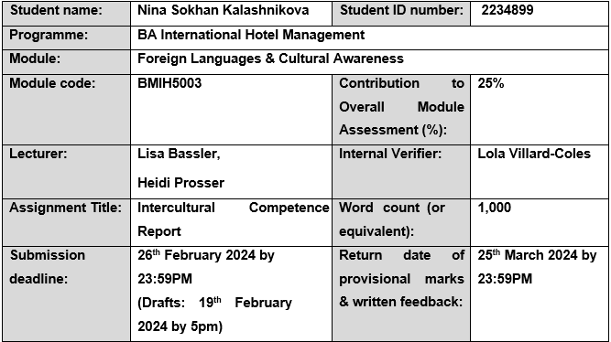
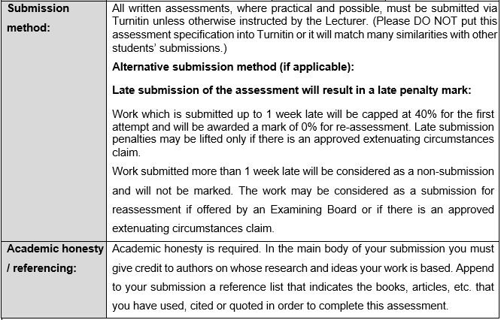

Executive Summary
This report presents a thorough analysis of the intercultural dynamics between Spain and England by the Assistant General Manager of Inclusivity Hotel & Spa. It highlights cultural differences, analyses the GLOBE Project, discusses the difficulties associated with intercultural leadership in the hospitality sector, and offers helpful suggestions for the hotel management team.

Table of Contents
Executive Summary 1
Introduction 3
Main Body 4
Culture Overview 4
GLOBE Project Overview 5
Incorporating Illustrations 5
Conclusion 8
Recommendations 9
References 10

Introduction
Using the perceptive lens of the GLOBE Project's culture and leadership study, this report sets out to analyse and comprehend the most significant cultural differences between England and Spain. We want to go beyond just contrasting languages, customs, and practices; instead, we want to assess critically the difficulties that intercultural leadership presents in the context of hospitality (Abushihab, 2016). Specific examples will highlight possible points of contention and lay the groundwork for practical suggestions designed to enable the hotel management team to promote a peaceful and culturally diverse workplace. We seek to not only close gaps but also to foster a collaborative and inclusive environment that embodies the spirit of Inclusivity Hotel & Spa as we navigate this cultural tapestry.

Main Body

Culture Overview
When examining the cultural differences between Spain and England, one comes across a patchwork of customs, social mores, and communication quirks that define the essence of each country. Even though they are slight, these differences have a significant impact on how people in the hospitality sector interact on a daily basis (Brown, 2020).
Key Differences Between England and Spain:
Customs: An organised approach to social interactions and a predilection for formality are ingrained in English culture. Conversely, relationships in Spain tend to transcend formality, with a warm, familial atmosphere prevalent (Selvi & Yazan, 2021).
Communication Styles: The passionate and expressive communication style that is common in Spain stands in stark contrast to the reserved nature of English communication. While in Spain conversations are frequently marked by animated gestures and emotive expressions, in England people place a great value on precision and brevity (Timko, 2022).
Work-Life Balance: Different perspectives exist regarding work-life balance. England has historically valued a distinct separation between work and personal life, whereas Spain embraces a more integrated approach in which leisure and family relationships are highly valued (Forney, 2020).
Country Overview - Spain
Spain is a country with a rich cultural diversity and historical tapestry that combines influences from the Iberian Peninsula, Roman heritage, and Moorish occupation. Spain, known for its vibrant festivals, intricate flamenco music, and delicious food, embodies the spirit of celebration. The importance of family ties cannot be overstated, and warmth and transparency are common traits in interpersonal relationships (Martin & Kaboré, 2023).
A celebration of life permeates Spanish culture, and people value their relaxed get-togethers with friends and family. A laid-back attitude towards time is reflected in traditional practices like the siesta, which promote an atmosphere where people enjoy life's rhythm. A captivating and unique cultural environment is created by the vivid colours of Spanish festivals, the rhythmic beats of flamenco, and the aromatic allure of paella (Marson & McKinney, 2020).

GLOBE Project Overview
According to Abushihab (2016), Since its inception in the 1990s, the GLOBE Project has made significant contributions to our understanding of the complex interactions that exist between organisational practices, leadership, and society culture. With more than 200 researchers from 62 societies, GLOBE has grown over the past 20 years into one of the biggest and most thorough studies in the social sciences. The project explores four key research questions in its most recent phase, GLOBE 2020: cultural shifts, the connection between interpersonal trust and national culture, perspectives from understudied MENA nations, and the influence of gender on leadership perceptions.

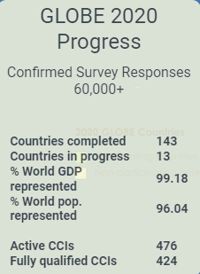
Source: Progress of Globe Project (Timko, 2022)

Incorporating Illustrations
GLOBE 2020's investigation of the degree of cultural shifts in the countries it first studied is one of its main goals. This entails using the original GLOBE instruments with extra questions and doubling the number of target countries. In order to provide important insights into the forces influencing modern cultures around the world, the research attempts to identify the main sociological drivers of cultural change (Goglia & Wolny, 2022).
Forney (2020) stated that the project also looks into the complex relationship that exists between national culture and the various cultural antecedents of interpersonal trust in various nations. Surveys are carried out in more than 120 countries using a newly created instrument, offering a detailed understanding of how cultural quirks affect trust-building techniques.
Brown (2020) reported that GLOBE 2020 ventures into MENA countries that have received relatively little research. Enhancing cross-comparative research, the project aims to gather cultural data from many Middle Eastern and African nations that were not included in the GLOBE study. This is especially important in the case of the Inclusivity Hotel & Spa, since it is expected that staff members from various cultural backgrounds will work well with the London team.
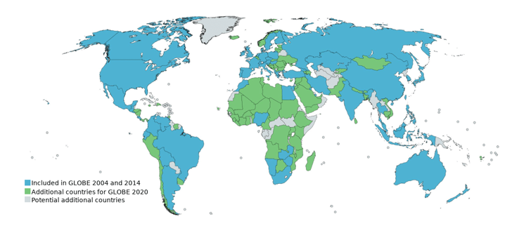
Source: Country Scores of Globe Project (Marson & McKinney, 2020)
GLOBE 2020's investigation of leadership perceptions across genders and cultures is another essential component. The project intends to investigate whether perceptions of exceptional leaders differ between genders and whether these differences vary across cultural contexts by incorporating a higher proportion of female leaders. This directly affects how the hotel manages its multicultural workforce (Fenner, 2017).
The report will include visual aids, such as screenshots of the country scores from the GLOBE Project website, to help convey the global reach of GLOBE 2020. These images will provide strong proof of the project's wide scope and significance. The insights from the GLOBE Project will contribute to our understanding of cultural dynamics and offer useful advice for improving Inclusivity Hotel & Spa's intercultural (Elkabas, 2018).
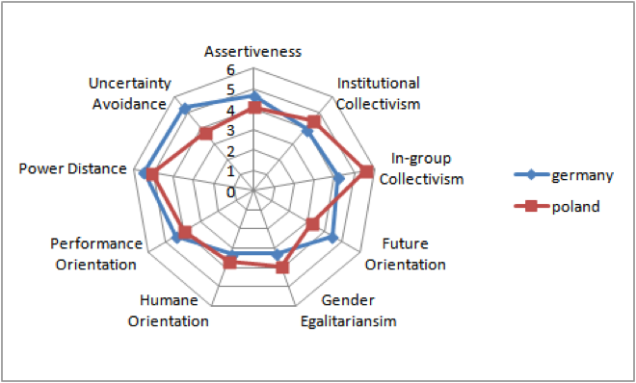
Source: Cultural Dimensions (Goglia & Wolny, 2022)
The report's depth and credibility will be improved by incorporating GLOBE's extensive research findings and visual aids, which will also place it in line with the most recent developments in cross-cultural management and leadership studies (Abushihab, 2016).
.

Conclusion
As it wraps up this intercultural investigation, the report emphasises how important cultural sensitivity was to Inclusivity Hotel & Spa's success. The GLOBE Project analysis highlights the diverse range of differences between Spain and England, which presents both opportunities and challenges for successful intercultural leadership. The Hotel Management Team can use the suggested actions, which are based on useful insights, as a guide. This report establishes the framework for a harmonious, culturally sensitive workplace where each employee adds to the vibrant mosaic that defines the essence of this prestigious establishment, just as the doors of Inclusivity Hotel & Spa open wider to welcome a diverse team.

Recommendations
- Provide thorough cultural training courses to employees who are English and Spanish-speaking.
- Encourage sensitivity to cultural quirks in order to improve collaboration and reduce miscommunication.
- Discuss issues like decision-making, communication, and handling conflict in a multicultural setting.

References
Abushihab, Dr.I. (2016) ‘The effect of cultural awareness on motivating students to learn English as a foreign language in Jordan’, Journal of Foreign Languages, Cultures and Civilizations, 4(1). doi:10.15640/jflcc. v4n1a6.
Brown, K. (2020) The routledge companion to Digital Humanities and art history. New York: Routledge, Taylor & Francis Group.
Elkabas, C. (2018) ‘Cultural awareness and intercultural competence in foreign languages’, EDULEARN Proceedings [Preprint]. doi:10.21125/edulearn.2018.0572.
Fenner, A.-B. (2017) ‘Cultural awareness in the foreign language classroom’, Language Awareness and Multilingualism, pp. 205–217. doi:10.1007/978-3-319-02240-6_16.
Forney, G.R. (2020) Rebels, rascals, and ruffians: Profiles from early Montana. Norris, MT: Raven Publishing, Inc.
Goglia, F. and Wolny, M. (2022) Italo-romance dialects in the linguistic repertoires of immigrants in Italy. Cham: Springer International Publishing, Imprint: Palgrave Macmillan.
Marson, S.M. and McKinney, R.E. (2020) The Routledge Handbook of Social Work Ethics and values. London: Routledge, Taylor & Francis Group.
Martin, M.T. and Kaboré, G. (2023) African cinema: Manifesto and practice for cultural decolonization. Bloomington, IN: Indiana University Press.
Selvi, A.F. and Yazan, B. (2021) Language teacher education for global englishes: A practical resource book. Abingdon, Oxon: Routledge.
Timko, N. (2022) ‘Raising Cultural Awareness and forming cross-cultural competences of students studying foreign languages’, SSRN Electronic Journal [Preprint]. doi:10.2139/ssrn.4024994.

