Assignment 1 – POSTER
Developing Emotional Intelligence Skills
LCLM5006

Student name: Teya Todorova Ceneva
Student ID: 2325754
Lecturer name : Nishi Ramsurrun

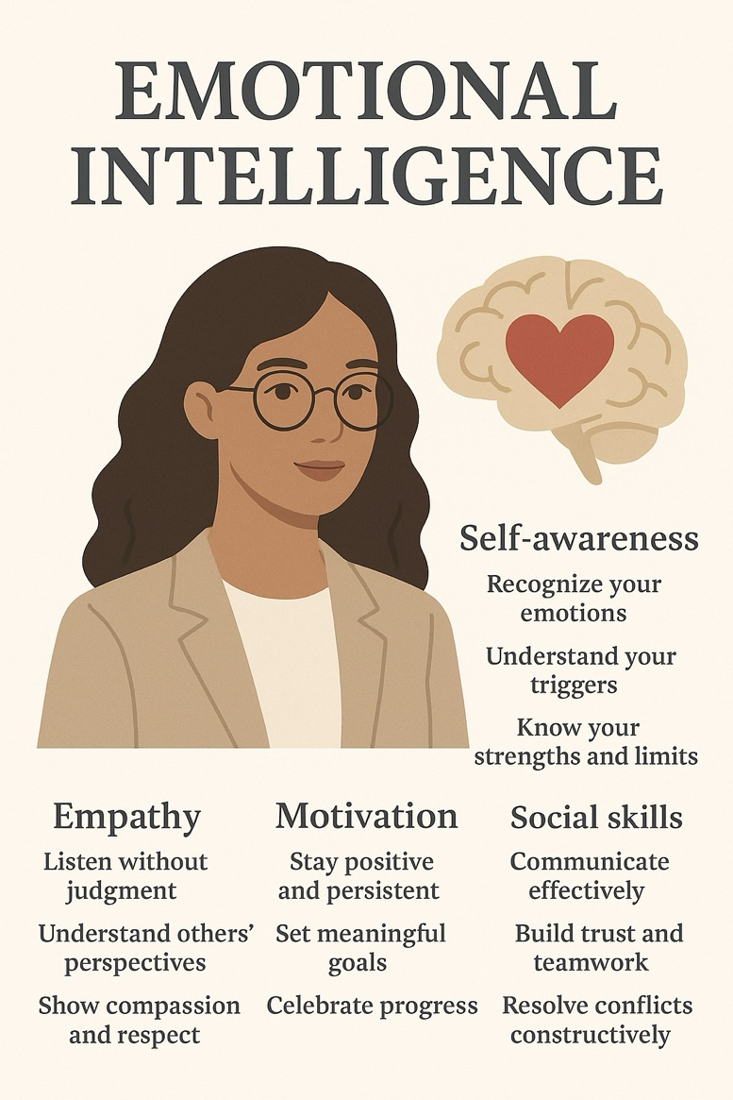

Emotional intelligence is recognizing, understanding, managing, and using emotions effectively in ourselves and others to guide thinking, behaviour and relationships.

