University of Wales Trinity Saint David
School of Computing
Advanced Software Development & OOPS and Algorithm
ACCB5011_Algo / ACCA5032
Jericho Uzzell
1702201
09/04/2021


1. Introduction 3
2. Arrays, linked lists and evaluation; 3
2.1. Benefits and drawbacks to arrays and linked lists; 3
2.1.1. Arrays; 3
2.1.1.1. Overview; 3
2.1.1.2. Benefits; 3
2.1.1.3. Drawbacks; 4
2.2.1. Linked lists; 5
2.2.1.1. Overview; 5
2.2.1.2. Benefits; 5
2.2.1.3. Drawbacks 5
2.2. Search one thousand records daily; 5
2.2.1. Should you use array or linked lists when adding new data? 5
2.3. Evaluate the probable performance of this data structure; 6
2.4. Demonstrate how a binary search tree is constructed; 7
3. Algorithms; 8
3.1. What is an algorithm? 8
3.2. Using Dijkstra’s Algorithm; 8
3.2.1. Lowest cost; 8
3.2.2. Priority queue; 10
3.3. Minimax algorithm; 10
3.3.1. What is Minimax algorithm works; 10
4. References; 11
5. Bibliography 11

1. Introduction
This report will cover the use of arrays and linked lists. This report will discuss the advantages and disadvantages for both. This report will also evaluate searching through a set of data, this data being a binary search and a search through an array or linked list.

Lastly, this report will discuss the use of algorithms, how they can make searching through data fast, how they themselves can be improved and the problem that comes with searching through a lot of data.

2. Arrays, linked lists and evaluation;

2.1. Benefits and drawbacks to arrays and linked lists;

2.1.1. Arrays;

2.1.1.1. Overview;
What is an array? According to [2], within a computer code, variables are used to store data. An array is used within code to store single items of data. Think of it as such, instead of continually typing a variable name with something different on the end like a number, for example, username1, username2 -- you would append it to an array.

2.1.1.2. Benefits;
According to [1], arrays can represent data using a single name (variable). This data is accessed via an “index” at the end of the name, usually in brackets with a number signifying the data to access. Some languages such as Lua start at one whereas almost all languages start at zero.

One of the main reasons Lua and other languages do this is to allow new coders easiness to understand. This is notable as [1] states that you can access any part of the array at any time randomly, as long as you provide a correct array index.

[1] continues and states that arrays can allow for other data structures such as but are not limited to: linked lists, stacks, queues and more; [1] lastly states that arrays in two dimensions can be used for matrices.

2.1.1.3. Drawbacks;
Within programming languages, arrays can be placed into two categories, fixed and dynamic. [4] states a fixed array is the size or length of an array at the time it is created or allocated, this cannot be changed whilst the programme is being run.
On the other hand, a dynamic array allows for the size to be edited whilst the programme is active, this extends to adding, editing and removing array indexes.

Languages that use fixed array size are but are not limited to: C#, C++ and Java; using fixed arrays can add problems and result in using alternatives -- this report will be talking more on C# arrays.

[3] states that as soon as an array is created within C#, the size cannot be edited, this reaffirms what [4] stated. [3] offers solutions such as creating a new array with the previous one appended on, creating more available slots or the potential of oversizing the array which wastes memory.

[3] states that you could never deleted or add elements to the middle of an array, all of these issues were overcome with the introduction of including a collection into a C# programme.

2.2.1. Linked lists;

2.2.1.1. Overview;
According to [5], a linked list is a linear data structure, elements of the linked list are using pointers to locate the memory. Essentially, a data field with a reference link to the next link.

2.2.1.2. Benefits;
[6] states that a linked list allocates memory to a data structure whilst the program is running making it dynamic. [6] states that it can reduce access time, allows for insertion and deletion of a data structure and lastly allows for stacks and queues with linked lists.

2.2.1.3. Drawbacks
[6] states that linked lists tend to use more memory due to pointers, the linked list must be read from the beginning due to the sequential behaviour, nodes are stored contiguously increasing time required to access elements and lastly, singly linked lists are cumbersome due to memory being wasted when allocating space.

2.2. Search one thousand records daily;

2.2.1. Should you use array or linked lists when adding new data?
This question this report is trying to answer is, should you use an array or linked list if you are creating new entries every day (one thousand records daily)?

Comparing the advantages for arrays and linked lists, this report has concluded that the best practice to use would be to use an array. This conclusion is due to the new entries this report has stated will be required to do. In the early days of C#, you were not able to make an array dynamic however, nowadays you can. Arrays can be one dimensional or multidimensional.

Another question was stated, should you use an array within a linked list? Ultimately, from what this report has gathered, linked lists are one dimensional and are not intended to be multidimensional -- this report found that arrays would be best so no, this report cannot endorse linked lists within arrays.

2.3. Evaluate the probable performance of this data structure;
From question 2.2, we are trying to calculate
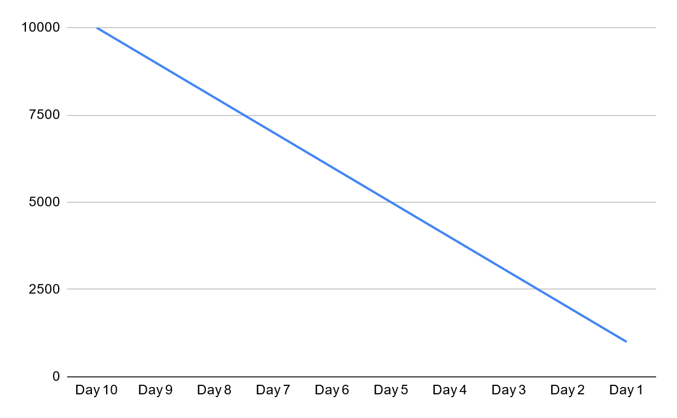
The above graph shows the big o notation for the code that will search through the array or linked list from the above. If the entries every day maxes out to one thousand entries, the big o notation increases dramatically. The big o notation, written like O(n), means that the array can be executed a finite amount of times.

2.4. Demonstrate how a binary search tree is constructed;
A tree is a data structure of nodes which have a root node (also known as a parent node), root nodes have zero or more children with the children nodes having zero or more children according to [7].
[7] states that a binary search tree (BST) adds some rules from the above, each node has a maximum of two nodes, the value of the left node is less than the current node which is less than the right node if any is present.

[7] states that the basic operations of a BST are the following: create, insert, search, delete, inorder, preorder and lastly postorder; when searching for a node, you always go from the root node down.

What is an unbalanced tree? An unbalanced tree is when you have data that is located more to one side of the tree. A tree may become unbalanced when inserting or deleting nodes. To rebalance a tree, you must apply a rotation to the side of the tree which is unbalanced, these rotations are called right or left rotations, then you target the node.
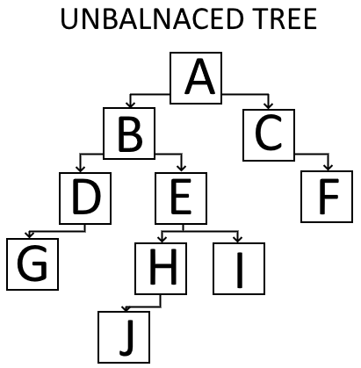

What happens if you have an unbalanced tree? Having an unbalanced tree and making the search extremely difficult, it can make understanding and managing the data difficult.
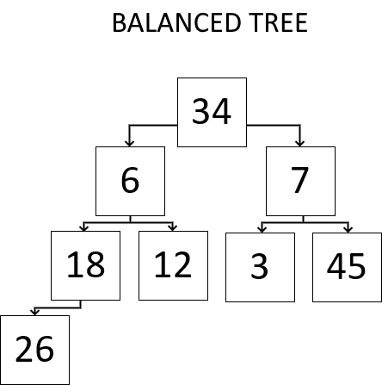

3. Algorithms;

3.1. What is an algorithm?
According to [8], “An algorithm is a set of instructions and rules that a computer needs to do to complete a task”, they are used to do a set of tasks or a way to solve a problem.

3.2. Using Dijkstra’s Algorithm;

3.2.1. Lowest cost;
This report will use Dijkstra’s algorithm to solve the below problem. This algorithm is known as a greedy algorithm as it always checks each vertex for their weight, if the weight is less than the current value, it will use it.
An example can, A is always zero. The algorithm will check the connected vertices, such as B and C -- B will be three and C will be four. The algorithm will pick B and will check B's vertex, E and F will be connected to this vertex, E will be weighted as six and F will be four. The algorithm will pick F because it will add the recent values (three from B and four from F becoming seven).
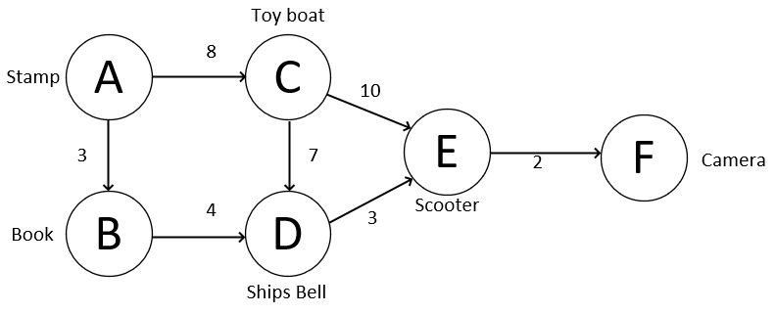
The diagram above demonstrates the path from Stamp to Camera. Using Dijkstra’s algorithm, we can make the fastest path. The numbers on the line represent the weight (cost) to that vertex.

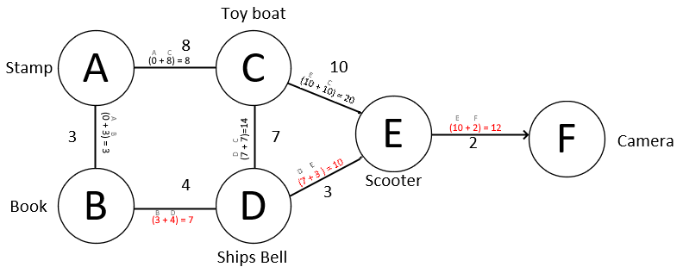

For a much clearer view, this is what the algorithm is doing. The purple icons are the chosen path, the red lines are considered approaches.
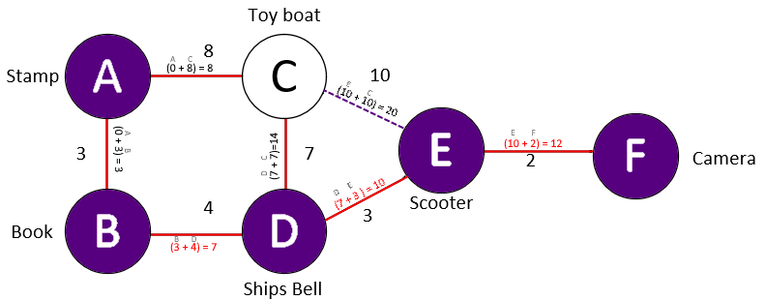

 | Vertex | A | B | C | D | E | F
Start | Parent | null | null | null | null | null | null
 | Cost | 0 | ∞ | ∞ | ∞ | ∞ | ∞
1 | Parent | null | A | A | null | null | null
 | Cost | 0 | 3 | 8 | ∞ | ∞ | ∞
2 | Parent | null | A | B | B | null | null
 | Cost | 0 | 3 | 8 | 4 | ∞ | ∞
3 | Parent | null | A | B | B | D | null
 | Cost | 0 | 3 | 8 | 4 | 3 | ∞
4 | Parent | null | A | B | B | D | E
 | Cost | 0 | 3 | 8 | 4 | 3 | 2
5 | Parent | null | A | B | B | D | E
 | Cost | 0 | 3 | 8 | 4 | 3 | 2

3.2.2. Priority queue;

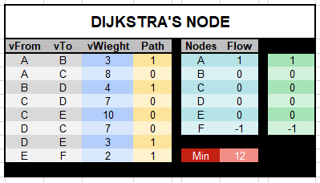

3.3. Minimax algorithm;

3.3.1. What is Minimax algorithm works;
Minimax is an algorithm. This algorithm calculates its next best move, the algorithm assumes that the opponent always picks the most successful outcome in the attempt to win, according to [8]. [8] states that the algorithm has three main rules: maximise, minimise and utility calculation; the algorithm calls maximise which calls minimise, minimise then calls maximise.

4. References;
[1] faceprep. “Advantages and Disadvantages of Arrays in C, C++ and Java.”, faceprep, 06 March 2020, [Online.] Available: https://www.faceprep.in/data-structures/advantages-and-disadvantages-of-arrays/, [Accessed 16 April 2021]
[2] BBC Bitesize. “What is an array?” BBC Bitesize, 2021, [Online.] Available: https://bbc.co.uk/bitesize/guides/zy9thyc/revision/1, [Accessed 16 April 2021]
[3] DoNetTutorials. “Advantages and Disadvantages of Arrays in C#.” donettutorials, 2021, [Online.], Accessed: https://dotnettutorials.net/lesson/advantages-and-disadvantages-of-arrays-csharp/#:~:text=As%20the%20elements%20of%20an,the%20middle%20of%20an%20array, [Accessed 16 April 2021]
[4] Press Rebus Community. “Fixed and Dynamic Arrays.” press.rebus.community, 2021, [Online.], Available: https://press.rebus.community/programmingfundamentals/chapter/fixed-and-dynamic-arrays/, [Accessed 16 April 2021]
[5] geeksforgeeks, “Linked list data structure”, geeksforgeeks, April 18 2021, [Online.], Available: https://www.geeksforgeeks.org/data-structures/linked-list/, [Accessed 26 April 2021]
[6] developer-interview, “What is a linked list and how it works? What are the advantages and disadvantages of linked lists?”, developer-interview, January 28 2016, [Online.], Available: https://developer-interview.com/p/algorithms/what-is-a-linked-list-and-how-it-works-what-are-advantages-and-disadvantages-of-linked-lists-39, [Accessed 26 April 2021]
[7] freecodecamp, “Binary search trees: BST explained with examples”, freecodecamp, November 16 2019, [Online.], Available: https://www.freecodecamp.org/news/binary-search-trees-bst-explained-with-examples/, [Accessed 26 April 2021]
[8] thinkautomation, “What is an algorithm? An ‘in a nutshell’ explanation”, thinkautomation, 2021, [Online.], Available: https://www.thinkautomation.com/eli5/what-is-an-algorithm-an-in-a-nutshell-explanation/, [Accessed: 26 April 2021]
[9] M.Eppes, “Game Theory - The Minimax Algorithm Explained”, towardsdatascience, August 7 2019, [Online.]. Available: https://towardsdatascience.com/how-a-chess-playing-computer-thinks-about-its-next-move-8f028bd0e7b1, [Accessed 26 April 2021]

5. Bibliography
https://www.geeksforgeeks.org/dijkstras-shortest-path-algorithm-greedy-algo-7/ - used for Dijkstra’s algorithm
https://www.thecrazyprogrammer.com/2016/11/advantages-disadvantages-linked-list.html
https://towardsdatascience.com/linked-lists-vs-arrays-78746f983267
https://www.php.net/manual/en/function.array.php - used to talk about array length, resizes and information.
https://www.youtube.com/watch?v=JkZkGxVZ8ao
https://www.excel-easy.com/examples/shortest-path-problem.html

