
University of Wales Trinity Saint David London

Module No: BMSW4006_LON
Module Title: Managing Enterprise in the 21st Century
Lecturer: Dr Anupam Mazumdar
Student Number/Name:
1914905 Maria Sabrina Belcianu
1916221 Williams Kwame Dapaah
1917235 Vanessa Emmanuella Liverpool
1907172 Uwe Olisemeke Eric
1916038 Ivanovitch Girao Paiva

BUSINESS PLAN
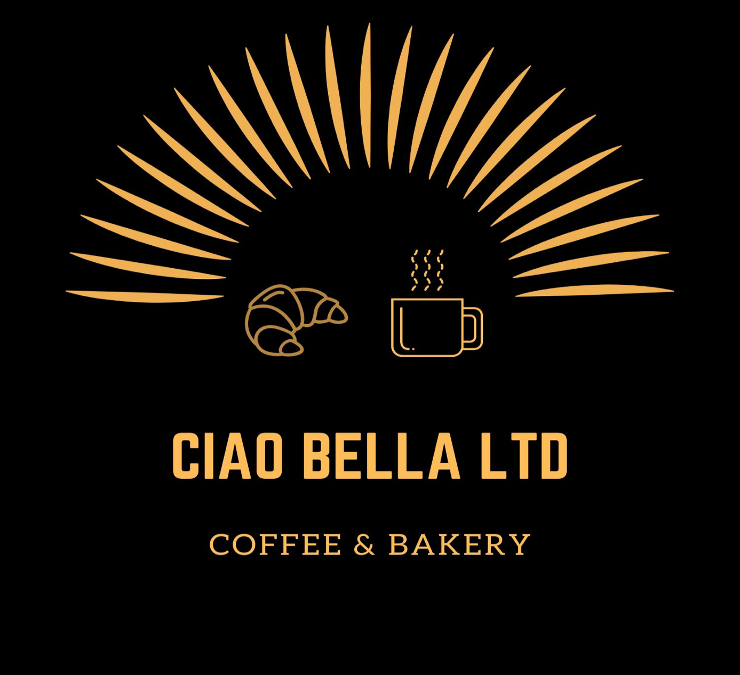

Executive Summary
Ciao Bella Ltd seeks to undertake a project in Tottenham which is located at 712 High Road, Tottenham, and London, N17 0BX.Ciao Bella Limited is going to be one of the best restaurants where the customers’ demand for bakery food with delicate quality can be ensured, and the customers can get the value of a soothing place while having the delicious food. The purpose of this marketing plan is to establish a well-organised marketing strategy with financial forecasting so that the new venture can succeed with planned development. This plan has been developed using the market environment analysis, competitor analysis, risk analysis, financial forecasting, and primary research in the current market for estimating the acceptance and current situation of the bakery shops. The core finding of the marketing plan is that the market is expanding and there is high possibility of entrance with low cost and advantages can be taken from the differentiating strategies. Finally, it can be concluded that with the cooperative effort of the team and proficient activities, Ciao Bella Limited can be a choice of the customer demand of the current market as this will not only provide delicious food service but also enrich customers’ memory with the shop.
The greatest need of the people of Tottenham and its surrounding area is a restaurant that can add or provide varieties of international cuisine dishes, bakery, and coffee in the large quantities daily. Our business will include assorted alcoholic, non-alcoholic beverages, and entertainment in the afternoon. Our well-trained staff will make every customer visit special and personalized.
Ciao Bella as a launching company, intends on having a management team with eight people. The team will consist of; a general manager, an assistant manager, two floor managers, and four team leaders. The management team will be responsible for making sure that the whole workforce is working towards achieving organisational goals and objectives.
The restaurant is a partnership with five members and have contributed £400,000 at the beginning is seeking to obtain a loan amounting to £500,000 to finance its projects.

Table of Contents
Executive Summary 3
1.0 Business Overview 9
1.1 Business description 9
1.2 Core products of Ciao Bella 9
1.2.1 Coffee based products 10
1.2.2 Bakery Products 10
1.2.3 Cooked food dishes 10
1.3 Current plans and future aims 10
1.4 Business objective 10
1.5 Mission Statement 11
1.6 Vision Statement 11
1.7 Ownership 11
1.8 Legal compliance of business 11
1.8.1 Setting Up 12
1.8.2 Naming our partnership 12
1.8.3 Register the partnership 12
1.9 Start-up Summary 12
2.0Marketing Audit 13
2.1 Market Research 13
2.2 SWOT analysis 19
2.3 Competitor analysis 21
3.Products and Services 24
3.1 Products Description 25
3.2 Competitive Landscape 26
3.3 Sales Literature 28
3.4 Sourcing 29
3.5 Technology 30
3.6 Future Products 30
4.Management Team 32
4.1 Importance of a management team 32
4.2 Communication on the Vision and Mission of the company 33
4.3 Risk management 33
4.4 PESTEL Analysis 33
4.5 The Structure of the Management Team 34
General Manager 34
Requirements 35
Assistant Manager 35
Requirements 36
Executive Floor Manager 36
The Floor Manager 37
Team Leaders 37
Management Team Meetings 38
Weekly meetings 38
Monthly meetings 38
Recommendation 38
5.Target Market 41
5.1Market Analysis 41
5.2 Market Segmentation 41
5.3 Target Market Strategy 42
5.4 Market Needs 42
5.5 Market Trends 43
5.6 Market Growth 43
6.Marketing Plan 43
6.1 Marketing Strategy 44
6.2 Sales Programs 44
Specific sales programs 44
6.3 Positioning Statement 45
6.4 Pricing Strategy 46
6.5 Promotion Strategy 46
6.6 Marketing Programs 47
7.FINANCIAL PLAN AND FUNDING REQUIREMENT 49
7.1 Project Description 49
7.2 Project Funding 49
Table 2: Budgeted Operating Cost for Restaurant for the first year 51
Table 3: Budgeted Expense for Labour Requirements for the Restaurant 52
Table 4: Projected Income Statement for three years 53
Table 5: Projected statement of accumulated income surplus 54
Table 6: Projected statement of Financial Position as at 31st December 55
Table 7: Projected Statement of Cashflow 57
Capital Expenditure of CIAO BELLA LTD 58
7.4 MOBILIZATION OF RESOURCES 60
9.Appendix 66

Business Overview
By Maria Sabrina Belcianu 1914905

1.1 Business description
Ciao Bella Limited is a new business where anyone can have bakery, palatable dishes, and coffee items. In this restaurant, a customer can find some delicious bakery foods such as sausage rolls, pastries, sandwiches, cakes as well warm food such as pasta, wraps, piri-piri chicken etc. also in the evening the restaurant will have live entertainment. The location is in Tottenham next to Tottenham Stadium and Tottenham Overground Station. The exact address of this store is 712 High Road, Tottenham, and London, N17 0BX. Ciao Bella’s aims at having customers who are residing in the market area but as this restaurant is located near the Tottenham Hotspur Stadium, some customers will be coming to the location on Match day. So, Ciao Bella is opened for bakery, delicious food and coffee lovers every day. A schedule is maintained by this restaurant to open and close. The everyday schedule is given below:

Opening Time | 6:00 AM Monday-Thursday  7:00 AM Friday-Saturday
Closing Time | 10:00 PM Monday-Thursday  12:00 PM Friday-Saturday

Our staff is also concerned about the customer and will try to make every visit special and personalised; employees are extremely glad to make happy all customers.

1.2 Core products of Ciao Bella
As Ciao Bella is a restaurant for bakery, cooked food dishes and coffee, it will serve some products which are extremely popular to the customer. Products are described below:

1.2.1 Coffee based products
Ciao Bella always tries to provide authentic products to their beloved customers. So, Ciao Bella imports quality full coffee beans which are grown in Brazil. As the raw materials of coffee are improved in quality, the demands are increasing day by day. In terms of coffee and coffee-based products, Ciao Bella attempts to serve Cappuccino, Flat White, Americano, Latte, and Mocha.

1.2.2 Bakery Products
Ciao Bella is familiar to most of the customer because of the tastiness of bakery and pastry products. The restaurant will serve freshly baked products. Ciao Bella has a large collection of bakery and pastry products which are made and inspired from French recipes such as Cheese and Onion Bake, Sausage Roll, Chicken Bake, Sandwich, Triple Chocolate Doughnut, Caramel Custard Doughnut, Cookies, Pink Jammie, etc.

1.2.3 Cooked food dishes
Ciao Bella is recognisable for the variety styles of international food, cooking techniques and ingredients used. Dishes served are inspired from homemade recipes that is why they have a personal touch. The menu will include Spaghetti Carbonara, Spaghetti Bolognese, Tagliatelle, Pasta meat balls etc.

1.3 Current plans and future aims
The aim of this business is offering products at a competitive price to meet the demand of the local market areas residents and match-day football supporters.

1.4 Business objective
Ciao Bella has 4 business objectives to cover the demand of customers.
- To provide completely sophisticated yet casual dining and/or coffeehouse experience.
- To provide a much-needed neighbourhood base retail food.
- Establishing and operating delicious bakery, cooked products and coffee-based products to complete the need of the targeted customer.
- Confirming the hygiene and good health of all customer

1.5 Mission Statement
Providing high-quality products with personal customer service and competitive pricing.

1.6 Vision Statement
The vision of Ciao Bella is to become the first choice of the customers in the restaurant and food services. The business also wants to become the top manufacture of best quality bakery products in the country.

1.7 Ownership
Ciao Bella is equally owned and directed by 5 partners. Every partner has owned by 20% of the business share. The operation which is managed by owners is given below:
Owners | Managing position
Yvanovitch | General manager
Eric | Assistant manager
Vanessa | Executive Chef
Sabrina | Floor Manager
Williams | Floor Manager

1.8 Legal compliance of business
Ciao Bella has 5 owners and every owner acquires the same portion of equity. As this business is acquired by 5 partners, we can call this business as a partnership business. In the legal view, this business is a general partnership business.
UK legal requirements to open a partnership business are very flexible and business-friendly. As Ciao Bella starts its business operation as a partnership business, Ciao Bella needs to obtain all the regulations regarding the general partnership. According to the UK Partnership business law (1890). The process to start the partnership business is divided into steps such as 1) Setting up, 2) Naming your partnership, 3) register the partnership. How these steps can affect Ciao Bella is discussed below:

1.8.1 Setting Up
According to UK partnership Business law (1890) in this step, the owners need to select a name for the business. Furthermore, the partners need to select the person who will be partners and register their business in HRMC. The owners of Ciao Bella have done all the procedures in this step such as select the name of the business as “Ciao Bella” and select partners for the business.

1.8.2 Naming our partnership
Ciao Bella can complete these steps properly by not using any offensive name and Limited at the end of the name. Besides, the owners of this business must register all their names.

1.8.3 Register the partnership
According to UK partnership Business law (1890) now the owners need to register their business for self-assessment with HRMC. After registering the business every owner is responsible for paying tax individually.

1.9 Start-up Summary
As Ciao Bella is a new business organisation, we can call this business as a start-up. Every start-up has some fixed and variable costs. These costs are such as shop rental cost, cost of purchasing bakery equipment, equipment, and supplies for storage purchasing cost, display and packaging, equipment, machines, and other decoration.

2.0Marketing Audit
By Maria Sabrina Belcianu 1914905

2.1 Market Research
In market research for Ciao Bella, the researcher surveyed the competitors market consisting of 11 people to know the feedback from the customers who have visited different bakery stores, restaurants and coffee shops in Tottenham. The answers from the customers are analysed below:
Q1: What is your opinion about the different restaurants and bakery shops product price? Higher, lower, or about the same?
The answer is
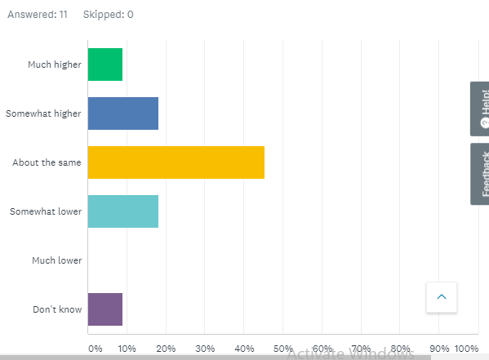

In the survey, we can see that among 11 customers 45.45% of customers replied that the prices are about the same among other shops and restaurants, and 18.18% of customers expressed that the price is lower than other bakery shops and restaurants. So, we can say that Ciao Bella needs to take effective steps about price strategy. As most of the other business products price is same, if Ciao Bella keeps the competitive price of its bakery products and fresh cooked food, Ciao Bella can get the leading position in this industry.

Q2: How likely is it that you would recommend any of our competitors to a friend or colleague?
The answer is
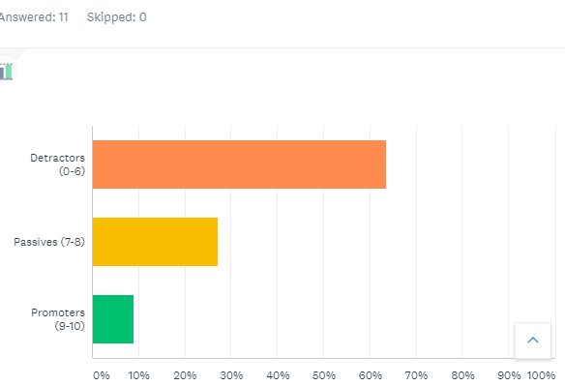

In the above survey, among 11 customers most people do not suggest other bakery shops and restaurants to their friends and colleague. So, Ciao Bella needs to improve its product quality and product prices. Besides, 27.27% of customers will passively recommend the restaurants. So here is some opportunity for Ciao Bella because if the restaurant improves in their product and price section, the percentage of promoting Ciao Bella will increase rapidly.
Q3: Overall, how would you rate a restaurant ,bakery and pastry shop which you have visited already?
The answer is:
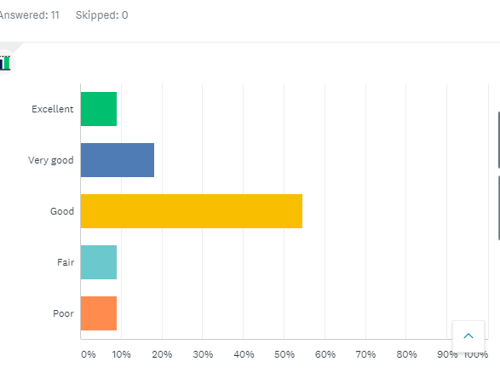

After analysing this question, we can decide that 54.55% of customers think that other restaurants and pastry shops are good for main dishes, bakery, pastry, and coffee-based items. It is an average review from the customers. This is a positive sign for the opening of this business because the maximum number of customers is not fully satisfied with the products of other stores. By enhancing the quality of foods, Ciao Bella can get the chance of the best rating from the customers as there is a market gap.
Q4: Overall, how professionally do other restaurants employees behave?
The answer is:
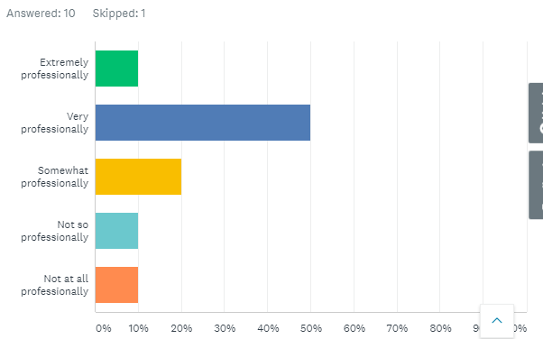
To take a decision, after analysing this question, we can see that the employees are very friendly and well behaved to the customer in other restaurants. So maximum customers reviewed the employees behave very professionally. As employees have a direct relationship with the customers and at the pre-stage of the business, the employees, as well as the owners, are trying to engage with the customers to meet the demand frequently with a positive attitude, the customers are viewing the business having some professionalism in the business which our survey shows positively. So, if Ciao Bella wants to open this restaurant, Ciao Bella needs to engage professional and customer friendly employees to be a leading and successful shop in the country.

Q5: What is your first reaction to the product you have taken from a bakery shop?
The answer is
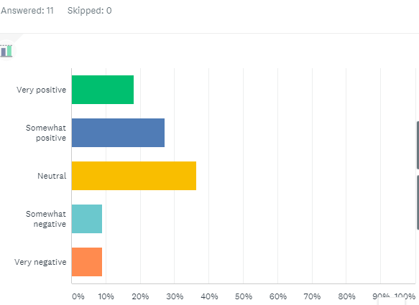

The reaction of most of the customers is neutral after taking the product. Some customers reaction is somewhat positive so there is some opportunity for the Ciao Bella to make the reaction better in future. So, to impress the customer, Ciao Bella needs to provide not only the best quality products but also good service to the customer. These can make the customers reaction as positive.
Ciao Bella will be a new start-up in the bakery industry. It is natural to get an average review from the customer but after passing some weeks or months, Ciao Bella will take part in the customers minds by their outstanding products and service and avoiding the weaknesses of competitors of Ciao Bella.

2.2 SWOT analysis
SWOT analysis is discussed now to understand strengths, weakness, opportunity, threats of Ciao Bella:

Strength  1. In Bakery products, customer demands more variety.  2. Ciao Bella has advance baking technique from French recipe and cooked dishes inspired from international cuisine.  3. Professional and educated employee.  4. Enough equipment ability to fulfil demand. | Weakness  - The low range of products.  - The packet design of the product is not attractive.  - New store in the city.
Opportunity  - Locating near Stadium will promote products easily.  - People from different area will be informed in match time.  - Easily getting new customer for innovating pastry products.  - Easy way to expand product range. | Threats  - More than 10 famous bakeries in that area.  - Downturn economic situation of the country.  - Less possibilities of sales during no match time.

2.3 Competitor analysis
In Tottenham, several restaurants, bakery, and pastry shops provide quality foods to their customers. Ciao Bella needs to follow their strength and opportunity to lead the food industry.
Some well-known bakery shops are such as Fabrique Bakery, Konditor & Cook, and Fork Deli Patisserie. Now we are going to discuss and analysis about these shops.
Fabrique Bakery
Fabrique Bakery is a famous bakery that is Stockholm-based. This bakery is well-known for its bun, reasonable prices, and quality of coffee (Fabrique Bakery, 2019). Fabrique bakery accepts to takeout the food. Another advantage of this shop is accepting debit cards for payment. There is some weakness for Fabrique Bakery such as no system for home delivery, nothing to sit outside of shops, no Wi-Fi.
Konditor & Cook
Konditor & Cook is one of the leading bakeries in Tottenham for their delicious and beautiful cakes and pastry products (Konditor, 2020). Konditor & Cook accept takeout the foods. Along with accepting debit and credit cards Konditor & Cook accepts apple pay. It has a parking option for both cars and motorcycles. However, it is not available for home delivery. There is no system for sitting outdoor and Wi-Fi availability. Above all, its employees are not well behaved to the customer.
Fork Deli Patisserie
Fork Deli Patisserie is an eminent bakery in London by providing the best quality pastries and coffee (Fork Deli, 2020). Moreover, Fork Deli Patisserie has a relaxed and buzzing atmosphere. Like other bakery shops, Fork Deli Patisserie offers to takeout food home. Besides, it accepts credit and debit cards. A customer can park his bike when come to the shop. One of the main advantages of the fork Deli patisserie is the noise level of this shop is not high which will relax your mind. Despite a good atmosphere, it is not good for kids and car parking.

After analysing these competitor shops in Tottenham, there are plenty of opportunities for Ciao Bella to become the top restaurant in London. The first thing is customer satisfaction by serving the best quality food with the best quality ingredients and customer service. Besides, applying a relaxed atmosphere and home delivery system like Fork Deli Patisserie, accepting Debit, credit, and other card payments like Konditor and Cook, keeping some way to sit outdoor like Fabrique bakery will enhance the customer satisfaction and lead to the top in production and business.
According to Jennifer Holmes (2018) to become successful in the food industry, it’s not needed to be a chef. The only thing which is needed to succeed is dedication and passion in the industry. Despite bakery product consumption make problem in our body system, many people take it positively (Fernando Rodrı´guez-Artalejo, et al., 2003). The competitive price of the products of Ciao Bella will add another feather to become the leader.
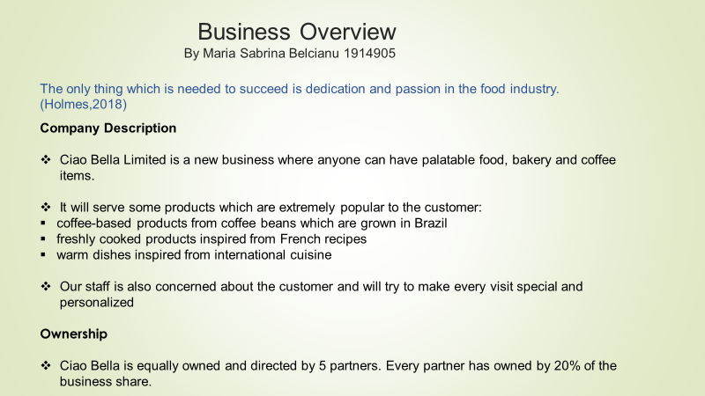
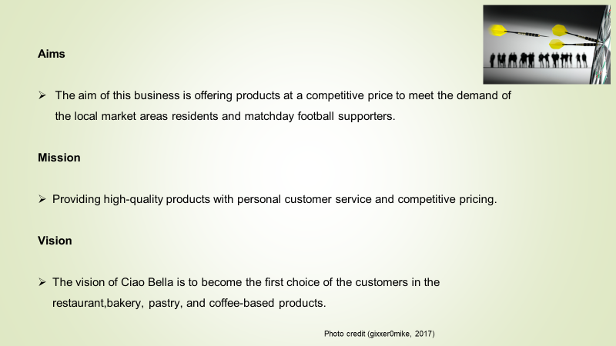
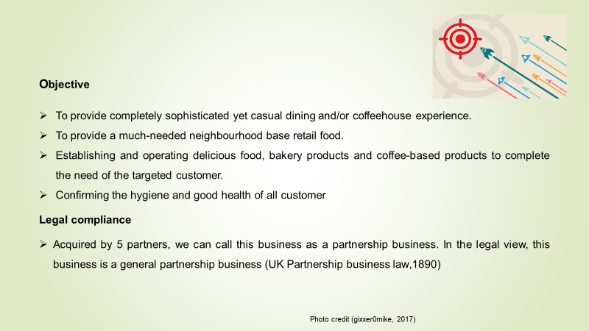
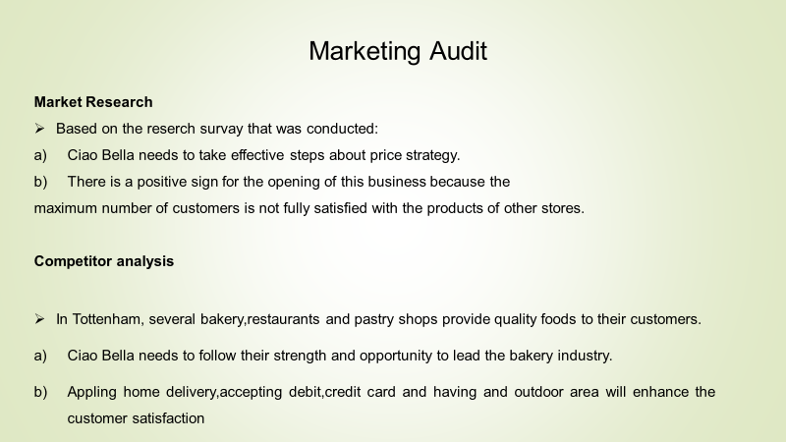

3.Products and Services
By Vanessa Emmanuella Liverpool 1917235
The Ciao Bella LTD is a restaurant café, which offers a range of coffee and coffee - based products, all from highly quality Brazilian beans. The venue provides, brewed coffee and expresso- based beverages, fruits juices and other beverages typically associated with a coffee shop. We also provide freshly bakery and pastries products from French recipes - A dessert corner which serves freshly prepared pastries, as well as other baked food collaborating breakfast.
According to expressocoffeeguide.com, Brazil is the world`s largest grower and exporter of coffee beans. They are a prolific exporter, many high - quality expresso blends are made from Brazil -Cerrado which is part mild, balanced flavour Brazilian coffee beans. (Expresso & coffee guide on the foodie pro theme, 2020)
A delectable of edibles, and a contemporary menu selections subject to change every year; a dining service such as wraps, light pasta meals, and a full service at the bar for alcoholic and non- alcoholic beverages, with a romantic, vibrant, live entertainment such as jazz, violin and piano, on a weekend.
Additionally, Ciao Bella Ltd, will give customers access to the live entertainment equipment, such as birthdays, anniversaries, engagements, via our online booking (subjected to availability). We will also provide a live band once a Month towards the end of the month.
Ciao Bella ltd, will provide a take-out service, for on the go customers and provide a delivery service, only for evening orders; we take orders by phone, online and onsite - we are also in collaboration with uber eats. Due to Covid-19, we encourage our customers to take advantage of our collection and delivery services. We will provide a vending machine in our terrace area.

3.1 Products Description
Ciao Bella Ltd contemporary menu will highlight, a selection of European dishes influenced by Italian Portuguese, Romania and French cooking cultures. We will also explore from time to time on African and Caribbean dishes, exploring and celebrating black history month each year, Ciao Bella menu will have an identifiable African origin and influence. However, our focus will mainly be on the Italian aspect of things.
As a custom, the plat du jour, will offer a variety on countries cooking cultures or themes. Such as seafood, vegetarian, meat, and poultry, which is subject to change seasonally.
Dinner will only be available in the dinning area, whilst wraps and light bites such as cheese and onion bake, chicken bake, sausage roll and a varieties of sandwiches, will be served in the in the café sector and terrace area until closing time. A vending machine will also provide a variety of chocolate bars and crisps.
Our niche of speciality however, which is coffees, such as expresso - based drinks such as, Flat White, Americano, Latte, Cappuccino and Mocha. Desserts- pastries, such as, Triple Chocolate, Doughnut Caramel, Custard Doughnut, Cookies, Pink Jammie, éclair, Profiteroles and Sandwiches will be available at café and terrace area.
Entertainment, such as Jazz, Afro - beats, Violin, the Bucovina, Soca, Zouk and other traditional musicals. The stage will expose great performance for great artist, comedian, poet and much more, so that our customers can express their sentiments through our entertainment platform.

3.2 Competitive Landscape
The competitors of Ciao Bella Ltd, are relatively close to location which are, Fabrique Bakery, Konditor & Cook and Fork Deli Patisserie. These competitors project similar priced menu, Fork Deli Patisserie offer an element of high- class French Patisseries, with a light, flaky and tasty pastries. Konditor & Cook offer a traditional English menu with a very old Victorian décor. Fabrique Bakery on the other hand usually provides a similar service to Greggs, take away pastries and sandwiches, however, due to covid-19, shop in this branch has not been able to re-open, and might be potentially closing down.
According to study.com there are three primary types of market competition, which are direct competitors, indirect competitors and replacement competitors. (Study.com, 2020)
Consequently, none of these establishments, features a contemporary restaurant/café atmosphere, such as themed menu, nor do they provide a live entertainment evening.
Due to Ciao Bella`s location, it is imperative that customers join us considering we provide all these entertainment and attractions with lighting which we offer for a happy, vibrant, yet contemporary evening. other differences are found in table below.

Competitors | What we have, they do not have | What they have, we do not have
Fabrique Bakery | No system for home delivery  No outside sitting facilities  Wifi  Loyalty card  Terrace for our customers | Reasonable price  More variety
Konditor & Cook | Sitting facility  Home delivery  Good customer service | Parking  Good packaging  WIFI
Fork Deli Patisserie | Kids friendly  High quality food  Entertainment | A calm noise free setting
Other | Entertainment

Customer service - excellent service is perhaps the most important thing that we can add to any product and services. Whilst this is an extremely busy area, we will be offering a top – notch customer service. Ciao Bella Ltd, has built its reputation by providing an outstanding customer service, making it our top priority.
Fast delivery – no one wants to wait around for delivery, we offer a fast delivery hence why the collaboration with uber eats; giving our customers unremarkable products into an attractive service.
Service agreement guarantee – when customers know they can get products under a service guarantee or refund they are often more likely to support us over competitors, which offers less warranties. We at Ciao Bella Ltd, we offer our customers a hundred per cent satisfaction guaranty.

3.3 Sales Literature
Additionally, most people want to pay less for their products. We, at Ciao Bella Ltd, offer our customer good quality products, with reasonable prices. We offer an expedite service, and so, customers who are office based or are catching a train, will be served quickly as we will have a ticket service and an online ordering system letting them know in how many minutes will their products be ready.

Market analysis - These are huge, we are targeting customers from various angles: our competitors, commuters, bankers, parents for coffee mornings, busy workers on the way to work, students on the way to class, first daters, study partners, readers, WIFI obscessor. We are expecting around five hundred customers minimum per day in our quite period.
We aim to get new customers every day, instead of focusing on our competitors, we are aiming to keep our prices affordable, we are hoping to keep the millennials by creating a loyalty card scheme for all our new customers in our café corner. Ciao Bella Ltd will be targeting customers by creating seasonal drinks, we will be playing around with flavours such a pumpkin spice drinks come fall.
Marketing and sales plans – Admittedly, marketing is a major part of our development plan, so we conducted a survey and we created a questionnaire from around fifty people in order to understand the market. We then had a social media data collection, so we created a Facebook account and we received another count understanding consumer need. Ciao Bella Ltd will have its own website, we will advertise through social media (Facebook, Twitter, Instagram); we will have an opening soon banner on the front of the building and a pavement sign near the train station.
Ensuring that we are everywhere, our take-out coffee cups will be personalised, our name, logo, and social media accounts. While more and more people are using their phones and laptop, we will endeavour to advertise great deals on social media where we will promote our adverts, with electronic coupons or buy one get one half price, lunch deals and much more. Ciao Bella Ltd will provide free samples give away such as expresso morning give away. Ciao Bella Ltd aims to offer free Wi-Fi to our customers and charging points for devices. Study show that customer spend over 60% more time in shops with free Wi-Fi and spend 50% more money too. (Shoes for crews Europe, 2017)
With our great amount of staff for service in the restaurant, we will have a great turn over, meaning, customers will be served speedily with a great customer service and enabling us to welcome walk -ins customers. We pride our self in giving our customers a great menu which is subject to change every so often, as we will be offering our services based on seasonal products.
A sample copy of a menu and café price list to be displayed at the Ciao Bella Ltd is attached in the appendix at the end of this business plan.

Service society – Although we are aiming to have a successful business, we are under no illusion that there will be waste, it is our social responsibility to give back to the community. As a result, we are aiming to donate a portion of our pastries, smoothies and much more to the homeless unit or any non- profit organisation at the end of every month. We will provide tokens towards a free coffee for every disposable cup returned to us for recycling. Together we are working towards an Eco -friendly environment.

3.4 Sourcing
Ciao Bella Ltd, will purchase good from various suppliers and alcohol distributors. Direct sales will be established, with fresh products, meat and seafood distributors based at Smithfield and Billingsgate market.
The restaurant/café will be offering and receiving discounts from its contractors providing a signature design to Ciao Bella Ltd, such as equipment, furniture, lightning, entertainment pieces, lighting, dinnerware, paintings at the Ciao Bella LTD.
As part of our potential agreement with Ikea, the business will display their products in exchange for these discounted fixtures and equipment. Ikea has a range of contemporary items that we would love to explore from time- to -time.

3.5 Technology
Ciao Bella Ltd logo is protected by GOV.UK/trademarks, all of our menus may not have the same legal protection, however, where possible, our trade name will be protected – at the moment Ciao Bella is ensuring that we have access to technology which will enable us to take orders on a computer system, which will send orders straight into the kitchen. We will also provide WIFI facilities, which will enhance the potential for our customers to capture their moment at zero cost. Cards machines are paramount to the flexibility and the turn - over, for customer float.
We will be providing vending machine in the café terrace, where payments can be made from machine to machine service taking card payments, giving our customers flexibility. Charger reloader for customers who may have forgotten their chargers, a key will be provided.
Although this would be in the near future, we will be focusing on creating an app, in order to give our customer more flexibility, this will enable them to order on the go as these services has become increasingly important. Once this is up and running, we will provide our customers with a digital loyalty program.

3.6 Future Products
According to Oxford reference, future goods must be distinguished as a subject of a contract of sale from existing goods, which are owned or possessed by the seller. (Oxford University Press, 2020).
While we will maintain our focus on the café terrace at Ciao Bella, we will also focus on the dining and entertainment, we aim to expand to create function rooms, for weddings, baby dedications, birthdays and special events and services, such as seminars, trainings and much more. We will provide our customers with two options, which we call “dry hire. The client will hire the venue and provide themselves with all their catering facilities at a higher cost. The second option which we really encourage is “value for your money hire”, this includes all your crockery, a selection of our best set menu, staff, entertainment (DJ, karaoke, face painting, singer), catering.
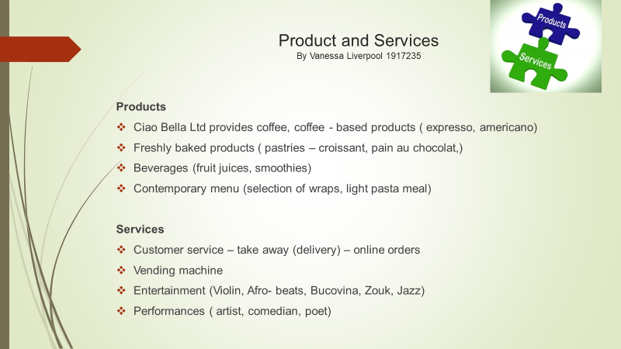
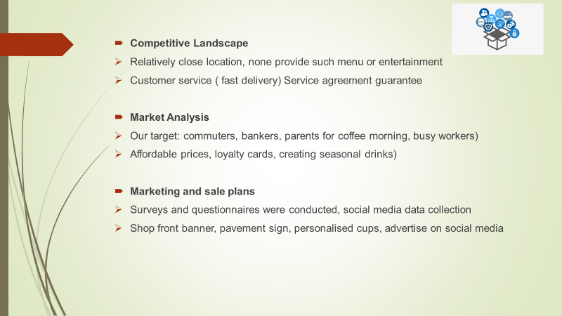

4.Management Team
By Uwe Olisemeke Eric 1907172
A management team is a group of people that work on higher levels in the company. The different people in the management team have different roles, which entails the management of daily activities and also management of the rest of the staff (Novikov 2016, p.15). The management team is responsible for making sure that the whole workforce is working towards achieving organisational goals and objectives. For any company to excel in performance, a management team is needed to make sure that everything progresses according to plan. Ciao Bella as a starting company, plans on having a management team with eight people. The team will consist of; a general manager, an assistant manager, two floor managers, and four team leaders.

4.1 Importance of a management team
Every company operate differently and hence the role of the management team varies from company to company. The general duty however, is to ensure that the strategy of operations by employees is in line with organisational goals and objectives (Faulkner 2019, pp.290-291). Working as a team ensures that quality decisions are made as compared to when only one person makes the decisions. Ciao Bella LTD, will be a company that will deal in selling of coffee, bakery products and warm food. The management team will impact the company in the following ways.

4.2 Communication on the Vision and Mission of the company
An organisation is governed by a mission and a vision. A mission is used to explain what the organisation stands for while the vision shows what the company aspires to achieve. Ciao Bella LTD will not be different. The management team will have a duty of informing, explaining and reminding the staff about the mission and vision of the company from time to time. By doing this, the management will be assured that all the employees are doing what is expected of them.

4.3 Risk management
In all the operations of a business, some risks are bound to happen. The management has a role of analysing all the possible risks faced by the company. After the risks are identified and analysed, an assessment should be done to determine how it will impact the company (Zafar 2016). Lastly, ways in which the company can overcome and prepare itself to sustain the risks should be addressed. Ciao Bella being in the food industry, will be faced by risks such as possible fires, poisoning complaints, and theft. Therefore, the management team have to be ready for such risks and threats. The team should plan ahead on how they will handle the situation if it occurs.

4.4 PESTEL Analysis
Each organisation has an external environment that greatly influences the performance of the company. Ciao Bella’s management team, will have to explore and investigate all the external factors that have an impact in the business. With the analysis, the team will be able to determine how the market and competition is. Before any company starts operating, a legal requirement forces them to fill in some documents. The investigation will enable Ciao Bella’s management team to prepare all the documents that will be required.

4.5 The Structure of the Management Team
The structure of the management team describes how the organisation looks like (Benoliel, 2017). This is because the structure simply shows the chain of command in the business. It explains who answers to who, and clearly states the duties of each person in the company. Ciao Bella LTD will have a management team of eight people and the structure of the organisation is as follows;

General Manager
The General Manager will oversee all the operations of the company. He will be responsible for all employees, the budgets of the company, and establishing the strategies to follow. Ciao Bella will require a general manager that is bold, and more of a leader than a boss. The general manager will be paid a salary of £36,000.
The duties of the General Manager

Establish Policies
A company is governed by existing policies. Since the people working in the company are different, and their personal beliefs also vary, the policies will help in creating a common ground for the whole staff. The general manager at Ciao Bella will be responsible for creating policies that are agreeable to all, and also enforcing them.

Recruitment, Selection and Training
The general manager will be required to handle all the recruitment procedures of the company. The manager will have to identify when there is shortage of staff, create ways with which people will be hired and handle all issues involving recruitment. The general manager will also have to select employees and delegate tasks to them. From time to time, employees need training and development to develop their working skills. At Ciao Bella, the general manager will handle all training programs.

Decision Making
Even though the other managers will make some of the decisions, the general manager will make most of the decisions. Decisions on marketing strategies, change in the budget, hiring and firing, and employee rotation will be made by the general manager. In some of the situations he will consult with other managers.

Requirements
For a person to be qualified as a general manager at Ciao Bella LTD, he/she will be required to have the following qualifications. The person should have 3-5 years’ experience of experience as a general manager, in the same industry or any other. The person will also be required to be eloquent and have good communication skills. Since she will be responsible for most of the work being carried out, she should possess a problem-solving mindset. Having a BA in this field of study will be an added advantage.

Assistant Manager
The Assistant Manager will be answering to the general manager. He will be assisting in creating strategies that will attract more customers for the company. The assistant manager will take over all the duties of the general manager when she is unavailable. He will be the second highest paid employee with a salary of £33,000.
The Duties of the Assistant Manager

Monitor the business’ stock
The company will be using a lot of materials for its operations. For example, Ciao Bella LTD will have to buy ingredients for coffee, food and materials to be used at the bakery. The assistant manager will be responsible for managing and monitoring stock, how it comes and leaves the company. He will use the information gathered to prepare a list for what is needed and giving it to the general manager for further processing.

Performance Appraisal
Ciao Bella will have to work effectively and efficiently in order to survive in the competitive market. The assistant manager will have to evaluate the performance of all employees which will enable him to identify areas that need improvement. Performance appraisal will guide him to making decisions on where training and development is required. In addition, performance appraisal guides the manager on motivation activities to be taken for performance improvement.

Requirements
The assistant manager will be required to have a 2 years’ experience working as an assistant manager in any industry. He should be familiar will performance evaluation methods and be experienced in enforcing them. He should be flexible since the job is demanding. Lastly, the assistant manager will be required to have great communication skills and proper customer service skills.

Executive Floor Manager
The floor manager is also called the executive floor manager, he will be handling all employee requirements, and will be answering to both the assistant manager and the general manager. He will be delegating tasks to employees as he sees fit. His salary will be £32,400 and his duties will include conflict management and team building. In conflict management, he will be acting as the guidance counselor and will try resolve interpersonal conflicts within the organisation. Team building ensures the success of any business since people can channel ideas and come up with the best solution. At Ciao Bella LTD, the executive floor manager will be responsible for creating and motivating teams.
The executive floor manager will be required to have any kind of managerial experience. Flexibility is also a concern since he will be required to work shifts, alternating with the floor manager. Experience in conflict management and problem-solving capabilities is a requirement. The manager will be dealing with employees all day long therefore, having knowledge in psychology will be an advantage.

The Floor Manager
The floor manager will be the immediate supervisor. The team leaders will report to him about everything that happens with their teams. The floor manager will then consult with the executive floor manager where need be. The floor manager will select the teams and nominate the team leaders. The manager will watch the employees’ every move and keeps a register of late comers and those who are absent. His salary will be £30,000, and Being the immediate supervisor, he will monitor all the employees and make a report on how they are progressing. The manager will also have to train the employees on how to perform some activities. The manager will also administer pay slips to casual workers. The staff will report to him on any complaints which he will solve it is a minor problem. He will be the head of all the team leaders. Additionally, the floor manager will be scheduling shifts to the employees, while also alternating shifts with executive floor manager.The floor manager will be required to have 1-year experience working in managerial position, and a high school diploma is a must. The manager must have team building skills and excellent communication skills.

Team Leaders
Ciao Bella LTD will hire 4 team leaders to manage the rest of the workers. The team leaders will be paid a total of £112,800.There will be two team leaders on every shift and each team leader will guide his group in performing a specific task. This will be done through provision of instructions on what is expected of everyone. A team leader will be selected among the employees. Each team will have its own objectives. The team leader will be responsible for coming up with a strategy which will help the team in completing the tasks. The team leader will also have to communicate the strategy and ensure that team activities are aligned to the objectives of the whole company. The team leader will listen to the team member’s feedback and use the information to improve performance. The team leader should be assertive, duty oriented, and have team building skills. Being assertive and duty oriented will help the team to continue being focused on the goal. Many distractions can happen in the team. Therefore, the team leader will be required to maintain order.

Management Team Meetings
The management will be having two different meeting schedules in a fiscal year. The schedule will include; Weekly, and Monthly Meetings.

Weekly meetings
This type of meeting will be held in the last day of the week. The role of the meeting will be for status update on how each field is performing. The meeting will be for thirty minutes only. The activities for the coming week will be discussed during this meeting, and any development that occurred in between the week will be addressed then.

Monthly meetings
Monthly meeting will be held at the end of the month. The time period is 1 hour for each meeting. The management team will be combining all the data collected within the month. The meetings will be held in different places in order to lighten the mood as crucial matters are being discussed.

Recommendation
An effective management team leads to a successful business. Ciao Bella should strive to create a strong management team, which will in return bring good performance for the company. Effective management teams can be created through empowerment and support by the shareholders. The management team should be given independence as a way of showing them that you have complete faith in their efficiency.
A management team is essential for the success of any business. Ciao Bella LTD will have to create a strong and effective management team, which will lead them in achieving competitive advantage. Each member of the team has will have different roles which will be allocated to him or her. They will later combine their results to determine how the company is performing. Ciao Bella’s management team will include the general manager, assistant manager, executive floor manager, floor manager and team leaders.

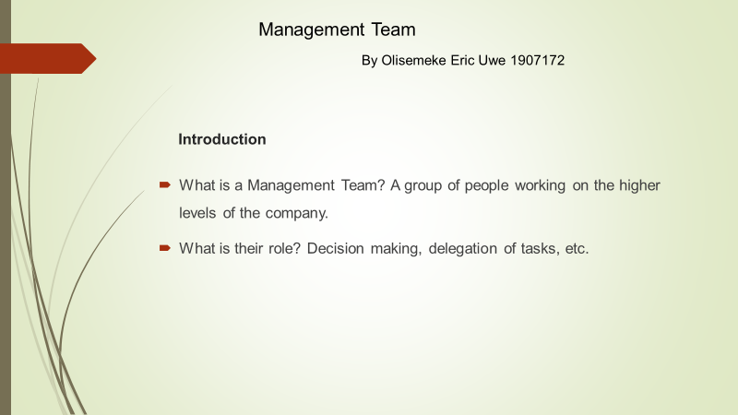
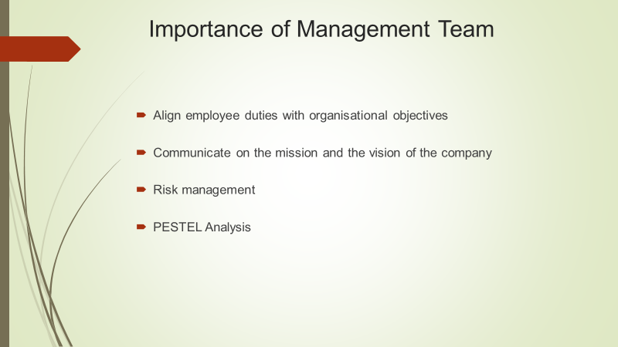
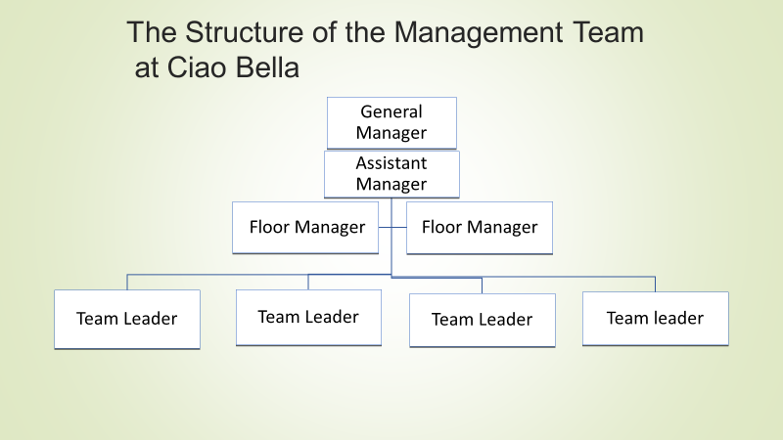

5.Target Market
By Ivanovitch Girao Paiva 1916038

5.1Market Analysis
The Ciao Bella LTD is a coffee shop with dining full-service restaurant, in a £200 million industry in the United Kingdom retail that increase annually 10%. More and more people are choosing to eat out to suit their lifestyle. According to the specialist coffee association of England this market is growing in a rate of 30% per year in the last decade. (Bplans, 2018)

5.2 Market Segmentation
A coffee shop will provide benefits to all residents inclusive to the early workers, would attract 10 million visitors per month because of the Tottenham stadium. The location is great two road in front of the stadium, the target market will be mixed and will provide the best coffee and pastry for the 700, 000 annual visitors and supporters. Tottenham football club stadium has the capacity of 62, 214 spectators.
The coffee shop will fill the demand for people that likes football match and live music, we will design our space with some tv and projectors for the match days, and a space for a small band for live music and karaoke.
The target market will be mixed with office workers, local visitors, football club supporters, residents and teenagers.
The chart below outlines the total marketing potential of The Ciao Bella LTD.
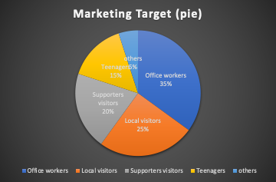
(Bplans, 2018)

5.3 Target Market Strategy

The Ciao Bella LTD will appeal to football supporters, residents, early workers, teenagers, and local business staff. The business will also be ready for all pedestrians that are in rush with quick menus and products ready to eat, build a family atmosphere that will catch and attract even newcomers in the area.
People in this area dine out frequently, two or three days per week target market segment is made up with single people between 24 to 38 and married 35 to 45, tourist, students and the football club supporters.

5.4 Market Needs

Our structure is full design for dining and entertainment, our costumers’ needs are ready to be answer we want to provide good experience in The Ciao Bella LTD to have regulars costumers, our entertainment package is fully made for our target costumers we made specially to attract all visitors and residents.
The capacity of the Tottenham stadium is 62, 214 spectators on those days we will have a lot of costumers that want to watch the football match therefore we create the condition to sustain the demand, we will have tv’s and projectors for entertain all football lovers.
The entertainment menu will have constant new events to avoid costumers to get boring and to be more attractive, we will rotate the artists and the type of music. (U.S Small business Adminustration, 2018)

5.5 Market Trends
The Ciao Bella LTD is a trend toward to new experience of dining, with a lot of entertainment that will become popular in the area because of the recognition, and the new ideas that we will bring, we have our eyes on social trends so we can transform and bring to our restaurant. Because of the popularity we will have big local artist preforming in our restaurant to present their works.
The coffee shop business in this area is very good, people are joining a lot and we are surrounded with office and other local business, the rush in this area starts early so this type of business is establishing.

5.6 Market Growth
Tottenham is a town with good population and surrounded by buildings, with a lot of singles teenagers and couples that have the mindset to live closer to their works and to the central of the city, and that will contribute to be a growing city with an active nightlife.
Teenagers are looking for entertainment every time most of them with sports and going out, remarkable growing is visible people are opting to dining out, spend their time in coffeeshop, night houses, and pubs to entertain themselves in the town.

6.Marketing Plan
The most important aim for us Is to deliver “Quality”, quality products and service, make our customers have more products choices and we will invest in technology, our menu will be simple and easy to understand and face of the social distancing we will have the bar code on the table that the costumers just need to scan their smartphone to have the menu.
We want to have the customers trust we will offer free wi-fi with terms and condition to accept our daily updating via email of entertainment nights and new products.
Nowadays people are looking for distraction everywhere for make the difference of our competitors we will have specifics night, like football match days and live music like that we will attract football and music lovers at the same time. We want to stablish relationship with the local residents and the visitors of the stadium and create opportunities for the city visitors to try the experience of The Ciao Bella LTD. (Bplans, 2018)

6.1 Marketing Strategy
The Ciao Bella LTD wants to bring benefits for all employees that needs to be early at the workplace, we will provide fast breakfast with multiple choices, we will have ready to eat products to make the process easy.
For the city visitors that are coming for entertainment they will be beneficiated with live music and karaoke, they will be playing various types of music to cover all range of ages.
We want to attract was well all the football supporters that are coming around the country to support their team, we will have tv and cover all important football match.
The objective is to be able to cover the demand, we will have highchair, baby change, and wi-fi everything ready to a family atmosphere. (U.S Small business Adminustration, 2018)

6.2 Sales Programs

Specific sales programs
- Football Match Day- Create opportunities to pass the most important games in Premier League, Champions League, and Europa League put the number of tv susceptible for the demand. The assistant manager will be responsible for promoting, choose the days and be aware of the important games.
- Live Music Concert- It will be on Thursdays and Friday’s night one single person with a small band playing classic music to entertain every range of ages with duration of one or two hours we will work with big and local artists to promote our restaurant and make the activity a success.
- Specific coffee and pastry sell- we will choose two times in the year specifics months to sell especial coffees and pastries to make the product more sellable is a strategy to make the product especial and like that we will sell more, because the product will be rare.
- Highchairs and baby changing to attract families- is an area with a lot of families and the most of them are young, make them comfortable creating the condition to make them feel at home is the objective.
- Free wi-fi and toilet code if you dine in- is more profitable if customers dine in, we have a small tax to eat in, and giving free wi-fi and access to the toilets will be a good way to make them eat in.
- Donation program- we will work with local charity organization to help the community, all the products that we don’t sell will be send to the charity.
- Especial offers- offers campaign is necessary to give the access to everyone to try our product and make them like.
- Online Orders- we will have our company application for make easy the access to our products, we will work with delivers company in a range of 30/35 miles from our store,
give the costumer the easy access and more choices to get our products.

6.3 Positioning Statement
Our target market, local residents, stadium visitors, supporters from another city, who wish to watch the game in a good atmosphere with the best coffee and pastry with a great customer service and entertainment, everything ready to handle the needs from the demand. Unlike our competitors, The Ciao Bella LTD have an invite structure and organised entertainment program, our exclusive roast coffees will offer our costumer a great experience.
Attract all range of ages is our aim, and we are working thinking in every aspect, to bring everyone to experience our service, working with local artist will be one of the methods have the customer trust is the objective. (Bplans, 2018)

6.4 Pricing Strategy
We are projecting our entertainment program, coffees and pastry to attract the confidence of our customers and consumers, we want flexibility and not to remain repetitive to pass a fresh atmosphere every day, offering new experience and quality to the costumer. Especial offers to get the consumers trust, quick menu to all visitors in rush and fast food, a menu with a lot of stereotypes of food from Portugal, Ghana, Jamaica, Greece and we will serve the classic English breakfast.
Our food, drink and especial entertainment nights will have a price to attract the costumers one affordable value to all consumers

6.5 Promotion Strategy
We will promote our company name more than the products; we know that the base of success is to promote our brand, more knowable the brand is more attracting will be to be more precise we will do some offers and include some combos in our menu and bring recipes from others country, like that we will increase our target customer. The focus will be on our events, live music and football match to bring every time new experience.
Investing in promotion is very important we will put a budge for advertising in social media and working with delivery companies.
We made a research in the area to know witch social media they use the at most, and Facebook came out with 40% table below for represent.

Therefore, we will create pages on the most important social medias and promote more on the Facebook to get the attention of all range of ages for that we been working also with a company Dotmuds for data analytics.
Criteria | Q1 | Q2 | Q3 | Cost
Tv Advert. | All day | All week | All Month | 2000£
Social Media | Facebook | Instagram | YouTube | 1500£
News paper | BBC | The Guardian | The independent | 1000£
Radio | Playlist | Radio Program | News | 500£

6.6 Marketing Programs
Our marketing program will be handled by internal marketing company Dotmuds Date and Marketing, they will assist us with visibility, with the annual budget of 5000£ they will handle the marketing strategy of The Ciao Bella LTD everything ready to start.

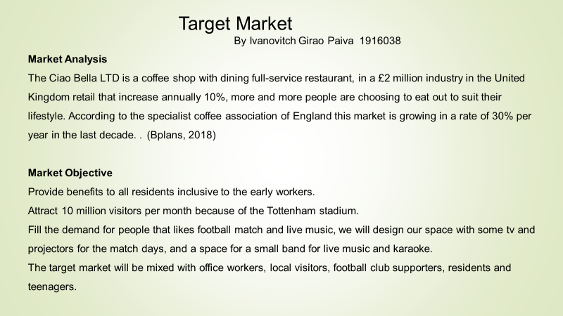
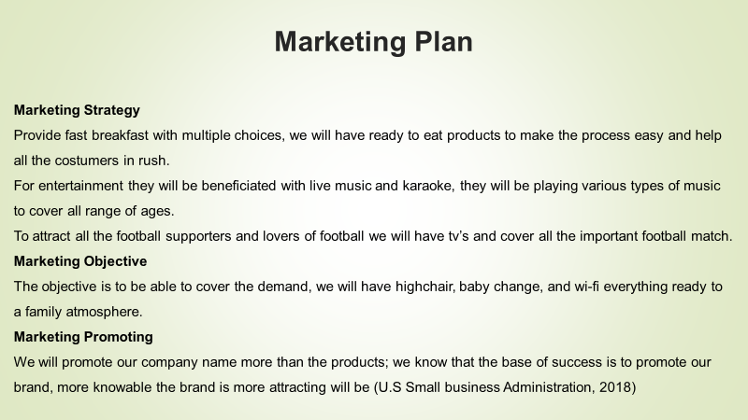

7.FINANCIAL PLAN AND FUNDING REQUIREMENT
By Williams Kwame Dapaah 1916221

7.1 Project Description
The organization which starts from 1st August 2020 shall have a financial manager responsible for the financial issues. He helps management make financial decisions, prepare financial statements, business activity reports and forecast, review financial reports and find ways to reduce cost.

7.2 Project Funding
Source | Confirmed (GBP) | Anticipated (GBP) | Total (GBP)
Bank Loan | 100,000 | 400, 000 | 500,000
Personal Contribution from Shareholders | 400, 000 | 350, 000 | 750,000
Contribution from Investors | 250, 000 | 500, 000 | 750,000
TOTAL | 750, 000 | 1,250, 000 | 2,000,000

Ciao Bella Ltd is seeking to obtain a loan amounting to £500,000 to finance its projects. Bank loans are considered as a key source of mobilizing financial resources for Ciao Bella Ltd not because of insufficient equity funding but to take advantage of allowed deductions. The interest payable on the loan is an allowable deduction which would reduce the chargeable income of the business and hence reducing the tax liability. A bank loan of £100,000 was acquired at a fixed interest rate of 8.5 per cent for four years.
The restaurant is a partnership with five members and have contributed £400,000 at the beginning of the business. We are anticipating that an amount of £350,000 will be contributed to the effective running of the restaurant.
Table 1: Budgeted Total Capital Investment for the Establishment of the Restaurant
Items | GBP(£)
Building:
Building – Leasing | 750,000
Site preparation - Renovation | 104,000
Processing equipment and machinery:
Cost of equipment and machinery* | 200,000
Installation (30 per cent of the cost of equipment) | 60,000
Engineering and design (10 per cent of equipment and machinery cost) | 20,000
Start-up expenses (5% of equipment and machinery cost) | 10,000
Cost of Delivery van | 23,843
Total Capital investment | 1,167,843
*Equipment and machinery include Chopping and slicing machines, Gas ranges, Flat-top griddles, refrigeration, food processors, mixers, blenders and immersion blenders, cookware, bakeware and small ware.

Table 2: Budgeted Operating Cost for Restaurant for the first year
Cost of Operation
 | GBP(£)
Cost of Sales
Food and beverage | 480,000
Wine and Beer | 115,200
Merchandise and Catering | 76,800
 |  | 672,000
General expense
Packaging materials | 9,400
Maintenance supplies (5% of equipment and motor van cost) | 15,692
Marketing, promotion and advertisement | 2,000
Storage and warehousing expenses | 2,000
Printing and publication | 2200
Stationery | 500
Waste removal | 1,000
Legal fees | 2,500
Gas bill | 5,500
Transportation cost – Fuel | 9,000
Insurance | 10,000
Miscellaneous expenses | 1,500
Bank charges | 1,000
Total General Expense |  | 62,292
Finance Cost
Interest expense (8.5% of bank loan) |  | 34000
Labour Cost |  | 556,560
The total cost of operation |  | 652,852

Table 3: Budgeted Expense for Labour Requirements for the Restaurant
LABOUR | GBP £ | GBP £
1 General manager (3,000 x 12) | 36,000
1 Assistant manager (2,750 x 12) | 33,000
1 Executive chef /Floor Manager (2,700 x 12) | 32,400
1 Sous chef Floor Manager (2,500 x 12) | 30,000
4 Team leaders (2350 x 4 x 12) | 112800
1 Chef Garde Manager (2000 x 12) | 24000
2 Prep cooks (2,000 x 2 x 12) | 48,000
1 Pastry Chef (2,000 x 12) | 24,000
1 Hosts (1,570 x 1 x 12) | 18,840
2 Food runner and busser (1,400 x 5 x 12) | 84000
2 Dishwashers (1,250 x 2 x 12) | 30,000
3 Waiters (1,570 x 3 x 12) | 56,520
Drivers (2,250 x 12) | 27,000
Wages & Salaries |  | 556,560

Table 4: Projected Income Statement for three years
 | 2020 | 2021 | 2022 | 2023
 | GBP(£)
Sales revenue | 504,000 | 1,312,416 | 1,837,382 | 2,077,086
Cost of sales | 308045 | 843,019 | 931,687 | 1,091,029
Gross Profit | 195,955 | 469,397 | 905,696 | 1,384,724
Labor Costs | 231,900 | 556,560 | 556,560 | 556,560
General expenses | 25,955 | 62,292 | 57,309 | 58,455
Finance cost | 76,981 | 64,283 | 44,862 | 8,500
Net profit/loss before tax | -138,881 | -213,738 | 246,965 | 761,209
Tax paid | - | - | 61,741 | 190,302
Net profit/loss after tax | -138,881 | -213,738 | 185,224 | 440,792
Projections on Income Statement
Profit: While the cost of sales is forecasted to increase by 1 per cent yearly, sales revenue is expected to keep increasing at a faster rate of 26.29 per cent in the year 2023. This projection is attributed to the increase in capital expenditure and the upgrading of equipment and machinery.
Expenses: There is a projection of a 1 per cent increase in the operating costs of Ciao Bella Ltd each year due to the inflation. Management is committed to ensuring that net profit margins increases, hence, tracing records of sustaining a steady operational cost over time.
Tax: The organization projected 25% on its profit before tax as an annual tax.
Assets: Ciao Bella Ltd Shall increase its statement of financial position at the end of the year 2023. Therefore, the company is committing to increase its capital expenditure by purchasing a delivery van and improve upon the equipment and machinery as well as buying its building which is been leased.

Table 5: Projected statement of accumulated income surplus
 | 2020 | 2021 | 2022 | 2023
 | £
Balance brought forward | - | -138,881 | -352,619 | -167,395
Prior year adjustment | - | - | - | -
Net profit / Loss for the year | -138,881 | -213,738 | 185,224 | 440,792
Balance as at 31st December | -138,881 | -352,619 | -167,395 | 273,397

Projections on Statement of Financial Position
Assets: As at the end of business activities on 31st December 2023, an amount of £750,000 was realized from the sales of shares (937,500). Other shares subscribed are yet to be paid for in the subsequent year. At the end of the 2023 year of business operation, Ciao Bella Ltd is expected to increase its total assets from £1,412,105 to £1,457,860. This is because, there will be massive growth in its current assets particularly investment level, cash and bank balances, as well as its inventory.

Table 6: Projected statement of Financial Position as at 31st December
 | 2020 | 2021 | 2022 | 2023
 | GBP
Non-current asset
Right of use asset – building | 984393 | 943,376 | 849,037 | 764,133
Property, Plant and Equipment | 417,843 | 400,433 | 392,583 | 353,325
Total Non-current Assets | 1,402,236 | 1,343,809 | 1,241,620 | 1,117,458
Depreciation | 58,426 | 134,381 | 124,162 | 111,746
Net Book Value | 1,343,809 | 1,209,428 | 1,117,458 | 1,005,712
Current Assets
Inventories | 32,055 | 43,877 | 64,814 | 71,574
Treasury bonds | - | - | 40000 | 100,000
Certificate of deposit (CD) | - | - | 15,522 | 136,230
Trade Receivables | 24,186 | 26,771 | 34,394 | 32,097
Cash and bank balances | 12,055 | 16,932 | 35,084 | 112,247
Total Assets | 1,412,105 | 1,297,008 | 1,307,272 | 1,457,860
Liability and Shareholder’s equity
Non-current liability
Lease liability | 734393 | 557,832 | 363,615 | 149,977
Current liabilities
Trade payables | 30,354 | 71,968 | 81,414 | 97,697
Bank Overdraft | 10,000 | 30,500 | 40,000 | 3144
Other account payables | 11135 | 47,403 | 67,837 | 63,270
Directors pay | 14,236 | 86,600 | 65,633
Certificate of deposit (CD) |  | 101,418 | 101,418
Long term liabilities
Bank loan | 100,000 | 100,000 | 100,000 | 100,000
Shareholder’s Equity
Capital account | 650,000 | 650,000 | 650,000 | 750,000
Capital surplus | 31,250 | 31,250 | 31,250 | 46,875
Income surplus | -169,262 | -379,963 | -193,895 | 246,897
Total Shareholder’s Equity | 1,412,105 | 1,297,008 | 1,307,272 | 1,457,860

Liabilities: Ciao Bella Ltd uses the reducing balance method of depreciation. All the non-current assets are forecasted to be in use for 10 years. During the first year of operation, it is worth mentioning that, trade receivables are 5 per cent of total sales revenue. However, in subsequent years, trade payables have reduced, Ciao Bella Ltd will manage to reduce its trade payables. Although trade payables are a major source of financing business activities, it is not a significant net source of funding (Bărbuţă-Mişu, 2018) and besides, restaurant operation is among the few industries that usually receive goods on credit. The company trade-credit reduced by 83.19 and 44.13 per cent in the year 2022 and 2023 respectively.

Table 7: Projected Statement of Cashflow
 | 2020 | 2021 | 2022 | 2023
 | GBP
Operating Activities
Profit/(Loss) before Tax | -169,262 | -210,700 | 186,068 | 440,792
Adjustment for non-cash items
Prior Year | - | - | - | -
Depreciation | 58,426 | 134,381 | 124,162 | 111,746
Changes in current assets and liabilities
(Increase) and decrease in inventories ( Stock) | -32,055 | -11,822 | -20,937 | -6,760
(Increase) and decrease in trade receivables | -24,186 | -2,585 | -7,623 | 2,297
Increase and (decrease) in trade and other payables | 55,725 | 150,246 | 8,913 | -53,917
Net cash inflow/outflow from operating activities | -111,352 | 59,520 | 290,583 | 494,158
Tax paid |  |  | -62,023 | -190,302
Investing Activities
Capital expenditure | -1,343,809 | -1,175,162 | -1,207,825 | -1,213,375
Short term investment |  | 101418 | 45,896 | -190,334
Net cash inflow/ Outflow from investing activities | -1,343,809 | -1,073,744 | -1,161,929 | -1,403,709
Financing Activities
Loan | 100,000
Proceeds from issue of shares | 281,250 |  |  | 165,625
Contribution from partners | 400,000
Net cash inflow/ Outflow from financing activities | 781,250 |  |  | 165,625
Increase in cash and cash equivalent | 22,055 | 37,432 | 44,584 | 105,891
Cash and cash equivalent as at 1st January | 0 | -22,055 | -15,377 | -29,207
Cash and cash equivalent as at 31st December | 22,055 | 15,377 | 29,207 | 76,684

Capital Expenditure of CIAO BELLA LTD
This is projected because the business has interest in investment once it is within its strength and capacity. Table 8: Capital expenditure projection from the period of 2020 to 2023
Capital Expenditure | 2020 | 2021 | 2022 | 2023
 | GBP
Lease and buying of Building | 984,393 | 984,393 | 984,393 | 984,393
Improvement on building | 104,000 | 2,500 | 5,000 | 4,000
Motor vehicle | 23,843 | 23,843 | 55,135 | 55,135
Equipment and machinery | 290,000 | 295,000 | 297,500 | 304,500
Less: Accumulated depreciation | 58,426 | 130,574 | 134,203 | 134,653
Net Plant, Property and Equipment | 1,343,809 | 1,175,162 | 1,207,825 | 1,213,375

Projections on Capital Expenditure
The company shall improve the building structures by £2,500; 5,000 and 4,000 in the year 2021, 2022 and 2023 respectively. It expects a new motor vehicle in the year 2022 which increases the amount by £32,192. To expand operational capacity, Ciao Bella Ltd is looking forward to purchase additional equipment and machinery amounting to £5,000; 2,500 and 7,000 respectively in the year 2021, 2022 and 2023

7.4 MOBILIZATION OF RESOURCES
Mobilizing resources describe all forms of activities undertaken by a person or body of persons which is intended to secure new and/or additional resources (Seltzer, 2014). It may also be used to describe the various ways by which organizations make better utilization of their existing resources (Seltzer, 2014). Mobilizing resources is critical to every organization and to successfully executing a project. To execute our project successfully, there was the need to identify the various sources of mobilizing resources. We have human, capital and financial resources. A discussion for now will base on financial and capital resource.
Financial Resources: These include all funds accrued to finance the activities of Ciao Bella Ltd. Some of the funds were obtained through banks loan and the reason is given at the beginning. We will also liaise with investors and other influential persons interested in the project to raise funds. Personal contributions from shareholders of the team are also employed.
Capital Resources: They c the building, plant and machinery, vehicle and equipment. The building for administrative and production functions will be obtained through the lease. The plant, property and equipment that will aid production to be purchased. The purchasing of the building rather renting is mainly done to take advantage of the capital allowance. Capital allowance, which is an allowable deduction will ensure that the business can minimize its tax liability and have enough liquidity to continue operations. Again, the capital allowance will be granted on other depreciable assets such as vehicles and equipment as a deductible expense that will be used in running the restaurant. The implication for tax purpose is that finance cost will be granted as a deductible expense.
OVERALL PROJECTIONS
- Ciao Bella Ltd will fully purchase its building which we are currently leasing at £50,000. This is to help improve our capital structures as well as enjoying capital allowance which is a deduction to reduce our tax liability.
- The shares shall be sold at £0.80 per share at no par value. Currently, 312,500 shares are on the market. The application of share will be opened on the 1st of December to the 15th of December 2023 to enable the general public to subscribe to additional shares of 625,000 for the business to raise £500,000. The proceeds from the sale of shares will be used for business expansion.
- Dividend Policy: Directors has declared that shareholders will receive a dividend of 20% of the business distributable earnings each year until further notice. An increase will depend on the future cash flow, net earnings and reserve requirements. The Board of Directors is assuring shareholders that the distribution of the dividend will be in such a way that it will not affect the smooth operation of the business.
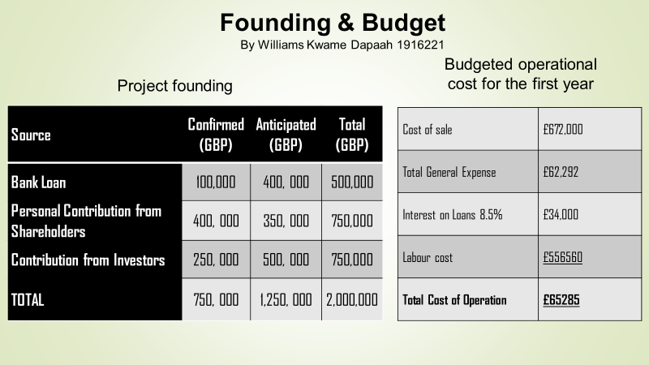
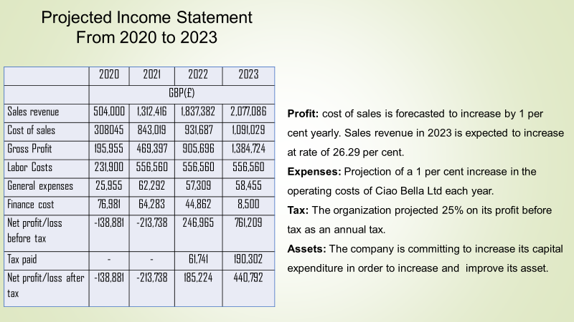
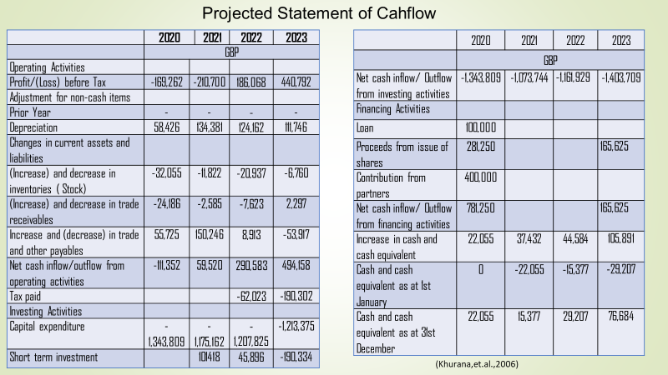
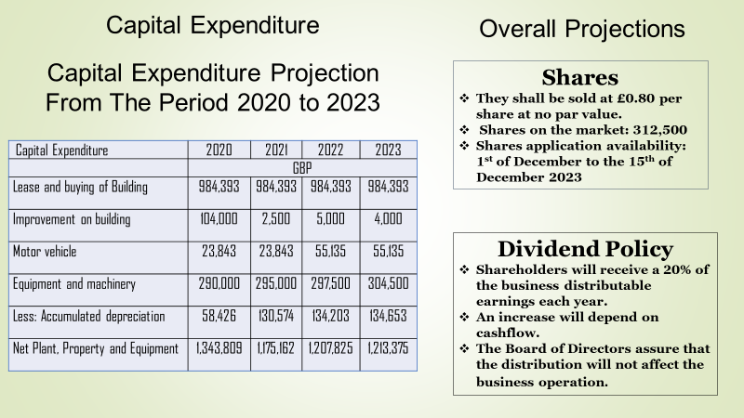

8.References
F. R.-A.et al., 2003. Consumption of bakery products, sweetened soft drinks, p. 421.
FabriqueBakery, 2019. FabriqueBakery. [Online] Available at: http://fabrique.co.uk/#oss [Accessed 24 07 2020].
ForkDeli,2020. ForkDeli. [Online] Available at: http://www.forkdeli.co.uk/#about [Accessed 24 07 2020].
Holmes, J., 2018. Bakery Business Startup: How to Start, Run & Grow a Trendy Bakery Business. 1st ed. s.l.: Valencia Publishing Press.
The UK, G. o., 1890. Set up a business partnership. [Online] Available at https://www.gov.uk/set-up-business-partnership [Accessed 23 July 2020].

Expresso and coffee guide (2020). [online] available at: https://espressocoffeeguide.com/gourmet-coffee/coffees-of-the-americas/brazil-coffee/ [accessed 01.08.2020]

Gov.uk/trademarks (2020). [online] available at: https://www.gov.uk/how-to-register-a-trade-mark/apply [accessed 05.08.2020]

Oxford University press, (2020). [online] available at: https://www.oxfordreference.com/view/10.1093/oi/authority.2011 [accessed 01.08.2020]

Study.com (2020). [online] available at: https://study.com/academy/lesson/what-is-competition-in-marketing-definition-types-quiz.html# [accessed 01.08.2020]
Shoes for crews Blog (2020). [online] available at: https://www.google.co.uk/amp/s/blog.sfceurope.com/simple-coffee-shop-marketing-ideas%3fhs_amp=true [accessed 14.08.2020]

Bărbuţă-Mişu, N. (2018). Analysis of factors influencing managerial decision to use trade credit in the construction sector. Economic research-Ekonomska istraživanja, 31(1), 1903-1922.
Hut, P. M. (2008, September 7). PMH. Retrieved from PMHunt Web site: http://www.pmhut.com
Khurana, I. K., Martin, X., & Pereira, R. (2006). Financial development and the cash flow sensitivity of cash. Journal of Financial and Quantitative Analysis, 787-807.
Li-Hua, R., & Lu, L. (2013). Technology strategy and sustainability of a business. Journal of Technology Management in China.
Miller, G. F., & Spoolman, S. (2011). Living in the environment: principles, connections and solutions (17th ed.). Belmont, CA, U.S.A: Brooks-Cole.
Seltzer, J. B. (2014, October 20). Health Communication Capacity Collaborative. Retrieved April 22, 2018, from Health Communication Capacity Collaborative Web site: http://www.healthcommcapacity.org/resource-mobilization-important
Benoliel, P. (2017). Managing senior management team boundaries and school improvement: An investigation of the school leader role. International Journal of Leadership in education, 20(1), pp.57-86.
Faulkner, B. (2019), April. Leading your sub-team managers. In BSAVA Congress Proceedings 2019 (pp. 290-291). BSAVA Library.
Nagorichna, O. and Kapitanets, S. (2019). Leadership potential of the manager of the management team of the state fiscal service. Fundamental and applied researches in practice of leading scientific schools, 31(1), pp.146-149.
Novikov, V. (2016). Shared leadership in a department of defense acquisition project management team. The Coastal Business Journal, 15(1), p.15.
Ruiz-Jiménez, J.M. and Del Mar Fuentes-Fuentes, M. (2016). Management capabilities, innovation, and gender diversity in the top management team: An empirical analysis in technology-based SMEs. BRQ Business Research Quarterly, 19(2), pp.107-121.
Wuthnow, J., Elwell, S., Quillen, J.M. and Ciancaglione, N. (2016). Implementing an ED critical incident stress management team. Journal of Emergency Nursing, 42(6), pp.474-480.
Zafar, H., Ko, M.S. and Osei-Bryson, K.M. (2016). The value of the CIO in the top management team on performance in the case of information security breaches. Information Systems Frontiers, 18(6), pp.1205-1215.
Available at: https://www.bplans.com/cafe_bistro_coffeehouse_business_plan/strategy_and_implementation_summary_fc.php
[Accessed 14 August 2020].
Rampton, J., 2019. Entrepenuer Europe. [Online]
Available at: https://www.entrepreneur.com/article/281416
[Accessed 23 August 2020].
U.S Small business Adminustration, 2018. Business Guide. [Online]
Available at: https://www.sba.gov/business-guide/plan-your-business/write-your-business-plan
[Accessed 17 August 2020].

9.Appendix



