Derek Hughes

Tutor – Sian Addicott

Photojournalism

Narcissism Epidemic

Evaluation

narcissism
/ˈnɑːsɪsɪz(ə)m,nɑːˈsɪsɪz(ə)m/
Learn to pronounce
noun
- excessive interest in or admiration of oneself and one's physical appearance.

The first thing that became obvious was that the subject of Narcissism was such a vast subject matter with all of its possibilities, I decided early on in my research that I would need to concentrate on a specific idea, or I would undoubtedly stray with my ideas and lose my way. As I am a keen follower of fashion, I remembered that I had numerous vintage real Fur Coats, and these would be ideal to start my project. Not only would they be visually pleasing to photograph due to the vibrant colours and interesting textures, but I felt they were a good metaphor of egoism, a major trait of a narcissist.

I researched a few artists who were known for their powerful work towards animal cruelty, the first of which was Barbera Kruger.

"I work with pictures and words because they have the ability to determine who we are and who we aren’t."

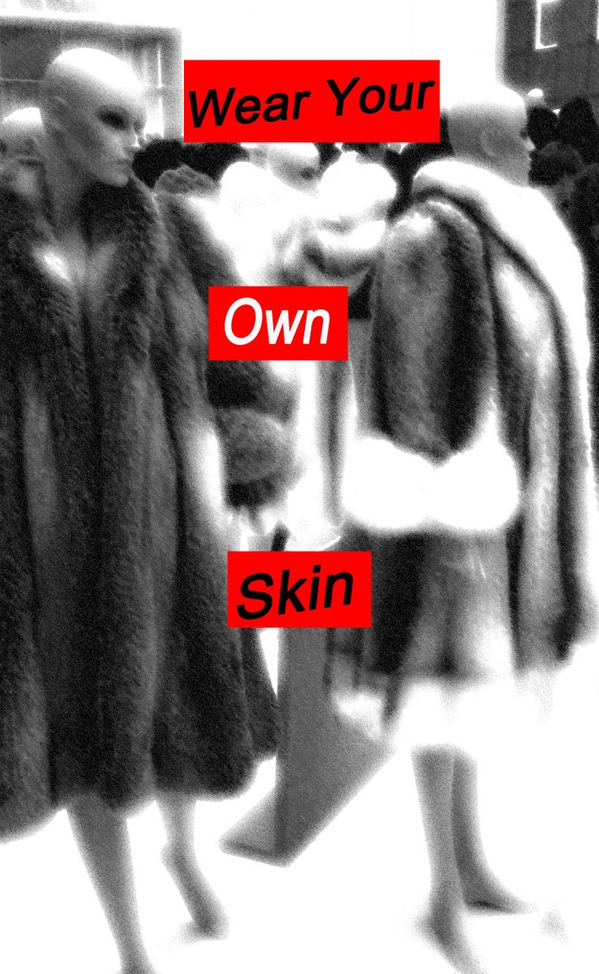

Barbera Kruger is most famous for her Black and White Pictures that have bold messages (usually Red boxes with White Letters) overlaid on top to try and get a hard-hitting message across. Visually they are amazing, she really knows how the human brain works and what grabs people’s attention, it’s a very basic concept but I am sure she realises why her images attract so much attention.
As in the photo above, the actual photo is not a great one, but that is intended I’m sure, as not to distract ones eye from the message, her work is more about the feelings and thought created than the actual quality of the picture itself. Her work was the srarting catalyst for my ideas, and I wanted to try to emulate her work by creating something hard hitting yet visually simple.

I also looked at the work of Danny Treacy, as he had done a body of work titled ‘Them’ in which he photographed powerful images of himself in a similar way that I had been experimenting with. They had a plain black background and used flash to illuminate himself eerily, with a dark, almost Gothic feel to them. I found the black backgrounds he used in his work to be the perfect solution for my images as it gave no distractions to the subject images I wanted to show, whilst adding an almost haunting appearance as if my jackets were floating.
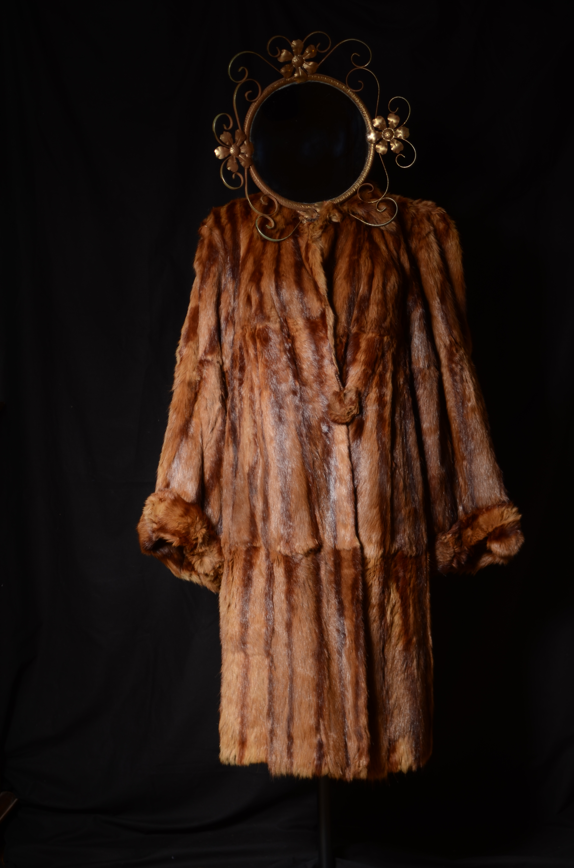
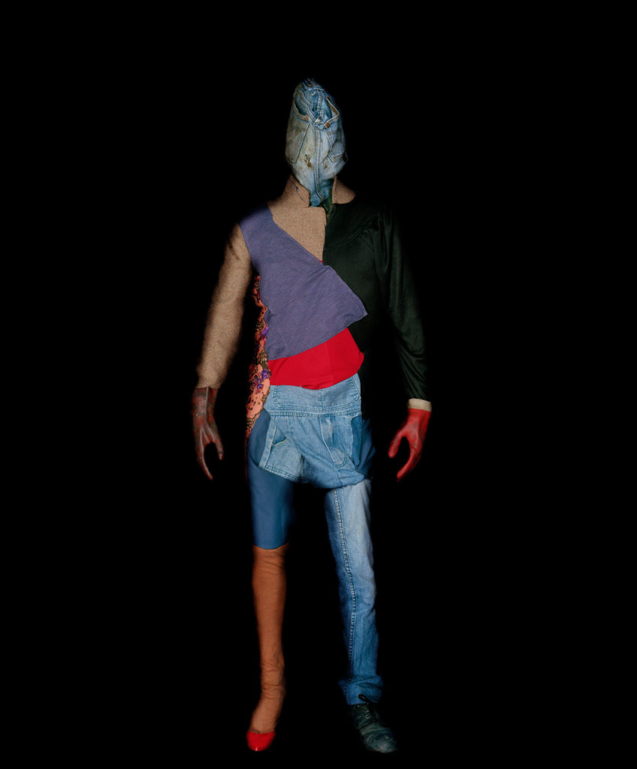

During the research process I also came across the work of Holbeins, a 16th Century artist, who was made famous by one of his paintings, ‘The Ambassadors’, as he was one of the first to include an anamorphic image in his painting, that of a skull. From the normal viewpoint the skull was illegible, however by viewing from a sharp angle, the skull was fully visible, a quirky idea that got me thinking.

This was the catalyst for my creative experimentation as it encouraged me to consider adding a quirky element to my work.

I had created a series of 4 images using the above artists as my influences, and decided to experiment with these, using photoshop, to see if I could develop my ideas further and add to the context.

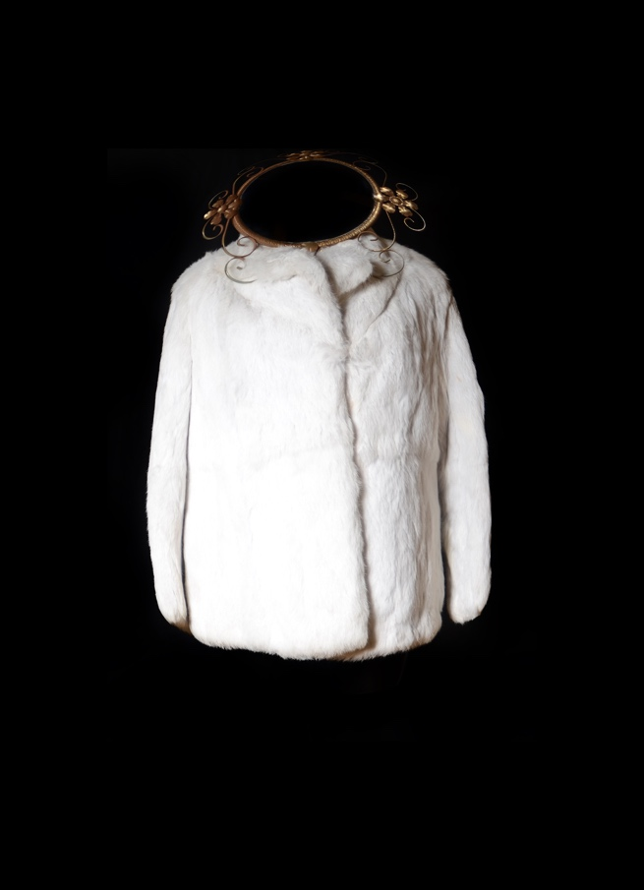
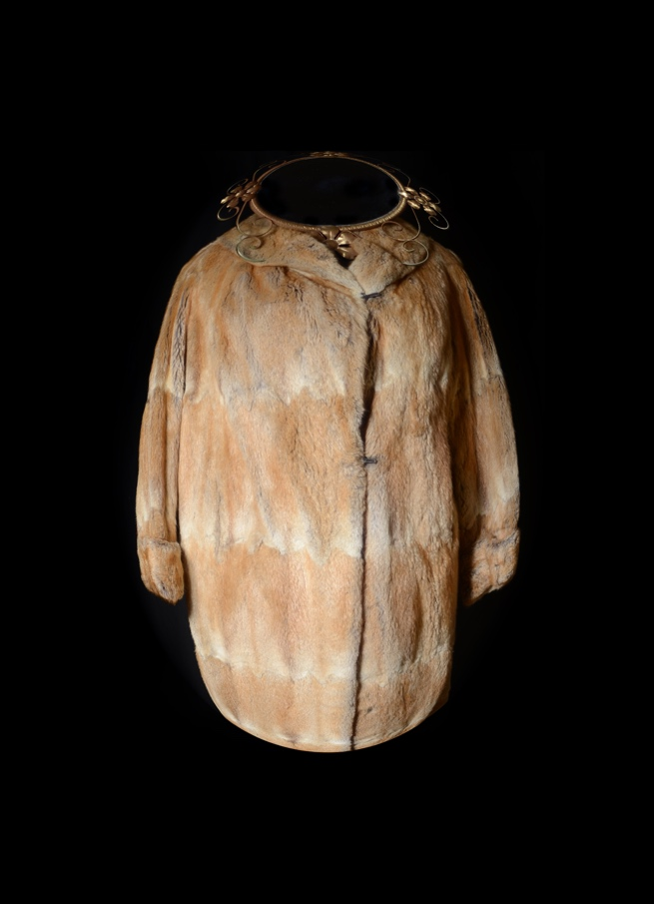
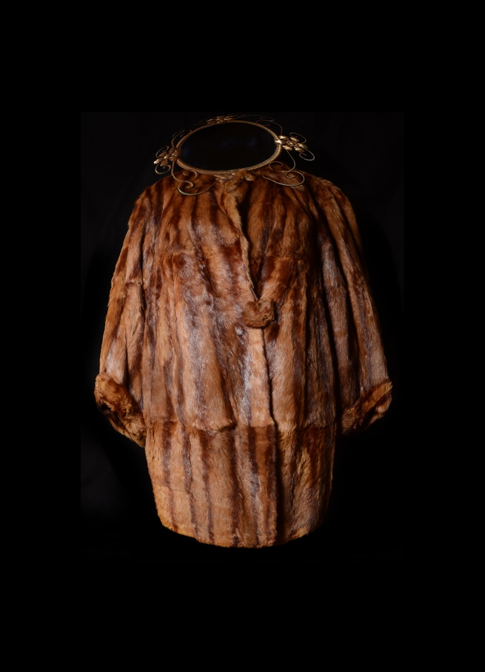
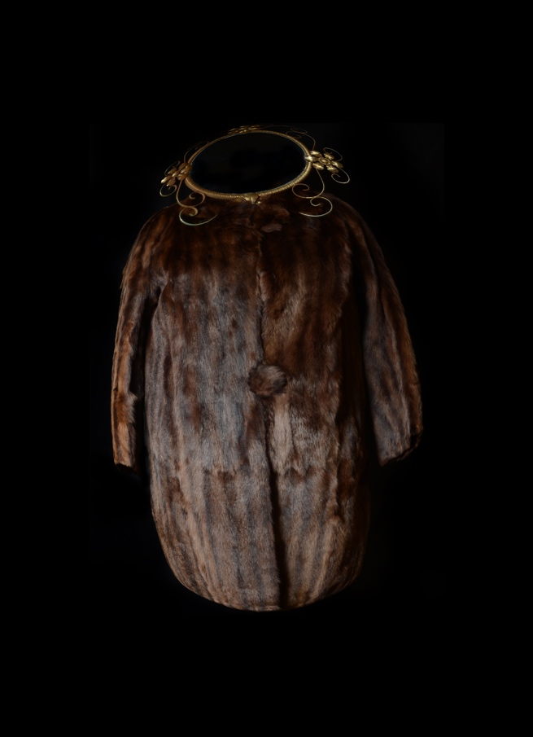
Here I tried inflating the jackets to portray a sense of greed and gluttony, as I feel they are connected to narcissism.

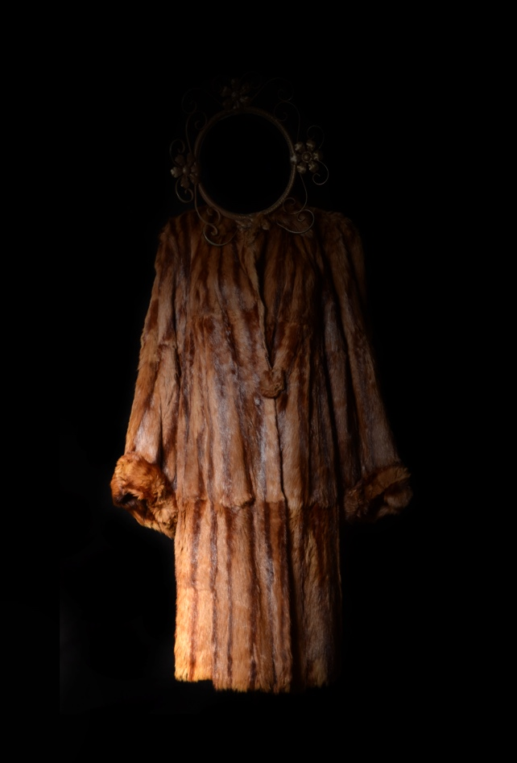
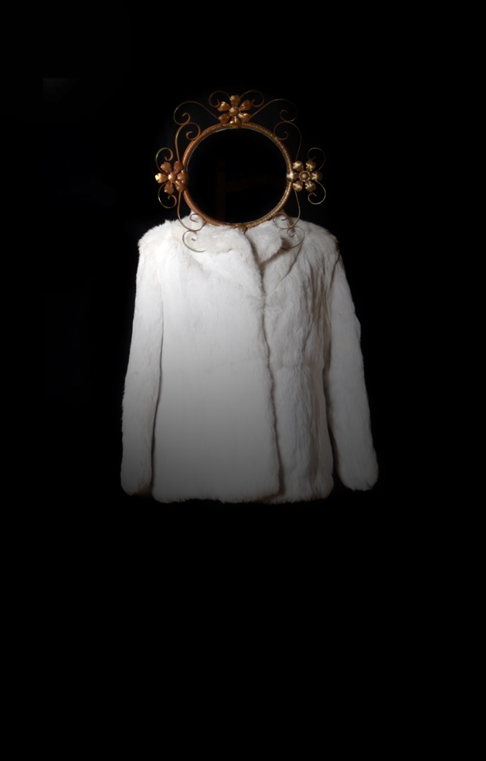
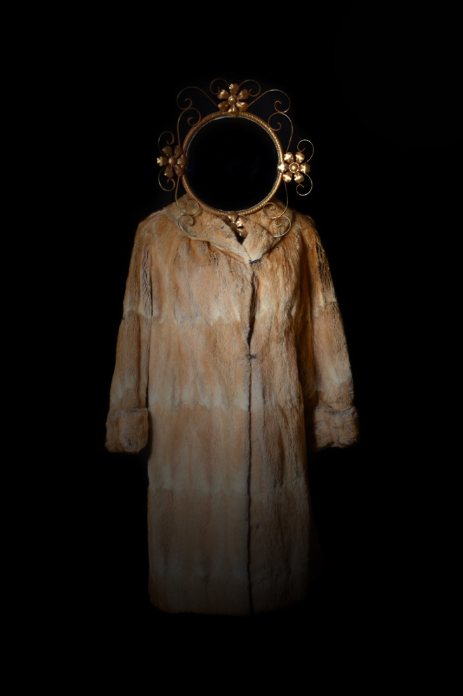
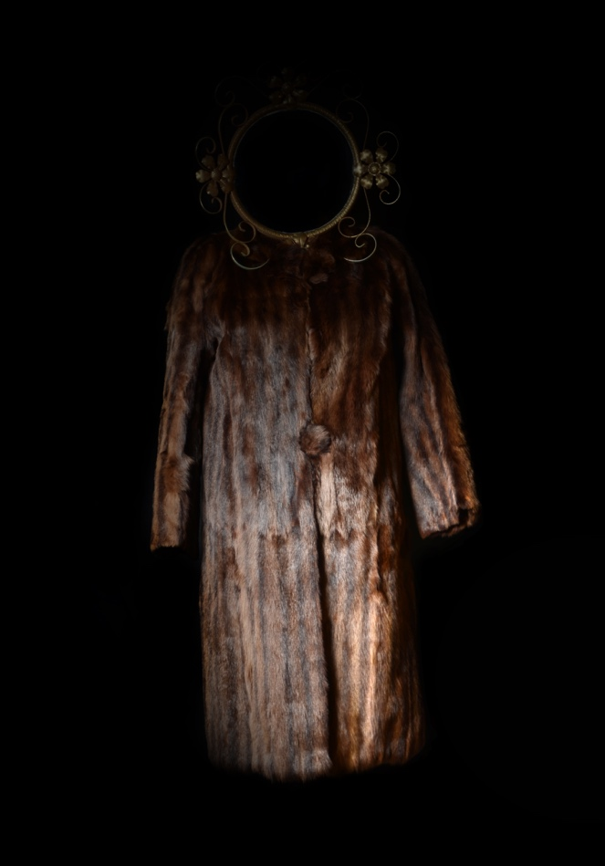

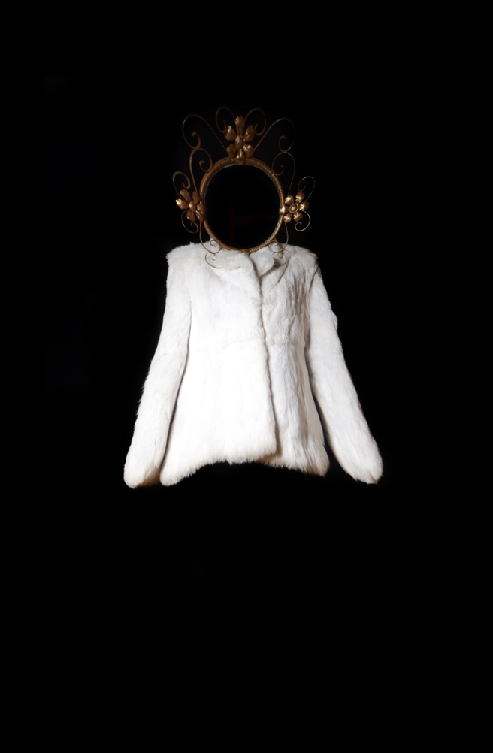
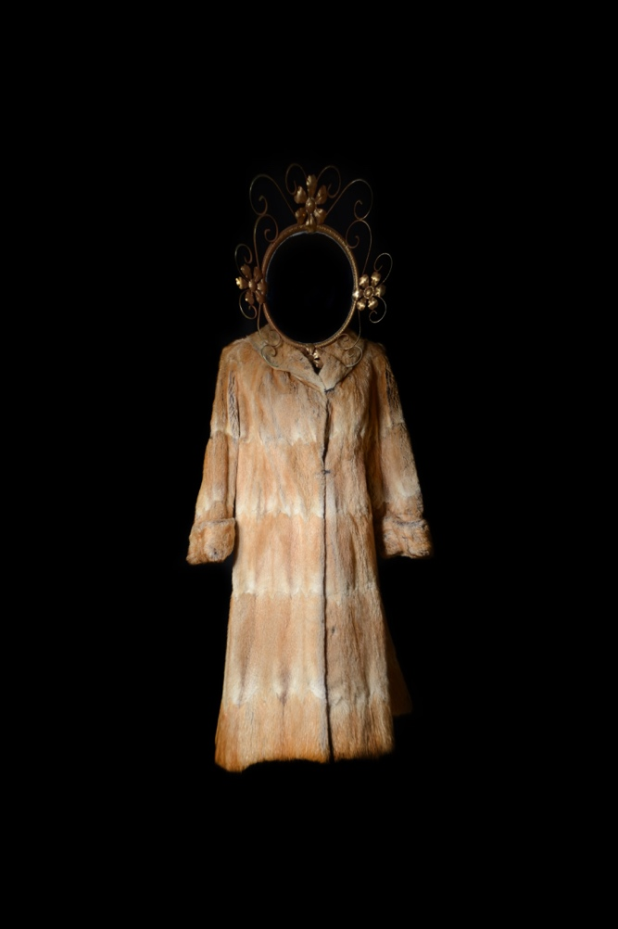
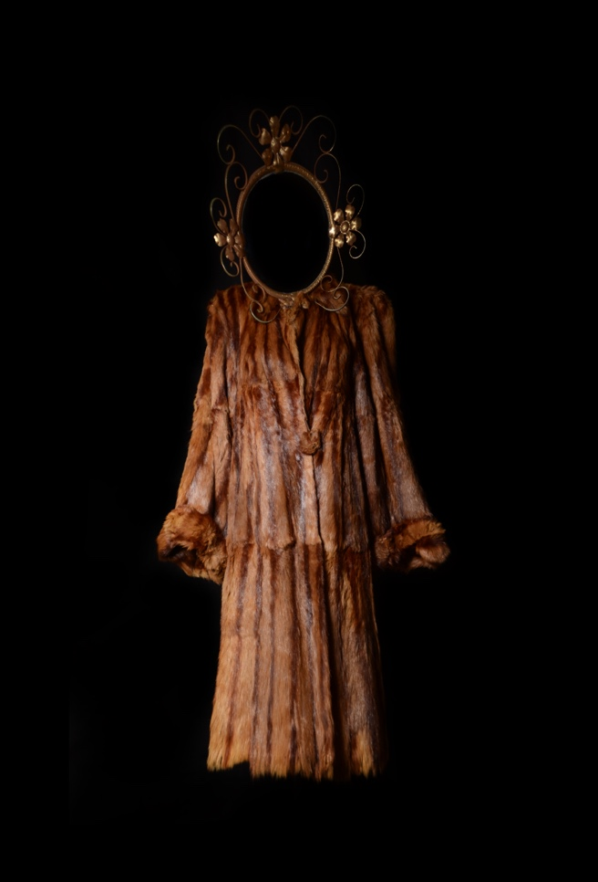
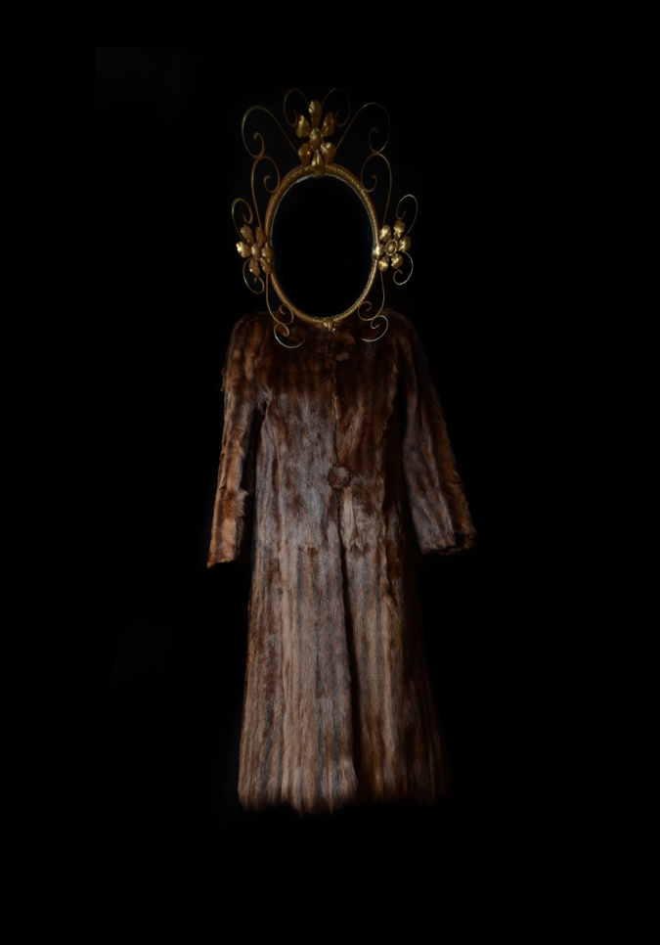

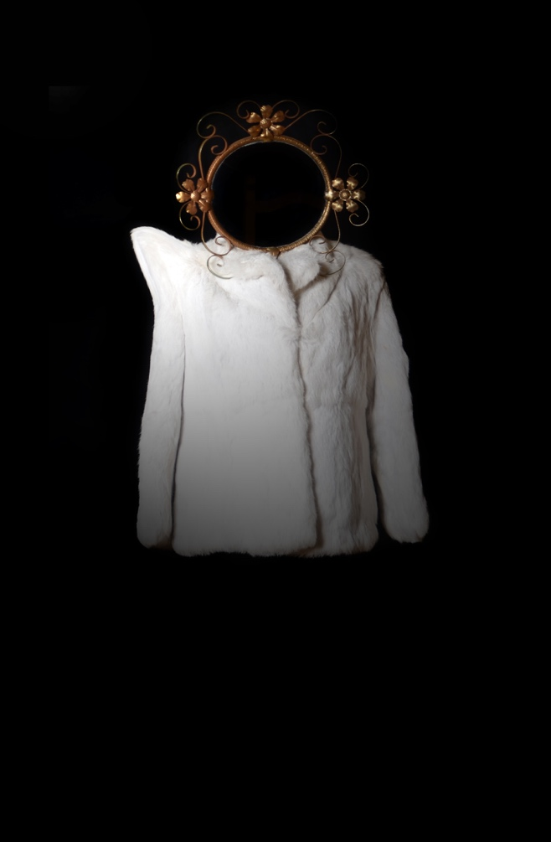
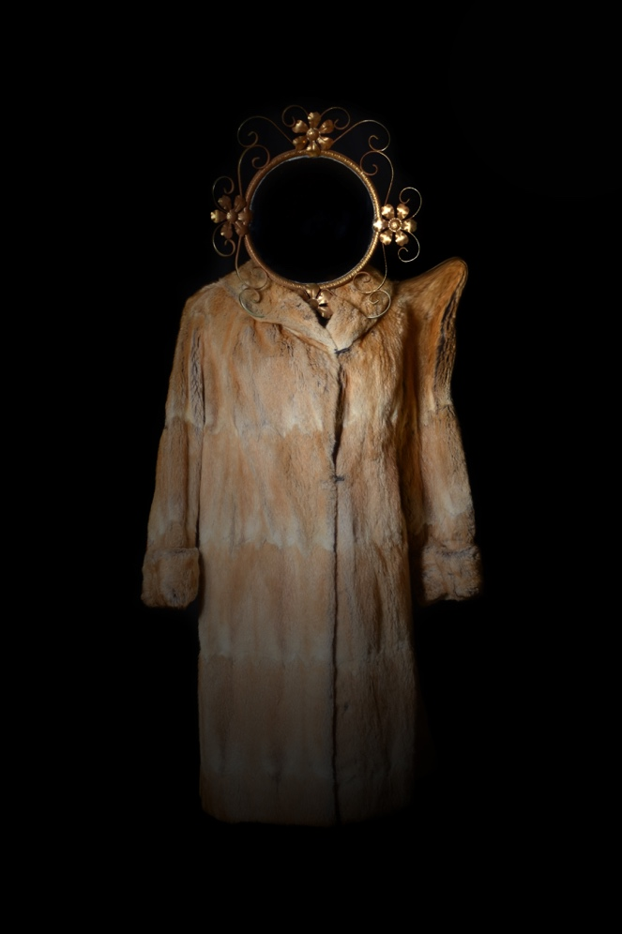
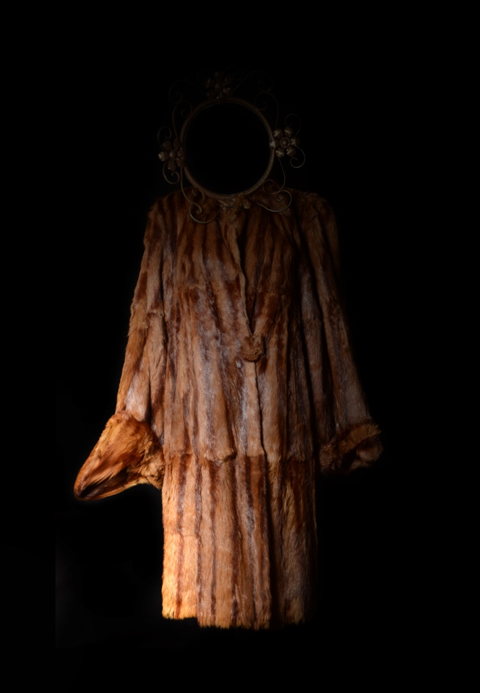
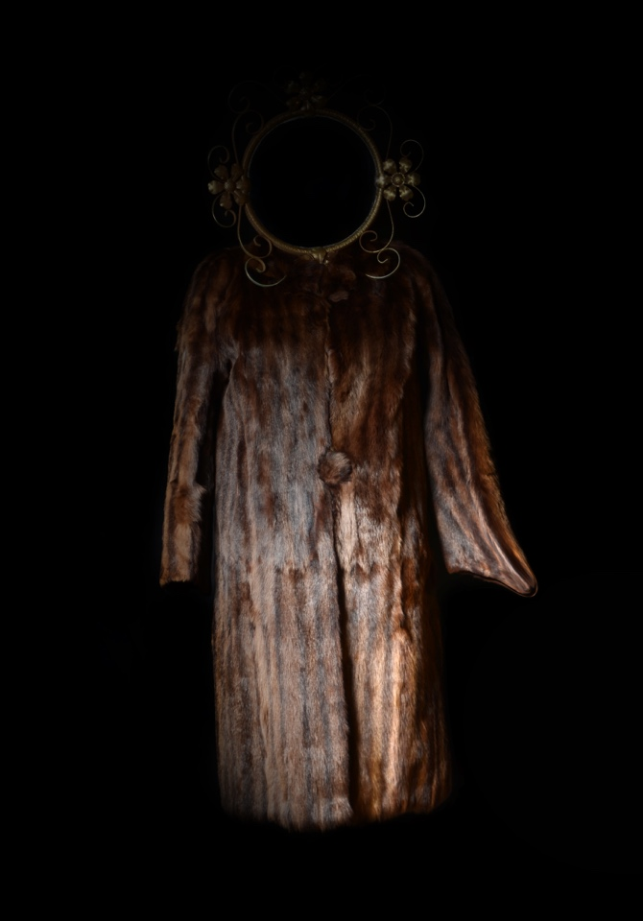

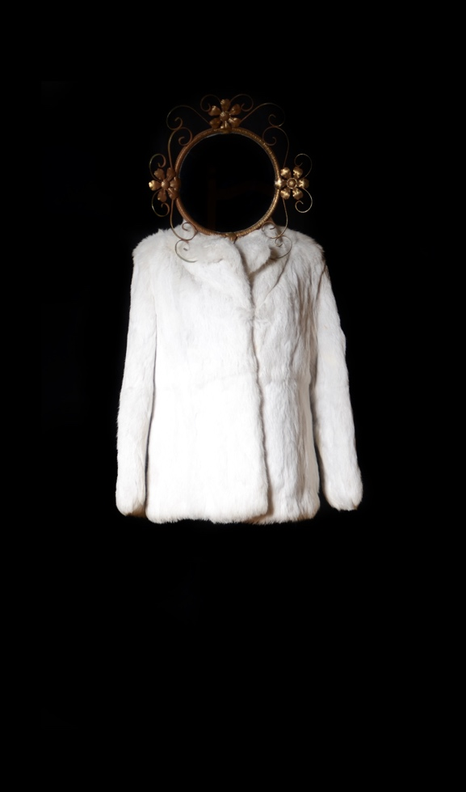
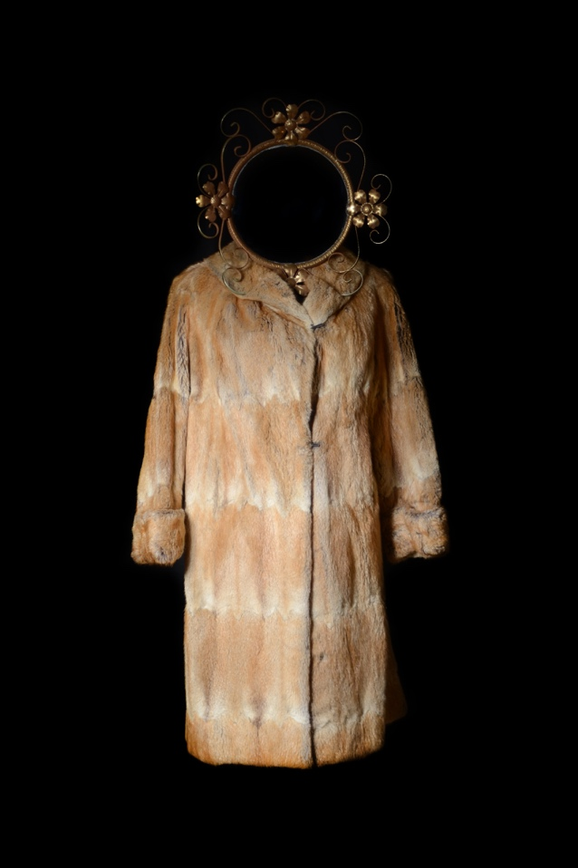
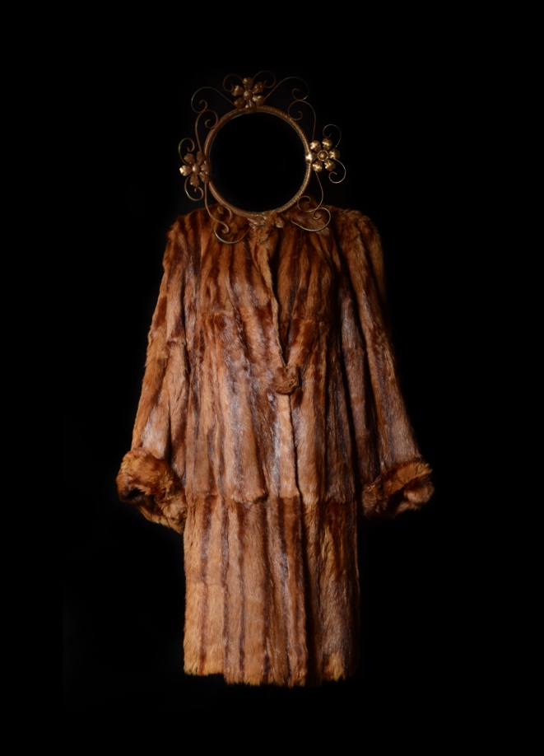
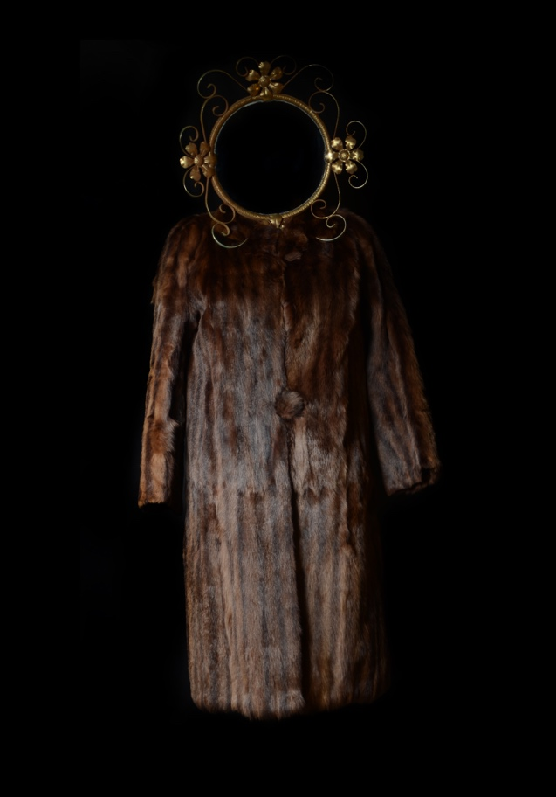

I also tried adding a spotlight effect, shining from a central position, this was purely for a visual effect, however I felt it detracted from the original images.

I then tried a squeeze effect which I found really emphasised the haunted appearance, but maybe too much so that it would be a distraction from the actual message I wanted to portray.

Finally I tried to stretch the arms and shoulders in an effort to make the images more interesting, however this really didn’t work, it made them look false and too fabricated.

In the end I decided to use my original images just as they were, it was certainly a case of too much experimentation having a negative effect, never the less I enjoyed all of the experimentation.

I ended up deciding on matching the frames as close as I could to the colours of the jackets, in a way a narcissistic idea in itself, as it threw the accepted decorum of an exhibition out of the window, and appeared to be a self-indulgent decision with an air of arrogance.

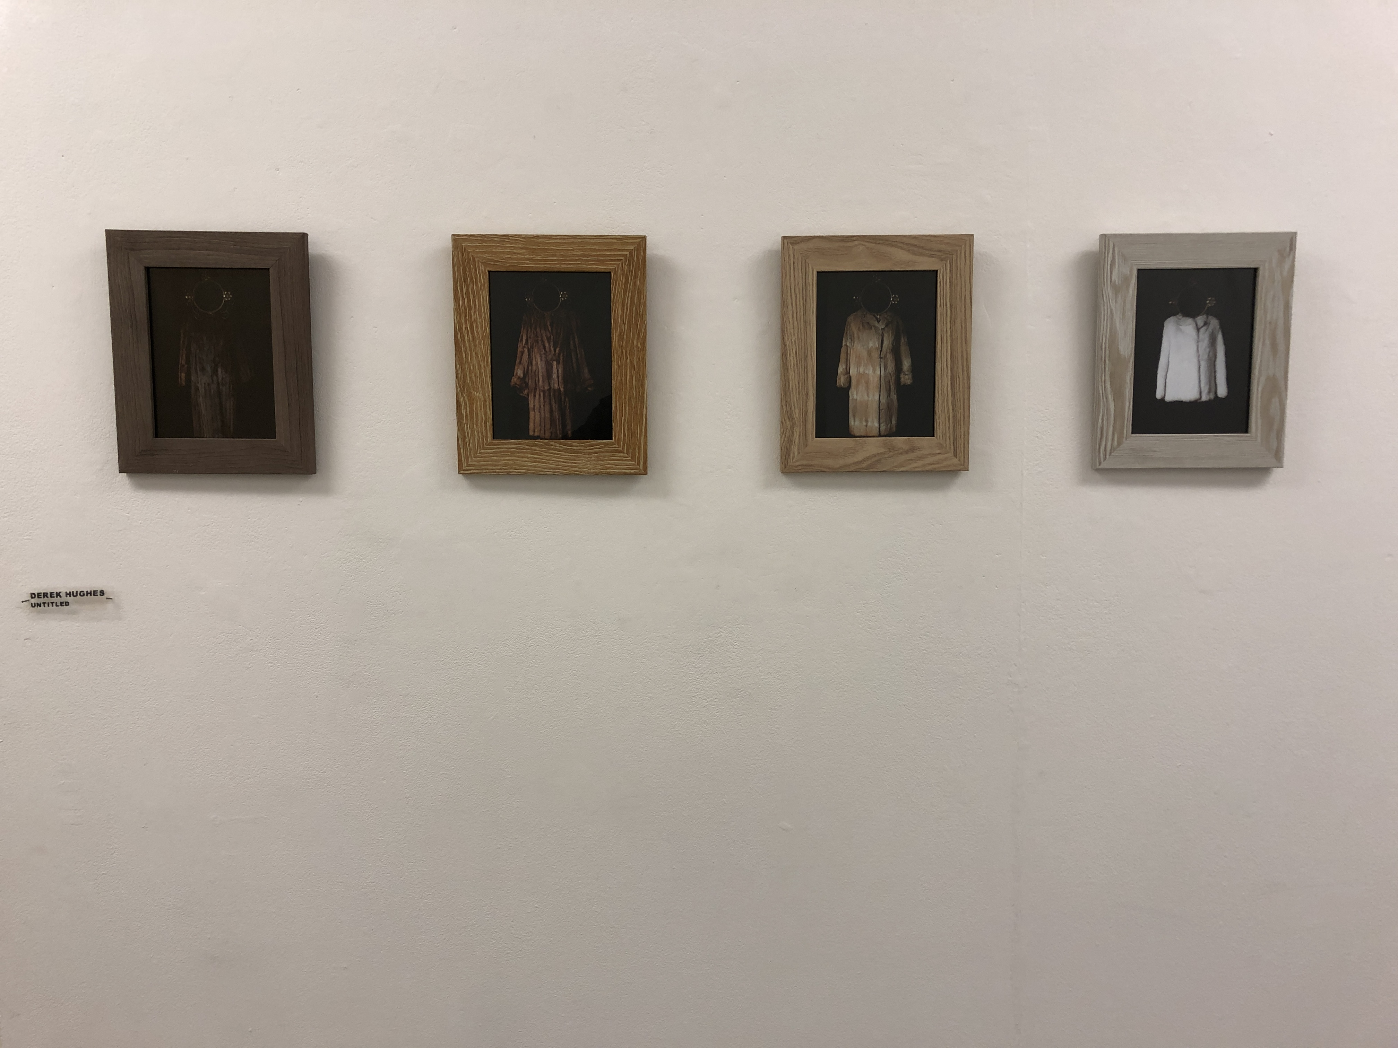

Contributions to the Exhibition Process

As a group, we started off by setting up a ‘group chat’ using messenger, and we would then be able to start the ball rolling with everyone’s input with regards ideas etc

We collectively decided on what roles would be needed in creating an exhibition and then everyone volunteered for roles, dependent on what they felt were they’re preference and strongest attributes.

Personally, I feel comfortable and confident undertaking manual roles, so I volunteered with preparing the exhibition space, and brought in my tools to help with the hanging of work and any cleaning.

As a group, we all gave our opinions and suggestions towards a range of things, and the whole decision process worked really well, such as

- Title of exhibition
- Style and font of lettering used
- Type of name plates used
- Refreshments
- Advertising Poster
- Social Media Promotion/Marketing eg Sharing of Poster online, Instagram, Facebook etc
- Curators
- Money collectors for contributions towards the Drinks and cakes.
- Sample images for the Posters

I also took it on board to have regular discussions with a couple of other mature students to ensure we all understood the task in hand and to help us complete the work with a good understanding of the assignment. I tried to emphasise that it was primarily a module to show that we can work as a team as professionally as we could, all self-directed as a team, using our initiative to complete a successful exhibition to show our work.

I feel that the end result of the exhibition was a great success, as it not only appeared very professional and interesting, but also it brought us all together as a group and enabled us to listen and discuss everyone’s ideas and concerns.

It soon became apparent that there was a great array of different styles of work to be shown, so it was never going to be a uniformed exhibition, and instead allowed for irregular styles to be shown but yet in a collective format.

I feel everyone enjoyed having the freedom to go anywhere with the style of their work, and that was reflected in the end with a diverse selection of pieces from Photos (large and small), video, images shown on iPads, Vinyl prints etc.



