
Report
Effective Team Working and Communication (BMSW4002_LON)

Lecturer Name: Lloyd Beharry
Student Name: Luigi Testaguzza (2021829)

Table of Contents

- Introduction……………………………………………………2

- Models of Communication…………………………………...2
  - Shannon and weaver model……………………...2
  - Schramm’s model………………………………….3
  - Berlo’s model……………………………………….4

- Communication skills…………………………………………4
  - Verbal Communication...…………………………..4
  - Non-Verbal Communication……………………….5
  - Listening…………………………………………….6

- The advantages and disadvantages of the communication technology……………………………………………………..7
- Conclusion………………………………………….…………7

- Introduction

There are a wide variety of factors that can influence how a message is transmitted from the sender to the recipient. These include our feelings, the surrounding cultural context, the communication method, and even our geographic location. It is because of this complexity that companies from all over the world place such a high value on strong communication skills. Many different barriers might arise affecting the success of the transmission of the message, some of these could be caused for example:
- By the sender.
- By problems in the transmission of the message as distortions or noise in a phone call, or in a message could be the language since the sender and the receiver might not speak the same language.
- By the receiver.
Nowadays an effective communication in not only a fundamental skill but also the key for the growth of any organization.

- Models of Communication

  - Shannon and Weaver Model

This model of communication was created by Shannon, a mathematician, and Weaver, a scientist, in 1948. This is a linear model made to improve technical communication mainly for telephonic communication. According to Shannon and Weaver, communication takes place when a Sender sends a Message through a Channel (such as a telephone) to a Receiver. The communication is complete when the receiver receives the message. However, the message may be affected by noise, which is the physical disturbances like environment or people, preventing the recipient from receiving the message exactly as it was delivered.
Businesstopia (2018).
To better understand this model, we take into consideration the case study of Maria and Pedro. Maria phoned Pedro and told him to buy a chicken for dinner, but because of the noise on the building site where he works, he thought she said ‘kitchen’ and not ‘chicken’. Only when he comes back home and Maria ask him for the chicken, he realizes the mistake.
I have a similar example in my previous job where during the shift I had to wear a radio to communicate with managers and security. A member of the security says on the radio that a waiter accidentally dropped the tray and there were broken glasses on the floor that needed to be removed. I understood that the waiter fell from the stairs, so I run off the bar to go to help and fortunately due to the loud music, I did not understand the message.

  - Schramm’s model

This model of communication was created by Wilber Schramm in 1954 and is based on Shannon and Weaver’s model, but Schramm argues that Communication is not complete unless the receiver gives feedback to the sender. It is mentioned that miscommunication can be given by differences between the individuals such as: different background, different language, or religion. In conclusion, according to this model of communication, when a sender passes on a message to the receiver, this needs to make sure to decode the information correctly and to send back feedback to respond accordingly, if there is no feedback from the receiver the communication is not effective and incomplete.
Janse, B. (2019)
Going back to the case study taken into consideration before (Maria and Pedro), it is possible to see how this model would solve the problem. Pedro could simply ask to Maria whether the message was right or not and act consequently.

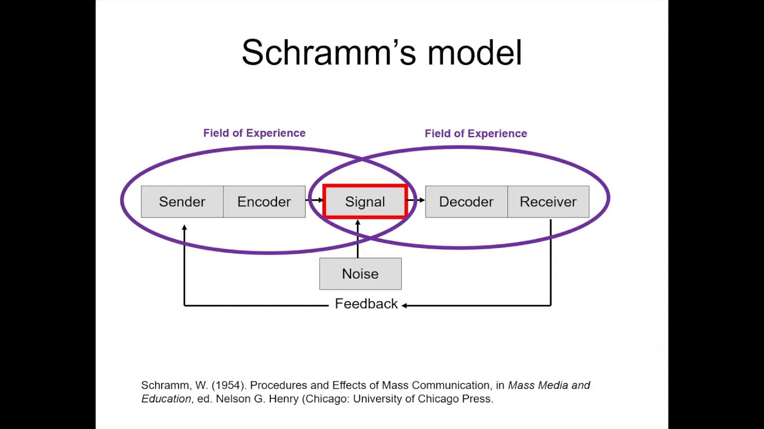

  - Berlo’s model

David Berlo founded this model in 1960 from Shannon and Weaver’s model. He identifies four main components to analyse the communication process: sender, message, channel, and receiver. Each component might be affected by many factors, such as, the communication skills, language, culture and education of the sender and receiver.
This is a linear model and there is no feedback sent from the receiver to the sender and this might cause problems to deliver the message without any distortions and he never mention any external noise that could affect the information such as traffic or a building site.
Businesstopia (2018).
To better understand this model of communication we refer to the case study of “The professor and the village people”. In this case the professor owns a house next to a village of not very well-educated people that are mainly doing manual jobs. During the night he accidentally starts a fire with his pipe and try to go the village people to ask for help but the language he uses is too complicated for them, so they keep working ignoring the professor. Only at the end he understands that if he would have used the word ‘fire’ instead of ‘conflagration’ the people would have helped him when needed. This a perfect example to underline how the difference in knowledge, in this case the word used by the professor, affect the message since at the end his house totally burned.

- Communication Skills

  - Verbal Communication

Verbal communication includes both the words we use and the filler vocabulary we add. Some of the qualities you need to have for effective verbal communication includes to be clear as much as possible avoiding a too complicated language. An individual if wants to achieve this skill should speak in a clear way choosing the right words to say what you meant without bringing any confusion to the person is listening. A good oral speaker should understand when to be empathic and put him/herself in the other’s person position, trying to be friendly using facial expression and a comprehensive tone of voice are very important, keeping eye-contact also evaluate the conversation and make feels the other person as you are sincere on what you are saying. (Quintanilla, K. M., 2020, pp. 21-22) Verbal communication can also be written using formal or informal language. We mostly use informal language when we talk to our friends, when we feel relaxed or when we want to communicate to our friends through social media or text message. On the other hand, we use formal language when we want to write an e-mail to our employer or someone we do not know, and we want to be able to impress the reader. To do this, there are some topics you want to cover such as:
- Purpose: the reason why you are writing this letter should always be clear. Either you are applying for a job or send a letter to a customer, you should always think about the purpose you are sending this email and include details that could help the reader to understand the message.
- Tone and Language: the tone you generate when writing a formal letter, it is very important, and you can achieve this by avoiding slang or emotive language.
- Layout and Structure: three sections to include: address and date, beginning/ending and paraphrasing.
Bitesize (2022).

  - Non-Verbal Communication

Non-Verbal communication happens when we do not need words to communicate and we send messages with our body language, the way we dress or the gestures we make during a conversation. Some examples of non- verbal communication can be:
- Silence: if you are very quiet the people around you might think that you are sad, angry or annoyed.
- Body Language: if two individuals are arguing about something an external person can understand the tone of the conversation, if you see two people hugging you would think they are friends, if you see two people shaking hands this might be a sign of a first meeting or something similar.
- Posture: the way we stand, or we sit could be a sign of an uninterested person.
- Appearance: nowadays the way you look is very important so if you need to go to an interview for an offer job you might want to wear something formal as a shirt rather than a simple jumper where you might be seen as if you are not interested in the position.
(Quintanilla, K. M., 2020, pp. 24-27)
When this topic was covered during this term, we saw the example of the case study of “A Day with the chief”. This case study explains how Mark, a salesman, had as a reward for his hard work the chance to meet the CEO of the company. He heard that Mrs. Brown was very difficult to talk to and anyone who talks with her has been intimidated by her attitude. At the beginning he was very stressed when he starts to speak with her, and he took care of what and how he was saying and his posture. He notices that Mrs. Brown is not as bad as his colleagues were saying and he starts to get comfortable losing his tie and he starts to talk on how the supervisor failed his job and how they should be paid better. Mrs. Brown stood up and she ask him to leave in a rough way. This case study let us understand that if Mark would have kept a formal attitude not getting too comfortable the output of the meeting would have been positive.

  - Listening
Listening is one of the most important communication skills since it is very hard to use it efficiently, in general we think ourselves as good listener but if we have closer look, we can understand it comprehend also other skills.
The first distinction we need to make, as suggested by Quintanilla, K.M. (2020, pp. 44-46), is the difference between hearing and listening:
- Hearing: this is the human physical ability to detect sound.
- Listening: this requires our attention to focus on the verbal and non-verbal messages sent to us and determine their meaning.
Listening is considered as a most basic skills in many sectors and job figures also, when for example a business wants to advertise their product, it is essential they take into consideration the feedback of their customers to understand their needs and if their product is up to the competition on the market; it is important for a manager of a business to be an active listener to make sure every employee is happy.
There are different types of listening:
- Informational Listening: it occurs when you concentrate on the meaning of the message to acquire knowledge.
- Critical Listening: it occurs when you are asked to evaluate the information being sent, for example when you have more than a proposal for a job and you want to analyse positive and negative aspects of every different place.
- Empathetic and Active Listening: it occurs when the speaker has a problem, and you can put yourself in their situation understanding and helping the speaker with a simple exclamation. To do this you need to be interested in the speaker’s problem, listen critically, and try not to interrupt their speech.
In class we had a look at the case study of “Max the Multitasker” where Max is a very expert event organizer, but since the mother has a terrible sickness who requires him to buy expensive medicine for her, he must work by himself because he could not afford them. One of his customers Tamara asked him to plan her parents’ 50th wedding anniversary and she gave him the date, location, and time, he accepts even if he finds himself doing many things. Two weeks later Tamara calls to change the date of the event and Max agreed forgetting to note the change. On the day of the event Tamara and her parents go to the hotel where it was supposed to be their party finding instead another event. At this moment everything is ruined, and Max explains to Tamara how sorry he is and tries to make a discount, but Tamara is too angry, so she decides to cancel everything and not coming back.
I believe this is a clear example of what empathetic listening is: if Max would have been more honest with Tamara saying that he was too busy to take the job he would have lost the job for that time but not Tamara as a guest forever.

- The advantages and disadvantages of the communication technology
Internet has had a huge impact on our society and on how we communicate each other, it made the communication by making gathering information has never been easier, making communication between people from different countries quicker by emails and social media, making it easier and quicker to do business online, playing games and watching videos, allowing access to cloud computing and storage, and creating thousands of new and highly paid jobs globally.
However, there are many disadvantages to communication technology and one of them can be the high risk that the users’ information can be hacked and sold to the black market. It also reduces face-to-face communication and can bring to depression, lack of confidence or bad posture. Another aspect to considerate is also online bullying or the “haters”. Influencers have many followers and many times not all of them are saying nice things to what they are posting on the platform, and this might bring to depression and anxiety.
(Reference,2020)

- Conclusion
During these weeks in class, we start from the first model of communication, Shannon and Weaver, arriving to analyse the internet and how technology changed the way we communicate each other, it can be more efficient but also dangerous for the user’s privacy or health.
I am pretty sure we will continue to use internet and hopefully it will be safer for who uses it.

List of reference
- Bitesize (2022) How to write a formal letter. Available at: https://www.bbc.co.uk/bitesize/topics/zv7fqp3/articles/zkq8hbk (Accessed: 18 July 2022)
- Businesstopia (2018) Berlo’s SMCR Model of Communication. Available at: https://www.businesstopia.net/communication/berlo-model-communication. (Accessed 23 July 2022)
- Businesstopia (2018) Shannon and Weaver Model Of Communication. Available at: https://www.businesstopia.net/communication/shannon-and-weaver-model-communication (Accessed: 18 July 2022).
- Janse, B. (2019) Schramm Communication Model. Available at: https://www.toolshero.com/communication-methods/schramm-communication-model/. (Accessed: 23 July 2023).
- Quintanilla, K. M, (2020) Business and professional communication: keys for workplace excellence. SAGE Publications, Inc. Available at: https://contentstore-cla-co-uk.ezproxy.uwtsd.ac.uk/EReader/Index?guid=64870509-7b86-eb11-85aa-281878520afa&pcid=1801892&t=eyJhbGciOiJIUzI1NiIsInR5cCI6IkpXVCJ9.eyJqdGkiOiI0N2VmOTYxYS0wMDJmLTQ3MWItODdiNC04NjY0OTQyNWYyODAiLCJuYmYiOjE2NjAxNDA0NzYsImV4cCI6MTY2MDE0MDc3NiwiaWF0IjoxNjYwMTQwNDc2LCJpc3MiOiJEQ1MiLCJhdWQiOiJSZWFkZXIifQ.3SLBhU3XjLpljkYLstoBcDfrWmiwXWWjwYHX_e6wRJo&b=False (Accessed: 18 July 2022).
- Reference (2020) What Are the Advantages of Using the Internet?. Available at: https://www.reference.com/world-view/advantages-using-internet-1da29a51c2965a5c (Accessed: 1 August 2022).

