Cover Page

E-Portfolio

Ozzy Hopkins

Contents Page

Task one – Article Summary How adverse childhood
experiences shape our brains 1

Task two – Video presentation link 2

Task three – part 1 – Poster 3

Task three – part 2 – Reflection on my contribution 4

Task three – part 3 – Evidence of team communication 5

Task one

How adverse childhood experiences shape our brains
Human Brains are complex organs and during their development stage which ranges from birth all the way to around 25 years of age they are very delicate and susceptible to change due to normal or adverse experiences. An article written by Gary Donohoe in August of 2022 summarises how adverse childhood experiences shape our brains.
Donohoe explains that many popular forms of therapy start from the view that psychological difficulties have been shaped by childhood adversity. Take his own example of CBT, the ethos of this therapy is that experiences in a person’s life are the cause of their current view on the world. Donohoe goes on to describe how recent developments in cognitive neuroscience around mental health have helped to ‘shed light’ on the biological impact and implications of adverse childhood experiences. An example given is how the development of the amygdala region of the limbic system is affected by the negative childhood experiences. The linked study of Mothersill and Donohoe 2016 found that it was participants who had suffered adverse childhood experiences that where more easily ‘triggered’ in situations. In these individuals the amygdala was observed to become more highly activated than people who had not experienced adverse childhood experiences. The study shows a correlation between adverse childhood experiences and a biological impact on the brain which would cause a change in behaviour. It is important to note that correlation does not necessarily mean causation and there could be other factors involved like inheritance of certain disorders that affect the amygdala area and similar behaviours and reactions to stimuli have been recorded.
Just like the evaluation of the research the journal shows that there is a strong correlation between adverse childhood experiences and how that shapes our brain, but there is also an argument that this is too reductionist and there could be other factors involved for example genetics and inheritance.

Task two
Video presentation link:
Meeting with Zoe Cooke-20221203_100726-Meeting Recording.mp4 (please ensure you have set your permissions so that ANYONE WITH THE LINK can view your video)

Task three – part 1
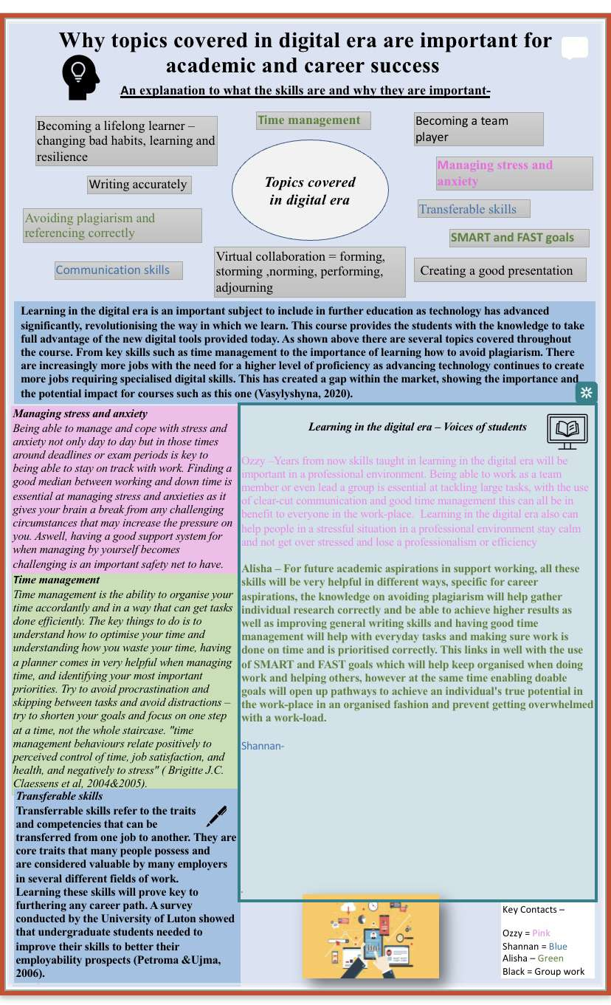
Poster

Task three – part 2
After the completion of the academic poster and in reflection of the process it is fair to say that there have been some positives and some definite draw backs in the completion of this task. Some of the positives is that the group all had a plan in the end on what we all had to individually do and during the process everyone’s individual specialities shone threw. However some of the draw back as we couldn’t meet up in person a lot or at all due to the far distance between us and the communication between all of us did become confusing at some point but every time it was corrected by it self.

Task three – part 3

https://1drv.ms/v/s!AhijlXVVwNbjgbQxQM_t4n_wexYHqA?e=haj8KS

References
ALL REFERENCES HERE FROM EVERY TASK

- Alsalem, W. S. Y., Alamodi, L. A., Hazazi, A. T. M., Shibah, A. M., Jabri, S. A., & Albosruor, Z. A. (2017). The effect of time management on academic performance among students of Jazan University. The Egyptian Journal of Hospital Medicine, 69(8), 3042-3049.
- MindTools | Home. (n.d.). https://www.mindtools.com/arb6j5a/what-is-time-management
- Gilboa, S., Shirom, A., Fried, Y., & Cooper, C. (2008). A meta‐analysis of work demand stressors and job performance: examining main and moderating effects. Personnel psychology, 61(2), 227-271
- Gausvik, C., Lautar, A., Miller, L., Pallerla, H., & Schlaudecker, J. (2015). Structured nursing communication on interdisciplinary acute care teams improves perceptions of safety, efficiency, understanding of care plan and teamwork as well as job satisfaction. Journal of multidisciplinary healthcare, 8, 33.
- Donohoe, G. (2022). How adverse childhood experiences shape our brains. The Psychologist. September 2022. UK. Retrieved from https://www.bps.org.uk/psychologist/how-adverse-childhood-experiences-shape-our-brains

