

Consumer Perceptions of Celebrity Endorsement: A Case Study Analysis of Sportswear Retail in the UK

Module name: Dissertation
Module code: LCMB7035
Lecturer name: Hoang Nguyen, Masud Ibrahim

Student name: Tajwar Ahmed
Student ID: 2436033

Word count: 2331
Submission date:

Contents
1. Introduction 3
1.1 Industry Context 3
1.2 Consumer Context 3
1.3 Academic Context 3
1.4 Research Gap and Justification 4
1.5 Aim, Objectives and Research Questions 4
2. Literature Review 5
2.1 Theoretical Foundations of Celebrity Endorsement 5
2.2 Consumer Perception and Brand Attitude 5
2.3 Trust and Authenticity 6
2.4 Celebrity Endorsement in Sportswear Branding 6
2.5 Conceptual Framework of Consumer Perception in Celebrity Endorsement 6
2.6 Research Gap 8
3. Methodology 8
3.1 Research Design Framework: Saunders’ Research Onion 8
3.2 Research Philosophy 9
3.3 Research Approach 9
3.4 Research Design 9
3.5 Data Collection 10
3.6 Data Analysis 10
3.7 Trustworthiness and Rigour 11
3. 8 Ethical Considerations 11
3.9 Research Timeline 11
4. Expected Findings 12
5. Limitations 12
7. Conclusion 12
References 13

1. Introduction

1.1 Industry Context
Celebrity endorsement is one of the most important methods in the global fashion and sportswear market, where marketers fight over the cultural irrelevancy and the emotional connexion. It does not just serve as a promotional tool, but it also acts as a symbolic value creation mechanism, allowing brands to transfer aspirational meanings to consumers (Dwivedi et al., 2021). The dominant sportswear companies like Nike, Adidas, Under Armour and Puma have moved past the performance positioning and have embraced lifestyle branding inherent in the popular culture. They create the discourses of aspiration and identity through collaboration with world-renowned celebrities. These partnerships enhance brand equity, through cultural symbolizing into products and campaigns (Mou, 2025), which assists brands to maintain the differentiation in competitive markets.

1.2 Consumer Context
The shift in consumer behaviour is no longer passive reception, but active evaluation especially in online spaces where social media contributes to a more transparent and critical evaluation of celebrity endorsements (Audrezet, de Kerveler and Moulard, 2020; Lou and Yuan, 2019). Consumers are no longer evaluating the expertise or attractiveness of a celebrity, but authenticity, ethical compatibility and value congruence. It has been shown that a perceived authenticity can seriously impact the brand attitude, enhancing the trust when the endorsements can be considered authentic (Djafarova and Trofimenko, 2019; Schouten, Janssen and Verspaget, 2020). Nonetheless, highly commercialised or inappropriate endorsements can create a sense of distrust and undermine trustworthiness (Chung, Derdenger and Srinivasan, 2013). Therefore, authenticity, trust and congruence are considered to be more effective when it comes to the endorsement than the status of celebrity.

1.3 Academic Context
The effectiveness of celebrity endorsements is explained in academic research in terms of Source Credibility Theory and the Match-Up Theory that correlate the characteristics of celebrities with the reactions of consumers. Credibility, especially expertise and trustfulness, has a significant impact on consumer attitudes (Halder, Pradhan and Chaudhuri, 2021), and the endorser-brand congruence increases the trust and brand judgement (Jun et al., 2023). Nonetheless, these frameworks might not be sufficiently applicable to the modern digital setting, where authenticity, transparency and consumer scepticism become the determinants of interpretation (Dwivedi et al., 2021). Also, research that has been conducted tends to analyse these constructs individually resulting in scattered knowledge. This underlines the necessity of a more integrated concept of consumer perception in the sportswear branding situations.

1.4 Research Gap and Justification
Despite the extensive research on celebrity endorsement, knowledge gaps in consumer perception of endorsement strategies in sportswear branding still exist. The literature also presents credibility, attractiveness and endorser-brand congruence as a factor influencing consumer attitudes (Halder, Pradhan and Chaudhuri, 2021), although authenticity, trust and identification are also discussed as important factors in the digital context (El Hedhli, Zourrig and Becheur, 2021). Nevertheless, these aspects are typically researched separately, which gives disjointed information (Knoll and Matthes, 2017). Moreover, there is a lack of literature that explicitly addresses the topic of sportswear branding in which identity and lifestyle are the key aspects. This research fills this gap by applying the secondary data to give a combined insight on consumer perception.

1.5 Aim, Objectives and Research Questions
Aim
To explore how consumers perceive celebrity endorsement in the sportswear industry through secondary research using market reports, industry data and case study sources.
Objectives
- To identify recurring patterns in secondary data that reflect consumer perceptions of celebrity endorsement within the sportswear industry.
- To analyse how factors such as credibility, authenticity and celebrity–brand congruence influence consumer attitudes toward sportswear brands.

Research Questions
- How do consumers perceive and interpret celebrity endorsement in the sportswear industry?

2. Literature Review

2.1 Theoretical Foundations of Celebrity Endorsement
Celebrity endorsement is described in terms of models that connect the characteristics of the celebrities with the reactions of the consumers, with their applicability still changing in the digital environment. The Source Credibility Theory emphasises knowledge and reliability as the major sources of persuasion, which impact consumer attitudes and intentions (Halder, Pradhan and Chaudhuri, 2021). The Theory of Source Attractiveness focuses on familiarity, likeability and similarity, which reinforce identification and emotion bonding, especially in the social media context (Schouten, Janssen and Verspaget, 2020). The Match-Up Theory emphasizes endorser-brand congruence, in which high alignment increases trust and brand judgment, particularly in identity-based industries like sportswear (Jun et al., 2023). Also, Meaning Transfer Theory describes how celebrities bring symbolic values such as lifestyle and identity to brands, which are increasingly influenced by authenticity in contemporary settings (Audrezet, de Kerveler and Moulard, 2020).
Nevertheless, these models can simplify the perception of consumers, since online spaces bring new and more intricate interpretation mechanisms that cannot be explained by older models (Knoll and Matthes, 2017).

2.2 Consumer Perception and Brand Attitude
Consumer perception is a key factor in the effectiveness of the celebrity endorsement, since brand image is created through the perception of the symbolic meanings. Functional attributes are not the only factors that contribute to consumer attitudes, but also emotional and symbolic relationships that are formed with the help of endorsements (El Hedhli, Zourrig and Becheur, 2021). The theory of self-congruency is based on the idea that consumers choose the brands that match their identity, and aspirational celebrities often contribute to this situation (Um, 2022). Also, consumer-brand relations are reinforced by emotional attachment to human brands, in which the characteristics of celebrities like attractiveness and relatability can increase brand attitudes and intentions to buy (El-Shihy, 2024). Therefore, endorsements play a role in symbolic consumption and identity expression in branding sportswear.

2.3 Trust and Authenticity
The main predictors of endorsement are trust and authenticity, which must be central in the digital and social media sphere. Authenticity is a socially constructed meaning in which the consumers assess the fact that an endorsement is authentic and consistent with personal values and brand identity (Kennedy, Baxter and Kulczynski, 2021). Endorsements increase positive brand attitudes and trust when they are perceived to be authentic. These effects are reinforced by the presence of parasocial relationships because customers develop an emotional bond with celebrities, which enhances identification and influence (Moraes et al., 2019). However, too many or too commercialised endorsements can lead to lack of credibility resulting into scepticism. Therefore, on the one hand, authenticity increases trust, whereas too much authenticity decreases the effectiveness of endorsement.

2.4 Celebrity Endorsement in Sportswear Branding
The most important part of sportswear branding is celebrity endorsement which assists brands to relate products with values like performance and aspiration. Athletes are human brands, who give products symbolic meaning (Arai, Ko and Ross, 2014). In addition to the performance, endorsements spread to lifestyle and fashion narratives, which impact identity expression and consumer perceptions as a result of cultural and symbolic associations.

2.5 Conceptual Framework of Consumer Perception in Celebrity Endorsement

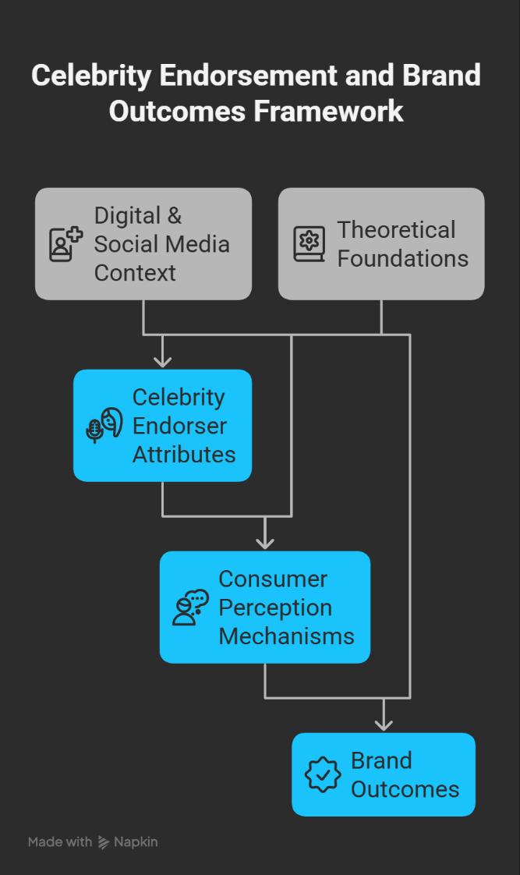
Figure 1: Conceptual Framework of Consumer Perception in Celebrity Endorsement within Nike’s Fashion Branding Context
(Compiled by Author)
The theories discussed above are incorporated into the conceptual framework. It hypothesises that the credibility, attractiveness, authenticity and endorser-brand congruence attributes of celebrity endorsers determine consumer processes of perception such as trust, identification, emotional attachment and meaning transfer. Such perceptions then determine brand performance including brand attitude, image, purchase intention and brand loyalty. The framework also acknowledges the moderating role played by digital and social media environments which determine the manner in which the consumers perceive the endorsement messages. In general, the framework offers a systematic approach to thematic analysis of the existing studies.

2.6 Research Gap
Although celebrity endorsement has been widely studied, gaps remain in understanding how consumers interpret endorsements in sportswear branding. Studies indicate that credibility, attractiveness and congruence affect effectiveness (Halder, Pradhan and Chaudhuri, 2021; Jun et al., 2023), and authenticity and emotional attachment influence trust and attitudes (El Hedhli, Zourrig and Becheur, 2021; Kennedy, Baxter and Kulczynski, 2021). Nevertheless, they are usually analysed independently, which results in disjointed knowledge (Knoll and Matthes, 2017). Besides, little research is specifically on sportswear branding, where identity and symbolic consumption play a major role (Schouten, Janssen and Verspaget, 2020; El-Shihy, 2024). This research fills this gap by use of secondary research.

3. Methodology

3.1 Research Design Framework: Saunders’ Research Onion

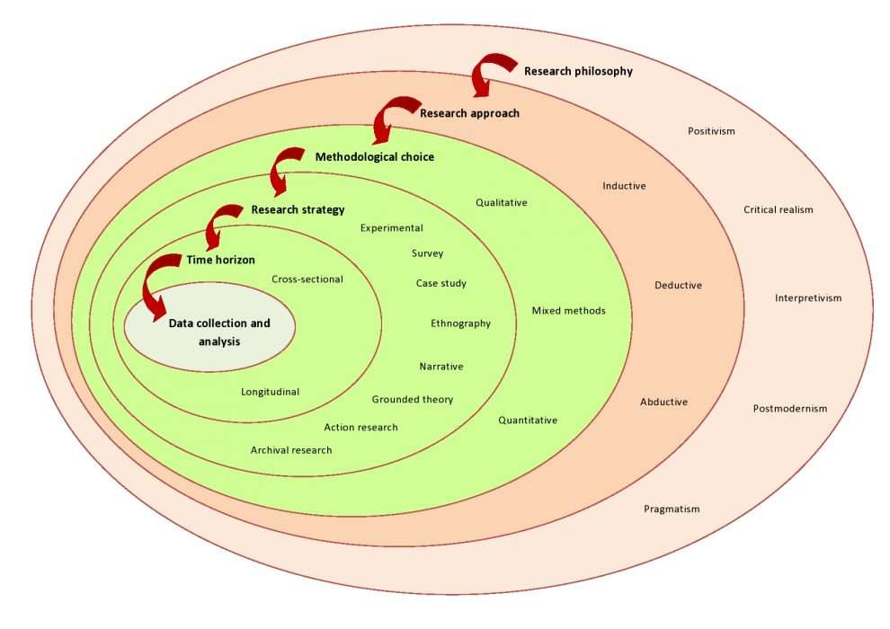
Figure 2: Research Design Based on Saunders’ Research Onion
(Saunders, Lewis and Thornhill, 2019).
The research design decisions in this paper rely on the Research Onion by Saunders that offers a systematic approach to structuring research design decisions (Saunders, Lewis and Thornhill, 2019). In this pattern, the research will be based on the interpretivist research philosophy and an inductive qualitative approach. The research plan will entail the secondary data analysis of the market reports, industry sources and existing research performed in a cross-sectional time frame. The method allows recognising the trends regarding trust, authenticity and celebrity-brand congruence in sportswear branding.

3.2 Research Philosophy
The research philosophy in this work is the interpretivist research philosophy that deals with the process of meaning construction of individuals in social situations. It presupposes that the reality is socially constructed and focuses on the interpretation of subjective experience, instead of determining the causal relationships (Scotland, 2012). This technique in marketing assists in investigating consumer perceptions. It can be associated with this study because it analyses the meaning of celebrity endorsements as it is interpreted by consumers, with the emphasis on symbolic meaning, trust, and authenticity (Nickerson, 2024).

3.3 Research Approach
The study follows an inductive qualitative approach, which develops insights from existing data rather than testing hypotheses. Patterns are identified through analysing secondary data such as market reports and industry publications. This enables integration of insights across sources and identification of themes like trust, authenticity and symbolic meaning, providing a broader understanding of consumer perceptions in sportswear endorsement contexts.

3.4 Research Design
The research design employed is the secondary qualitative design where data that was used include market research reports, company reports and reliable business sources. In this way, it will be possible to analyse the available information on consumer perceptions in sportswear branding. It facilitates the determination of patterns of credibility, authenticity and congruence, providing a real world knowledge without necessarily collecting primary data.

3.5 Data Collection
he information used in this research is obtained through a variety of secondary sources such as market research reports, industry publications, company websites and reliable online business databases. The relevant information on the sportswear branding and celebrity endorsement strategies is collected by using sources like Statista, MarketLine, company reports and industry analysis platforms.
The selection of data is guided by the following criteria:
- relevance to celebrity endorsement or sportswear branding
- focus on consumer perception factors such as credibility, authenticity and brand attitude
- inclusion of real-world examples or case-based insights
- reliability and credibility of the data source
Relevant information is identified using key search terms such as “celebrity endorsement”, “sportswear branding”, “consumer perception”, “authenticity” and “brand attitude”. The collected data is then reviewed and organised to identify recurring patterns and insights related to consumer interpretation of celebrity endorsement.

3.6 Data Analysis
The secondary data was analysed using Braun and Clarke’s (2006) six-phase thematic analysis framework, a widely used qualitative method for identifying patterns within textual data.
The stages include:
- Familiarisation with the secondary data
- Generating initial codes
- Searching for themes
- Reviewing themes
- Defining and naming themes
- Producing the final analysis based on case-based secondary data

3.7 Trustworthiness and Rigour
The methodological rigour was provided by the clear documentation of coding decisions and clear inclusion criteria of academic sources. Reflexivity was also taken into account to accept the interpretive role of the researcher. Moreover, the analytical decisions were recorded through an audit trail to increase the level of transparency and reliability.

3. 8 Ethical Considerations
This paper will use secondary data. The research is not directly associated with any ethical risks since no primary data with human participants were used. Ethical practises were also observed by proper citation, recognition of original authors and following institutional guidelines in academic integrity.

3.9 Research Timeline
TASK | W  1 | W  2 | W  3 | W  4 | W  5 | W  6 | W  7 | W  8 | W  9 | W  10 | W  11 | W  12 | W 13 | W 14 | W  15 | W  16
Research Proposal Development
Literature Search & Screening
Literature Review Writing
Methodology Writing
Data Collection (Secondary Data)
Data Analysis
Interpretation of Findings
Conclusion & Final Editing

Figure 3: Research Timeline and Project Plan (Gantt Chart)
(Created by Author).
This section outlines the proposed timeline for completing the research project. The Gantt chart below illustrates the sequence of key stages, with the 16-week project duration represented on the horizontal (X) axis and the research activities on the vertical (Y) axis. It highlights the progression of stages including literature review, data collection, data analysis and final dissertation writing.

4. Expected Findings
The thematic analysis, according to the secondary data, should highlight some major trends in terms of consumer perceptions of celebrity endorsements in sportswear branding. Credibility of the endorser/expertise and trustworthiness credibility is likely to emerge as a core factor in influencing consumer judgments. Nevertheless, authenticity can mediate this connexion by influencing the extent to which credibility would be converted to favourable brand perceptions (Audrezet, de Kerveler and Moulard, 2020). It is also anticipated that endorser-brand congruence will positively impact on endorsement and that emotional attachment to celebrities will lead to symbolic consumption and brand attachment.

5. Limitations
The research is based on secondary case study and this can be a drawback in the study as it may not give a picture of the current consumer behaviour and the new practises in the industry. Findings may also be affected by publication bias. Also, thematic analysis is an interpretive subjectivity. These problems were countered by use of transparent coding process and clear inclusion criteria.

7. Conclusion
This proposal explores the concept of consumer interpretations of celebrity endorsements in the branding of sportswear. Credibility, authenticity and symbolic meaning are some of the concepts that are combined in the study by secondary analysis of case study. The research will use an interpretivist methodology approach to synthesise the fragmented results, and offer theoretical understanding and practical recommendations on effective endorsement strategies.

References
Arai, A., Ko, Y.J. and Ross, S. (2014). Branding Athletes: Exploration and Conceptualization of Athlete Brand Image. Sport Management Review, 17(2), pp.97–106. doi:https://doi.org/10.1016/j.smr.2013.04.003.
Audrezet, A., de Kerviler, G. and Guidry Moulard, J. (2020). Authenticity under Threat: When Social Media Influencers Need to Go beyond self-presentation. Journal of Business Research, [online] 117(1), pp.557–569. doi:https://doi.org/10.1016/j.jbusres.2018.07.008.
Braun, V. and Clarke, V. (2006). Using Thematic Analysis in Psychology. Qualitative Research in Psychology, 3(2), pp.77–101. doi:https://doi.org/10.1191/1478088706qp063oa.
Chung, K.Y., Derdenger, T.P. and Srinivasan, K. (2013). Economic Value of Celebrity Endorsements: Tiger Woods’ Impact on Sales of Nike Golf Balls. Marketing Science, 32(2), pp.271–293. doi:https://doi.org/10.1287/mksc.1120.0760.
Djafarova, E. and Trofimenko, O. (2019). ‘Instafamous’ – Credibility and self-presentation of micro-celebrities on Social Media. Information, Communication & Society, [online] 22(10), pp.1432–1446. doi:https://doi.org/10.1080/1369118X.2018.1438491.
Dwivedi, Y.K., Ismagilova, E., Hughes, D.L. and Carlson, J. (2021). Setting the future of digital and social media marketing research: Perspectives and research propositions. International Journal of Information Management, [online] 59(1), pp.1–37. doi:https://doi.org/10.1016/j.ijinfomgt.2020.102168.
El Hedhli, K., Zourrig, H. and Becheur, I. (2021). Celebrity endorsements: Investigating the interactive effects of internalization, identification and product type on consumers’ attitudes and intentions. Journal of Retailing and Consumer Services, [online] 58(1), p.102260. doi:https://doi.org/10.1016/j.jretconser.2020.102260.
El-Shihy, D. (2024). Unveiling the psychological mechanisms behind sports celebrity social media endorsements. Cogent Business & Management, 11(1). doi:https://doi.org/10.1080/23311975.2024.2376771.
Halder, D., Pradhan, D. and Roy Chaudhuri, H. (2021). Forty-five years of celebrity credibility and endorsement literature: Review and learnings. Journal of Business Research, [online] 125(1), pp.397–415. doi:https://doi.org/10.1016/j.jbusres.2020.12.031.
Jun, M., Han, J., Zhou, Z. and Eisingerich, A.B. (2023). When Is Celebrity Endorsement effective? Exploring the Role of Celebrity Endorsers in Enhancing Key Brand Associations. Journal of Business Research, [online] 164(1). doi:https://doi.org/10.1016/j.jbusres.2023.113951.
Kennedy, A., Baxter, S.M. and Kulczynski, A. (2021). Promoting authenticity through celebrity brands. European Journal of Marketing, ahead-of-print(ahead-of-print). doi:https://doi.org/10.1108/ejm-10-2019-0802.
Knoll, J. and Matthes, J. (2017). The Effectiveness of Celebrity endorsements: a meta-analysis. Journal of the Academy of Marketing Science, [online] 45(1), pp.55–75. doi:https://doi.org/10.1007/s11747-016-0503-8.
Lou, C. and Yuan, S. (2019). Influencer Marketing: How Message Value and Credibility Affect Consumer Trust of Branded Content on Social Media. Journal of Interactive Advertising, [online] 19(1), pp.58–73. doi:https://doi.org/10.1080/15252019.2018.1533501.
Moraes, M., Gountas, J., Gountas, S. and Sharma, P. (2019). Celebrity influences on consumer decision making: new insights and research directions. Journal of Marketing Management, 35(13-14), pp.1159–1192. doi:https://doi.org/10.1080/0267257x.2019.1632373.
Mou, G. (2025). The Influence Mechanism of Brand Collaborations and Sports Team Collaborations on Consumer Perceived Value and Willingness to Pay a Premium. Advances in Economics and Management Research, 15(1), p.960. doi:https://doi.org/10.56028/aemr.15.1.960.2025.
Nickerson, C. (2024). Interpretivism Paradigm & Research Philosophy. [online] Simply Psychology. Available at: https://www.simplypsychology.org/interpretivism-paradigm.html.
Saunders, M., Lewis, P. and Thornhill, A. (2019). Research Methods for Business Students. 8th ed. S.L.: Pearson Education Limited.
Schouten, A.P., Janssen, L. and Verspaget, M. (2021). Celebrity vs. Influencer endorsements in advertising: the role of identification, credibility, and Product-Endorser fit. Routledge eBooks, [online] pp.208–231. doi:https://doi.org/10.4324/9781003155249-12.
Scotland, J., 2012. Exploring the philosophical underpinnings of research: Relating ontology and epistemology to the methodology and methods of the scientific, interpretive, and critical research paradigms. English language teaching, 5(9), pp.9-16.
Um, N. (2022). Impact of Parasocial Interaction, Perceived Ad Message Authenticity, and Match-Up between Brand and Celebrity in Evaluation of Instagram Celebrity-Based Brand Endorsement. Sustainability, 14(5), p.2928. doi:https://doi.org/10.3390/su14052928.

