Developing Workplace Critical Thinking

University of Wales Trinity Sant David

Course: BA Leadership and Management

              - Student name: Daniela Vidrascu
              - Student number: 1817905
              - Module title: Developing Workplace Critical Thinking BMSW5101 LON
              - Assignment title: Developing Workplace Critical Thinking
              - Lecture’s name: Gregory Cowan

Executive Summary
This report provides a close look into details about the organisational performance concerning its culture and the external environment along with the impact of Covid-19. It is necessary to make sure that the organisations meet such challenges with proper strategic planning. It should include careful consideration of the external and internal environment of the companies. Amazon has been chosen for the sake of clarity regarding the concerned subject. PESTEL analysis is performed along with Porter’s five forces model’s detailed description concerning Amazon. Also, the ethical dilemmas are explained concerning the organisation selected for this report. In the end, a brief conclusion along with the recommendation regarding the highlighted subject are also discussed. This report will help to critically analyse and assess the structure of Amazon concerning the above-mentioned topics and develop a critical understanding of the well-established models and tools in the business environment.

Table of Contents
Executive Summary: 2
Task 1: Report 5
Introduction 5
Amazon: 5
The background of Amazon: 6
Products and Services: 6
The operating Markets: 6
The share in the Market: 6
Business environmental tools 7
The PESTEL Framework: 8
Porter’s five forces: 8
Cultural Web Analysis: 9
The external Environment Analysis of Amazon: 10
Drivers of Change: 12
Industry Analysis of Amazon: 13
Organisational culture and external factors in Amazon: 15
Effect of five key external factors on Amazon and Addressing them in detail including Covid-19:
Organisational Culture and Performance: 16
The ethics and workplace cultural issues in Amazon: 17
The Ethical Dilemmas: 17
Environmental Issue: 18
Conclusion and Recommendations: 18
Create Conditions favourable for humans: 18
Diversifying leadership: 19
References: 19
Task 2: Reflective Essay 22

Task 1: Report

Introduction
In this report, a detailed analysis is performed regarding the environmental factors that affect the business environment in an organisation along with the impact of covid-19. The company of Amazon is selected for the sake of thorough analysis and critical assessment of the culture within an organisation is done. Along with that, an evaluation of Amazon is performed concerning the organisational analysis techniques. The PESTEL analysis, Porter’s five forces model and cultural web are also explained in the context of the selected organisation. In the end, the ethical dilemmas of Amazon and the recommendations regarding that factor are also presented briefly.

Amazon:
Amazon is an American company that has got its large centre in the UK that focuses on the internet, distributed media, computer production, and social thinking. It is one of the largest companies in the data centre industry, along with Google, Apple, Microsoft, and Facebook (Amazon 2021). The organisation has been hailed as perhaps the most empowered and most resilient nation in the world, a symbol of global recognition.

The background of Amazon:
Jeff Bezos launched Amazon from its parking space in Bellevue, Washington, in July 1994. It is a store that specializes in selling hardware, code, computer games, fashion, furniture, food, and jewellery. Amazon is known for its market share associated with advancements in mechanics and the massive scale in the masses. It is a global online vendor, bringing together AI operators, life systems, and a distributed integration system that adds to the investment in the marketing system. Amazon is the world's largest Internet company concerning income.

Products and Services:
Amazon.com products can be found on their site including other promotions (books, DVDs, CDs, tapes and programs), clothing, toys, consumer goods, luxury items, good kitchens, food, health and safety in the community. By 2021, they will have more than 55,000 people across the UK with 1.3 million worldwide(Amazon, 2021).

The operating Markets:
With 263.5 billion retail sales, the United States is the largest Amazon market share by 2020. Germany is in second place with $ 26 billion, ahead of the UK with the US $ 26.5 billion.

The share in the Market:
Amazon increased its e-commerce sales in the UK by 28.8% in 2018 to 30.1% in 2019, according to a recent report from e-commerce information company Edge and Ascential.
The statement made it clear that Amazon controls e-commerce in the UK (30.1%), accounting for $ 30 billion in sales in 2019. Next to eBay, which has a 9.8% market share online, followed by Sainbury (4.6%), Tesco (4.5%), Walmart / Asda (3.9%) and John Lewis (3.6%).
The UK is the third-largest commerce market in the world behind China and the US, with an estimated $ 101 billion in 2019. In addition, Edge analysts from Ascential predict the e-commerce share in the stock market will continue to rise rapidly in the UK, from 21% in 2019 to 26% in 2024(Jr, 2019).

Business environmental tools
Following is a brief explanation of the business environment tools that will be explored in the context of Amazon company. It includes PESTEL analysis, Porter’s five forces model and cultural web(Matovic, 2020).
Business environment:
Many layers in the business environment should be considered while dealing with this factor. It includes;
- The business environment cannot be operated in a vacuum.
- It has its reaction from internal and external factors influence.
- These factors affect the company’s forward business as well as the company’s goals and plans.

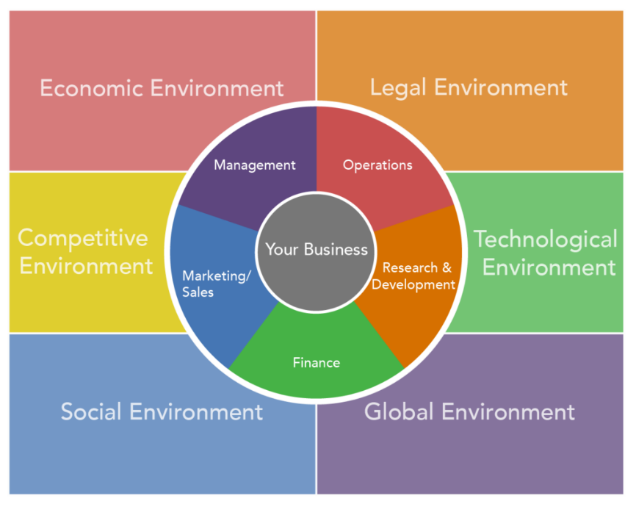
Business Environment (Lumen Learning, 2021)

The PESTEL Framework:
The goal is to provide a complete description of the outcome of a system's success or failure. PESTEL represents the political, economic, social, technological, environmental and legal factors in detail (Shatskaya et al., 2016).

Porter’s five forces:
- The competitive Rivalry:
This assesses the size and strength of competitors. What kind of politics do they have? Who are they, and how do their products and services compare with one’s organisation? If the competition is strong, companies can attract customers by lowering the price and with a higher level of marketing (Bruijl, 2018).
- Power of Supplier:
This is designed to make it easier for marketers to promote their business. What types of products and services are selected and how much does it take to switch from one vendor to another?
- Power of Buyer:
Here, one wonders how easy it is for consumers to lower their prices. How much is the customer and how is the order? How expensive would it be for them to convert their products and services to that of their competitor? Do the customers find it difficult to explain the business situation?
- The Threat of Substitution:
This means that the opportunity for the customers to find another way to do what they do. For example, if they provide a special software product that only fixes the system, people can replace it by manually performing the operation or removing it.
- Threats of new entries:
The ability of people to enter their markets can affect their position. So think about how they can do this easily. How easy is it to find a place in the company or business? How much will it cost and how much do they control in their area?
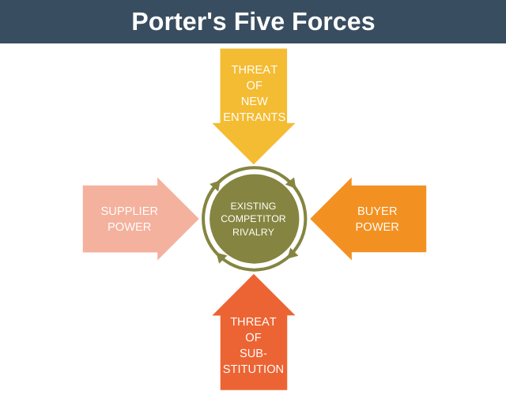
Porter’s five forces model ( Expert Program Management, 2021)

Cultural Web Analysis:
It is such a way in which group culture is identified and coordinated ways to control the different powers associated with this organisation. It can be used to describe the existing culture and to shape the future the custom corresponds to the question: ‘What changes should be done in the culture to make that particular aspect happen? Both maps can be upgraded for the sake of discussion and demonstrate, where and how to change that aspect (Radomska, 2016).

The external Environment Analysis of Amazon:
This PESTEL / PESTLE review is done concerning Amazon.com Inc. and highlights the need to expand operations in other markets to support the full complement of e-commerce.
The Political Factors affecting Amazon:
Amazon.com Inc. works with politics. This part of the PESTEL / PESTLE model focuses on the role of government and its impact on companies in and around them. In the case of Amazon, the following are some important steps in developing commerce companies:
1. The political situation and the stability in developed countries, especially the USA, UK and European countries (opportunities)
2. Government supports e-commerce or not (opportunities and threats)
3. Increasing the effect of government state in cyber testing (Opportunity)
Economic Factors about Amazon:
Amazon's performance depends on the economic situation in which it uses the online portfolio. The environmental impacts on climate or environmental change are discussed in this section of the PESTEL / PESTLE model. In the case of Amazon.com Inc., some resources are important:
1. The economic situation of successful markets, especially the United States and European countries (opportunities)
2. Increasing income generation in developing countries (opportunities)
3. China's economic recession (threat)
Social Factors related to Amazon:
This section of the PESTEL / PESTLE research system reflects the impact of social and cultural change or position and the company’s performance as an online vendor and provider of information and technology information. Considering these systems in remote or remote areas, Amazon faces the following public problems:
1. Increase economic disparity (threat)
2. Increase in consumerism in third world countries (opportunities)
3. Adding online stores for more buyers (opportunities)
Technological Factors on Amazon market:
Technological advancement has gripped Amazon rapidly, providing the core of its expertise and business (Baboolal-frank, 2016). The results of technology related to local or large-scale ecosystems cover this part of the e-commerce industry in PESTEL / PESTLE analysis. This type of external factors influences Amazon in the following ways;
1.obsolescence concerning rapid technology (Opportunity)
2. increase the efficiency of IT resources (opportunity)
3. high levels of cybercrime (threat)
Environmental Factors in Amazon:
Although Amazon.com Inc. is an online business, its performance depends on the location of the site (Althafeiri et al., 2016). This section of the PESTEL / PESTLE analysis shows private or large industries are undermining environmental change. Amazon considers external and internal factors in its design features:
1. Increase interest in environmental programs (opportunities)
2. Increase business capacity and support (opportunities)
3. increase the popularity of low carbon type of lifestyle (threat)
Legal Factors Affecting Amazon:
Amazon.com Inc. e-commerce services are required to comply with the law. The error of the controller error in remote or large areas is seen in this section of the PESTEL / PESTLE model. In the case of Amazon, some external factors are important:
1. Add product measurements/regulations (opportunities)
2. Change and import and export customs/regulations (opportunities)
3. Protection of the environment and industry (opportunities)

Drivers of Change:
The companies are well aware that the key leaders for change in the retail industry are the ones who will beat the competitors. Based on a strong search and analysis of stores in the UK, the following drivers of change will describe the Amazon company in the following years:
- The presence of markets:
Retailers in the US will have to deal with the fact that next year’s consumers expect retailers to be easier to find. Therefore, companies need to search their store carefully. At the same time, fierce competition in the industry demands that the company grow smarter where they live, to satisfy as many customers and financially as possible from their competitors especially in the UK(Tardieu et al., 2020).
- Change in the customer expectations and actions:
Young people are accustomed to buying what they want when they need it at a lower price. This practice also extends to the grocery industry. In other words, the industry prioritizes natural resources and make sure that they are making their overall goals and achievement by considering such changes in the customer expectations.
- Option of Online Shopping:
. Whether the customers are buying online at high quality or time-saving benefits, the reality is that online retailers are increasing their knowledge. Entrepreneurs should consider giving customers an attractive and friendly look on the shopping list to prevent them from choosing what is offered by competitors online.
4. New technologies:
Good progress and the implementation of new technologies will be critical to the external marketing industry. To keep prices down, companies need to consider acquiring, using or developing technologies that are tailored to their needs.

Industry Analysis of Amazon:
Following is the brief description of Porter’s five forces model concerning Amazon;
These five forces are:
1. Threats regarding the new entries
2. Power of buyers
3. Threat regarding the substitutes
4. Power of Suppliers
5. The competitive Rivalry

Points to Remember:
Amazon leads the market in the e-commerce industry and, to maintain its position even as it grows competitive, should focus on its brand and the image created by it. The industry in Amazon seeks to promote customer experience regularly by making the company's e-commerce website easier to use. Amazon contains a variety of products and services like Amazon Prime, Alexa, Kindle, Fire TV, Amazon Fresh and many more to facilitate a large number of customers ( Sadq et al., 2018).
1. Threats regarding the new entries:
It is easy to start an online retail store or e-commerce website online, but it can be difficult for any brand to compete with a major like Amazon. It will require huge investments in storage, distribution, marketing, easy-to-create creations, customers, logistics and much more.
Currency exchange: It is easy to get into the e-commerce industry and also easy to win competitors, customers, due to the lowest exchange rates in the market.
Thus, the huge investment in Amazon in its advertising business and also, in consumer experience, makes it difficult for competitors to compete in the market. For any other product, it takes billions of dollars to invest and, to compete with Amazon.
2) Economy: Amazon has several other successful economies due to its reputation as the largest retailer in the market. While new entrants may be able to help in the market, they may not be able to use their wealth and popularity to reach Amazon.
3) Customer loyalty: Amazon recognizes that a customer may be creating or breaking a business, that is, investing heavily in customer service from the start, or by changing customer-friendly websites, delivery time, and product returns. Amazon aims to provide its customers with the best information on the market.
2. Power of Buyers:
Amazon maintains that customer satisfaction seeks to give its customers high value. Amazon has a customer-focused approach to its e-commerce business. It promises to be the best product of the company and receive on time. Consumers usually have a large enough contract due to strong competition in the e-commerce industry. Therefore, based on Porter’s analysis of Amazon’s five forces of power, it should put customers in the highest interest position to maintain long-term success(Culpepper and Thelen, 2020).
3. Threat regarding the substitutes
Amazon competes with other online retailers and a major hurdle facing Amazon is the cost of switching to a company, where customers can switch from other Amazon products quite easily which should be managed by it.
- Power of Suppliers
Vendors have provided Amazon with the product customers need for its e-commerce business. The disadvantages of e-commerce retailers are even greater because, without them, retailers will not be able to serve their customers. Thus, based on Amazon's review of five patent rights, external factors show us that retailers have the lowest rights in the industry.
5. The competitive Rivalry in Amazon:
Amazon competes with strong competitors in online retail companies. Because in recent years, the number of players entering the industry has increased and more retailers are introduced, small businesses and start-ups are starting to sell their products online. It provides intense competition to the Amazon company. But no other company can still invest as much as Amazon has done, thus it stands in the top position as the leader of the e-commerce market (Miguel et al., 2016).

Organisational culture and external factors in Amazon:
The culture of the Amazon organisation can be described as:
Trust Among its users:
Amazon promotes trust. The company manufactures and sells a wide range of products online, starting from paper, through state-of-the-art technology, demonstrating this form of business culture. Amazon has made it clear to consumers that they will get what they want and their expectations will be respected (Wahyuningsih et al., 2019).
Differences: Differences also affect the culture of Amazon.com Inc. This cultural character refers to the chosen point of view of the questions to be asked. For example, Amazon encourages its employees to dedicate themselves to traditional and independent patterns of corporate life.
The difference in Workforce: Amazon’s corporate culture focuses on thinking about different employees. At Amazon, they focus on a higher standard: employees stay strong and have high moral standards. Managers regularly upgrade their Bar and encourage their team to provide advanced products, services and systems.

Effect of five key external factors on Amazon and Addressing them in detail including Covid-19:
The five key external factors are stated below that have affected the culture of Amazon. The factors are described briefly below and related to the PESTEL model as it closely deals with this kind of aspect in detail.
The Environment of Amazon matters a lot as in this age of social media, it is relevantly easier to catch any mishap and then promote it on social media websites. That can tarnish the image of the company. Therefore, the careful implementation of the rules at the workplace in different environments (since it operates in many countries) is vital for its success ( Nacher et al., 2021).
Moreover, the second factor is economical which deals with the image of Amazon as an online company. It is necessary to deal with the different economical conditions in different places to achieve the overall goal of the company and attain sustainability (Rich, 2016).
The third factor is the social one which affects the consumerism concept and requirement to add more online stores for the sake of getting more customers. The fourth factor is technological which is extremely important as it can make or break the overall company situation in this age. It is necessary to stay up-to-date with the latest technical development that affects the overall business environment (Clay-warner and Robinson, 2011).
In this time of Covid-19 when many companies are facing severe challenges and are forced to make changes in their business structure, Amazon has made sure it deals with this situation with proper strategies that can have positive effects on the customers as well as on employees. Following are some changes done in Amazon in this context.
They completed 100,000 new jobs announced in March and added 75,000 to help meet customer needs and help existing employees meet the requirements for key manufacturing products.
Amazon is investing more than $ 800 million in COVID-19 storage.
They have made Amazon employees pay for COVID-19 patients or install it independently.
They will add another $ 2 per hour effective in April through a tax of $ 15 / hour or more, depending on the region, C $ 2 per Canada, GBP 2 per hour and the UK cost about € 2 a year in most EU countries. The fundraising agreement at the end of April represents $ 3.3 million in top salaries for employees working in the United States, Europe and Canada.

Organisational Culture and Performance:
Cultural researchers have done a lot of research on the definition of culture. The aspect that the organisational culture and performance are closely related begins with a notion that the culture can affect both things in the competition of companies. There is a positive relationship between the culture of the company and the performance of the employer (Mullins and Laurie, 2019). Theologians emphasize that the benefits of continuous competition come from the establishment of competencies in an organisation concerning the culture defined within it(Kassem and Russel, 2019). Experts and scholars have shown that the functioning of an organisation depends on how moral values ​​are handled. A morally corrupt company cannot stay longer in the market considering the exposure of events that can badly affect the consumer’s perception regarding the organisation.

The ethics and workplace cultural issues in Amazon:
Those familiar with the company - and anyone who has read Brad Stone's close relationship with Amazon's rise will certainly not be surprised by the New York Times detailed description of that great e-commerce company’s ethics.
Investment in the UK:
Since 2010, they have invested more than £ 23 billion in services in the UK. These include budgets (such as our resources, such as content area, company location and database) as well as utility (depending on our UK-based service). These investments increase economic activity in a given area. The investment enhances its economic potential as Amazon retailers increase and increase their investment income.

The Ethical Dilemmas:
In modern organisations, moral and ethical issues are at stake. The main areas are:
The crime in White Collar:
The company's fraudulent behaviour has resulted in financial loss. White-collar crimes can also occur in subtle ways. Utilising working hours to do their own business, using company information to send people information are some of the ways (Graham et al., 2019).
Employee rights:
Employee rights management creates several ethical issues in the industry. Some of these problems are privacy issues, medical tests regarding drugs, and more. The use of data from users of computer systems raises several cultural issues.
Sexual harassment:
Sexual harassment is harassment, whether verbal or physical, which affects the worker's environment or creates a work environment. Sexual harassment costs the company in the form of unemployment, trafficking, and unemployment.
Is Amazon Ethical?
The research reflects a wide range of issues regarding ethics about Amazon, including climate change, environmental reports, habitat and products, pollution and waste, handicrafts and military deployments, human rights, labour rights, labour management, free trade titles, animal rights, animal experiments, industrial agriculture, the use of technology, political programs and opposition funds to name a few.

Environmental Issue:
The environment ratings in Amazon are supposedly the worst considering the sustainability reports in the last few years. There was no mention of its usage of electronic devices and the textiles being used having an impact on the environment which makes one think that they don’t consider it an issue at all worthy enough to be talked about. Moreover, there is no information available regarding the usage of harmful chemicals in the preparation of the clothes being sold at their stores which is a major factor. The harsh chemical being used in the clothes released such substances which affect the overall environment in the worst way and Amazon doesn’t feel it necessary to even talk about it(Tollefson et al., 2015).
The use of chemicals in the Products:
There should be a clear description of what should be used in the baby care products, beauty products and the ones related to personal care and Amazon just has issued one statement telling everyone that all the brands should take care of not using such materials which is such a weaker statement considering the impact it has on the consumer in the long run. If people don’t know what they are using on them, and if it negatively affects them, they will certainly develop negative perceptions about that company.

Conclusion and Recommendations:
Following are some of the suggestions that can be utilised to deal with the identified problems above in Amazon and the supposed benefits of applying them in the long run.

Create Conditions favourable for humans:
Blue-collar and white-collar employees in all countries in the Amazon are mistreated. Instead, Amazon should have the goal to be the place where it can come in the top ten places to work in the world.

Diversifying leadership:
Of the 16 most powerful corporate executives, 17 were men. At the bottom, 74% of Amazon’s corporate offices are white men. Jeff Bezos ’10 direct employees describe a single woman and they are all white. So far, 9 of 11 Amazon executives have been white.
Changing the law to describe that the employees can be selected from 40 percent of company members should be the rule.
In the end, it can be said that the above-mentioned tasks are extremely critical to implement in such times when the consumer is particularly inclined towards those companies which favour the employees regardless of the colour of their skin. The ethical dilemmas are indeed present in the Amazon company and should be dealt with likewise. Amazon indeed is a giant in the retailing business market and the critical evaluation of it concerning various business environment tools have highlighted its strength, opportunities and threats in the best possible way (Onyusheva and Seenalasataporn, 2018). Furthermore, the ethical dilemmas, the organisational culture and its impact on the performance are also evaluated briefly.

Task 2: Reflective Essay
The writing of this report which was the essential requirement in this module has helped me in many aspects regarding personal as well as professional development. The emphasis throughout the assessment brief has been on the critical analysis and thorough understanding of the key factors either external or internal regarding the organisational behaviour along with the impact of covid-19 as an essential element to be considered. The process of a study done through the whole process has enabled me to criticise and think analytically to question the workplace behaviour of the organisation and how it impacts its employees. For example, the PESTEL analysis and Porter’s five forces model described in the context of Amazon has made me able to think and analyse how the structure should be developed within an organisation to deal with the outside factors. Moreover, the knowledge gained through the facts, and information is valuable in terms of getting employment in big retail companies like Amazon. Furthermore, the inclusion of my analysis throughout the report has made me able to understand the whole organisational structure with meaning. The usage of the concept of cultural web helps to enable the question regarding the change that should be done concerning the culture in an organisation. The economical details regarding the company help to analyse the situation of Amazon in the market and revealed many important statistics regarding it. The investment enhances its economic potential as Amazon retailers increase and increase their investment income.
It has also helped me to realise how to become a responsible employee by making appropriate personal decisions in the specific culture of the organisation and take the responsibility for them. The ethical issues are also explained in detail concerning Amazon and that shows how big giants like this company also faces challenges in this regard. The responsibility is not only on the concerned company but also on the employees to make sure that they create such an atmosphere that is encouraging and helps to deliver the assigned goals by following the guidelines within the time frame. The detailed analysis was done by reading various resources not only helps to develop a critical understanding o the assigned task but also help to broaden the horizon regarding the concepts that are closely interlinked with the focused content.
It also helps in developing an understanding of business ethics and considering the legal and logical recommendations regarding the business environment. Overall, the cultural character of an organisation refers to the chosen point of view of the questions to be asked. For example, Amazon encourages its employees to dedicate themselves to traditional and independent patterns of corporate life. It can help develop critical skills necessary for the employee to work in a diverse environment.

References:

Althafairi, B., Alhoumaida, N., Saxena, M. and Almsri, Z., 2019. Case study-AMAZON. Journal of the Community Development in Asia (JCDA), 2(2).
Amazon, 2021. About us. Available at: https://www.amazon.co.uk/
Baboolal-Frank, R., 2021. ANALYSIS OF AMAZON: CUSTOMER-CENTRIC APPROACH. Academy of Strategic Management Journal, 20, pp.1-16.
Bruijl, G.H.T., 2018. The relevance of Porter's five forces in today's innovative and changing business environment. Available at SSRN 3192207.
Culpepper, P.D. and Thelen, K., 2020. Are we all Amazon primed? Consumers and the politics of platform power. Comparative Political Studies, 53(2), pp.288-318.
Clay-Warner, J. and Robinson, D.T. eds., 2011. Social structure and emotion. Academic Press.
Expert Program Management, 2021.Porter’s Five Forces. https://expertprogrammanagement.com/2021/06/porters-five-forces/
Graham, M., Kitchin, R., Mattern, S. and Shaw, J. eds., 2019. How to run a city like Amazon, and other fables. Meatspace Press.
Kassem, Rassel (2019), Organisational culture and achieving business excellence : emerging research and opportunities, IGI Globe, Hershey, PA :
Lumen, 2021. External Forces. Available at: https://courses.lumenlearning.com/wmopen-introductiontobusiness/chapter/external-forces-that-shape-business-activities/
Mullins, Laurie J. (2019), Organisational behaviour in the workplace [electronic resource], 12th ed. Pearson (Harlow)
Matovic, I.M., 2020. PESTEL Analysis of External Environment as a Success Factor of Startup Business. ConScienS, p.96.
Miguel, J.C. and Casado, M.Á., 2016. GAFAnomy (Google, Amazon, Facebook and Apple): The big four and the b-ecosystem. In Dynamics of big internet industry groups and future trends (pp. 127-148). Springer, Cham.
Nacher, M., Rousseau, C., Succo, T., Andrieu, A., Gaillet, M., Michaud, C., Servas, V., Douine, M., Schaub, R., Adenis, A. and Demar, M., 2021. The Epidemiology of COVID 19 in the Amazon and the Guianas: Similarities, Differences, and International Comparisons. Frontiers in Public Health, 9.
Nguyen Jr, O., 2019. Setting Up an Online Store on Amazon UK. Case Company: Finarte Oy.
Onyusheva, I. and Seenalasataporn, T., 2018. STRATEGIC ANALYSIS OF GLOBAL E-COMMERCE AND DIVERSIFICATION TECHNOLOGY: THE CASE OF AMAZON. COM INC. The EUrASEANs: journal on global socio-economic dynamics, (1 (8)), pp.48-63.
Radomska, J., 2016. Tools and actions for increasing the effectiveness of the strategy implementation. In Business Challenges in the Changing Economic Landscape-Vol. 2 (pp. 23-32). Springer, Cham.
Rich, B. (2016) Future-Proofing: Seeking Resilience in the Historic Built Environment, Univ of Washington.

Sadq, Z.M., Sabir, H.N. and Saeed, V.S.H., 2018. Analyzing the Amazon success strategies. Journal of process management. New Technologies, 6(4).
Shatskaya, E., Samarina, M. and Nekhorosheva, K., 2016. PESTEL analysis as a tool of strategic analysis in international markets. SCOPE ACADEMIC HOUSE B&M PUBLISHING, p.47.
Tardieu, H., Daly, D., Esteban-Lauzán, J., Hall, J. and Miller, G., 2020. Technology Trends—Historical and Future Drivers of Change. In Deliberately Digital (pp. 29-38). Springer, Cham.
Tollefson, J., Kapuscinski, A.R., Locke, K. and Moutinho, P.R.D.S., 2015. International media spotlight on the Amazon roams, but rarely enlightensInternational media spotlight on the Amazon roams, but rarely enlightens. Elementa: Science of the Anthropocene, 3.
Wahyuningsih, S.H., Sudiro, A., Troena, E.A. and Irawanto, D., 2019. Analysis of organisational culture with denison’s model approach for international business competitiveness. Problems and perspectives in management, (17, Iss. 1), pp.142-151.

