Lidl – German Discounter Gaining Market Share



November 26th 2019

MODULE NAME: Strategic Management and Sustainability
Name: Samuel charles Dymock-Brown
Word count: 2536
Student Number: 1706575

Table of Contents
1. Executive Summary 3
2. Introduction 4
2.1 Report Remit 4
2.2 Background of the Organisation 4
2.3 Definitions of Major Concepts 5
3. Main Body 8
3.1 Implementation of The Strategy 9
3.2 Advantages and Disadvantages 10
4. Conclusion 11
4.1 Recommendations 11
5. Bibliography 13

Table of Figures

Figure 1: Porter's Generic Strategies Model (Business Balls, 2017) 7

Executive Summary
Within this report the reader will be notified on the background history of Lidl and how they have had the ability to rise to the giant brand that they are today. The report will provide the reader with the knowledge to explain how Lidl, a German Discounter have been able to gain immense market share throughout all of Europe. Lidl opened their first grocery retailer in 1973 and have now proved they are capable of taking on the ‘big four’ supermarkets in the UK alone. The report will show the model in which is used to source the strategy that Lidl use for their success. The model used is Michael Porter’s Generic Strategies and the strategy that Lidl have used for the success of the company is cost leadership. The findings of the report show how the cost leadership strategy has benefited Lidl by showing the advantages and disadvantages of the strategy. To conclude, the report shows that cost leadership has been the best way for Lidl to go about building the business throughout the years and especially since the credit crunch in 2008. The recommendations show that Lidl should just stick to the market they are currently in and not try to use two different strategies as it would be very hard for them to pull it off and gain consumers as they would gain in one market but lose in the other.

2. Introduction
Within this report, there will be information regarding the identification of the business strategy that Lidl comply with in order to compete and progress there competitive position. The report will include a critical evaluation of the strategy possessed by Lidl, contained within this evaluation will be advantages and disadvantages of the strategy that Lidl have put into use. To conclude this report, there will be recommendations for ways the organisation can move forward, based on the previous findings.

2.1 Report Remit
This report will seek to understand the strategy that Lidl input into their overall business plan in order to attempt to gain a competitive advantage. The report will aim to provide reasoning as to why Lidl have implemented this strategy and show how they have implemented the strategy to become one of the leading European grocery retailers. As well as finding why they are using the strategy they have chosen the report will also hold information around the advantages and disadvantages of using the strategy they have chosen.

2.2 Background of the Organisation
Lidl, as the majority of the European population know it, is fully named as Lidl Stiftung & Co. KG. dating all the way back to the 1930’s in Germany, an independent grocery wholesaler was built into action (Ward, 2011). Nowadays the same small, independent wholesaler is one of the largest grocery retailers in Europe. The first store named, Lidl, with 3 employees, was opened in 1973 with 33 more stores being opened across Germany by 1977, and by the 1980’s Lidl was an established brand throughout Germany. From the 1990s Lidl were able to branch outside of Germany to countries such as France and the United Kingdom (Lidl, 2017). Up until 2008 Lidl has been looked down upon due to the low prices, the lower class people would tend to shop there due to the reasonable prices and society looked down at them for this. Fast forward to todays society, since 2008s recession most of the UK population is looking for the good products at the most reasonable prices. For Lidl, the recession helped a lot due to the credit crunch seeing Lidl’s sales up by 13%, with only Aldi ahead of them with an increase of 21% (Thompson, 2008). From all the success Lidl have encountered, their vision remains the same and that is,
‘To enhance the lives of our customers, by providing quality products at market leading value, whilst ensuring that customer satisfaction is at the heart of everything we do.’ (Lidl, 2018)
At the current time, Lidl have an estimated annual revenue of $84.6 billion and over 315,000 employees (Owler, 2019). As of August 2019, Lidl recorded their highest ever market share 45 years after opening their first branded store with a 5.9% UK market share (Makortoff, 2019).

2.3 Definitions of Major Concepts
There are many concepts that are used by organisations such as Lidl to allow them to create the best strategy in order for them to compete with their competitors and ultimately gain a competitive advantage. Strategy can be defined in many ways but the main form of business strategy is linear strategy.
‘Strategy is the determination of the basic long-term goals of an enterprise, and the adoption of courses of action and the allocation of resources necessary for carrying out these goals.’ (Chaffee, 1985)

Business-level strategy has multiple strategies within, the definition is,
‘Business-level strategy focuses on how to attain and satisfy customers, offer goods and services that meet their needs, and increase operating profits.’ (Garcia, 2018)

To do this, business-level strategy emphases the positioning of itself against competitors and staying up-to-date on market trends within the industries and technology changes.

Competition is the vital area for the success or failure of a business. Businesses are always looking for innovative ways to gain a competitive advantage over competitors. The definition of a competitive strategy is,
‘The search for a favourable competitive position in an industry, the fundamental arena in which competition occurs. Competitive strategy aims to establish a profitable and sustainable position against the forces that determine industry competition.’ (Porter, 1985)

The model that is going to be applied to Lidl in this report is going to be Porters Generic Strategies. Porters Generic Strategies are made up of four strategies which include:
- Cost Leadership
- Differentiation
- Focus
- Cost Focus / Focus Differentiation
Cost Leadership emphasises the production of standard products at a low cost per-unit or to product consumers who are price-sensitive. This strategy is aimed at a large market due to the low priced products. The cost leadership strategy is
‘The primary focus of the cost leadership strategy is to compete on price as the major marketing tool.’ (Brown, 1990)
Businesses using the cost leadership strategy have a continual focus on cost reduction so they are able to drop the price of their products which in turn allows them to gain a competitive advantage over their close competitors. With the focus on cost reduction organisations keep finding new ways to become more operationally efficient.
Differentiation is one of Porter’s generic strategies aimed at producing products and services that are looked upon as unique in the markets being directed at consumers who are relatively price-insensitive.
‘Successful product differentiation involves identifying and communicating the unique qualities of a company's offerings while highlighting the distinct differences between those offerings and others on the market.’ (Kopp, 2019)
This strategy offers something different, the organisations using this strategie offers products that are perceived as unique or better than other products on the market. Due to the unique products the organisations are able to offer, the price charged is often of a premium level due to the quality and exclusivity.
Focus is another element of Porter’s generic strategies, it involves producing products or services that have the ability to fuel the needs of small groups of consumers in a target market. There are multiple types of focus strategy which include, low-cost focus, best value focus and focus differentiation. Focus strategy
‘Selects a segment or group of segments in the industry and tailors its strategy to serving them to the exclusion of other.’ (Porter, 1980)

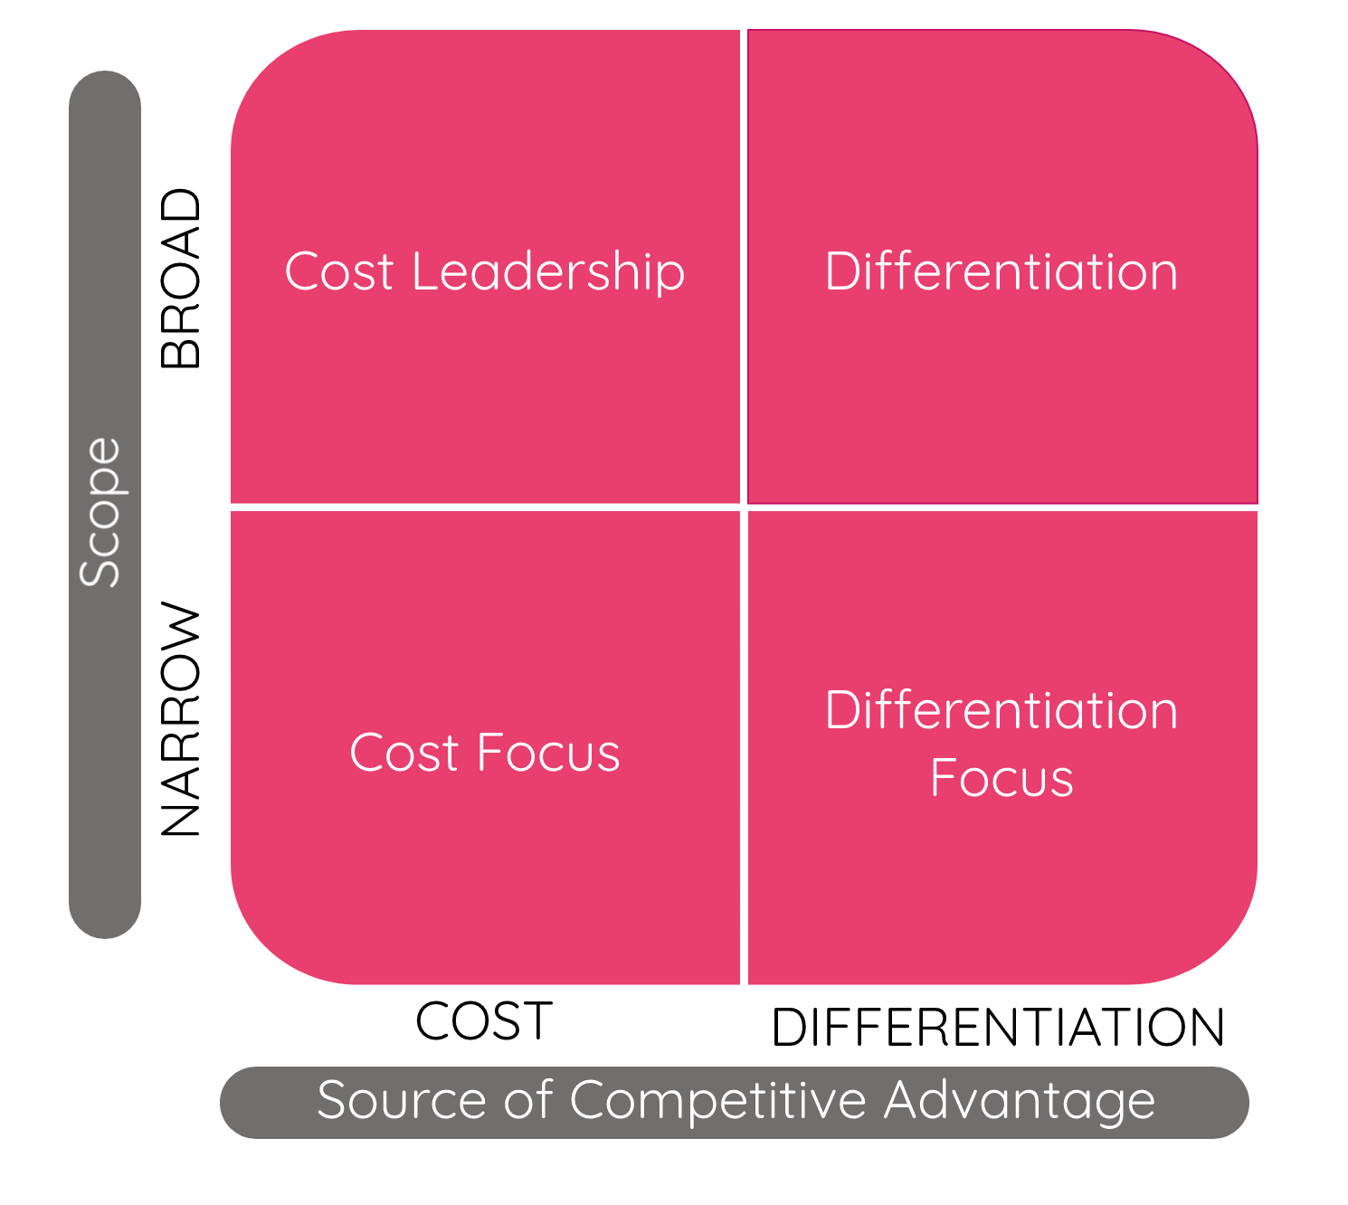
This strategy allows organisations to focus on the consumers and market their products directly to them. A focus strategy is beneficial to organisations that sell limited products in the same area so they have the ability to direct their products to a specific target market. Low cost focus is also a focus strategy that many organisations adopt due to the way society is nowadays with many people searching around for the most reasonably priced products.
Figure 1: Porter's Generic Strategies Model (Business Balls, 2017)

Stuck in the middle, this is what Porter referred to when using two of the four strategies. The generic strategies are not necessarily compatible with one another but it is possible for an organisation to use two and still gain a competitive advantage. For example, if an organisation differentiates itself by selling high quality products, it risks lowering the quality if it seeks to become a cost leader. If thought out well and planned thoroughly there is a possibility that the two can become compatible. An example of this is the watch industry, Omega, Tag Heuer and Cartier are all similar quality in the products but Tag Heuer have the competitive advantage due to the lower prices but the ability to keep the quality of the products they manufacture.

3. Main Body

As shown, the model being used to identify which strategy Lidl have implemented is Michael Porter’s Generic Strategies. With the model being compelled of four key areas in strategy, Lidl fit the ‘Cost Leadership’ strategy in the finest way. As previously described, cost leadership is where the cost per unit is as low as possible allowing the organisation is then able to sell the products for a low price and still have room for profits to be made due to the higher number of customers. Lidl have shown all of these characteristics and that is why they are under the cost leadership strategy. Lidl’s main competitor in the grocery retailer industry is Aldi, another European organisation in the industry with the same views and the same strategy in place (Rodionova, 2016). The ways in which Lidl are best able to achieving the competitive advantage over Aldi is by increasing their profits by reducing costs, while charging industry average prices. Another way they are able to gain a competitive advantage over the main competitors is by increasing market share, this is done by charging lower prices on their products while still making reasonable profit on each sale because of the reduced initial costs (MindTools, 2017).

3.1 Implementation of The Strategy
For an organisation to effectively implement the cost leadership strategy shown by Michael Porter, they must slash their costs in all productive areas, from efficiency of transport to product placement. They must compete with the lowest possible cost all over the business to gain a competitive and ultimately become cost leaders. Due to the low costs all over the business this allows for a higher profit margin which helps with the goal of gaining a competitive advantage (Jorgenson, 2015).
The first way in which Lidl express their cost leadership strategy is by selling very few branded products, around 90% of the products within Lidl stores are own-label brands which have been made specifically for the company. By doing this Lidl have the ability to control their manufacturing costs and cut out supply costs as they have no middleman. This is beneficial to them as they are able to charge less for the products but still make more of a profit than it does on the big brands. For instance, for Lidl to have the ability to take this further by having a limited range on products, for example they only source their milk from one place. This allows them to purchase their products in massive bulk meaning they have a large buying power over other brands looking for the low cost products due to Lidl being prepared to buy all of the produce from the manufacturer (Bentley, 2018).
Another way that Lidl show that they are using a cost leadership strategy is the way they display their products. Most of the products that Lidl do sell are often displayed in their arrival boxes. This allows for a quick, free flowing transition when re-stocking the shelves and this method of displaying means there isn’t a need for as much manpower to transfer the products onto shelving. As well as it being functionally easier this reduces the in store promotion costs as there are no needs for seasonal displays for different products. The downside to this cost cutting method that Lidl use is that it isn’t the most aesthetically pleasing to the eye and is more of an eye sore, but very rarely will you have someone who cares about a stores aesthetic compared to the reasonable priced products (Bentley, 2018).

3.2 Advantages and Disadvantages
As shown previously, Lidl use the cost leadership strategy in which they implement into their overall business plan. Although this strategy from Porter’s Generic strategies has helped Lidl tremendous amounts the strategy does have its disadvantages as well as advantages.
Advantages include:
- Ability to outperform rivals.
- It can increase an organisations market share.
Disadvantages include:
- Possibility of price wars.
- It encourages lower quality products to be offered.
For an organisation using a cost leadership strategy the primary advantage they seek is having the ability to outperform their rivals. This means the organisation must have the most reasonably priced products for the expected quality from consumers. The organisation must also keep up to date with the average cost in a certain area across the industry so they are able to continuously offer the lowest priced products, keeping that mission of outperforming their rivals. (Mack, 2017)
The final advantage of cost leadership mentioned within this report is that it can increase an organisations market share. Organisations do not only achieve higher profit margin, they have the potential to achieve a greater market share. Consumers which are cautious when it comes to spending balance the needs of price along with value. If the products are at the lowest prices, but with an acceptable value for the price of the product, the organisation will be considered for purchase first, ultimately this will induce higher sales, causing an increase to the market share. (Regoli, 2015)
The first disadvantage of the cost leadership strategy that will be discussed is the possibility of price wars. A price war is a period of fierce competition in which organisations cut their prices in an attempt to increase their market share. Price wars have the ability to generate devastating and psychological debilitating situations that can take a massive toll on a company and even industry profitability. No matter what organisation wins, the combatants always end up worse off before they took part (Rao, et al., 2000).
The final disadvantage for the cost leadership strategy is that the strategy encourages lower quality products to be offered to the market. Organisations wanting to cut costs know that it is not an easy process. It may require the businesses to use lower quality set of ingredients for their products or even use raw materials to generate a higher profit margin. (Regoli, 2015)

4. Conclusion
To conclude this report, the findings have shown that from Michael Porter’s Generic strategies Lidl use the cost leadership strategy to have the ability to operate at the high standard that they do. The findings of the cost leadership strategy that Lidl use shows that it is a competitive market and they must stay on their game and be prepared for anything in order to gain a competitive advantage. The advantages and disadvantages show that there are two sides to the cost leadership and how hard the strategy is to pull off for businesses entering the industry, but this shows how well Lidl have been able to implement the strategy for their gain in market share.

4.1 Recommendations
Overall by Lidl using the cost leadership strategy they have become one of the leading grocery retailers in Europe. Recommendations for Lidl are not easy to give due to their high performance in their sector. The main recommendation for Lidl would be to not try to compete with grocery retailers such as Tesco and Morrisons by attempting to sell branded products for a higher price than their current alternatives. The markets for Lidl and Tesco are completely different due to Lidl consumers wanting the best value for the reasonable prices that they pay for the products, Tesco consumers are most interested in the branded products that they sell for higher prices. If Lidl push for higher quality products which cost more their profit margin is going to lower substantially due to consumers preferring to have an overall better shopping experience in one of the ‘Big Four’ supermarkets. As well as a loss of potential profits they would also fall into what Porter phrased as ‘Stuck in the middle’ due to them attempting to use two strategies as they wouldn’t be able to uphold the cost leadership by trying to focus onto the shoppers that prefer to buy branded products.

5. Bibliography
Bentley, D., 2018. Cambridgeshire News. [Online]
Available at: https://www.cambridge-news.co.uk/news/uk-world-news/lidl-aldi-shopping-tricks-discounts-14267830
[Accessed 25 November 2019].
Brown, L., 1990. Competitive Marketing Strategy: Developing, Maintaining and Defending Competitive Po. South Melbourne: Thomas Nelson.
Business Balls, 2017. Business Balls. [Online]
Available at: https://www.businessballs.com/strategy-innovation/porters-generic-competitive-strategies/
[Accessed 25 November 2019].
Business Dictionary, 2018. Business Dictionary. [Online]
Available at: http://www.businessdictionary.com/definition/focus-strategy.html
[Accessed 25 November 2019].
Business Dictionary, 2019. Business Dictionary. [Online]
Available at: http://www.businessdictionary.com/definition/cost-leadership.html
[Accessed 25 November 2019].
Chaffee, E. E., 1985. Academy of Management Review. Three Models of Strategy, 10(1), pp. 89-98.
Garcia, M., 2018. Bizfluent. [Online]
Available at: https://bizfluent.com/info-7900064-business-vs-corporate-level-strategy.html
[Accessed 24 November 2019].
Jorgenson, E., 2015. Medium. [Online]
Available at: https://medium.com/evergreen-business-weekly/how-cost-leadership-builds-powerful-businesses-and-why-it-always-matters-83685eb1c55e
[Accessed 25 November 2019].
Kopp, C., 2019. Investopedia. [Online]
Available at: https://www.investopedia.com/terms/p/product_differentiation.asp
[Accessed 25 November 2019].
Lidl, 2017. Lidl. [Online]
Available at: https://careers.lidl.co.uk/en/our-history-1819.htm
[Accessed 24 November 2019].
Lidl, 2018. Lidl. [Online]
Available at: https://www.lidl.co.uk/about-us/vision-and-mission-statement
[Accessed 24 November 2019].
Mack, S., 2017. Small Business. [Online]
Available at: https://smallbusiness.chron.com/advantages-costleader-strategy-67155.html
[Accessed 26 November 2019].
Makortoff, K., 2019. The Guardian. [Online]
Available at: https://www.theguardian.com/business/2019/aug/20/lidl-attains-biggest-uk-market-share
[Accessed 24 November 2019].
MindTools, 2017. MindTools. [Online]
Available at: https://www.mindtools.com/pages/article/newSTR_82.htm
[Accessed 25 November 2019].
Owler, 2019. Owler. [Online]
Available at: https://www.owler.com/company/lidl
[Accessed 24 November 2019].
Porter, M., 1980. Competitive Strategy: Techniques for Analysing Industries and Competit. New York: Free Press.
Porter, M. E., 1985. Competitive Advantage. New York: The Free Press.
Rao, A. R., Bergen, M. E. & Davis, S., 2000. Harvard Business Review. [Online]
Available at: https://hbr.org/2000/03/how-to-fight-a-price-war
[Accessed 26 November 2019].
Regoli, N., 2015. Future of Working. [Online]
Available at: https://futureofworking.com/14-advantages-and-disadvantages-of-cost-leadership-styles/
[Accessed 26 November 2019].
Rodionova, Z., 2016. Independent. [Online]
Available at: https://www.independent.co.uk/news/business/news/aldi-and-lidl-are-now-beating-their-competitors-on-non-budget-items-a6969461.html
[Accessed 24 November 2016].
Thompson, J., 2008. Independant. [Online]
Available at: https://www.independent.co.uk/news/business/news/lidl-and-aldi-see-sales-soar-amid-economic-downturn-853614.html
[Accessed 24 November 2019].
Ward, L., 2011. TheFactSite. [Online]
Available at: https://www.thefactsite.com/history-of-lidl/
[Accessed 24 November 2019].

