
Skills for the Workplace
Module Assignment Submission
Student Name: | Andre Cadogan
Student Number: | 1712352
Module No: | BMSK4002
Module Title: | Effective Teamworking and Communication
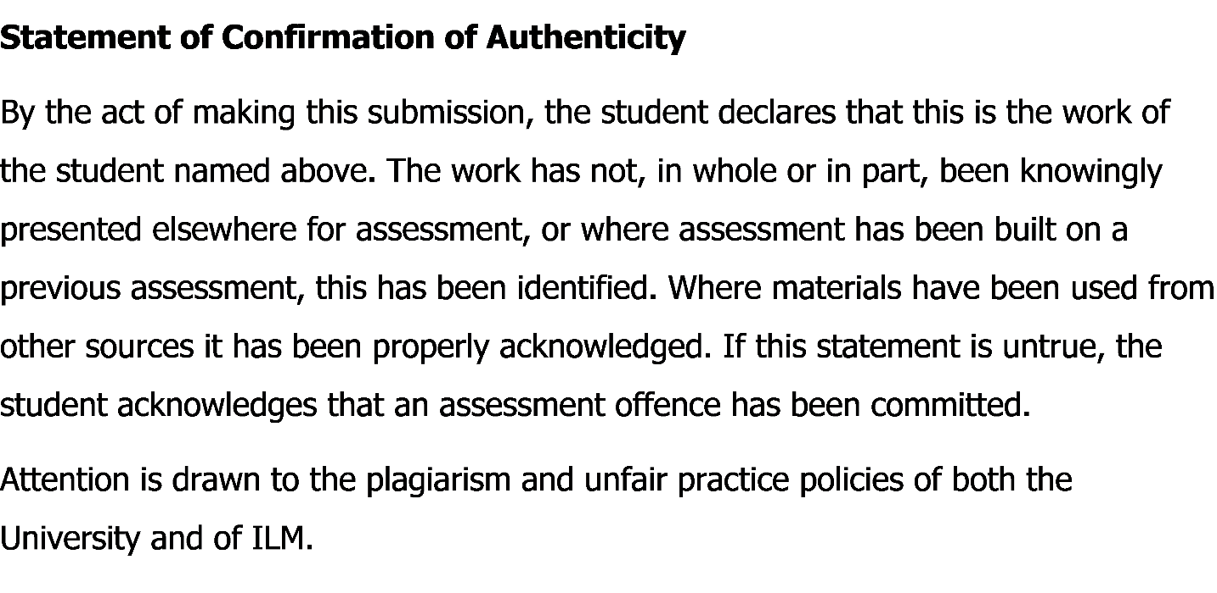

Contents
Introduction: 3
Communication and its Procedures: 3
Formal Communication: 4
Informal Communication: 4
Importance of Communication in the Workplace: 5
Conflicts and Communication in Workplace: 5
Different Theories of Communication: 6
Linear Model: 6
Berol’s Model: 7
Interpersonal Communication: 8
1. Body Language: 8
2. Active Listening: 8
3. Personal Presentation: 8
4. Context Awareness: 9
Findings: 9
Written Communication: 9
1. Letters: 10
2. Memos: 10
3. Reports: 10
Conclusion: 10
References: 11

Introduction:
Communication is the essential element of modern life and also important for any organizations to accumulate with the flow of work. According to David & Richard, stated that communication is the process of maintaining or transferring information between two or more people (David & Richard, 2012). The way of communication are many. Among them oral, written, verbal, non-verbal communications are mostly used. In organizations, written communication is the best way to interact and transferring information in a very suitable and secured way. Effective communication is the key in the workplace and it will give the maximized output to achieve organizational objectives for the management. In this report, I will discuss about a friend of mine, Peter who is currently working as a client relationship manager in a company for two years. How he is solving problems, how he is maintaining a good relationship with his clients and how his management is evaluating will be discussed briefly in this report. As an employee of his organizations, he has team to solve problems and by doing so, he has to motivate, organize and control others to meet the target. To maintain an effective team and problem solving procedure, he needs an effective team. For this, he needs to motivate, organize and interact both internal and external employee accordingly from inside and outside. Now, in this report I am going to describe overall communication procedures of my friend Peter which he described to me.

Communication and its Procedures:
There are many forms of communication. My friend Peter has several communication experiences while working as a client relationship manger in his company. He has communicated orally and written with his clients and employees of his organizations. He has faced various types of people in many times and has to communicate with them in many ways. According to Angela J., stated that communication is actually a process of conveying information among people (Angela J., 2018). So, Peter always try to conveying people and to maintain a good relationship. For Peter, he has used two types of communication procedures. One is formal and another is informal communication.

Formal Communication:
In this section, Peter has used some written documents for communication with his clients and employees. There are many forms of written communication. Letters, memos, research reports etc. are some forms or formal communication. Letter is actually a document that describes any matters in a brief and authenticate way to its sender. Peter always use letters on making purchase anything, sending any vouchers to his clients, sending proposals of new shipments. Various issues can be briefly elaborated by a letter and so, Peter uses mostly this type of communication. After that Peter uses memos for any purchases of materials or shipment of products to his clients. Memos are actually the financial part of the organization and Peter uses it for any financial transactions for future reference with his clients. It is very much effective for both Peter and his clients. Then Peter prepares sales reports and financial reports of his company. Reports help the company to organize and evaluate the financial condition and thus Peter uses this for a clear idea about company’s financial strengths and opportunities.

Informal Communication:
According to Sarah A. Paul, stated that modes of communication are complicated and for reducing the complexity in the working environment, informal communication is effective which is unofficial and communicated through various people without any chain of command or official rules by the management of company (Sarah A. Paul, 2009). Informal communications for organizations are eye contact, gesture, proximity, posture, face to face, body language etc. Peter used both oral and verbal communication with employees and clients. He also stated that informal communication is way too effective for him. Peter said that informal communication process is very much easy to him to solve any problems and to discuss any matter with his manager and supervisor. Several times he uses his eye contact in any meeting to get a positive response and attention from employees under him. He said informal communication has no boundary which effects his working environment and working situation. But he also said that informal communication has no documentation and thus in future it will create many problems.

Importance of Communication in the Workplace:
According to Adair, J.E. stated that communication is important for any organizations both internally and externally among the employees for ensuring an effective working environment (Adair, J.E., 2009). Peter actually working as a client relationship manager in his company and the job focuses on the customer’s feedback and their satisfaction about the service. So, communication is one of the important measurement for getting the information to Peter. Peter also be confident and confidential about some information that shouldn’t be leaked outside. In this point of view, Peter has a written agreement with the company for not sharing any information outside with any other company or third party. So, written communication has an effective rule, Peter said. According to Peter, he said about some points about the importance of communication in organizational workplace. They are given below-
- Proper communication will ensure the employee satisfaction and employee engagement internally in the organization.
- Internal communication will make motivated employees inside the organization.
- Peter has maintained a social communication with his priority clients for ensuring a better service.
- Effective communication will cut the sunk cost of the company and thus the management can achieve the organizational goals and objectives.

Conflicts and Communication in Workplace:
Communication process has some lacking and those lacking create problems and conflict among employees, clients and management. According to Kalle Siira, stated that conflict may create due to a lack of organizational communication between employees and management and sometimes with clients and shareholders (Kalle Siira, 2013). Peter shared with me some negative issues and conflicts about his working experiences with me. Sometimes a communication gap occurs between him and his employees which directly effect on the work and task given by the management. This conflict mostly occur due to a lack of interpersonal communication. Peter has faced personal and management problem. Peter has faced many hard situations against his co-workers and felt angry on them because of a communication gap. Peter faced some employees and clients those who were arrogant and aggressive which actually decreased the working motivation and made him stressed. Apart from this, Peter also faced some managerial problems with management of his company. Some top level employees were not supportive and co-operative for Peter. As Peter is a client relationship manager, he sometimes needed assistance regarding various issues but didn’t get enough support from some of the employees. Before joining in the company as a client relationship manager, Peter was informed policies and rules regarding the company. But after joining, the company told him different information that wasn’t heard by Peter before. It was hectic for Peter and so, he felt angry on the higher management. These are some conflicts in the communication process for Peter.

Different Theories of Communication:
There are many theories are found about the process of communication. According to Peter, I will analyze Linear Model and Berol’s Model of Communication.

Linear Model:
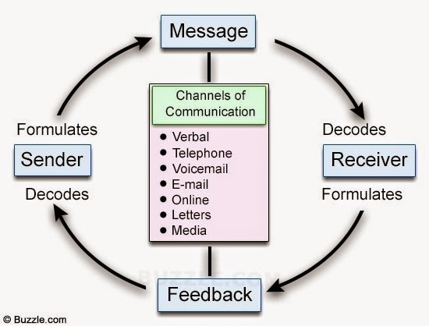
Figure: Liner Model
Source: http://2.bp.blogspot.com/-vg0_wF1V6lE/U-xp0YTDWiI/AAAAAAAAAMg/iuBC1WXk72U/s1600/communication-cycle.jpg
According to Peter, he needs to communicate with a lots of people. Linear model actually shows that sender decodes a message to the receiver and the receiver gives a feedback to the sender. According to Tuckman, he stated that channels of communication has a great influence in the workplace environment (Tuckman, 2009). In this linear model, communication channels are effective and regarded as the message. Peter also needs to decode those messages through verbally, telephone, email and in many ways for an effective workplace environment.

Berol’s Model:
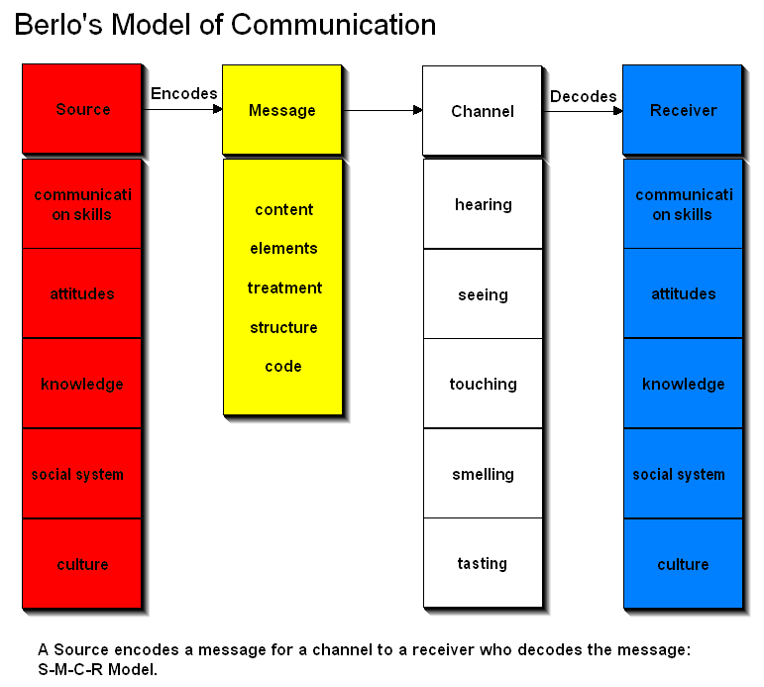
Figure: Berol’s Model of Communication
Source: https://i.pinimg.com/originals/58/f4/c1/58f4c10f519a656be5e42c755fcab533.jpg

Berol’s model is very much informative. Berol stated that a specific source can send the message with a specific channel to the sender. Here, sources are attitude, knowledge, culture, norms those are being encoded through a message with content, element, meaning through a channel like hearing, seeing, touching to the receiver who must have communication skills, social value, culture etc. Peter also needs to encode his message with different communication styles and approaches based on his attitude and behavior in the workplace for various situational problems. Peter’s message should be meaningful and needs to have decoded successfully to his manager, employees or co-workers who are actually the receivers.

Interpersonal Communication:
Peter has also shared some interpersonal communication skills that he is developing. According to Dally, he stated that interpersonal communication skills are dependent on the expression (Dally, 2010). So, in Peter’s job, interpersonal communication helps him to communicate better with his employees and co-workers. Some interpersonal skills according to Peter are given below-

Body Language:
Body language is a communication which can be expressed by the movement of the body with feelings and emotions. According to Collins, he stated that body language is a mode of communication using body movement and expression with emotions and feelings (Collins, 2007). Peter uses body language to communication with his employees and subordinates in the organization.

Active Listening:
Listening is an important interpersonal skill for Peter. Peter always listen to his listener carefully and actively. This skill develop Peter to communicate better without any managerial conflicts among employees.

Personal Presentation:
For developing interpersonal communication with management and employees, personal presentation is important, Peter said. He is making and giving various presentation to his top management. Personal presentation has a great influence on other employees in terms of sharing knowledge and information.

Context Awareness:
Context awareness actually means what an employee does and what the employee doesn’t. It is better for Peter to know the activities of his employees and staffs what they are sharing among the organization. Peter always check and monitor his employees under the supervision of top management in his company.

Findings:
Communications inside the organizations is important and Peter has developed various skills regrading communication for his company. Without an effective communication, Peter can’t be able to work and motivate employees and so, there will always be conflict. Peter also said that communication outside organization is also important for him to handle his clients and stakeholders. Overall finding and analysis given below-
- Effective communication makes a workplace easier and efficient for employees.
- Lacking of communication will create conflict both inside and outside of the organization.
- Without communication, it is impossible to monitor, control and manage people.
- Modes of communication are many. So, verbal communication is effective now a days in organizational context.
- To handle situation, interpersonal communication is also needed based on situation.

Written Communication:
Written communication is one type formal communication. Peter has said that written communication is the most using communication style in organizational workplace. Written communication is secured so Peter is using it with his clients in any transactions or agreement. Letters, memos, reports etc. are some types of written communication. Peter said that he has given different information about many products and services of his company to his clients by letters. Peter analyzes sales reports and financial reports of his company and give a feedback to his clients about the market situation of his company. As Peter is a client relationship manager, he always perform a written communication for future preference. For any purchase of products or services, he makes a memo and give a signature which is the evidence of the purchase by his clients. Apart from this, he also maintains a log and time schedule foe his clients to make a better communication. Some written communication types are given below-

Letters:
Peter said that letter has a structured format. He makes letters for any business proposals and offers. Peter said letters should be specific and to the point. It should be supportive to the reader and positive. Letter should be big.

Memos:
Peter said that memos works for any financial transactions. When a client purchases something, Peter instantly makes a memo about the purchase details which will be useful to both Peter and clients for any future inconvenience.

Reports:
Peter also said that he uses business reports and financial statements for his clients. He shows sales reports, annual reports to his clients for getting positive feedback. It is most used and structured communication process in organizational context.

Conclusion:
In fine, Peter has elaborated his experience and communication process with me in his company. Without proper communication, it is impossible to be effective in team work, problems solving and rational decision-making process. Peter also needs different methods and approaches of communication procedures in different situation with different people both inside and outside of the company. Communication has helped Peter to perform better in the organization and to be effective with his job. So, communication practices should be practiced in every organizations.

References:
Adair, J.E. (2009). Effective Team Building. London: Pan Books.
Angela J. (2018, February 14). What is the Communication Process? - Definition & Steps. Retrieved August 23, 2018, from Study.Com: https://study.com/academy/lesson/what-is-the-communication-process-definition-steps.html
Collins. (2007). Communication Skills for Managers (6 ed., Vol. 2). Chicago: Pearson.
Dally. (2010). Developing Skills. How to Influence People by Skills, 76-69.
David & Richard. (2012). Skills for the Workplace. An Analysis of Effective Team Work and Communication in the Workplace, 5(7), 45-49. Retrieved August 23, 2018
Kalle Siira. (2013). Organizational Conflict Management. A Social Complexity Perspective, 96-97. Retrieved August 23, 2018, from https://helda.helsinki.fi/bitstream/handle/10138/41886/siira_dissertation.pdf?seq
Sarah A. Paul. (2009). Communication Skills for Managers (8 ed., Vol. 5). NY: Pierce & Hill.
Tuckman. (2009). Educational Research (6 ed.). USA: Rowman & Littlefield.

