

Mental Disorders and Pathology
Assessment 2
BMHP6006

Student name:​Helenita Gelsano Payac
Student ID: ​2027358
Lecturer name: Bianca Sanfilippo ​
Date: 29th August 2023

Table of Contents

General anxiety Disorder
Schizophrenia
Autism

Introduction
This essay will provide a critical evaluation of three mental diseases' ICD-10 categorization, diagnosis, treatment, and rehabilitation measures, including:
- General Anxiety Disorder
- Schizophrenia
- Autism

General anxiety disorder
The NHS (2021) defines worry as a continuous feeling of well-being that can substantially impair a person's everyday life, as well as their physical and mental health. Generalised anxiety disorder GAD
Classification of GAD within ICD-10
The group "F40-F48 Neurotic, Stress-Related, and somatoform disorders" includes GAD. Gad is below F41.1.
General Anxiety Disorder Statistics UK
Examining UK anxiety statistics reveals the amount of people who need assistance and the extent to which groups are affected by anxiety. The research shows that:
- Every week, six out of every 100 people in England will be diagnosed with generalised anxiety disorder.
- There are already more than 8 million sufferers of anxiety disorders in the UK.
- There are an estimated 822,000 people who experience depression and stress at work. • Anxiety problems currently affect more than 8 million people in the UK. In charge of health and safety
- • Only around half of those who suffer from generalised anxiety disorder obtain therapy.
- 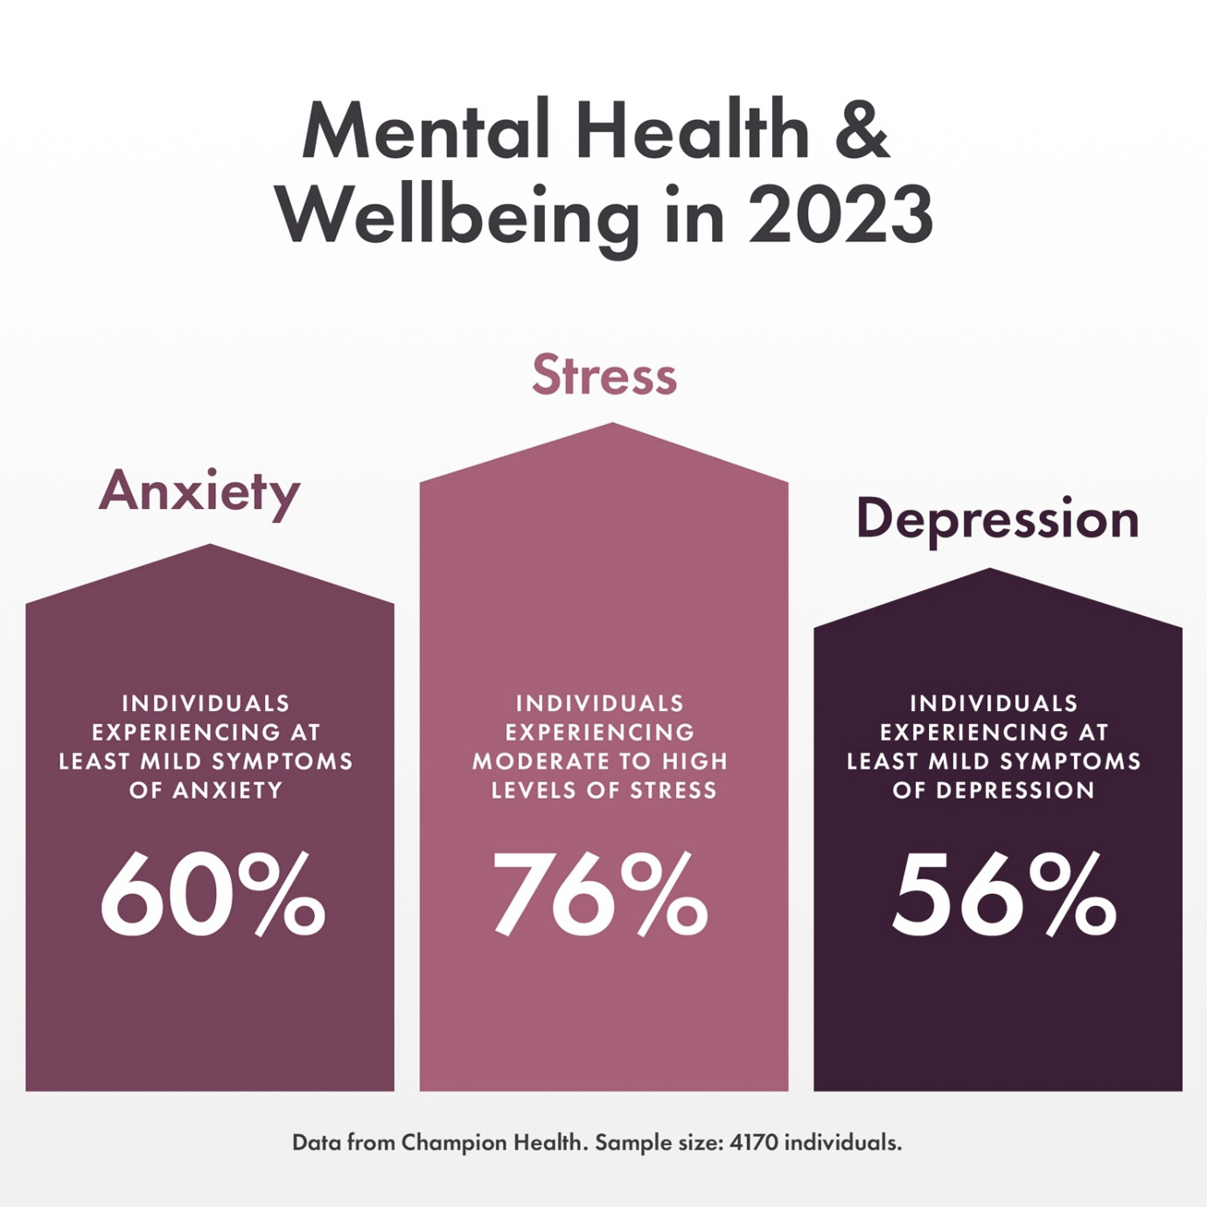

Source: anxiety in UK percentage 2020 - Bing images

Causes of generalised anxiety disorder
The causes of anxiety disorders are not fully understood. When a person is already prone to anxiety, life events like stressful occurrences seem to be the catalyst for anxiety disorders. Traits that are inherited might also play a role.
As is the case with most mental health disorders, generalized anxiety disorder (GAD) is likely the consequence of a complex interplay of several variables rather than a single cause. (Anon., 2023)
If several of the following symptoms exist together, your risk of developing GAD may increase.
Genetics: There could be some genetic impact. If one or both of your parents have GAD, for example, you may be more likely to develop the illness yourself.
Experiences: If you have a history of stressful or unpleasant situations, such as a sudden loss, instability at home, bullying, spousal abuse, or child abuse, you may be more likely to develop GAD.
Drug use: Some medicines and substances may cause more anxiety in some persons than in others.
Physical health: If a person has a continuously painful medical condition or a physical disability, they may be more likely to develop GAD.
Signs and Symptoms
Include:
- Feeling nervous, restless, or tense
- Having a sense of impending danger, panic, or doom
- Having an increased heart rate
- Breathing rapidly (hyperventilation)
- Sweating
- Trembling
- Feeling weak or tired
- Trouble concentrating or thinking about anything other than the present worry.
- Having trouble sleeping
- Experiencing gastrointestinal (GI) problems
- Having difficulty controlling worry
- Having the urge to avoid things that trigger anxiety. (Anon., 2023)
Diagnosis.
The doctor can order tests to aid in the diagnosis. A diagnosis of GAD is more likely to be made if you have had symptoms for at least six months. You may also be impacted by the disorder if you struggle to manage your anxiety symptoms. Get a physical examination and/or blood tests performed, such as: to rule out any underlying medical issues that might be the source of your symptoms.
Anaemia (a lack of iron, vitamin B12, and folate, or hyperthyroidism, an overactive thyroid gland)
If there's a potential that your physical health and anxiety are related, ask your primary care doctor. He or she can search for clues that point to a condition that could need medical attention. (Anon., 2023)
You might need to speak with a mental health professional if your anxiety is really acute. A physician referred to as a psychiatrist is a specialist in identifying and treating mental health issues. A psychologist, along with a select few other mental health professionals, is trained to recognise anxiety disorders and provide counselling (psychotherapy).
Mental health provider may:
- • Evaluate your psychological state. To make a diagnosis and look for associated conditions, consider your thoughts, feelings, and behaviour.
- Assess your symptoms in relation to the diagnostic standards of the DSM-5. Doctors utilise the Diagnostic and Statistical Manual of Mental Disorders (DSM-5) created by the American Psychiatric Association to identify an anxiety condition.
Current Treatment of Generalized Anxiety Disorder
Treatment approaches frequently include both medication and psychotherapy. Placebo-controlled trials, however, support cognitive behavioural therapy (CBT). For children with mild generalised anxiety disorder, CBT can be equally as helpful as medication since it frequently combines self-reward with problem-solving. Combining CBT and medications can be quite helpful when the patient is resistive. If CBT is not beneficial, people have used a variety of psychotherapies, such as supportive psychotherapy, relaxation therapy, and mindfulness-based approaches.

For hospitalization may include:
- Serious functional disability (unable to satisfy own daily needs). Several psychotherapies, such as supportive psychotherapy, relaxation therapy, and mindfulness-based treatments, have been used when CBT has not been helpful.
- Suicide or homicide risk
- Lack of social skills (for example, the person is so concentrated that they are unaware of the possibility that their actions and behaviours might encourage others to violence).
GAD is treated with pharmacological and behavioural therapies. One of the best therapies for GAD is CBT.
The Rehabilitation Process and Effective Treatments.
The rehabilitation metrics must be understood to evaluate the therapy's efficacy. This is because if a therapy is ineffective, it should be altered.
The "Generalized Anxiety Disorder Questionnaire (GAD-7)" is one of the indicators of GAD rehabilitation. (Refer to appendix A) This survey is designed to gauge your level of anxiety during the past two weeks.
Recommendations for improvement of anxiety
If the symptoms of your generalised anxiety disorder are affecting your everyday life, you should make an appointment with your doctor.
Implementation of complementary treatments. For instance, research by Shohani et al. (2018) showed the advantages of yoga for lowering women's anxiety. As fewer medications are required, their adverse effects will be reduced, which will have a good effect.
Principles of care for people with generalised anxiety disorder (GAD)
(NICE)
Useful link: National charity helping people with Anxiety - Anxiety UK
Source NHS - https://www.nhs.uk/mental-health/conditions/generalised-anxiety-disorder/diagnosis/?msclkid=5661d0a9a54011ec880a278cfce57bff

SCHIZOPHRENIA
Psychosis and schizophrenia are two complex mental health conditions. There are many of myths about it. Even mental health experts differ on this. In actuality, this diagnosis will be given to one in every 100 people.
Data Related
The lifetime prevalence of schizophrenia and disorders associated with it is around 14.5 per 1000 people in the UK, despite large variations in estimates.
Classification of Schizophrenia within the ICD –10
ICD-10-CM code F20, which is categorized as schizotypal and delusional illnesses (F20-F29), went into effect on October 1, 2022.
Causes

Despite the numerous possible causes of schizophrenia, a combination of genetic, psychological, and environmental factors is most likely to be to blame. These components could include, but are not necessarily limited to:

Stressful life events
Schizophrenia can occasionally be brought on by extremely stressful or life-changing events. These include being mistreated or harassed, losing a loved one, losing your job, feeling lonely or alone, going through financial hardship, and becoming homeless.

Genetic inheritance

You have a higher chance of developing schizophrenia if a parent or sibling experienced psychosis. Your place of residence influences your likelihood of developing schizophrenia. For example, some research suggests that living in a metropolis raises the likelihood, albeit the exact cause of this is uncertain.

Differences in brain chemistry
Schizophrenia may develop if a person's brain development was impeded during pregnancy or infancy. Not everyone with schizophrenia is conscious of structural abnormalities in their brain, though. Studies suggest that an imbalance of numerous neurotransmitters, including dopamine and serotonin, may be the root cause of schizophrenia. (Anon., n.d.)
Antipsychotic drugs, which are infrequently used to treat schizophrenia, can lower dopamine levels. See our antipsychotics webpage for further details. (Anon., n.d.)

Signs and Symptoms of generalised anxiety disorder GAD

Can be either mental or physical and is connected to the following:
- Anxiety or restlessness.
- Palpitations in the chest
- increased perspiration
- Easily worn out.
- Irritation
- Having trouble focusing or having a mental block.
- Painful and tense muscles
- A greater urge to use the loo.
- Having trouble falling and staying asleep.
- a sleepless night that doesn't feel restorative.
- Excessive anxiety or worry for at least several months.
- Be difficult to control.
- Not be accounted for by a different mental illness, such as post-traumatic stress disorder caused by traumatic experiences, obsessive compulsive disorder caused by contamination or ruminating, etc.
- Not be a result of drug use, medicine, or another illness like hyperthyroidism.
Even if you don't experience all these symptoms, you should still speak with your doctor so you can get the care you need if they are negatively affecting your life. (Anon., 2023)
Diagnosis
Schizophrenia cannot be diagnosed by a single test and is typically discovered after the patient has been reviewed by a mental health professional.
In most cases, schizophrenia is identified after the patient has been seen by a mental health expert because it cannot be identified by a single test.
You should consult a doctor right away if you think you could be showing signs of schizophrenia. It is best to treat schizophrenia early. You should consult a doctor right away if you think you could be showing signs of schizophrenia. It is best to treat schizophrenia early.
Current Treatment
The most common treatment for schizophrenia is an individualised prescription of drugs and verbal therapy. Community mental health teams (CMHTs) look after the majority of people with schizophrenia. To help you live as independently as possible, the CMHT provides daily support and therapy. A CMHT might have access to and include:
  - Social workers
  - Community Mental Health Nurse
  - Occupational Therapist
  - Pharmacist
  - Counsellors and psychotherapists
  - Psychologists and psychiatrists
Once you have your first episode of schizophrenia, you should be sent to an early intervention team. These specialised teams offer care and assistance, often consisting of support personnel, social workers, mental health nurses, psychiatrists, and psychologists. Depending on your demands, you might just need to often contact with one or two team members, or you could need the entire support of the CMHT.
Measurement and Rehabilitation
We can only assess how well the therapies and treatments used to treat this disorder avoid negative consequences such self-harm and suicide, drug misuse, self-neglect, loss of dignity, and human rights abuses. The same standards used to evaluate chronic mental illnesses may be used to gauge life satisfaction. Given that schizophrenia is a chronic condition, it is essential to assist service users in leading fulfilling lives. We can assess this by using rehabilitative therapy indicators that are relevant to all chronic mental health problems.

Principle of Care NICE
Rehabilitation for adults with complex psychosis

‘Quality Indicator for Rehabilitative Care (QuIRC-SA)’ (SEE APPENDIX B).
This tool includes specific indicators that show that quality of care and effective are provided to manage the condition (see appendix b). https://quirc.eu/quirc-sa/.
NHS (2021) Anxiety and panic attacks. Anxiety and panic attacks - NHS (www.nhs.uk) .

World Health Organisation, WHO (2010) ICD-10 VERSION. https://icd.who.int/browse10/2010/en#/F30-F39 .

Recommendations
There for, the recommendations to those people who have general anxiety disorder. Self-help or Complimentary Approaches may help with mild anxiety and can also assist whilst undergoing other forms of therapy. (See also BAP Guidelines) It can help the service users to improve their health condition.

Autism
Autism results in a permanent neurological impairment. For those with autism, information is processed differently. They experience, feel, and understand the world differently than those who are not autistic do. Autism results in a permanent neurological impairment. For those with autism, information is processed differently. They experience, feel, and understand the world differently than those who are not autistic do. Autism is a disease that is on a spectrum. Autistic persons may have certain qualities, but their needs, abilities, and degrees of care may differ. (Anon., 2023).
Classification (F80-F89 Disorders of psychological development, ICD-2010)
The World Health Organization's International Classification of Diseases, or ICD-10-CM, is a resource.

Data related.

The data below demonstrate the prevalence of autism and how educational requirements are being satisfied.

In the UK, there are 700,000 autistic individuals, or more than 1 in 100. Every day, 2.8 million people with autism and their families struggle.

In the UK, just 21.7% of those who have autism work in any capacity. The employment rates for those with special needs or impairments are among the lowest.
Autism is three times as common in boys than in females. Autism symptoms in females may manifest differently, increasing the possibility that they may be overlooked or misinterpreted and leading to a diagnosis in more males.
Autism is listed as the primary requirement for 31.3% of kids with EHCPs. The most frequent demand type seen in UK EHCPs is 103,400 pupils. More than 7 in 10 children and teens with autism agreed that schooling would be enhanced if there were more teachers who understood autism.

The UK spends more than £32 billion annually on care and missed wages to support autistic children and adults. People with autism can live more independently if they receive the appropriate early intervention and support.

Causes of Autism

Since autism is a part of every individual, it cannot be cured. Why some people get autism is still a mystery to researchers. According to the most recent research, autism may have several underlying causes. According to current views, autism may be caused by several physical factors that have an impact on how the brain develops. There could be a genetic component as well, and scientists are investigating if genes might shed any light on the autism spectrum.
Signs and symptoms of Autism
- finding it difficult to understand what others are feeling or thinking.
- having severe nervousness in social situations
- a predilection for isolation or difficulty forming friends.
- accidentally conveying harshness, unpleasantness, or lack of concern in other people.
- Having difficulty expressing your emotions.
- taking things literally; this might prevent you from understanding humor or idioms like "break a leg."
Autism may have quite diverse effects on men and women. Therefore, it can be more challenging for women to get an autism diagnosis. having a daily routine and being highly worried if it changes.

Diagnosis,
If you or your kid displays any indicators of autism, the next step is to talk with someone about it. For children under the age of five, you may speak with a general practitioner (GP) or health visitor. SENCOs at your child's school and any other doctors you or your child see, including a separate doctor or therapist. Obtain their opinion on whether sending you for an autism evaluation would be a good idea. Autism specialists administer a test. You or your child cannot be diagnosed with autism by any other means. Autism assessment to establish if you or your child is autistic, a team of autism specialists will conduct an autism evaluation. The assessment group could search for problems:
For children
The assessment group may: Enquire about your child's development, such as when they first began speaking. Keep an eye on how your child plays and engages with you. You should read any reports that your doctor, school, or nursery has provided you. Your child's school may send a team member to monitor them throughout class and when playing outside of it. If you or your kid has autism, the results of the evaluation will be detailed in a report.

Diagnosis in adults

It's common for people to go through life undiagnosed. Some people might be better able to comprehend their issues and get help at work or school if they obtain a diagnosis.Your doctor could suggest visiting a local diagnostic facility as the first step in receiving a diagnosis. You can ask for a new appointment or seek a second opinion if your primary care physician doesn't provide you any advice.

(Anon., 2023)
Current treatments:

The goal of present therapies for autism spectrum disorder (ASD) is to reduce symptoms that negatively impact everyday living and quality of life. Since everyone with ASD experiences autism differently, everyone also has a varied mix of strengths, difficulties, and treatment requirements. Because of this, treatment programmes frequently involve a wide range of professionals and are tailored to the needs of each patient. The provision of therapies may take place in a variety of contexts, including those related to education, health, community, or the home. Making sure that treatment objectives and advancement are on track requires open communication between experts, the person with ASD, and their family.

Common treatments for Autism

Therapy

Every individual with autism has unique requirements, and the illness is a spectrum disorder that affects many people. Patients' troublesome behaviour are reduced, their social, communication, and language skills are enhanced, and a patient's ability to live independently is emphasised throughout therapy. Among the options for therapy are behavioural, psychological, and educational therapies. Research suggests that early intervention can improve linguistic, social, and cognitive abilities.

Medication

Autism itself does not require medicine, even though issues like anxiety that are usually associated with autism may be treated.

Awareness Raising

Autism might not need therapy. However, many autistic people can need assistance with a variety of aspects of their lives. Numerous organisations have worked to increase public understanding of autism, educate the public about it, and remove any stigma associated with it in an effort to help autistic people feel more accepted for who they are.

Metrics for evaluating rehabilitation.
During the 12- to 14-minute procedure, the doctor can watch the room through an observation glass to look for any indications of autism. The assessments are properly documented with consent, and parents, carers, and children all report pleasure with them. (Anon., n.d.)
Recommendations
if a member in your family suffers from autism. They can encourage your youngster to adopt behaviors that will enhance their quality of life by employing the positive reinforcement technique.
As an antipsychotic and mood stabilizer, risperidone is also used to treat tic disorders and irritability associated with autism. Only Risperdal and Abilify have FDA approval for the treatment of autistic kids. Both soothing and aggressive effects are produced by antipsychotic drugs.

Guidance and Principle of Care - NICE

https://www.nice.org.uk/media/default/about/covid-19/specialty-guides/management-patients-learning-disability-autism-during-pandemic.docx

Autism spectrum disorder in under 19s: recognition, referral, and diagnosis
Clinical guideline [CG128] Published: 28 September 2011 Last updated: 20 December 2017

‘Childhood Autism Rating Scale (CARS)’ (SEE APPENDIX C) and observation, called ADOS - ‘Autism Diagnostic Observation Schedule’.

Autism spectrum disorder in adults: diagnosis and management

Clinical guideline [CG142] Published: 27 June 2012 Last updated: 14 June 2021

The National Autistic Society have more information about autistic women and girls.

Autism spectrum disorder in adults: diagnosis and management
Clinical guideline [CG142] Published: 27 June 2012 Last updated: 14 June 2021

Conclusion
The goal of person-centered planning is to base all decisions on what is significant to everyone from their own perspective.
In other words, individuals with learning impairments shouldn't be denied the opportunity to exercise any other Act-guaranteed rights because of their condition.
Based on the 2010 Equality Act, the Human Rights Act prohibits discriminatory behaviour.

References
Anon., 2020. Mental Health Research. [Online]
Available at: https://www.mentalhealthresearchuk.org.uk/
[Accessed 19 August 2023gust].
Anon., 2023. Beyond Autism. [Online]
Available at: https://www.beyondautism.org.uk/about-autism/understanding-autism/diagnosis/
[Accessed 19 August 2023].
Anon., 2023. Mayo Clinic. [Online]
Available at: https://www.mayoclinic.org/diseases-conditions/anxiety/symptoms-causes/syc-20350961
[Accessed 14 August 2023].
Anon., 2023. Mental Health UK. [Online]
Available at: https://mentalhealth-uk.org/help-and-information/conditions/generalised-anxiety-disorder/causes/?gclid=Cj0KCQjwoeemBhCfARIsADR2QCvqMd6r3hRHNW-_PrE995wx7zpEcC0lUcE0C161M5XTnB289boNI2MaAsJdEALw_wcB&gclsrc=aw.ds
Anon., 2023. Mind. [Online]
Available at: ( Mental Health UK) https://mentalhealth-uk.org/help-and-information/conditions/generalised-anxiety-disorder/symptoms/
[Accessed 19 August 2023].
Anon., 2023. MQ Mental Health Research. [Online]
Available at: https://www.mqmentalhealth.org/conditions/autism/
[Accessed 19 August 2023].
Anon., 2023. NHS. [Online]
Available at: https://www.nhs.uk/mental-health/conditions/schizophrenia/diagnosis/
[Accessed 19 August 2023].
Anon., n.d. Mental Health UK. [Online]
Available at: ( Mental Health UK) https://mentalhealth-uk.org/help-and-information/conditions/generalised-anxiety-disorder/symptoms/
[Accessed 19 August 2023].
Anon., n.d. MIND. [Online]
Available at: https://www.mind.org.uk/information-support/types-of-mental-health-problems/schizophrenia/causes/
[Accessed 19 August 2023].
Anon., n.d. NHS. [Online]
Available at: https://www.nhs.uk/conditions/autism/getting-diagnosed/how-to-get-diagnosed/
[Accessed 19 August 2023].
Anon., n.d. NHS. [Online]
Available at: https://www.nhs.uk/conditions/autism/getting-diagnosed/how-to-get-diagnosed/
[Accessed 19 August 2023].
Anon., n.d. NHS Kent Community Health. [Online]
Available at: https://www.kentcht.nhs.uk/service/community-paediatrics/assessment-and-diagnosis-of-autism-spectrum-disorder/#:~:text=It%20usually%20takes%2012%20to,by%20parents%2C%20carers%20and%20children
[Accessed 19 August 2023].



