Charlie Williams (2235685)
Computing (Networks and Cyber Security)
L5 - Network Programmability (ACCB5029)

Reflections upon “in class” activity and technical reading

Table of Contents
- Introduction
- Task 1
- Module 2: The DevNet Developer Environment
- Module 3: Software Development and Design
- Module 4: Understanding and Using APIs
- Conclusion
- Task 2
- Activity 1: DevNet
- Overview of Cisco Devnet
- Cisco DevNet Learning Labs
- Cisco DevNet Sandbox
- Cisco DevNet Exchanges
- Cisco DevNet Developer Support
- Sandboxes
- Activity 2: Software Development Methodologies and Version Control
- Which software development methodology is best?
- Waterfall
- Agile
- Version Control System Tools
- Conclusion
- Reference List

Introduction
This document will contain two essays. One of which will cover my experience with and learning on Netacad’s DevNet Associate Course. The course covers topics such as DevNet itself, software development, and some of the fundamentals of APIs. The second will detail my reflections on in-class activities.

Task 1
Module 2: The DevNet Developer Environment
This module focuses entirely on the developer resources that are available on Cisco DevNet. The resources are incredibly varied, which means that anyone, from a beginner developer to a veteran can make use of the resources available on the site, and largely for free.
Cisco DevNet can support developer projects in many ways. It is an excellent place to start for those looking to work on Cisco APIs. The site provides developer support, both directly through conversation with Cisco’s support team through tickets, and indirectly through things like the developer forums. It also provides thorough documentation, educational resources, code, and access to fully built sandboxes and lab environments. [1]
DevNet has a variety of different sandboxes that developers can use for testing. The sandboxes are built for realism, emulating a real environment, which enables developers to test their code/applications without having to worry about potential interruption to existing systems. Within these sandboxes, developers can try various Cisco hardware and environments.
A helpful tool for developers working with DevNet are the DevNet exchanges. These act as forums where developers can share code with one another. There are a few different types of exchanges:
- Automation Exchange- Netacad’s course describes the automation exchange as a: “collection of network automation use cases with different solutions and toolkits” -2.2.4[2]
These can assist developers with network configuration, policies, health checks etc. [3]
- Code Exchange- A large repository of tools and code. Similar in nature to GitHub, anybody can upload a helpful repo for use by other developers.
- Ecosystem Exchange- Solutions for solution providers across various platforms.

DevNet also provides some in-person events, such as Devnet create, where developers from all over the world come together to discuss to discuss new programmable infrastructure and APIs. [4]

Module 3: Software Development and Design
This module focuses on software development. This includes but is not limited to:
- Methodologies
- Life cycle
- Software Design Patterns
- Version Control Systems
- Coding basics
- Code review and testing
- Data formats (YAML, JSON, XML [5]

The software development life cycle, or SDLC, is a process by which code will be developed. However, it is not limited to merely coding, setting out the requirements for the software, testing, debugging, and creating a proof of concept are all vital parts of the process.
The cycle is broken down into:
- Requirements and Analysis- Better define the issue. What do investors need from the software?
- Design- Based on the previous part of the process, create a high level and low level design.
- Implementation- Implementing the design and creating the code.
- Testing- Testing of the code, likely in a test environment, according to the test plan.
- Deployment- Debugged code is taken into a production environment.
- Maintenance- Provide support, fix bugs
- Requirements and Analysis [6]
These definitions are not set in stone but are what they are most often referred to as.

Software methodologies are essentially guides that help developers plan out the development process. Each one has different strengths and weaknesses. My methodology of choice, and one that a lot of modern software developers utilise, is the agile model.
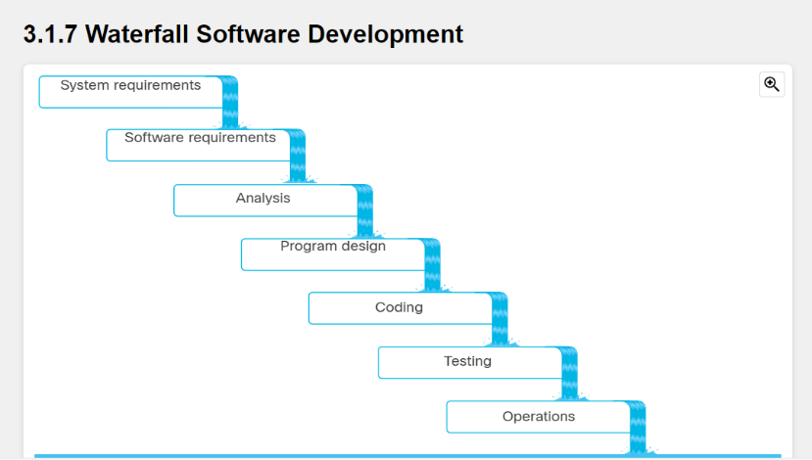
This model is versatile, and as the name implies, it tends to be quicker than other models.
The waterfall model is an older model (although still used frequently) that requires each stage of development to be completed thoroughly before the next one can begin. You cannot go back a step, you can only flow downwards, hence the name.

Version Control systems help developers keep track of a set of files. There are a few types, but my favourite is the distributed version control system, which is made up of applications like Git. [8] Distributed version control systems enable greater collaboration and allows developers to work anywhere. [7]

Module 4: Understanding and Using APIs
APIs, or application programming interfaces, are an integral part of network automation [9]. An API is essentially a way for software to communicate with one another [10]. APIs can lend information from one software to another, for example, maps, lists, images, etc. They can also have specific conditions and parameters applied to them, set out by the API’s creator. They can do much, much more, but that is one simple and digestible example.

A quote from module 4.2.1- Types of Design Styles [11], reads:
“APIs can be delivered in one of two ways: synchronously or asynchronously. You need to know the difference between the two, because the application that is consuming the API manages the response differently depending on the API design.” [11]
Synchronous APIs are designed to respond in sync with the request, or as close to that as possible, as the name would suggest. This means that theoretically, these APIs will be significantly faster than their asynchronous variants.
Asynchronous APIs are the opposite- they are designed to take time to respond with the requested data. These APIs are usually created when the action required of the API requires more time or resources, which would deem a synchronous API unsuitable. This type of API can better multitask. Ultimately, I think synchronous APIs are better when you can confirm for certain that your API will receive an expected amount of traffic, and vice versa.
API architectural styles are a series of standards, protocols and design methods [12]. There are several different styles, but the 3 most relevant are SOAP, RPC, and REST. For the purposes of this essay, I will discuss REST APIs.
REST APIs follow the REST architectural style. The API communicates over HTTPS with a client to return the results of a client’s query. Most REST APIs force a client to authenticate before they can return requests to them, for security purposes. [12]

Conclusion
I enjoyed the DevNet Associate course. It’s concise and provides a good baseline for those who want to learn about software development, DevNet, and APIs. Admittedly, I am not particularly interested in software development in my career; however, I can appreciate the importance of some baseline knowledge on the subject.

Task 2

Activity 1: DevNet

Overview of Cisco DevNet
Cisco DevNet is Cisco’s own developer support program and community that assist developers, network engineers, cyber security specialists etc. with all things Cisco [14]. It features a plethora of learning methods, tools, documentation, and support for developers of all levels of experience and skill. As you might expect, DevNet almost exclusively supports Cisco products.

DevNet is an excellent place for developers to begin learning about Cisco APIs. The resources that enable anyone to start learning about and creating APIs will be detailed further below.
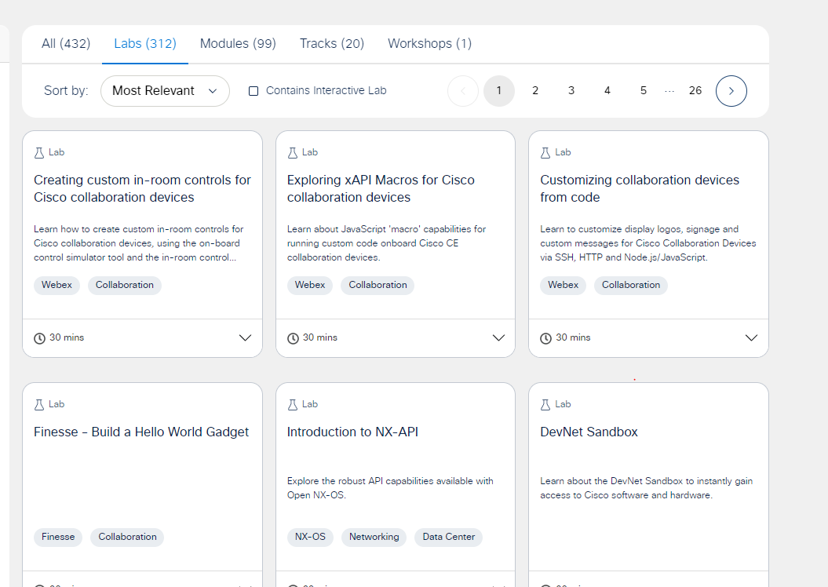
“You'll see that the site is organized by the type of offerings which include Start Now, Learning Tracks, Video Course, Sandbox, Code Exchange, and Ecosystem Exchange. You can also explore based on the platform that interests you, including IoT, Cloud, Networking, Data Center, Security, Mobility, Open Source, Collaboration, and Services, or navigate links specifically for application developers or for infrastructure developers or for network engineers.”- [15]
Cisco DevNet Learning Labs
Learning labs are an excellent way to learn on Cisco DevNet. They come with a custom environment and instructions on how exactly to complete the lab, which can have you completing various activities, such as network configuration, creating and running code, building APIs, or even labs dedicated to teaching you about some of the vast number of tools available within DevNet.
[16] – Screenshot of the learning labs section of Cisco DevNet
Cisco DevNet Sandbox
Somewhat similarly, DevNet also provides users with many free-to-use sandboxes. The sandboxes come pre-configured, and are perfect for testing solutions, dashboards and APIs. They can be launched in a browser, but users may need to reserve certain, busier or resource-heavy sandboxes, ahead of time. Some examples of sandboxes:
- Sandboxes focused on security
- Sandboxes focused on networking
- Sandboxes emulating real production environments or data centres
Cisco DevNet’s sandboxes, in many cases, are quicker and more convenient to set up than a traditional virtual machine one might use for testing purposes. More on sandboxes later.

Cisco DevNet Exchanges
There are a few different kinds of exchanges contained within Cisco DevNet. There are the following:
- Automation Exchange
- Code Exchange
- Ecosystem Exchange
All three exchanges function as essentially a moderated developer forum. Developers can share code, network use cases, solutions with one another, and learn from one another. It is an excellent learning environment for both experienced and newer developers.

Cisco DevNet Developer Support
As the name suggests, developer support offers support to developers. This can be in a few forms. Developers can log tickets for direct human interaction, post on one of the exchanges/forums mentioned previously, or use Webex Teams. DevNet also has a wealth of knowledge base articles. These are all geared towards Cisco products, where possible.
Additionally, Cisco also hosts some live events. Some examples include the DevNet Zone at Cisco Live, DevNet Express, and DevNet create.

Sandboxes
Sandboxes have many purposes. The most well-known purpose for sandbox is for software development, as a means of testing.
The goal of a sandbox is to see how a particular piece of software or configuration would act in a given simulated environment. These are, more often than not, virtual machines which have been configured beforehand to closely simulate production environments.
‘“Living labs” can be defined as “user-centred open innovation ecosystems based on a systematic co-creation approach” [8]. They operate in simulated or real-world environments during the earliest stages of product development, encouraging all stakeholders to collaborate early in the innovation process.’ [16]
In addition to testing of newer software prior to deployment in a real production environment, sandboxes enable software developers to experiment with processes that may not be in line with current production environment standards. This can potentially open the door to larger benefits should said standards be adjusted. [16]
On a similar vein, developers who are designing and testing processes for another environment can use sandboxes pre-configured to mimic their target’s production environment.

Sandboxes also have an application for cyber security purposes. Cyber security researchers make avid use of sandboxes to observe suspected malicious code. These sandboxes can be specialised to pick up on frequently used tactics and behaviours, which can be used to build a comprehensive view of what a process can do. Sometimes, those tactics and techniques can even be used to build out the full attack chain. Some solutions, such as Defender for Identity, can even automatically sandbox suspected suspicious URLs or attachments in emails. Similarly, other cyber security vendors like Crowdstrike [18] or VirusTotal [17] have APIs that can also allow sandboxes to be done automatically.
When it comes to cyber security, however, sandboxes are not perfect. Advanced malware can often detect that it is within a sandbox by picking up various attributes on the machine and will feign benignity.

Activity 2: Software Development Methodologies and Version Control
Which software development methodology is best?
Of the methodologies frequently utilised on software development scenarios, my two personal choices for the “best” one is split between the traditional waterfall method, and the agile (scrum) method.

Waterfall
I will cover some of the main points of the waterfall method first. The focus of the waterfall method is planning ahead of time and strong forward momentum.
The waterfall methodology says that each phase of the software development life cycle should be absolutely completed, down to the minute details. This is because in waterfall, you are unable to go back to the previous stages. This is also why thorough up-front planning is important in the waterfall methodology.
“Historically, development teams usually followed these phases in order in the waterfall method. The goal of waterfall was to complete each phase of SDLC down to the last detail before proceeding to the next, never returning to a prior phase, and writing everything down along the way.” -[19]
The downside of waterfall is, because it flows in one direction, an unnoticed mistake can cause significant issues down the line. This can cause spikes in cost and delays in delivery to the client. – [20]

Agile
Agile methodologies are more modern, versatile and quicker-to-execute methods compared to waterfall. It’s comprised of sub-methodologies, including agile scrum, lean, extreme programming and feature-driven development (FDD).

Agile Methodology’s prioritises:
- “Individuals and interactions over processes and tools
- Working software over comprehensive documentation
- Customer collaboration over contract negotiation
- Responding to change over following a plan” – [21]
To select one singular “best” agile methodology, I think it is necessary to evaluate them across the board. For example, Lean, which focuses on conservation of effort and “trimming of fat” on projects is effective with smaller teams, or those who are likely on a time crunch. While this methodology is effective for these scenarios, the “best” methodology should be one that can be applied to most scenarios and be successful. To this end, I believe agile scrum to be the best agile method. [21]
Agile scrum is the most popular method [21]. Scrum uses frequent, smaller team meetings to maintain focus between the team ensure everyone is up to date. These are called, “scrums”. These are an excellent opportunity for team members to share ideas, discuss challenges faced, and receive solutions or feedback on work that’s been completed. I believe agile scrums likely work best smaller teams that benefit from frequent meetings to keep them on task, while Waterfall is likely more effective for larger teams that are not already familiar with one another. The downside of waterfall is that it is prone to waste, as teams may need to wait for other teams to complete their side of a stage before they can proceed.

Version Control System Tools
In this section, I will provide some examples of local, centralized, and distributed version control systems.

One example of a local version control system is the revision control system (or RCS). This is an old group of Unix commands [22] first released in 1982 [23]. There are not many modern-day examples of local version control systems, as they are entirely operated within one host. This limits collaboration with other users at any time, which has become a mainstay of modern version control systems like Git. Therefore, it is best suited to single person projects. Similarly to GIT, RCS enables users to “make their own revisions of a document, commit changes, and merge them” [23].

An example of a centralized control system is Microsoft’s Azure DevOps server. Previously named “Team Foundation Server”, Azure DevOps Server (henceforth ADS) is a set of tools for collaborative software development, including a centralized VCS [25]. The product is designed to be integrated IDEs, Git clients (for pulling/pushing repos, read more here for the integration [26]), web hooks and APIs.

Mercurial is a distributed version control system designed for larger projects [27]. Launched in 2005 [28], Mercurial emphasises simplicity and ease of use, which reduces training requirements before use. According to this site [28] which compares Mercurial vs Git, Mercurial, although more accessible in some respects, has a complicated branching system compared to Git.
Branching is important in DVCS as developers will often want to create separate branches for testing versions and production versions [29]. Mercurial emphasises that it is fit for use with bigger projects, so it is inevitable that many branches will be created which may cause issues due to its confusing structure [28]. Mercurial is also described as easier for users to learn overall.

Reference List
[1] https://www.netacad.com/launch?id=99efd965-973c-4d63-a5cb-1151c359ddf3&tab=curriculum&view=0716b013-f962-5c98-bd4a-fa3b0360cb4e – DevNet Associate 2.1 – DevNet Overview and 2.2.1- Getting Started with DevNet Resources
[2] https://www.netacad.com/launch?id=99efd965-973c-4d63-a5cb-1151c359ddf3&tab=curriculum&view=0716b013-f962-5c98-bd4a-fa3b0360cb4e= DevNet Associate 2.2.4- Devnet Exchanges
[3] https://chatgpt.com/c/6735151e-a494-8009-bd5f-3cc13702d2f2= I used ChatGpt on the quote above to help me understand it. I did not fully understand what was meant by “use cases” so wanted some more context. This is not a direct quote from ChatGPT.
[4] https://www.netacad.com/launch?id=99efd965-973c-4d63-a5cb-1151c359ddf3&tab=curriculum&view=0716b013-f962-5c98-bd4a-fa3b0360cb4e - 2.2.3
[5] Netacad DevNet Associate Course- Module 3.0.2
[6] Netacad DevNet Associate Course- Module 3.1.2
[7] Netacad DevNet Associate Course- Module 3.3.1
[8] Netacad DevNet Associate Course- Module 3.3.2
[9] Netacad DevNet Associate Course- Module 4.0.1
[10] Netacad DevNet Associate Course- Module 4.1.1
[11] Netacad DevNet Associate Course- Module 4.2.1
[12] Netacad DevNet Associate Course- Module 4.3.1
[13] Netacad DevNet Associate Course- Module 4.9.1
[14] https://en.wikipedia.org/wiki/Cisco_DevNet - Yes, this is a Wikipedia page, but by this point I am already more than familiar with Cisco DevNet and wanted a source to help me articulate what exactly DevNet does. Everything I source from here (not much) is sense checked.

[15] Netacad DevNet Associate Course- Module 2.2.1
[16] (2021) The Sandbox Approach and its Potential for Use in Health Technology Assessment: A Literature Review. Available at: https://link.springer.com/article/10.1007/s40258-021-00665-1.
[17] https://docs.virustotal.com/reference/overview
[18]
https://www.reddit.com/r/crowdstrike/comments/14ysvfz/exploring_crowdstrike_sandbox_api/
What I’m really referencing here is the URL contained within which is a link to Crowdstrike API documentation, however, you can’t reach that without a Crowdstrike login.
[19] Netacad DevNet Associate Course- Module 3.1.2
[20] Netacad DevNet Associate Course- Module 3.1.7
[21] Netacad DevNet Associate Course- Module 3.1.8
[22] https://medium.com/@viralruparel/rcs-revision-control-system-by-walter-f-tichy-2786b0cb4691
[23] https://en.wikipedia.org/wiki/Revision_Control_System (obviously sense checked and verified from other external sources, but this is where I saw the information first, as a baseline.)
[24] https://azure.microsoft.com/en-gb/products/devops/server
[25] https://azure.microsoft.com/en-gb/products/devops/repos/
[26] https://en.wikipedia.org/wiki/Azure_DevOps_Server
[27] https://www.mercurial-scm.org
[28] https://www.perforce.com/blog/vcs/mercurial-vs-git-how-are-they-different
[29] https://confluence.atlassian.com/bamboo/bamboo-best-practice-branching-and-dvcs-398393354.html

