Learning in the Digital Era
Component 2: Professional Development Plan (PDP)

Submitted by: kaleem

Student number:

Date:

Table of contents
Contents
Task 1 – Self evaluation 3
Task 2 – PDP 4
Task 3 – Unit 4 topic summary. 5
Task 4 – Video presentation 6

Task 1 – Self evaluation
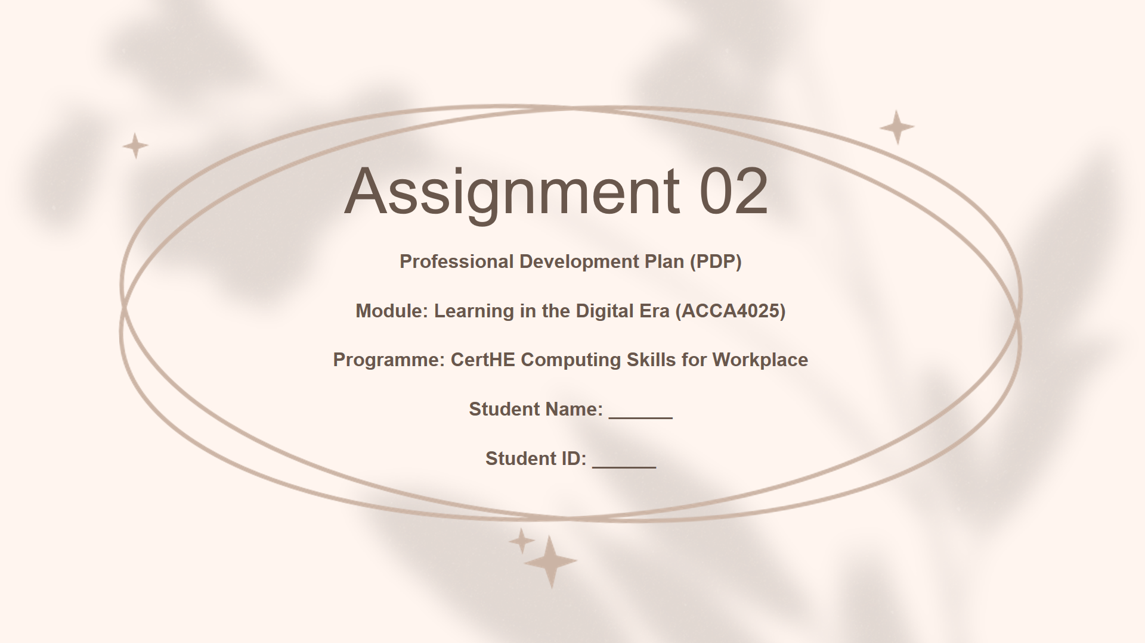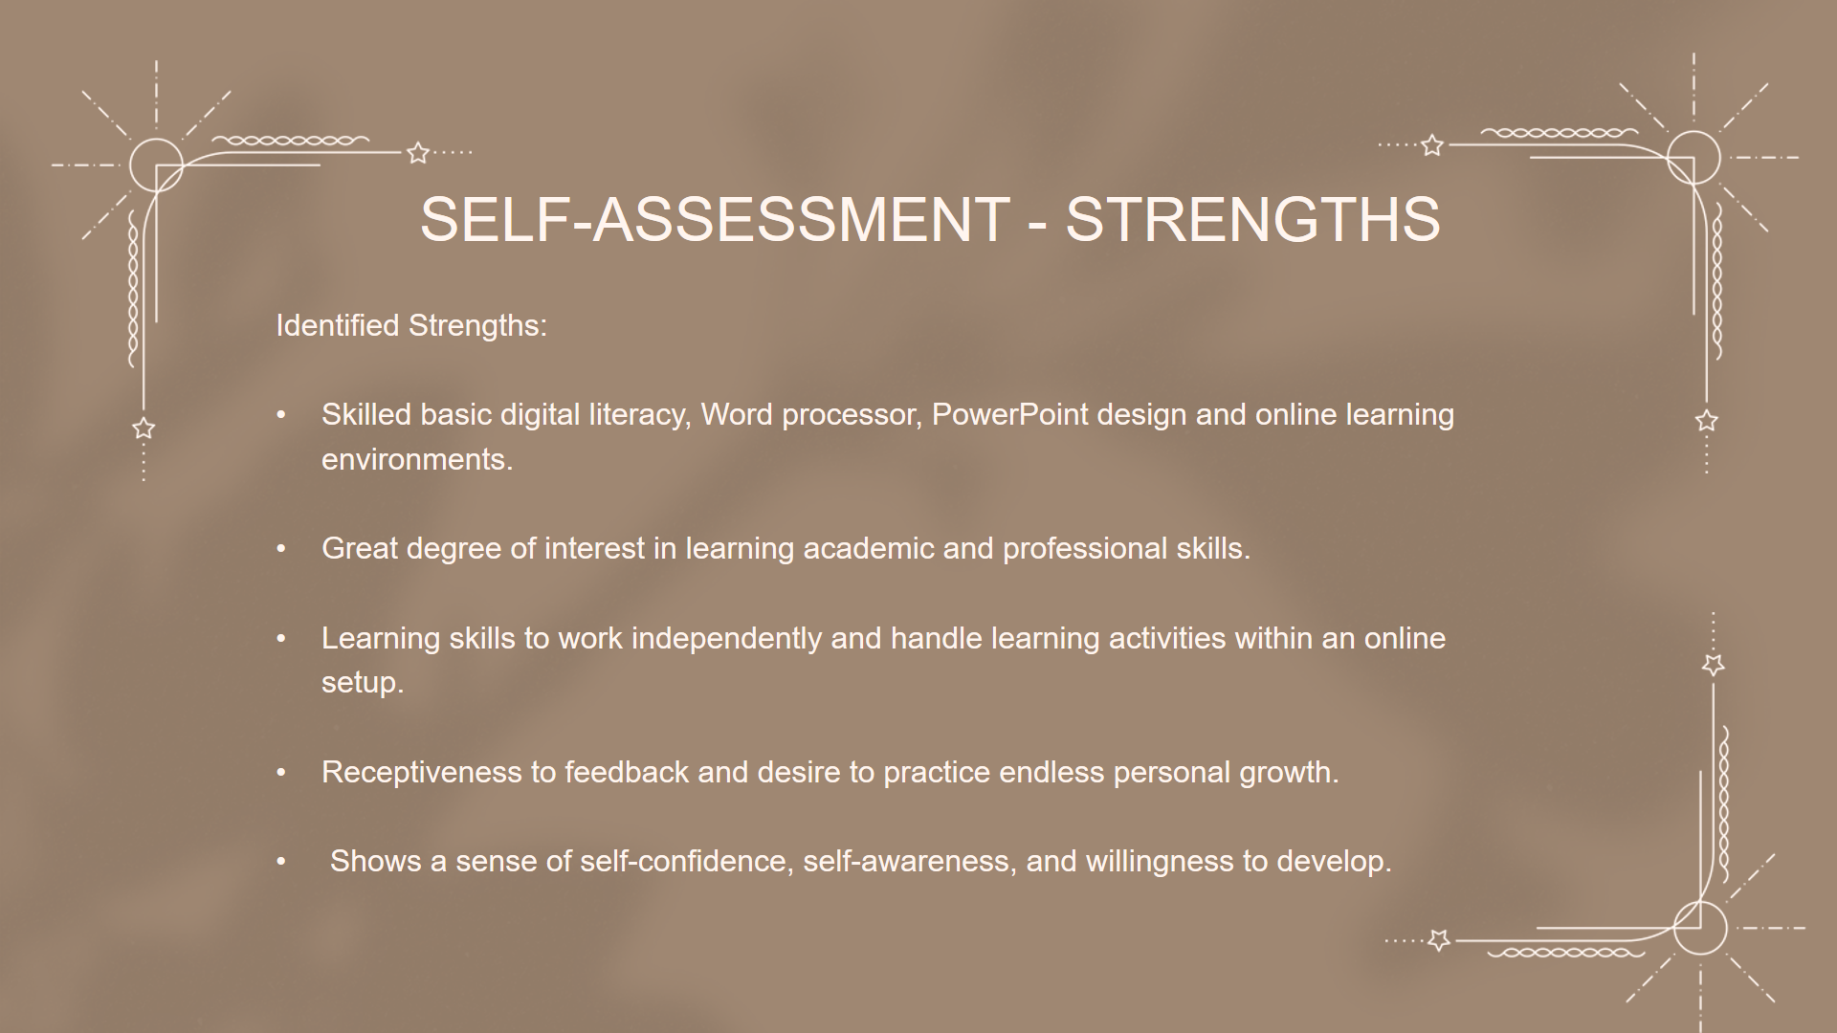

Task 2 – PDP
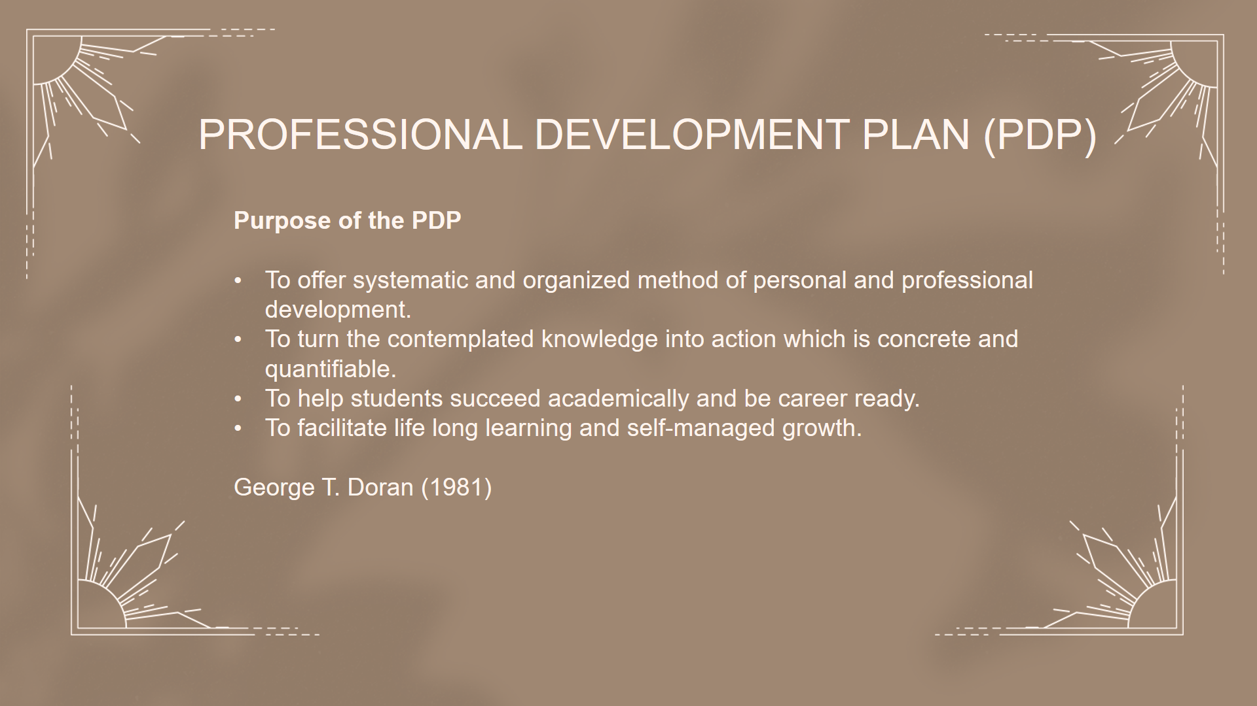
* A link to view/download the PDP from it’s cloud storage (e.g. OneDrive, google drive).
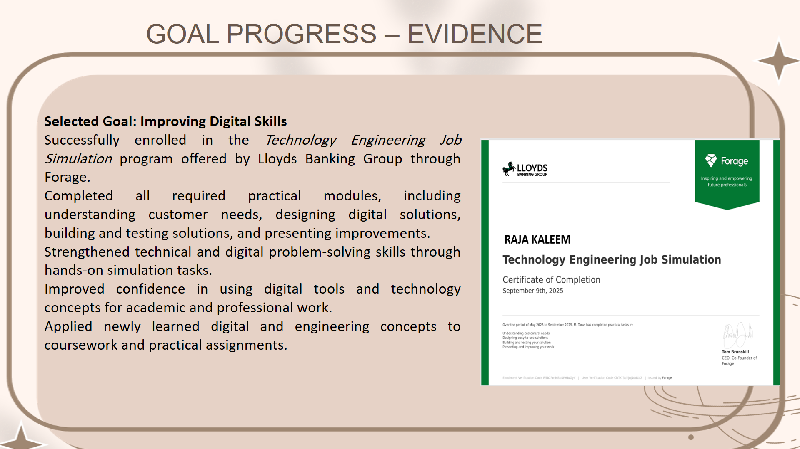
Task 3 – Unit 4 topic summary.
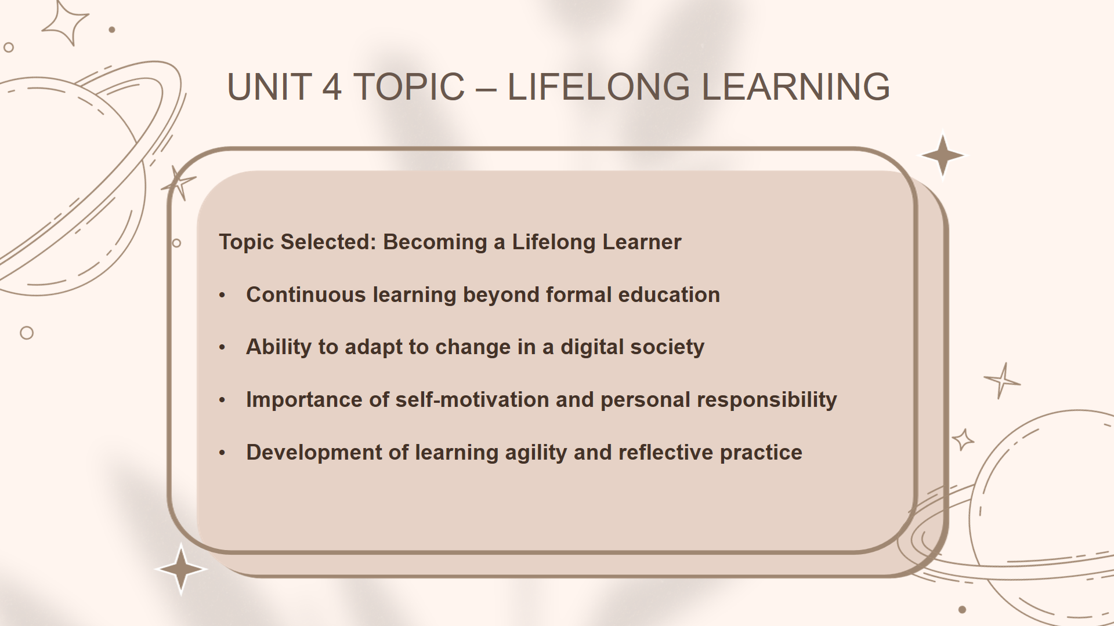

Task 4 – Video presentation
- A link to the Video in it’s cloud platform (e.g. YouTube).
- A single screenshot of the Video in it’s cloud platform (e.g. YouTube).
- A link to view/download the Presentation (e.g. PowerPoint file) from it’s cloud storage (e.g. OneDrive, google drive).
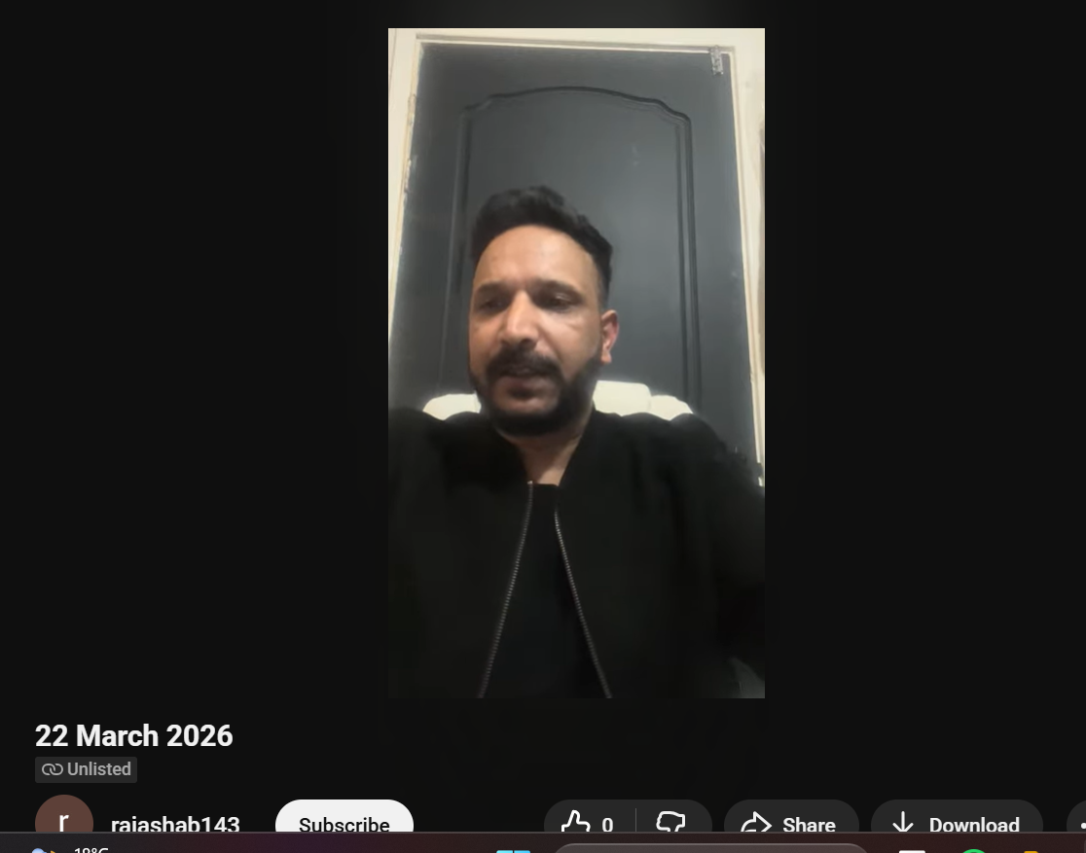
https://youtu.be/gnG3SP9X99w?si=edRxNpigoovC1Ust

