The global destination

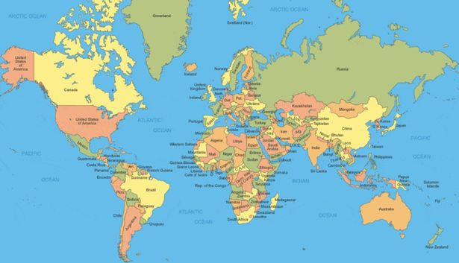

Courtney Pendry

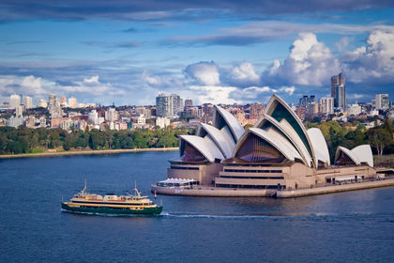
For this review the country that has been chosen is Australia, this has been chosen to be written about seen as it is one of the world’s best beach side countries and being the 6th largest nation in the world. The population of this country is at an estimate of 24.6 million people (2017). Australia is lying south-east of Asia, which is between the pacific and Indian oceans. Australia is also surrounded on the north side by Timor and Arafura seas, north-east by the coral sea, east by the Pacific Ocean, south-east by the Tasman sea and the south and west by the Sydney opera house Indian ocean. This meaning that Australia’s coastline by 25,760 km (16,007 miles).

The number of visitors that arrives into Australia a year is 8.8 million people, this being a 6.6% increase from last year, there are 1.4 million New Zealand tourists that arrive in Australia a year, 1.35 million tourists from china, 781 thousand from the united states and 731.9 thousand tourists visiting from the United Kingdom. The key stakeholders within the tourism industry of Australia is the national government, the local governments of each city in Australia, tourism Australia, intrepid travel, road scholar, employees of each tourist destinations, associations of tourism establishment and tourism enterprises, tourism professionals and consultants, plus many more other tourism stakeholders.
The tourism industry within Australia is one of the most important aspect of the economy seen as tourism has contributed over an estimate of $115 million a day, this is great seen as it means that the contribution from the tourism industry which create a large employment opportunity, the amount of tourism related employment has increased by around 11,400 employees to 543,600 employed people within the tourism industry.
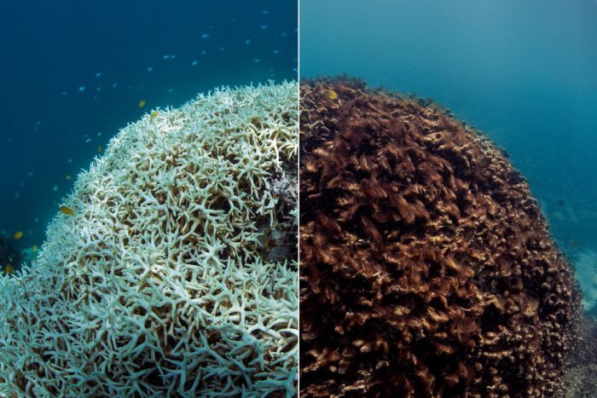
The social impacts that affect Australia is mostly within the rural and metropolitan areas of Australia, an example being that a place such as Bondi beach in Sydney is overcrowded by tourists which has led to the residents of the surrounding areas of Bondi beach feel the need to conserve the natural environment. Tourism has affected Australia negatively due to the fact that it attracts an increase of crime and illegal substance use, alongside any anti-social behaviours.
The environmental impacts that tourists have caused for Australia is due to a large number of tourists that are wanting to travel through Australia for nature activities have negatively affected Australia’s environment due to the large number of visitors littering which has caused places such as the great barrier reef is starting to decompose from the rise in sea temperatures and the bleaching of the corals to appeal to the tourists.
ABC NEWS.net.au

There are plenty of different tourist destinations within Australia such as the Sydney opera house, great barrier reef, Sydney harbour bridge and Bondi beach.
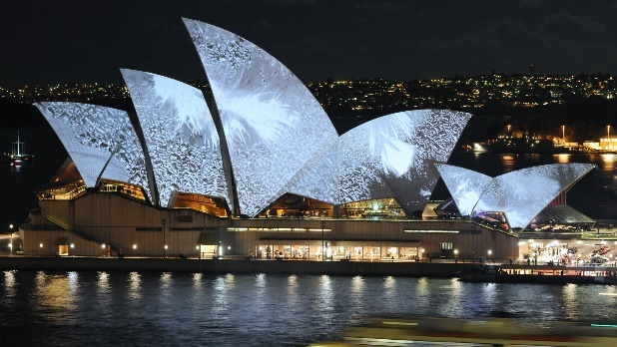
Sydney opera house was founded in 1973 and is on of the 20th centuries most famous and distinctive buildings which has been built to be into the shape of the sails of a boat. The heritage asset is one of the most important parts of the tourism infrastructure due to an estimate of 300,000 tourists visiting to see the Sydney opera house on guided tour. The Sydney opera house has brought in thousands of tourists to specifically go to the opera house and see the unique shape of the building, the value of the opera house is significantly high due to the fact it is one Sydney opera house of the most popular tourist destinations
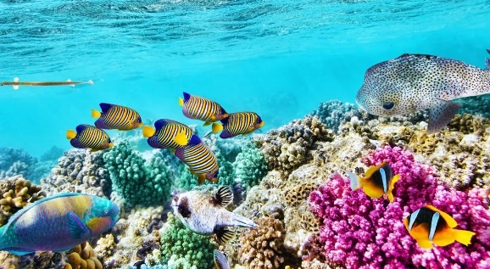
The great barrier reef is the largest living thing on earth that is visible from space which is made up from over 600 types of hard and soft coral, the great barrier reef brings in an estimate of 2 million visitors each year. The great barrier reef is valuable to the tourism sector as well as the environmental sectors due to the fact it brings in a large turnover for tourists which spend money on being able to dive into the great barrier reef which then helps national geographic to heighten the GDP to make Australia better than it currently is, with the high GDP it can also mean that it will help to prevent to decay of the great barrier reef.
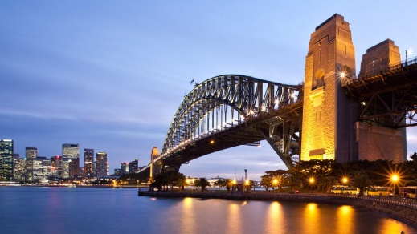
Sydney harbour bridge is a heritage steel arch bridged build that carries most transport vehicles such as pedestrian, rail, bicycle and vehicular traffic from the Sydney central district and the north. The values that the Sydney harbour bridge offers to the tourism sector is that it gives the tourists the opportunity to travel further through to more areas of Australia, also is one of the most iconic travel destinations to adventurous visitors bridge climb for those to have a guided tour to the top of the bridge to see over the whole of Sydney.
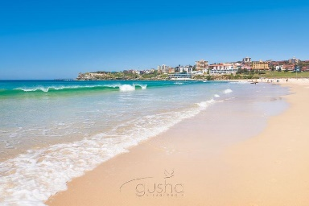
Bondi beach is Australia’s most iconic white sand beach with a high turnover for waves which bring in more tourists that like to surf. Bondi beach brings in an estimate of 2.6 million tourists a year, 53% of these visitors are international whilst 47% of these tourists account for domestic tourism. Bondi beach is one of the most valuable tourist destinations in Australia due to being one of the most famous beaches in the world due to gusha.co.uk being one of the most famous surf and relax beaches.

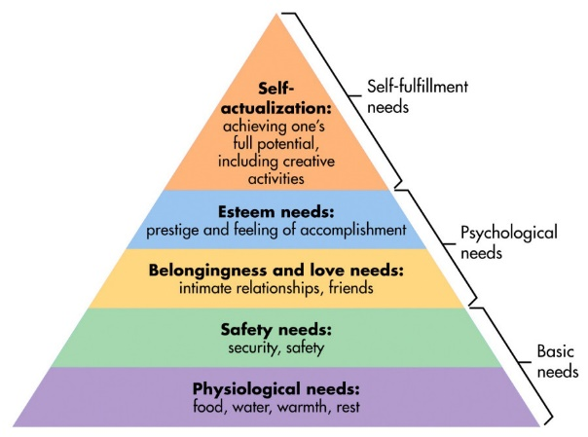
The key target market that has been chosen for this segment is the back packers for Australia. Back packers account for 13% of Australia’s tourism industry which is roughly 606,000 people back packing through Australia with the estimate of $5295 spent per back packer, back packers have risen 4% since last year, this has helped to bring in a larger turn over throughout the year due to the amount that each back packer spends within their stay for them to then go on to recommend to friends and family about going solo back packing. Butlers theory applies to this seen as it shows that from the high amount of spending generated from the back packers it helped to expand Australia’s tourist sector. Australia has further developed and gotten better by the number of back packers traveling alone which is slowly increasing the number of tourists coming in each year and spending more, furthering the GDP from $1,208 trillion (2016) to $1.323 trillion (2017), this being a growth of $115 billion within one year.
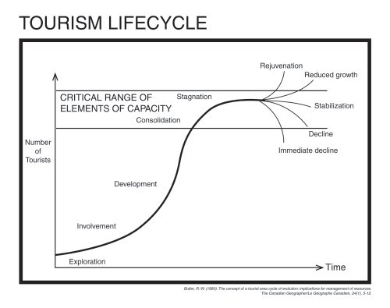
Simply psychology
This has helped to bring in a higher number of tourists seen as back packers feel safer to travel through Australia alone or in groups rather than any other countries, Australia is the safest place to back pack alone due to the fact of the low crime rates. Australia caters for the needs of backpackers by ensuring that the crime rates stay at a low and that they have enough to cater for back packers. Maslow’s hierarchy applies to this seen as the 5 Google sites needs are all to ensure that the crime levels are kept at a low and the safety levels are kept at a high

The marketing positioning within Australia is that this country is one of the most beautiful countries for the back packers to go solo traveling with feeling safe walking the streets alone and booking in to stay in hostels with little to no information on those stays. There is also a lot of people that go solo back packing through the whole of Australia alone which is a mean that the country has a history of being the best destination for the younger generation to back pack through Australia without having the consent worry of what is to happen to them if they go down that certain area alone. Australia is also one of the easiest countries to book last minute trips to Australia alone seen as it is easy to get cheaper flights, a holiday/ working visa and there are frequent places to stay at a cost affective rate due to there being plenty of hostels or hotels to stay at each city. Cohens theory applies to this due to the fact that it is dedicated into making the traveling process as smooth as it could be for the consumers, minimizing the risks and discomforts of traveling.

Back packing throughout Australia offers out more to the locals living in those cities as well as benefiting the backpackers seen as it not only gives the local community more money to flow through to the system but also gives more locals to meet new people and learn more of different cultures. Australia helps to promote themselves within the backpacking market seen as they offer out a large availability of stays and flights to each specific country, with this in mind it helps the country to expand whilst offering out great service to the valued customers because whilst they are having more frequent flights at a cheaper rate it means that due to the frequent flights the companies are offering it helps the country to bring in a higher amount of money.
Most cities within Australia help to cater for the more allocentric tourists, this being as there is plenty of different type of tourist attractions that are more of the adventurous and risk-taking people, such as backpackers and adventure seekers. An example as to how Australia caters more towards to allocentric tourists is because they offer a wide range of guided tours that are riskier, such as- hiking through the blue mountains, diving into the great barrier reef and climbing to the peak of Sydney harbour bridge. Whilst Australia mainly caters for allocentric tourists they also offer a range of destinations for mid-centric such as Bondi beach, Bondi beach is one of the most populated and calming white sand beach Australia has to offer where they can just lounge at the beach or a near by hotel without having to do anything out of their comfort range.
In conclusion to this it is believed that Australia is one of the most famous tourist destinations for allocentric tourists to go solo traveling and have the thrill of being able to travel alone but also have the safety that Australia has to offer to ensure a safe but fun stay. Although Australia offers a large variety of activities to allocentric tourists it is believed that they do also cater at a large majority to mid-centric tourists so that it would mean that Australia is able to maximise their GDP to the highest they can whilst still maintaining a healthy country for the tourists and locals to enjoy. Australia is one of the most popular tourist destinations for backpackers because of this reason, backpackers are able to get their full experience of solo travelling as well as having in the back of their heads that they are back packing through one of the most popular and safest solo traveling destinations there are in this world.
Due to Australia being more allocentric it has meant that they’re able to charger more for activities so that it ensures that everyone is covered in events of an accident whilst on a thrill taking activity, from this it means that the solo travellers that have experienced these will then go on to tell friends and families which could then turn into more allocentric tourists visiting Australia.

References
Budgetdirect. (January 2019). Australian Tourism Statistics 2019. [online]. https://www.budgetdirect.com.au. [accessed date- 02/03/2019].
B, Mike. (05/08/2015). Latest Backpacker Stats From Tourism Research Australia. [online]. https://www.thebyte.com.au. [accessed date- 05/03/2019].
Countryeconomy. (2019). Australia GDP- Gross Domestic Product. [online]. https://countryeconomy.com/gdp/australia. [accessed date 03/03/2019].
Great barrier reef facts. (2019). Fun Facts And Interesting Information About The Great Barrier Reef. [online]. http://www.greatbarrierreef.org/about-the-reef/great-barrier-reef-facts/. [accessed date- 04/03/2019].
Google. (2019). Destination. [online]. https://www.google.com/destination. [accessed date- 04/03/2019].
K, Hastings. (2019). 14 Top- Rated Tourist Attractions In Australia. [online]. https://www.planetware.com/. [accessed date-06/03/2019].
Nationsencyclopedia. (2019). Australia- Location, Size and Extent. [online]. https://www.nationsencyclopedia.com. [accessed date- 02/03/2019]
Stridetravel. (2019). Best Australian Tour Companies. [online]. https://www.stridetravel.com/australia-tour-companies. [accessed date- 01/03/2019]
R, Kubalsky. (30/09/2014). Impacts Of Travel And Tourism On Australia. [online]. https://prezi.com/cviyzkwdv5b3/impacts-of-travel-and-tourism-on-australia/. [accessed date- 03/03/2019].
Safe coastal tourism NPO. (2019). “Stakeholders In Tourism Development” According To UNWTO. [online].http://www.safecoastaltourism.org. [accessed date- 01/03/2019].
Tourism Australia. (December 2016). Bondi Visitor Profile. [online]. http://www.destinationnsw.com.au. [accessed date- 04/03/2019].
Worldatlas. (2/10/2015). Where Is Australia?. [online]. https://www.worldatlas.com/oc/au/where-is-australia.html. [accessed date- 02/03/2019].
Worldometers. (07/03/2019). Australia Population (LIVE). [online]. http://www.worldometers.info/world-population/australia-population/. [accessed date- 07/03/2019].

