[Date]
1912914@student.uwtsd.ac.uk
furure plan
9 August 2022
Fadul Mikhail Omar
Student Number: 1912914

BA Leadership and Management Skills for the Workplace

Module Code: BMSW 6104
Lecture: D. Richmond Lamptey

Strategic Management for SMEs
Table of contents

1. Introduction 2
1.1. Company background 2
2. Critically appraise the organization’s current strategic 3
3. Environmental scanning Using PESTLE and Porters 5 forces 3
4. Internal environmental analysis Using SWOT and VRIO 3
5. Stakeholder Analysis 3
6. Discuss available strategic growth choices for SMEs 3
7. Provide key strategic recommendations for the organization 3
8. Conclusion 3
9. References 3

Introduction

Mackin Construction provides groundworks services in the United Kingdom has been classified as one of the following, medium and small sized businesses enterprises and reason for the selection of Mackin Construction to identify the current company’s strategic directions, vision and mission of the company how link to sustainable development in the competitive markets and used analytics such as TESTLE analysis and Porter’s 5 forces to analyzed company external environmental scanning to identify the clear picture of the company risks and opportunities for future growth in which Mackin Construction has a number of satisfied customers long time relationships but the morrow location with large numbers of competitors could shrinking the possibility of growth alternative to expanding wider locations.
Taken further company internal examination such as SWOT and VRIO analysis to go in-depth internal financial evaluate the possible capability of Mackin Construction well established according to the previous works, size of the customers and financial states VRIO analysis identified the current competitive advantage and how to sustain the services for the future and SWOT analyses identify the present internal strengths satisfied customers, services quality, own machinery and weaknesses small segment lack of finding new customers, opportunity to develop engineering software, automated machinery and the risks of threats limited customers, a large number of competitors and lack of new developments. For example, stakeholders’ satisfaction is the leaders’ responsibility and stakeholders need to be categorized in different aspects and satisfy their needs reach situation.

Company’s Background
The company background is identifying the activities, and continuity of the organization and how to operate in the actual world. “Mackin Construction Limited is an active company incorporated on 13 February 2003 with the registration office located in Stanmore, Greater London. Mackin Limited has been running for 19 years. There are currently 2 active directors and 1 active secretary according to the latest confirmation statement submitted on 7th April 2022” (Suite Endole, No date).
Moreover, hard to find credible sources but extra effort to make. Research has been conducted to identify small or medium-size local companies operating in the United Kingdom however, according to Indole, ZoomInfo, LinkedIn and Global databases websites all have recorded valuable information about Mackin Construction, a turnover of £6 million and around 34 employees. Mackin Limited is a construction company that provides groundwork services across the London area.

Critically appraise the organization’s current strategy.
Strategy: strategy is a plan of action to achieve a business’s overall goal and objectives and to identify competitive advantages by looking to the company’s direction on how and where to avoid the risk of losing the market. However, “a strategy, this approach starts by identifying activities that have an impact on the ability of a firm to create and appropriate economic value and then specifying exactly how a particular firm accomplishes these activities” (Barney and Hesterly, 2018, p. 34)
It is important to carry out a full investigation of the business to evaluate the capabilities and to identify the best of the company’s advantages by using such as tools like SWOT Analytics, Porter’s 5 forces, VRIO, and PESTL, to develop a clear understanding to include vision and value of the chosen organization according to Mackin Construction limited website invest more money in training and technology to deliver best services to satisfy clients and build strong relationships to drive company for future growth to achieve a planned vision.
Vision: However, the mission and vision of any organization are usually directed to the company’s goal and objective strategy and what the aim wants to achieve. “My vision is a business based on relationships and best practices. I want our business to be the environment where all involved are impacted positively and can thrive, identifying common goals and working towards them together. I am very excited about this current stage in our evolution. We have built an exciting team of passionate construction professionals, striving to deliver for us and our clients every time” (MACKIN, 2020). However, Mackin engaged everyone to drive more to be the biggest by measuring any steep to leap for the better.
Mission: Mackin Construction has highlighted the importance of competitive advantage that drive the company through the objectives and goals to achieve the vision. Mackin Construction’s mission is based on a vision that believes, because the managers are very proud of the present achievements building a strong strategy investing in employees to ward client’s satisfaction and long-term relationship and look after everyone that may affect them in the future by the company’s actions this is sustainable services add value to rich a planned vision, the Mackin Construction setup mission step by step to achieve goals that stated on the vision, wanted to be environmental fit and to see that big picture impact on a positive outcome to continue the sustainability of the business to drive competitive advantages.
Objectives: Macken’s core values believe in targets to reach mission based on the timeline duration success provides quality service with integrity and respect to gain the trust of clients and includes everything to do with potential care. Mackin’s objectives provide welfare to make everyone around the company to be happy and close to the mission to achieve competitive advantage.
Strategies: Mackin Construction is creating a long-term plan strategy for the company to reach a desirable future to achieve goals and objectives to differentiate a quality service and saleable for customers to generate appropriate profits. Mackin Construction`s strategy includes a successful competitive market advantage, building a constructive cultural environment to motivate internal followers the same as external needs must be provided to add value.
Tactics: the tactics are very important elements to make sure that support strategy and meet business growth. Mackin’s tactics use history over twenty years of experience to impress new clients that including the company’s reputation, individual employees engineering professionals’ long-time reputation aligning with their previous works, and list all previously groundworks services done for clients with details images of attractive buildings, duration one job can take over four years. Mackin has over eight companies depending on the services Mackin provides and uses this trust as a tactic to attract more customers and to create desirable competitive advantages.
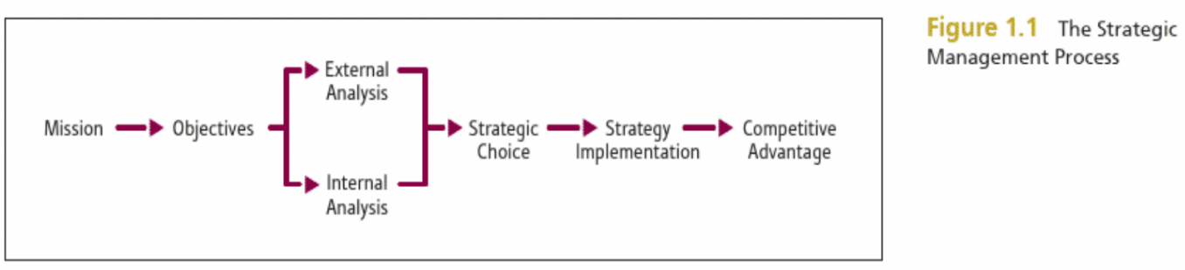
Image adapted from: (Barney and Hesterly, 2018)
The image above explains the management strategic processes that can be achieved. Mackin construction managements operate similar objectives based on their mission to progress competitive advantage.
Environmental scanning Using PESTLE and Porter 5 forces
PESTLE Analysis factors are an effective tool that can help managers to make the right decision to improve organization performances and identify potential risks. And the most useful analytic tool as an external organization analysis. “PESTLE is a strategic planning tool used to evaluate the impact of political, economic, social, technological, environmental, and legal factors might have on a project. It involves an organization considering the external environment before starting a project. It is a good way of ensuring one has captured all potential risks and issues”. (Rastogi and Trivedi, 2016, p. 3). However, PESTLE Analysis will identify the advantages and disadvantages of Mackin Construction and how strong or weak comparative to the macro environment. For example,
Political Factors: the current government stability may change from time to time and the level of substitute could impact Mackin Construction government policy, tax policy, and political environmental changes. Mackin uses internal financial buying new machinery or maintains them, and the company employees are highly professional with higher salaries that decrease Mackin’s profits and increase revenue because Mackin Construction natural works require skilled workers and expensive machinery to buy, maintain or hire cost stay but the same depends on the Macken’s assets may help to survival. This resulted in the impact being high in profits and cannot raise the price to push clients may seek alternatives, but Mackin used different strategies such as reputation, integrity, job quality, and long-lasting relationship with clients that allows Mackin to adjust prices to increase profits and to prevents loss of profits.
Economic Factors: this economic uncertainty include inters rate, inflation rate, exchange rate, and deficit of the government’s budget, these factors affect Mackin Construction in all surrounding external environment especially suppliers and consumers but for Mackin cases are the nature of the business Mackin Construction provides services as groundworks include concrete, paving, drainage and landscaping and increase the demands in the favour of services that Mackin provides unless the national economic decline because of the government high interest.
Social Factors: identify only the most important factors related to Mackin Construction including educational level demographic locations of Mackin Construction’s high level which positively affect as Mackin required skilled and professional workers, and the population value this may impact Mackin Construction choosing a segment of London high rate of an aging population and reduce as some required physical age group. “These factors are especially important for marketers when targeting certain customers. In addition, it also says something about the local workforce and its willingness to work under certain conditions” (De Bruin, 2016). The political uncertainty may impact Mackin Construction, for example, Brexit rules and European employees find it hard to support themselves because of the cost of living and visa issues.
Technological Factors: these factors include technological awareness, automaton and access to new technology Mackin provides services and expectations of quality is high technology helps to increase job efficiency, productivity and save time many companies use the machine is already new technology impeded in them to make the job easier and research department activities help Mackin Construction to find out that technology and machine cand reduce the physical job that always required certain workers of course automation machine can assist Mackin and reduce manpower.
Environmental Factors: impact on such as changes in weather, climate, natural disasters, environmental policies, and air pollution. However, these factors may impact Mackin Construction in several ways because of the natural services that Mackin offers weather and climate change may slow the works in the construction site to operate in difficult conditions and cost money similarly to natural disasters such as Covid-19 can many businesses have been impacted only those who can manage to online but unfortunately for Mackin need more physical interaction. And environmental policies government may enforce the new law and certifications in construction, digging under the ground in the very old land could cause human health issues, always health and safety first.
Legal Factors: the government name some specific laws that apply including employment laws, discrimination laws, copyright, and patent laws, health and safety laws, and attitude laws. For Mackin construction, managers must have a clear awareness of these laws’ changes, but companies based in the United Kingdom as Mackin Construction have identified a clear segment and know what populations very easy to comprehend laws such as discrimination laws, consumers protection laws, etc. because of the community background of education level live in that location where Mackin Construction operates it helpful and easy to spread awareness among employees.
Michael Porter (1979) invented the five forces tool meant to help companies to identify potential competitive advantages among other rivalries to prevent external entrants that may be highly impacted in the organization in the short or long term. “These forces determine an industry structure and the level of competition in that industry. The stronger competitive forces in the industry are the less profitable it is. An industry with low barriers to enter, having few buyers and suppliers but many substitute products and competitors will be seen as very competitive and thus, not so attractive due to its low profitability” (Jurevicius, 2021). For example:
The threat of new entrants: when new entrants come in always disadvantages to the companies that have similar products or services to prevent from customers running away look at the bargaining power of buyers or differentiation of the products and services away far from rivalries. For example. Mackin Construction provides services as ground workers there are many companies that do the same, but Mackin uses a different strategy to stay in an appropriate sustainable business. identified certain locations build close relationships with customers, and job quality, and make sure these barriers difficult for new intranets.
Bargaining power of suppliers: this force of suppliers has got the power to rise prices or switch costs to highly establish companies or strong drives of business mission in case of economic changes and that determine the firm level of distribution and uniqueness of products or services. Again, Mackin Construction provides services quality depends on the professional techniques’ suppliers have less power, but Mackin uses machinery that which mainly owned by them and sometimes can hire.
Bargaining power of buyers: customers can put pressure on the quality of the products or services, and low prices that can be able to switch for better availability. As Mackin Construction managed to secure a big segment in case of new entrants able to bargain to save existing customers because of the sources Mackin has such as tangible asset building, machinery, skilled staff, greater relationships, brand loyalty, etc. as intangible assets.
The threat of substitute products or services: having a few permanent customers is better than getting prepared to stop them from the attraction of change by knowing surrounding similar products when the substitute provides the same needs and lower prices, for example, in the United Kingdom the government trying to persuade people to stop cigarette by putting 50% higher smokers switch to rolling Tabaco then get Tabaco to your shop or customers go to the next door for it and buy extra need do not back you anymore. Mackin Construction uses clear strategies as a substitute to enforce more technology automated systems to generate data to know more about rivalries operating in the segment.
Rivalry among existing competitors: here where need more focus and ask questions about how competitors may be there and knowing their capabilities to survive, considering that the level of competitors stays the same and that can give power to consumers and slow the market for each competitor. For example, Mackin Construction managers have been aware of the local competitors and ensured the consumers that job quality, commitment, loyalty, legal requirement, and easy problem solving because of the long-time relationship, well work done showcase clear vision aimed to stay in the business with higher integrity and own better tangible assets in case of increase the insurance liability big companies obliged to sub-contractors with higher revenue.
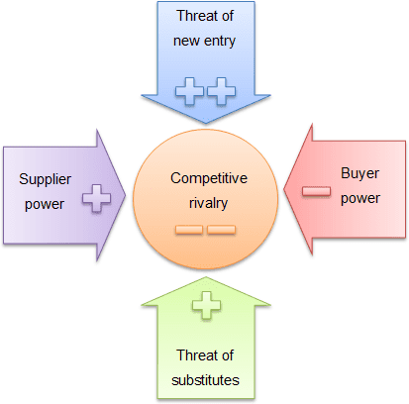
Image adopted from: (Jurevicius, 2021)
These diagrams explain the Porter`s five forces, the micro ang macro environmental analysis each related in term of impact less of consumers cost reflect on suppliers that create cap for new entry in which computer comes in, alternative of substitute higher may have chance of survival.

Internal environmental analysis Using SWOT and VRIO.
VRIO framework tool used to analyzing the internal of the organizations’ resources, capabilities, and sustainability of competitive advantage. The VRIO framework stand for value, rare initiable and organize. Example:
Value: is recourses that add value to the company to takes advantage of any opportunities to build strength against threats. However, questions to be answered by yes or no, Mackin Construction`s expertness management, skilled employees, own buildings, machines, vehicles, and cash these physical elements can be included in balance sheets and financial statements as tangible sources and intangible sources as non-physical assets such as trademarks, copyright, brand loyalty, and software. However, these are considered as the value that adds competitive advantages to Mackin Construction and can reduce the level of competence and increase the value of Mackin Construction.
Rare: rarity of the products or services enables the company to stay at top of the competition when others are not able to copy and puts the organization in a better position of competitive advantage when companies have similar products or services Mackin Construction services are easy to imitate and increase the risk.
Imitate: Mackin Construction’s services can be duplicated by other competitors but, Machin is able to use the resources available as an advantage to reduce the price to motivate consumers to that supplier do change the course of long-time relationships and that may impact Mackin Construction’s profit in a short period while warning new entries that Mackin is able to secure surrounding territory.
Organized: relying on the organization’s efficient management systems, well company structures, and employees’ environmental culture can change the workers’ behaviors toward training costs but can reflect on the company`s advantages. “The company that has the best system of selection, the best training program for employees, the best reward system, etc., will have an advantage over its competitors”. (Pesic, Milic and Stankovic, 2013, p. 5) Mackin Construction provides cost-effective systems to support the company’s internal activities and a well-organized cultural environment to motivate workers and customers’ satisfaction, Mackin is aware of local competitors’ capabilities and always finds alternatives to stay competitive empowering the market by using existing resources.
Capability
Valuable | Rare | imitate | organized
Yes | No | Yes | Yes
findings | No | Yes | Yes

VRIO frameworks table above identifies Mackin Construction has resources to enable the company services sustainability to encourage competitive advantage, but rarity is enforcing a cap for Mackin Construction to uses internal resources to fight against new entry in temporary level, because the imitation allows the competitors can easily copy the same service or product and that determined by how the organization’s systems levels. Mackin Construction is not only having own machinery but obtained customers’ loyalty and provides a promising future for employees’ welfare and everyone that can be impacted by the actions of Mackin Construction.

The SWOT Analysis is a tool that use to identify the internal organization’s strengths, weaknesses, opportunities, and threats. And giving options to managers to exploit the best alternative available for business growth.
SWOT Analysis Internal Factors
Strengths | Weaknesses
- Organization structure  - Established management systems  - Skilled staffs  - Internal resources  - Services Quality  - Own machinery  - Chosen right customer segments | - Competitors or new entry  - Imitation of the services  - Lack of employees training  - Lack of internal resources  - Not known for identifying customers’ locations
Opportunities | Threats
- New relevant technology benefits to us  - Market growth in our favour  - Fewer resources of competitors  - Customers’ interest in the service | - Customers change attitudes  - Emerge of new competitors  - Existing competitors’ exploitation  - Uncertain economic changes  - Imitation of the services

The SWOT Analysis has identified Mackin Construction’s internal factors and the company is able to use its strengths as valuable to compete against rivals such as vehicles, machinery, professional workers including intensive care of employees, and customers satisfaction these kinds of tangible resources always Mackin Construction to focused on in future and try to minimize the internal weaknesses knowledge of the surrounding companies provide similar services, customers and community needs, well monitoring those territories in case of emerging markets to mitigate threats and abilities to take any opportunities in contest.
Strengths: Mackin Construction is well established with skilled employees and a company provides ground services for long-time customers relationship in specific areas around London and which allows them to build a good knowledge of knowing the community’s needs, suppliers, technicians that may help them in some relevant issues or exchanges benefits such experience can enable a business to grow, having the control to stay in balance and strongly active.
Weaknesses: Mackin Construction has several competitors that provide the same services as Mackin Construction does and put pressure on Mackin as a leading company with a limited location in London. However, competitors can be internal when the company utilizes many resources to fight against new entries. The research department can help Mackin Construction to improve exciting activities and undertake new innovations to produce quality services.
Opportunities: a new technology allows Machin Construction to use automated machinery to develop further market opportunities for business advantage growth and the decline of competitors can limit the consumers’ opinion to rely on exciting providers. An advantage for Mackin Construction to an advertising tip to cover certain areas of the community to know the benefits of the services that have been provided and may expand the demographics another opportunity.
Threats: an external factor that increases the Mackin Construction risks because of the limited locations that the company operates any loss of customers can rise the risks or any environmental changes in such location Mackin Construction must seek new customers somewhere else or create a new business strategy in which drive to cost and increase the risk of losing exciting customers. Negative media reviews can rewind the company’s reputation.
Stakeholder Analysis
“The stakeholder concept, and its sensitivity to different wants, helps to understand the organizational politics of strategic decision-making. Taking stakeholder expectations and inﬂuence into account is an important aspect of strategic choice” (Regner et al., 2019, p. 133). The importance of stakeholders’ analysis to identify stakeholders, power, and property that include everyone working in the organization, owners, investors, customers, suppliers, local authorities, and local neighborhoods.
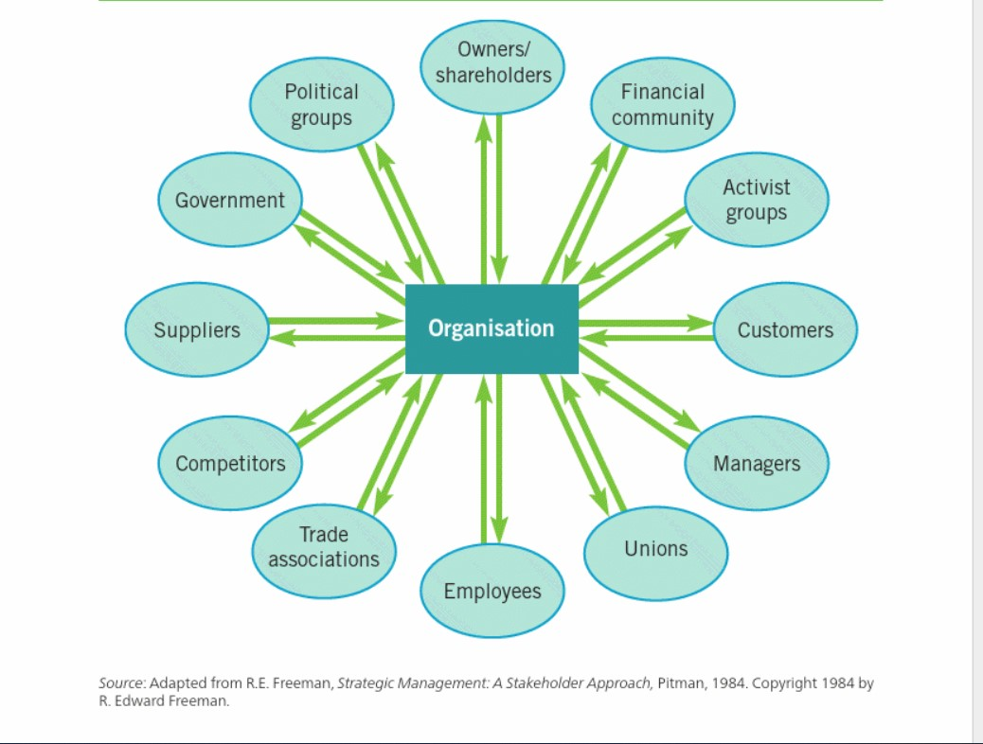
Image adopted from: (Regner et al. 2019)
The above image identified the the stakeholders mangenet methodology and enble organisation to identitys all types of stakeholders and manage them carefully.

Example of stakeholders mopping diagram.
A | Managers
B | Investors
C | Employees
D | Clients
E | Suppliers
F | competitors
G | Government
H | Banks groups
I | Technicians
J | Community
K | Medias
A  B  C  D | G  F  E
J  K | H  I

High

Power

Lower

Lower Interest High
The stakeholders identified and need to be satisfied base on the categories of how to impact Mackin Construction has a clear mission to achieve a vision by doing that planned to work with highly motivated internal staff for example engineers works in very tough condition as groundworkers greatest care have been provided such as training, health, and safety, consultants provided any personal issues for the individual, lifestyle and better salaries to satisfy the need and to keep all high power from A to D red selected stakeholders going effectively aligning with company’s mission to achieve goals and objectives.
Lower power and high interests blue selections Mackin must satisfy them as government policies and certification very important that type of services it provides by Mackin to follow government guidelines at all the time and it is very necessary to Inform in regular bases to exchange information. Mackin has its own machinery and provides services but still needs to work with suppliers closely and very importantly, competitors must watch all the time to know their direction.
Lower power high-interest stakeholders must be monitored from time to time to make sure they are satisfied for example, the media may affect Mackin in a bad influence or reduce a company’s values and reputation.

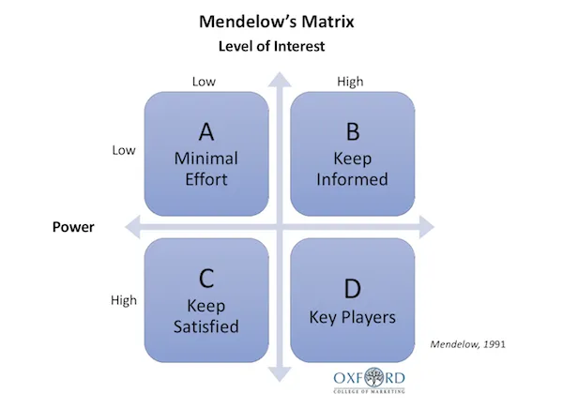
This image adopted from: (Barrington, 2022)

The above diagram identified Mendelow’s Matrix four boxes are explaining the stakeholders level of power that organisation leaders must deal with the situation.
Accourding to Barrington (2022) it is very important to identify stakeholders and to make a selections among them high power high interests top priority but do not ignore others. For example of the details below:
High power, highly interested people: can be managed closely to achieve full engagement with these people and try to satisfy them.
High power, less interested people: put extra work to keep them satisfied, but do not put too much pressure on them they may get distracted by sending constantly messages.
Low power, highly interested people: these people keep them informed adequately within a direct communication to ensure that no major problems are arising. These people can also help point out any areas that could be improved or have been neglected.
Low power, less interested people: can be monitored from time to time do not ignore these groups can be treated as a mediums level of communication and keep an eye to check that they may change in their levels of power or interest.
Discuss available strategic growth choices for SMEs
Strategic choice is a decision-making plan to identify new strategies for sustainable development of the business’s long-term survival and able to explore available options or opportunities to implement the existing resource to add significant value to the company’s potential future. “The nature of strategic management will change as industries move along the life cycle. In the introductory phase, organizations attempt to develop an interest in the product. As the industry moves towards growth, competitors are attracted by its potential and enter the market: from a strategic perspective, competition increases” (Lynch, 2018, p. 81).
New strategy technique, Mackin Construction leaders take responsibility for creating strategies that friendly environmental stage to stakeholders’ systematic approach to adopting changes and tackling challenges to improve profitability growth and increase company values. Leaders must take serious measures to expand company segments and seek opportunities in any new market available. By providing training a long internal staff and strategic platform communications across customers and to increase services differentiation to exploit the technical advantage, automated machinery may add to building services to their existing groundwork to generate more revenue and stop points to attract customers and these capabilities bring long term market growth and competitive advantage that warned competitors entries.
Ansoff Matrix’s four elements are identifying the importance of market growth.
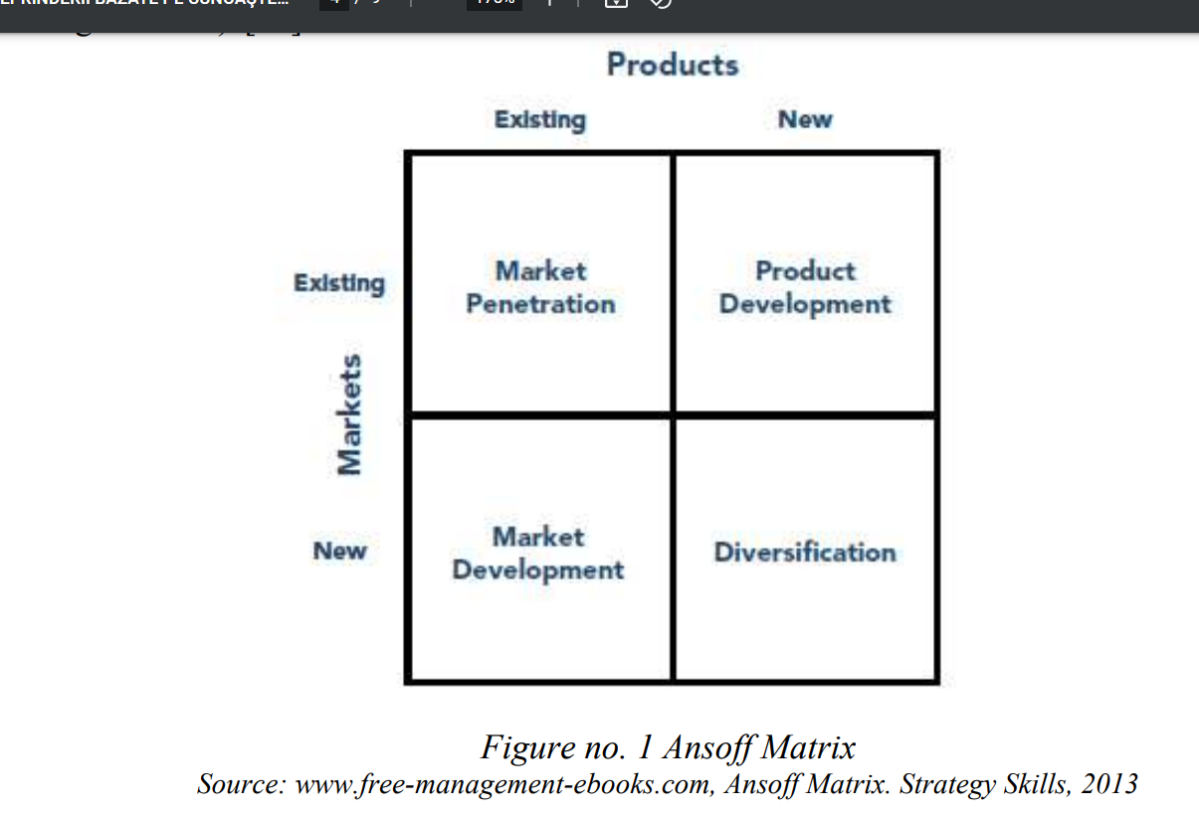
This image adopted from: (Loredana, 2016)
The Ansoff Matrix targeting the existing market with current products or services use promotion offer for better market share. And find new market for present services by using market development and improve new services for exciting market and diversification to target new markets for services. accounting to Loredana (2016, p. 4) demonstrates four elements as a follow:
Market penetration: Mackin Construction considers a new marketing strategy selling point to the existing services finding more segments and focusing to achieve a wider market by offering reasonable competitive pricing, improving service quality, and customer satisfaction.
Market Development: when Mackin Construction’s leaders identified a new strategic plan it is very important to take risks for further development of the existing services as entering the new market needs to think carefully about customers and competitors’ reactions.
Services Development: Mackin Construction’s leaders must focus on developing new services for the exciting market and ensure that these changes are not affecting the previous clients.
Diversification: changes come to enforcement of new developments to sale. Mackin Construction leaders must prepare of entering a new market to reduce risks that may impact the company in a negative way. Cease many positions to target customers with clear proposals, educate clients as much as possible about the new development, and measure the output come for future company’s progress.
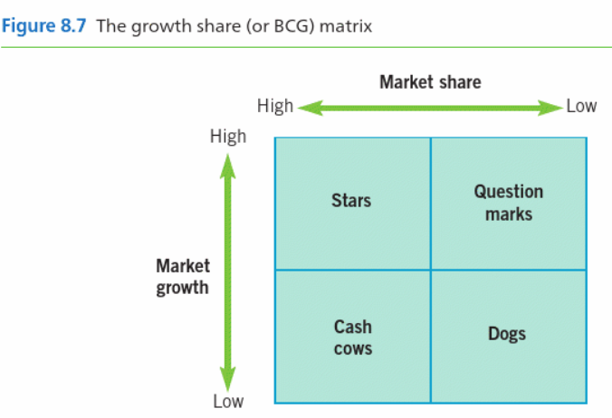
Image adopted from: (Regner et al., 2019)

The BCG Matrix Growth Share the star create high profit but require ongonig investment. Cash Cow can support star to raises more fund because Cow less competetors. Dog less growth, lack of share and even profit loss and finally Question mark loking for solutions considering market aspect on what is wrong. However, accourding to Reeves (2022) argues that as following steps:
Low Growth, High Share: Mackin Construction should milk these cash cows for cash for more investments.
High Growth, High Share: Mackin must substantially invest in it may have a high potential for future growth.
High Growth, Low Share: Mackin should have extra investments or removes these question marks depending on the prospects of how to achieve the star.
Low Share, Low Growth: Mackin Construction must eliminate the pet or rethinks reviewing the strategy pet may add some value in the long-term.

Provide key strategic recommendation
Key strategic, Mackin Construction leaders must review the company directions to expand their locations to find new customers and add more services by exploiting the advantages of the technology such as automated machinery, to provide more training for engineers to find an alternative that can reduce the physical workload. Mackin Construction provides the groundwork services for landscaping and drainage jobs that require quality and skilled workers but with the help of computer software engineering easily identifying what is underground while excavating or drilling systematic software or computer display output to guide workers but automagical machines are accurate and faster than manual works.
Mackin Construction should identify the number of competitors that operating in the areas may create potential threats it is important for Mackin must differentiate the services from other competitors by adding a brickwork services strategy that may make a different approach to gain more customers it becomes one-stop shopping for client’s advantage and reducing sup-contractors process and procedures it benefits both for Mackin to increase customers and raise levels of competitive advantage.
Strong market position decisions are made by the company’s leaders to set a better plan for the business’s future to identify the gaps between annual reports that determine the financial statements for gradual revenue growth or other ways. Managers must find ways to increase the company’s revenue by engaging everyone for the benefit of company goals and objectives to generate profits and educate customers about the new services that may offer low costs, service quality, and add value to the company’s growth.

Conclusion
Finally come to conclude Mackin Construction the current strategic objectives and take further actions to investigate insight into the company’s activities to identify the future growth measured from the present capabilities of the company by using analytical tools such as PESTLE, Porter 5 Forces Analysis to identify external factors to minimize risks and find alternatives development strategy for the company to stays competitive. and VRIO and SWOT Analysis are used to classify the internal factors that the company’s strengths and current internal financial are good leading competitors but that may not confirm long-term sustainability according to VRIO analysis new market entry can change Mackin Construction’s present state unless finding alternatives leaders to expand the demographic areas to attract more consumers to increase market share and provide stakeholders satisfaction to achieve competitive business advantage.

References
Mackin, M. (2020) Mackin Construction Ltd. Available at: https://www.mackinltd.com/about-us
(Accessed: 15 July 2022).

Suite Endole, (No date) Mackin-construction-limited. Available at: https://suite.endole.co.uk/insight/company/04666142-mackin-construction-limited
(Accessed: 15 July 2022).

Barrington, R. (2016) 'What is a PESTEL analysis?', Oxford College of Marketing Blog, -06-30T16:21:37+00:00. Available at: https://blog.oxfordcollegeofmarketing.com/2016/06/30/pestel-analysis/ (Accessed: 16 Jul 2022).
Barney, J. and Hesterly, W. (2018) 'Strategic Management and Competitive Advantage: Concepts and Cases, EBook, Global Edition'. 6th edn. Harlow: Pearson Education, Limited.
Barrington, R. (2022) 'What Is Mendelow’s Matrix And How Is It Useful?', Oxford College of Marketing Blog, . Available at: https://blog.oxfordcollegeofmarketing.com/2018/04/23/what-is-mendelows-matrix-and-how-is-it-useful/ (Accessed: 31 Jul, 2022).
De Bruin, L. (2016) PESTEL Analysis (PEST Analysis) EXPLAINED with EXAMPLES | B2U. Available at: https://www.business-to-you.com/scanning-the-environment-pestel-analysis/ (Accessed: 18 July 2016).
Jurevicius, O. (2021) Porter's Five Forces: The Ultimate Guide - SM Insight. Available at: https://strategicmanagementinsight.com/tools/porters-five-forces/ (Accessed: 18 Jul, 2022).
Loredana, E.M. (2016) 'The use of Ansoff matrix in the field of business', In MATEC Web of Conferences., 44, pp. 01006.
Lynch, R. (2018) 'Strategic Management 8th edn', Harlow, United Kingdom: Pearson Education, Limited.
Pesic, M.A., Milic, V.J. and Stankovic, J. (2013) 'Application of vrio framework for analyzing human resources role in providing competitive advantage', Tourism & Management Studies, pp. 575-586.
Rastogi, N. and Trivedi, M.K. (2016) 'PESTLE technique–a tool to identify external risks in construction projects', International Research Journal of Engineering and Technology (IRJET), 3(1), pp. 384-388.
Reeves, M. (2022) What Is the Growth Share Matrix? Available at: https://www.bcg.com/about/overview/our-history/growth-share-matrix (Accessed: 01 Aug, 2022).
Regner, P., Johnson, G., Johnson, G. and Scholes, K. (2019) 'Exploring Strategy, Text and Cases 12th edn,' Harlow, United Kingdom: Pearson Higher Education & Professional Group.

