
Module Assignment Submission
Student Name: | Jemma Rees
Student Number: | 2008032
Module Code: | BMSK 6006
Module Title: | Developing Emotional Intelligence Skills for the Workplace

Statement of Confirmation of Authenticity
By the act of making this submission, the student declares that this is the work of the student named above. The work has not, in whole or in part, been knowingly presented elsewhere for assessment, or where assessment has been built on a previous assessment, this has been identified. Where materials have been used from other sources it has been properly acknowledged. If this statement is untrue, the student acknowledges that an assessment offence has been committed.
Attention is drawn to the plagiarism and unfair practice policies of the University.

Table of Contents
1.0 Introduction 3
2.0 Critically evaluate theories of emotional intelligence and their relevance to workforce development and business performance. 3
2.1 Theories of Emotional Intelligence 3
3.0 Theory 1 - The Four Branch Model of Emotional Intelligence 4
3.1 Non-Verbal 4
3.2 Using emotions to prioritise thinking 4
3.3 Understanding and interpreting emotions 4
3.4 Management of Emotions 5
3.5 The Four Branch Model of Emotional Intelligence – Summary 5
4.0 Limitations of Emotional Intelligence Measurements 5
5.0 Theory 2 6
6.0 How is emotional intelligence relevant to the workplace 6
7.0 How is emotional intelligence relevant to business performance 7
8.0 Review how the theories of EI and mindfulness affect emotions and impact my workplace performance 7
Conclusion 7
References 7
Bibliography 13
Appendices 13
Appendix 1 13
Appendix 2 14
Appendix 3 14
Appendix 4 15
Appendix 5 15

1.0 Introduction

2.0 Critically evaluate theories of emotional intelligence and their relevance to workforce development and business performance.

2.1 Theories of Emotional Intelligence

Several theorists have defined emotional intelligence (EI). However, the most influential is Goleman (1995), who asserts that EI is the most significant predictor of business success; EI refers to a person's capacity to control emotions and express them in acceptable and productive ways.
EI is a crucial factor of personal and professional success, as it enables individuals to identify and control their emotions, as well as the emotions of others. According to Joseph & Newman (2010), individuals with high emotional intelligence are likelier to experience favourable outcomes in their personal and professional lives.
Furthermore, EI consists of several skills: self-awareness, self-control, ambition, empathy, and social skills. Self-control is the ability to regulate and control one's emotions, whereas self-awareness is the skill to recognise and understand one's emotions. Ambitions are achieved by setting and accomplishing goals; overcoming challenges and failures is crucial to this growth. Social skills are the ability to interact with others effectively and resolve disputes, while empathy is the understanding and sharing of emotions within these interactions. (Goleman, 1995).
However, Mayer, 2004 recognises the impact of Goleman's book (1995) but refutes Goleman's claim that EI is unrelated to intelligence quotient (IQ). As a result, Mayer & Salovey (2000) defined the term' mixed models', which refer to EI but include several unrelated personality traits unrelated to emotion or intelligence.
Individuals with well-developed emotional intelligence are likelier to achieve personal and professional success. Developing deeper connections enables effective communication within team environments, promoting coherence and efficiency within the workplace.

3.0 Theory 1 - The Four Branch Model of Emotional Intelligence

According to Mayer, Caruso & Salovey (1999), EI is the capability to identify and interpret emotions and to use this understanding to effectively manage one's own emotions and the emotions of others. Furthermore, Mayer (2009, as cited in Craig, 2019) asserts that individuals with high EI can identify facial expressions correctly and are more likely to demonstrate creative thinking. According to Mayer's (2004) theory, 'The Four Branch Model of Emotional Intelligence' (Appendix #), four main areas are attributed to EI, briefly discussed next.

3.1 Non-Verbal

According to Mayer (2004), the first branch relates to non-verbal emotions, the ability to perceive facial expressions, and how others perceive these. Psychologists and evolutionary biologists have observed how emotional expression evolved in animal species as a vital method of social communication; neurochemical reactions are triggered by emotions (Zych & Gogolla, 2021). Humans' expressions of joy, sorrow, hostility, and panic might all be recognised by looking at their faces. Roter et al. (2006) assert that nonverbal behaviour studies have significantly progressed in understanding how people identify and communicate emotions.
During human evolution, non-verbal communication was critical to survival (Šimić et al., 2021). However, in recent times non-verbal communication is considered a crucial basis for developing a deeper awareness of emotions is the ability to recognise emotions in others' faces or voices.

Using emotions to prioritise thinking

The second branch refers to using emotions to elicit a particular state of mind; for instance, Brackett et al., 2011) suggest that when in a state of sadness, the thought process is more detail-oriented, significant and determined. Mayer (2004) asserts that emotions can be harnessed to encourage mental processes, including judgement, problem-solving, and social communication.
Newton (2013) asserts that emotions are necessary for creative thinking. However, Damasio, 2000; Oatley and Jenkins, 1996 (cited in Newton 2013) warn that emotions elicited from fear trigger a survival response and produce irrational actions.

Understanding and interpreting emotions

Emotions contain information and lead to social cohesion when correctly interpreted by others; a positive emotion encourages others to come together, whereas a negative emotion has the opposite effect. The ability to comprehend the information conveyed by emotions is essential, but correctly interpreting this information allows for reasoning and judgement (Salovey et al. (2004).

Management of Emotions

According to Mayer (2004), the final branch refers to emotional regulation, which is the ability to identify and calculate one's physiological reaction to adverse events while employing effective regulation techniques to control the emotional reaction.
Price & Hooven (2018) support this theory, asserting that strong evidence proves the link between poor or disordered interoceptive awareness, or the awareness of sensory information, resulting in problems regulating one's emotions.
This view is supported by neuroscience (Craig, 2015 as cited in Price & Hooven, 2018), who report that the intricate interactions between the body and mind affect how emotion is experienced and understood.

The Four Branch Model of Emotional Intelligence – Summary

These studies indicate a relationship between emotional intelligence and the ability to manipulate and regulate emotions. Where there is a disconnect between the interpretation of emotions and the inability to respond correctly, this can damage one's health and well-being and those around them.

4.0 Limitations of Emotional Intelligence Measurements

Mayer and Salovey (1997; Salovey & Mayer,1990, as cited in Salovey and Grewal (2005), identified the need for an analytical framework within psychology to research and measure EI from which (The Institute for Health and Human Potential, 2022)was created.
However, Brackett & Mayer (2003, as cited in Salovey and Grewal (2005) argue that EI self-report tests are subject to the honest and correct identification of one's emotional abilities. For example, narcissistic participants may highly rate their abilities, and conversely, those with neurotic personalities may rate their abilities lower, suggesting these types of tests are highly subjective.
In the interest of this report, an online EI test (The Institute for Health and Human Potential, 2022) has been completed, further supporting the above assertion. The results indicated an 'Excellent EQ' (Appendix #); however, the results are caveated, suggesting that based on the answers, the respondents' EI is either extremely high or extremely low, stating the users' self-awareness' as a 'foundational competency' of an accurate assessment.
The Mayer-Salovey-Caruso Emotional Intelligence Test (MSCEIT) (Mayer, Salovey, & Caruso, 2002), as cited in Salovey and Grewal (2005), is central to The Four Branch Model of Emotional Intelligence, thus addressing concerns of accuracy. They are supported by O'Connor et al. (2019), who assert that The MSCEIT is "the most researched and supported measure of EI ability", stating that "it has been cited in more than 1,500 academic studies".
More recent attention has focused on the Situational Test of Emotion Management (STEM) and the Situational Test of Emotional Understanding (the STEU) (MacCann and Roberts, 2008); their studies of over 300 participants assist in validating the connective evidence between EI (emotions and personality) and clinical conditions such as anxiety and depression.
Overall, the research indicates that currently, there is no overarching method of measurement; each empiric test faces challenges in collecting accurate data from participants for the reasons stated previously. For this reason, the theorists mentioned above recommend utilising several measures and cross-referencing the findings for validity.

5.0 Theory 2
6.0 How is emotional intelligence relevant to the workplace
There is a large amount of research into the importance of EI and workplace development; however, there is little empirical evidence to conclusively determine its impact and validity (Ashkanasy, Hartel, & Daus 2002; Zeidner, Matthews, & Roberts 2004, as cited in Idowu Dayo et al., 2012)
However, several studies have revealed a correlation between EI and business performance (Hagmaier & Abele, 2015); (Agarwal, 2020); (Sharma & Pawan Kumar Chand, 2022).
One of the characteristics that is thought to be a good indicator of a leader's performance is emotional intelligence (Akafo and Ayitey, 2019).
Additionally, research conducted by Wolfe (2016), Wagner (2013), and Trehan and Shrivastav (2012, as cited in Akafo and Ayitey, 2019) supports this with findings that suggest all employees, regardless of position, benefit from EI training and that in becoming more aware of their own EI and the EI of their colleagues they are better placed to collaboratively create a positive work environment, resulting in effective decision making and greater empathy.
Bin Sayeed and Shanker (2009, as cited in Akafo and Ayitey, 2019) assert that when a leader understands the emotional needs of an employee, they possess a greater ability to communicate and motivate them, enhancing interpersonal relationships; these are considered desirable qualities within leadership (Issah, 2018), (Mayer et al., 2000).
Based on the previous research, we must infer that since EI is directly related to organisational success and business performance, there must be benefits of EI and workplace development, and EI will inevitably nurture and develop workers.

7.0 How is emotional intelligence relevant to business performance

8.0 Review how the theories of EI and mindfulness affect emotions and impact my workplace performance

Conclusion

References

Agarwal, S. (2020, July 28). An Association Between Emotional Intelligence and Performance of Workforce. ResearchGate; Blue Eyes Intelligence Engineering and Sciences Engineering and Sciences Publication - BEIESP. https://www.researchgate.net/publication/343262687_An_Association_Between_Emotional_Intelligence_and_Performance_of_Workforce
Akafo, V., & Ayitey, V. (2019). Emotional Intelligence and Leadership effectiveness: A theoretical review Ayitey |56 Emotional Intelligence and Leadership Effectiveness: A Theoretical Review. ResearchGate, 1(1), 56–59. https://www.researchgate.net/publication/368336992_Emotional_Intelligence_and_Leadership_effectiveness_A_theoretical_review_Ayitey_56_Emotional_Intelligence_and_Leadership_Effectiveness_A_Theoretical_Review
Brackett, M. A., Rivers, S. E., & Salovey, P. (2011). Emotional Intelligence: Implications for Personal, Social, Academic, and Workplace Success. Social and Personality Psychology Compass, 5(1), 88–103. https://doi.org/10.1111/j.1751-9004.2010.00334.x
Craig, H. (2019, January 30). The Theories of Emotional Intelligence Explained. PositivePsychology.com. https://positivepsychology.com/emotional-intelligence-theories/
Gardner, K. J., & Qualter, P. (2010). Concurrent and incremental validity of three trait emotional intelligence measures. Australian Journal of Psychology, 62(1), 5–13. https://doi.org/10.1080/00049530903312857
Goleman, D. (1995). Emotional Intelligence: Why It Can Matter More than IQ. Bloomsbury.
Hagmaier, T., & Abele, A. E. (2015). Determinants of job satisfaction: Living one’s calling as a neglected predictor? ResearchGate; unknown. https://www.researchgate.net/publication/273770285_Determinants_of_job_satisfaction_Living_one%27s_calling_as_a_neglected_predictor
Hooijberg, R., Hunt, J. G. (Jerry), & Dodge, G. E. (1997). Leadership complexity and development of the leaderplex model. Journal of Management, 23(3), 375–408. https://doi.org/10.1016/S0149-2063(97)90036-2
Houston, E. (2019, February 6). The Importance of Emotional Intelligence (Incl. Quotes). PositivePsychology.com. https://positivepsychology.com/importance-of-emotional-intelligence/#matter-more-than-iqScientifically reviewed by Tiffany Sauber Millacci, Ph.D.
Idowu Dayo, Dayo Idowu Akintayo, Sunday, S., & Sunday Samson Babalola. (2012). The impact of emotional intelligence on workers’ behaviour in industrial organizations. ResearchGate; unknown. https://www.researchgate.net/publication/261286823_The_impact_of_emotional_intelligence_on_workers%27_behaviour_in_industrial_organizations
Issah, M. (2018). Change Leadership: The Role of Emotional Intelligence - Mohammed Issah, 2018. SAGE Open. https://journals-sagepub-com.ezproxy.uwtsd.ac.uk/doi/10.1177/2158244018800910
Jacobs, R. L., & Hawley, J. D. (2009). The Emergence of “Workforce Development”: Definition, Conceptual Boundaries and Implications. International Handbook of Education for the Changing World of Work, 2537–2552. https://doi.org/10.1007/978-1-4020-5281-1_167
Joseph, D. L., & Newman, D. A. (2010). Emotional intelligence: An integrative meta-analysis and cascading model. Journal of Applied Psychology, 95(1), 54–78. Apa.org. https://doi.org/doi.org/10.1037/a0017286
Koman, E. S., & Wolff, S. B. (2008). Emotional intelligence competencies in the team and team leader. Journal of Management Development, 27(1). Emerald Insight. https://www-emerald-com.ezproxy.uwtsd.ac.uk/insight/search?q=emotional+intelligence&showAll=false&p=1
MacCann, C., & Roberts, R. D. (2008). New paradigms for assessing emotional intelligence: Theory and data. Emotion, 8(4), 540–551. https://doi.org/10.1037/a0012746
Mayer, J. (2004). What is Emotional Intelligence? What Is Emotional Intelligence? https://scholars.unh.edu/cgi/viewcontent.cgi?article=1007&context=personality_lab
Mayer, J. D., Caruso, D. R., & Salovey, P. (2016). The Ability Model of Emotional Intelligence: Principles and Updates. Emotion Review, 8(4), 290–300. https://doi.org/10.1177/1754073916639667
Mayer, J. D., Salovey, P., & Caruso, D. (2000). Models of Emotional Intelligence. Handbook of Intelligence, 396–420. https://doi.org/10.1017/cbo9780511807947.019
Newton, D. P. (2013). Moods, emotions and creative thinking: A framework for teaching. Thinking Skills and Creativity, 8, 34–44. https://doi.org/10.1016/j.tsc.2012.05.006
O’Connor, P. J., Hill, A., Kaya, M., & Martin, B. (2019). The Measurement of Emotional Intelligence: A Critical Review of the Literature and Recommendations for Researchers and Practitioners. Frontiers in Psychology, 10. https://doi.org/10.3389/fpsyg.2019.01116
positran_auriane. (2020, June 25). What is emotional intelligence? 2 theories and measures | POSITRAN. POSITRAN. https://www.positran.eu/what-is-emotional-intelligence-theories/
Price, C. J., & Hooven, C. (2018). Interoceptive Awareness Skills for Emotion Regulation: Theory and Approach of Mindful Awareness in Body-Oriented Therapy (MABT). Frontiers in Psychology, 9. https://doi.org/10.3389/fpsyg.2018.00798
Roter, D. L., Frankel, R. M., Hall, J. A., & Sluyter, D. (2006). The Expression of Emotion Through Nonverbal Behavior in Medical Visits. Mechanisms and Outcomes. Journal of General Internal Medicine, 21(S1), S28–S34. https://doi.org/10.1111/j.1525-1497.2006.00306.x
Salovey, P., Brackett, M. A., & Mayer, J. D. (2004). Emotional intelligence : key readings on the Mayer and Salovey model. Dude Pub.
Salovey, P., & Grewal, D. (2005). The Science of Emotional Intelligence. Current Directions in Psychological Science, 14(6), 281–285. https://doi.org/10.1111/j.0963-7214.2005.00381.x
Salovey, P., & Mayer, J. D. (1997). What is emotional intelligence?, Emotional development and emotional intelligence: Educational implications (D. J. Sluyter, Ed.; pp. 3–34). Basic Books.
Sharma, G., & Pawan Kumar Chand. (2022, April 24). Emotional Intelligence and Job Performance: A Review Based Study. ResearchGate; Electrochemical Society. https://www.researchgate.net/publication/360283052_Emotional_Intelligence_and_Job_Performance_A_Review_Based_Study
Šimić, G., Tkalčić, M., Vukić, V., Mulc, D., Španić, E., Šagud, M., Olucha-Bordonau, F. E., Vukšić, M., & R. Hof, P. (2021). Understanding Emotions: Origins and Roles of the Amygdala. Biomolecules, 11(6), 823. https://doi.org/10.3390/biom11060823
Srivastava, K. (2013). Emotional intelligence and organizational effectiveness. Industrial Psychiatry Journal, 22(2), 97–99. NCBI. https://doi.org/10.4103/0972-6748.132912
The Institute for Health and Human Potential. (2022, March 4). Test Your Emotional Intelligence, Free EQ Quiz, EI Test. The Institute for Health and Human Potential. https://www.ihhp.com/free-eq-quiz/
Wong, C.-S., & Law, K. S. (2002). The effects of leader and follower emotional intelligence on performance and attitude. The Leadership Quarterly, 13(3), 243–274. https://doi.org/10.1016/s1048-9843(02)00099-1
Zeidner, M., Matthews, G., & Roberts, R. D. (2004). Emotional Intelligence in the Workplace: A Critical Review. Applied Psychology, 53(3), 371–399. https://doi.org/10.1111/j.1464-0597.2004.00176.x
Zych, A. D., & Gogolla, N. (2021). Expressions of emotions across species. Current Opinion in Neurobiology, 68, 57–66. https://doi.org/10.1016/j.conb.2021.01.003

Bibliography

Appendices

Appendix 1
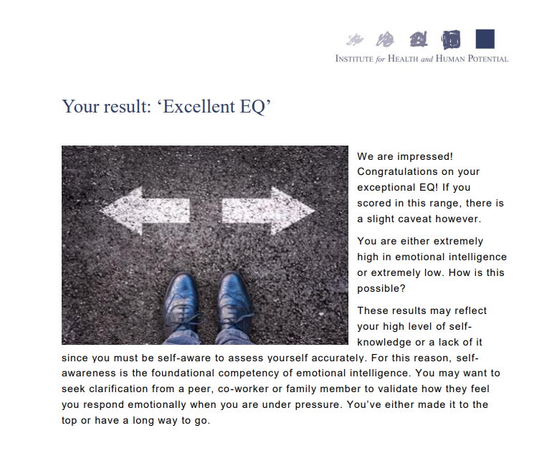(The Institute for Health and Human Potential, 2022)

Appendix 2
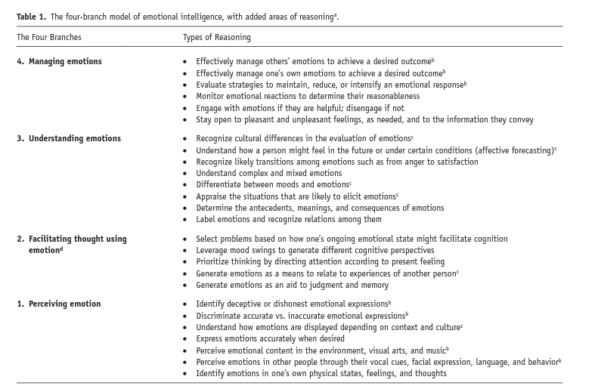
Mayer et al. (2016)

Appendix 3
The Four Branch Model of Emotional Intelligence
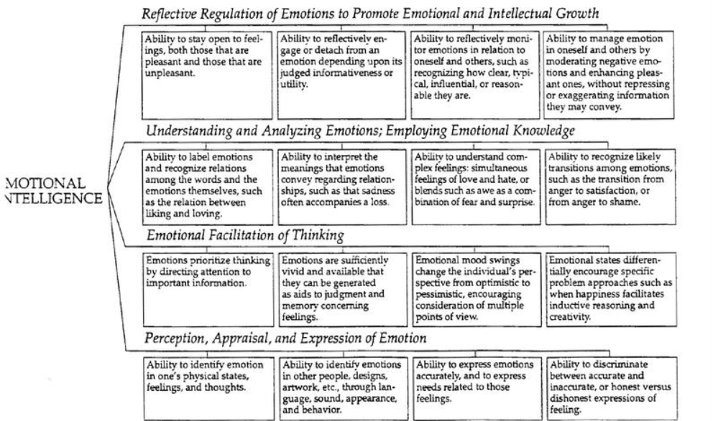
(Salovey & Mayer, 1997, pp. 3–34)

Appendix 4

Appendix 5

