
APPENDIX GA36a

LEVEL 4 ASSESSMENT SPECIFICATION

Student name: | Mohammad Moosavi | Student ID number: | 2418433
Programme: | BEng Embedded Electronic Systems  BEng Electrical and Electronic Engineering  DipHE Electrical and Electronic Engineering
Module: | Electrical & Electronic Principles
Module code: | ACDA4006 | Contribution to Overall Module Assessment (%): | 50%
Lecturer: | Steve Mosey | Internal Verifier:
Assignment Title: | Resonance | Word count (or equivalent): | 2500
Submission deadline: | 10/Jan/2024 | Return date of provisional marks & written feedback: | 30/Jan/2024
Submission method: | All written assessments, where practical and possible, must be submitted via Turnitin unless otherwise instructed by the Lecturer. (Please DO NOT put this assessment specification into Turnitin or it will match many similarities with other students’ submissions.)  Alternative submission method (if applicable):  Late submission of the assessment will result in a late penalty mark:  Work which is submitted up to 1 week late will be capped at 40% for the first attempt and will be awarded a mark of 0% for re-assessment. Late submission penalties may be lifted only if there is an approved extenuating circumstances claim.  Work submitted more than 1 week late will be considered as a non-submission and will not be marked. The work may be considered as a submission for reassessment if offered by an Examining Board or if there is an approved extenuating circumstances claim.

resonant frequency (f_{r}) is 5.032k hz
Q= fr/bandwidth =5000/200=25

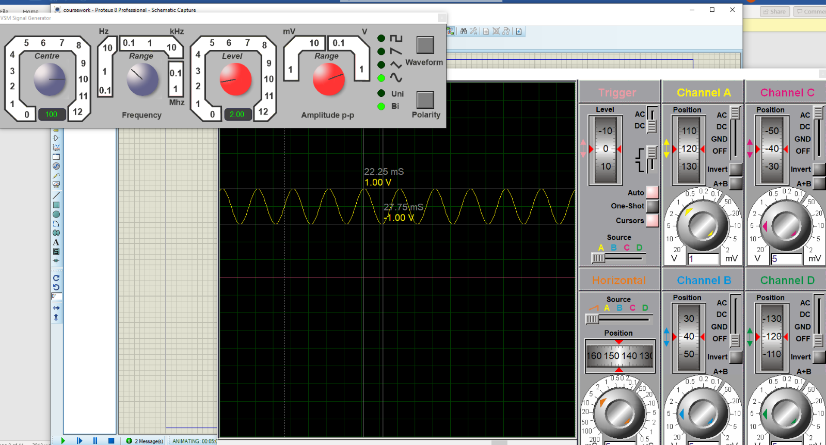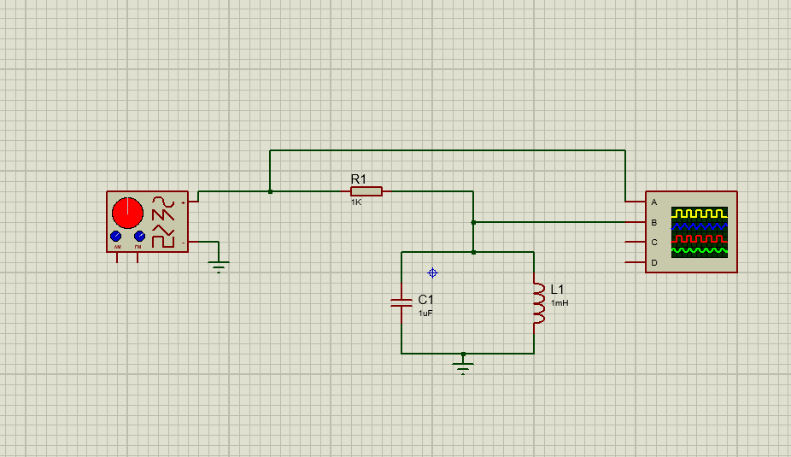
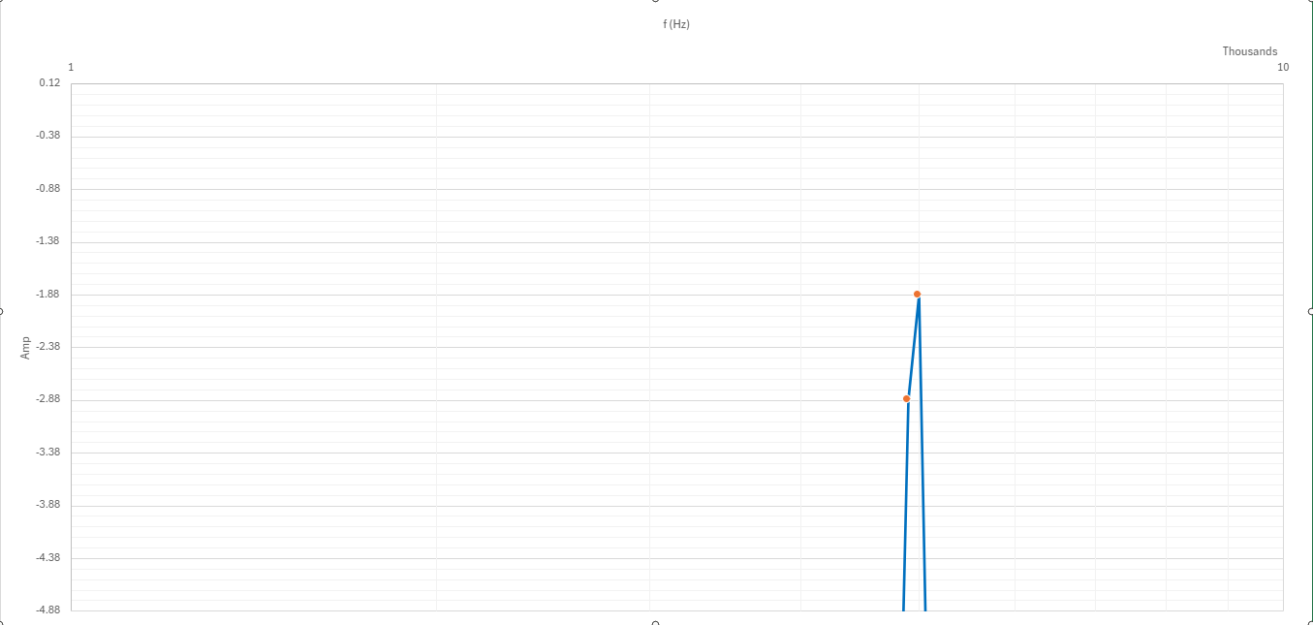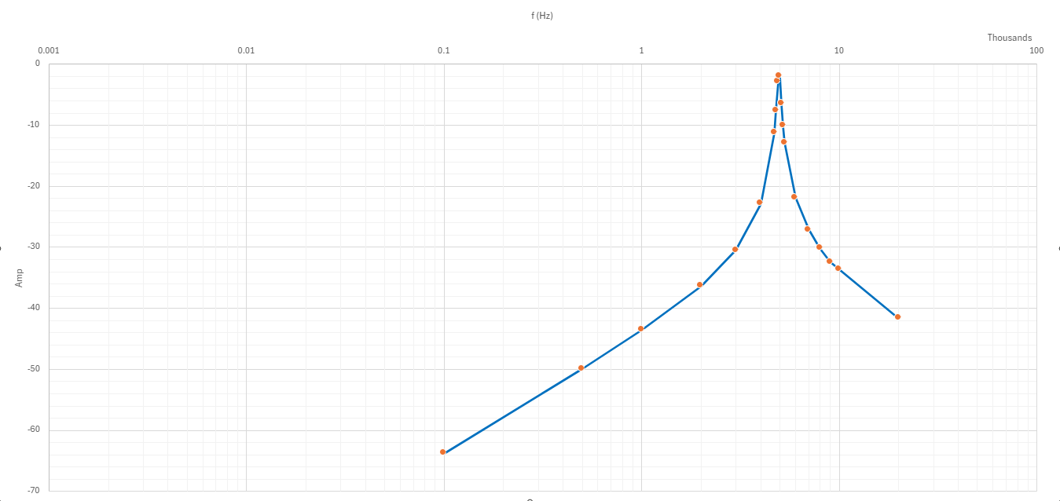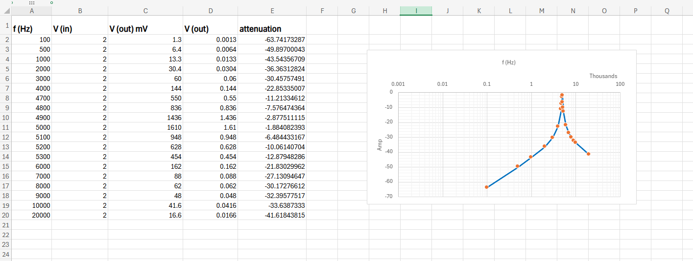
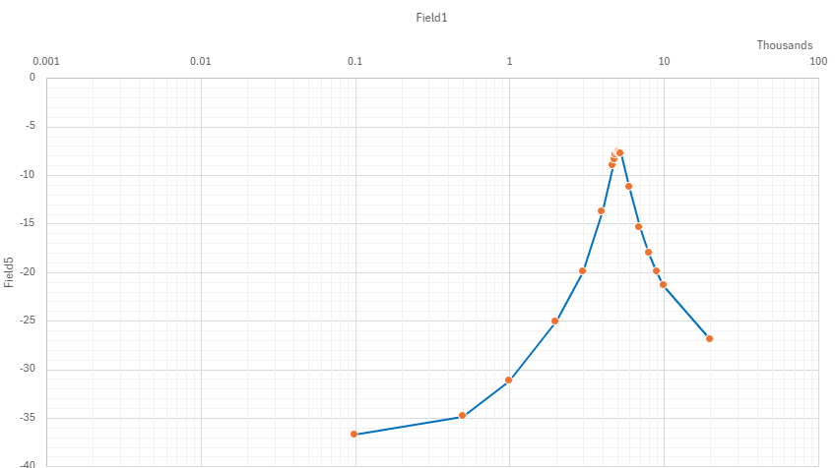
This is circuit and the test result in the lab



