Student Learning Log

Name: Muhammed Azizur Rahman
Student ID: 210783

Module Code: BMIH6002

Module: Managing Food and
Beverage Operations

Lecturer: Neil Dyer

Table of Contents
Introduction 3
Section 1: Reflection on Experience and Personal Development 3
Section 2 Critical Analysis of Work-Based Skills and Technical Knowledge 4
Section 3: Reflection on Organisational Issues 5
Section 4: Future Action Plan 6
Conclusion 7
References 8

Introduction
The study provides a critical reflection of supervisory positions in the food and beverages department. The reflection is oriented into four segments to address the work-based skills, technical knowledge and exceptional guest services. The study holds a reflection model, Donald Schon's reflection analysis.
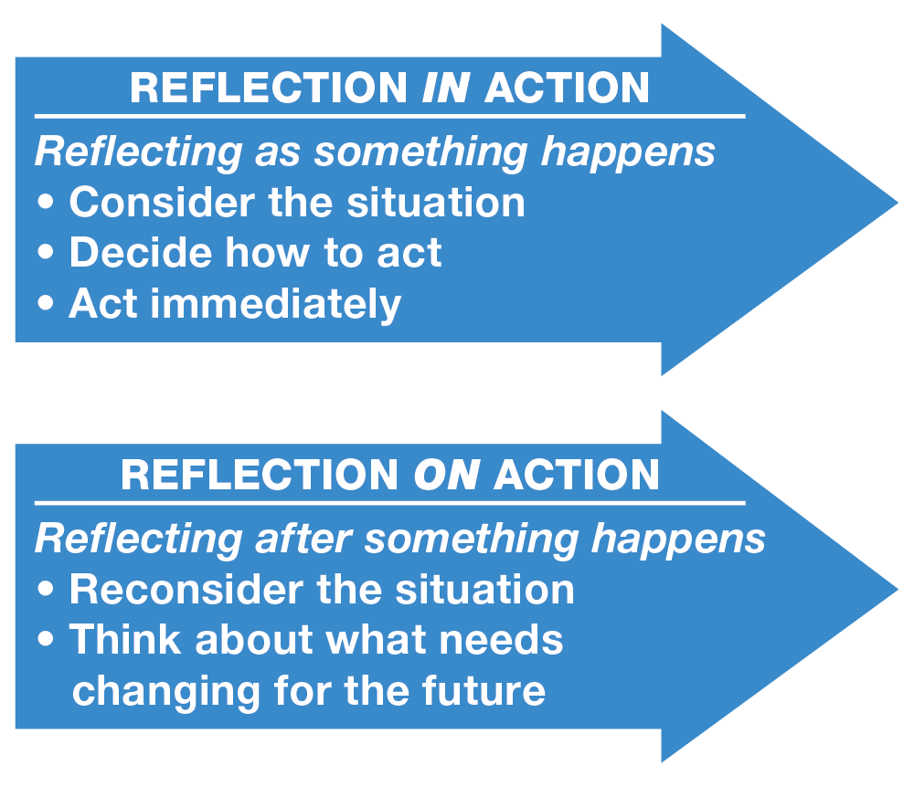
Figure: Donald Schon's reflection analysis (Ali and Aboelmaged, 2022).

Section 1: Reflection on Experience and Personal Development
As a staff-oriented food and beverages department, my primary concern is to take orders from the customers. I take orders and ensure accuracy in recording their food and beverage choices to personalize the service system. Based on the questions and curiosity, I answer calls from customers which are mainly menu-based (Brownlee, 2019). Often, I face customer conflicts and issues regarding service and food taste which I handle. I am engaged with clearing tables, resetting them and preparing for the next customer. In terms of technical expertise, I handle cash and process payments accurately through a cash register or POS system. To provide an efficient service system, I work in a collaborative mode with kitchen and bar staff. The goal of this approach is to coordinate the timing and delivery of food and drinks to ensure customer satisfaction. However, in terms of conducting these tasks, I needed to maintain kitchen hygiene, and standards to arrange tables for customers.

If I consider what I need to do in the following workplace, I must hold a professional and courteous attitude with customers and colleagues. I need to adapt to pressure situations where customers rush. Under that scenario, I needed to be patient and hold diplomacy in providing service. In order to articulate this pressure situation in a smooth scenario, I arrange dining areas and maintain a queue. I have witnessed staff movements, delegation of tasks and collaborative work. These approaches guided me to learn effective team dynamics (Demir and Dincer, 2020). I believe that team efficiency can create higher productivity. This can ensure my career development as well. To ensure customer satisfaction I often needed to communicate with customers and understand their food desires. The ability to communicate and understand the customer's desire also provides emotional intelligence which is a key attribute for a successful work environment. I found my experience in the food and beverages department provided this scope to develop my emotional intelligence which is practised through customer handling.

Section 2 Critical Analysis of Work-Based Skills and Technical Knowledge
The importance of work-based skills in meeting guest service standards cannot be overstated. Here I find effective communication is a key part. I needed to understand the customer's demands and put a note on their desire. By their order, I need to arrange the dishes for customers. In that process, I deliver the guidelines to our chef. Here communication is a key factor. Any mistake in this communication can dissatisfied customers and result in a bad reputation for the brand. I find it a key component in the following work experience (Francisco and Nuqui, 2020). Effective communication is also needed to be in a systematic process. I need to arrange my customers in a serial and category where I will deliver the menu cards to them. Based on their category I communicate their food desire to the chef. Without this systematic category, work efficiency doesn't get up to the mark. Therefore, systematic arrangement is another major feature of concern in work-based skills.

However, there are technical areas as well which require attention to provide customer satisfaction with the brand. In my food and beverages department, I handle the payment process as well. In the payment process, I am often required to provide invoice data to our cashier. In that process, I need to carry the codes and dish numbers which were previously ordered by customers (Brownlee, 2019). The proper accuracy of information here helps to create suitable billing for customers. When I reflect on a POS system, I am reminded of how it effortlessly calculates a customer's purchase amount, adds the necessary sales tax, efficiently processes the payment, and dutifully logs the time and date of the transaction (Guo et al., 2020). Once I finish the transaction, I often find that most POS systems automatically generate a receipt, both in paper and digital format. Additionally, these systems also update the inventory records accordingly. I have come to realize that POS systems serve as the contemporary iteration of cash registers.

Section 3: Reflection on Organisational Issues
Here one example is provided on organisational issues of the food and beverage industry.
Orders may get mixed up during busy times. I wonder if someone took the wrong order, the kitchen served it to the wrong table, or there was a miscommunication. I've learned that stresses and tensions in myself or others can cause situations like this. I think staying cool is essential to solving any problem. Being objective rather than blaming others is more beneficial. Avoid getting emotional and focus on solving the problem. First, I apologize to our valued guests for the order mix-up. Always promise them that I will personally double-check their order. After receiving their dish, I explain things in the kitchen (Kim and Shin, 2020). After a long wait, receiving the wrong order might be frustrating. I apologize for the delay and appreciate your patience. The restaurant is filled, which may be confusing. May I replenish your beverages or give you a free side dish while you wait? I recommend vocally clarifying orders with consumers before serving. This prevents confusion and ensures everyone is on the same page. Some restaurants place the order chit on the table and check off each dish as it's served. Interesting technique to track orders.
Here an associated theory or model is presented to the relevant organisational issue.

Situational Leadership
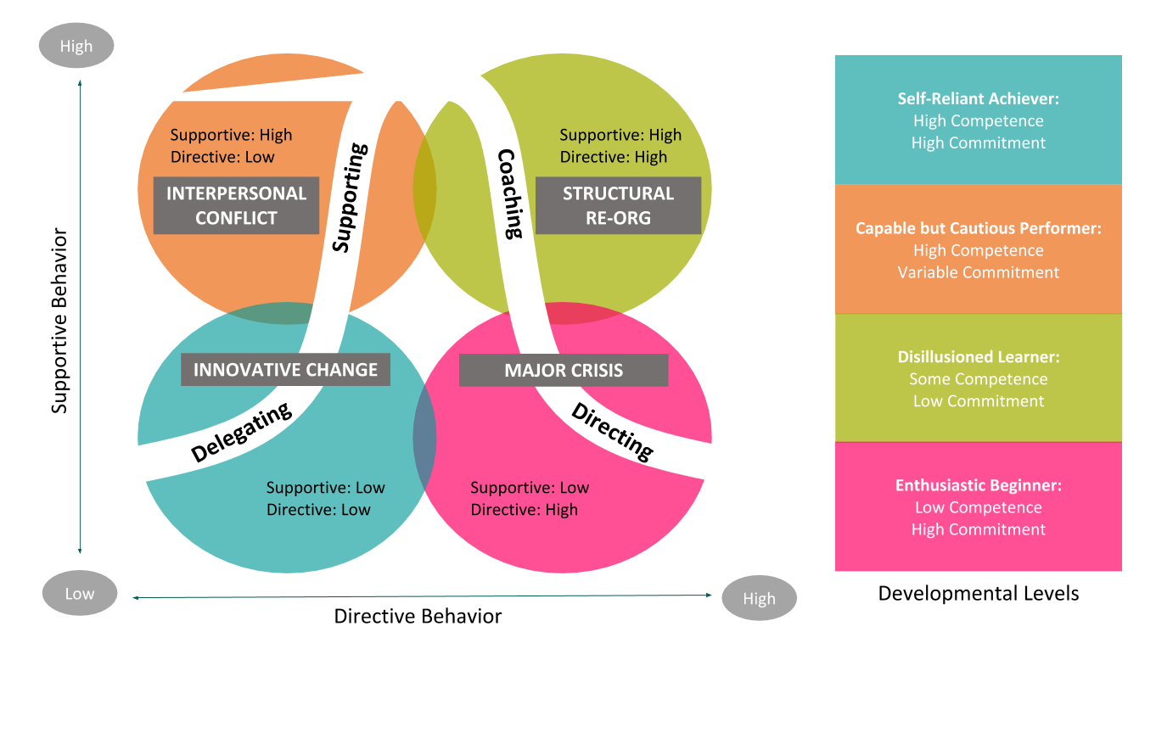
Figure: Situational Leadership method (Kim and Shin, 2020)
I find the situational leadership model to be a truly fascinating and effective approach to leadership. It places a strong emphasis on building and nurturing relationships, which I believe is crucial for successful leadership (Kim and Shin, 2020). I have found that as a leader, it is crucial to be adaptable and flexible in my approach. Understanding the unique needs and dynamics of each team member and situation allows me to tailor my leadership style accordingly. By doing so, I can effectively guide and support my team in the best possible way (Riegel et al., 2021). I have come to realize that the choice of leadership style can truly make a significant difference in the performance of a team. I have come to realize that choosing the appropriate leadership style for a given situation is essential to ensure the success of my team (Roy and Uekusa, 2020).

Section 4: Future Action Plan
Here some of my future action plan is provided.
Kitchen staff training: I believe it is important to organize training sessions for all kitchen staff to update our processing standards (Riegel et al., 2021). This will not only ensure that our food remains delicious but also maintain the safety and hygiene standards of our restaurant chain.

Learn from others: One of the finest methods to learn new skills and get insights is to observe and interact with other food and beverage professionals (Wuryani et al., 2021). This includes my employees and outsiders. Mentorship from top managers, online or offline forums and networks, workshops and seminars, and travelling to different areas might be helpful.

Keep up with trends: I find it crucial to stay updated with the ever-evolving and dynamic F&B industry. It's essential to be aware of the latest trends and innovations that can have an impact on our operations (Yan, 2020). I have found that there are numerous sources and platforms available to me to stay updated. These include industry publications, blogs, podcasts, social media, and online courses.

Conclusion
My tenure at Delta Hotel in the food and beverage area enhanced my work-related abilities, technical expertise, and standards of guest service. The significance of personal and vocational development in influencing future career aspirations within the guest service industry was emphasized.

References
Ali, I. and Aboelmaged, M. G. S. (2022) “Implementation of supply chain 4.0 in the food and beverage industry: perceived drivers and barriers,” International Journal of Productivity and performance management, 71(4), pp. 1426–1443.
Available at: https://doi.org/10.1108/ijppm-07-2020-0393
(Accessed: 17th Feb 24)

Brownlee, D. (2019) How the ‘best companies to work for’ engage employees and retain top talent, Forbes.
Available at: https://www.forbes.com/sites/danabrownlee/2019/09/04/how-the-best-companies-to-work-for-engage-employees-and-retain-top-talent/?sh=13b529c91eca
(Accessed: 3 Feb 2024)

Demir, Y. and Dincer, F. I. (2020) “The effects of Industry 4.0 on the food and beverage industry,” Journal of Tourismology, 6(1), pp. 133–145.
Available at: https://doi.org/10.1111/1541-4337.13227
(Accessed: 3 Feb 2024)

Francisco, C. D. and Nuqui, A. V. (2020) “Emergence of a Situational Leadership during COVID-19 Pandemic Called New Normal Leadership,” Online Submission, 4(10), pp. 15–19.
Available at: https://doi:org/10.3389/fpsyg.2022.919941
(Accessed: 3rd Feb 2024)

Guo, P. et al. (2020) “A review of project-based learning in higher education: Student outcomes and measures,” International Journal of Educational Research
Available at: https://doi:org/10.1016/j.ijer.2020.101586
(Accessed: 3rd Feb 2024)

Kim, J. H. and Shin, H. S. (2020) “Effects of self-reflection-focused career course on career search efficacy, career maturity, and career adaptability in Nursing students: A mixed Methods Study,” Journal of Professional Nursing: Official Journal of the American Association of Colleges of Nursing, 36(5), pp. 395–403.
Available at: https://doi:org/10.1016/j.profnurs.2020.03.003
(Accessed: 6th Feb 2024)

Riegel, B. et al. (2021) “Self-care research: Where are we now? Where are we going?” International journal of nursing studies, 116(103402), p. 103402.
Available at: https://doi:org/10.1016/j.ijnurstu.2019.103402
(Accessed: 3rd Feb 2024)

Roy, R. and Uekusa, S. (2020) “Collaborative autoethnography:‘Self-reflection’ as a timely alternative research approach during the global pandemic,” Qualitative Research Journal, 20(4), pp. 383–392.
Available at: https://doi.org/10.1108/QRJ-06-2020-0054
(Accessed: 18th Feb 2024)
Wuryani, E. et al. (2021) “Analysis of decision support system on situational leadership styles on work motivation and employee performance,” Management Science Letters, pp. 365–372.
Available at: http://doi:org/10.5267/j.msl.2020.9.033
(Accessed: 5th Feb 2024)

Yan, Z. (2020) “Self-assessment in the process of self-regulated learning and its relationship with academic achievement,” Assessment and evaluation in higher education, 45(2), pp. 224–238.
Available at: http://doi:org/10.1080/02602938.2019.1629390
(Accessed: 8th Feb 2024)

