

An Explainable Pre-Execution Ransomware Detection
Framework Using Static PE Header Analysis and Lightweight
Ensemble Learning

by
Md Sadikur Rahman Chowdhury

Supervisor: Munyaradzi Nicholas Murira
Second Marker: Kapilan Radhakrishnan

Project submitted as part of the requirements for the award of MSc Cybersecurity and Digital Forensics
September 2026

DECLARATION AND FORM OF CONSENT

DECLARATION
I, Md Sadikur Rahman Chowdhury, declare that I am the sole author of this Project; that all references cited have been consulted; that I have conducted all work of which this is a record, and that the finished work lies within the prescribed word limits.

This work has not previously been accepted as part of any other degree submission.

Signed: Md Sadikur Rahman Chowdhury
Date: 07/09/2026

FORM OF CONSENT
I, Md Sadikur Rahman Chowdhury, hereby consent that my Project, submitted in candidature for the M.Sc. Cybersecurity and Digital Forensics, if successful, may be made available for inter-library loan or photocopying, subject to the law of copyright, and that the title and abstract may be made available to outside organizations.

Signed: Md Sadikur Rahman Chowdhury
Date: 07/09/2026

ABSTRACT
Ransomware is a threat that continues to pose an operational and security risk as it can deny access to files, systems and services before it can be adequately responded to by the defenders. In this project, an explainable pre-execution ransomware detection framework based on simple and static features of the Windows Portable Executable header and ensemble learning is designed, implemented and evaluated. The PE Header Feature Dataset used was public. There were 2,157 samples in the local corrected experiment, 1,134 benign/goodware and 1,023 ransomware samples. The original family field was binned to create binary target and those fields that were deemed to be either target or leakage risk (ID, GR and target) were removed prior to modelling. The accuracy, precision, recall, F1-score, ROC-AUC, training time, prediction time, and the size of the model were used to train and compare the performances of the three algorithms Random Forest, XGBoost and LightGBM using five-fold cross validation. Next, the selected model was used with SHAP to help with transparent feature attribution analysis. The final holdout results indicated that the LightGBM model achieved the highest accuracy (0.9792), highest F1-score (0.9782), strong ROC-AUC (0.9978) and the shortest prediction time per sample, proving to be the most efficient and effective model among all the other models. LightGBM was also the best model in the corrected dataset, as shown by the cross-validation results. The study reveals that static PE-header features are useful during ransomware triage prior to execution, but only for the data set and experiment setting. Production deployment, universal ransomware detection or replacement of dynamic analysis is not claimed by the project. Further external validation, semantic feature mapping and adversarial robustness testing are recommended.

TABLE OF CONTENTS
Declaration and Form of Consent 2
Abstract 3
List of Figures 8
List of Tables 9
CHAPTER 1: INTRODUCTION 11
1.1 Introduction and Research Background 11
1.2 Static PE Header Analysis 12
1.3 Lightweight Ensemble Learning and Explainable AI 12
1.4 Research Problem Statement 12
1.5 Research Aim 13
1.6 Research Objectives 13
1.7 Research Questions 13
1.8 Contribution of the Study 13
1.9 Scope and Delimitations 14
1.10 Structure of the Study 14
1.11 Chapter Conclusion 14
CHAPTER 2: LITERATURE REVIEW 15
2.1 Introduction 15
2.2 Literature Review Methodology 15
2.3 Ransomware as a Detection Problem 18
2.3.1 Ransomware Attack Lifecycle 18
2.3.2 Ransomware Infection Chain 19
2.4 Ransomware PE Header Datasets 19
2.5 Static, Dynamic and Memory Analysis 20
2.5.1 Static Analysis 20
2.5.2 Dynamic, Behavioural and Memory Analysis 21
2.6 Machine Learning for Malware and Ransomware Detection 21
2.6.1 Random Forest, XGBoost and LightGBM 21
2.6.2 Evaluation Metrics and Validation 22
2.7 Explainable Artificial Intelligence in Malware Detection 22
2.8 Robustness, Evasion and Practical Risk 23
2.9 Literature Themes and Project Alignment 23
2.10 Chapter Conclusion 24
CHAPTER 3: METHODOLOGY 25
3.1 Introduction 25
3.2 Research Strategy 25
3.3 Research Design 27
3.4 Hardware and Execution Environment 27
3.5 Software 28
3.6 Experiment Inputs 28
3.7 Experiment Process 29
3.8 Validity, Reliability, Ethics and Safety 30
3.9 Chapter Conclusion 30
CHAPTER 4: DESIGN AND IMPLEMENTATION 31
4.1 Introduction 31
4.2 Detection Framework Design 31
4.3 Data Preparation 32
4.4 Model Formulation 32
4.5 Model Translation and Workflow 33
4.6 Validation and Quality Controls 33
4.7 Experimentation 34
4.8 Chapter Conclusion 34
CHAPTER 5: RESULTS AND DISCUSSION 35
5.1 Introduction 35
5.2 Corrected Holdout Test Results 35
5.3 Error Pattern and Confusion Matrix 36
5.4 ROC Curve Analysis 36
5.5 Efficiency and Model Size 37
5.6 Five-Fold Cross-Validation 38
5.7 SHAP Explainability Results 39
5.8 Practical Interpretation of the Selected Model 41
5.9 Discussion Against the Research Questions 42
5.10 Chapter Conclusion 42
CHAPTER 6: RECOMMENDATIONS, CONCLUSION AND LIMITATIONS 44
6.1 Introduction 44
6.2 Recommendations 44
6.3 Conclusion 45
6.4 Limitations 46
6.5 Suggestions for Further Work 46
6.6 Chapter Conclusion 46
CHAPTER 7: REFLECTION 47
7.1 Introduction 47
7.2 Reflection on the Research Process 47
7.3 Reflection on Implementation 47
7.4 Reflection on Critical Judgement 47
7.5 Future Personal Development 47
7.6 Chapter Conclusion 47
References 49
Appendices 53

LIST OF FIGURES
Name | Page
Figure 1. Literature selection process used for the ransomware PE-header review. | 17
Figure 2. Corrected class distribution after binary target mapping. | 20
Figure 3. Research onion framework adapted from Saunders, Lewis and Thornhill [59]. | 26
Figure 4. Detection framework design for the ransomware PE-header artefact. | 31
Figure 5. Implementation workflow for the ransomware PE-header detection artefact. | 33
Figure 6. F1-score comparison across the corrected models. | 35
Figure 7. LightGBM confusion matrix from the corrected holdout test. | 36
Figure 8. Combined ROC curve for Random Forest, XGBoost and LightGBM. | 37
Figure 9. Prediction time per sample comparison. | 38
Figure 10. Saved model size comparison. | 38
Figure 11. Five-fold cross-validation F1-score comparison. | 39
Figure 12. SHAP summary bar plot for the selected LightGBM model. | 40
Figure 13. SHAP beeswarm plot for the selected LightGBM model. | 41
Figure 14. Recommendation framework for safe use of the static PE-header detection artefact. | 45

LIST OF TABLES
Name | Page
Table 1. Inclusion and exclusion criteria used for literature selection. | 16
Table 2. Databases and source repositories searched for the literature review. | 16
Table 3. Keywords and search strings used to retrieve relevant literature. | 16
Table 4. Literature evidence map aligned with this project. | 18
Table 5. Critical appraisal of selected ransomware and PE-based malware detection studies. | 23
Table 6. Literature themes aligned with the research objectives and research questions. | 23
Table 7. Research strategy mapping using the research onion. | 27
Table 8. Execution environment recording approach. | 28
Table 9. Software and library stack. | 28
Table 10. Dataset facts used in the corrected experiment. | 29
Table 11. Model evaluation plan. | 30
Table 12. Design requirements and implementation decisions. | 32
Table 13. Corrected feature preparation summary. | 32
Table 14. Corrected holdout test performance for the three models. | 35
Table 15. Corrected efficiency comparison. | 37
Table 16. Five-fold cross-validation summary. | 38
Table 17. Top ten SHAP feature indices for the selected LightGBM model. | 39
Table 18. Recommendations and future work. | 45

ACKNOWLEDGEMENTS
I would like to express my sincere gratitude to my supervisor, Munyaradzi Nicholas Murira, for his guidance, feedback and support throughout this project. His comments helped me refine the research scope, improve the literature review, strengthen the methodology and present the implementation evidence more clearly.
I am also grateful to the lecturers and staff of the University of Wales Trinity Saint David for their teaching and academic support during the MSc programme. Finally, I would like to thank my family and friends for their encouragement during the project period.

CHAPTER 1: INTRODUCTION

1.1 Introduction and Research Background
Ransomware is one of the most destructive types of malware as it is specifically engineered to prevent access to files, systems or services until a ransom demand can be made. It is not only a technical issue. It can disrupt normal business operations, result in the loss of money, impose legal pressures and erode public confidence. Ransomware is a severe security and resilience problem, and this may help justify the need for detection methods that can prevent a suspicious executable from running [1], [2]. Ransomware detection framework should not be evaluated based on the ability to classify a ransomware sample as malicious or not. Additionally, it must be evaluated if it can provide a safe, efficient and transparent defensive flow. Malware analysis techniques are often reliant on running or watching malware. Dynamic analysis and Sandboxing can provide valuable insight into what activities a particular process carries out at runtime, such as file writes, process creation, registry changes and network activity. They also, however, need controlled environments and a more extended period and a careful management of safety [3]. Static analysis is the process of analyzing a file or features extracted from a file without running the program. This difference is significant for this project because the goal of the project is to classify suspicious Windows executable evidence prior to running it. Static analysis is not a replacement for dynamic analysis but can help de-risk and aid in early triage when time and safety are a critical concern. This study will be targeted on the Windows Portable Executable files. PE is the normal executable file format for Windows executable images, object code and dynamic-link libraries. PE files contain information organized into structure elements like headers, optional headers and the optional sections [4]. They can be used to represent numeric features for malware detection research. The previous work has demonstrated that there are features that can be extracted from an executable and make it possible to use supervised classification to categorize malware [5] - [7]. However, the static features need to be dealt with carefully. Some of these fields might not be as useful as evidence of malware behavior as metadata or target-related identifiers. The research of ransomware specific PE-headers is relevant to this study. Moreira et al. explored the use of PE-header information to detect ransomware and published a public dataset of PE-header features for goodware and ransomware samples [8], [9]. Their findings contradict the notion that ransomware are indistinguishable from legitimate software, using PE-header evidence to help them. For this project, the following lesson was learned: Evidence of PE is promising, and the model selection and evaluation design need to be carefully considered. This project therefore does not follow the same deep-learning path. Rather, it is a comparison of lightweight ensemble models, with the addition of explainability. Random Forest, XGBoost and LightGBM are chosen as the models. Random Forest is an ensemble of decision trees, which helps to overcome the drawback of a single tree [10]. XGBoost is a scalable gradient boosting with regularisation and efficient training procedure [11]. LightGBM is another gradient boosting method, which was designed to be efficient trained on the high dimensional data [12]. From this project, these models will be regarded as potential classifiers. They are not recommended as a 'one size fits all' ransomware remedy. Another is explainability. A model that may be very accurate, but whose decision may not be examined, may not be trusted. In cybersecurity, it is essential because if there is a false positive it would disrupt the normal operations while a false negative would mean that the malicious file could continue through. SHAP offers a feature-attribution approach to explain the impact of features on model predictions [13], [14]. To demonstrate the SHAP explanation of the selected model, the features of the PE-header are calculated in this study and applied to SHAP after the model selection process. The interpretation is kept conservative since SHAP is an explanation of model behaviour, and not an actual explanation of the cause of the ransomware behaviour in reality.

1.2 Static PE Header Analysis
This project is appropriate for static PE header analysis since it enables a PE executable that is suspected to be malicious to be analyzed without it being run. Windows executables have structured fields which can be extracted and translated back to numbers. Such values can represent image properties, section information, header values and other values of the file-structure. This type of information can be useful in a defensive workflow for triaging a file prior to running it. This is the pragmatic answer as to why the project concentrates on pre-execution evidence, rather than on runtime behaviour. The approach has its drawbacks, too. It might be possible to hide important behavior in the malware using packing or obfuscation methods at runtime [16]. Ransomware strains can also evolve over time and a trained model for one type may not be able to be generalised to other types. With this in mind, the project will focus on a static classification artefact with a PE-header. It is not designed to be used in place of dynamic/anomaly analysis or memory analysis or a commercial endpoint security platform.

1.3 Lightweight Ensemble Learning and Explainable AI
Lightweight ensemble learning is applicable since pre-execution screening pays off on accuracy, speed and not unnecessarily large models. Random Forest, XGBoost and LightGBM are good options given that they are applicable to tabular numerical data and have been explored in the supervised learning literature [10], [12]. In addition to the accuracy, precision, recall and F1 score, this project includes the training time, prediction time, and model size. This is the practical aspect which is crucial; a classifier could be correct, but not necessarily suitable for rapid triage. The black-box problem is addressed through use of Explainable AI. SHAP doesn't pinpoint the actual cause of a ransomware attack. Rather it provides the explanation of trained model distribution of contribution on the input features [13], [14]. This helps to interpret the selected classifier. In addition, it is useful to see how much of the model's results stem from a few important features, when evaluating for potential leakage or a reliant set of data features.

1.4 Research Problem Statement
A problem that needs to be solved is the lack of a ransomware detection technique that can enable safe, efficient and explainable pre-execution screening. Dynamic analysis and behavioural monitoring are useful because it is able to watch the behaviour of malware during execution. But they need to be run in an isolation environment and could not be aware of ransomware until the activity has begun [2], [3]. Early detection is better and safer using static PE-header based detection, as it is based on structural information that does not need to be run. Meanwhile, static machine learning can generate suboptimal conclusions when metadata is available in the dataset that is related to the target, when there is poor validation, and when the model does not include an explanation. Current ransomware and malware research include very good classification results, but a high score doesn't necessarily mean a high performance ransomware or malware. This is because a dataset might be separable, because the split turns out to be favourable, or because the features contain some class information due to the use of identifier like fields. As such, this research employs a modified experimental procedure. It incorporates a public ransomware PE-header dataset, eliminates certain metadata leakage-risk and target style fields, performs a comparison on three different classification models (Random Forest, XGBoost and LightGBM), and assesses model performance and efficiency, along with interpreting the selected model with SHAP.

1.5 Research Aim
This research aims to design, implement and evaluate an explainable pre-execution ransomware detection framework using static Windows PE header features, lightweight ensemble learning models and SHAP-based feature attribution.

1.6 Research Objectives
Objective One: To critically review current literature on ransomware detection, static PE header analysis, machine learning malware classification, lightweight ensemble learning and explainable artificial intelligence.
Objective Two: To design and implement a supervised binary classification artefact using a public ransomware PE header feature dataset, Random Forest, XGBoost and LightGBM.
Objective Three: To evaluate and compare the selected models using accuracy, precision, recall, F1-score, ROC-AUC, training time, prediction time, model size and five-fold cross-validation.
Objective Four: To apply SHAP-based explanation to the selected model in order to identify influential PE-header feature contributions and support transparent interpretation of ransomware classification.

1.7 Research Questions
RQ1: How effective are static PE header features for distinguishing ransomware samples from benign executable samples before execution?
RQ2: Which selected lightweight ensemble model, among Random Forest, XGBoost and LightGBM, provides the most suitable balance between detection performance and computational efficiency for this dataset?
RQ3: Which anonymised PE-header features contribute most strongly to ransomware predictions according to SHAP-based feature attribution?
RQ4: To what extent can SHAP-based explanation support transparent ransomware classification in a static pre-execution detection framework?

1.8 Contribution of the Study
The study's significant contribution is an experimental artefact that can be reproduced, which provides a classification of ransomware and goodware using static features in the PE-header. The project doesn't set out to create a commercial security product ready to go on the market. It offers a controlled comparison of three lightweight ensemble models to a ransomware specific PE-header dataset. It also implements a leakage aware workflow, where it discards metadata and target style fields prior to the model training. This enhances the educational value of the experiment as the end of experiment assessment is towards more suitable features for the realistic screening setting. The second contribution is the one of performance and efficiency and interpretability. Most malware literature revolves around the predictive performance aspect. The training time, prediction time and model size are also taken into account in this study since a pre-execution classifier should be efficient as well as accurate. Then it uses SHAP to generate insights into feature contribution for the chosen model, in a way that is transparent. The study has thus far provided an evidence based workflow which can be analyzed, vetted and built on, without engaging actual ransomware samples.

1.9 Scope and Delimitations
The project only utilizes a public, pre-extracted Windows PE header feature set, and is restricted to binary classification. The positive class is those files that are ransomware and the negative class is those files that are benign or goodware. The project does not run malware, do dynamic sandboxing, do memory forensics, collect network traffic and deploy a production EDP system. Furthermore, it will not conduct ransomware family-level classification as its primary objective is to be able to conduct pre-execution screening against ransomware-versus-goodware. Another type of delimitation is found in the area of interpretation of features. Numerical feature columns are present in the data set, and many corrected feature names have been anonymised and/or numbered. The study can then speak to model level feature contribution but cannot guarantee detailed semantic meanings for each PE field without a corresponding meaning in the dataset documentation. Higher levels of generalisation would need external validation with other datasets, and a controlled deployment study.

1.10 Structure of the Study
This chapter introduces the background of the research, problem statement, aim and objectives, research questions, contribution and scope. Chapter Two summarizes the literature regarding ransomware, static PE analysis, ransomware datasets, machine learning, evaluation and explainable AI. The explanation of the research strategy, design, environment, tools, dataset, experimental process, validity, reliability, ethics and safety controls are explained in Chapter Three. It outlines the process of designing and making the artefact in Chapter 4. The corrected results are reported and discussed in chapter Five. Recommendations, Conclusion, limitations and future work are provided in Chapter Six. Chapter Seven is a reflection on the technical, academic and professional learning of the project.

CHAPTER 2: LITERATURE REVIEW

2.1 Introduction
In this chapter, literature is critically reviewed to make sure that the project will be able to carry out all four objectives. It's a discussion of the ransomware being a detection problem, why static PE-header analysis is relevant to pre-execution screening, a review of public malware and ransomware datasets, and a discussion of machine learning and explainable AI approaches relevant to the proposed artefact. The interaction of selected systematic search principles and a narrative literature review is used in the chapter. This approach is used because there is a need for a transparent and focussed review of the project but without the need to undertake a full systematic review or meta analysis. The literature review is also employed to include a research voice. Thus, the chapter is not just a list of previous authors' work. It discusses the value and limitations of the principal works, and identifies lessons learned that can be utilized in this project, and its decision to build the final experiment around leakage-aware static PE-header classification using lightweight ensemble models. The research gap is summarised and the various themes of the main literature are summarised and related to the research objectives and the research questions at the end of the chapter.

2.2 Literature Review Methodology
The concepts from the SLR guidance were used to guide in a transparent, repeatable and project topic focused search process [39, 40]. This review was not intended to be a comprehensive systematic review and meta-analysis. Rather, the principles of systematic search were applied to guide source selection, the definition of inclusion/exclusion criteria and the recording of the databases searched, and to organise the literature within themes that help to meet the research objectives. Five questions were used for conducting the review. What is the rationale behind why ransomware is hard to detect prior to malicious activity? Secondly, what applications have been employed in malware and ransomware detection, based on static PE analysis and PE-derived features? Third, what machine learning techniques work well for classification for tabular PE-header features? Fourth, what role can explainable AI play in the process of interpretation and trust in ransomware categorization? Last but not least, what gaps do current studies show in terms of methodology on leakage control, efficiency measurement, validation and modelling explanation?
Criteria area | Included | Excluded
Topic relevance | Ransomware, Windows PE files, static malware analysis, PE-header features, supervised learning, evaluation metrics and explainable AI. | General cybersecurity papers with no clear link to ransomware, malware detection, PE analysis or model evaluation.
Date range | Mostly 2019-2026 sources, with older seminal work used for methods, models, metrics and PE concepts. | Older sources with no continuing methodological or technical relevance unless they are seminal.
Source quality | Peer-reviewed journals, conference papers, recognised preprints and official documentation from trusted organisations. | Unverified blogs, marketing pages and sources without accessible bibliographic details.
Technical fit | Windows PE files, static analysis, tabular features, ensemble learning, ransomware detection and explainability. | Android-only, IoT-only, cloud-only or network-only studies unless used briefly for contrast.
Availability | Sources with a DOI, publisher page, official repository, official documentation page or stable accessible metadata. | Records with unclear authorship, weak publication information or no usable source details.
Table 1. Inclusion and exclusion criteria used for literature selection.
The table 2 shows the primary academic literature sources that were chosen to be included in the literature review. Selected literature review papers for this project are included in this table, but official documentation, software manuals and method references are not included if they are used to support the project. This would prevent the misleading impression that all of the materials in the final reference list are empirical and/or survey papers.
Database / source repository | Selected academic sources | Main contribution to the review
IEEE Xplore | 8 | Recent ransomware detection papers, model evaluation studies and security-focused machine learning work.
ACM Digital Library | 5 | Ransomware behaviour studies, XGBoost source material and black-box explanation research.
ScienceDirect / Elsevier | 7 | Computers & Security, JNCA and JISA papers on malware detection, PE analysis and ransomware classification.
SpringerLink | 5 | Design science, adversarial learning and malware analysis studies.
Google Scholar snowballing | 8 | Backward and forward searching from key ransomware, PE-header, SHAP and malware detection papers.
arXiv / recognised preprints | 4 | EMBER, SOREL, adversarial PE malware detection and recent technical machine learning sources.
Official security reports used as context | 3 | CISA, NIST, ENISA and MITRE guidance used for background and defensive context.
Table 2. Databases and source repositories searched for the literature review.
Search area | Defined keywords and example search strings
Ransomware detection | (ransomware OR crypto-ransomware) AND (detection OR classification) AND (machine learning OR static analysis)
PE-header analysis | (portable executable OR PE header OR PE file) AND (malware detection OR ransomware detection)
Static malware analysis | (static analysis) AND (Windows executable OR PE file) AND (machine learning OR supervised classification)
Lightweight models | (Random Forest OR XGBoost OR LightGBM) AND (malware OR ransomware OR PE features)
Explainability | (SHAP OR explainable AI OR feature attribution OR interpretability) AND (malware detection OR ransomware detection)
Datasets | (EMBER OR SOREL OR Ransomware PE Header Feature Dataset) AND (Windows PE OR malware)
Table 3. Keywords and search strings used to retrieve relevant literature.
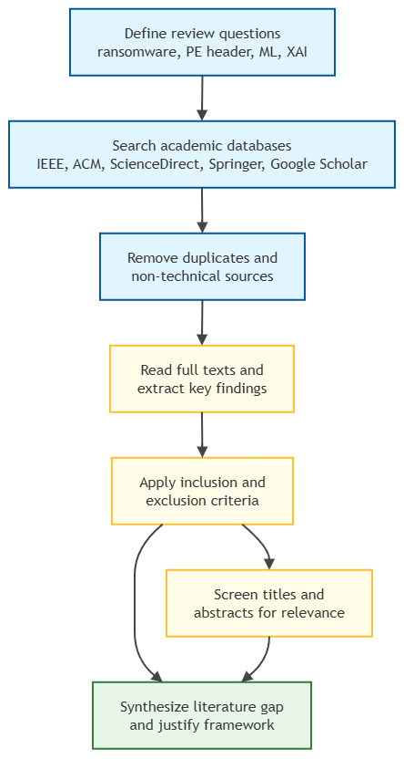
Figure 1. Literature selection process used for the ransomware PE-header review.
The literature was screened and the literature organized thematically, not paper-by-paper. This enabled the review to make comparisons of approaches and gaps rather than to simply identify studies with no synthesis. Ransomware threat and timing, ransomware infection routes, static PE-header analysis, ransomware datasets, lightweight machine learning, model evaluation, leakage control and SHAP-based explainability are the main themes.
Evidence group | References used | Role in the project
Ransomware threat and guidance | [1], [2], [17]-[24] | These sources define the operational risk of ransomware, attack timing and behavioural detection context.
Static malware and PE evidence | [3]-[9], [15], [16], [25]-[29], [36] | These sources support static analysis, PE-derived features, ransomware PE-header datasets and broader malware benchmarks.
Machine learning and evaluation | [10]-[12], [30]-[32], [68]-[75] | These sources justify tabular models, ensemble learning and evaluation beyond accuracy.
Explainability and trust | [13], [14], [33]-[35], [66], [67], [76]-[81] | These sources justify SHAP and explain why explanations should not be treated as causal proof.
Methodology and reproducibility | [39]-[43], [51]-[65] | These sources support structured review, design science, Python workflow, software libraries and report formatting.
Robustness and wider malware context | [82]-[100] | These sources support the discussion of adversarial pressure, behaviour-based malware evidence and future validation.
Table 4. Literature evidence map aligned with this project.

2.3 Ransomware as a Detection Problem
Ransomware typically is defined as a type of malware that prevents access to files, systems or services and requires a ransom to regain access. The user and/or organizational data can be encrypted using crypto-ransomware and the system and/or interface access can be restricted by locker ransomware [17], [18]. Modern campaigns are frequently related to broader criminal activities such as initial access, credential abuse, data theft and double extortion. This is because ransomware is more than just one ransomware file. It is a series of events that can occur prior to encryption and/or following the theft or disruption of systems [1], [19]. The ransomware behaviour can be hard to detect as it may be seen at the end of the attack. This highlights the importance of runtime monitoring as seen in behavioural systems like CryptoDrop, ShieldFS and RWGuard which are able to see ransomware-like file-system activity once the system has been executed [22]-[24]. These are not, however, pre-execution screening methods. A static classifier can aid the previous stage of the triage by analyzing the executable prior to its execution, but it cannot directly observe its runtime behavior. The literature also indicates that there are a number of other signals that can be used for the detection of the ransomware. There are some methods that rely on file-system action, changes in entropy, API calls, registry events, process activity, or network activity. The static approaches include byte sequences, strings, imports, sections, headers or PE-derived metadata [25, 26]. There is a compromise for each evidence source. Behavioural evidence is more likely to be the actual malicious behaviour, but it will only be executed or witnessed. Static evidence is easier to gather and quicker, but it can not capture all types of behaviour (packing), or only those that occur while the application is running.

2.3.1 Ransomware Attack Lifecycle
Delivery or initial access is a very common part of ransomware attacks. Attackers can exploit remote services [19] that are compromised, phish, use malicious attachments, steal credentials, or obtain services with exposed ports [1]. Once access is gained, the attacker can create persistence, compromise other privileges, traverse horizontally and look for any valuable data. In many of the current incidents, prior to the encryption, data is exfiltrated which can induce disclosure pressure and loss of availability to the victim [17]-[19]. This implies the need for detection before people start acting destructively, and this lifecycle can be used for that purpose. A pre-execution classifier is not a complete incident response system, but can play a role in improving the timing of a decision in a layered defence strategy.

2.3.2 Ransomware Infection Chain
Malicious documents, malicious scripts, malicious loaders, malicious droppers, packed binaries or direct executable payload [19, 25] all could be part of the infection chain. The Campaign can start with a document/script and then later, a Windows PE artefact can be a payload, loader or support piece. This is important because the data set on which the tools in this guide are based is oriented towards features of the Windows PE header instead of email content, network logs or memory images. The project does not assert that all of the ransomware infection chains will be initiated with a PE file. It examines a more limited, but significant, case: executable samples that are subject to inspection prior to execution.

2.4 Ransomware PE Header Datasets
The conclusions that can be drawn from the dataset used in malware detection is heavily dependent on the dataset used. Important research on static PE malware learning [27, 28] has been enabled by general windows PE malware datasets like EMBER and SOREL. They, however, are general malware datasets and not for ransomware only datasets for PE-header. A ransomware-specific dataset is more relevant to this project, as the research problem is ransomware vs. goodware classification within this project, instead of malicious vs. benign classification in general. The primary data source for this project is the Ransomware PE Header Feature Dataset, Version 3 (available on Mendeley data 10.17632/p3v94dft2y.3 [9]). It is related to the PE-header ransomware study of Moreira et al. [8]. 2,157 records were loaded to the local experiment. All family values, other than 0, were identified as ransomware in the corrected binary mapping.The corrected binary mapping classified family value 0 as benign or goodware and all other family values as ransomware. It resulted in 1,134 benign/goodware samples and 1,023 ransomware samples. Currently the classification up to family is not done. Subsequently, a similar work was carried out by Moreira et al, which extended the ransomware detection by including structural PE features, and a different combined structural feature set was provided for additional research in the ransomware field [36], [46]. The take-home message from Moreira et al. is that a ransomware-specific PE-header detection can serve as a good base for detecting ransomware [8], [9]. The point of the lesson though is not to use the same data set and to report a high score. It is also important to take care with the handling of features, as columns or groups of information that are designed to identify the classes (such as identifier, group label, target-related columns) might not be evidence in the PE-header and can be used to separate different classes. The new evaluation focus in the present project is the corrected results at the end of the experiment where fields for ID, GR and target-style leakage-risk are excluded.
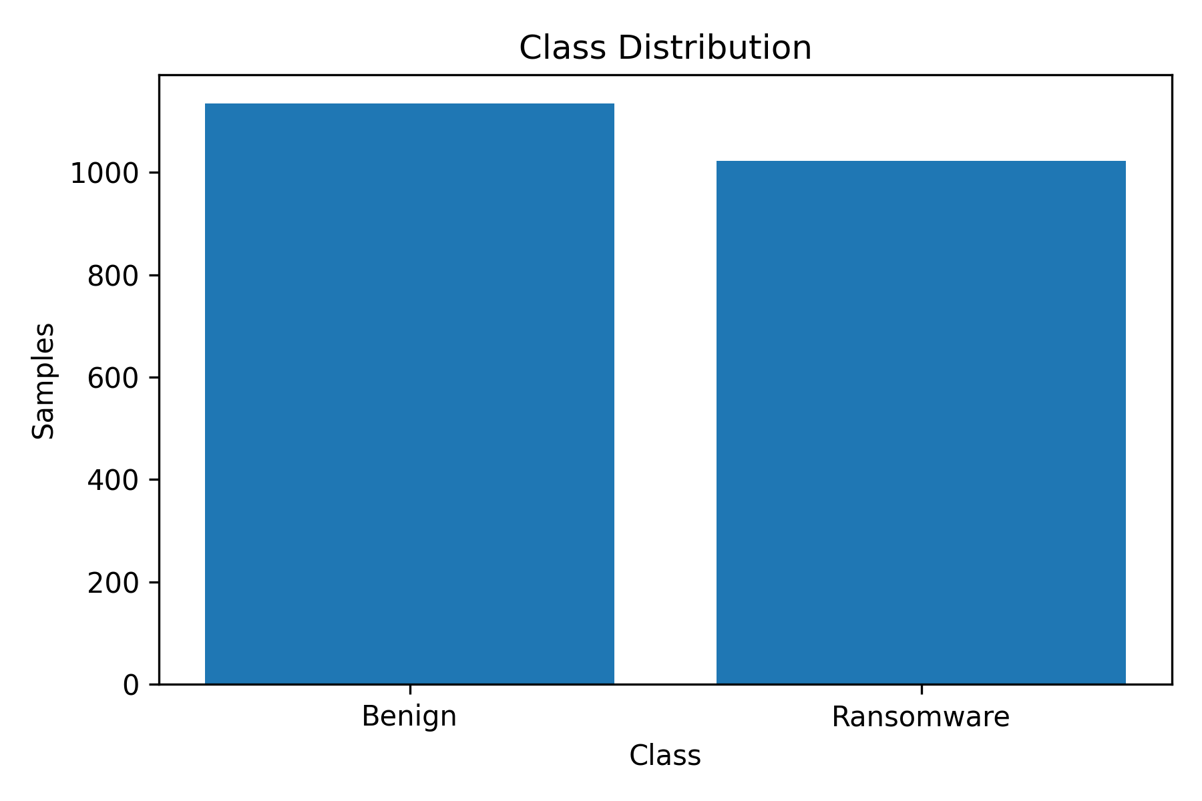
Figure 2. Corrected class distribution after binary target mapping.

2.5 Static, Dynamic and Memory Analysis
There are three main areas of malware analysis that can be talked about: Static analysis, Dynamic analysis, Memory analysis. Static analysis is a type of analysis that looks through a file without running it. Dynamic analysis: It is used to watch the behavior of the program in a controlled environment during execution. Volatile memory analysis is used to find runtime artifacts like active processes, loaded modules, injected code, and network-related artifacts [3], [15], [16]. These methods are similar but not the same type of evidence.
Dynamic and memory analysis can be useful for ransomware detection as it can identify changes to the file system, registry, processes, or communication with an external infrastructure [20], [24]. But they need to be executed or to be observed at runtime. This affords a different safety and experimental requirement. This project is more appropriate for static analysis as it is a pre-execution screening project. Instead, the project is geared towards analysing PE-header feature evidence prior to the execution of a suspicious executable. This isn't to say that static analysis is superior in all cases. Instead, it is only in this particular scope of the present study that the static analysis proves relevant.

2.5.1 Static Analysis
Examples of static analysis techniques are header inspection, string extraction, import table analysis, section analysis, entropy calculation and byte-level feature extraction [15, 16]. PE-header analysis is a subset of static analysis in that it only deals with structured fields in Windows executables, such as those pertaining to executable image structures described in the Microsoft Windows development material [50]. These fields can be extracted and are numerical features that can be used for supervised learning. Previous studies in malware analysis demonstrated that features of an executable can be used to classify a malware sample [5]. Raw byte, deep learning and PE-structure techniques have been explored for classification [6, 7, 27]. Static PE-header analysis is selected for this project for three reasons. First, it is congruent with PRE-execution detection as the sample doesn't have to execute. Secondly it is appropriate for tabular machine learning as it has numerical feature columns. Third, there is less risk for experimentation with the project as pre-extracted features are used, rather than handling and executing live ransomware payloads. The advantages are not exempting the restrictions. Packed or obfuscated binaries may contain a significant amount of useful information that is concealed, and static classifiers can be affected by distribution shift due to the emergence of new ransomware families that may differ from the training sets [29].

2.5.2 Dynamic, Behavioural and Memory Analysis
Dynamic and behavioural analysis are used to study the behaviour of a program while it is executed. Ransomware research could involve ransomware techniques, such as file encryption, mass file writes, uncommon file renaming, process generation, registry editing, trying to disable recovery capabilities, and communication with external infrastructure [20]-[24]. Memory analysis can give evidence of running processes, injected code, open network connections and artefacts which may only occur after the program has executed [15], [16]. Although these methods are significant, they are not equal to the pre-execution research end of this project. They need a different type of evidence, and a different experimental set up. Because of this, they are not to be used as implemented methods, but as comparison methods.

2.6 Machine Learning for Malware and Ransomware Detection
Random Forest is an ensemble method using random sampling of training sets (bagging) to grow many decision trees and use their predictions to make one prediction [10]. XGBoost is a scalable tree boosting system, which sequentially constructs trees and enhances performance by only considering the errors made in the previous tree [11]. Another gradient boosting framework that is well suited to train large and high dimensional data is lightGBM [12]. The models are able to be used in the corrected PE-header feature matrix where it is high dimensional and numerical. They also enable direct comparison of the performance of the detectors, speed of the inference and the model size. The lesson from the model literature is that reputation is not an adequate criterion with which to choose the best model. Random forest is a good baseline method, XGBoost is one of the good boosting methods and LightGBM is an efficient structured data method [10]-[12], [68]-[74]. Hence the project includes the assessment of all three with the same corrected workflow. This results in an evidence-based end selection.

2.6.1 Random Forest, XGBoost and LightGBM
Random Forest is an ensemble method using random sampling of training sets (bagging) to grow many decision trees and use their predictions to make one prediction [10]. XGBoost is a scalable tree boosting system, which sequentially constructs trees and enhances performance by only considering the errors made in the previous tree [11]. Another gradient boosting framework that is well suited to train large and high dimensional data is lightGBM [12]. The models are able to be used in the corrected PE-header feature matrix where it is high dimensional and numerical. They also enable direct comparison of the performance of the detectors, speed of the inference and the model size. The lesson from the model literature is that reputation is not an adequate criterion with which to choose the best model. Random forest is a good baseline method, XGBoost is one of the good boosting methods and LightGBM is an efficient structured data method [10]-[12], [68]-[74]. Hence the project includes the assessment of all three with the same corrected workflow. This results in an evidence-based end selection.

2.6.2 Evaluation Metrics and Validation
The detection of malware cannot be solely based on the accuracy of the detection. It may obscure significant error patterns particularly when the consequences of a false-positive and false-negative are different. Precision refers to the number of the predicted ransomware samples that are actually ransomware; recall refers to the number of ransomware samples that are actually identified. F1-score is a compromise between precision and recall and ROC-AUC measures ranking ability against thresholds [30, 31, 72]. To get a more stable view, training and testing is repeated across several folds using cross-validation [32]. In this project, 5 fold cross validation after the holdout evaluation is used. This won't be external generalisation, but it does lessen the reliance on one split.

2.7 Explainable Artificial Intelligence in Malware Detection
Explainable AI is relevant because the ability to interpret a malware detection model is important for analysts to be able to trust, check error rates and be able to examine the model for academic purposes. Defending a model that only reports a label can be challenging, particularly if it prevents legitimate files from being reported and it is not able to report malicious files. There are a number of arguments in XAI literature supporting the use of explanations in making predictions, comparing models, and identifying unwanted model behaviour [33]-[35], [66], [67], [75] - [81]. In the world of cybersecurity, there is also a connection between explainability and accountability as decisions on malicious files may impact the availability of the system and the activities of its users. This project employs SHAP as it offers feature attribution for the model predictions. SHAP is a package that can be used for local and global interpretation of tree-based models, [13], [14]. After the model comparison, the selected model is used in this study to apply the SHAP. This assists in determining the most important features to be included in the PE-header that contribute to the model output. The meaning of the interpretation is still limited, however. SHAP values do not demonstrate causality of a feature with respect to a ransomware behaviour in real world [66]-[67], [80]-[81].
Source | What was done | Lesson/gap for this project
Moreira et al. [8], [9] | Used PE-header information for ransomware detection and released the public dataset used in this study. | This paper gives the strongest dataset basis for the project. What I take from it is that PE-header evidence can be useful, but this project must still test lightweight models and leakage-aware evaluation.
Moreira et al. [36] | Combined broader structural PE features for new ransomware family detection. | The study is useful because it shows ransomware PE research is moving beyond one feature type. This project keeps a narrower PE-header focus so that the scope remains realistic.
EMBER and SOREL [27], [28] | Provided major public PE malware datasets for static malware learning. | These datasets show the value of large static PE resources, but they are not ransomware-specific PE-header binary datasets.
Kharraz et al. [20], [21] | Analysed ransomware behaviour and large-scale detection. | The findings are useful for understanding ransomware behaviour, but they mainly support runtime and behavioural detection rather than this static pre-execution design.
CryptoDrop, ShieldFS and RWGuard [22]-[24] | Demonstrated behavioural ransomware detection and protection. | These studies show that ransomware can be detected by behaviour after execution begins. The gap for this project is earlier screening before execution.
Ferdous et al. and Alzahrani and Xiao [37], [38] | Reviewed AI-based and broader ransomware detection methods. | What I take from these surveys is that ransomware detection is not solved by one model. Practical work still needs careful data preparation, validation and realistic limitations.
SHAP/XAI studies [13], [14], [33]-[35] | Provided explanation concepts and feature-attribution methods. | These studies support using explanations, but they also show that explanation should not be confused with causal proof.
Table 5. Critical appraisal of selected ransomware and PE-based malware detection studies.

2.8 Robustness, Evasion and Practical Risk
Adversarial adaptation is able to force static malware classifiers. An attacker can fill the executable with bytes that do not perform any actions, modify non-functional bytes, modify the imports, modify any of the features to affect a classifier's decision while maintaining the malicious function [29], [82], [91]. It is important to note that a good static result does not necessarily mean a complete protection result. This should be taken to mean that the selected features are effective for the particular data set and process. The rest of the literature on malware analysis highlights the same as to why there is never one single evidence source for operational defence. Examples of this include behavioural clustering [92]-[97], dynamic analysis [98] and environment-sensitive malware research [99]-[100] that shows that malware can alter its behaviour depending on the environment. These studies are not applied in this project, but they influence the limitation and future work parts. They encourage the adoption of the PE-header model as just one layer in a broader defense model.

2.9 Literature Themes and Project Alignment
Literature theme | How the theme supports the project | Linked objective / research question
Ransomware threat and attack timing | Shows why early detection is valuable before encryption or disruption becomes visible. | Objective 1; RQ1
Static PE header analysis | Justifies using executable structure without running live ransomware samples. | Objectives 1 and 2; RQ1
Ransomware PE-header datasets | Supports the use of a ransomware-specific public dataset and highlights target mapping and leakage risk. | Objective 2; RQ1
Dataset leakage and validation | Shows why ID, GR and target-style metadata should be excluded before model training. | Objectives 2 and 3; RQ2
Lightweight ensemble learning | Justifies comparing Random Forest, XGBoost and LightGBM for tabular PE features. | Objectives 2 and 3; RQ2
Evaluation beyond accuracy | Supports precision, recall, F1-score, ROC-AUC, timing, model size and cross-validation. | Objective 3; RQ2
Explainable AI and SHAP | Explains why feature attribution is needed and why SHAP should not be treated as causality. | Objective 4; RQ3 and RQ4
Table 6. Literature themes aligned with the research objectives and research questions.

2.10 Chapter Conclusion
As discussed in the literature, the detection of ransomware is still relevant as ransomware can cause damage before attacks can be detected and mitigated by defenders [17], [18], [1]. It also demonstrates that while static PE analysis is a valuable pre-execution evidence source it cannot take the place of dynamic or memory analysis [4], [15], [16]. The datasets used in this project are ransomware specific PE-header datasets [8], [9] and general malware (not ransomware) datasets like EMBER and SOREL for static PE malware learning [27, 28]. The primary challenge lies not just with the lack of ransomware classifiers. There are numerous classifiers that are already available. The gap addressed in this project is a realistic and explainable static PE-header artefact for comparing the performance of lightweight ensemble models with the exclusion of meta-data that has the potential to leak, and reporting efficiency, five-fold crossvalidation, and explainable selected model using SHAP. The combination is significant since pre-execution detection should be evaluated not only based on one accuracy. It should also be reproducible, efficient and safe within the confines of the data set; reliable; and transparent. The method to design and test this artefact is explained in the next chapter.

CHAPTER 3: METHODOLOGY

3.1 Introduction
This concept is explained in this chapter in terms of the research design and evaluation of the experimental artefact. It starts with the research strategy, and situates the study in the research onion. Then it describes the design science rationale of the artefact, the execution context, software tools used, inputs for the experiments, the process of the experiments, and the checks for validity, reliability, ethics and safety. The chapter emphasizes on the method and not the end results. Detailed output from the model and interpretation only included in results and discussion chapter.

3.2 Research Strategy
This project's research methodology is quantitative experimental with a design science artefact development and evaluation. The ransomware detection framework is the artefact in the present study, with the features extracted from the PE-header (static), supervised machine learning models and SHAP-based explanation. The study provides measurable evidence like numerical PE-header features, binary class labels, model predictions, classification metrics, training time, prediction time, the model size, and SHAP feature-attribution values. As a result, from a philosophical perspective, this research is considered positivist as the effectiveness of the artefact to be created is measured by observable and measurable outputs, not based on opinion [59]. The research onion can be used to clearly and systematically organize the methodological options [59]. From the philosophical point of view positivism is chosen since the project relies on quantitative measurement and the objective output of the models. The study takes a deductive approach at the approach layer as it starts with an expectation from the literature that static PE-header features can be used to distinguish ransomware samples from benign/goodware samples and then puts this expectation to test through an experiment. The study is mono-method quantitative at the methodological choice layer since the main evidence is of numerical nature. While the discussion chapter does have interpretation, the primary evidence to be presented is based on the results of the models. The study is done at the strategy layer and this is done through experiment with design science. This is because in this project not only the discussion of ransomware detection takes place in theory but a technical artefact is also constructed and tested. The artefact consists of the loading of the datasets, binary target mapping, preparation of features, exclusion of leakage risk columns, training of models, comparison of models, cross validation and SHAP explanation. The study is cross-sectional at the time horizon layer because it is based on one dataset of the public, as opposed to creating observations over a long period. Finally, at the techniques and procedures level, a secondary public dataset is used, supervised learning is employed, evaluation metrics are used, five-fold cross-validation and feature attribution using SHAP.
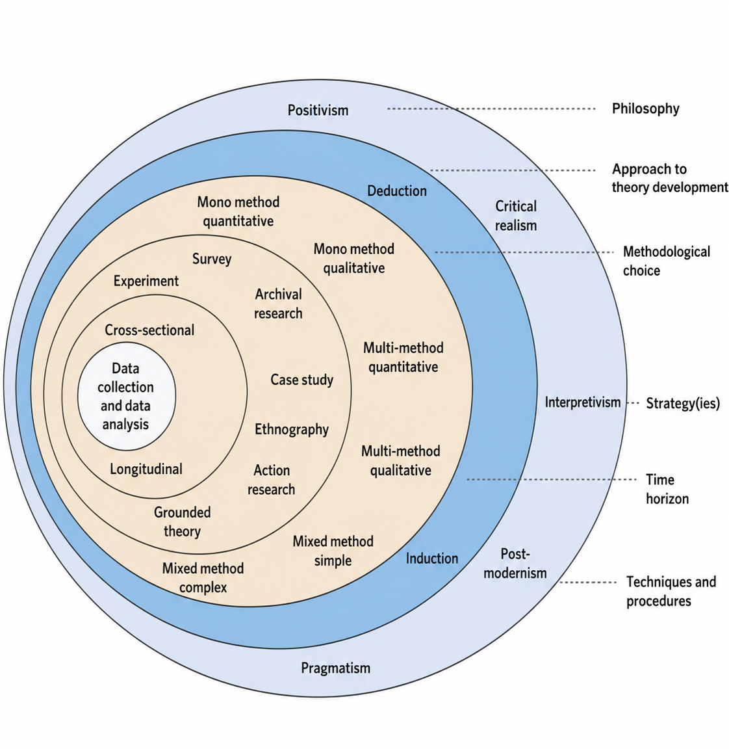

Figure 3. Research onion framework adapted from Saunders, Lewis and Thornhill [59].

Research onion layer | Choice in this study | Justification
Philosophy | Positivism | The study measures features, labels, predictions, classification metrics, timing values and model-size outputs.
Approach | Deductive | The experiment tests whether static PE-header features can support ransomware-versus-goodware classification.
Methodological choice | Mono-method quantitative | The core data and outputs are numerical, although discussion is used to interpret the results.
Strategy | Experiment supported by design science artefact | The project develops and evaluates a ransomware detection framework rather than only reviewing existing literature.
Time horizon | Cross-sectional | The public dataset is analysed as a fixed dataset at one point in time.
Techniques and procedures | Secondary dataset, supervised learning, evaluation metrics, five-fold cross-validation and SHAP | These procedures directly support the research objectives and research questions.
Table 7. Research strategy mapping using the research onion.

3.3 Research Design
The research design is based on the principles of an experiment that creates an artefact. The artefact consists of the ransomware detection pipeline which loads the dataset, maps the target, prepares features, removes metadata that poses a risk of leakage, trains selected models, assesses performance, cross validates and saves the outputs with the explanation provided by SHAP. This is in line with design science as it involves the development and assessment of an intentional technical product, given a clear problem [60]-[62]. The design also conforms the computing project guidance which stipulates that there should be a clear relationship between the research problem, the method, the artefact and evaluation [63, 64]. The design is started from the problem definition. The ability to support safe, efficient and explainable pre-execution screening for ransomware detection. This problem is then mapped into the PE-header detection workflow as an artefact design. The step to implement, we will adopt Random Forest, XGBoost and LightGBM using python based notebooks. The evaluation stage involves metrics from the classification, timing values, model size, cross-validation and SHAP feature attribution. The design diagram itself is introduced in Chapter Four as it provides focus when dealing with artefact design and the implementation of the design. Safety boundary is an integral aspect of the design. The project is not an actual ransomware project. It relies on features extracted in advance (static PE-header features) of a public dataset. This minimizes the chance of malware spread and means that it's easier to avoid having to run a live malware sandbox. The choice maintains the project goal of testing if the static PE-header features can aid in binary classification and provide explanation, and it is not to analyse the runtime behaviour of the features.

3.4 Hardware and Execution Environment
The project is based on a workflow with notebooks in python and outputs of experiments. The specific physical equipment of the Cloud notebook may be variable and the student may not have complete control over the equipment. As such, this report does not specify a local CPU, GPU or memory configuration, unless provided in the experiment logs. This prevents making unsupported claims with regards to execution conditions. The model size saved during training, prediction time, and observed experimental output are recorded as training time, prediction time and saved model size. These values may be used for comparison within a workflow, but are not necessarily standards for comparison. The absolute timing values might vary if the same code is executed on various pieces of hardware. It is still useful to make a relative comparison as the models selected are assessed using the same project workflow and the same corrected feature matrix.
Item | Position in this study
Execution platform | Python notebook workflow using saved evidence outputs.
Local hardware claim | No specific local CPU, GPU or memory configuration is claimed unless documented in logs.
Timing interpretation | Timing values are observed experimental outputs and may vary across environments.
Safety boundary | No live ransomware execution; only pre-extracted static features are used.
Table 8. Execution environment recording approach.

3.5 Software
The software stack was chosen to enable data analysis on a reproducible set and supervised machine learning. We used pandas and NumPy to handle tabular data and perform numerical computations [52, 53] and the train-test split, model evaluation, cross validation and Random Forest modelling were performed using scikit-learn [32, 56]. The gradient boosting classifiers were implemented using XGBoost and LightGBM which are available in the literature [11, 12, 57, 58]. Figures [54] were created with matplotlib and feature-attribution outputs [13], [14] and [55] were created with SHAP. Each one of the tools deals with a certain phase of the workflow. It is not proposed that the software stack is the only possible choice to implement. The reasons are that the libraries are documented, widely-used and suitable to the experiment design. Furthermore, the ability to save CSV files, figures, model files and logs allows for the reproducibility of the dissertation's content as the values reported in the dissertation can be compared to the items created in the dissertation.
Software / library | Purpose in this project
Python | Main language for data loading, modelling and output generation.
pandas | Reading CSV data, cleaning columns and managing tabular data.
NumPy | Numerical operations and array handling.
scikit-learn | Train-test split, metrics, Random Forest and cross-validation support.
XGBoost | Gradient boosted tree classification model.
LightGBM | Efficient gradient boosted tree classification model.
Matplotlib | Figure generation for charts and model comparison.
SHAP | Model explanation and feature attribution.
Notebook environment | Experiment execution and saving of output artefacts.
Table 9. Software and library stack.

3.6 Experiment Inputs
The input to the experiment is the Ransomware PE Header Feature Dataset, Version 3, from Mendeley Data [9]. The dataset is appropriate since it is directly related to the project topic: classification of ransomware using the features extracted from PE-headers. An experiment was run locally that loaded 2157 rows and 1028 original columns. Identifiers, target or family information and numerical PE-header feature columns are included. This project does not collect any personal data, it is considered to be the use of a secondary public data set. The family field was used to prepare the binarized target. Samples that had family = 0 were mapped as benign/goodware. Any other family value in the sample was plotted as ransomware. This resulted in 1134 benign/goodware samples and 1023 ransomware samples. For binary classification the class distribution is fairly well balanced, so that accuracy is the only metric that would not be able to capture the error pattern, and the study reports precision, recall, F1 score and ROC AUC. ID, GR and the target-style were excluded from the feature matrix prior to modelling.ID, GR and target-style were removed from the feature matrix prior to modelling. Such fields can be used to store information about the identity of a dataset or class, which required a correction. If they remain the model can learn collection artefacts instead of patterns that are useful for the PE-header. The feature matrix was corrected after metadata/exclusion of leakages and now only had 2157 rows and 1018 numerical feature columns. These values are constant throughout the design, implementation, results and appendices.
Dataset item | Final value used
Dataset name | Ransomware PE Header Feature Dataset, Version 3.
DOI | 10.17632/p3v94dft2y.3.
Rows loaded locally | 2,157.
Original columns observed | 1,028.
Binary class mapping | family = 0 as benign/goodware; other family values as ransomware.
Benign/goodware samples | 1,134.
Ransomware samples | 1,023.
Corrected feature matrix | 1,018 numerical features after metadata/leakage-risk exclusion.
Table 10. Dataset facts used in the corrected experiment.

3.7 Experiment Process
The experiment process starts with loading the data and examining the data. This CSV file is imported into a dataframe and the shape of the dataframe, whether the duplicate rows are present and what the distribution of target fields is, are checked. This is then mapped to a binary target with the family mapping described above. Next, the feature set for the columns (excluding metadata/leakage-risk or target) is the numerical PE-header feature set, selected as appropriate. This step is needed since the first job of the experiment is to obtain a fair feature matrix, but not necessarily to maximise accuracy. This prepared data is then further divided into a training set and a holdout set of test data. Random Forest, XGBoost and LightGBM use the same feature matrix and target vector that were used above. The same scoring is used for each model, for training and evaluation. The accuracy, precision, recall, F1-score and the ROC-AUC are recorded as evaluation results. It also keeps track of the training time, total prediction time, prediction time per sample and saved model size. These extra measurements, in addition to the above, help to answer the research question regarding practical efficiency. The five-fold cross-validation is used to decrease the influence of one train-test split after holdout evaluation. The cross-validation results presented average and standard deviation of the accuracy, precision, recall, F1 score and ROC AUC. The "best" model is chosen by using the corrected balance of detection performance and efficiency only, not accuracy of the model alone. Lastly, the selected model is used to generate the outputs of global feature-attribution using the method SHAP explanation. The experiment saves values, CSV files, model artefacts and logs to make it possible to validate reported values.
Evaluation area | How it is measured | Reason
Classification performance | Accuracy, precision, recall, F1-score and ROC-AUC. | Measures detection quality from several angles.
Error pattern | Confusion matrix. | Shows false positives and false negatives.
Efficiency | Training time and prediction time per sample. | Checks suitability for early screening.
Resource footprint | Saved model size in MB. | Shows practical storage and portability.
Stability | Five-fold cross-validation. | Reduces reliance on a single split.
Transparency | SHAP feature attribution. | Explains model feature contribution.
Table 11. Model evaluation plan.

3.8 Validity, Reliability, Ethics and Safety
Validity is covered in the preparation of the datasets, in controlling the leakage and by several evaluation measures. Perhaps the most crucial validity control is that of the exclusion of ID, GR and target-style metadata from the feature matrix. This decreases the chance for the model to learn a class identifier or artefact for building the dataset instead of the patterns of PE-headers. Another validity verification is into the use of a number of metrics as opposed to accuracy alone. The three control is the 5-fold cross validation, which provides evidence of stability of the performance in the data set. Outputs are saved in a structured evidence folder, providing support for reliability. The workflow produces and outputs CSV files, figures, model files and logs. This allows for checking the values given in the dissertation, and the values that are obtained during actual experiments. The values used in the dissertation are the same as those corrected in the appendices, presentation and viva discussion. This minimises the risk of ambiguity and makes things more transparent. Ethics and safety are integral component of the project. The study is not conducted with the actual hackers and does not involve any personal information. It is based on a public pre-extracted feature data set. This decreases the danger of malware spread and not handling any alive ransomware payloads. The report also does not disclose the instructions on how to operate, which would help those who would want to use malware. The artefact is not a ready-to-use security system, but rather a research prototype for use in dataset-based classification purposes. The project does not attempt to collect or execute live malware samples from malware repositories and scanning services (like VirusShare, MalwareBazaar or VirusTotal) as the artefact to be submitted consists of features pre-extracted from the PE-headers of the malware sample [47]-[49].

3.9 Chapter Conclusion
The methodological stance of the project has been explained in this chapter. The research method used in the study is quantitative, deductive and positivist with the support of design science which is a technical artefact creation and evaluation development. The chapter also set up the data set, software, process, evaluation plan and safety boundary and validity control. It then shifts to methodology to practical design and implementation evidence in the next chapter, where the detection framework diagram and artefact output evidence are presented.

CHAPTER 4: DESIGN AND IMPLEMENTATION

4.1 Introduction
The methodology is explained in this chapter as to how it has been translated to a working experiment. The artefact implemented is not a general endpoint protection solution. It's a static PE-header ransomware detection pipeline a public feature database is loaded, a leakage-aware feature matrix is created, three lightweight ensemble models are trained, performance and efficiency measures are recorded, and the results are validated and SHAP explanations are produced. The design is appropriate to the project aim since at each stage of the project evidence is gathered that will answer the questions being posed in the project. Data ingestion is the starting point and artefacts saving at the end of the main process. Those artefacts contain processed data, feature names that have been selected, model files, classification reports, confusion matrices and ROC curves, comparison figures, cross-validation summaries, SHAP outputs and logs, and more. This is especially significant, as the report is not only based on written claims, but also on oral statements. The values presented in Chapter Five can be found in files generated.

4.2 Detection Framework Design
The detection framework will be an intentional research artifact. Its input is a pre-extracted feature record for a PE-header which is included in a Windows executable. The decisions about features are then corrected in the framework, it feeds the numerical values into the trained classifier and it returns a prediction. Once model selection is done, the explanation layer highlights the indices of the most influential feature(s) to the result using SHAP. The output is not only a label; it also provides evidence that can be discussed in the analysis.
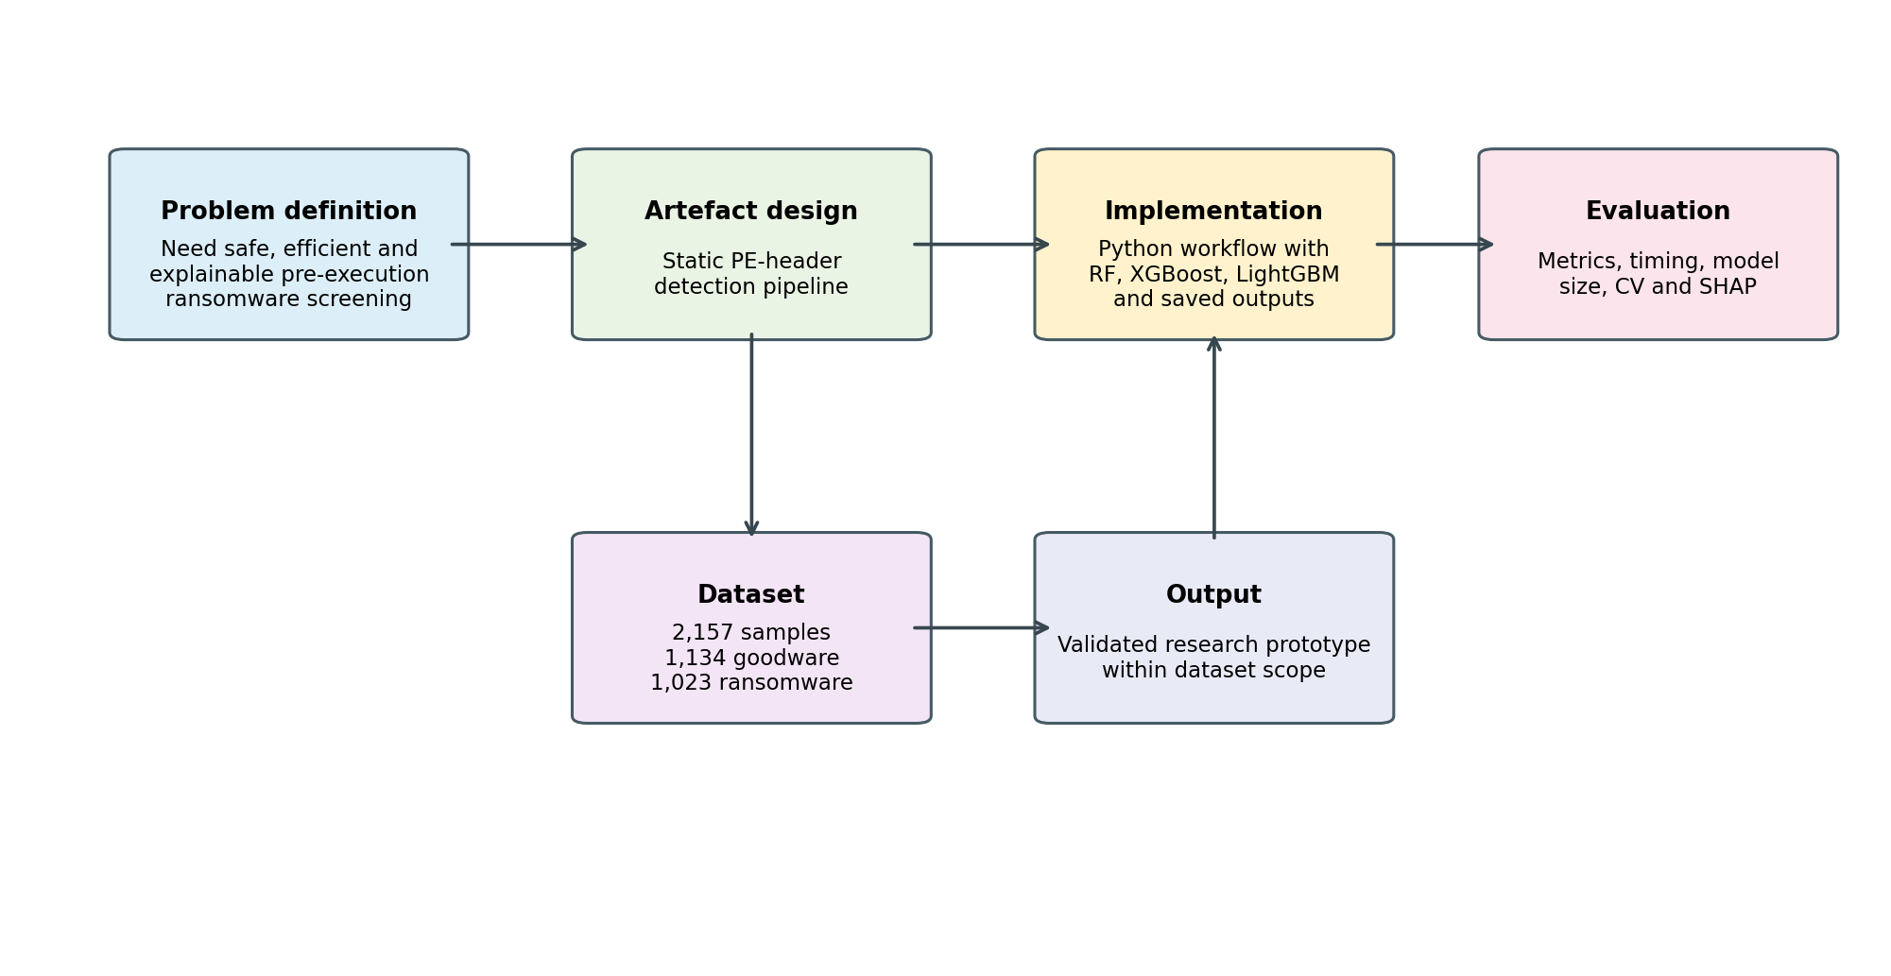
Figure 4. Detection framework design for the ransomware PE-header artefact.
The design has been kept as narrow as possible. Does not allow live ransomware files, does not run binaries and does not check runtime behaviour. The narrowness in this project isn't a problem, it's a feature to ensure the project's safety and scope control. The research question is if static PE-header features can aid in the creation of a helpful and comprehensible pre-execution classification artefact. The design thus maintains that the evidence source, the method of comparison and explanation is aligned with that question.
Requirement | Implementation decision | Reason
Safety | Use pre-extracted static features and avoid live ransomware execution. | Reduces malware handling risk and keeps the study within the static-analysis scope.
Leakage control | Remove ID, GR, target and other target-style fields before modelling. | Protects the validity of the model comparison.
Model comparison | Train Random Forest, XGBoost and LightGBM using the same corrected feature matrix. | Allows a fair comparison of selected lightweight ensemble models.
Efficiency measurement | Record training time, prediction time and saved model size. | Links the experiment to practical pre-execution screening.
Validation | Use holdout testing and five-fold cross-validation. | Reduces dependence on one split and improves discussion of stability.
Explainability | Apply SHAP to the selected model. | Supports transparent discussion of feature contribution.
Table 12. Design requirements and implementation decisions.

4.3 Data Preparation
This data was first loaded and viewed. The raw local shape had a number of rows of 2,157 and columns of 1,028. The original data set has “id” identifier columns, numerical feature columns, and the information of the target or family. The family field is a binary detection study, so the family = 0 is considered to be benign/goodware while all the other family = X values are considered ransomware. A total of 1,134 benign/goodware samples and 1,023 ransomware samples were created from this mapping. The first modelling duty was to keep the leaks to a minimum. The information in columns such as ID, GR and target was excluded prior to training as they might contain class information or information about how the data set was constructed. An important consideration in design. These fields could be added and the model might seem to be very accurate during the learning of identifiers that would not be acceptable in a real pre-execution screening workflow. When removing metadata and target-style fields from the feature matrix, the corrected feature matrix ended up with 1,018 numerical features.
Preparation item | Corrected value
Raw rows | 2,157
Original columns | 1,028
Target mapping | family = 0 benign/goodware; family != 0 ransomware
Excluded fields | ID, GR and target-style metadata
Constant columns removed | 0
Corrected feature columns | 1,018
Table 13. Corrected feature preparation summary.

4.4 Model Formulation
Three models were put in place: Strong baseline method used was random forest. The widely used gradient boosting technique for structured data was used, namely XGBoost. We employed LightGBM as it is an efficient learning algorithm for learning with high dimensional features. All three models were corrected for all of the same features and labeled with the same corrections. This is to prevent any advantage due to different data preparation of one model over another. The classification problem is a binary classification. The result will be benign/goodware or ransomware. The models generate predictions of labels and prediction scores. The accuracy, precision, recall, F1-score and confusion matrices are predicted on the basis of the predicted labels. The probability scores are used for plotting of ROC-AUC, plotting of ROC curve. This design links the implementation directly with the evaluation plan.

4.5 Model Translation and Workflow
This workflow was realized using Python. Therefore, the libraries required were imported and the project folders were created. Secondly, the data was imported and verified the target mapping. Third, fields in the target-style were deleted, as were metadata. Fourthly, train-test splitting was done. Fifth, training and evaluation of the three models were done. 6th, it was stored the model metrics and figures. Finally, selected model was explained using SHAP.
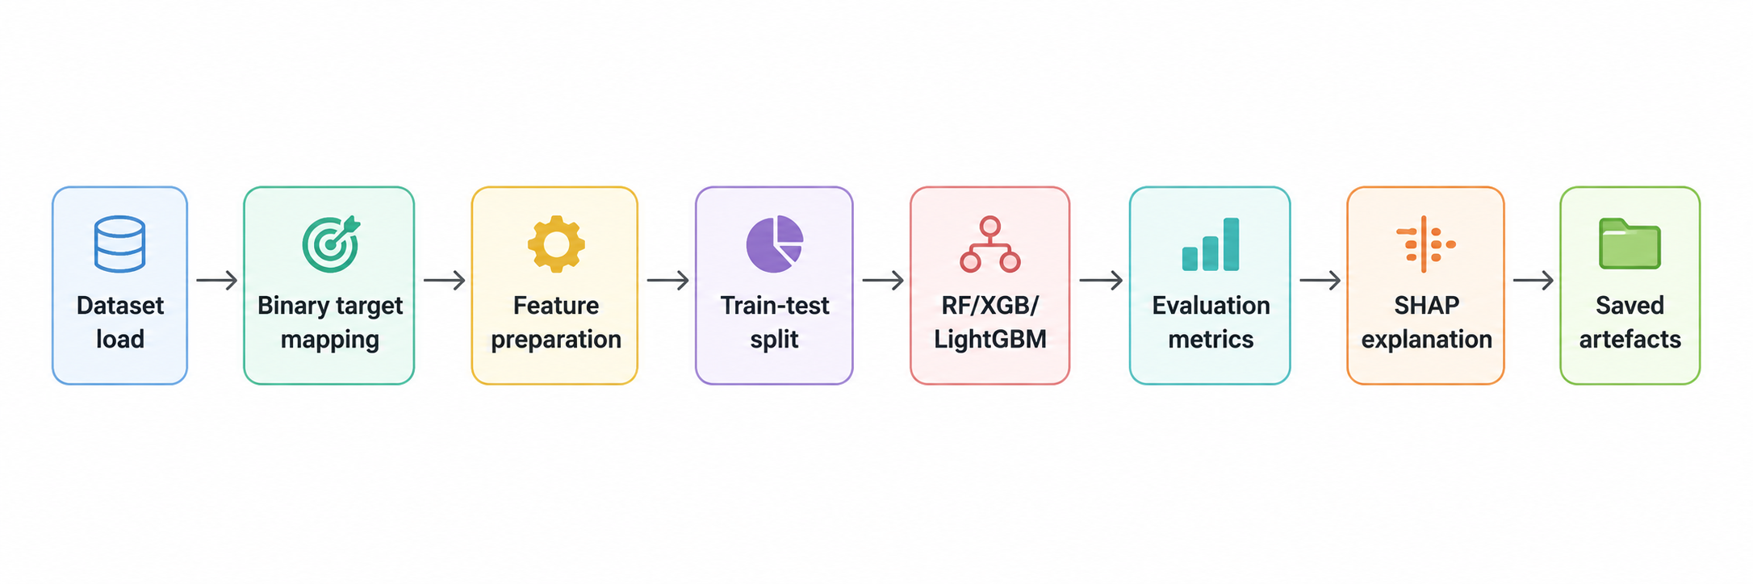

Figure 5. Implementation workflow for the ransomware PE-header detection artefact.
Supporting evidence was saved as part of the workflow, too. Confusion matrix files, classification reports, prediction files and feature importance files, were generated for each model. A summary of the various metrics was created and saved together to compare the models side by side. The outputs of the cross validation and the outputs of SHAP were saved as separate entities and the SHAP outputs were saved in a dedicated explanation folder. This makes it easier to audit this experiment and assists the viva as the values reported can be traced back to the generated outputs of this organisation. Appendix II includes detailed notebook evidence which supports the learning.

4.6 Validation and Quality Controls
The work flow included 3 levels of validation. The first level was data validation, the class mapping, feature count and excluded columns were validated and saved on the first level. Model validation was done on the second level in which the 3 models were tested with the same holdout test split and the same metrics. The third level was stability validation – they used five-fold cross-validation to minimize the dependency from one train-test split. The following steps are not sufficient to demonstrate readiness to deploy, but do increase the credibility of the experiment over one accuracy. Efficiency was also observed in the implementation. This was required because the project is based on the pre-execution screening process. An accurate but slow and/or large model will not be as useful for early triage. Thus, training time, total prediction time, prediction time per sample and saved model size have been recorded during the implementation. This enabled for a balanced approach to be taken to selecting the best model, rather than simply for their accuracy.

4.7 Experimentation
An evidence folder was created from this experiment. The run corrected is the one that will be included in the final report. An exploratory run was performed earlier, and gave unusual good results, but this result was approached with great care as metadata or target style fields may cause leakage. The corrected run did not include ID, GR and target-style columns and yielded good, but more realistic results. This is necessary as the project is assessed according to genuine evidence and not on the best possible score. The results of the final experiment contain the processed dataset, feature names selected, model files, comparison tables of the models, confusion matrices, ROC curves, cross validation summaries and SHAP plots. Those corrected results, and the interpretation of them in the context of the research questions are reported and interpreted in the next chapter. The discussion is also kept on track by maintaining the limits: it is a prototype, a security product that is not being built, it is based on a dataset, not on a production security product.

4.8 Chapter Conclusion
The practical design and implementation of the ransomware detection artefact has been depicted in this chapter. It provided an explanation of the requirements of the design, the detection framework, data preparation, model formulation, the workflow, validation controls and implementation evidence. The reasons for using the corrected leakage-aware run as the final evidence were also explained in the chapter. In the next Chapter the corrected performance and efficiency, the cross validation and SHAP results are reported and discussed.

CHAPTER 5: RESULTS AND DISCUSSION

5.1 Introduction
The results of the experiments described are presented and interpreted in this chapter. Not only who got the highest score in the correct model, but also the focus is on which one of the models got the best score. The error pattern, ROC-AUC, efficiency, cross validation and SHAP feature attribution are also explored in the chapter. This is essential as the project is to understand the pre-execution ransomware detection artefact is accurate, efficient and explainable. The results in this chapter are from a corrected run in which the leakage-risk columns (metadata) were omitted.

5.2 Corrected Holdout Test Results
Model | Accuracy | Precision | Recall | F1-score | ROC-AUC
Random Forest | 0.9745 | 0.9619 | 0.9854 | 0.9735 | 0.9981
XGBoost | 0.9722 | 0.9617 | 0.9805 | 0.9710 | 0.9929
LightGBM | 0.9792 | 0.9712 | 0.9854 | 0.9782 | 0.9978
Table 14. Corrected holdout test performance for the three models.
As can be seen in Table 14, all three models' corrected holdout test performance were strong. Random Forest achieved an accuracy of 0.9745 and an F1-score of 0.9735. XGBoost was able to achieve the accuracy of 0.9722 and the F1-score was 0.9710. The corrected accuracy of LightGBM was 0.9792 and corrected F1-score of LightGBM was 0.9782. This means that LightGBM model achieved best classification score for the models considered when given the corrected holdout split. The ROC-AUC values obtained were also good for all the models. Random Forest achieved the highest ROC-AUC of 0.9981, XGBoost was 0.9929 and LightGBM was 0.9978. The accuracy and F1-score were best for LightGBM while it was also the fastest model at prediction time, Random Forest had the highest ROC-AUC. This is important, because in the end, it's not just one criterion that determines the best model! The project deals with three aspects: detection quality, speed, and model size and explainability.
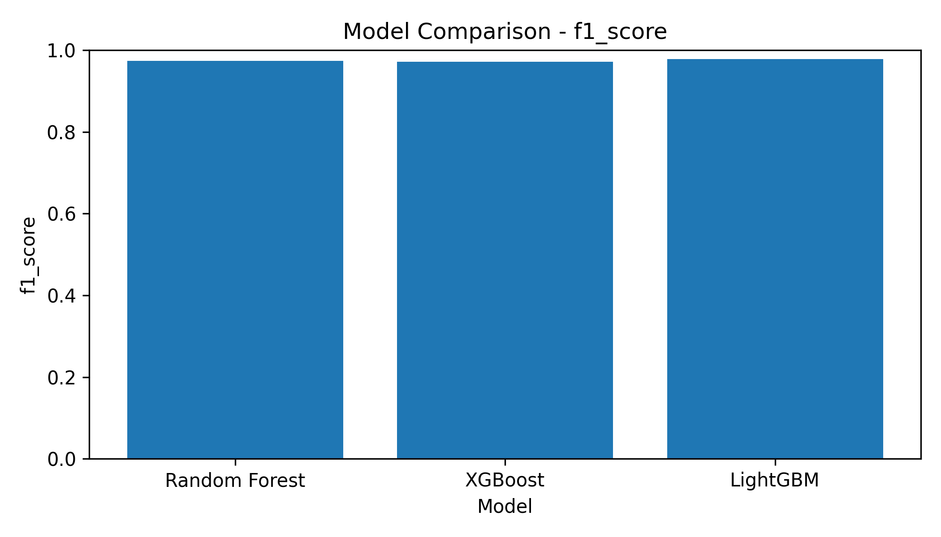
Figure 6. F1-score comparison across the corrected models.

5.3 Error Pattern and Confusion Matrix
The results of classification are interpreted with the help of the confusion matrix. Ransomware detection is especially relevant as regards false-negatives, as the latter will be those samples that ransomware is expected to be benign. False positives are also not to be ignored as they are classed as benign or goodware samples that are being predicted as ransomware. The ideal model would have low false positive and low false negative rates, but generally the false negative case is more significant due to the potential for security issues.
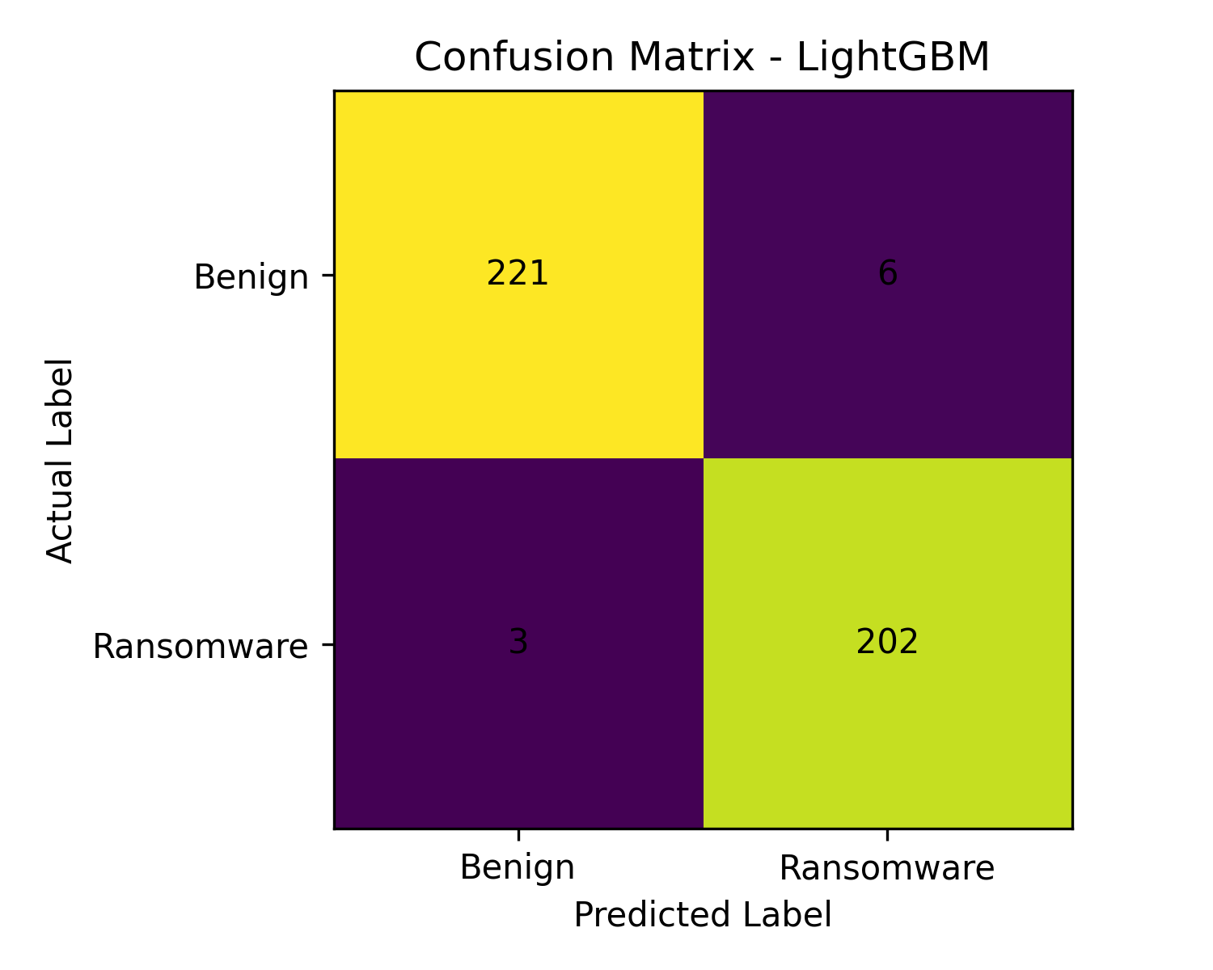
Figure 7. LightGBM confusion matrix from the corrected holdout test.
The confusion matrix of the LightGBM model indicates that this model made some minor mistakes in the corrected hold out test. This result corroborates the hypothesis that the static PE-header characteristics are able to separate ransomware samples from benign/goodware samples in this dataset. It doesn't mean that the same performance will be seen on all external datasets, however. The experiment is good enough within its scope but there is a need for external validation to be put through before deployment in operation.

5.4 ROC Curve Analysis
A threshold independent ranking perspective is given by ROC curves. A high ROC-AUC is good at identifying ransomware samples over benign samples at various thresholds [31]. As seen in figure 8, the three models generated very strong ROC curves, with ROC-AUC values above 0.99 in the corrected experiment. The feature matrix still retains some classification information even after the leakage-risk fields have been removed, supporting the notion that the removal of these fields does not remove the feature matrix's classification information.
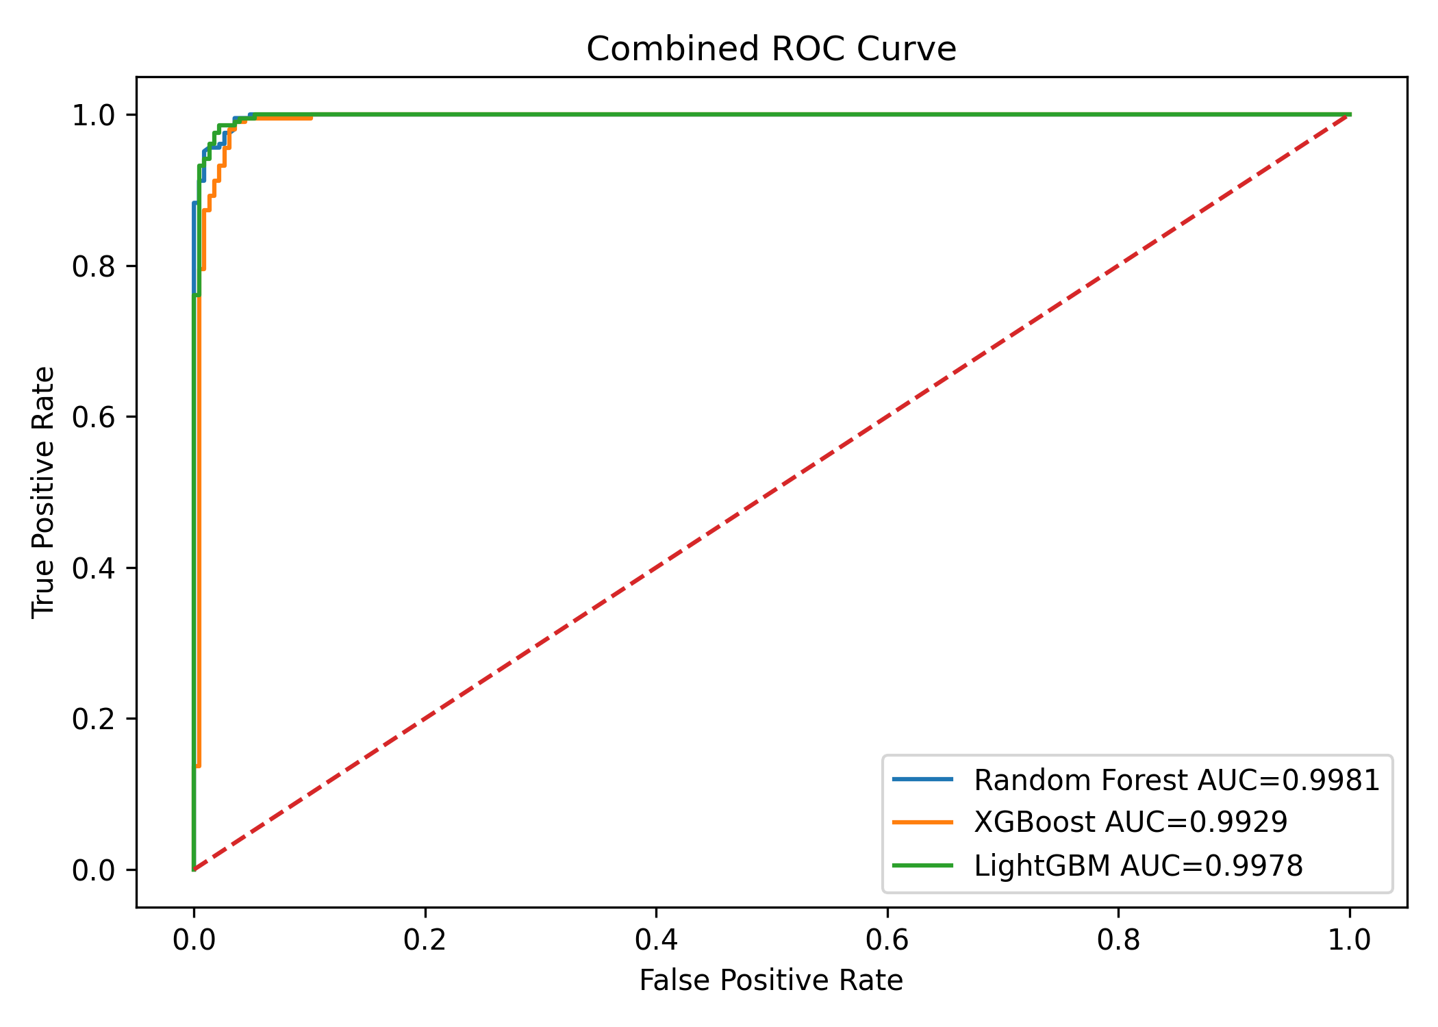
Figure 8. Combined ROC curve for Random Forest, XGBoost and LightGBM.
F1 Score and the confusion matrix must be taken into account along with the ROC-AUC result. ROC-AUC is threshold-independent, but it should still be interpreted with the confusion matrix because a chosen operating threshold can still create false positives or false negatives. However, report does not consider ROC-AUC as the selection criterion for the final model. We chose LightGBM for its overall performance, which achieved the strongest balance of corrected accuracy, F1-score, shortest prediction time and small model size.

5.5 Efficiency and Model Size
Model | Training time (s) | Prediction time per sample (s) | Model size (MB)
Random Forest | 1.1007 | 0.00006413 | 2.3419
XGBoost | 1.0706 | 0.00032928 | 0.0835
LightGBM | 1.5777 | 0.00003094 | 0.2813
Table 15. Corrected efficiency comparison.
Efficiency is a key requirement since pre-execution screening is a project goal. From Table 15, it can be seen that LightGBM took the least amount of time to predict (approximately 0.000031 seconds per sample). Random Forest got the prediction time of about 0.000064 second per sample while XGBoost got the prediction time of about 0.000329 second per sample. XGBoost was the smallest sized model but failed to achieve the best classification results, nor the best prediction time. The size of the model was the largest for Random Forest, presenting less of an appealing option when storage and transportability are taken into account.
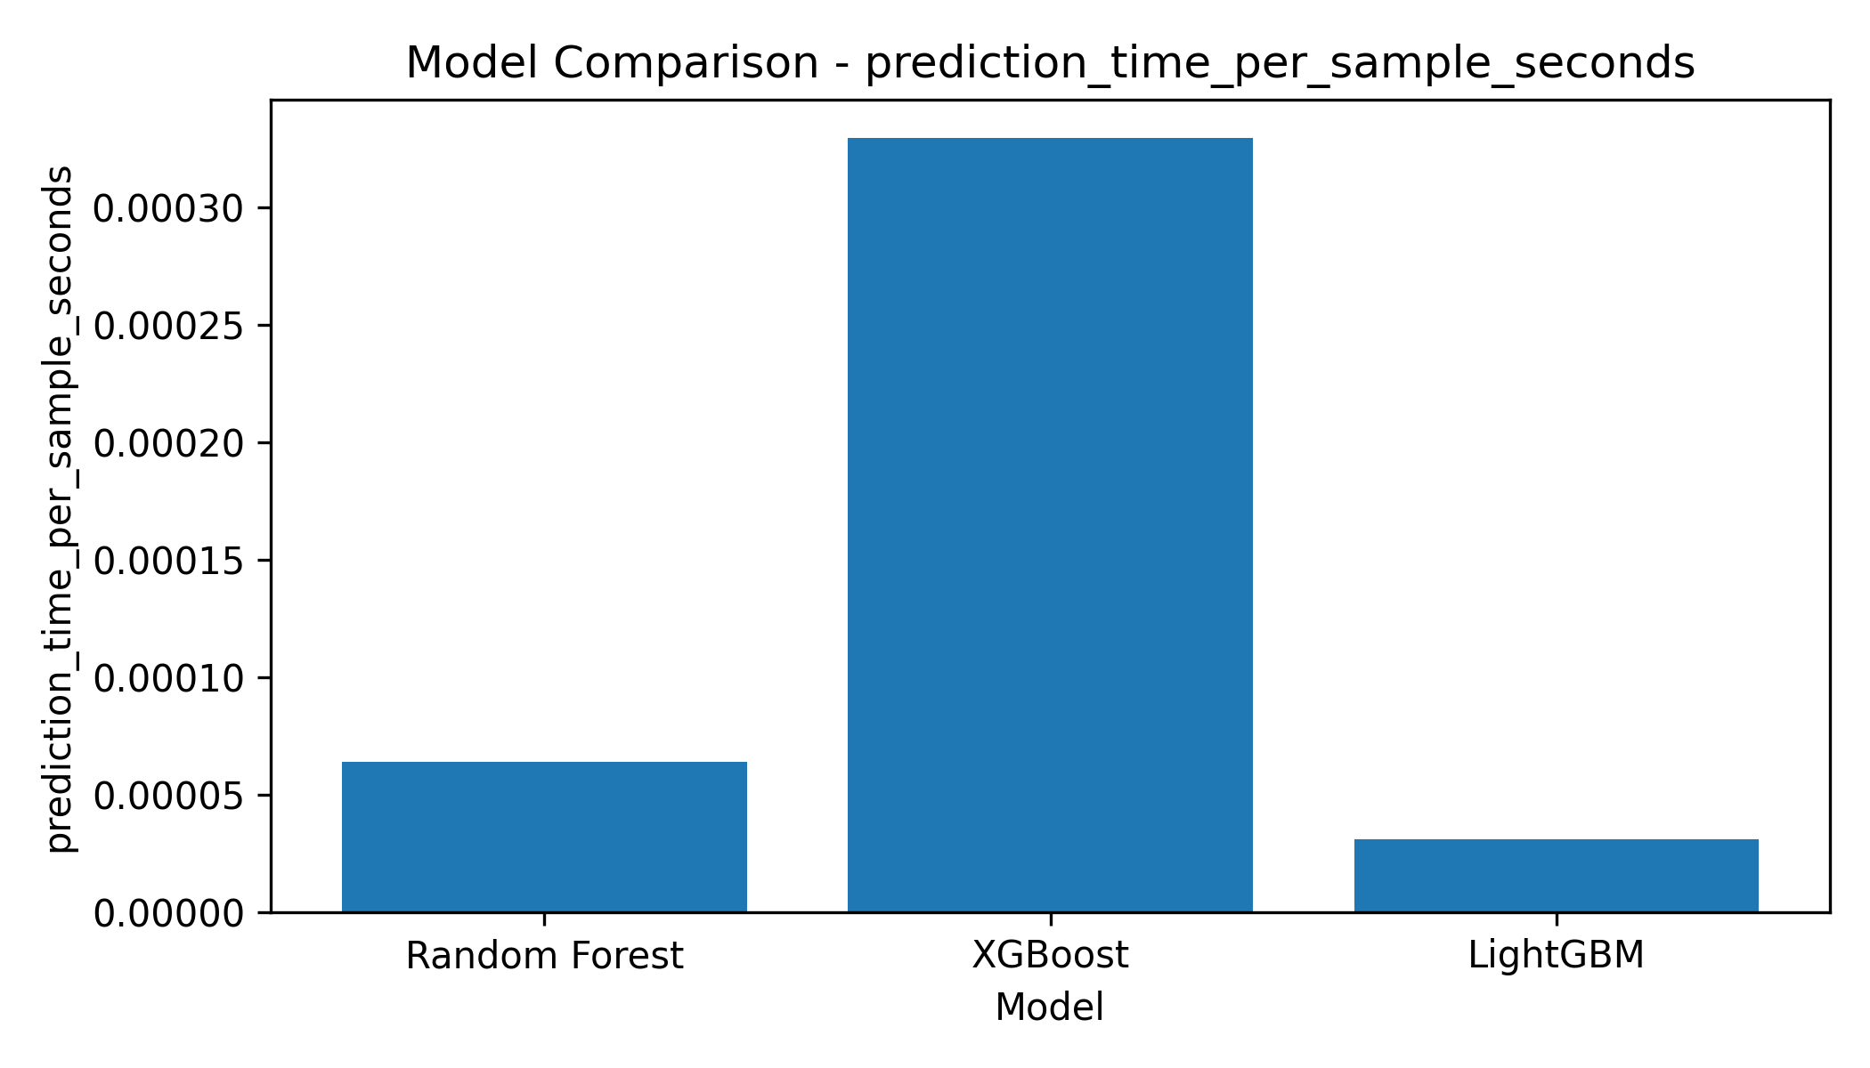
Figure 9. Prediction time per sample comparison.
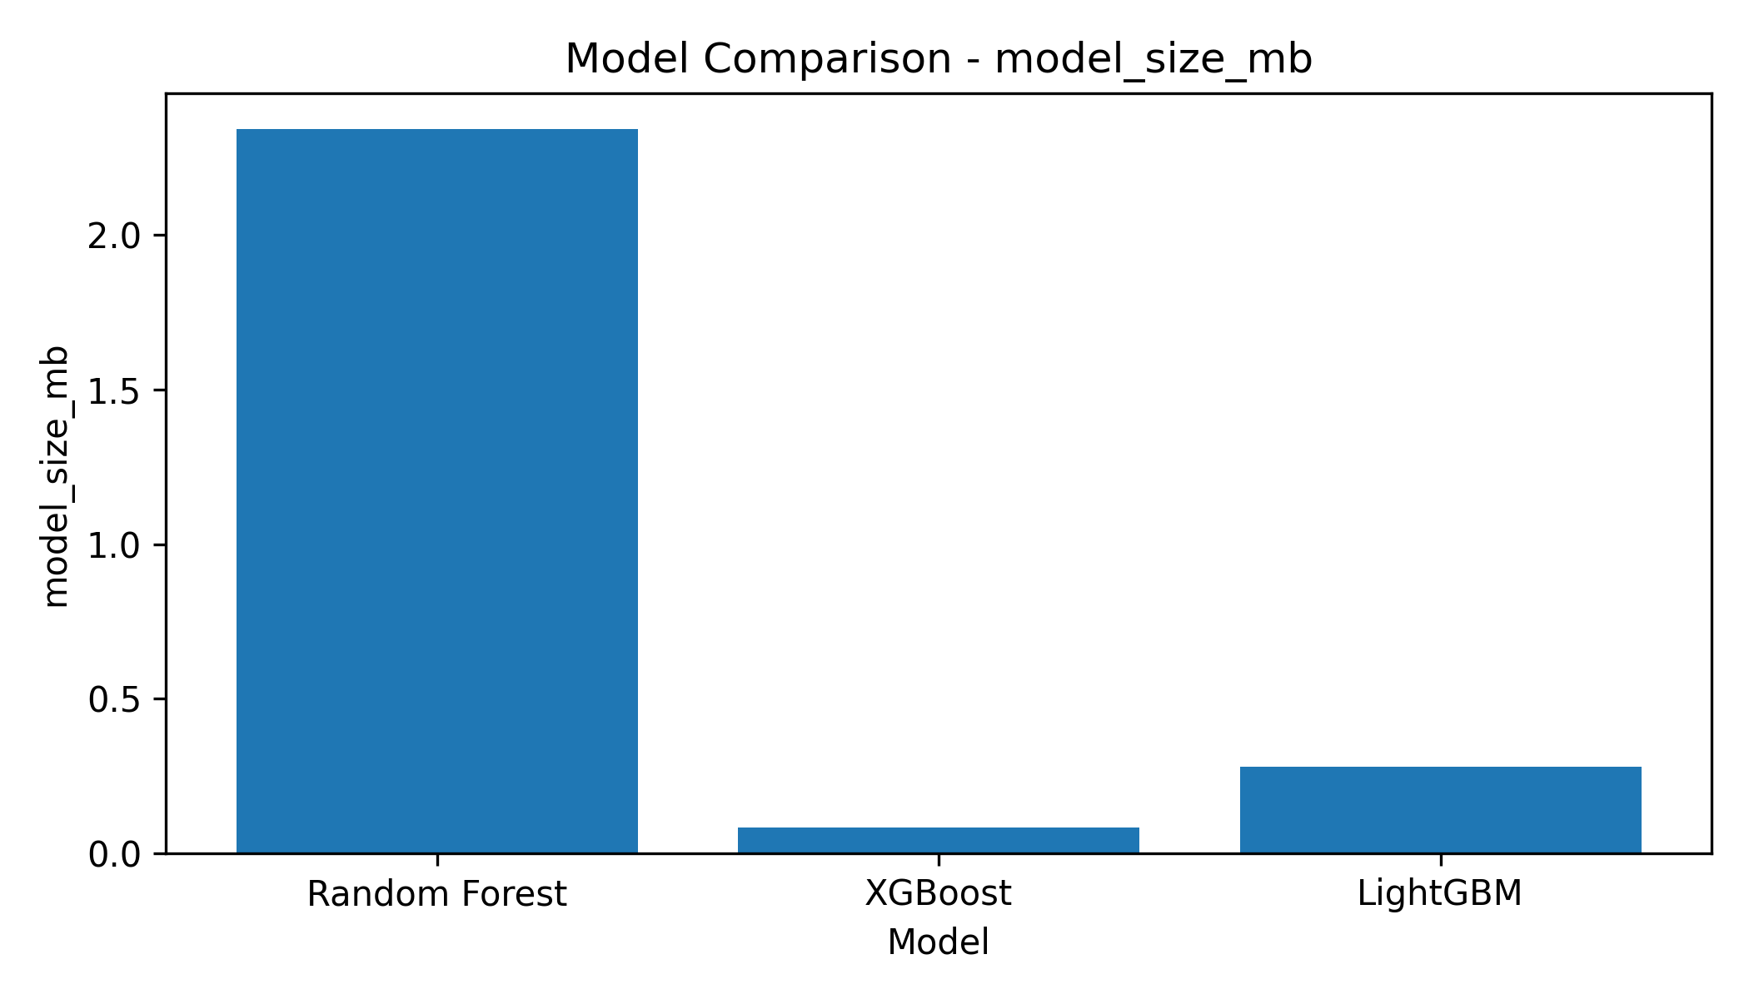
Figure 10. Saved model size comparison.
Based on efficiency results the choice of LightGBM is justified. It was not only accurate but was also the fastest inference time in corrected experiment, and had small model-size saved. A balance is key for a screening artefact. The timing values are still considered as experimental values and not as universal values. The absolute values of the timing could vary depending on hardware or notebook configuration, but these values would be valid within the same workflow.

5.6 Five-Fold Cross-Validation
Model | Accuracy mean | Accuracy SD | F1 mean | F1 SD | ROC-AUC mean | ROC-AUC SD
Random Forest | 0.9624 | 0.0030 | 0.9605 | 0.0033 | 0.9943 | 0.0007
XGBoost | 0.9522 | 0.0063 | 0.9502 | 0.0067 | 0.9890 | 0.0022
LightGBM | 0.9694 | 0.0034 | 0.9681 | 0.0036 | 0.9963 | 0.0013
Table 16. Five-fold cross-validation summary.
A cross-validations was also performed to minimize relying on one train-test split. Results from the five-fold cross validation indicate that LightGBM still outperforms the other models overall with a mean accuracy of 0.9694, mean F1-score of 0.9681 and mean ROC-AUC of 0.9963. Random Forest was the second best performance with 0.9624 mean accuracy and 0.9605 mean F1 score. XGBoost achieved the mean accuracy of 0.9522, and mean F1-score of 0.9502. This is slightly less than the holdout scores as the latter are an average of the score over multiple splits. But, the main thing is that the same model ranks are basically constant.
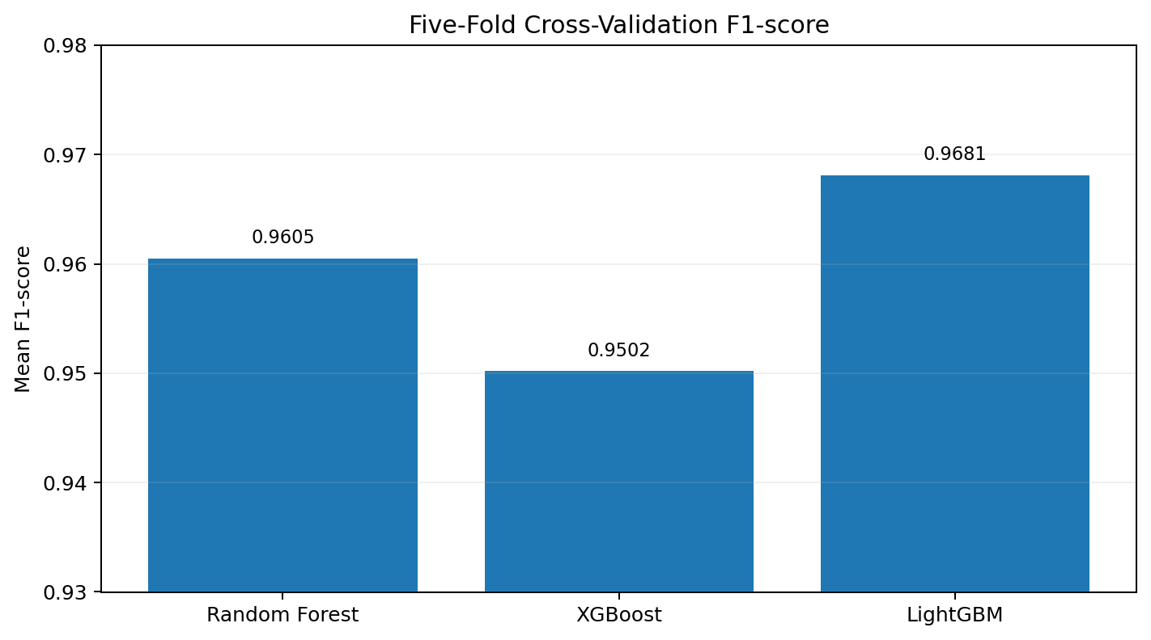
Figure 11. Five-fold cross-validation F1-score comparison.
A cross validation analysis has been carried out, and the results confirm the model selection. The model which showed to be the best model remained as LightGBM when retraining across the folds. This is not an exhaustive list of threats to validity. The folds remain the same as in the previous experiments and external validation would still be required. But, it's more powerful than using one holdout split.

5.7 SHAP Explainability Results
Rank | Feature index | Mean absolute SHAP value
1 | 335 | 0.960064
2 | 320 | 0.667580
3 | 60 | 0.495314
4 | 306 | 0.352305
5 | 191 | 0.347743
6 | 343 | 0.335578
7 | 337 | 0.323324
8 | 304 | 0.314746
9 | 436 | 0.282879
10 | 296 | 0.260129
Table 17. Top ten SHAP feature indices for the selected LightGBM model.
Selected LightGBM model was supplemented with SHAP for transparent interpretation. The ten most important feature indices, determined by the average absolute SHAP value, are shown in Table 17. The mean contribution to the model was the largest for feature 335 followed by 320, 60, 306 and 191. The report doesn't make-up semantic PE-field meanings as the features are anonymised or numbered. These features numbered from 1 to 10 are influential in the trained LightGBM model and the corrected dataset.
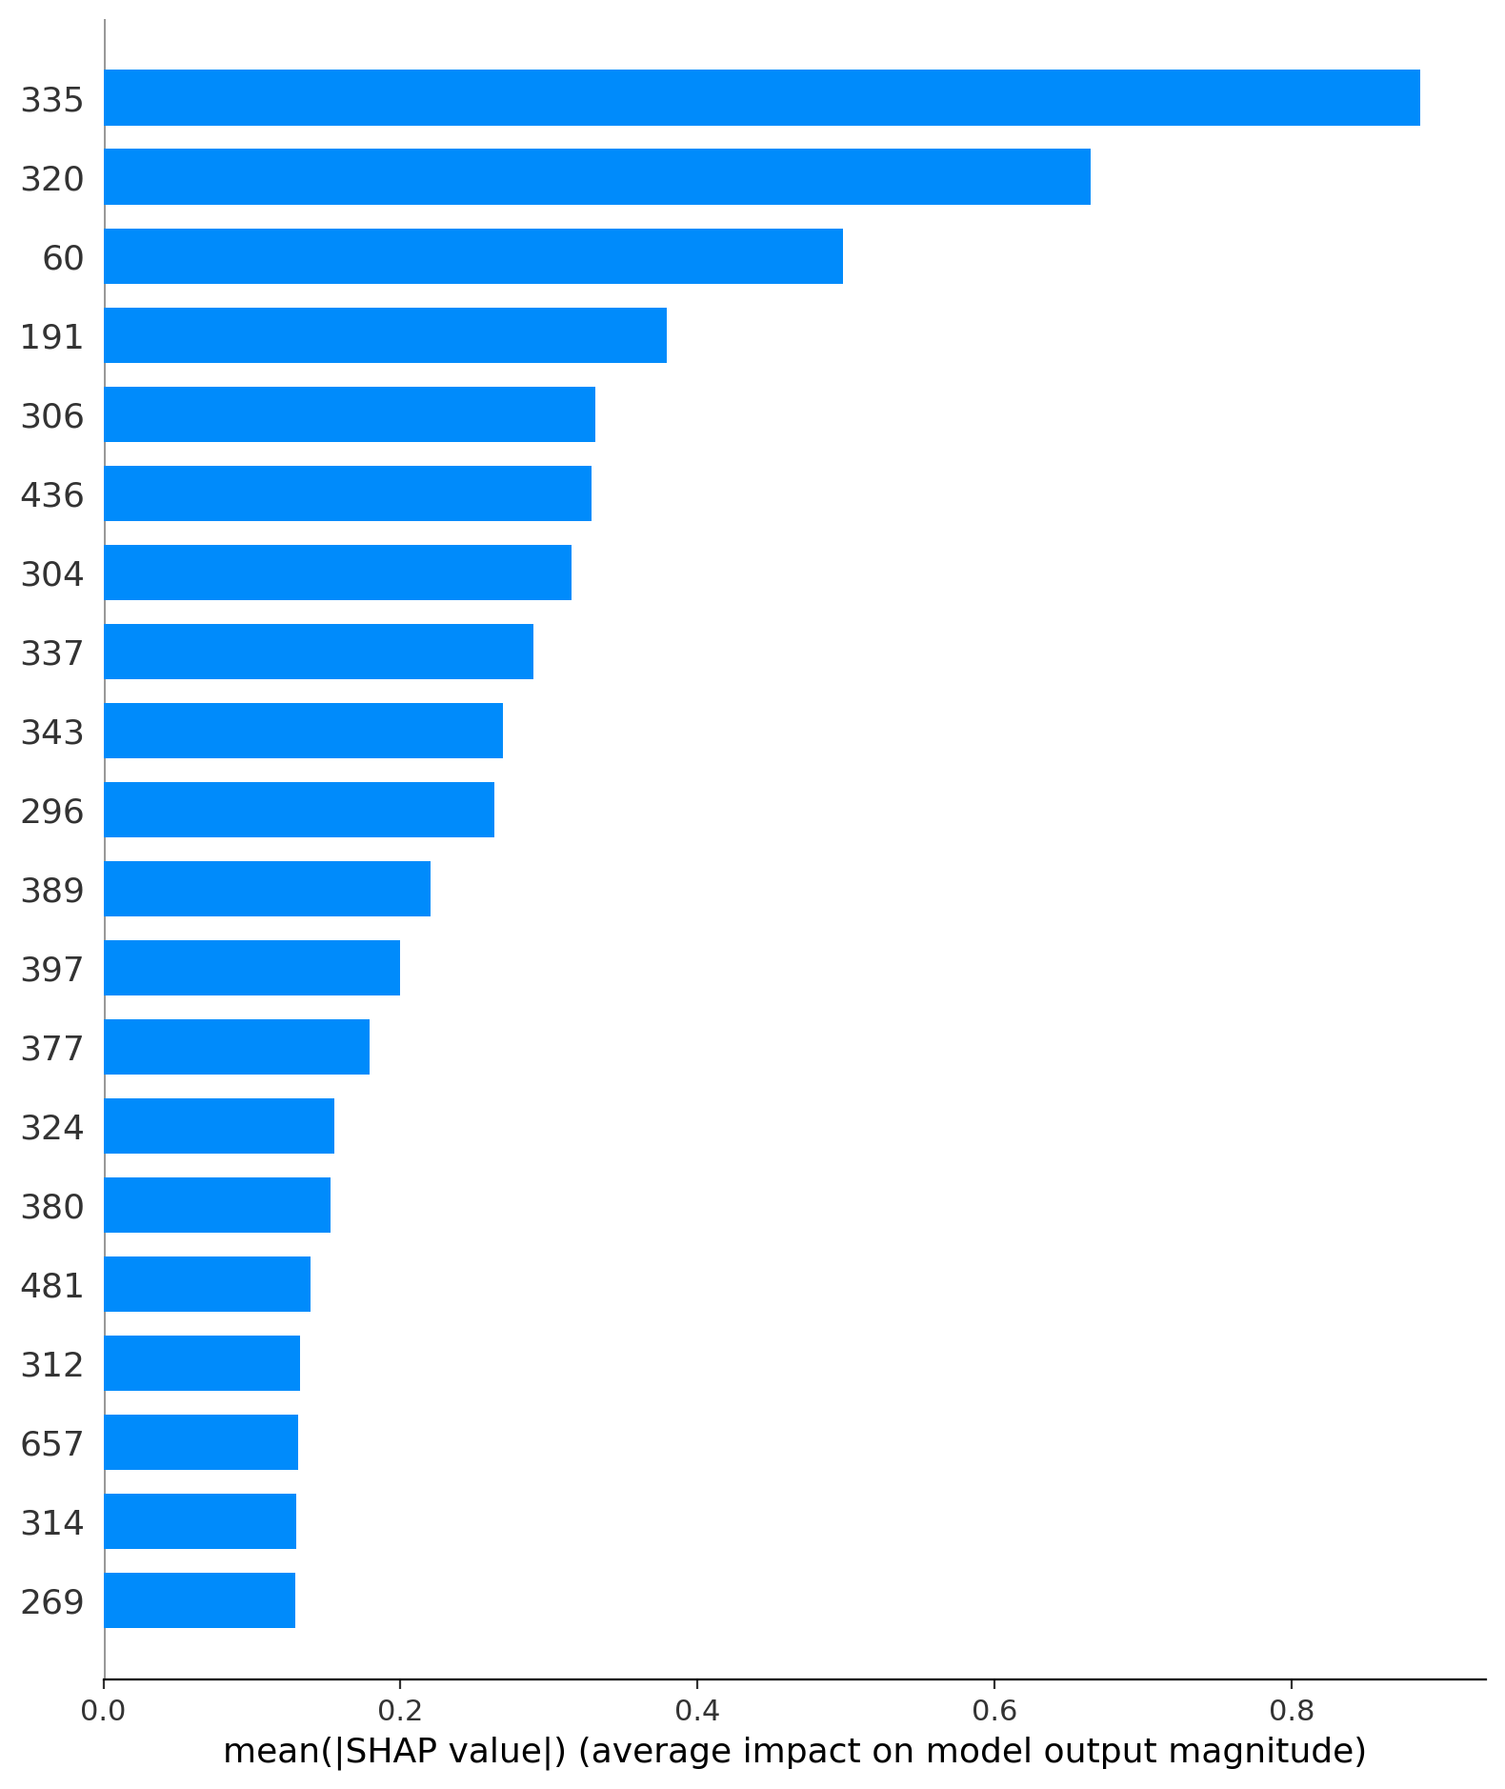
Figure 12. SHAP summary bar plot for the selected LightGBM model.
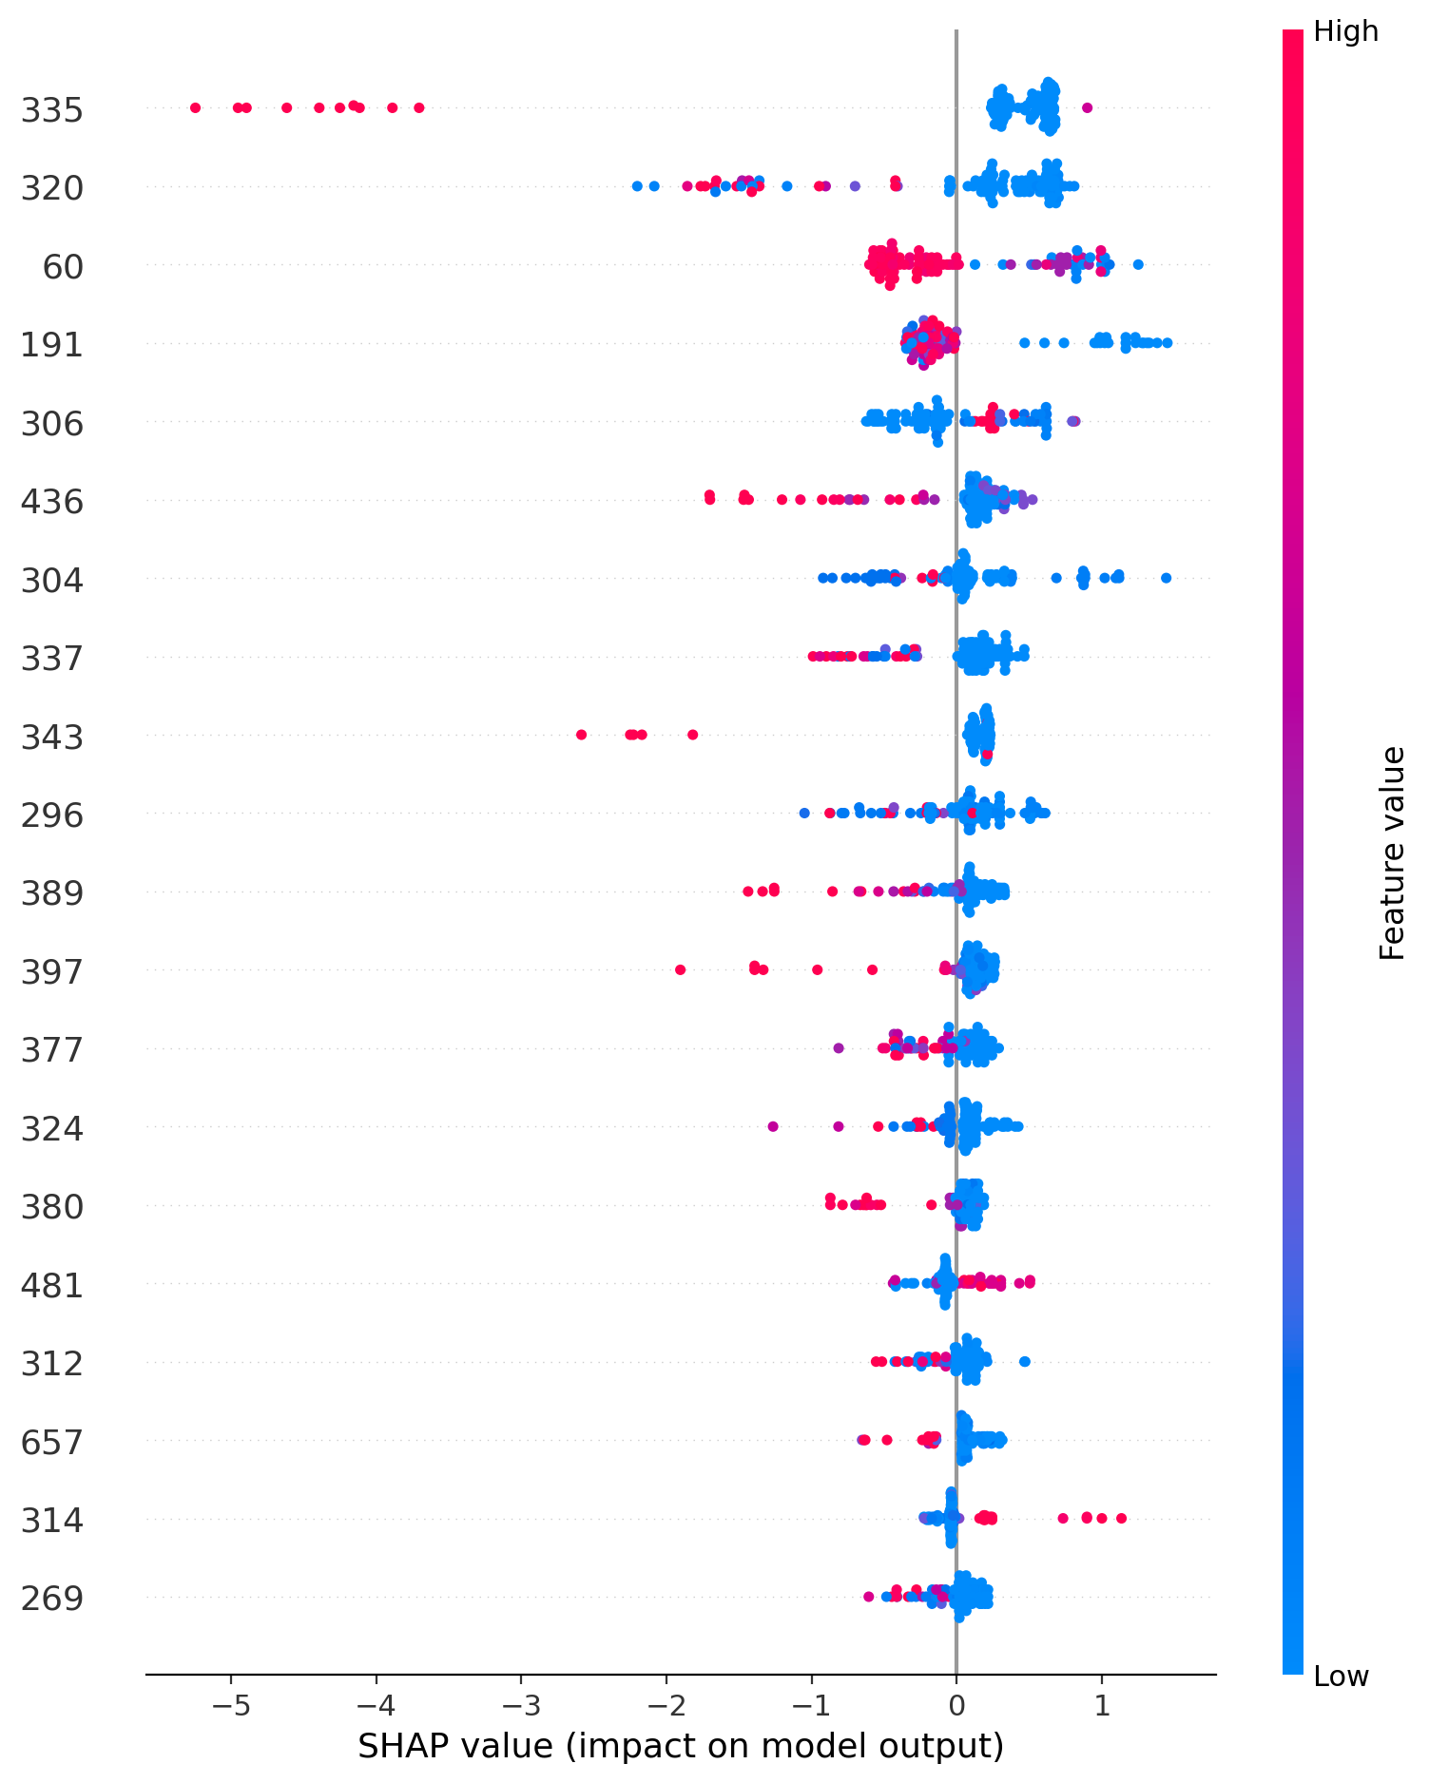
Figure 13. SHAP beeswarm plot for the selected LightGBM model.
There are two forms of explanation in the SHAP plots: The bar plot displays the mean absolute SHAP value of the features in the model when applied to the data across the full dataset. The beeswarm plot illustrates the contribution of individual feature values in the samples. Such numbers make the model more comprehensible than a “label only” classifier. They also provide support for a careful discussion of the use of models. However, it is important to not over-interpret SHAP. It is not a description of the reasons behind the ransomware attack in the real world, but rather an explanation of the trained model's behaviour.

5.8 Practical Interpretation of the Selected Model
The results of the model-selection decision should be interpreted as a practical judgement and not as a ranking table. LightGBM did not achieve the best performance on each of the metrics. Random Forest had the slightly better holdout ROC-AUC and XGBoost had the smallest of the saved model files. The goal of the project is not to identify the "best" model that trumps just one metric, though. The goal is to find one that would allow for pre-execution screening that offers a good balance of detection quality, speed, compactness and explainability. In the corrected experiment, LightGBM is the best model if they are combined. This is a significant interpretation as ransomware detection is a risk sensitive task. The combination of good recall and accuracy decreases the number of ransomware samples that are missed and benign software that is blocked. F1-score is good because it takes into account both sides. Another advantage of using ROC-AUC is that it illustrates the ability of the model in ranking the samples at different thresholds. But a true screening process would take latency and cost of resources into account as well. This has made it possible to provide the project report in addition to the standard classification metrics, as well as a prediction time and model size. The corrected answer also makes a methodological sense. The earlier perfect scores have not been included as the ultimate evidence as the metadata was target oriented and might have led to leakages. Following ID, GR and target-style columns were removed and the models still had good performance. That's more convincing since it would indicate that there is information in the PE-header that is useful for discriminating. That is, the revised answer is not as impressive, but it's a more credible academic answer. This represents an improvement from the highest possible number as it demonstrates critical judgement rather than just reporting the highest number, so is a more appropriate basis on which to develop a Level 7 project.

5.9 Discussion Against the Research Questions
The question of RQ1 is when ransomware samples are about to be executed, how often are they succeeded in distinguishing them from non-ransomware executable by the static PE-header features? The corrected results demonstrate that the feature set is useful for this data set. The models delivered high corrected accuracy, F1 and ROC-AUC without having any of the metadata leakage-risk fields. This backs up the importance of static PE-header features for dataset based pre-execution screening. RQ2 was: What is the best ensemble model for detecting subset of the light weight set in terms of detection performance and efficiency? Based on this experiment, LightGBM is the best option. It was the best performer in terms of holdout accuracy and F1 score, the mean cross validation accuracy and F1 score, the prediction time per sample and a small model size. Random Forest slightly outperforms the holdout ROC-AUC score, but is larger, yet not as powerful when measured on the balanced selection criteria. XGBoost was small, but not as good overall and was slower to predict. For RQ3, the model was trained to predict the features to be added to the PE-header, and SHAP was used to identify the most important ones. The SHAP output identified feature 335 as the strongest global contributor, followed by features 320, 60, 306, 191, 343, 337, 304, 436 and 296. Since there is no detailed feature-name mapping for some indices, it is not possible to state any particular PE semantics for those features in the report. It's a conscious decision of honesty. RQ4 was tailored to see if SHAP is able to help with transparent ransomware classification. That is the case within a certain limit. SHAP explains the model and it can be used to discuss which features are important to the predictions. It also provides a means of determining if the model is based on a focus on elements. But SHAP does not establish causality, cannot supersede validation and can't ensure that the classifier will perform well on all future families of ransomware.

5.10 Chapter Conclusion
The experiment results presented here indicate that a static PE-header feature matrix can be used to achieve good classification rates of ransomware-versus-goodware in the dataset tested in this experiment. LightGBM showed the best performance/efficiency in terms of detection. Choices of models were confirmed by cross-validation in combination with an explanation layer provided by SHAP. The outcomes are good, although not limitless. They are meant to be taken as an indication of a research prototype of a ransomware detector over a publicly available, static data set, and not as evidence of a ransomware detector ready for use in production.

CHAPTER 6: RECOMMENDATIONS, CONCLUSION AND LIMITATIONS

6.1 Introduction
In this chapter, the results are synthesized and recommendations are given for the next steps. It offers some practical suggestions for the safe use and further development of the artefact, concludes the project, outlines any limitations and recommends further research. The chapter is written prudently since the experiment was based on one public static data set. The outcomes are helpful, but don't serve as the evidence for universal ransomware detection.

6.2 Recommendations
The first is to leverage the proposed framework as an early triage element, instead of as a standalone security product. The corrected results indicate that the use of "static PE-header features" is beneficial but should be embedded in a layered ransomware defence strategy, which also includes “prevention,” “backup,” “access control,” “monitoring,” “guidance for incident response and recovery” [1], [2], [41]-[43]. The model can be used in practice to rank or flag suspicious evidence prior to it being executed but should not be the sole decision making control. The second suggestion is to continue testing in the future with the leakage in mind. Identifiers, hashes, file names, family labels and collection group labels and target-style fields should be checked in any future dataset before modelling. This is because leakage can lead to artificially high performance, and compromise the authenticity of the artefact. External validation should also be reported in future work as well as time-split or family-split validation (where applicable) to account for the possibility of hidden collection bias in the malware datasets [29], [82]-[91]. The third suggestion is to make better feature interpretation. The SHAP output indicates the indices of the features that influenced the prediction, but it is not always easy to get the semantic meaning of the PE-field. In a future version, it should be possible to trace the feature index back to the original PE-field source as far as possible. In this way, the meaning of the explanation will be more useful to the analysts. It would also aid in the understanding of whether or not the features that influence this are meaningful executable structure or artefacts of the dataset being constructed. The four recommendations include testing for robustness. There are a number of ways in which malware authors can alter the binary [29] or pack the executable and/or adjust the feature patterns to confuse static classifiers [84]–[91]. Thus, future research should focus on the robust adversarial performance, under packed samples, on unseen ransomware families, and on independent datasets. This will allow to discern if the existing results are still of value after the public dataset employed in this study.
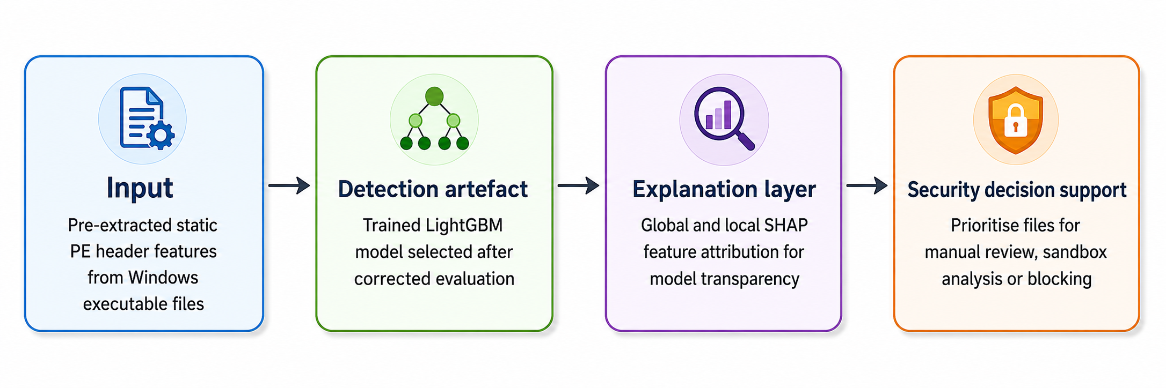
Figure 14. Recommendation framework for safe use of the static PE-header detection artefact.
Recommendation | Action | Reason
External validation | Test the selected model on an independent ransomware PE dataset. | Checks whether the result is dataset-specific or more general.
Family-aware testing | Use family-level or unseen-family splits where metadata allows it. | Tests whether the model handles new ransomware families.
Feature-name mapping | Map numbered features to original PE fields. | Improves semantic interpretation of SHAP outputs.
Adversarial robustness | Evaluate packed, obfuscated or modified samples. | Tests the static model against realistic evasion pressure.
Deployment design | Build a controlled prototype interface for static feature input only. | Supports safe demonstration without live malware execution.
Table 18. Recommendations and future work.

6.3 Conclusion
The goal of this project was to design, implement and assess an explainable pre-execution ransomware detection framework based on the static features of the Windows PE-header and lightweight ensemble learning. This was done in a public pre extracted feature dataset. Relevant Literature was reviewed, data set was prepared, three models were fit (Random Forest, XGBoost and LightGBM), and multiple metrics were used to evaluate these models, followed by cross validation and using SHAP on the last model selected. The corrected results provide an answer to the research problem. The features that were extracted from PE headers were effective in the classification of ransomware and goodware in the dataset in the context of static analysis. LightGBM achieved the best overall performance with 0.9792 holdout accuracy, 0.9782 F1-score, 0.9978 ROC-AUC and the fastest speed of prediction per sample. This selection was also validated using five-fold cross validation. SHAP provided a helpful explanation layer by showing the indices of the features that were influential in the model, which I selected. The most important aspect of the study is not just the good result. The primary value is the method for the evaluation which has been corrected and cautioned. The project does not include any metadata leakage risk fields, it does not only rely on accuracy, it has efficiency metrics and it does not overstate the meaning of SHAP. This helps to make the structure more academically defensible. It also provides a real structure which can be expanded by future researchers.

6.4 Limitations
The first limitation is that of using a specific dataset. One public dataset of PE-header ransomware is employed in the experiment. This data is directly applicable but cannot be used to represent all ransomware families, collection procedure, packer/compiler and real world deployment parameters. Thus, these results are to be taken as evidence in the dataset, but not as proof. The second drawback is that there are no live dynamic tests. This is a conscious scope of effort and safety determination. The project does NOT run ransomware on-the-fly. This means that it is not possible to assert any runtime properties like network communication, registry modifications, process injection or encryption speed. Those are questions that need to be answered using dynamic or memory analysis, which is beyond the scope of the current questions. Feature semantics is the third one. The SHAP results suggest important numerical feature indices but there are many features that are anonymised. This will limit the discussion. It is not possible to make up elaborate PE-field meanings. A future study should have a documented feature dictionary, to enable explanation to be more operationally meaningful. The fourth constraint is “environmental timing.” The training time and prediction time were measured in the experiment environment and the values may differ from one another depending on the different hardware or notebook platforms. The timing comparison is appropriate when it comes to any one workflow but should not be regarded as a baseline for all workflows.

6.5 Suggestions for Further Work
Future work should focus on independent validation, feature-name mapping and controlled demonstration. The selection of the LightGBM model could be further verified by an external dataset to see if the model generalises to the real dataset. SHAP explanations would be more useful if they were provided in a feature dictionary. With these pre-extracted PE-header features, a safe prototype interface could then be used to receive them, and provide a prediction and the top SHAP contributions displayed. This will enhance the usefulness of the artefact and will ensure that it does not encroach upon the safety boundary. The next step would be to get a better package of model governance. This may include a model card, a sheet of a description for the data set, a note on choosing thresholds, as well as a list of known failure modes. This set of documents would not make the model deployment ready, but would make the testing process more transparent in the future. They would also assist a future researcher in understanding how the classifier was trained, what data it was trained with, what were the assumptions of the classifier and what are the risks associated with it?

6.6 Chapter Conclusion
The project is completed and the key recommendations and limitations along with future works have been mentioned in this chapter. The best conclusion is that the suggested static PE-header construct is helpful for the corrected data set and would be extended so as to provide a stronger test. The project is still a research prototype, though, and has not reached the stage of commercial detector. This is a very important cautious judgement because it affords the true information of the evidence.

CHAPTER 7: REFLECTION

7.1 Introduction
This chapter reflects on the research process, technical learning and academic decisions made throughout the project. Reflection highlights learning of the literature review, design and implementation process, modified evaluation process, and reporting phase.

7.2 Reflection on the Research Process
This project helped me get a better understanding of the design and defense of a cybersecurity machine learning experiment. In the initial stages it was easy to be concerned principally with accuracy. As the project evolved, it was known that a very high level of accuracy was required. Fields that can leak make a model look strong, but it is not actually. Thus a corrected workflow was one of the most significant learning points throughout the project. I also learned some different aspects of the topic by reading the literature. There is no easy solution to ransomware detection. Dynamic systems can watch the behaviour, static systems can aid in the early detection of behaviour, and explainability can aid analysts in better understanding the model output. The difficulty is to understand what each method can do, and what it cannot. This helped me to narrow down my scope of the project and make better claims.

7.3 Reflection on Implementation
I worked on my practical skills in the implementation phase. I have learnt how to structure folders for experiments, save the outputs from the experiments, compare the models, and maintain consistency of the results in tables, figures and discussion. I also found out that there have to be high attention on the visual outputs. A figure may be technically correct, but not clear if it is out of place or is not described in the text. The figures and tables, as such, are therefore included near the discussion in the final report.

7.4 Reflection on Critical Judgement
The greatest challenge was to be confident while at the same time being prudent. The results are good, but don't expect this model to detect all ransomware samples or to be suitable for deployment in the enterprise. This project has been an eye opener for me in not exaggerating results in a research report. It should provide an explanation of the evidence, limitations and realistic recommendations.

7.5 Future Personal Development
I would begin to use the reference management and result tracking earlier if I were to do the project again. I would also attempt to get a feature dictionary (in a document) so as to be able to correlate the SHAP explanations with named PE fields. Despite this, the project contributed to the enhancement of my research design, static malware analysis, machine learning evaluation, explainability, and academic writing skills. The skills are helpful for future cybersecurity and AI research activities.

7.6 Chapter Conclusion
The project has enhanced my technical knowledge and academic knowledge. It gave me the idea that there was more to a successful cybersecurity machine learning project than coding and high scores. A strong project requires a well-defined research problem, a sound method, honest limitations, proper handling of evidence and a defensible interpretation of results. I feel these lessons will be of benefit to me in further studies and work.

REFERENCES
[1] Cybersecurity and Infrastructure Security Agency, "#StopRansomware Guide," CISA. [Online]. Available: https://www.cisa.gov/stopransomware/ransomware-guide.
[2] M. Souppaya and K. Scarfone, "Guide to Malware Incident Prevention and Handling for Desktops and Laptops," NIST SP 800-83 Rev. 1, 2013, doi: 10.6028/NIST.SP.800-83r1.
[3] Cuckoo Foundation, "Cuckoo Sandbox documentation." [Online]. Available: https://cuckoo.readthedocs.io/.
[4] Microsoft, "PE Format," Microsoft Learn. [Online]. Available: https://learn.microsoft.com/en-us/windows/win32/debug/pe-format.
[5] J. Z. Kolter and M. A. Maloof, "Learning to detect and classify malicious executables in the wild," Journal of Machine Learning Research, vol. 7, pp. 2721-2744, 2006. [Online]. Available: https://www.jmlr.org/papers/v7/kolter06a.html.
[6] J. Saxe and K. Berlin, "Deep neural network based malware detection using two dimensional binary program features," in Proc. MALWARE, 2015, doi: 10.1109/MALWARE.2015.7413680.
[7] E. Raff et al., "Malware detection by eating a whole EXE," arXiv:1710.09435, 2017. [Online]. Available: https://arxiv.org/abs/1710.09435.
[8] C. C. Moreira, D. C. Moreira, and C. de S. de Sales Jr., "Improving ransomware detection based on portable executable header using Xception convolutional neural network," Computers & Security, vol. 130, Art. no. 103265, 2023, doi: 10.1016/j.cose.2023.103265.
[9] C. C. Moreira, D. C. Moreira, and C. de S. de Sales Jr., "Ransomware PE Header Feature Dataset," Mendeley Data, Version 3, 2024, doi: 10.17632/p3v94dft2y.3.
[10] L. Breiman, "Random forests," Machine Learning, vol. 45, no. 1, pp. 5-32, 2001, doi: 10.1023/A:1010933404324.
[11] T. Chen and C. Guestrin, "XGBoost: A scalable tree boosting system," in Proc. ACM SIGKDD, 2016, pp. 785-794, doi: 10.1145/2939672.2939785.
[12] G. Ke et al., "LightGBM: A highly efficient gradient boosting decision tree," in Advances in Neural Information Processing Systems 30, 2017, pp. 3146-3154. [Online]. Available: https://papers.nips.cc/paper_files/paper/2017/hash/6449f44a102fde848669bdd9eb6b76fa-Abstract.html.
[13] S. M. Lundberg and S.-I. Lee, "A unified approach to interpreting model predictions," in Advances in Neural Information Processing Systems 30, 2017, pp. 4765-4774. [Online]. Available: https://papers.nips.cc/paper_files/paper/2017/hash/8a20a8621978632d76c43dfd28b67767-Abstract.html.
[14] S. M. Lundberg et al., "From local explanations to global understanding with explainable AI for trees," Nature Machine Intelligence, vol. 2, pp. 56-67, 2020, doi: 10.1038/s42256-019-0138-9.
[15] M. Sikorski and A. Honig, Practical Malware Analysis. San Francisco, CA, USA: No Starch Press, 2012.
[16] M. Alazab, "Profiling and classifying the behavior of malicious codes," Journal of Systems and Software, vol. 100, pp. 91-102, 2015, doi: 10.1016/j.jss.2014.10.031.
[17] H. Oz, A. Aris, A. Levi, and A. S. Uluagac, "A survey on ransomware: Evolution, taxonomy, and defense solutions," ACM Computing Surveys, vol. 54, no. 11s, pp. 1-37, 2022, doi: 10.1145/3514229.
[18] ENISA, "ENISA Threat Landscape for Ransomware Attacks," European Union Agency for Cybersecurity, 2022. [Online]. Available: https://www.enisa.europa.eu/publications/enisa-threat-landscape-for-ransomware-attacks.
[19] MITRE, "ATT&CK Enterprise Matrix." [Online]. Available: https://attack.mitre.org/.
[20] M. Kharraz, W. Robertson, D. Balzarotti, L. Bilge, and E. Kirda, "Cutting the Gordian Knot: A look under the hood of ransomware attacks," in Proc. DIMVA, 2015, doi: 10.1007/978-3-319-20550-2_1.
[21] M. Kharraz et al., "UNVEIL: A large-scale, automated approach to detecting ransomware," in Proc. USENIX Security Symposium, 2016. [Online]. Available: https://www.usenix.org/conference/usenixsecurity16/technical-sessions/presentation/kharraz.
[22] N. Scaife, H. Carter, P. Traynor, and K. R. B. Butler, "CryptoLock (and Drop It): Stopping ransomware attacks on user data," in Proc. IEEE ICDCS, 2016, doi: 10.1109/ICDCS.2016.46.
[23] A. Continella et al., "ShieldFS: A self-healing, ransomware-aware filesystem," in Proc. ACM ACSAC, 2016, doi: 10.1145/2991079.2991110.
[24] S. Mehnaz, A. Mudgerikar, and E. Bertino, "RWGuard: A real-time detection system against cryptographic ransomware," in Proc. RAID, 2018. [Online]. Available: https://www.usenix.org/conference/raid2018/presentation/mehnaz.
[25] D. Ucci, L. Aniello, and R. Baldoni, "Survey of machine learning techniques for malware analysis," Computers & Security, vol. 81, pp. 123-147, 2019, doi: 10.1016/j.cose.2018.11.001.
[26] D. Gibert, C. Mateu, and J. Planes, "The rise of machine learning for detection and classification of malware: Research developments, trends and challenges," Journal of Network and Computer Applications, vol. 153, Art. no. 102526, 2020, doi: 10.1016/j.jnca.2019.102526.
[27] H. S. Anderson and P. Roth, "EMBER: An open dataset for training static PE malware machine learning models," arXiv:1804.04637, 2018. [Online]. Available: https://arxiv.org/abs/1804.04637.
[28] R. Harang and E. M. Rudd, "SOREL-20M: A large scale benchmark dataset for malicious PE detection," arXiv:2012.07634, 2020. [Online]. Available: https://arxiv.org/abs/2012.07634.
[29] X. Ling et al., "Adversarial attacks against Windows PE malware detection: A survey of the state-of-the-art," arXiv:2112.12310, 2021. [Online]. Available: https://arxiv.org/abs/2112.12310.
[30] D. Chicco and G. Jurman, "The advantages of the Matthews correlation coefficient over F1 score and accuracy in binary classification evaluation," BMC Genomics, vol. 21, Art. no. 6, 2020, doi: 10.1186/s12864-019-6413-7.
[31] T. Fawcett, "An introduction to ROC analysis," Pattern Recognition Letters, vol. 27, no. 8, pp. 861-874, 2006, doi: 10.1016/j.patrec.2005.10.010.
[32] F. Pedregosa et al., "Scikit-learn: Machine learning in Python," Journal of Machine Learning Research, vol. 12, pp. 2825-2830, 2011. [Online]. Available: https://jmlr.org/papers/v12/pedregosa11a.html.
[33] A. Barredo Arrieta et al., "Explainable Artificial Intelligence (XAI): Concepts, taxonomies, opportunities and challenges toward responsible AI," Information Fusion, vol. 58, pp. 82-115, 2020, doi: 10.1016/j.inffus.2019.12.012.
[34] R. Guidotti et al., "A survey of methods for explaining black box models," ACM Computing Surveys, vol. 51, no. 5, Art. no. 93, 2018, doi: 10.1145/3236009.
[35] M. T. Ribeiro, S. Singh, and C. Guestrin, "Why should I trust you? Explaining the predictions of any classifier," in Proc. ACM SIGKDD, 2016, pp. 1135-1144, doi: 10.1145/2939672.2939778.
[36] C. C. Moreira, D. C. Moreira, and C. de S. de Sales Jr., "A comprehensive analysis combining structural features for detection of new ransomware families," Journal of Information Security and Applications, vol. 81, Art. no. 103716, 2024, doi: 10.1016/j.jisa.2024.103716.
[37] J. Ferdous, R. Islam, A. Mahboubi, and M. Z. Islam, "AI-Based Ransomware Detection: A Comprehensive Review," IEEE Access, vol. 12, pp. 136666-136695, 2024, doi: 10.1109/ACCESS.2024.3461965.
[38] S. A. Alzahrani and Y. Xiao, "A Survey of Ransomware Detection Methods," IEEE Access, vol. 13, pp. 57943-57982, 2025, doi: 10.1109/ACCESS.2025.3556187.
[39] M. J. Page et al., "The PRISMA 2020 statement: an updated guideline for reporting systematic reviews," BMJ, vol. 372, n71, 2021, doi: 10.1136/bmj.n71.
[40] B. Kitchenham and S. Charters, "Guidelines for performing systematic literature reviews in software engineering," EBSE Technical Report EBSE-2007-01, 2007. [Online]. Available: https://www.elsevier.com/__data/promis_misc/525444systematicreviewsguide.pdf.
[41] NIST, "Artificial Intelligence Risk Management Framework (AI RMF 1.0)," NIST AI 100-1, 2023, doi: 10.6028/NIST.AI.100-1.
[42] NIST, "Security and Privacy Controls for Information Systems and Organizations," NIST SP 800-53 Rev. 5, 2020, doi: 10.6028/NIST.SP.800-53r5.
[43] NIST, "Secure Software Development Framework (SSDF) Version 1.1," NIST SP 800-218, 2022, doi: 10.6028/NIST.SP.800-218.
[44] A. Souri and R. Hosseini, "A state-of-the-art survey of malware detection approaches using data mining techniques," Human-centric Computing and Information Sciences, vol. 8, Art. no. 3, 2018, doi: 10.1186/s13673-018-0125-x.
[45] A. Bensaoud, J. Kalita, and M. Bensaoud, "A survey of malware detection using deep learning," arXiv:2407.19153, 2024. [Online]. Available: https://arxiv.org/abs/2407.19153.
[46] C. C. Moreira, D. C. Moreira, and C. de S. de Sales Jr., "Ransomware Combined Structural Feature Dataset," Mendeley Data, Version 2, 2024. [Online]. Available: https://data.mendeley.com/datasets/yzhcvn7sj5/2.
[47] VirusShare, "VirusShare.com." [Online]. Available: https://virusshare.com/.
[48] abuse.ch, "MalwareBazaar database." [Online]. Available: https://bazaar.abuse.ch/.
[49] Google, "VirusTotal." [Online]. Available: https://www.virustotal.com/.
[50] Microsoft, "ImageHlp Structures," Microsoft Learn. [Online]. Available: https://learn.microsoft.com/en-us/windows/win32/debug/imagehlp-structures.
[51] Python Software Foundation, "Python 3 documentation." [Online]. Available: https://docs.python.org/3/.
[52] W. McKinney, "Data structures for statistical computing in Python," in Proc. 9th Python in Science Conference, 2010, pp. 56-61, doi: 10.25080/Majora-92bf1922-00a.
[53] C. R. Harris et al., "Array programming with NumPy," Nature, vol. 585, pp. 357-362, 2020, doi: 10.1038/s41586-020-2649-2.
[54] J. D. Hunter, "Matplotlib: A 2D graphics environment," Computing in Science & Engineering, vol. 9, no. 3, pp. 90-95, 2007, doi: 10.1109/MCSE.2007.55.
[55] SHAP developers, "SHAP documentation." [Online]. Available: https://shap.readthedocs.io/.
[56] scikit-learn developers, "Model evaluation: quantifying the quality of predictions." [Online]. Available: https://scikit-learn.org/stable/modules/model_evaluation.html.
[57] XGBoost developers, "XGBoost Python package." [Online]. Available: https://xgboost.readthedocs.io/.
[58] Microsoft, "LightGBM documentation." [Online]. Available: https://lightgbm.readthedocs.io/.
[59] M. Saunders, P. Lewis, and A. Thornhill, Research Methods for Business Students, 8th ed. Harlow, U.K.: Pearson, 2019.
[60] K. Peffers, T. Tuunanen, M. A. Rothenberger, and S. Chatterjee, "A design science research methodology for information systems research," Journal of Management Information Systems, vol. 24, no. 3, pp. 45-77, 2007, doi: 10.2753/MIS0742-1222240302.
[61] A. R. Hevner, S. T. March, J. Park, and S. Ram, "Design science in information systems research," MIS Quarterly, vol. 28, no. 1, pp. 75-105, 2004, doi: 10.2307/25148625.
[62] R. J. Wieringa, Design Science Methodology for Information Systems and Software Engineering. Berlin, Germany: Springer, 2014, doi: 10.1007/978-3-662-43839-8.
[63] C. W. Dawson, Projects in Computing and Information Systems: A Student's Guide, 3rd ed. Harlow, U.K.: Pearson, 2015.
[64] Z. O'Leary, The Essential Guide to Doing Your Research Project, 3rd ed. London, U.K.: Sage, 2017.
[65] IEEE, "IEEE Reference Guide." [Online]. Available: https://ieeeauthorcenter.ieee.org/wp-content/uploads/IEEE-Reference-Guide.pdf.
[66] F. Doshi-Velez and B. Kim, "Towards a rigorous science of interpretable machine learning," arXiv:1702.08608, 2017. [Online]. Available: https://arxiv.org/abs/1702.08608.
[67] C. Molnar, Interpretable Machine Learning, 2nd ed., 2022. [Online]. Available: https://christophm.github.io/interpretable-ml-book/.
[68] J. H. Friedman, "Greedy function approximation: A gradient boosting machine," Annals of Statistics, vol. 29, no. 5, pp. 1189-1232, 2001, doi: 10.1214/aos/1013203451.
[69] T. Hastie, R. Tibshirani, and J. Friedman, The Elements of Statistical Learning, 2nd ed. New York, NY, USA: Springer, 2009. [Online]. Available: https://hastie.su.domains/ElemStatLearn/.
[70] C. M. Bishop, Pattern Recognition and Machine Learning. New York, NY, USA: Springer, 2006.
[71] I. Goodfellow, Y. Bengio, and A. Courville, Deep Learning. Cambridge, MA, USA: MIT Press, 2016. [Online]. Available: https://www.deeplearningbook.org/.
[72] D. M. W. Powers, "Evaluation: From precision, recall and F-measure to ROC, informedness, markedness and correlation," Journal of Machine Learning Technologies, vol. 2, no. 1, pp. 37-63, 2011. [Online]. Available: https://arxiv.org/abs/2010.16061.
[73] G. Biau and E. Scornet, "A random forest guided tour," TEST, vol. 25, pp. 197-227, 2016, doi: 10.1007/s11749-016-0481-7.
[74] A. Natekin and A. Knoll, "Gradient boosting machines, a tutorial," Frontiers in Neurorobotics, vol. 7, Art. no. 21, 2013, doi: 10.3389/fnbot.2013.00021.
[75] T. Miller, "Explanation in artificial intelligence: Insights from the social sciences," Artificial Intelligence, vol. 267, pp. 1-38, 2019, doi: 10.1016/j.artint.2018.07.007.
[76] H. Lakkaraju, S. H. Bach, and J. Leskovec, "Interpretable decision sets: A joint framework for description and prediction," in Proc. ACM KDD, 2016, pp. 1675-1684, doi: 10.1145/2939672.2939874.
[77] R. Nori, S. Jenkins, P. Koch, and R. Caruana, "InterpretML: A unified framework for machine learning interpretability," arXiv:1909.09223, 2019. [Online]. Available: https://arxiv.org/abs/1909.09223.
[78] L. van der Maaten and G. Hinton, "Visualizing data using t-SNE," Journal of Machine Learning Research, vol. 9, pp. 2579-2605, 2008. [Online]. Available: https://www.jmlr.org/papers/v9/vandermaaten08a.html.
[79] M. T. Ribeiro, S. Singh, and C. Guestrin, "Anchors: High-precision model-agnostic explanations," in Proc. AAAI, 2018. [Online]. Available: https://ojs.aaai.org/index.php/AAAI/article/view/11491.
[80] A. Ghorbani, A. Abid, and J. Zou, "Interpretation of neural networks is fragile," in Proc. AAAI, 2019, doi: 10.1609/aaai.v33i01.33013681.
[81] D. Slack, S. Hilgard, E. Jia, S. Singh, and H. Lakkaraju, "Fooling LIME and SHAP: Adversarial attacks on post hoc explanation methods," in Proc. AIES, 2020, doi: 10.1145/3375627.3375830.
[82] E. M. Rudd, A. Rozsa, M. Gunther, and T. E. Boult, "A survey of stealth malware attacks, mitigation measures, and steps toward autonomous open world solutions," IEEE Communications Surveys & Tutorials, vol. 19, no. 2, pp. 1145-1172, 2017, doi: 10.1109/COMST.2016.2636078.
[83] N. Idika and A. P. Mathur, "A survey of malware detection techniques," Purdue University, 2007. [Online]. Available: https://www.cs.purdue.edu/homes/apm/courses/cs590-spring2010/Mathur-idika.pdf.
[84] S. Ye, S. Boren, and A. Oprea, "Feature squeezing for detecting adversarial examples in malware detection," arXiv:2007.03126, 2020. [Online]. Available: https://arxiv.org/abs/2007.03126.
[85] B. Biggio et al., "Evasion attacks against machine learning at test time," in Proc. ECML PKDD, 2013, doi: 10.1007/978-3-642-40994-3_25.
[86] N. Carlini and D. Wagner, "Towards evaluating the robustness of neural networks," in Proc. IEEE Symposium on Security and Privacy, 2017, doi: 10.1109/SP.2017.49.
[87] A. Demontis et al., "Why do adversarial attacks transfer? Explaining transferability of evasion and poisoning attacks," in Proc. USENIX Security Symposium, 2019. [Online]. Available: https://www.usenix.org/conference/usenixsecurity19/presentation/demontis.
[88] O. Suciu, S. Coull, and J. Johns, "Exploring adversarial examples in malware detection," in Proc. IEEE Security and Privacy Workshops, 2019, doi: 10.1109/SPW.2019.00015.
[89] K. Grosse, N. Papernot, P. Manoharan, M. Backes, and P. McDaniel, "Adversarial examples for malware detection," in Proc. ESORICS, 2017, doi: 10.1007/978-3-319-66399-9_4.
[90] D. Maiorca et al., "Adversarial detection of flash malware: Limitations and open issues," Computers & Security, vol. 96, Art. no. 101901, 2020, doi: 10.1016/j.cose.2020.101901.
[91] F. Pierazzi, F. Pendlebury, J. Cortellazzi, and L. Cavallaro, "Intriguing properties of adversarial ML attacks in the problem space," in Proc. IEEE Symposium on Security and Privacy, 2020, doi: 10.1109/SP40000.2020.00073.
[92] B. Kolosnjaji, A. Zarras, G. Webster, and C. Eckert, "Deep learning for classification of malware system call sequences," in Proc. AI 2016: Advances in Artificial Intelligence, 2016, doi: 10.1007/978-3-319-50127-7_14.
[93] E. Raff and C. Nicholas, "A survey of machine learning methods and challenges for Windows malware classification," arXiv:2006.09271, 2020. [Online]. Available: https://arxiv.org/abs/2006.09271.
[94] B. Athiwaratkun and J. W. Stokes, "Malware classification with LSTM and GRU language models and a character-level CNN," in Proc. IEEE ICASSP, 2017, doi: 10.1109/ICASSP.2017.7952603.
[95] A. Nataraj, S. Karthikeyan, G. Jacob, and B. S. Manjunath, "Malware images: Visualization and automatic classification," in Proc. VizSec, 2011. [Online]. Available: https://dl.acm.org/doi/10.1145/2016904.2016908.
[96] K. Rieck, T. Holz, C. Willems, P. Duessel, and P. Laskov, "Learning and classification of malware behavior," in Proc. DIMVA, 2008, doi: 10.1007/978-3-540-70542-0_7.
[97] U. Bayer, P. M. Comparetti, C. Hlauschek, C. Kruegel, and E. Kirda, "Scalable, behavior-based malware clustering," in Proc. NDSS, 2009. [Online]. Available: https://www.ndss-symposium.org/ndss2009/scalable-behavior-based-malware-clustering/.
[98] M. Lindorfer, C. Kolbitsch, and P. M. Comparetti, "Detecting environment-sensitive malware," in Proc. RAID, 2011, doi: 10.1007/978-3-642-23644-0_17.
[99] P. Trinius, C. Willems, T. Holz, and K. Rieck, "A malware instruction set for behavior-based analysis," University of Mannheim, Tech. Rep., 2010. [Online]. Available: https://www.mlsec.org/malheur/docs/tr.pdf.
[100] K. Rieck, P. Trinius, C. Willems, and T. Holz, "Automatic analysis of malware behavior using machine learning," Journal of Computer Security, vol. 19, no. 4, pp. 639-668, 2011, doi: 10.3233/JCS-2010-0410.

APPENDICES

Appendix I: Evidence Folder Summary
The supporting evidence folder contains the corrected dataset output, selected feature list, model metrics summary, cross-validation summary, confusion matrices, ROC curves, SHAP outputs, saved model files and run logs. These files support the values reported in Chapters Four and Five.
Item | Value
Rows used | 2,157
Benign/goodware | 1,134
Ransomware | 1,023
Corrected feature columns | 1,018
Best model | LightGBM
LightGBM holdout accuracy | 0.9792
LightGBM holdout F1-score | 0.9782
LightGBM holdout ROC-AUC | 0.9978
LightGBM CV accuracy mean | 0.9694
LightGBM CV F1 mean | 0.9681
Table A1. Locked corrected values for report and viva consistency.

Appendix II: Kaggle Notebook and Output Evidence
The screenshots below record the project folder structure, dataset-loading log and saved experiment outputs. The corrected result values in Chapter Five remain the final values used for interpretation. Earlier exploratory output is not treated as final evidence where leakage-risk features were later corrected.
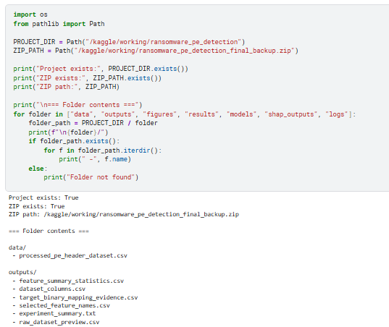
Figure A1. Project directory and saved data/output files in the notebook environment.
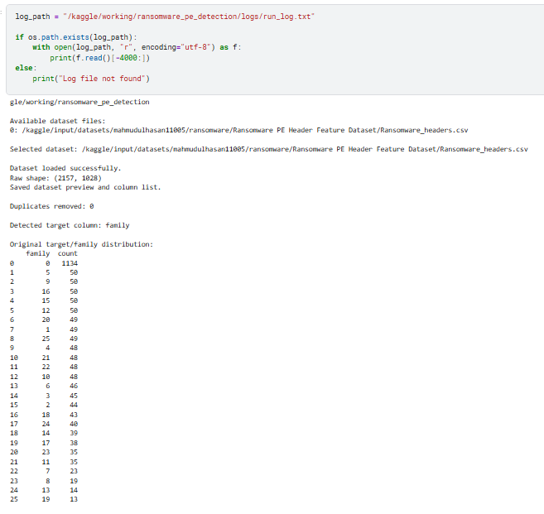
Figure A2. Dataset-loading log showing file path, raw shape, duplicate check and target column.
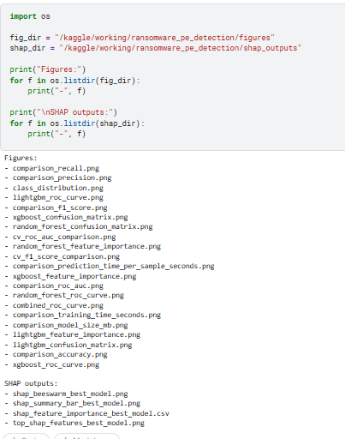
Figure A3. Saved figure and SHAP output files generated by the experiment workflow.
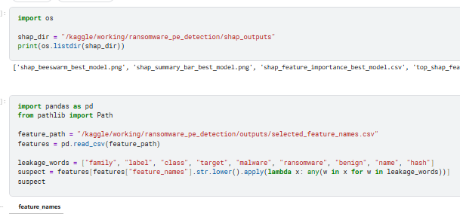
Figure A4. SHAP output folder and selected feature-name leakage check.

Appendix III: AI Assistance and Integrity Note
AI tools may be used for explanation, structure, formatting support and checking where permitted by university guidance. The student remains responsible for understanding, verifying and defending all submitted work. The submitted report should be checked against the original dataset outputs, references and supervisor requirements before final submission. The final reference list is presented in numeric IEEE style, with cited sources linked to the relevant sections of the report [65].

Appendix IV: Supervision Log Book
The following supervision log summarises the main meeting schedule and agreed deliverables recorded during the project period.
Date | Focus | Action or feedback recorded
1 July 2026 | Research problem presentation | Refine the project scope, use the dissertation template and MSc handbook, and prepare implementation/experiment details.
8 July 2026 | Chapter 1 discussion | Combine introduction and background, include at least four objectives, remove Chapter One summary, start Chapter 2 and prepare SLR search material.
22 July 2026 | Chapter 2 first draft | Add database searched table and selected paper counts; continue identifying literature themes aligned with objectives and research questions.
28 July 2026 | Chapter 2 second draft | Review Chapter 2 and report implementation/experiment progress.
6 August 2026 | Chapter 3 draft | Submit methodology draft and discuss implementation/experiment details.
11 August 2026 | Chapters 1-3 feedback | Discuss detailed feedback and prepare Chapter 4 design and implementation.
26 August 2026 | Chapter 4 discussion | Submit Chapter 4 and continue remaining chapters.
1 September 2026 | Draft final report | Discuss final draft, results, objectives and plagiarism-check preparation.
4 September 2026 | Final project review | Prepare a 20-minute presentation and final submission corrections.
7 September 2026 | Final submission | Submit final project report.
15-18 September 2026 | Viva period | Defend the project, corrected results, limitations and contribution.
Table A2. Supervision log book summary.

