

ANA DZHIPOVA

Student Number: 2013882

HUMAN RESOURCE MANAGEMENT
LCMB7000
Assignment 2

Module Lecturer:
Dr. Gladius David Kulothungan

Table of content

- Introduction………………………………………………………………………………………….3

- Hanoi - brief overview of the company and its problems in HRM……..3

- Models of motivation and reward strategies ………………………………………4

- Recommendations ……………………………………………………………………..………10

- Conclusion………………………………………………………………………………………….12

Referencing

- Introduction
Management of the modern business is extremely complicated. HRM is a major part of the overall management and its importance constantly increases caused by the increasing importance of the workforce for the business performance. HRM is continuous process and building and changing the HRM strategies is influenced by dynamic external forces and internal factors which are very specific for different organisations. Measure for reliability of HRM strategy is the level of meeting the workforce needs of the company at any time.
This report is focused on the strategy that can be used by hat manufacturer called Hanoi to sort problems in HRM caused by the changes in the manufacturing process. It includes an overview of the HRM practices used by the company and detailed analysis of the problems related to human management. There are theories of motivation and reward strategies presented as well. Based on all of this, there are included some ideas about how the company can improve its HRM in relation of strategic goals of the organisation.

- Hanoi - brief overview of the company and its problems in HRM
The case, which is subject of the report, is about Hanoi – company used to produce limited range basic models hats and caps and changes in the business caused problems in HRM. Hanoi is simply structured and HRM tasks are allocated to administrative office and line managers who deal with personal problems. Cutters payment system is based on piece-rate. After starting work with new contractor, company faces some difficulties in managing workforce. First one – dissatisfaction of the cutters, occurred because of decreased productivity and respectively, their earnings dropped. “Production line employees’ performance may equate with job and income security and workplace health and safety” (Shields, Rooney, Brown and Kain, 2020).
Other affected group of employees are line managers. Difficulty with them is their resisting provoked by the General manager decision to appoint HR Manager. They are worried that this will reduce their influence and think it is unnecessary expense. Having in mind that the line managers communicate with the workers, their impact on their team members must be pointed as well. Williams (2002) explains the line manager key role with “interactive nature” of their work.
Despite of the reaction of the line managers, organisation meets acute need of effective management of human capital because the current problems can be solved only by creating efficient reward strategy which require competent opinion for the situation, analysis, and professional decisions. Also, it happened because company was not prepared for changes. Hiring of HR manager will protect the company from similar situations in the future.
Hanoi faces problems in HRM which can lead to decreasing of the efficiency of the manufacturing process and difficulties in the process of business growth. That is why company must provide professionally created reward strategy fitting changed needs and ensuring individuals satisfaction as soon as possible.

- Models of motivation and reward strategies

As stated, company growth caused difficulties in HRM. Dissatisfaction of workers can lead to dropping of the productivity and increasing of the human turnover which is a serious threat for company performance.
The critical situation needs creating the HR rewarding strategy fitting the needs of the company.
According to Shields, Rooney, Brown and Kain (2020) there are two key components of HRM: managing people performance and managing rewarding, which are “very close and in complex interdependency”. Both are oriented to effective management of the human capital and support each other because high performance of people is impossible without their high motivation and high motivation is impossible if no opportunities for personal performance. This explains why rewarding practices should help increasing the employee’s motivation and engagement and both -performance and rewarding strategies must be composed in harmony which will ensure that their elements will reinforce each other. “Reward management is concerned with the strategies, policies and processes required to ensure that the value of people and the contributions they make to achieving organisational, departmental and team goals is recognised and rewarded.” (Armstrong, 2006).
Reward strategy is a process of motivation of the employees used for rewarding them in terms of their performance within the company.
There are several motivation theories, all of them based on people’s needs and explaining how they can be satisfied.

Maslow Hierarchy of needs
It is most popular theory about the motivation and is based on human needs. This theory determinates 5 levels of needs which are reflected in a pyramid shape model.

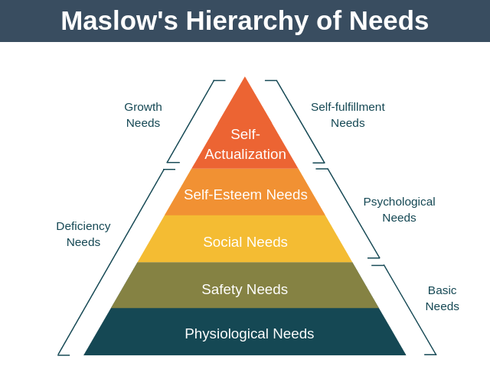
Figure 1, Source: https://expertprogrammanagement.com/2019/06/maslows-hierarchy-of-needs/

According to this model motivation is unsatisfied needs and once the level of needs gets satisfied, people start pursuing next level needs, but they keep chasing the satisfied ones.

Two-factors theory
Herzberg developed Maslow’s need hierarchy model by application to people at work. His model determinates two groups of factors: motivation (satisfaction) and hygiene where motivators area group of factors influencing the motivation positively and hygiene factors if not present, can lead to dissatisfaction.
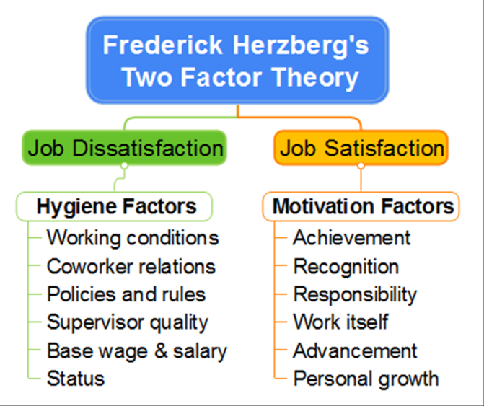

Figure 2, Source: https://www.biggerplate.com/mindmaps/ubbWTg1P/frederick-herzberg-39-s-two-factor-theory

Theory X (authoritarian) and theory Y (participative)
Explains the importance of commitment and integrating of needs of employer and employees. (Armstrong, 2006).

Vroom’s Expectancy theory of motivation
It holds that individual’s motivation is dependent on the expectancy that their behaviour can result in achievement of wished outcomes or decision to act in a certain way is based on the expected result of the chosen act. It means that their effort to achieve the expectations will be recognised and rewarded.

Equity theory
The fundamental idea of equity theory is that people are better motivated if treated equitably, so this explains why one of the principles of rewarding must be equitability. (Armstrong&Taylor, 2014).

Reinforcement theory
States that certain actions are and other are not useful for performance, so rewarding system must reinforce desired behaviour through rewards and penalties.
Reward strategies
Reward management could be determined as a core element of HRM systems. Specific of particular organisation is very important for designing a reward strategy and must be taken into account.

Cash compensation
A company’s pay structure can be defined by the number of work levels, the pay differentials (the pay differences between levels) and the criteria used to determine those levels ( Milkovich & Newman , 2004 )
There are two main bases to pay – time and performance, companies can combine or both. Payment on time base is hourly rate. Payment based on performance is more complicated – require considering the “nature of performance and whether it is achieved by an individual. (Boots and Hook, 2011).

Effort-reward model
The idea of the model is: “failed reciprocity between high efforts spent at work and low rewards received in turn elicits strong negative emotions and stress reactions with adverse long‐term effects on health.” It explains that stress at work environment causes stress relates health risk. (Siegrist, 2017)

Traditional Incentive Strategy
It is a performance based pay system which is currently used by Hanoi but obviously is not suitable because in the new circumstances cutters suffered decresed earnings. In some points this system can be considered as fairer rather the fixed salaries (Miller, 2015).

Goal setting theory
According with this theory the clear goals, feedback, and the relationship between them motivate employees. “The motivational impact of goals may be affected by moderators such as ability and self-efficacy. Deadlines improve the effectiveness of goals.” (Lunenburg, 2011)

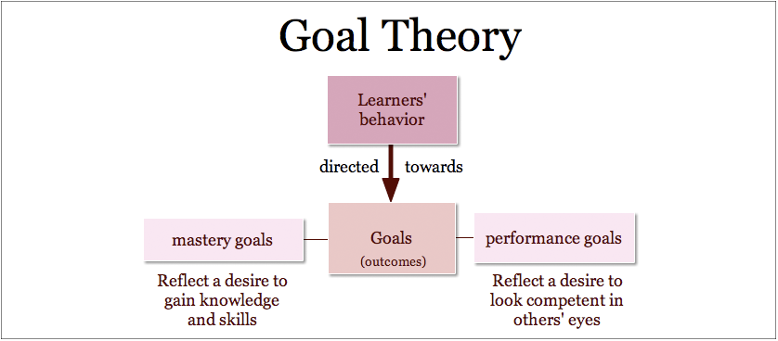
Figure 3, Source: https://www.performancemagazine.org/what-is-goal-setting-theory/

The author of the theory, Edwin Locke, together with Dr Gary Latham determinate 5 components:
1. Clarity – goals must be clear (Young, 2017);
2. Challenge – goals should be not easy but not too high, (Young, 2017);
3. Commitment -n goals must be well understood by employees, (Young, 2017);
4. Feedback – aims to keep the goal on track, (Young, 2017);
5. Task complexity –timescales must be realistic, and the process broken down on sub-goals reviewed regularly.

Total rewards model
This system is built on the fact that pay is not the only driver for motivation and goes further by including more components of the reward package. (Foot and Hook, 2011).
“The total reward approach recognizes that it is necessary to get financial rewards (pay and benefits) right. But also appreciates the importance of providing people with rewarding experiences which arise from the work they do, their work environment, how they are managed, and the opportunity to develop their skills and carers.” (Armstrong, 2007)
According to Shields, Rooney, Brown and Kain (2020) the elements of the model are:
1.Extrinsic –tangible rewards “generally focus on offering performance- monetary rewards, long term incentive plans, team-based rewards, and security benefits to employees” (Laursen and Foss, 2003). According to the authors they are favourable for values of these types of rewards in “boosting the morale of employees and improving their productivity at the same time. The result of this to the organization is better bottom-line performance” through increased revenue and profitability. These rewards can be:
- Financial – they can be direct (wages, salaries, bonuses, “be on call” and indirect like sick pay, pension, health insurances etc.
- Development rewards
- Social rewards
They are particularly effective for short-term motivation of the employees to work towards on specific organizational goal.
2.Intrinsic - intangible rewards of recognition, work feedback and experience, referred to personal satisfaction and benefits.
- Intrinsic - intangible rewards are non-monetary rewards, direct motivators. “intended to encourage people to work harder to achieve more. (Armstrong, 2014). They can be: sense of achievement, words of praise from the seniors, recognition.

“While non-financial rewards constitute an increasingly important aspect of a total rewards management, financial rewards are almost always of primary importance on reward management practice” (Shields, Rooney, Brown and Kain, 2020).

What should a reward strategy consider?
- Cash compensation
There are two main bases for payment – time or performance.
Payment based on time worked and usually overtime rate is higher than the standard one.
Performance-based pay - implementing performance related pay systems, firms still must pay the employee a base hourly wage.
- Benefit packages
Most of the employers provide benefit packages. The benefits include holidays, insurance and medical care, and pension schemes.
- Personal Growth
Providing opportunities for personal development is an area which importance increases. It can be training, opportunities for career and developing employees’ skills.

4.Work Environment
Internal environment is essential for attracting talents, retaining key workers, good relationships/ collaboration between people, and increasing the productivity. It includes all the social and physical condition at workplace. Core element of HRM is managing the stress.

Flexibility
Expands the options for attracting and retaining the right people and to improve the company as good employer.

Talent management
It is continuous process including attracting and retaining the best suitable employees, enabling their development within the company. The main aim of this strategy is to create a motivated workforce long-working at the company.

- Recommendations

For creating effective strategies and set suitable policies and procedures, human resource managers firstly must identify the company’s workforce needs and based on them to create strategies enabling company performance in parallel with people performance within the company. Policies and procedures must be complying principles like: fairness and equality, as transparently as possible, enabling individual performance, care about people wellbeing at work.
“Employee satisfaction with the organisation compensation system is not based solely on the level of the pay they receive. Satisfaction with pay and benefits is also influenced by perception of fairness in the design and implementation of the compensation’s plans” (Whittington, Meskelis, Asare, Beldona, 2017)., therefor suitable reward system for Hanoi could be total rewards strategy including mix of methods and techniques that can cover satisfaction areas of people. This will affect positively increasing of their engagement which is a key for achieving higher productivity in parallel with decreasing the staff turnover. (Armstrong 2010 ).
Designing the reward strategy requires considering of the following areas:
Payment :
One of the current problems of Hanoi occurred because the payment practice is not suitable anymore. HR Manager must analyse every single position – tasks, job description and to make sure that the tasks committed are affordable, how to deal with overtime, to fix the working times and all the conditions of working. Manufacture workers as stated, need income security, so the best choice is fixed salaries. It means there must be stated targets and this targets to be reviewed every time when the products or working processes are changed. Other important element that must be considered is overtime payment. It will be good if the overtime rate is higher than the standard one – this will make people interested in doing overtime if needed. Fixed salaries will contribute employee’s satisfaction and at the same time will benefit employer directly (easier organization of working processes and resource planning) and indirectly (by increased commitment of individuals and decreased human turnover).

Benefits
Benefit package can be different depending on specific of every role. And it can include for example extra sick pay for long time employees, extra days paid holiday leave, group insurances – life and health, some gym membership cards or massages …etc. some actions about people wellbeing at work, team building activities to create a good team and teamwork, bonuses.

Performance Reviews – key area in the strategy covering the communication of the company with the employees in order of evaluation of their performance. Appraisal meetings can be made every year regularly and when there are any changes in the manufacturing process that affects their outputs. Benefits of performance reviewing are that involve people in decision making by listening their voice, increase workers engagement, their feeling to perform well, make sure at any time tasks are affordable and people stimulated, gives opportunities for development, creates feeling that company care about wellbeing of the staff. All of this help he management to clearly understand all workforce difficulties at all places in the firm and based on this to develop polices.

The strategy that Hanoi will adopt must consist some activities related to team building (sport or culture events, parties etc.) and recognition of people (Birthday or Christmas gifts for example). This kind of activities improve the relationships between people and unite the teams – one more tool for increasing effectiveness of business.

Adopting the new reward strategy, in particular fixed salaries, will benefit the satisfaction of the cutters.
The situation with the line managers is extremely delicate and that is why should be considered very carefully. They are exactly people interfacing between the managers and team members and this explains their key role for the business. In our case line managers are in direct contact with the manufacture workers and particularly cutters while doing their jobs. Taking off some of their responsibilities makes them to think their influence will be badly affected. In my opinion the communication with them is the key for sorting this critical situation. General manager should explain them her decision to hire HR manager and to ensure them that in fact their role in HRM is getting even more important. The hiring of the HR Manager is needed because changes in the business led to increased volume of the HRM jobs and optimisation of this process require building of HRM strategy and set of policies and procedures. Line manager are expected to advise the HR manager for composing the job description, fix achievable targets and to participate in performance evaluation. With other words, line managers will keep managing their teams and that is why they are “found to be the other vital ingredient in making effective organisation. The line managers had not only to see the relevance of the HR policies and procedures to themselves but also to see how they could use them to contribute to an effective organisation” (Foot and Hook, 2011). Shortly, line managers will assist the HR manager and he will direct them. Also, the responsibilities they lost can be replaced with new ones. According to Armstrong (2007) new responsibilities are part of rewarding so it can be good idea to give them some new tasks (for example, to work for optimising the manufacturing process).
From one side, the communication is helpful for shortening of distance between the general manager and line manager and from other side, the translucent management helps for creating trust in the employees. Communication with people is powerful tool to engage them and to create good team, involvement with business, respectively loyalty and higher productivity. It is two-way process that allows the management to understand people’s problems and helps people to understand clearly what is expected in relation of their performance.

- Conclusion
This case is a good example that changes in the business cause some tension and need adapting of the human resources. For the companies will be better to predict the potential problems with the people and to prepare them on time for the changes and the staff to be trained in advance – this will help for avoiding difficulties that Hanoi faces. The analysis of the situation with Hanoi proves the importance of effective HRM. Human capital is the most important resource of the business and at the same time is extremely sensitive, so its management is the most delicate part of the overall management process. Company performance is possible only together with the people performance withing the company. This symbiosis gives numerous benefits for the organisation and for its employees and rewarding system plays a role of “the bridge” connecting employees’ with the company.

References:

Armstrong, A., 2007 Handbook of Employee reward management and practice, 2nd edition, London, Kogan page
Armstong, M. 2006, Handbook of Human Resource Management Practice, 10th Edition, London, Kogan page
Armstrong, M. (2010), 3rd Edition, Armstrong’s handbook of reward management practice, Improving performance through Reward, Kogan page
Armstrong, M, Taylor, S. 2014, Handbook of Human Resource Management Practice, 13th Edition, London, Kogan page
Foot, M. and Hook, C., 2011, Introducing Human Resource Management, Sixth Edition, Pearson Education Limited
Laursen, K. and Foss, N., 2003, New Human Resources Practices, Complementarities and the Impact of Innovation Performance, Cambridge Journal of Economics
Shields, Rooney, Brown and Kain, 2020, 3rd Edition, Management employee’s performance and reward – System, Practices, and Prospects, Cambridge University Press
Young, 2017, Heroes of Employee Engagement: No.4 Edwin A. Locke, online, available at: https://peakon.com/blog/future-work/edwin-locke-goal-setting-theory/, accessed: 03/01/2021.
Weightman, J., 2003,Managing people, Wiltshire, UK , The Cromwell Press
Whittington, Meskelis, Asare and Beldona (2017), Enhancing Employee Engagement : An evidence – based approach, online, Palgrave Macmillan, available at: www.google.co.uk/books/edition/Enhancing_Employee_Engagement/rW0uDwAAQBAJ?hl=en&gbpv=1&dq=compensation+and+employee+engagement&pg=PA73&printsec=frontcover, accessed on 28/12/2020
Williams, R., Managing Employees Performance: Design and implementation in organisation, 2002, London, Thompson learning
Siegrist,J., 2017, The Effort–Reward Imbalance Model, online, available at: https://onlinelibrary.wiley.com/doi/abs/10.1002/9781118993811.ch2, accessed: 02/01/2021
Lunenburg, F. 2011, Goal-Setting Theory of Motivation, INTERNATIONAL JOURNAL OF MANAGEMENT, BUSINESS, AND ADMINISTRATION, online, available at: https://static1.squarespace.com/static/5b0b8f55365f02045e1ecaa5/t/5b14d215758d46f9851858d1/1528091160453/Lunenburg%2C+Fred+C.+Goal-Setting+Theoryof+Motivation+IJMBA+V15+N1+2011.pdf accessed 28/12/2020

Miller, B., 2015, Pros and Cons of Monetary Incentives, online, available at: https://hrdailyadvisor.blr.com/2015/01/14/pros-and-cons-of-monetary-incentives/, accessed 02/01/2021.

https://expertprogrammanagement.com/2019/06/maslows-hierarchy-of-needs/
: https://www.performancemagazine.org/what-is-goal-setting-theory/
https://www.biggerplate.com/mindmaps/ubbWTg1P/frederick-herzberg-39-s-two-factor-theory

