DEVELOPING RELATIONSHIPS AND WORKPLACE ACHIEVEMENT

STUDENT NAME: SHIULI AKTER
STUDENT ID: 1706999
MODULE CODE: BMSK5002
TUTOR NAME: YAJESH KUMAR

Table of Contents
_Toc6397454Introduction 4
Benefits of Individual Development for The Organization and Personal Growth 4
Meeting the expectations and requirements of people based on theories and models 4
Managing employee as per guidelines and career pathways 5
Managing a career development program for employee 6
Potential Benefits of Individual Development for Organization and employee 7
Availability of development vehicles in the IKEA and extent of suitability for fulfilling development needs 9
Succession Planning Model of IKEA for Managing Performance 9
The organizational support structure of within IKEA 10
Techniques for supervision and formal appraisal 11
Method for ensuring fair and objective appraisal of IKEA 12
Method to monitoring evaluating and recording individual feedback 14
Individual Development Plan in order to improve the identified needs and Expectations 15
Learning styles and the range of training and development opportunities available in IKEA 15
Career development strategy for sustainable employee development 17
Personal Development Plan to meet the desired skill and experience 18
Conclusion 20
Reference 21

List of Figures
Figure 1: Impacts of Expectation Theory 5
Figure 2: Career Pathway Model 6
Figure 3 Super's Career Development Cycle 7
Figure 4: Potential Benefits to Organization and Individual 8
Figure 5: Succession Planning Model 10
Figure 6: Support Structure within IKEA 11
Figure 7: Technique for supervision and formal appraisal 12
Figure 8: Four-Dimensional Method of ensuring fair and objective appraisal of IKEA 14
Figure 9: Methods to monitor evaluate and record individual feedback of IKEA 15
Figure 10: Triangle of effective learning 16
Figure 11: Training & Development Program offered by IKEA 17
Figure 12: Career development strategy including the wider context of sustainability 18

Introduction
Every organization has its own set of rules, regulation and culture. These norms are expected to be respected and followed by the employees in order to achieve operational efficiency. As it is the duty of employees to follow them it is also the responsibility of managers to impose them. However, along with that, the organization is based on various theories and models. According to Baker et al. (2013), these strategies are set on the basis of these various defines and tailored models. This report solely focuses on "developing relationships and workplace achievement". The report sheds light on both the organizational context and individual context. The report is based on the operational management and employee development process of IKEA, leading furniture retailer in the UK. Various methods models and benefits of performance development are illustrated and critically evaluated. Along with this different way of developing a plan to meet both individual and organizational context has been followed.

Benefits of Individual Development for The Organization and Personal Growth

Meeting the expectations and requirements of people based on theories and models
Personal development of the individual is driven by the very need of climbing higher on the corporate ladder. According to Boons (2013), a motivated and driven person seeks to achieve the highest by doing their best in the workplace. It has many benefits for the organization and the person himself. This benefit is critically demonstrated below based on some dimensions.
The expectations and requirements of people set the potentiality of improved behaviour among employees. There have been many theories about rationing human behaviour as per expectation. These theories explain the connection between the expectation and requirement of employees. According to de Putter and Wijs (2017), based on the Pure Expectation theory, People behave accordingly after predicting the future outcome of a situation. As per this theory employees will develop themselves personally, they believe there is an effort for their development. According to Dickey, et al. (2016) however, there has been many counter-arguments against this theory. Peoples behave cannot always predict because if their irrationality. But in most of the cases, the future prediction of a certain outcome often makes the employee take advantage of others weakness. For example, the implementation of the theory can be seen on IKEA. IKEA sets a particular target for their employees based on ethics, moral, client grabbing and relationship management. IKEA reported that individuals are likely to work ten times efficiently if they believe that there is an opportunity for them to achieve bonus or promotion.
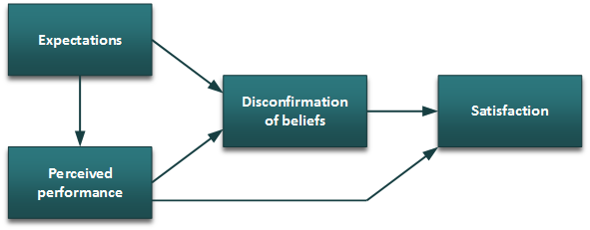
Figure 1: Impacts of Expectation Theory
Source: (LaDuke, 2014)
As the expectation of IKEA employees and managers increase so does their performance. Which in turn improves the efficiency of employees and productivity of the business. The IKEA believes that the highly ambitious and motivated employees become an investment for the organization. Their enthusiasm promotes IKEA employees’ career as well as boosts the HR asset of the organization. However, on the contrary, the gap between requirement and expectation might reduce the effectiveness of the training and development program. Along with that biases can arise in times of appraisal if employees’ requirements and expectations do not meet. Szelągowska-Rudzka (2016) opined as the motivation is set by the desire or outcome managers can easily influence this through leadership.

Managing employee as per guidelines and career pathways
Career Pathway Models are known as the guideline for achieving and. flourishing every stage of career planning. Kleinbaum, Stuart and Tushman (2013) opined that in the Career Pathway Model individuals start their career without any prior skill or experience. As time passes, they become more aware and upgrades their career through the achievement of skill and qualifications. According to Mayrhofer and Reiche (2014) at the pick of their career, the employee gains the jobs fixed for the unique and most demanding skills. The IKEA is Administering people in accordance with guidelines and career pathways in order to develop the Human resources. The implication of this model can be found in IKEA where unskilled personnel’s start their jobs with no prior skill of “Sales Executive” of IKEA outlet. As the gaining of training, experience and knowledge they are promoted to the next best position. This position is known as Sales Manager. At the top of their career development stage, they are given the position of Head of the Sales Department of IKEA.
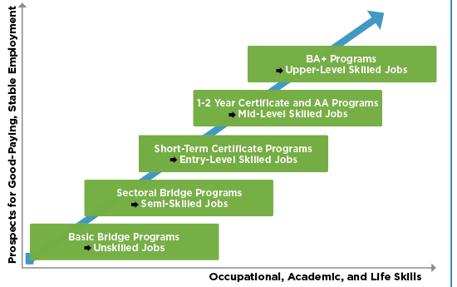
Figure 2: Career Pathway Model
Source: (Klingebiel, 2017)
According to the Carrera development model employees become more active and aware throughout their training and experience. Laudari (2014) opined as the requirement of Efficient HR increases the retaining of the trained employee also offers. When managers Administer individual with guidelines and career pathways, they become more loyal and responsible toward IKEA. Along with that employees become more efficient in using resources. According to N. and Kulkarni (2016), this also increases employee job satisfaction. On the contrary, in many cases, it has been seen that the guidance and career pathway increases the job switch. In IKEA this has been a major problem for the most trained and developed employees. IKEA had to bear a major sinking cost due to the ambitious employees.

Managing a career development program for employee
In order to retain a skilled employee, many organizations have involved in the Managing career development of people program. According to Career theorist, Donald Super just like our life cycle career also follows a cycle with similar characteristics. In the growth stage, various dream, passion, curiosity and fantasy about landing the dream job prevails. On the Exploration stage employees become more specific about their goal and tactical about implementing the goals. Kleinbaum, Stuart and Tushman (2013) opined the establishment stage is where most of the IKEA employee become consolidated and frustrated. On the next stage, IKEA elderly try to stagnate or innovate some new aspects. The top management can be included in this group. However, at the decline stage, these employees aim for retirement planning and leaving. According to Super, every stage has its own benefit and comes with the individual and particular risk.
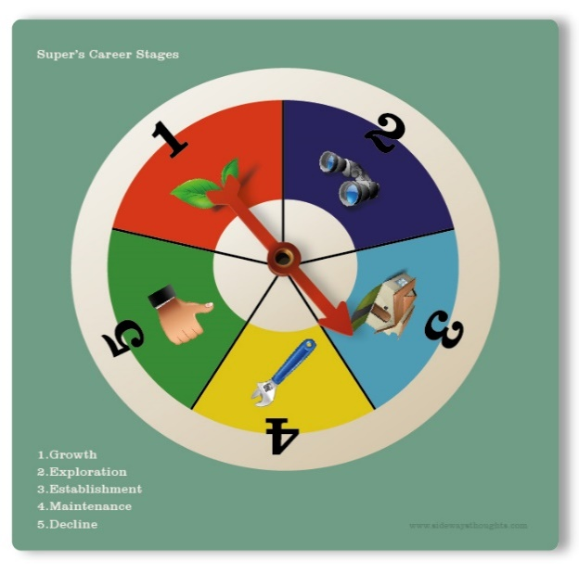
Figure 3 Super's Career Development Cycle
Source: (Zhang, 2018)
The benefit of the Career development program is that the individual can identify the stage of his career and take the required step in order to promote his career. Shin and Kelly (2015) said proper analysis and required skill can be easily found as per the program. On the contrary, for organization IKEA can choose the stage of employee and motivate him through his requirements. This will increase the capacity of adaptation and reduce employee turnover. The individual becomes eager to learn. This can also promote the innovation for the company, However, along with that, the carrier development program puts a hold on the actual job that the employee was hired for. Even though it is wonderful for the individual but if not monitored properly it might increase the recruitment cost. Also, the career development program might not give solid information about the aspiration of the employee.

Potential Benefits of Individual Development for Organization and employee
The general benefits of the organization can be sorted from these various perspectives. However, the potential benefits of personal development outweigh the cost or effort put by the managers or employees. Szelągowska-Rudzka (2016) opined one of the major potential benefits of individual personal development is increased job satisfaction. As the employee become more focused and efficient in order to gain a higher position they get noticed by the managers. This builds a better relationship and increases the job satisfaction of the employee. Which in the long run reduces employee turnover. According to de Putter and Wijs (2017) for an organization, this saves both time and cost of further recruitment. On the other hand, if management does not acknowledge the efforts put by the employee it can be disastrous for the relationship among employee and managers. The employee might want to switch the job if they feel devaluated.

Figure 4: Potential Benefits to Organization and Individual
Source: (Thornock, 2016)
According to Johnson, Jefferies and Nicholls (2015) the personal development of individual increases the motivation of employee as they have the Jeal for success. Laudari (2014) opined contrary to popular belief this also increases the innovation capacity of employees. For example, when the managers and employees of IKEA are motivated, they become more creative in designing. This can also be seen among the strategies made by the managers. On the contrary, in case of lacked motivation and no personal development goals, employee and manager tend to slack which increases the resource wastage of organizations like IKEA. Another important benefit is increased efficiency. It is only natural that when an employee tries to follow a plan for developing himself, he uses his times, training and learning more efficiently. As for the organizations like IKEA, this increases the Goodwill of better productivity and loyal employee base which serves as their asset. For this purpose, IKEA has always been keen to recruit employee with personal or career development plan. Klingebiel (2017) said the employee believes it will serve both the individual and the organization properly. Apart from these benefits o developing personnel helps the organization mitigate various risks that arise from operational activities. As the employee gets trained and aware of diversity, nepotism, sexual harassment in the workplace they become more serious about the values and norms of others. Shin and Kelly (2015) said employee become more respectful toward the people coming of all walks of life. This promotes brotherhood within the organization and improves the setting of the workplace. In the long run, this helps to create a healthy organizational culture for everyone. On the contrary, IKEA believes that with proper training strict monitoring and follow up counselling session is required in order to achieve these goals.

Availability of development vehicles in the IKEA and extent of suitability for fulfilling development needs

Succession Planning Model of IKEA for Managing Performance
After the discussion regarding the benefit of the individual personal development to both the individual and organization, it is evident that these particular benefits are worth the pursue. Skipworth (2018) said there are many frameworks and strategies that IKEA uses in order to make an environment of Individual Development for their employees. They use various development vehicles in order to push the working individuals for improvement. The development vehicles of IKEA along with their appropriateness regarding meeting development needs are discussed below:
One of the major development vehicles is the succession planning model for managing performance. For this vehicle to work IKEA uses the succession Planning model contain six steps that start by identifying the key position and ends with fulfilling the requirement of Key position and maintain employment.
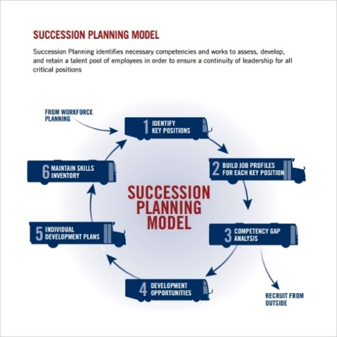
Figure 5: Succession Planning Model
Source: (Szelągowska-Rudzka, 2016)
According to Thornock (2016), the main concern here is to find a successor among the employees or existing managers who will play the roles of CEO, COO, or CFO of the regional IKEA. The Recruitment team of IKEA sought out the probable candidate for a particular position then they assess, develop and retain the employee in order to ensure the leadership capability for the key position. Budjanovcanin (2018) said the extent of this model into meeting the development need is remarkable. According to Johnson, Jefferies and Nicholls (2015), this model influences individuals to perform more diligently in order to achieve a key position. Also, individuals get the opportunity for higher career achievement without having to switch the job. They can also learn from the various training and development program undergone. However, this Succession planning model might increase nepotism and biases among the hierarchy Individuals might want to take advantage by creating the false illusion of working better or window dressing.

The organizational support structure of within IKEA
The Support structures within IKEA Serves as another major development vehicle. Laudari (2014) opened like every organization the organizational structure works as one; of the major supportive development vehicle for the employees of IKEA. Ikea follows the organizational structure that is divided into two major components line function and staff function. Presidents, VP and VP of each department are directly related to the core work such as operation, management and production. On the other hand, According to N. and Kulkarni (2016), individuals responsible for staff functions such as quality control manager, a corporate attorney and research specialists provide guidance and advisory services to presidents and vice presidents.
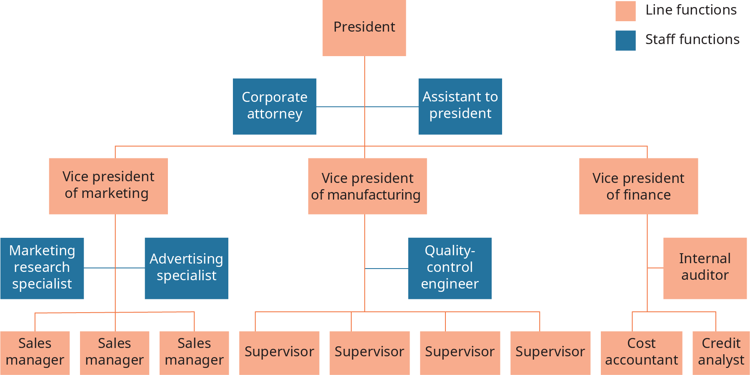
Figure 6: Support Structure within IKEA
Source: (Skipworth, 2018)
The extent of effectiveness can be measured by the adherence of this hierarchy to employee morale and efficiency. For example, IKEA offers their employee promotion through the organizational structure if the individual can shoe proper skills and motivation. Szelągowska-Rudzka (2016) opined an enthusiastic employee can also be offered double promotion based on their willingness and work ethics. This pushes an individual to become more inclined with their responsibilities and be innovative. Along with that the individual also exercises certain leadership traits in order to climb through the hierarchy. On the contrary, this hierarchy groups the individuals in certain positions. This might reduce employee motivation. Apart from that high competition may increase the chance of imitation and unethical behaviour in the workplace.

Techniques for supervision and formal appraisal
IKEA follows various Techniques for supervision and formal appraisal. This varies based on the employee value, norms, ethics and the organizational culture. The capacity of the employee and manager also plays a major role in the techniques for supervision. However, among many approaches, IKEA follows the following approaches.

Figure 7: Technique for supervision and formal appraisal
Source: (Shin and Kelly, 2015)
Among the various assessment system, only a few of these techniques becomes useful for the individual personal development of IKEA. The extent to which it helps a person develop becomes the measurement of usefulness. Skipworth (2018) said The Assessment Centre method puts the emphasis of the individual's social behaviour attributes. According to Thornock (2016) employees become more concerned about the fact of developing their social skills such as openness to subordinates tolerance and acceptability. On the contrary, this particular assessment criteria overlocks other assessment facts such as productivity, reliability and appraisal. To recover these aspects IKEA uses the Behaviorally Anchored Rating system. Elegido (2015) said this is the celebration of the assay method and Rating scale appraisal. More then individual this method seems to help the reorganization in achieving absolute efficiency. It is less complex and saves time and cost for the assessor while giving absolute efficiency. According to Johnson, Jefferies and Nicholls (2015), this method also overlooks the productivity and peers review. Therefore, employee assessed the top might lack some personal skills. For top-level management. For the line managers and entry level sales managers the most effective technique used for formal appraisal us the Human Asset Accounting Method. This method helps personal development by promoting self-appraisal and also creating transparency within the organization. Apart from that, this is the only method where biases are almost near to absent due to the elaborate and transparency code of conduct. In order for the succession planning, IKEA uses the Trait Focused Appraisal along with the 360-degree feedback. Noon (2012) said both of these appraisal methods require a better relationship with peers and promoting employees. Along with these two-appraisal methods also pushes an employee to improve the productivity of the IKEA through better performance management and leadership. On the contrary, According to Murtianingsih and Setiawan (2016), these might have a fatal impact on the organization if any biases arise along with the misconduct. As the performance development focuses more on the appraisal system, therefore, inefficiency in the proper feedback might reduce the effectiveness of these processes.

Method for ensuring fair and objective appraisal of IKEA
In order to get the most out of the efficiency from the employee, IKEA uses a four-dimensional Method for ensuring fair and objective appraisal. In the very first stage, IKEA set objectives that they want to achieve throughout the complete appraisal method. This is known as Performance Planning. The main target for this stage is to tailor the needs of, organization along with the performance development plan of the individuals. Laudari (2014) opined, failure to match this might bring unfavourable result. In the next stage Monitoring and development occur where the actual appraisal process takes place. The appraisal becomes an independent observer and employees feel more inclined to improve their ability. Sexton (2016) opined lack of appraiser’s experience and biases can be found in this stage. In the next stage, IKEA provides feedback to the person or employee appraised. In this stage evaluation, rating and scoring take place. In the third stage Performance Development Review where appropriate evaluation is carried out based on using a scientific approach. According to Mayrhofer and Reiche (2014) in this place various errors like raters’ error, Halo error might occur by the appraiser. Therefore, the appraiser needs to be most careful in this particular stage. In this stage, the employee becomes able to improve their particular activities through better efficiency and innovative approach.
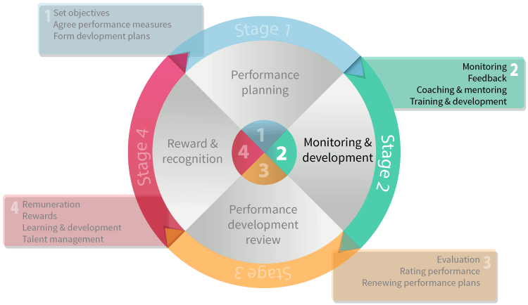
Figure 8: Four-Dimensional Method of ensuring fair and objective appraisal of IKEA
Source: (Sexton, 2016)
In the fourth and last stage, the Reward and Recognition take place. Luckily for the IKEA employees, there is a very small scope of punishment and devaluation. According to Murtianingsih and Setiawan (2016) in this stage, the high scorers and achievers are given reward and remuneration as a part of IKEA recognition which increases job satisfaction and motivation. As for the employees that perform lower, IKEA takes training and development plans that are best suitable for them. MCKEE and FROELICH (2016) opined, from the past review it has been seen that the Employees that performed lower often loses the motivation to work and takes the exit plan.

Method to monitoring evaluating and recording individual feedback
As an addition to the overall appraisal method, IKEA has been using a particular Method of monitoring evaluating and recording individual feedback. This method helps the employee to understand what is expected from them by IKEA. It helps the organizations understand the capacity and potential ability of individuals. Therefore, they can tailor their training and development programs as per requirement. On the contrary LaDuke (2014) opined as the feedback provides various option for the development and improving skills this becomes a perfect technique for the Individual Performance Development of the organization.
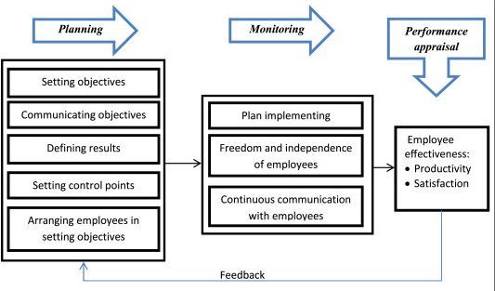
Figure 9: Methods to monitor evaluate and record individual feedback of IKEA
Source: (Noon, 2012)
Throughout the full process of performance monitoring, evaluating and recording individual feedback individual gets benefitted by creating an Individual Career Developing Plan and discussing with the superiors. This gives scope for improvement to both individual and organization. However, too much expectation and less work can result in disappointment. Klingebiel (2017) said the Performance Metrics which is often provided by the employers in order to self asses the employee. In this way, the employee can self asses himself by his own productivity. On the contrary, Budjanovcanin (2018) said, this also leaves room for fraudulent activity and window dressing. The performance appraisal also reduces the barrier among the employees and managers. This creates an opportunity for individual performance development by counselling and guidance opportunity. However, this may make the managers vulnerable toward making a decision and emphasizing. Zhang (2018) said the planning, feedback, monitoring and finally feedback provides multipurpose opportunities for personal development through increasing managers expectation. On the contrary, it can also demotivate individuals in some aspects.

Individual Development Plan in order to improve the identified needs and Expectations

Learning styles and the range of training and development opportunities available in IKEA
As a sales manager of IKEA, there are numerous sectors that I want to develop in my career. But in order to do so, a perfect plan is required for the development needs that individuals of have identified some key development needs that individuals need to work on.
IKEA implements different Learning styles. Also, various training and development programs are tailored as per the development necessity of employee. Zhang (2018) said the triangle of effective learning is used in order to make the best use of the learning outcome.
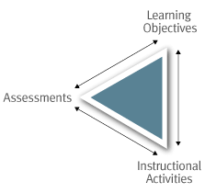
Figure 10: Triangle of effective learning
Source: (Klingebiel, 2017)
In order to target the efficiency in learning individuals set a goal of learning. The instructional activities such as training, workshop and seminars are carried out afterwards. According to Thornock (2016), these increases the skills and efficiency; of the individuals. However, after that individuals or IKEA assess the skill in order to identify whether the goal has been achieved or not. Skipworth (2018) said The triangle of effective learning provides an improved framework for learning quickly. On the contrary, MCKEE and FROELICH (2016) opined, it failed to measure the amount and effectiveness of learning in other words, this framework work might not show the outcome just shows a roadmap.
There is a range of activity that an individual can choose from. Noon (2012) said these activities serve as the stepping stone in the development of career and further development. In IKEA these typical topics of employee training include some major criteria.

Figure 11: Training & Development Program offered by IKEA
Source: (Murtianingsih and Setiawan, 2016)
Among the various ranges of training offered for the employees for the job position of Sales manager most important are the Communication skill and Human relationship management. Elegido (2015) said in order to have a better relationship with customers it is amendatory to understand their needs and desires. This will ensure the retention of customers, However, In order to ensure the overall efficiency of operational activity a sales manager knees the training of Total Quality Management. Quality circles, Benchmarking, total quality management initiatives are offered by the organization. Along with the basic concepts guidelines and instructions are also provided to maintain the best quality. Human relationship training covers a wide range of topics such as ensuring safety in the workplace, understanding the needs of the customer and the importance of ethical behaviour in the workplace. According to Dickey, et al. (2016) this training enables an individual in order to lead, motivate and manage both employee and customers in the workplace. The harassment and diversity training carefully demonstrate the organizational policy, rules and ethics against any kind of violence or sexual harassment. This also applies for the nepotism, racism or any kind of discrimination in the workplace. Kleinbaum, Stuart and Tushman (2013) opined based on this wide range of training and development

Career development strategy for sustainable employee development
program an individual or organization can choose based on their needs. IKEA always welcome employee if they want to know more or learn new techniques through these training programs.
According to Boons (2013), a career development strategy refers to the process of identification of the requirements for achieving long term goals as a career perspective and also as per the individual perspective. Even though there are various theories and models for career development procedure IKEA follows the following career development strategy in order to sustain the career development of individuals.

Figure 12: Career development strategy including the wider context of sustainability
Source: (MCKEE and FROELICH, 2016)
The strategy starts with the assessment of organizational need. In this particular area, the individual determines the facts and factors required for achieving a certain position. After that, they Identify individual CPD needs. Elegido (2015) said in this stage the individuals identify specific goals for each of the long-term short term and mid-term requirements. After that In the Plan development activities individuals carefully plans the resources, time and skills required for the achievement of a certain goal. As they are determined the individuals Undertake development activities based on the preset criteria’s and requirements. LaDuke (2014) opined The Review and learning application are then implemented in a certain job. This can range from as simple as applying new techniques in the current job to the complex situation where the individual plans for a job switch or recruitment exam. In the final stage.

Personal Development Plan to meet the desired skill and experience
Goals | Knowledge, skills to be Improved | Action Plan | Resources Required | Timescales
Individual Development Goals  Developing communication skill and building team working experience  Career-related goal Secure the position as a team leader of the sales executive team at IKEA | - Becoming a team leader  - Improving computer competency | Join various skill development training  Understand the practical implication of sales techniques | - Training sessions  - Team performance opportunities  - Leadership  - opportunity | Within 12 months
Individual Development Goals  Achieving resilience and pressure management skill  Career-related goal Obtain a senior sales position at IKEA | - Leadership skill  - Understanding the strategy and culture of the organization | Manage and observe daily activities in order to gain performance management skill and leadership quality | - Workplace Experience  - Career consultations | Within  2-5 years
Individual Development Goals  Long term commitment to employee relationship building  Career-related goal Achieving the position of “Head of the Sales department” at IKEA | - Analytical ability  - Networking skill  - Human Resource Management  - Quality Management skill | Participation in decision making and seminars involving activities with departmental heads | - Seminars  - Workshops  - Experience | More than 5 years

In order to develop my own individual plan and achieving the targeted goals, I have developed a personal development with Personal development plan goal and career development goal. For each of the goals, an action plan has been set along with the required skill and resources. The timeframe for review has also been set for review and achievement monitoring purpose,

Conclusion
The individual development plan has become one of the latest norms of the global organization. However, along with receiving various benefits organizations also faces various challenges while establishing the Individual development plans and strategies. IKEA has always been supportive as one of the largest retailers in the furniture industry. They have used and implemented various rules models and theories in their strategic plans in order to promote the development of employees. According to Baker, et al. (2013) apart from that employees are constantly motivated for the improvement of their skill. The IKEA supports the individual throughout the offering vast kinds of promotion and job improvements offers. Apart from that, organizations like IKEA are being more and more concerned about the appraisal system of employees and managers. This is also increasing employee morale in the organization. After the critical assessment and evaluation, it can be said that every organization can be far more benefited if they can influence employee for their individual growth.

Reference
Baker, A., Perreault, D., Reid, A. and Blanchard, C. (2013). Feedback and organizations: Feedback is good, feedback-friendly culture is better. Canadian Psychology/Psychologie Canadienne, 54(4), pp.260-268.
Boons, F. (2013). Organizing Within Dynamic Ecosystems. Organization & Environment, 26(3), pp.281-297.
Budjanovcanin, A. (2018). Actions speak louder than words: how employees mind the implementation gap. The International Journal of Human Resource Management, 29(22), pp.3136-3155.
de Putter, S. and Wijs, A. (2017). A formal verification technique for behavioural model-to-model transformations. Formal Aspects of Computing, 30(1), pp.3-43.
dickey, l., Walinsky, D., Rofkahr, C., Richardson-Cline, K. and Juntunen, C. (2016). Career Decision Self-Efficacy of Transgender People: Pre- and Posttransition. The Career Development Quarterly, 64(4), pp.360-372.
Elegido, J. (2015). Management Ethics: Placing Ethics at the Core of Good Management (by Domènec Melé). African Journal of Business Ethics, 8(2).
Johnson, M., Jefferies, D. and Nicholls, D. (2015). Exploring the structure and organization of information within nursing clinical handovers. International Journal of Nursing Practice, 18(5), pp.462-470.
Kleinbaum, A., Stuart, T. and Tushman, M. (2013). Discretion Within Constraint: Homophily and Structure in a Formal Organization. Organization Science, 24(5), pp.1316-1336.
Klingebiel, R. (2017). Risk-type preference shifts in response to performance feedback. Strategic Organization, 16(2), pp.141-166.
LaDuke, S. (2014). Evaluate employees with ease. Nursing Management (Springhouse), 35(6), pp.48-49.
Laudari, S. (2014). Planning and Performance: The Effect of Form-Focused Guided Planning on Learner Performance. Journal of NELTA, 18(1-2), pp.92-104.
Mayrhofer, W. and Reiche, B. (2014). Guest editorial: context and global mobility: diverse global work arrangements. Journal of Global Mobility: The Home of Expatriate Management Research, 2(2).
MCKEE, G. and FROELICH, K. (2016). EXECUTIVE SUCCESSION PLANNING: BARRIERS AND SUBSTITUTES IN NONPROFIT ORGANIZATIONS. Annals of Public and Cooperative Economics, 87(4), pp.587-601.
Murtianingsih, M. and Setiawan, A. (2016). THE IMPLEMENTATION OF FAIR VALUE ON SHORT TERM ASSESSMENT OF BIOLOGICAL ASSETS. Journal of Accounting and Business Education, 1(1), p.40.
N., N. and Kulkarni, R. (2016). Appraisal Management System using Data mining Classification Technique. International Journal of Computer Applications, 135(12), pp.45-50.
Noon, P. (2012). Managing for success. Librarian Career Development, 5(4), pp.128-135.
Sexton, G. (2016). Relationships as the Key to Attracting and Keeping People. Australian Journal of Career Development, 16(1), pp.66-69.
Shin, Y. and Kelly, K. (2015). Resilience and Decision-Making Strategies as Predictors of Career Decision Difficulties. The Career Development Quarterly, 63(4), pp.291-305.
Skipworth, S. (2018). Empower employees to step away, with the greater goal of enhancing leadership. Enrollment Management Report, 22(2), pp.8-8.
Szelągowska-Rudzka, K. (2016). Actions Objected at Employees in HRM - Report from the Study. Management, 20(2), pp.143-159.
Thornock, T. (2016). How the timing of performance feedback impacts individual performance. Accounting, Organizations and Society, 55, pp.1-11.
Zhang, X. (2018). The motivation of Enterprise Motivation Management Mechanism Based on Neuromanagement. NeuroQuantology, 16(5).

