
Student Name: | Clarissia De Weever
Student Number: | 1810426
Module No: | BMSK4002
Module Title: | Effective Team Work & Communication
Lecturer: | Anupam Mazumdar
Skills for the Workplace
Module Assignment Submission
Date of Submission: 9th January 2018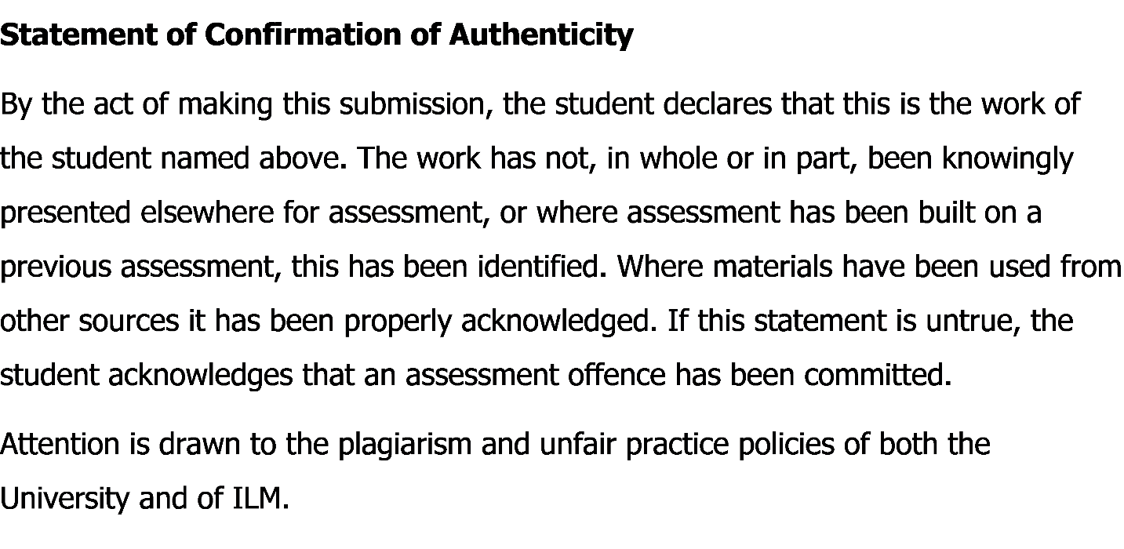

Table of Contents

Introduction: 3
Definition of Communication in Real Life Context: 3
Importance of Communication: 3
1. Motivation: 4
2. Information Sources: 4
3. Socializing: 4
Types of Communication: 4
1. Verbal Communication: 5
2. Non-Verbal Communication: 5
Written Communication: 6
Theory Based Analysis of Communication: 6
1. Shannon-Weaver Mathematical Model: 7
2. Berlo’s Communication Model: 8
Conflict in Workplace Related to Communication: 9
1. Discrimination Conflict: 9
2. Reviewing Performance Conflict: 9
3. Conflict with Clients: 9
Recommendation for Effective Communication: 10
Conclusion: 10
References: 10

Introduction:

Organizational goals and managerial implications depend on sustainable performance of employees. Motivation, self-esteem, interpersonal communication are effective and efficient for management to evaluate the best outcome. Effective team working and communication skills will analyze whether an organization is competitive both internally and externally or not. The aim of this report is to demonstrate effective communication in the workplace for achieving, sustainable competitive advantage and growth in a particular business industry. So, this paper will evaluate and briefly analyze the importance of communication in the workplace, types of communication such as; verbal communication, non-verbal communication, written communication and its effectiveness, relevant theories by scholars about communication, conflict in the workplace in terms of interpersonal communication and a recommendation. All these factors will be evaluated based on my real life working experience.

Definition of Communication in Real Life Context:

Communication is the systematic process to encode and decode a meaningful message through both verbally and non-verbally (Maund, A., 2017). Communication is a process of sharing information. In my real-life experience, working in a real estate company selling and trading different tangible products to their corporate and individual clients. The name of my organization is Oakville Real Estates, which is situated in North London. The company has almost a hundred employees performing various managerial jobs and tasks. To do that, effective communication is needed for all of us.

Importance of Communication:

Effective communication will enhance the opportunities for managers for planning, organizing and controlling managerial situation’s and employees. Communication encourages managers to see and check the performance of their job effectively. Responsibilities and all other things will be briefly cleared by a good interpersonal communication among employees and managers in the management (Morgan, P., 2007). According to above statement and literature, my workplace and organization needs effective and efficient communication through internal and external. Internally the managers need to have a good interpersonal communication among employees, internal employees should maintain good communication with other companies and clients also. Customer relations managers, customer service managers and employees should develop a better communication with our corporate clients, for our brand image of the company. The importance of communication in Oakville Real Estates are given below:-

Motivation:
Communication will increase motivation and managers need to motivate employees (Bown, G. & Berdy, J.K., 1991). In my organization, managers will clarify tasks and works with effective communication clearly. Managers should motivate employees and guide employees how to increase the task performance for achieving organizational goals with superior client satisfaction.

Information Sources:
Secondary data can be found on many information sources like internet, journal article, books, and newspapers (Chan, 1999). As I am working in a real estate company, employees should be able to share every information with both managers and their clients. It will enable the opportunities for exploring and evaluating new research and development with new ideas for managers and management. Communication is the bridge to share practical experience and information among all. So, the importance of communication is high in the perspective of information sources.

Socializing:
As a human being, we need to share our self with one another (Sandra Weltzien, 2018). To communicate with colleagues and employees about various information, it will be an effective working environment for me.

Types of Communication:
Communication in the workplace basically are of two types. One is verbal and another one is non-verbal communication (Delly & Burton, 2010). Apart from this, organizational communication process is differentiated and categorized based on some factors like organizational culture, organizational objectives and goals, organizational motto etc. In my real estate company, both verbal and non-verbal communication is being used by employees. The brief discussion of these two communication procedure are given below-

Verbal Communication:
Verbal communication is more flexible and simple mode of communication (Verbal Communication and its Importance, 2019). Verbal communication in my organization happens most of the time between employees and managers. This communication is flexible and effective enough for employees as they feel secure and also feel a better working environment. Verbal communication include clarification of information which impacts the outcome in managerial perspective (Tuckman & Harper, 2012). Verbal communication includes intrapersonal communication, interpersonal communication, and focus group communication. In my company, management sometimes does confidential discussion about our company policy, service details among employees. This is the example of intrapersonal communication. One-on-One conversation between one employee and another employee is known as interpersonal communication. Interpersonal communication is effective for workplace and individuals can be trustworthy and flexible in terms (Vohra, 2007). Apart from this, focus group communication, small discussion communication are also effective and efficient for workplace environment like my real estate company to serve our clients.

Non-Verbal Communication:
Non-verbal communication includes gesture, posture, body languages, proximity, facial expression etc. All of these communication modes are dependent on attitudes and behavior of employees. Some portions of the communication is substantial and these are known as non-verbal communication (Kendra Cherry, 2018). In my management, every day I have communicated with employees and clients with facial expression, body language and gesture. These all are personality attributes from the core of the individuals. Managers should motivate employees of my management with non-verbal communication which effective code of conduct. Mode of conduct is important in this regards. Due to a negative mode of conduct, sometimes conflict may arise with non-verbal communication. Non-verbal communication causes conflict because of cultural barriers and attitudinal problem of both employees and clients of Oakville Real Estates.

Written Communication:

Written communication is more effective and efficient for workplace (Written Communication in Business, n.d.). Written communication is mostly used in our real estates because of the validity and documentation of the written contract. Written communication is also known as a contract or an agreement between the company and the client. Written communication includes any types of communication approaches that based on the written word (Taylor, 2013). Written communication generally used of my management are-
- Email
- Websites (https://ore.uk.com/)
- Letters
- Proposals
- Job circular
- Fax
- Telegrams
- Contract paper
- Brochures
All of these written communication approaches are structured and formal for both employees and clients. These communication approaches will validate the relationship between the two parties as both the parties have the paper of the agreement which will secure the business agenda.

Theory Based Analysis of Communication:

There are a lot of theories can be found for communication approaches. Among them Shannon-Weaver Mathematical Model and Berlo’s communication model are significant. Both the models have briefly elaborated the two way communication process in both individual and organizational perspective.

Shannon-Weaver Mathematical Model:
Shannon-Weaver’s model is based on five factors for the communication approach with an external source of message which is noise source (Shannon-Weaver, 1949). The model is evaluated and analyzed briefly on the below based on my organizational context.
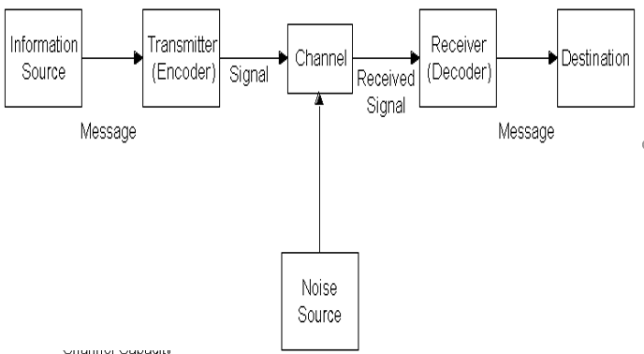
Figure: Shannon-Weaver Mathematical Model
Source: www.google.com/images/shannon-waever-model
Interpretation of the Model:
The model interprets that messages can be transferred from the information sources by the encoder. The encoder also known as the transmitter, the signal of the message goes from information sources to channel. Receiver will receive the message by the destination as vice-versa. All the process will be completed through an external channel name noise source. The model is a systematic process and thus model is called mathematical model. In my organization, managers always use the simple communication approaches to employees and staffs. Employees also handle clients with this model to share simple information sources of our company like company policy, our services, our legalities etc.

Berlo’s Communication Model:
Berlo’s communication model is complex compared to Shannon-Weaver’s model. The model is given below-
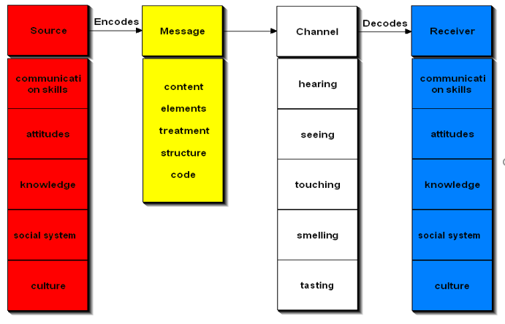
Figure: Berlo’s Communication Model
Source: www.google.com/images/Berlo’s-Model-of-Communication
Interpretation of the Model:
The model is actually known as S-M-C-R model of communication. S stands for sources of the information. The information source can vary from different category like communication skills, attitude, knowledge, social system and culture. These factors encode message through content, elements, treatment, structure and code. Messages need a channel to be transformed. Channels are hearing, seeing, touching, smelling and touching. These all are actually the modes of verbal communication. Finally receiver decodes the message with communication skills, attitude, knowledge, social system and culture of the receiver. In my organization, the communication approach of Berol is used mostly. Managers and employees used the factors from encoding messages through the factors of channels. Others (Employees, clients) will get the message through their communication skills, culture and some other personality attributes.
Overall Clarification:
From the above discussion from the two models of communication, my real estate agency is using both the communication approaches for effective performance and organizational behavior. Effective communication totally dependent on various external and internal situation. Management of mine should use both verbal and non-verbal communication for effective managerial outcome and organizational goals according to the objectives.

Conflict in Workplace Related to Communication:

There are a lot of negative issues can be raised because of lack of communication in the workplace. These are mostly known as conflict. Conflict can be raised because of lack of interpersonal communication, lack of employee engagement and motivation. Some conflict are given below for lack of communication in the workplace-

Discrimination Conflict:
Without proper communication, employees can sometime feel that they are being treated badly in the management by manager. Discrimination mostly is the source of heated conflict which indicates the lacking of intrapersonal communication.

Reviewing Performance Conflict:
Performance appraisal and employee motivation can be hampered without effective communication. Thus employee may sometime feel they are being deprived of rewards by the management.

Conflict with Clients:
Without proper communication, clients sometimes don’t get the proper information and can’t make a purchase but always seeks for their desired information. Employees feel angry on that time and thus a rational conflict begins.

Recommendation for Effective Communication:

From the above communication approaches with practical example and theories, some recommendations are given below-
- Managers along with employees should learn the basics of verbal and non-verbal communication approached for effective workplace behavior.
- Managers and employees both the parties should avoid the reliability of visual aid and census.
- Communication is a key. So, Managers should try to know about their audience to whom they are trying to communicate with.
- Managers should focus on the individual’s reaction after a successful delivery of a mode of conduct.
- Getting feedback from the employees to know whether they are cleared or not.
- Managers should follow the PIP (Purpose, Importance, Performance) process for effective interpersonal communication.
- Managers should record important speech properly to check for future preference.

Conclusion:
Effective communication is an essential element for organizational performance. Employees of an organization can be well motivated, self-dependent and flexible with effective intrapersonal and interpersonal communication. As this is the age of globalization and digitalization, management can implement various ERP software including intranet and extranet for maintaining a better communication with staffs, employees, stakeholders and clients. These communication approach will be recorded and can be evaluated efficiently for performance appraisals of individual employees in organizations.

References:

Bown, G. & Berdy, J.K. (1991). Successful Managers (19 ed., Vol. 55). London, UK, United Kingdom: Kogan Page Ltd.
Chan, J. &. (Ed.). (1999). Business Research Methods (11 ed., Vol. 5). Wales, United Kingdom: Pearson Publications.
Delly & Burton. (2010). Developing Influencing Skills (12 ed.). London: Universe of Learning Ltd.
Kendra Cherry. (2018, September 26). Types of Nonverbal Communication. Retrieved January 9, 2019, from Very Well Mind: https://www.verywellmind.com/types-of-nonverbal-communication-2795397
Maund, A. (2017). Skills for the Workplace (8 ed., Vol. 3). London: Prientice and Hill Publications.
Morgan, P. (2007). Business Student's Guide (13 ed., Vol. 6). Boston: Sage Publications.
Sandra Weltzien. (2018). Thinking of me. Self-Focus and Interpersonal Communication, 4(23), 50. Retrieved January 9, 2019, from https://doi.org/10.1371/journal.pone.0189752
Shannon-Weaver. (1949). Shannon-Weaver Mathematical Model of Communciation (21 ed.). London, UK: Hudson Publications. Retrieved January 9, 2019
Taylor. (2013). Sage Journals and Publications. An Analysis of the Study of the Written Communication, 30(4), 231-392. Retrieved January 9, 2019, from https://journals.sagepub.com/toc/wcxa/30/4
Tuckman & Harper. (2012). Conducting Educational Research (12 ed., Vol. 12). London: Hudson Publication.
Verbal Communication and its Importance. (2019, January). Retrieved January 9, 2019, from livestrong: https://www.livestrong.com/article/156961-the-importance-of-verbal-non-verbal-communication/
Vohra. (2007). Organizational Behavior and Communication (7 ed., Vol. 4). Manchester, UK: Palgrave McMillan.
Written Communication in Business. (n.d.). Retrieved December 9, 2019, from Study.com: https://study.com/academy/course/communication-in-the-workplace-help-course.html

