Business Intelligence systems

P150317

Rutendo Gore

Data analysis and mining

Nik Whitehead

Introduction
The database for the Adventure works database provides information regarding to sales, Human Resources and shipping information which is turned into data for the company’s performance within the years of 2001-2004. A geographical region has been assigned to the data analyst, to give a report outlining the summary of the company’s profit and sales over the period of the 12 months and the forecasting sales also within that period.
A description of how sales and profits have changed over time.
There has been an increase
There has been a decrease in sales
The main categories for goods sold is also shown and the significant subcategories.
Trends and forecasts for both the main categories and significant subcategories of goods sold.
Within the adventure tableau file , trends have been noticed and with this information , a forecast is able to be made for the goods sold.
Market basket analysis of items to identify any combinations of goods that occur together and might therefore benefit from promotion via special deals.
Market basket analysis is a modelling technique which is based upon a theory, the theory is that if you buy a particular group of items, you are more or less likely to purchase another group of items within the shop. For example people are in a pub and they buy pints of beer but instead of having a pub grub meal they are more likely to buy a packet of crisps. The term market basket analysis is there to seek a relationship between different purchase, like the analogy of the beer and the crisps. [1]
Identification of any problem items and recommendations as to how Adventure works should deal with the problems.

Brief description of the data
The data that is shown with Tableau is data relating to the Adventure works ,within the data set given , the geographical region that has been assigned is the Germany region within the data set.
Data set explained
In the data set for the Adventure works tableau file, attributes within the files are used in different ways to represent the information required , the attributes within the data file can be used as a measure or a dimension within Tableau to represent the information well using the correct visual representations in a bar chart ,heap maps, dual axis representations.
Attributes within the Adventure works
-Person contact
-Production product
-Sales
These are the attributes that are in the Adventure works data file, the attributes are classified into dimensions and measures and they have sub categories under the main attribute , for example the dimension person contact , has other attributes such as first name ,last name, middle name.
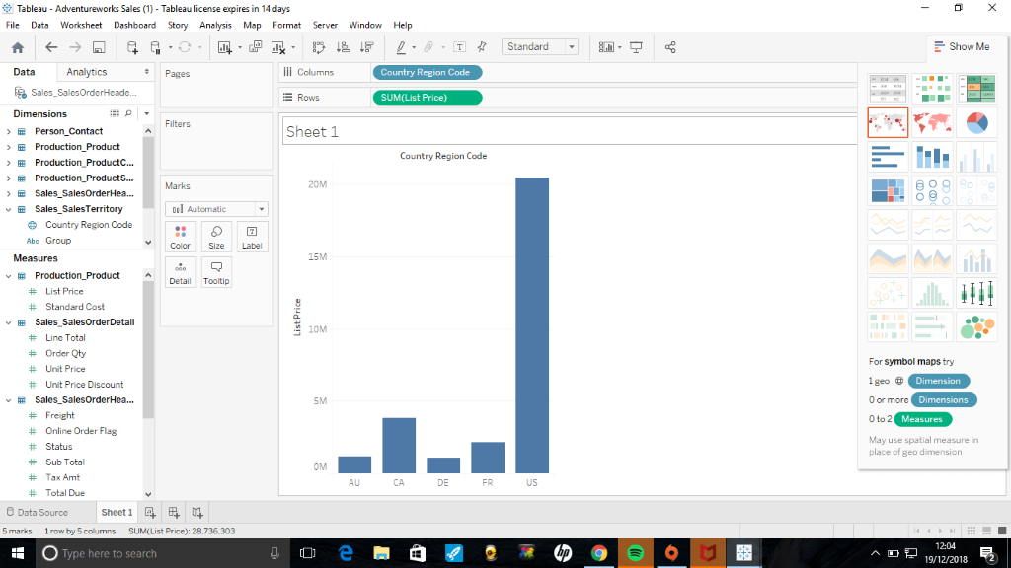
The above visualisation shows two attributes which have been placed into a column and row. The Screenprint is represented in a bar chart which is easy to follow and understand the information which is being represented. The visualisation shows five different regions and from the representation it shows the US region has the highest selling price.

SWOT analysis on Adventure works
Strengths
All the regions show significant sales.
Weaknesses
Between 2002 and 2003 there were no sales within the Germany region and the AU region, a visualisation with this information is represented in one of the visualisations, this visualisation will be shown below the swot analysis.
Opportunities
There are opportunities for people to make more purchases as certain regions with customers did not buy many products. This is shown in a visualisation also.
Threats
As previously mentioned, that there were no sales between 2002-2003 within the Germany region, the US and Canada made significant sales all the way through 2002 up to 2003, with the information shown it showed that sales increased and then decreased and increased.

The visualisation shown below shows a representation of the five regions with the list price. This visualisation represents the regions in a simple way by using one colour for all the regions. By using different colours its easier to represent each region in a unique way.
This screenshot shows the filtering of regions so that the region which was chosen is represented solely on its own to represent the information well, it's better to represent the visualisations with all the other regions to show comparisons in sales made across the regions and to predict sales forecast for the regions.
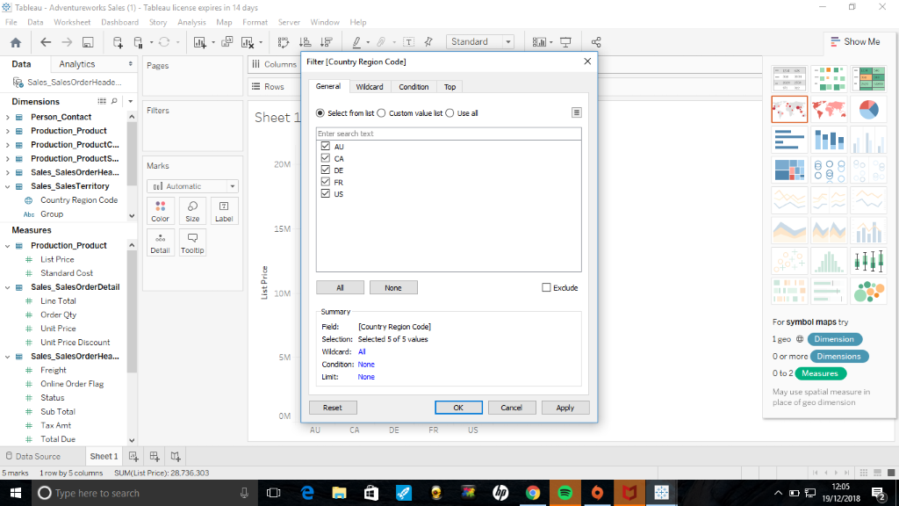
The representation of data in Tableau is represented in a visualisation in Tableau. The image shows that one dimension has been applied and four measures have been applied, the four measures are represented, and these measures are, line total, order quantity, unit price and price discount. From the image below there is a a variance of the results. All the regions have results, the AU region shows different variances, the unit price discount for the AU is more than the unit price, order quantity total. The US had very high results in all measures.
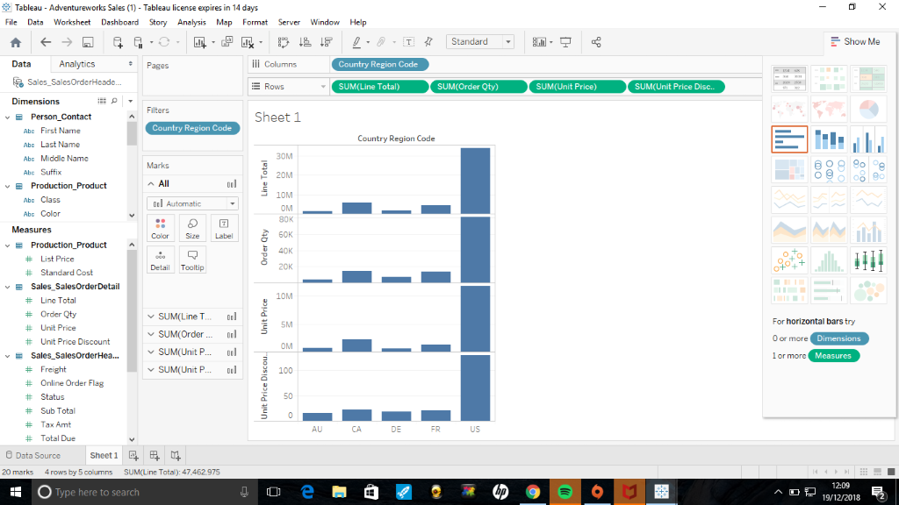
The screen print below shows that additional information has been added to the above visualisation. From the image the label of the sales are represented with numbers and the line total has been put into the colour mark to make it more visually representable to see the data clearer.
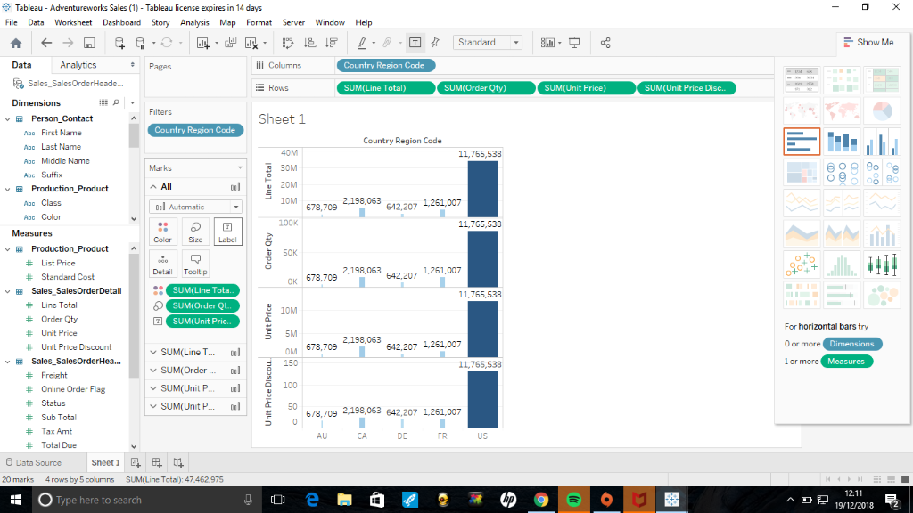
The visualisation represented here shows the geographical region which was assigned within the class. The region which was assigned for the project was the DE region which is Germany, the numbers are all the same for all the measures.
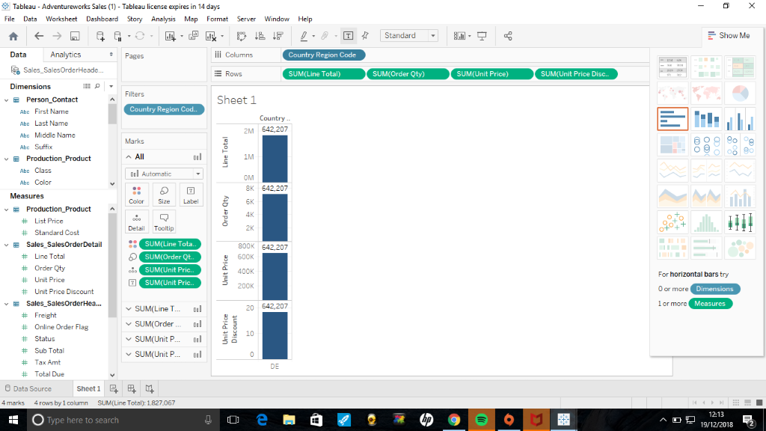
Data represented here is for the DE region which is the Germany region. From the visualisation there are four measures represented using the colour marks. The line total shows the highest result , the unit price discount doesn’t show any results.
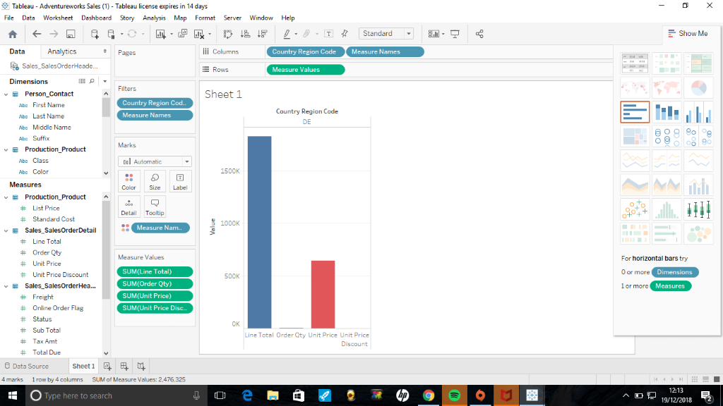
The visual representation shows the DE region for Germany, the information shown here is representing nine measures but only five measure show results and the remaining four measures are blank. The visualisation is represented in the form of a bar chart. This type of visual representation is very simple, the way it is represented is easy to understand to represent information.
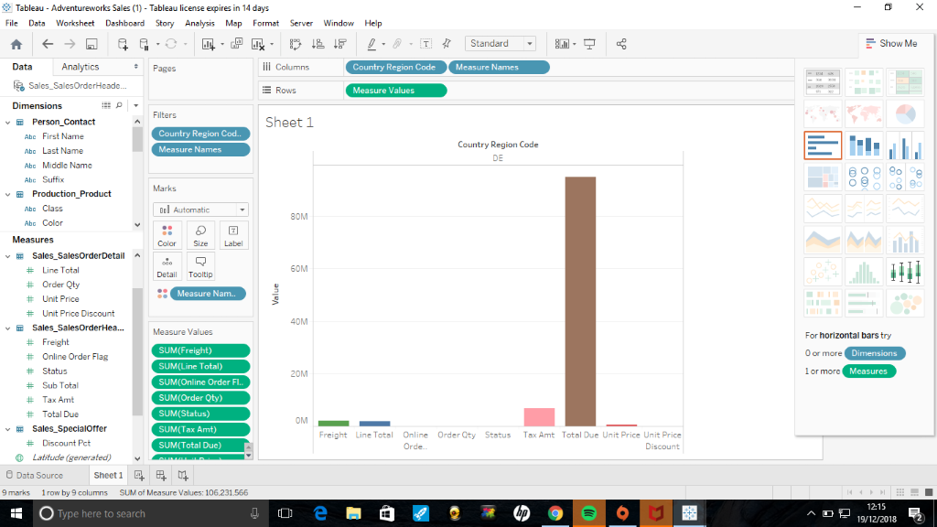
The screen print below shows the above image with labels of then numbers for the DE region for Germany. All of the measure values have been applied that’s what the results show.
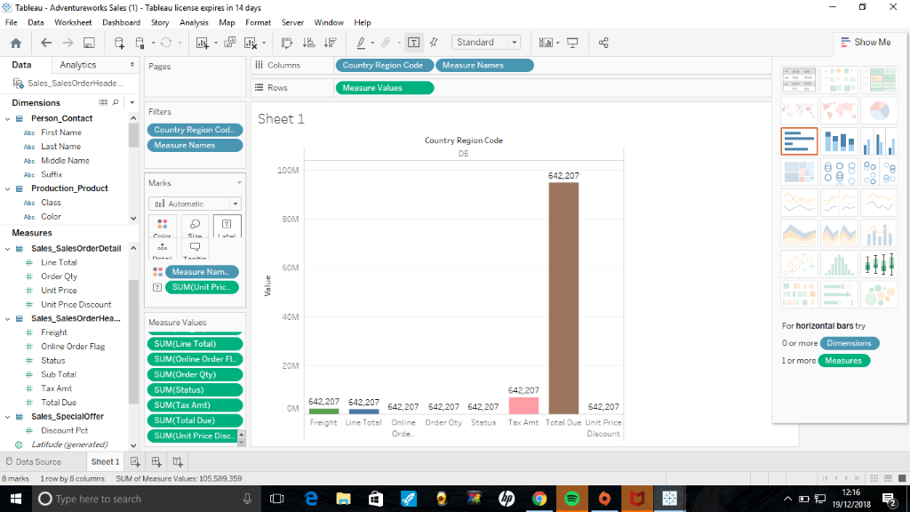
From the visualisation below shows the DE country code from Germany. The image shows a total of numbers for different sub attributes, for example the order qunaity is reading at 7033 which means that particular number of orders have been oput through , there are only eighteen unit price discount.
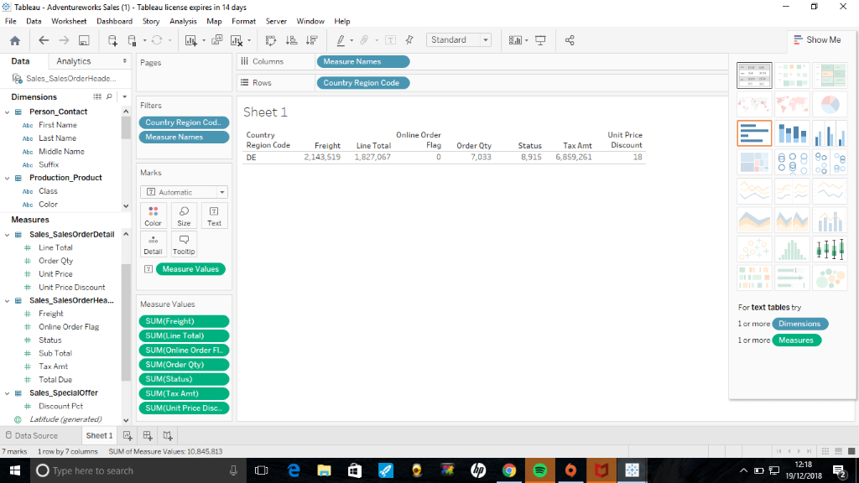
The image represents all five regions within year date and measures applied which are sum line total and the sum order quantity. From the visualisation we can see the AU region, the quantity is in the region of 2.5 k of orders and it only shows the year 2003 and 2004 for the AU region. The CA region runs from 2002 to 2004, in 2 years within that period they reached an order quantity of 5000 k for 2 years consecutively. In the DE region it almost reached the 5k order quantity. The US region had a lot of order quantities it reached over 10k. This representation was represented in unique way to analyse results differently.
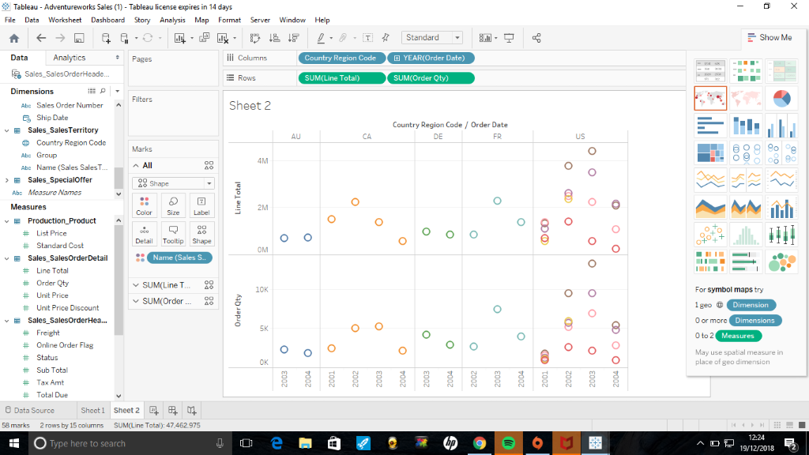
The visualisation represented shows the DE region for Germany , the order quantities are represented as follows. In 2003 the order quantity is a little bit over 4k and in 2004 the order quantity is 3k. The information is presented as a standalone region as a comparison was already made in the image above.
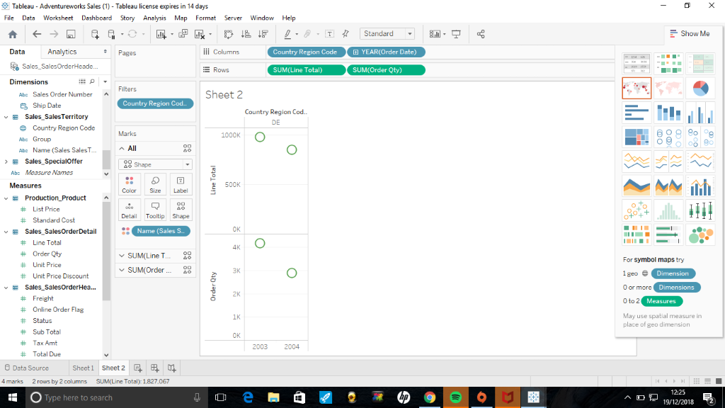
The visual representations show the DE region for Germany, the measures applied here latitude and longitude. The dimensions that have been added are group, product line and name of sales.
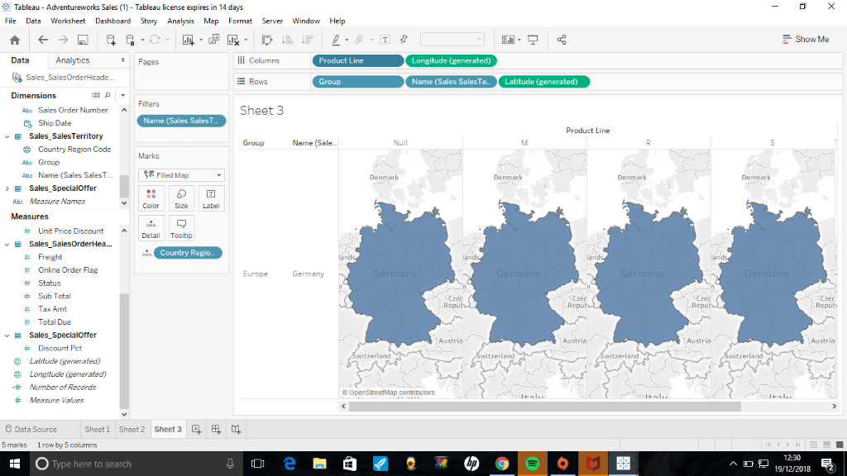
The visual representation shows a map with a big number. The measures that have been applied are Group and the name of sales. The dimensions applied to this visualisation are longitude and latitude. From the image we can gather that the DE region which is Germany is clearly represented on the map and the number is to represent the name sales sub total from the Germany region.
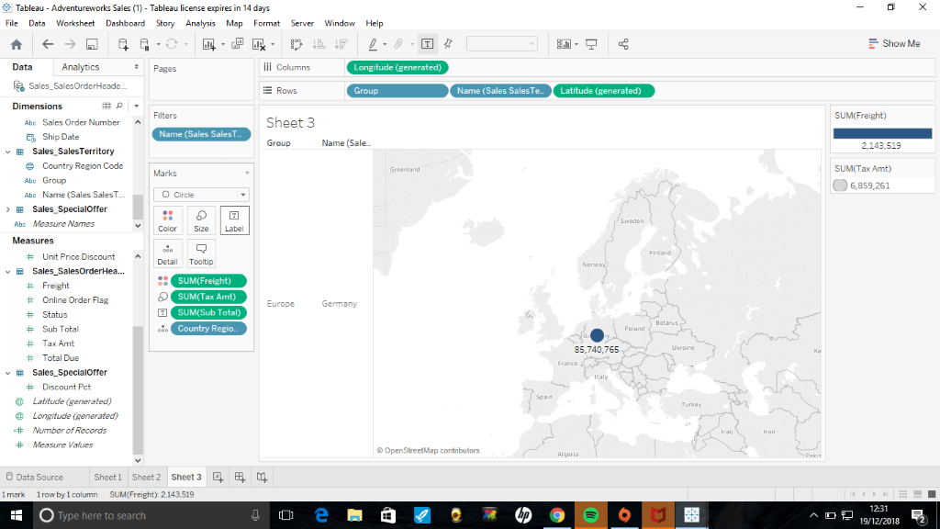
The image shows that dimensions are applied. The group is the Europe group and the name sales alone are 5,740,765.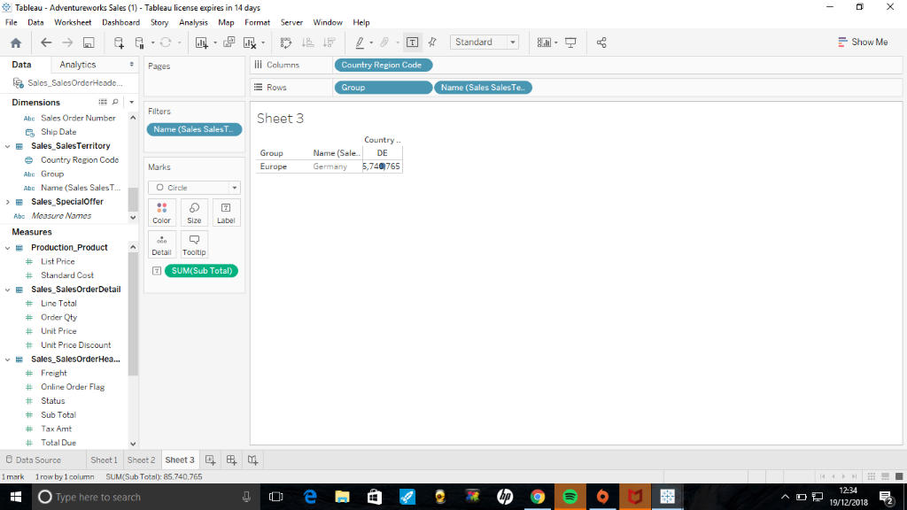
The image below shows all the regions, from the visualisation it is clearly shown that the France region has the highest subtotal and total due, the AU region has the lowest subtotal and total due. The measures used in this visualisation are the sub total and total due, the colours are a visual representation to identify each measure.
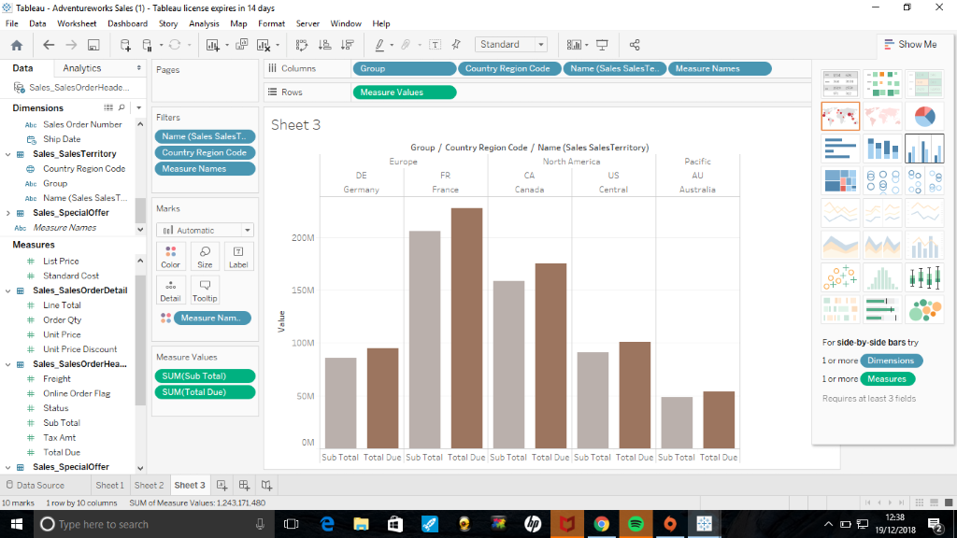
The image below shows all of the regions, the data is represented in a bar formation with the name sales labelled and the sales made within the region.
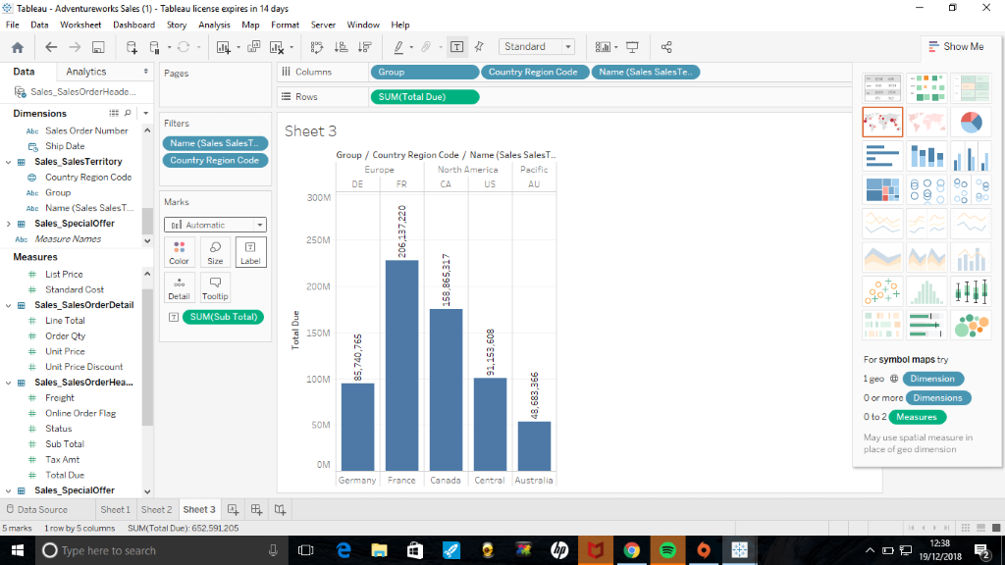
The visual representation shows the sub total and the total due which are the measures and the colours are also used to differentiate the two measures for the DE region.
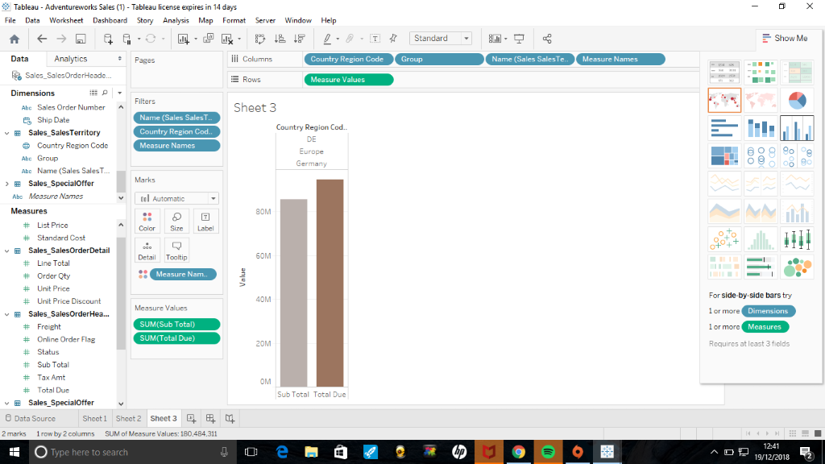
This image shows the DE region for Germany and it shows the total due as a measure and the name sales is identified also.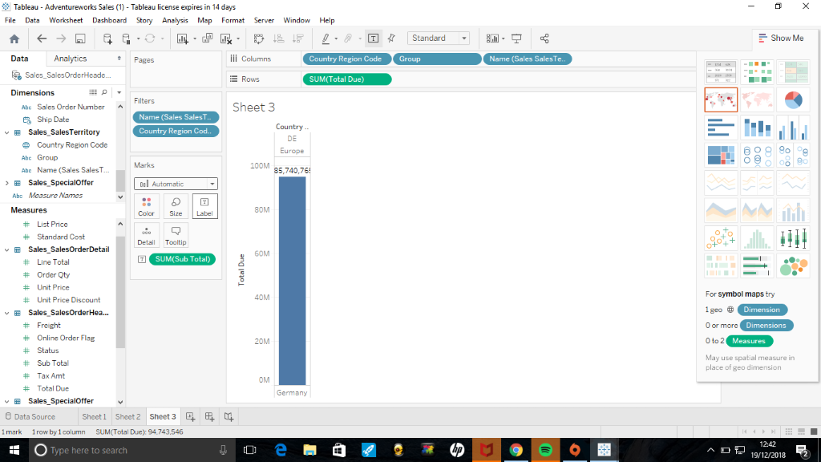
The image below shows the name sales represented by colour. The visualisation is not categorized by the county region code it is identified by the group and then identified by the country.
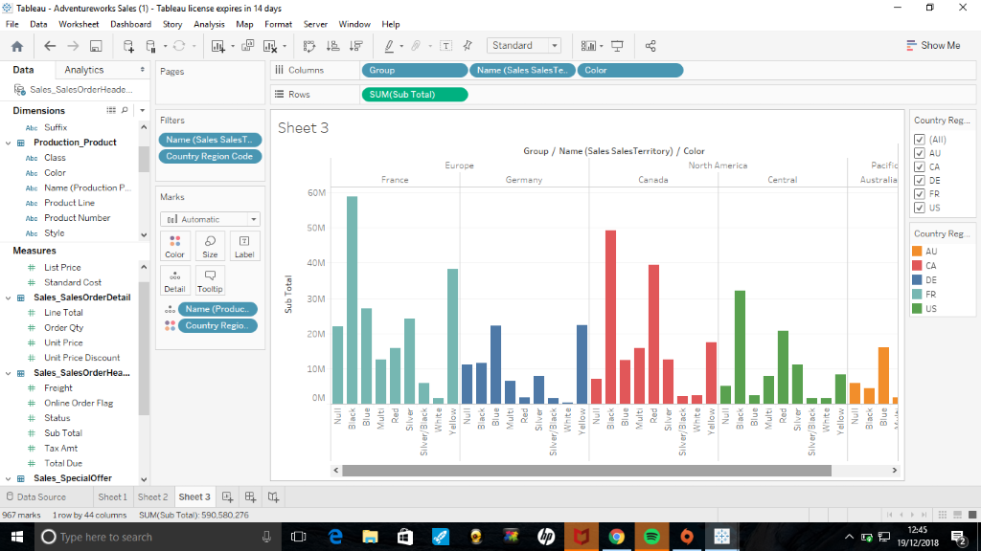
The image below shows the different regions, and sales made by induvial people. The most items brought was from the FR region and the least was brought from the AU and the CA region. For the DE region for Germany there was only one female who made purchases within that region. The overall view on the visualisation presented is that more people brought items within the US region and the other regions people didn’t seem to purchase a lot, excluding France as they made a substantial amount of purchases.
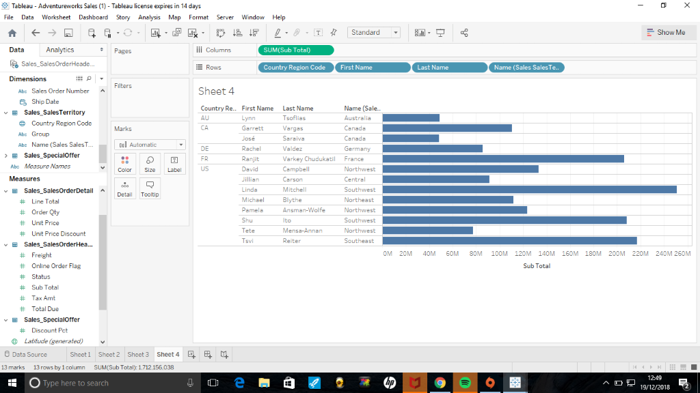
This image shows which people made purchases within the region. The lowest region with purchases is the AU region .
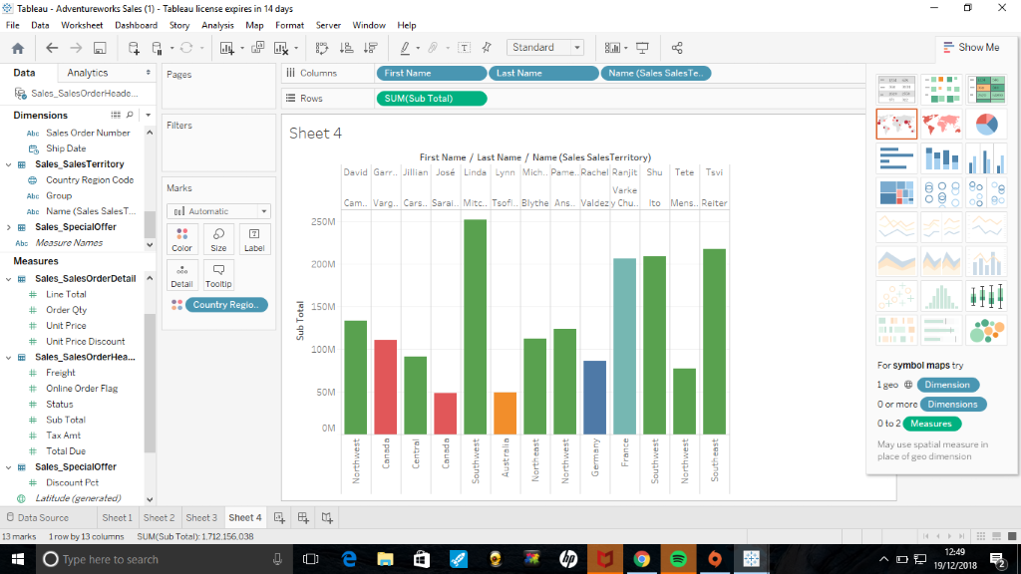

This visualisation shows the above image with the country region codes for all the regions within the data set.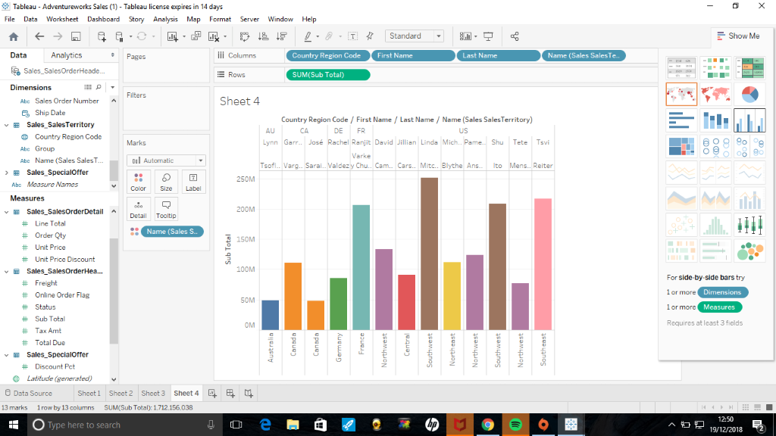
This image shows that not many sales were made within the AU region, the CA region made a few sales, the DE region made a few sales also however the FR region mad a little bit more sales than the other sales that have been mentioned. The last region which is the US region seemed to make considerably more sales with all the product categories, the highest product category sold was the bikes and the least was the accessories.
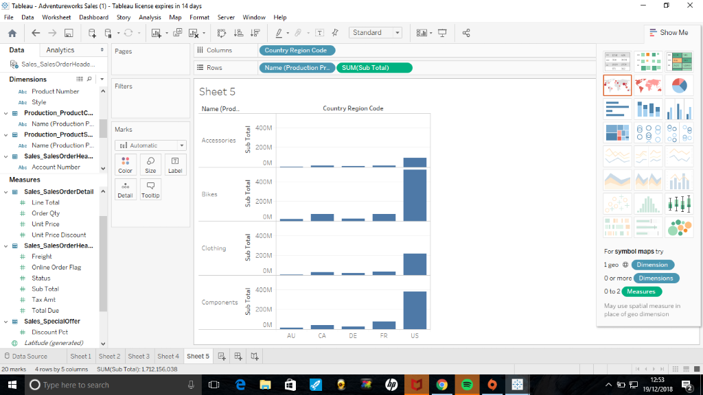
From this visualsation we can clearly see that the AU region doesn’t have many sales that were generated, the US region made lots of sales.
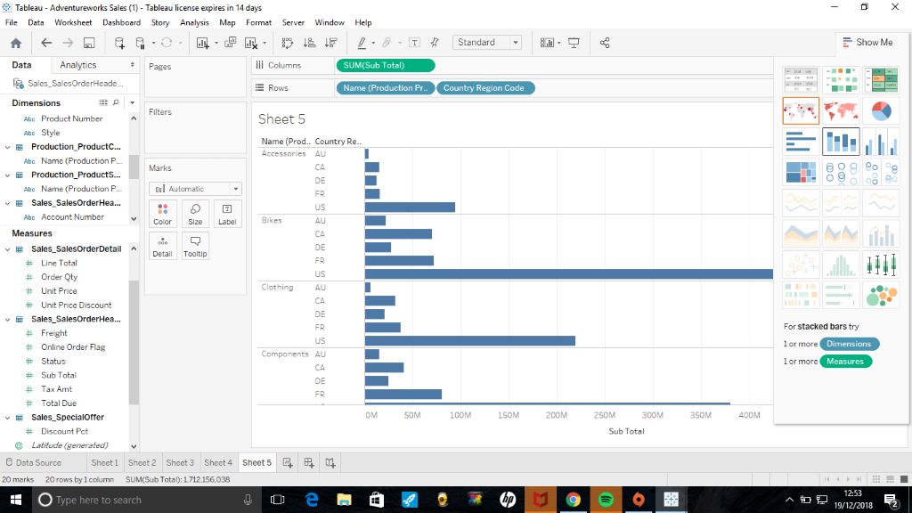

The image shows a clear representation of each region using the bar chart by using the labels of the products to see which products sold more in different regions.
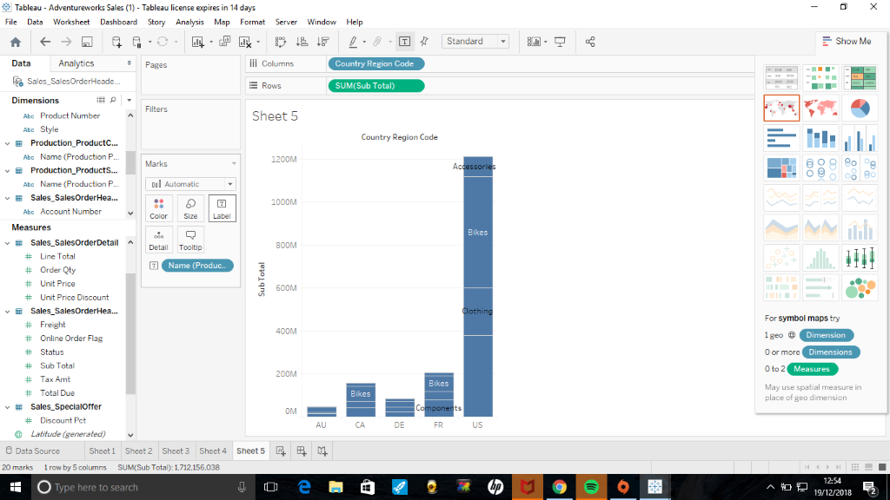
This image shows the products sold but instead of using the labels of the products , a colour scheme has been used to help represent the products without using labels.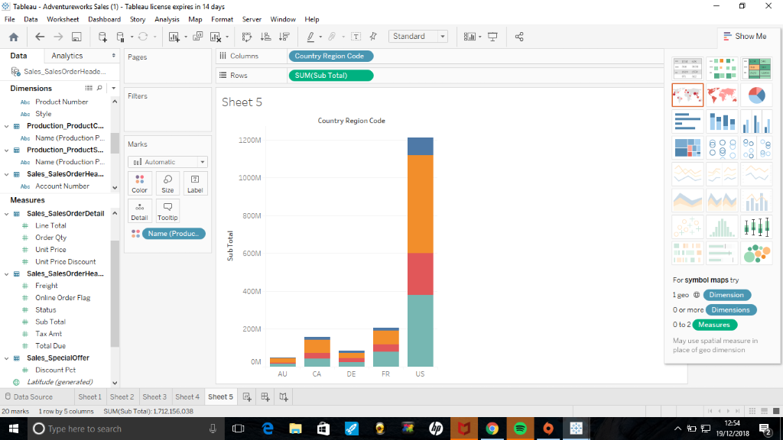
The image here shows different products represented by colour but adding the label for the products sold with each region. From the image below the US region made the highest sales and the AU region made the lowest sales.
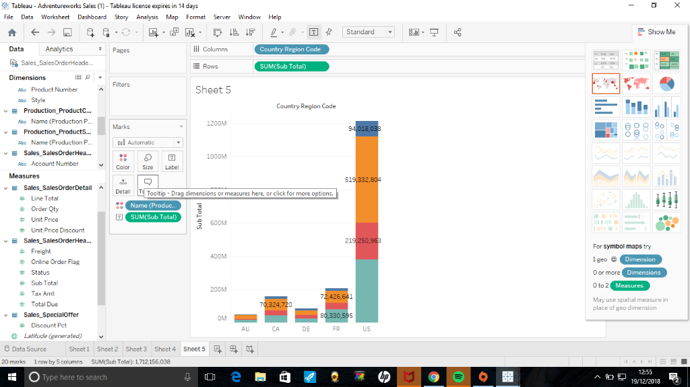
This image shows an individual breakdown for the selected region which was assigned which was the Germany region. The blue for accessories, orange is for bikes, pink is for clothes, teal is for components.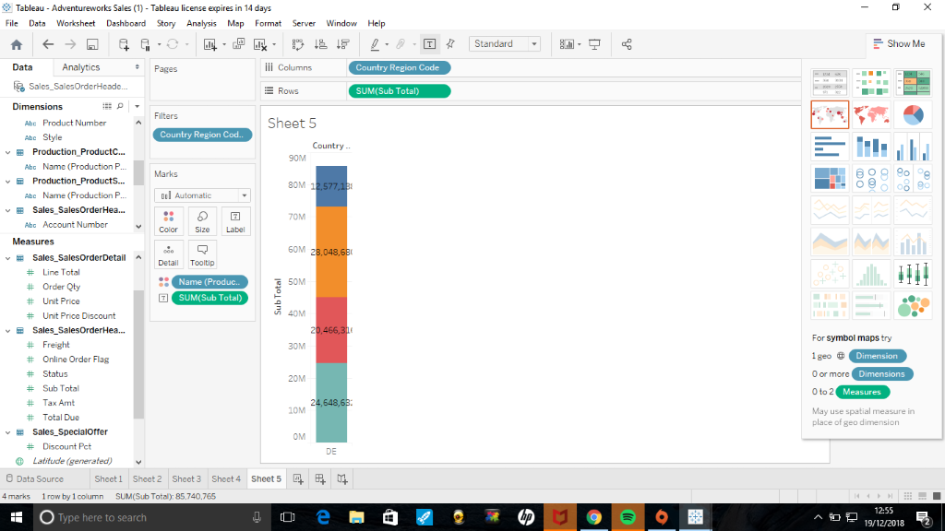
The image below shows the DE region which is Germany and the label marks are used to represent the chunks of data and the products that it relates too.
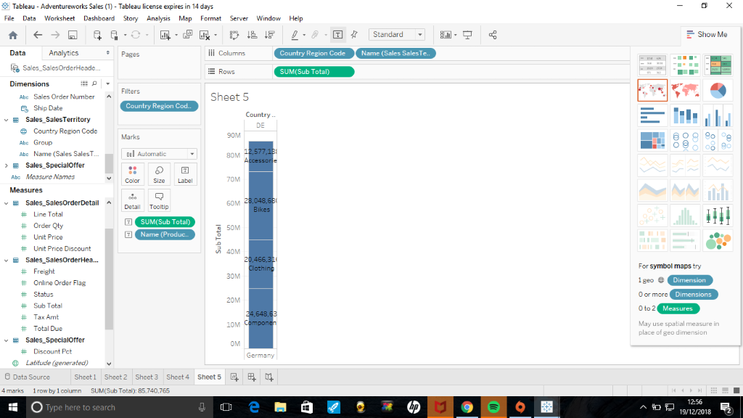
The image below shows sales labelled for each product listing, and the data is also represented within each country region and code to give a better breakdown of sales and a better analysis.
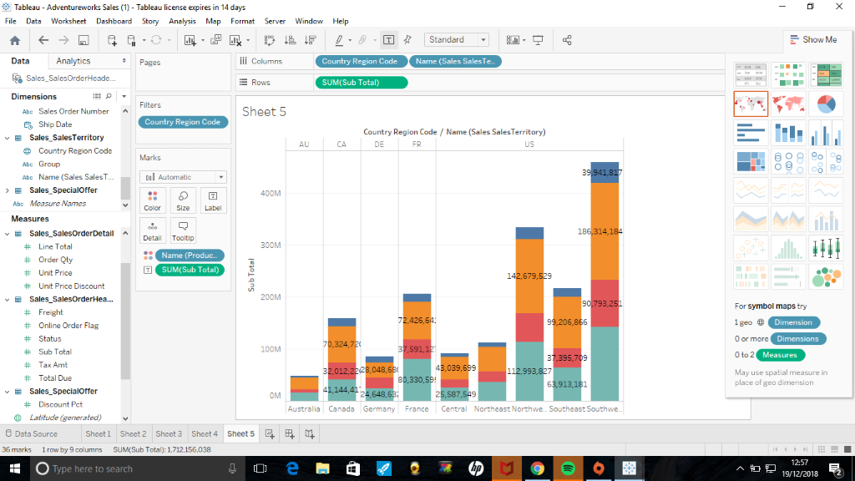
The image below shows a breakdown of each country code with the names of people who made a purchase , the colours are there to represent which products were brought with the region code.
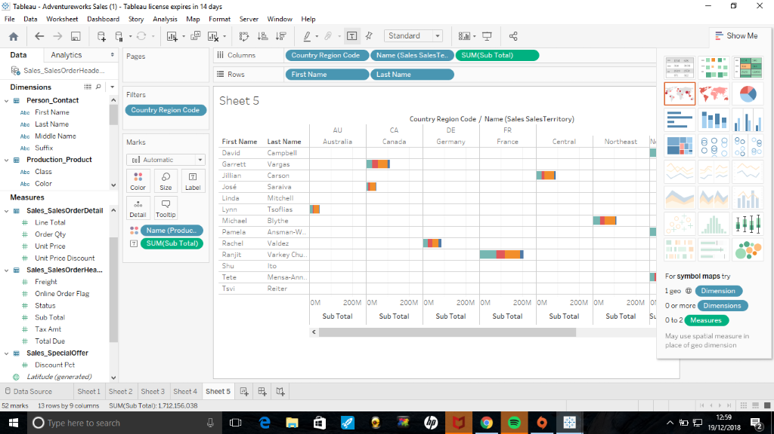
The visualisation below shows the three different groups which are, Europe, North America, Pacific.
This visualisation shows three bar charts, the lines on each bar charts represents a country within that continent.
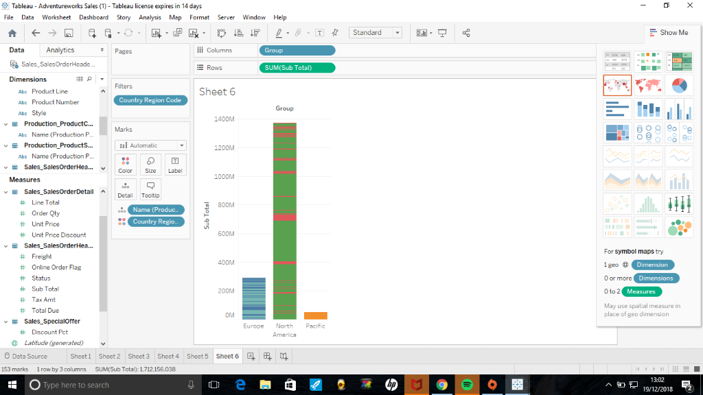
This visualsation shows three bar charts , the lines on each BarCharts represents a country within that continent.
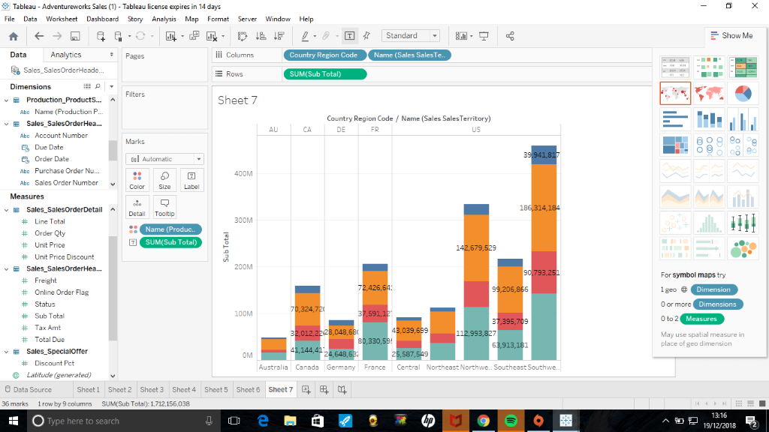
This Visualsations shows all the regions and the products sold in those regions, the blue stands for accessories, orange is for Bikes, Red is for clothing, Blue is for components.

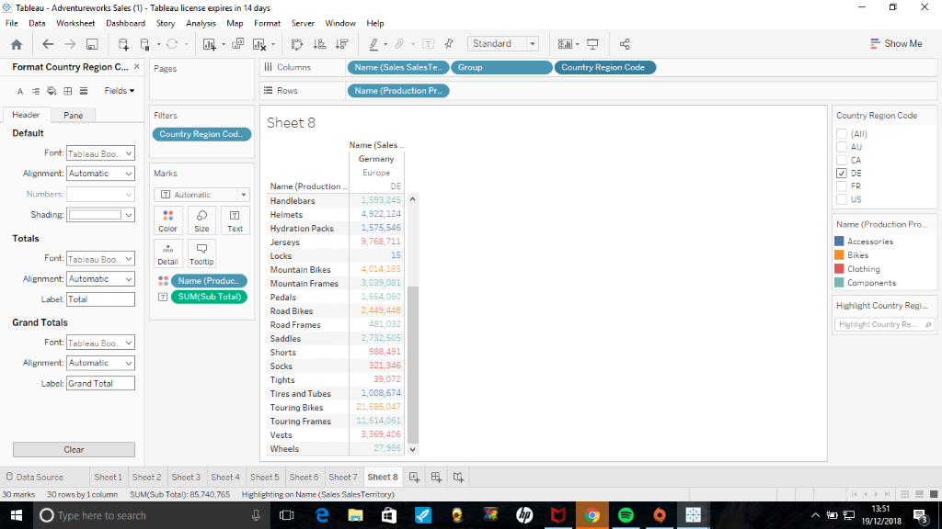
This visualsations shows the sales made from the categories provided ,which are accessories,bikes,clothing,components,.There is a key on the right hand side which gives a colour key to match the sales figures to thee products.
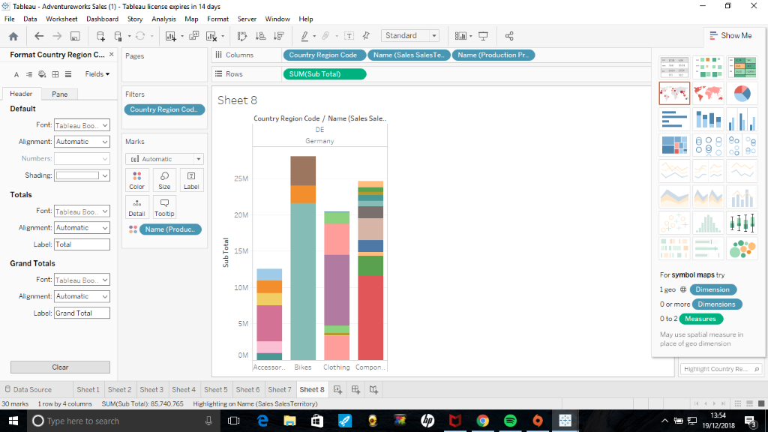
This visualsation shows a breakdown of products from the categories with the DE region for Germany. In the first bar chart it shows a breakdown of accessories ,second bar chart is bikes ,third bar chart is to represent clothing, the last bar chart represents components.

Accessories | Bikes | Clothing | Components
Cleaners | Touring bikes | Caps | Touring frames
Tires and tubes | Bikes | shorts | Saddles
Hydration packs | Mountain bikes | gloves | Road frames
Helmets |  | jersey | Handle bars
 |  | vests | Mountain frames

The visualsation below shows all the regions showing all the sub totals from the products sold in different regions. The sales figures for the products are represented using colours.
This visualsation shows all the regions showing the sub total from the products sold in the different regions.
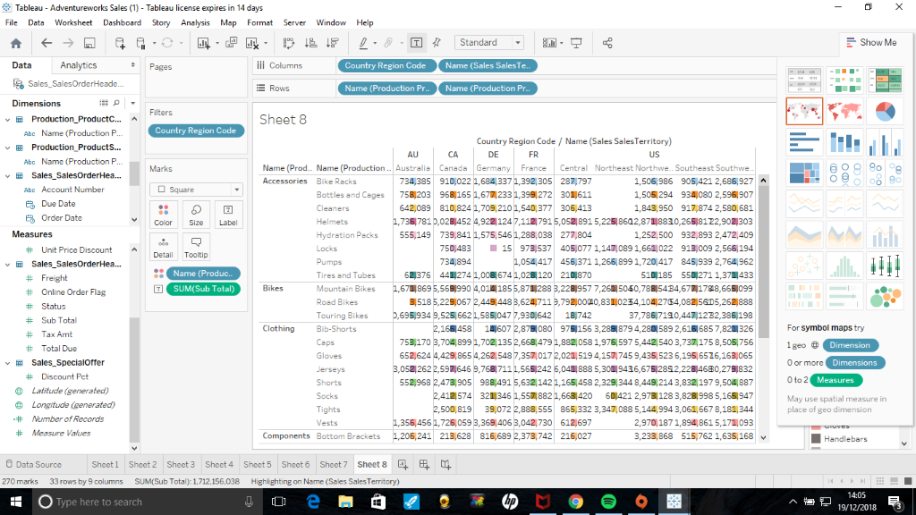
The next visualsations shows the region that was assigned to in the class. The image also shows the products spilt into product sub category which defines what product it is.
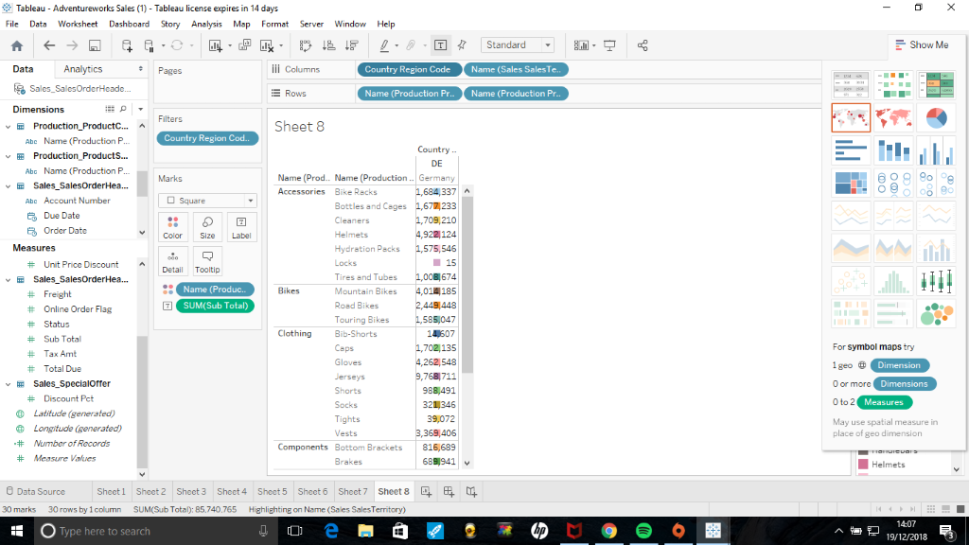
The image below shows a detailed visualation , the image shows the county region code, the four production categories and its represented in a bar chart format. In the accessories section the highest sold item was the helmets and the least sold was the locks. In the bikes section ,the touring bikes were the highest sold item within that sub category. Within the clothing section the Jerseys was the highest sold item, tights were the least sold item within the clothing section. In the components section the tour frames made the highest sales ,the least item sold was the wheels. From the image as a whole it clearly shows that touring bikes ,jerseys and touring frames were the most popular items sold within the DE region for Germany.
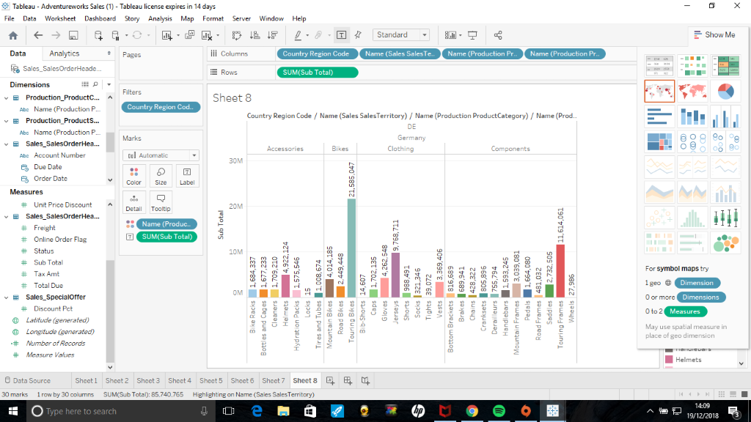
The visualsation below shows sales within all the regions across the period between 2001-2004 , the US has had significant sales within the 4 years as compared to the other regions didn’t have many sales as the US.
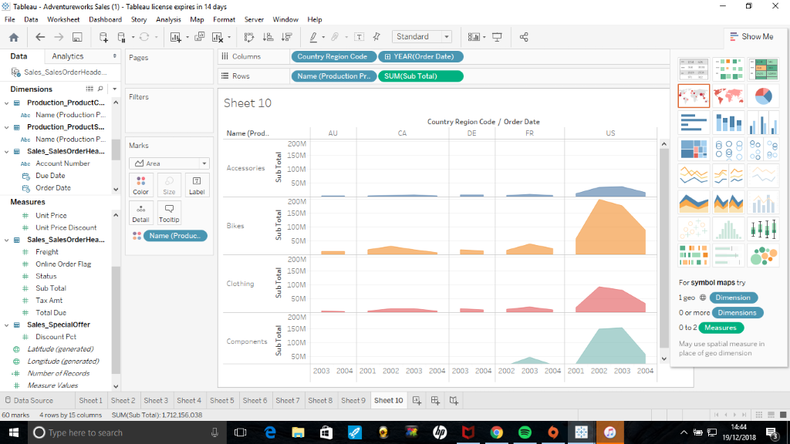
The image below shows the sales between 2003 and 2004 the colours represent the different product lines which are accessories,bikes,clothing and components. Gathering from the visual representation, accessories were not very popular from the representation shown, the highest item sold within the years 2003 and 2004 are the bikes and the second highest sold items are the components and the clothing comes into the third position and the accessories were the ones with the lowest results shown.
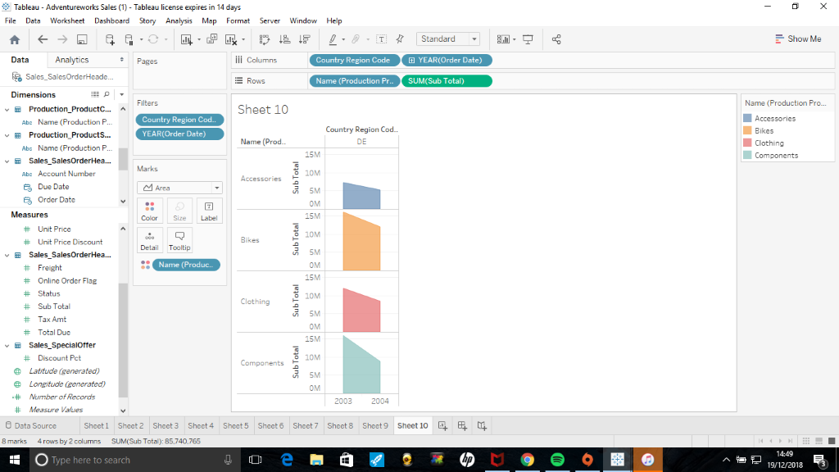
This visualsation shows how trends have improved over time in different regions, in the visualsation there were only sales in 2004 in the Australia region, as compared to the Canada region there is sales from 2001 to 2004, it increases, and it declines gradually. The DE region for Germany only made sales in 2004 there has been a decline in the sales regarding the bikes and there has been an incline in the sales for clothing. The France region only shows sales of items from 2003 to 2004 within the sales there has been an incline and a decline in sales over the various regions represented within the visualsation.
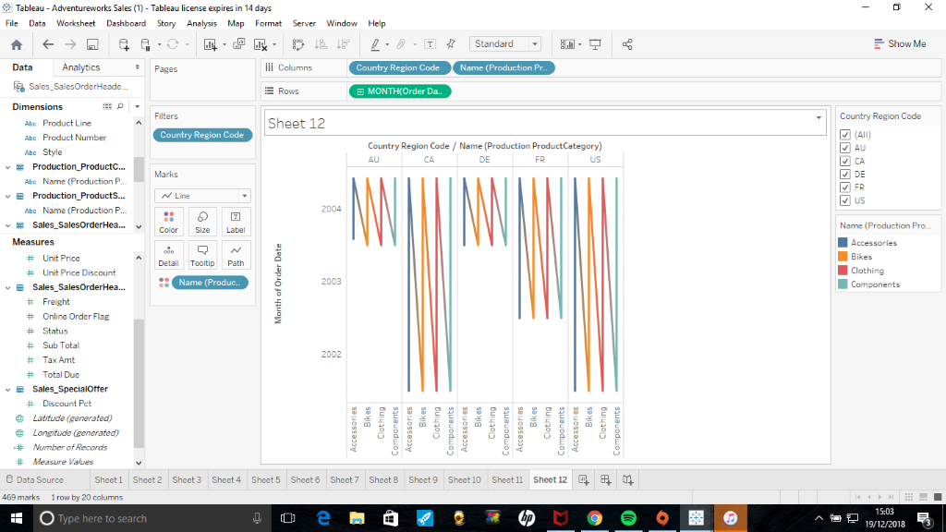
A description of how sales and profits have changed over time.
There has been an increase and decrease in sales throughout the regions represented.
The main categories for goods sold is also shown and the significant subcategories.
Sales have changed over tine within the Adventure works. Sales have inclined and declined throughout the visualsatios shown within the document.
Trends and forecasts for both the main categories and significant subcategories of goods sold.
Within the adventure Tableau file , trends have been noticed and with this information , a forecast is able to be made for the goods sold and a future forecast whether sales will increase or decrease. Sales have changed over time within the Adventure works. Sales have inclined and declined throughout the visualsatios shown within the document.
Market basket analysis of items to identify any combinations of goods that occur together and might therefore benefit from promotion via special deals.
Market basket analysis is a modelling technique which is based upon a theory, the theory is that if you buy a particular group of items, you are more or less likely to purchase another group of items within the shop. For example people are in a pub and they buy pints of beer but instead of having a pub grub meal they are more likely to buy a packet of crisps. The term market basket analysis is there to seek a relationship between different purchase, like the analogy of the beer and the crisps. [1]
Identification of any problem items and recommendations as to how Adventure works should deal with the problems.
There are significant problems that have been identified within the Adventure works file , the visualisation that has been created shows problems. In a particular visualsation there were no sales within the DE and the AU region from 2002 until 2003 , they only made sales in 2004.

Conclusion
Within the DE region for Germany , it has been concluded that accessories are not very popular within the Adventure works. To get a better understanding a particular visualisation could have been created with all the country codes to a show a better comparison between each region to come up with a strong analysis and a conclusion.

Bibliography

[1] | "Market basket analysis," Albion Research Limited, [Online]. Available: https://www.albionresearch.com/data_mining/market_basket.php. [Accessed 5 12 2018].

