NAME: Bolca Laura
ID:2112586
Module: MARKETING FUNDAMENTAL LCBB4004
LECTOR : Dr Nadeem MIRZA

Blogging to communicate

Costa Coffee

OUR STORY

All we love to drink when we wake up a cup of a good coffee before starting our activities. Sometimes we hurry and go fast to bring some coffee and from where? Always I chose COSTA COFFE which is the best taste.
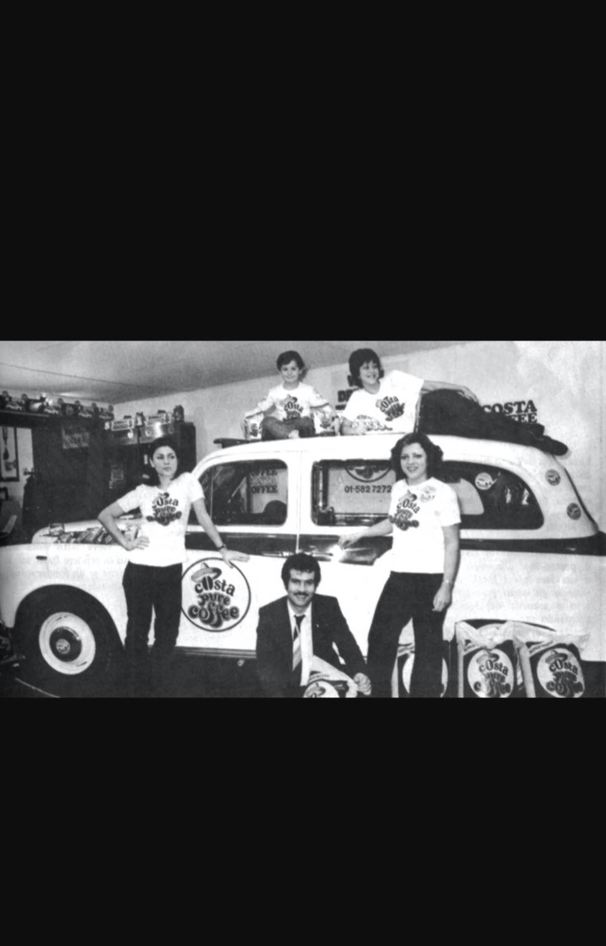
Costa coffee is a big business which start in 1971 in London, Fenchurch Street in a small roastery. Two brothers Sergio and Bruno start to make great-tasting coffee every day there. They tasted 112 variations till one tasted good enough.

FUTURE PLANS

Their plan was to extend the business in a lot of countries in the world till China and reduce competitors. Because they want tankful customer the second plan and not the last is to install an electric hub for people to order easier.
Mission and Value statement in company
The mission is to show the people the original flavour possible never to meet just in this coffee shop.
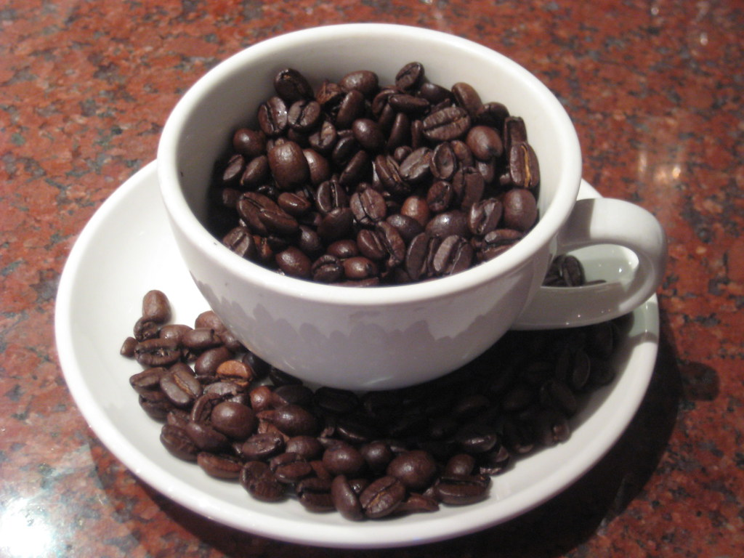
This Photo by Unknown Author is licensed under CC BY-NC
Their mission is the organisation’s reason for existation and their concept about coffee, original coffee. The mission supports the vision and serves as the direction to employees, customers, vendors, and other stakeholders. The mission statement tell you the fundamental purpose of the organisation. It define the customer and critical process.
The mission statement is to provide the best coffee Costa Coffee and ensure that people have the best coffee-drinking experience ”to save the world from mediocre coffee” . This sure is the company’s product confidence.
The values statement in a company or different organisation is a list with principles. This is a guide which creates a moral compass.
Costa coffee is focused to become the most loved brand of coffee in the world. They win, are the strongest brand and they grow, opening more markets like that more people can enjoy the taste of costa!
COSTA COFFE VALUES
Some of the values like passion, courage, warmth, trust, diversity, and inclusion define the costa organization.
The first value is the PASSION for coffee, all who work should have a little passion for coffee like the brothers who start with this brand of coffee.
They want a wonderful team and people who have enough courage to stay in the company and help in this competitive business.
In this business, the customers are expected to receive a smile and employees to be welcoming.
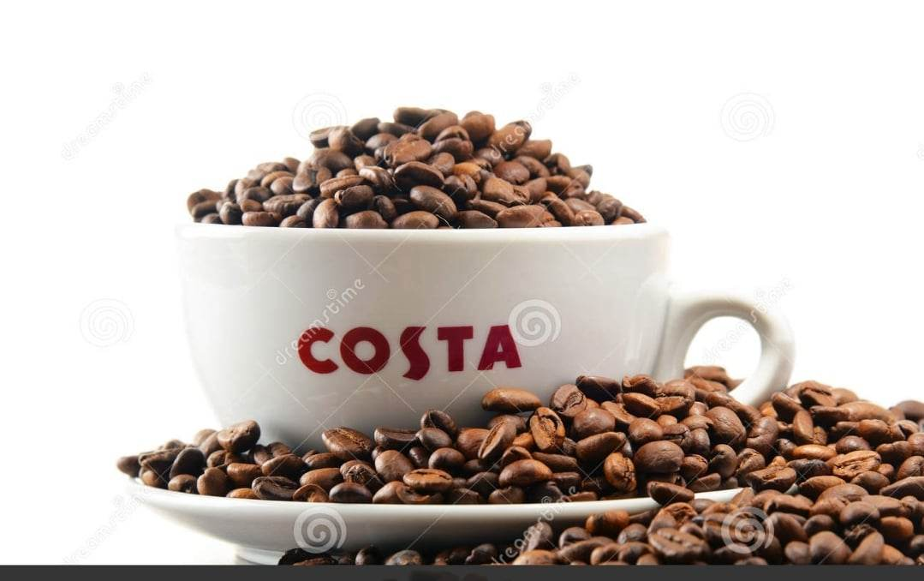
Trust is what Costa Coffee is all about like team members, products, customers, and all services.

The coffee brings together people from different countries, and distinct cultures and this looks like progressive work which promotes peace and harmony. Respect for others does not matter where you come from or which colour is your skin.
They have 50 years of experience and 10 from when is called the Nation favourite coffee.The brand has an immense success with more than 3800 stores in a different country.
BRAND is an important part of any organization. It is
a particular part of each company same as the logo.
LOGO
The history of the Costa Coffee logo: first is from 1971-1995 (fig1). This simply consists of the essence of the word Coffee and “O” is sowing the essence of coffee the bean.
From 1995 till in present they have a new logo completely different with colours. The logotype is used by the brand and the burgundy colour in the company visual are reflect Costa Coffee’s values which evoke friendliness. They keep the same logo till in the present and the both have in common the beans.

(fig1-logo 1)
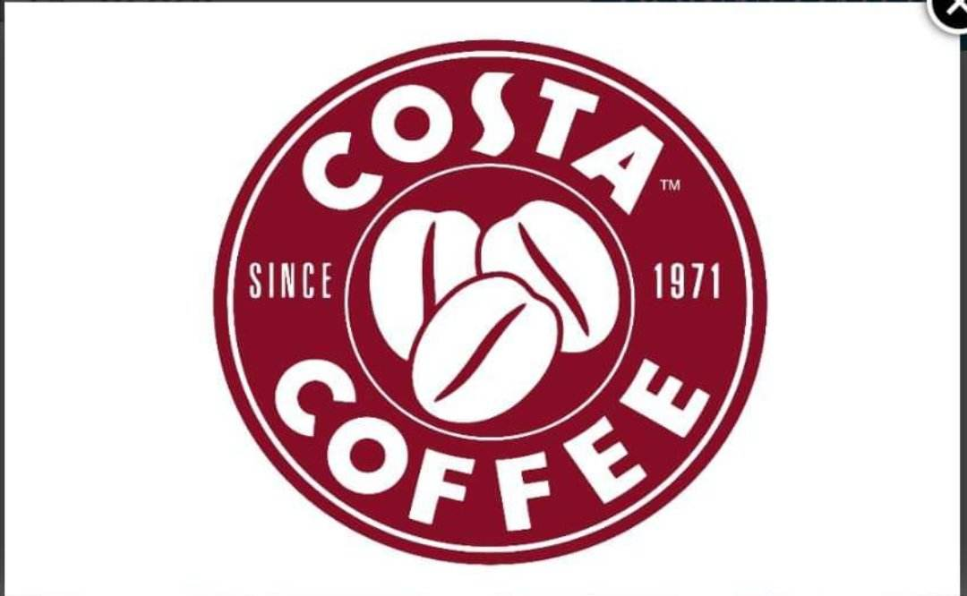(fig2)
CONCEPT MARKETING
This concept has 72 definitions. Marketing is defined by Dr Philip Kotler as a” science and art of exploring, creating, and delivering value to satisfy the needs of a target market at a profit.”
Jay Baer said “marketing is the messages and action that cause messages and actions”
American Marketing Association defined marketing as an activity, set of institutions, and processes for creating, communicating, delivering, and exchanging offerings that value for customers, clients, partners, and society at large.
The last definition and not at all Is all about Costa Coffee as a business the result of its success. They create the special taste of coffee and they use their value to deliver for customers.
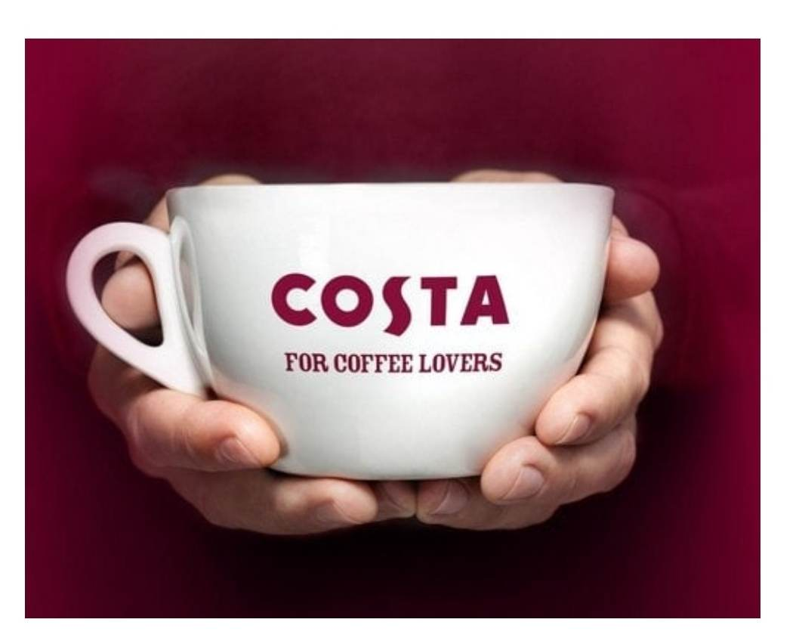
Costa Coffee have a different and various type of product they start from the best coffee till the delicious and quality food which are loved by people. Here is the marketing mix. Costa Coffee is a coffeehouse chain which is a branch of the American company Coca-Cola Company.
MARKETING MIX is a foundation model for business with four elements key: product, price, place, and promotion. Also, physical evidence, people and processes are part of the marketing mix.
PRODUCT
Different type of products is a crucial factor in the marketing mix because is a part of the marketing strategy. The principal product is coffee but also they have a lot of derivates of this like hot chocolate, frappe with different flavours, various tea cold drinks and specific food buy costa coffee.
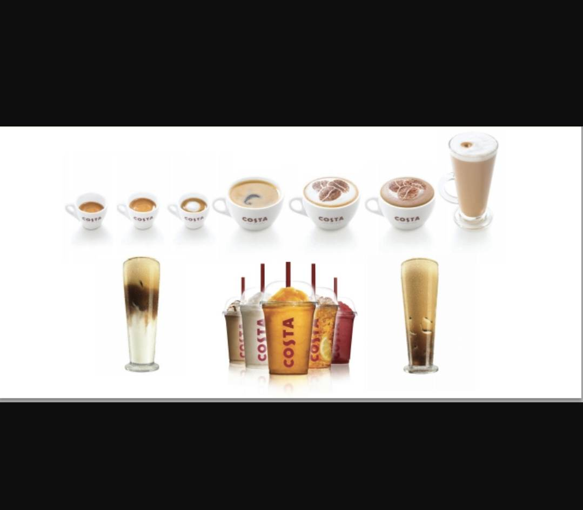
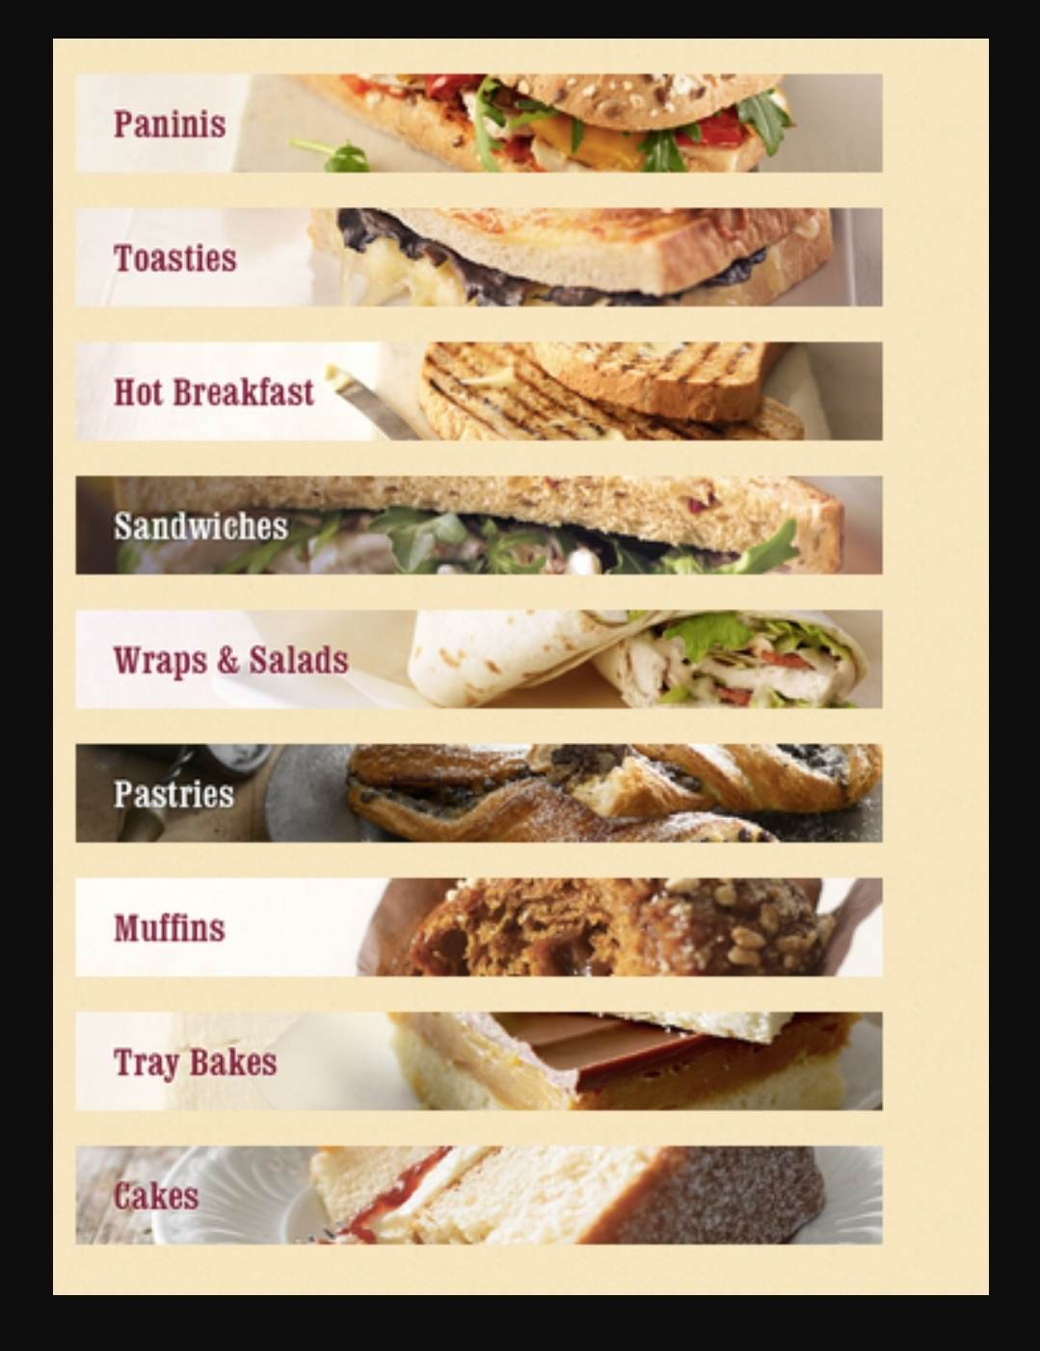
Also in coffee shops, Costa Coffee start to sell a new range of mugs, thermos, and different packages by Costa.
PRICE is another factor/part of the marketing mix. Costa Coffee believe in Premium pricing because they offer the best coffee taste and various product of excellent quality to customers. They think to delivering their value to customers is more important than prices.
PLACE is the location where service or product is going to be located.
Costa Coffee was started in London after they extend the business to over 200 countries. They open in 1995 41 stores in the UK and in 2009 in Cardiff 1000th stores in various places like airports, train stations, shopping centres and other places with traffic.
PROMOTION
In marketing usually, all companies /organisations have promotions but Costa Caffe does not have them. They use promotions like advertising on the buses in trains but not on social media. These kinds of promotions are not the key for Costa they prefer publicity from customers, with other’s words they believe in the power of words.
PEOPLE are a factor in the marketing mix, they define the service. Costa Caffe is more than a drink they encourage people to join their groups, they believe in diversity and passion. For this every year they celebrate and represent the company PRIDE.
PROCESS is the way how the service is delivered to the customer without loose the quality.
PHYSICAL EVIDENCE is the least element in the marketing mix to create a better customer experience with the service.
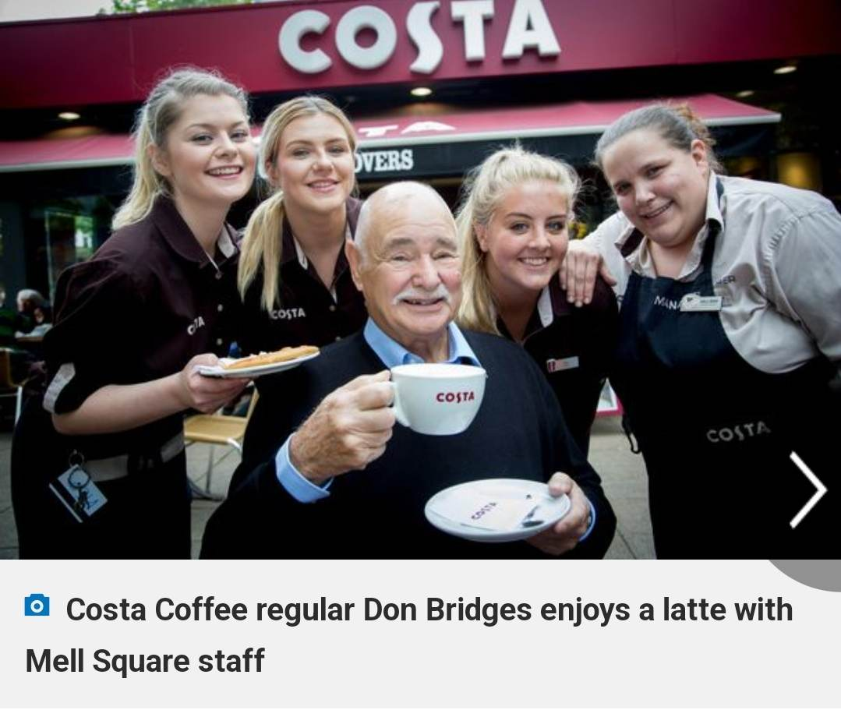
MARKETING STRATEGY is a plan to action in one company for contacting a potential consumer to promote and sell one product or service.
“The purpose of marketing is to contribute to maximising shareholder value, and marketing strategies must be evaluated in terms of how much value they create for investors” Peter Doyle(2008).
These words in this case Costa Coffee evaluate the strategies for their success.
Marketing segmentation is related to three factors: segmentation, targeting, and positioning.
POSITIONING “is a competitive strategy in the search for a favourable competitive position in an industry. “ Michael Porter (1985)
Costa Coffee on the global line is positioned strategically. Because of the quality of the coffee and other quality product they are a competitive advantage. Al the coffee shops are allocated in the zones with higher traffic of people.
Targeting is a market strategy which breaks the market into segments and focuses on segments of population: demographic, psychographic, geographic, and behavioural.
Segmentation is a process to divide the customer into more groups of the buyer and their needs.The Costa has various segmentation after economic profile, gender, age, and cultural groups.
Costa Coffee is a company with smart objectives with a strategic plan and a marketing mix have marketing strategy an advantageous position in the Chinese market and Italian coffee.
COMMUNICATION WITH CUSTOMERS is a factor important. This concept as the target audience can be reached efficiently and effectively. They use a gift card as one way to improve the sale of the business or membership card.
At the present, they have a website and they offer the opportunity to customers to buy online and taste at home the costa coffee with different flavours.
CONCLUSION
Costa Coffee is a macro Environnement. A company with smart objectives, with higher success. The name Costa represents luxury and perfection around the world. They have highly motivated and capable staff and are responsible to offer the best service to customers. Producing the best quality coffee is a strategy that Costa Coffee employees
I recommend thinking about one place for kids in the coffee shop for mothers who want to sit and enjoy the coffee.
References
Principles of marketing,Bishop Trinidad
Marketing Strategy and Competitive positions,Hooley Graham
Service Marketing Mix - 7Ps of marketing mix - Marketing mix of Services (marketing91.com)
Costa Coffee Mission Statement (mission-statement.com)
Costa Coffee Logo, symbol, meaning, history, PNG, brand (logos-world.net)
https://www.marketing91.com/marketing-mix-costa-coffee/
BRAND AUDIT BLOG STARBUCKS VS COSTA COFFEE: COSTA COFFEE MARKETING MIX (starbuckscostacoffee.blogspot.com)
What Is Marketing? (lardbucket.org)

