

BA BUSSINESS MANAGEMENT
INTERNATIONAL BUSINESS COMMUNICATIONS
Component 1 ESSAY

Module Code: LCBB6001
Lecturer: Dr. Laila Maazouz
Student: Cristina-Loredana Balaban, 2030114

28 of August 2024
Table of Contents

Introduction of the British business communication 2
A brief overview of the selected company 3
Evaluation of two EU countries based on cultural differences 4
Outline barriers to communication that British business may experience in EU countries 7
Recommendations for expanding the British company in Germany 9
Conclusion 10
References 11

Introduction of the British business communication
British people value clarity and precision in communication while appreciating politeness and indirectness. In this regard, it can be stated that businesses need to combine straightforward communication with politeness while articulating their offers and services. British business practices are characterized by their emphasis on formality, punctuality, and clarity. UK companies highly value structured communication. The benefit of structured communication is that it helps in maintaining professionalism and efficiency in business dealings. On the other hand, structured communication in the British business landscape also ensures that all stakeholders are well-informed and that business processes are streamlined. This section will evaluate some significant types of British business communication.
Cultural sensitivity in communication
British business personnel often prioritise cultural sensitivity in communication. It has been observed that British professionals appreciate politeness and indirectness and avoid assertive or aggressive tones in communication. This communication practice can be effective while interacting with international partners as it fosters mutual respect and smooth collaboration. The UK business professional is also highly focused on Customer Relationship Management (CRM) Systems to manage communication with customers (Chang, 2024).
Technological integration
Technology integration is a salient part of British business communication. British business landscape has included Technologies like Project Management Software, Instant Messaging Platforms, Video Conferencing Tools, and Email Communication (Chang, 2024). The inclusion of these Technologies helps British business to simplify their communication procedure. The integration of advanced communication technologies has become a cornerstone of British business operations.
Importance of written communication
Written communication is an important pattern of British business communication that plays a crucial role. British business personnel highly value clear and concise writing such as reports, emails, and official documents. According to Dziubaniuk et al. (2020), clear and succinct writing enables companies to transmit information accurately.
On the other hand, written communication is significant to mirror the commitment to professionalism and excellence of a company.

A brief overview of the selected company
Sainsbury's has established itself as a significant and leading British international retailer. The organisation is known for providing delicious and high-quality cuisine at reasonable pricing. The company began in 1869 with John James Sainsbury and his wife Mary Ann (Chang, 2024). The company has grown its operations and built over 800 convenience stores in the United Kingdom (Chang, 2024). Sainsbury is deeply committed to quality, innovation, and customer satisfaction. These approaches have helped this company grow into one of the UK's major grocery chains. Sainsbury's has 600 supermarkets in the UK and employs 148,000 people (Chang, 2024). This company's growth is further aided by its strong web presence. The company's internet presence and worldwide communication have enabled it to interact with millions of clients nationally.
The organisation has developed a diverse product portfolio including groceries, clothing, home goods, and financial services. Sainsbury's is committed to reducing its carbon footprint, minimizing waste, and promoting sustainable sourcing. It is worth mentioning that is company is highly concentrated on delivering good food to customers. Sainsbury's has made strategic acquisitions and partnerships to enhance its market position. The company has march with Argos in 2016 which is a leading digital retailer. Argos is the fourth most observed retail website in the UK (Chang, 2024). The collaboration with this digital retailer company indicates the commitment to meet evolving consumer needs and the adaptive strategy of Sainsbury’s. The company has positioned itself as a trusted and beloved brand in the UK by emphasizing customer service, community engagement, and innovation.

Evaluation of two EU countries based on cultural differences
Organisations need to investigate and understand the cultural differences of the different countries when expanding international business and planning communication. This section will focus on evaluating and planning communication for Sainsbury’s in Germany and Spain.
The cultural and social context of Germany
Germany has the largest economy in the EU and offers a stable and prosperous environment for business expansion. The country is known for its strong industrial base, high standards of living, and well-developed infrastructure. These aspects indicate the potential success of Sainsbury’s while expanding in Germany.
German society values punctuality, efficiency, and precision in both personal and professional contexts which matches British business communication. Based on the observation of Hennart et al. (2021), it can be explained that language differences are a significant barrier to the international expansion of business. However, the communication style of both Germany and the UK matches significantly.
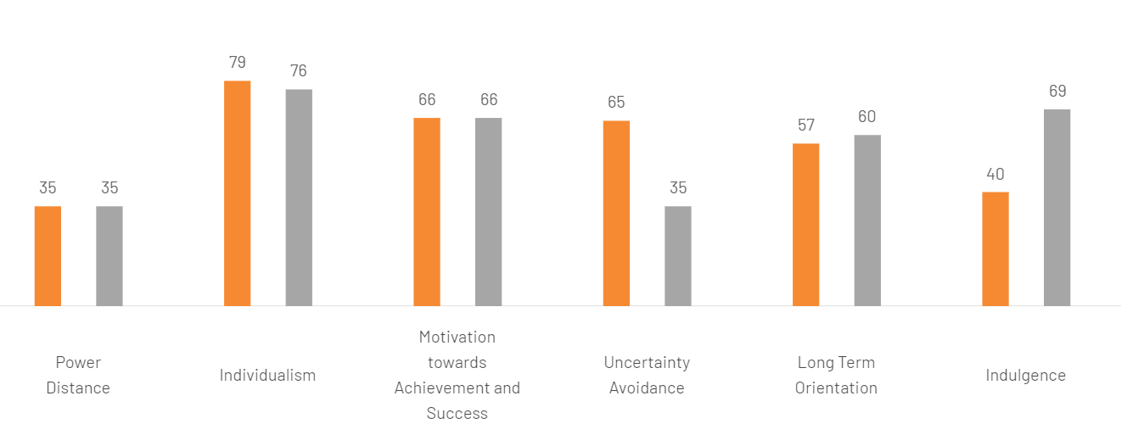
Figure 1: Cultural comparison of the UK and Germany
(Source: Hofstede Insights, 2024)
The above-mentioned figure displays the cultural differences between the UK and Germany by including Power distance, long-term orientation, uncertainty avoidance, individualism, and indulgence. The segment of power distance scored equal in both countries as it is 35. German is the official language but German’s people communicates in English in business. Therefore, Sainsbury’s needs to incorporate German language skills in its operations to connect with local consumers and employees effectively. Germany is highly focused on avoiding uncertainty as it scored 65 while the UK scored 35 in this segment. In this regard, it can be stated that this company needs to focus on implementing strategies to identify and eliminate uncertainty to cope with the mentality of German employees.
One of the significant risks in Germany is the regulatory environment, which can be complex and stringent. Sainsbury’s needs to investigate thoroughly the labour laws, environmental regulations, and food safety standards of Germany. Germany boasts a highly skilled and educated workforce who are equipped with robust vocational training programs and a strong emphasis on higher education. The mindset of individualism and long-term orientation is almost similar in both countries. The UK scored 76 and Germany scored 79 in individualism. Germany has a diverse population including 85.4% German, 1.8% Turkish, 1.4% Ukrainian, 1.1% Syrian, 1% Romanian, and 1% Poland (CIA.gov., 2024). As a result, this company will get diverse workforce support from this country.
The cultural and social context of Spain
Spain offers a different yet promising environment for business expansion as this country is full of vibrant culture and a dynamic social landscape. The Spanish market is characterized by its openness to innovation, strong consumer demand for quality products, and a growing middle class. It has been observed that Spanish society values relationships and personal interaction.
People of this country also emphasise the importance of trust and mutual respect in business dealings that directly connect with the concept of British business communication. In addition, this cultural trait aligns with Sainsbury's focus on customer service and community engagement.

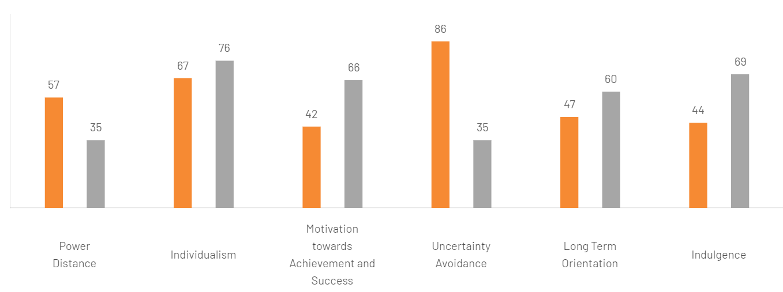
Figure 2: Cultural comparison of the UK and Spain
(Source: Hofstede Insights, 2023)
Spanish is the official language and people of this country prefer proficiency in Spanish for effective communication and operations. English is commonly spoken in business circles which can help Sainsbury’s to connect with large organisations. However, this company needs to learn and include the Spanish language to connect to the local market and Spanish-speaking employees.
Spain is highly focused on avoiding uncertainties as the score is 86 whereas the score of the UK is 35. In this regard, it can be stated that this company needs to focus on identifying uncertainties and developing strategies to avoid uncertainty to match the concept of business in Spain.
Spain's economy has experienced volatility in the past that poses potential economic risks. The average GDP growth of Spain is 1.99% from 1996 until 2023 (tradingeconomics.com., 2024). On the other hand, bureaucratic red tape and regional variations in regulations can complicate business operations. The labour market in Spain is rising constantly. The average workforce growth in 2023 was 63,242 and it has increased by 0.7% in quarter 1 of 2024 (Caixa Bank Research, 2024). This rising workforce seems to be meaningful for Sainsbury’s to recruit required employees in Spain.

Outline barriers to communication that British business may experience in EU countries
Communication barriers are significant difficulties for organisations who are intending to expand their business in new countries. Sainsbury’s also needs to identify potential communication barriers and develop relevant strategies to eliminate these barriers. This section will pacify and evaluate potential communication barriers of British businesses such as Sainsbury’s may have to face while expanding in Spain and Germany.
Communication barriers in Germany
Language difference is one of the most significant reasons for Sainsbury’s to expand in Germany as the majority of people in Germany speak the German language. However, people often communicate in English in business settings. 56% of the total population in Germany speaks English (Gillan, 2020). Therefore, this company needs to develop proficiency in Germany to maintain effective communication with local employees, suppliers, and customers. Language differences can lead to misunderstanding in a business landscape. Misunderstandings can result in potential operational inefficiencies and customer dissatisfaction. In this regard, it can be stated that Sainsbury's needs to invest in language training for its staff and incorporate the German language in its promotional strategy.
Germany's communication style is typically direct and to the point whereas the communication style of the UK is indirect. This cultural communication style also can be challenging for Sainsbury’s to maintain international communication. Both Germany and the UK value clarity and precision. According to the suggestion of Saputra (2021), it can be evaluated that precise and clear communication allows organisations to convey their messages. Sainsbury's must adapt to the directness of communication by fostering open and clear lines of communication. German business culture places a high emphasis on formality and respect for hierarchy.
On the other hand, it can be stated that the British business culture incorporates mode informal settings of business. British managers and employees at Sainsbury's will need to adapt to these formalities to build strong professional relationships and avoid any perception of disrespect or unprofessionalism. The foundation of the communication style of German includes speaking honestly, clearly and explicitly. Any miscommunication or misunderstanding of regulations can lead to compliance issues, fines, or delays in operations. This company needs to employ well-experienced German professionals who can handle regulatory factors proficiently.
Communication barriers in Spain
English is rarely spoken in Spain but proficiency in Spanish is crucial for this company to maintain effective communication with local people. The reliance on English alone may lead to misunderstandings or a sense of exclusion among local employees and customers. 22% of people in Spain speak English (Quora, 2019). This numerical figure indicates the urgency of this company to train Spanish language skills within its team and ensures all communications are accessible in both Spanish and English.
Spanish communication is often high context, relying heavily on non-verbal cues, relationships, and shared understanding. This procedure significantly differs from the concept of British Business communication. It is worth mentioning that communication is highly focused on low-context and explicit communication styles. Therefore, British managers may need to develop a deeper understanding of Spanish cultural nuances such as body language, tone, and context. The benefit of paying close attention to the cultural nuances is that it helps in effectively interpreting messages and building trust.
Spanish business culture places a strong emphasis on personal relationships and informality. Hence, Sainsbury’s needs to emphasize face-to-face interactions and social engagements to build trust and rapport. According to the observation of Battiston et al. (2020), it can be explained that individuals need to focus on their body language in face-to-face communication settings. This company needs to focus on the relationship between activities such as attending social events and engaging in informal conversation. These activities will help Sainsbury's to establish strong connections with Spanish partners and employees.
On the other hand, the company needs to examine distinct cultural identities and dialects of diverse regions in Spain. Different regions such as Catalonia, Andalusia, and the Basque Country may have very different communication practices. These regional differences can be another challenging factor for Sainsbury's as it will need to define different communication strategies in different regions.

Recommendations for expanding the British company in Germany
This section will provide recommendations for Sainsbury's to explain its business in Germany and eliminate communication barriers. It is believed that this company can expand its business in Germany after evaluating the cultural, economic, and operational contexts of both Germany and Spain. The robust economic growth and strong workforce seem to the suitable for Sainsbury's to expand in this country. The well-established infrastructure and strong regulatory framework provide a stable environment for business growth.
Comprehensive Language and Cultural Training
Sainsbury's should invest in comprehensive language and cultural training for its employees to mitigate language barriers and cultural misunderstandings. In order to be very specific, it can be stated that this company needs to develop a workforce that can interact in both German and English language. This workforce will be capable of communicating in a business setting along with communicating with local people. Based on the suggestion of Bargiela-Chiappini (2020), it can be explained that the use of local language will help organisations to attract and retain local communities in new countries. This training should cover German language skills and the nuances of German business etiquette such as the importance of formality, direct communication, and hierarchical respect.
Hiring Local Expertise
Another significant strategy for Sainsbury's to expand and fasten business in Germany is to higher local expertise. It is worth mentioning that connecting and hiring local expertise helps this company to understand current trends of the business easily. Local employees can serve as cultural intermediaries and facilitate smoother communication.
This strategy not only enhances operational efficiency but also demonstrates Sainsbury's commitment to integrating into the local community. On the other hand, local regulatory professionals also can assist this company in maintaining regulations while trading in this country as they have a clear idea and understanding of local regulations. Local employees also can provide where you will insights into consumer behaviour and preferences to customize products and services in the German market.

Conclusion
This essay concludes that British business communication highly values formality, punctuality, and clarity. Therefore, Sainsbury's can expand its business in Germany as this country's communication style somewhat matches the British business's communication style. The primary concept of communication in Germany involves a direct and precise style. Another significant reason behind expediting the business in Germany is its structured and disciplined environment compared to Spain's business environment. On the other hand, the economy of Germany is the most stable and growing economy when compared with other countries based on the EU. This company will also get the support of Advanced Infrastructures to streamline its operations in Germany.
However, organisations may have to face communication barriers while expanding in new countries. For example, Sainsbury's will encounter challenges like language differences, cultural communication styles, regulatory and legal communication, and formal communication while expanding its business in German. On the other hand, the company will face difficulties associated with language proficiency, high context communication, informality and relationship building, and regional variations while planning to expand its business in Germany. To eliminate these barriers, Sainsbury's can implement strategies like providing cultural training and awareness and hiring local talent.

References
Bargiela-Chiappini, F. (2020). Languages of Business: An International Perspective. [online] Google Books. Edinburgh University Press. Available at: https://books.google.com/books?hl=en&lr=&id=YHQxEAAAQBAJ&oi=fnd&pg=PR5&dq=benefit+of+using+local+languages+for+organizations+in+new+countries&ots=-60MrePsVG&sig=uSFZhkCVeZwiVFsNGEM4RZuQF1U [Accessed 23 Jul. 2024].
Battiston, D., Blanes i Vidal, J. and Kirchmaier, T. (2020). Face-to-Face Communication in Organizations. The Review of Economic Studies, 88(2), pp.574–609. doi:https://doi.org/10.1093/restud/rdaa060.
CaixaBank Research. (2024). The Spanish economy remains resilient in a challenging environment. [online] Available at: https://www.caixabankresearch.com/en/economics-markets/recent-developments/spanish-economy-remains-resilient-challenging-environment.
Chang, E. (2024). Top 15 Business Communication Solutions for UK Businesses. [online] Yo Telecom. Available at: https://yotelecom.co.uk/business-communication-solutions-uk/ [Accessed 23 Jul. 2024].
CIA.gov. (2024). Country Summary. [online] Available at: https://www.cia.gov/the-world-factbook/countries/germany/summaries/.
Dziubaniuk, O., Barner-Rasmussen, W., Koporcic, N., Ivanova-Gongne, M., Mandják, T. and Markovic, S. (2020). Business-to-business marketing research: Assessing readability and discussing relevance to practitioners. Industrial Marketing Management. doi:https://doi.org/10.1016/j.indmarman.2020.01.012
Gillan, C. (2020). What are the most spoken languages in Germany? [online] Lingoda. Available at: https://www.lingoda.com/blog/en/most-spoken-languages-in-germany/ [Accessed 23 Jul. 2024].
Hennart, J.-F., Majocchi, A. and Hagen, B. (2021). What’s so special about born globals, their entrepreneurs or their business model? Journal of International Business Studies, [online] 52(2). doi:https://doi.org/10.1057/s41267-021-00427-0.
Hofstede Insights (2023). Country Comparison Tool. [online] www.hofstede-insights.com. Available at: https://www.hofstede-insights.com/country-comparison-tool?countries=spain%2Cunited+kingdom.
Hofstede Insights (2024). Country Comparison Tool. [online] www.hofstede-insights.com. Available at: https://www.hofstede-insights.com/country-comparison-tool?countries=germany%2Cunited+kingdom.
Quora. (2019). How many people speak English in Spain? [online] Available at: https://www.quora.com/How-many-people-speak-English-in-Spain [Accessed 23 Jul. 2024].
Sainsbury's (2024). About Us. [online] www.about.sainsburys.co.uk. Available at: https://www.about.sainsburys.co.uk/about-us.
Saputra, F. (2021). Leadership, Communication, and Work Motivation in Determining the Success of Professional Organizations. Journal of Law, Politic and Humanities, [online] 1(2), pp.59–70. Available at: https://dinastires.org/JLPH/article/view/54.
tradingeconomics.com. (2024). Spain Full Year GDP Growth - 2021 Data - 2022 Forecast - 1996-2020 Historical. [online] Available at: https://tradingeconomics.com/spain/full-year-gdp-growth [Accessed 27 Feb. 2022].

