Ecocide in Vietnam

Environmental Disaster

HND/BSc in Civil Engineering and Environmental Management

Jacob Passmore

Contents
Abstract 3
Introduction 3
Ecocide in Vietnam 3
Why it happened? 4
Testing 5
Operation Ranch Hand 5
Effects of Operation Ranch Hand 5
What happened to the rest of the Herbicide? 7
Conclusion 8
References 9

Abstract

The United States air force used a herbicide which was nicknamed Agent Orange in 1961 to 1971 in the South of Vietnam, Laos and Cambodia so that they could disrupt their enemies bases, increase aerial vision and to destroy food supplies and push civilians into U.S / GVN controlled areas. This had effects on both biological and environmental and most importantly had long term effects which even devastated wood industries.

Introduction

This essay will include the disaster of the ecocide in Vietnam and explain how the causes that lead to the disaster, and analyse critically on the involvement of human errors or the lack of care that caused this disaster. This will also include any ongoing impacts of the disaster on the natural environment, what are the lessons learnt and what are the measures taken by the authorities to prevent further occurrences of this disaster.

Ecocide in Vietnam

Between the years 1961 and 1971, the United States of America and the republic of Vietnam armies sprayed 20 million gallons of military herbicides to destroy forests and mangroves in the south of Vietnam to prevent the enemy troops from using the forest as cover and so that the bombing targets were more visible and deprive the enemy of food as it would kill the crops. The chemical used was nicknamed the Agent Orange as the 55 gallon drums used to contain them were orange, the chemical was developed mainly by Monsanto and Dow Chemical, the mixture was of two commonly used herbicides butoxyethanol esters of 2,4 dichlorophenoxyacetic acid 2,4-D and 2,4,5 trichlorophenoxyacetic acid 2,4,5-T
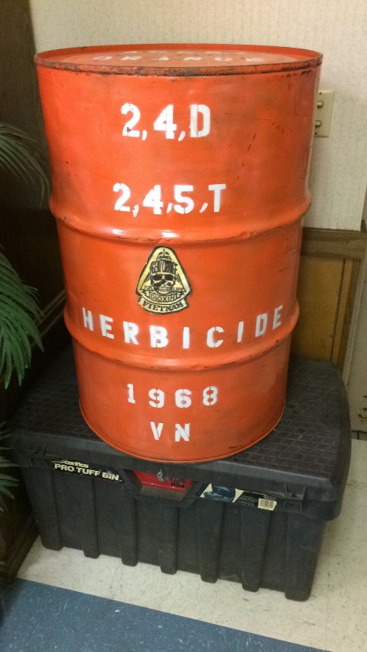

Fig 1

The deadly toxin in Agent Orange was called dioxin, dioxin enters the human tissue through direct contact with the skin, through the lungs when inhaling and through the food and water supply. This was responsible for a large amount of health related damages, this chemical was sprayed over 4.5 million acres of land in the south of Vietnam.

Why it happened?

The use of Agent Orange in Vietnam is connected to President John F Kennedy, as he attempted to get a policy which contained counterinsurgency against wars of national liberation, originating from Mao Zedong and Che Guevara’s treatises on guerrilla warfare that highlighted the necessity of winning the support of the rural population, the counterinsurgency strategy tried to separate guerrillas from the general populations by using strategic hamlets, loss of NLF controlled territories and the destruction of the crops they ate.

Testing

On August 10, 1961 the first test occurred when the United State of America sprayed the chemicals from aircrafts and contaminating soils, water and the air of areas of Laos and Cambodia near the Vietnam border. Results showed that returning U.S servicemen and Vietnamese population had serious health issues.

Operation Ranch Hand

Operation ranch hand began in 1961 as an experimental program, defoliation and crop destruction targeted to prevent movement of the military supplies and the manpower from the north to south Vietnam, when the war increased the U.S army used more volume and scope of herbicide operations, this was done to physically change the landscape to help American soldiers on the ground as it would be much safer and to make search and destroy missions easier.

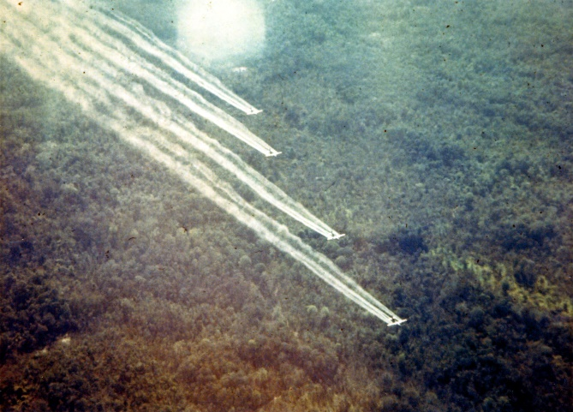

Fig 2

Effects of Operation Ranch Hand

When the chemical was sprayed it drifted into settlements, villagers immediately started to experience nosebleeds, nausea and dizziness, the people who was sprayed directly on by the herbicides or in close proximity to the crops that were sprayed, started to develop skin rashes, this symptom is the most common symptom of the dioxin exposure, it didn’t help when villagers kept checking on their crops after the herbicide was released so this increased their chances of getting exposed when they entered a contaminated area.
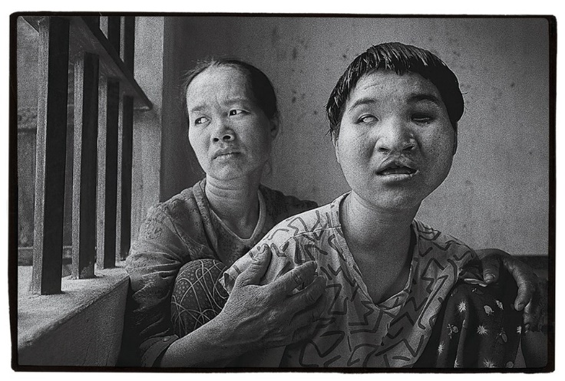
The main type of exposure to dioxin and continues to be through the food and water supply, the herbicide was primarily only meant to target rice but many different crops were also damaged such as sugarcane, maize, manioc, papaya and rubber trees. Crops weren’t the only thing that was affected by this herbicide as domestic animals were also affected. Villagers reported that pigs and chickens died shortly after the spraying and dogs and cattle died weeks after the disaster. Most importantly to the villagers was that fish was a main part of the Vietnamese diet, fish were swollen and had blackened gills rose to the top of the rivers and died, villagers still ate the dead fish but was warned by American troops not to. NLF soldiers that were captured were concerned about the safety of the herbicides used than the effects the herbicide operations on the military efforts, The NLF insisted that the miscarriages and the deceased livestock and crops were a lot more important to the maintenance of the NLF morale. They also informed the local health clinics to promote the use of protective covering of the skin and the crops they used for eating. The villagers done this by covering their crops with tents and nylon sheets and threw any unprotected and contaminated food supplies.

Fig 3

A main part of the pacification strategy used by the Americans depended on the development programs, that military officials hoped that giving assistance and fertilizers could increase production and show the benefits of the south Vietnamese government, but timber was important export of south Vietnam and the timber industry had a massive decrease in revenue as the defoliation kept on destroying more and more forests. In 1967 the pentagon commissioned a study and it reported that the defoliation had destroyed over a half a billion dollars in timber exports and in that same year the CORDS chief of the agricultural branch had expected that it take up to 80 to 100 years for the areas of deforestation to return to full productivity.
Mainly in rubber plantations there was a lot of unemployment due to the herbicides, the South Vietnamese military of labour were advised by the MACV to develop contingency plans for mass amount of unemployment in the rubber industry due to the biological changes in the rubber trees. There was a lot of commotion over this as there was a massive hit on production overall but a spokesman for the U.S defence department, “Jerry Friedman defended herbicide operations by suggesting that defoliation actually helped the South Vietnamese economy” (Edmoundson, 2012). He talked about how the defoliation permitted easier access so that crews could go in and bring out the wood, after this the South Vietnamese ministry of interior had accepted full responsibility for the defoliation and crop destruction accusations, this was done to demonstrate the effectiveness of the South Vietnamese government and to win the support of the rural population. Compensation was handed over to South Vietnam from the U.S government to compensate for the war damages, but they stated that they are not to blame for the processing damage claims or that the Vietnamese farmers were properly compensated.
U.S government dismissed the claims on which the herbicide used were harmful to human health as the product of propaganda war, they U.S military blamed some damage to leaky spray equipment and accidental drift, but said that the damage done to agricultural crops was primarily due to misuse, careless handling and disposition of used containers. Used drums are almost impossible to clean and can seriously cause massive damage so the MACV recommended that the used rums should not be released to the public, but the disposition of the herbicide drums continued to be the responsible of the ARVN, because of the increase of media speculation concerning the health effects of herbicides, the South Vietnamese government stopped any newspapers from reporting on scientific research, also a main part of South Vietnamese hospitals didn’t keep any records in the last phase of the war and doctors didn’t have any information about the symptoms of the herbicide exposure so the Saigon Embassy requested assistance and equipment for their laboratories from the united states to evaluate the effects of the herbicide program.

What happened to the rest of the Herbicide?

The U.S air force had finally decided what to do with the remaining supplies of Agent Orange after exploring several alternatives and they came up with to incinerate it, they had to contact a private hazardous waste company so that they could transport the herbicide and then incinerate it, this was done at sea near Johnston Island in the South Pacific. This was commenced in the year of 1977 but the U.S air force took a different approach from the Vietnam War in the aspect of safety procedures, these involved, all incineration personnel had to wear protective clothing, masks that had breathing respirators, goggles and personnel had to be monitoring with devices during the handling and transport of Agent Orange. The first emergency ban occurred on March 1st 1979 as the EPA issued that all uses of 2,4,5-T will be suspended from use, this was carefully considered with costs but there was alarming evidence of miscarriages and birth defects.

Conclusion

To conclude Agent Orange was used for the purposes of war and that the lack of care may not have been seen as they were at war, and that the governments and militaries policies failed to see that using this herbicide will cause serious damage to the environmental and biological aspect in the long term. There is questions such as was is the right thing to do as the U.S armies were losing as their enemies were using the forest to their advantage but was there another way instead of causing all this destruction?

References

- Google.co.uk. (n.d.). agent orange barrels - Google Search. [online] Available at: https://www.google.co.uk/search?q=agent+orange+barrels&rlz=1C1GCEB_enGB827GB839&source=lnms&tbm=isch&sa=X&ved=0ahUKEwiO1o_2yY7iAhVztHEKHVPbA9oQ_AUIDigB&biw=958&bih=878#imgrc=3BjhJ6uOhx8QrM: [Accessed 14 Apr. 2019].

- Edmoundson, B. (2012). Anatomy of a Tragedy: Agent Orange during the Vietnam War. [online] History.columbia.edu. Available at: https://history.columbia.edu/wp-content/uploads/sites/20/2017/07/Brittany-Edmoundson-.pdf [Accessed 14 Apr. 2019].

- Hitchens, C. (n.d.). Christopher Hitchens on Agent Orange and Its Continued Destruction in Vietnam. [online] The Hive. Available at: https://www.vanityfair.com/news/2006/08/hitchens200608 [Accessed 14 Apr. 2019].

