03/04/2026
University of Wales Trinity Saint David
London campus
E-Portfolio Link: Click Here
Module Name: Learning in the Digital Era
Module Code: ACCA 4025

Student Name: Munwar Hussain
Student ID: 2532062
Group: 2

Lecturer’s Name: Koushik Modak

LDE Assignment 1
E-Portfolio
Table of Contents
Introduction 2
Main Body 2
Task 1: Essential Academic and Employment Skills for the future career Path 2
Task 1 (a): Report on Essential Academic and Employment Skills 2
Task 1 (b): Evaluation of Task 1 (a) based on Similarity report 2
Task 2: Collaborative Mind Map and Individual Poster 2
Mind Map (Collaborative) 2
Poster (Individual) 2
Task 3: Virtual Collaboration and RefWorks 2
Report on Virtual Collaboration 2
Step-by-step process of using RefWorks with visuals 2
Task 4: E-Portfolio Creation and Evaluation 2
Task 4 (a): E-Portfolio Creation 2
Task 4 (b): Illustrative Review of E-Portfolio tool Selection 2
Conclusion 2
References 2
Task 1 References: 2
Task 3 References: 2

Introduction

I have assessed the fundamental skills needed for the future workforce using a set of structured tasks, with a particular emphasis on the pressing need for reskilling by 2026. My work demonstrates my ability to work in virtual settings, overcoming the difficulties of remote teamwork by applying the "Life is a Team Sport" philosophy. I have also proven my technical competence by becoming proficient with digital tools like Wix for creating professional e-portfolios and RefWorks for information management. In the end, this body of work demonstrates my dedication to developing the digital literacy and flexibility required to succeed in a career driven by technology.

Main Body

Task 1: Essential Academic and Employment Skills for the future career Path

Task 1 (a): Report on Essential Academic and Employment Skills
In the future, I understand that I would still have to continue studying beyond college. It is said that half of all workers will be required to reskill by 2025 due to such rapid transformations in technology. According to the employers, the most valuable skills at the moment are critical thinking and problem-solving. They are also seeking self-management skills such as resilience and flexibility. That is, I need to be able to compose myself during stress as well as have an aptitude to undergo change. Although machines will probably replace some jobs, come up will be a number of new jobs that people can do with technology and algorithms. Majority of the business leaders have come to expect that we will acquire these new things as we work through the job. Fortunately, with the help of online platforms, one can acquire new skills, such as digital marketing or data science, within several months. In my case, this implies that I am only ready to be a lifelong learner so that I will remain prepared to work in the future [1], [2].
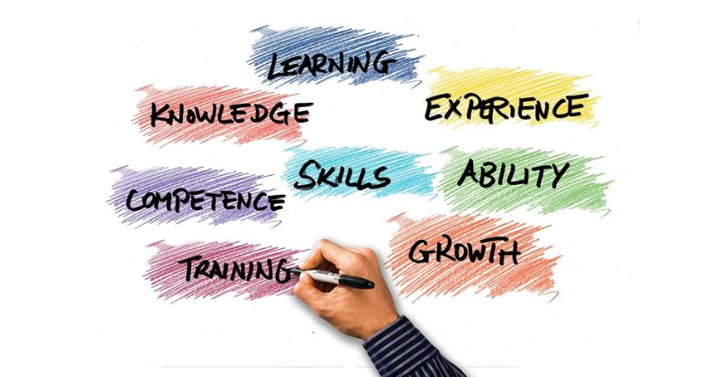Figur:1 picture [3]

I am sort of scared to think of my future career because tech is so changing everything so rapidly. I have just learned that of the entire world, some half of the workers will need to acquire new skills by the year 2026, in order to remain competitive. The majority of the businesses are largely seeking individuals with the ability to resolve issues and be critical thinkers. Digital literacy is also the desire, or more precisely the ability to use digital resources and be safe on the Internet. Nonetheless, the equally significant ones are soft skills such as communication and adaptability. Research indicates that a flexible personality and self-confidence make you get employment and enjoy your working environments. I need to possess a growth mind set and engage in life-long learning in order to be prepared tomorrow. By emphasising these human capabilities, I will be able to provide value that machines and AI cannot [4], [5].
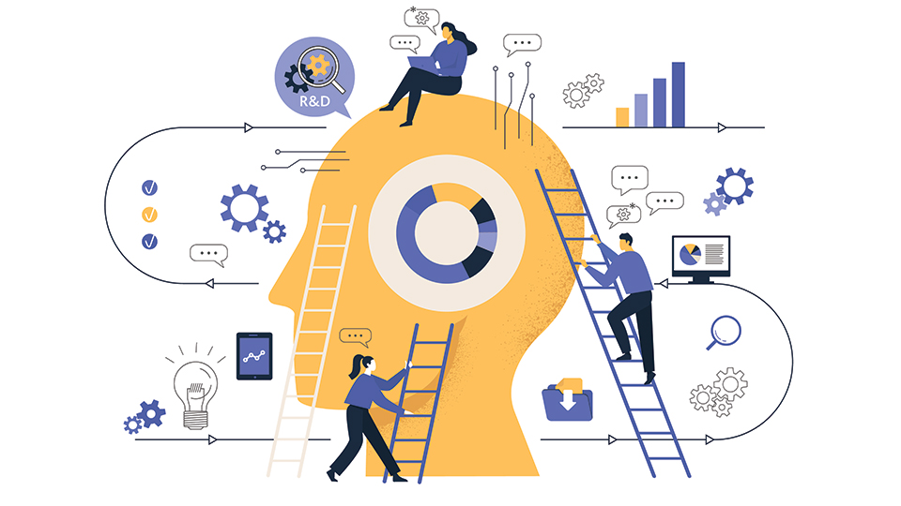Figure: 2 pictures [6]

Task 1 (b): Evaluation of Task 1 (a) based on Similarity report
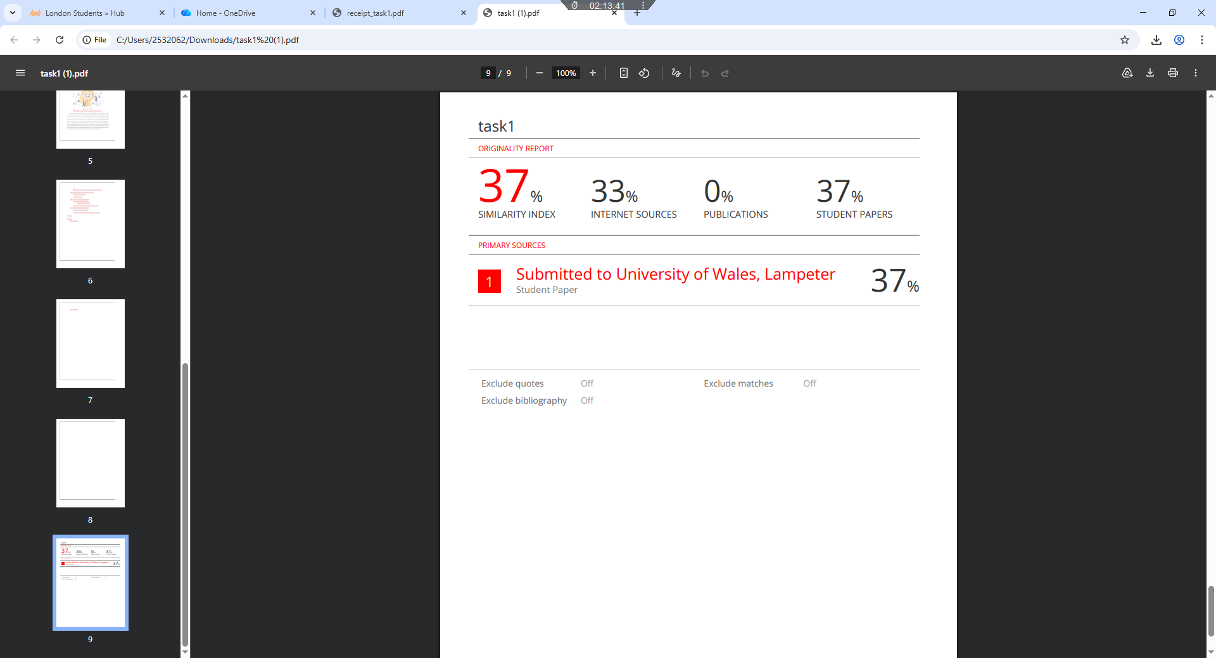Figure: 3 Report

My similarity report for Task 1(a) yielded a score of 37%, mostly due to the inclusion of precise technical information and properly referenced scholarly sources. The World Economic Forum's and McKinsey's statistics about the 2025–2026 reskilling requirements, as well as the necessity of using industry-standard terminology, are largely responsible for this percentage. I have used RefWorks and the IEEE UWTSD referencing style to properly credit all outside concepts and information to their original authors in order to maintain academic integrity. To reduce the matching percentage while upholding academic rigor, I will enhance my work going forward by further paraphrasing technical definitions and incorporating more introspection. Despite the higher similarity score brought on by the required technical citations, I would give my overall performance on this task an 80% since it successfully satisfies the learning objectives.

Task 2: Collaborative Mind Map and Individual Poster

Mind Map (Collaborative)
Mind Map link: https://mm.tt/map/3952803597?t=pruh6bcFFH
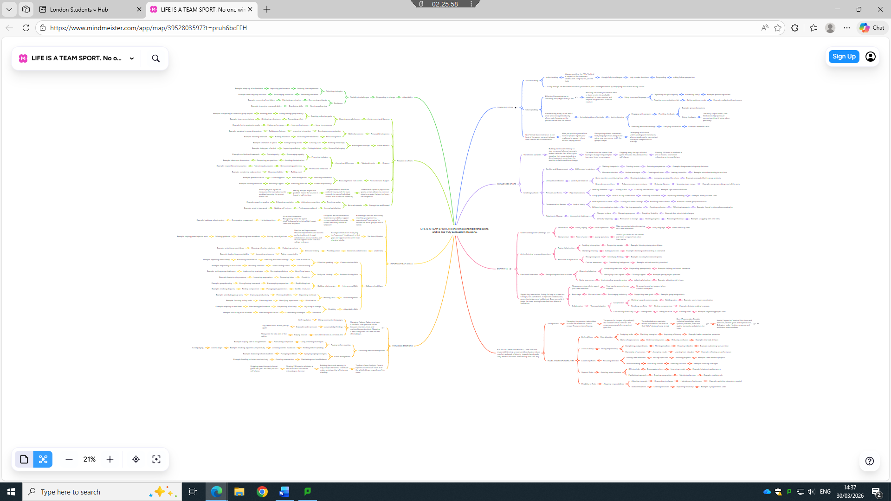

Poster (Individual)
Poster link: click here
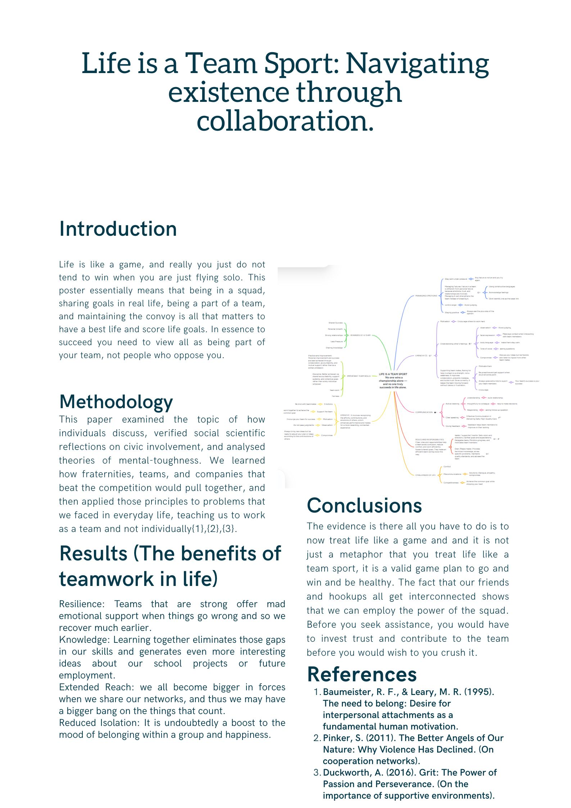

Task 3: Virtual Collaboration and RefWorks

Report on Virtual Collaboration
Riding the storm
When your remote crew enters the storming period, the conflict is rather inconspicuous but much more serious than is when you are at a real place. At a physical workplace, you can experience the strain in the air or iron out the wrinkle with a coffee break. On the Internet, that tension manifests itself in the form of passive-aggressive e-mail messages, ghosting on a chat, or missing out of call abruptly. Everyone is inclined to avoid the drama because it is so detached. Instead of trying to arrange a legitimate Zoom call and address an annoying remark, it is far simpler to simply forget about it and move on. The abandonment of the talk is what makes the storm bad, however. Not saying something does not always mean that it vanishes, it only grows. The smallest misunderstanding concerning deadlines or roles is transformed into an enormous grudge killing trust. Trust is lost at this point, the crew will lack psychological safety and transform into a nice, yet completely dysfunctional atmosphere in which no one gives actual feedback [1],[2],[3].
In order to make it through the storm, a distant leader must impose healthy friction. It is leaving the safety of sitting and being silent about texts and making those uncomfortable, face-to-face, video calls that allow everyone to re-examine their expectations and emerge better[4],[5].

Step-by-step process of using RefWorks with visuals
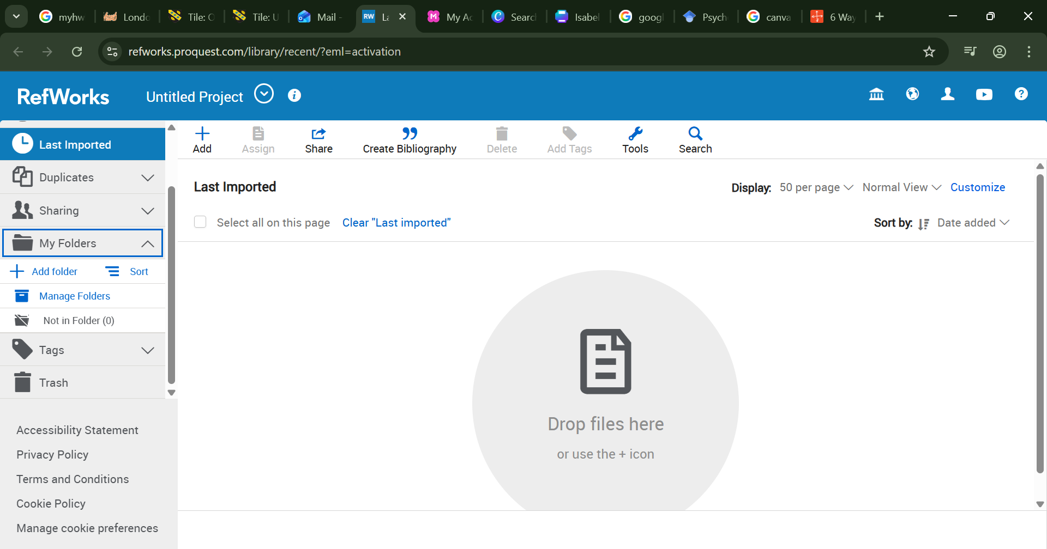Automatic reference tool (Refworks) home page.

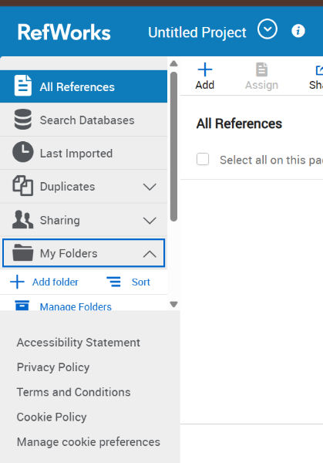
To create a folder, click on my folder and then add folder.
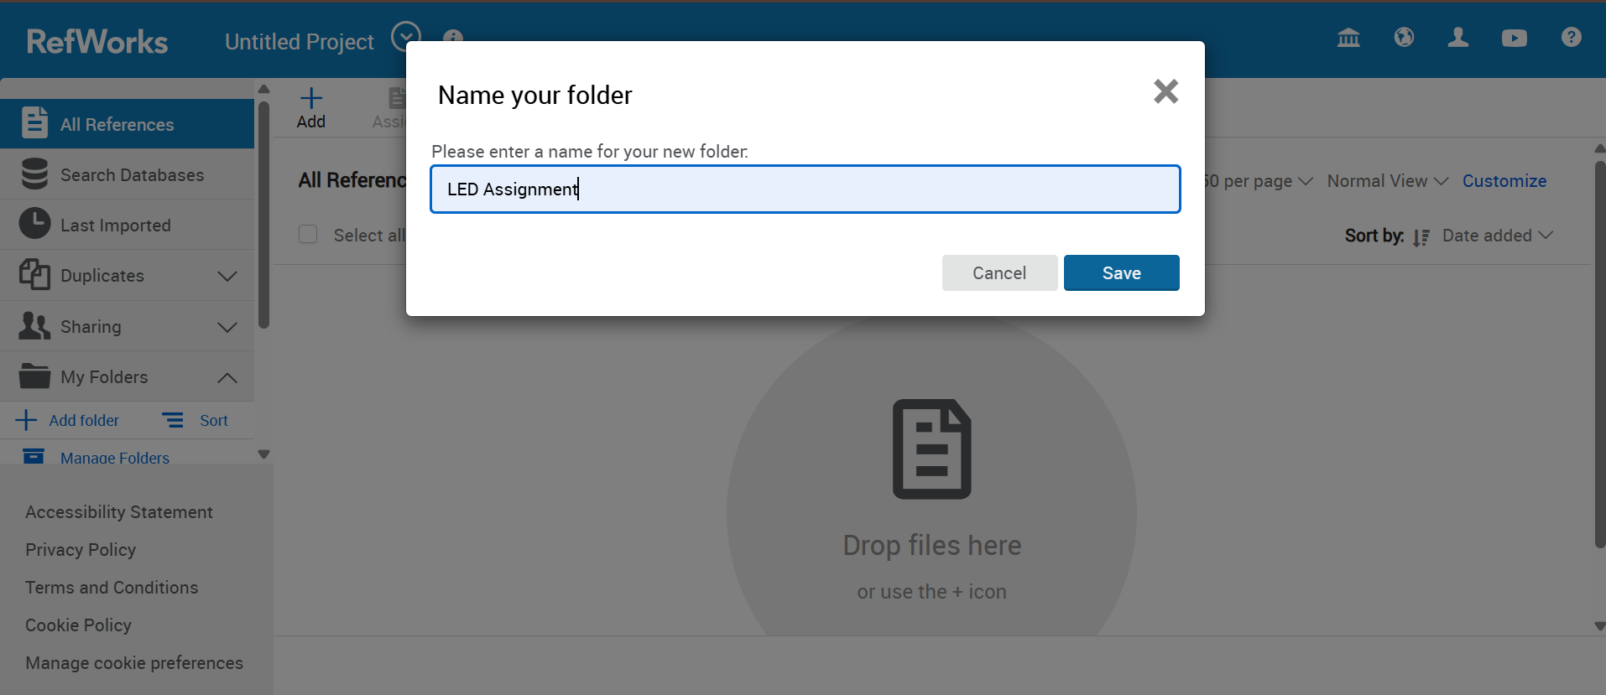Write a name of the folder and save it.

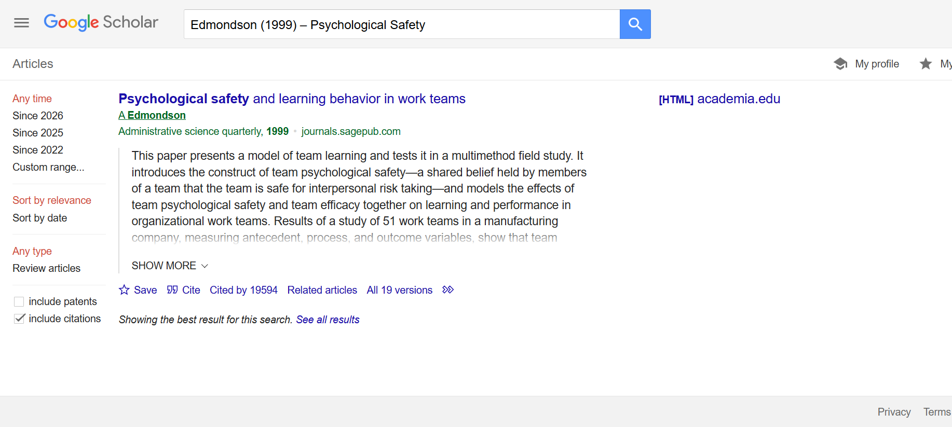Search on google scholar on the bottom of the search result there is option call “cite” click on it.

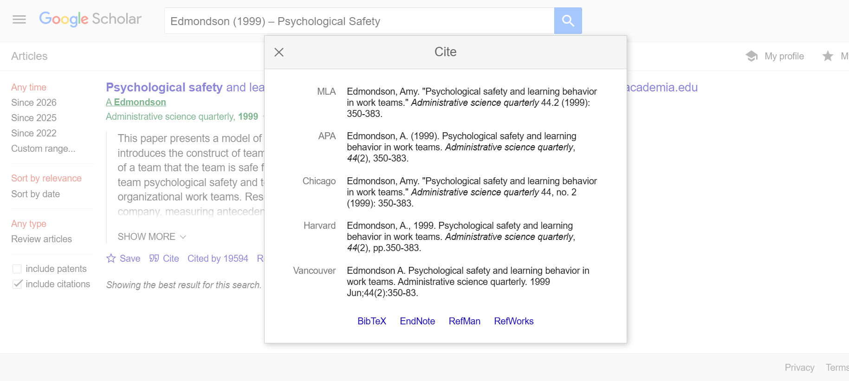After click on the cite information come up. Now click on Refworks.
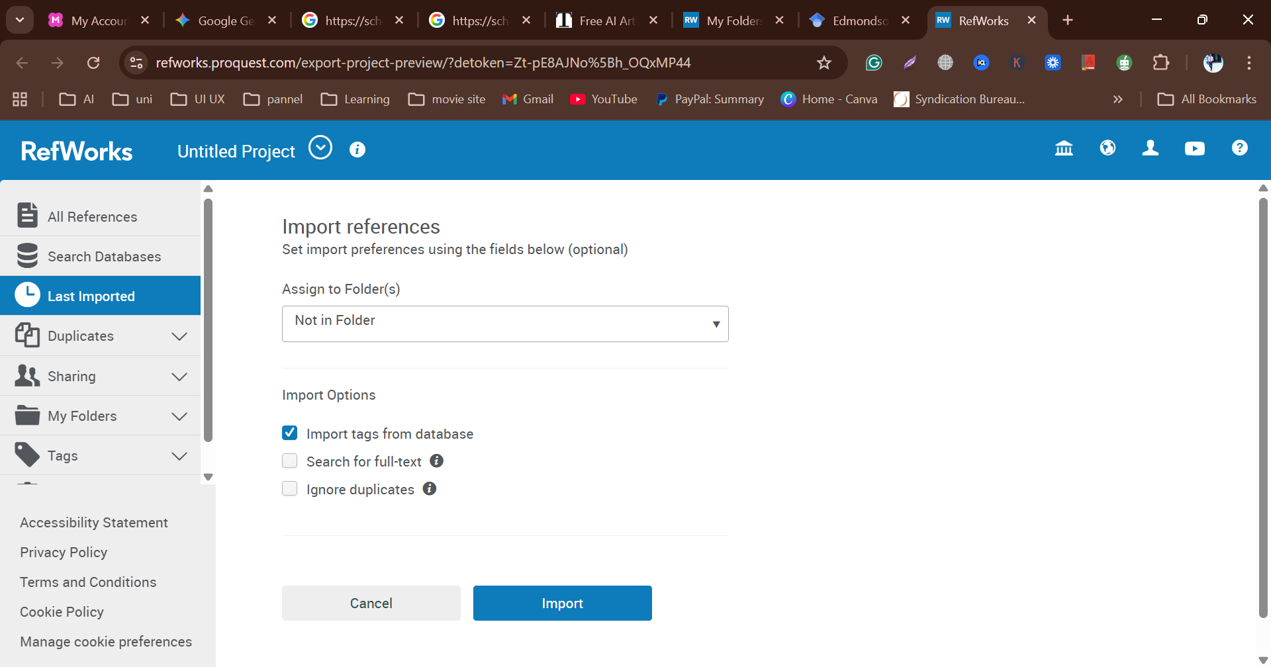To import references select the folder what I created earlier.

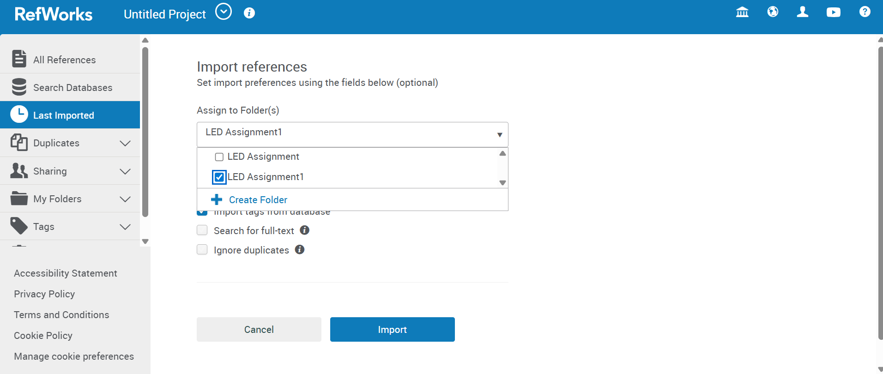Select the folder by click tick and click import.

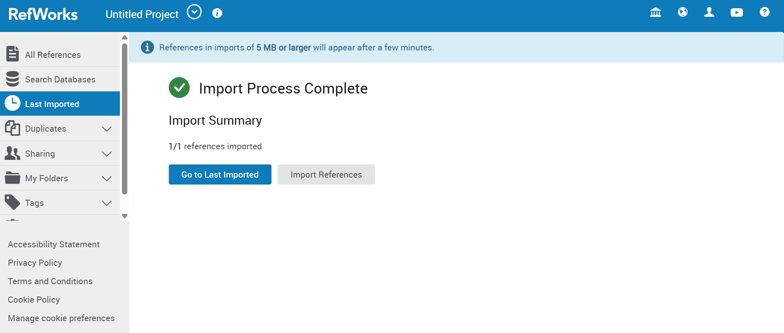When import complete click go to last imported.

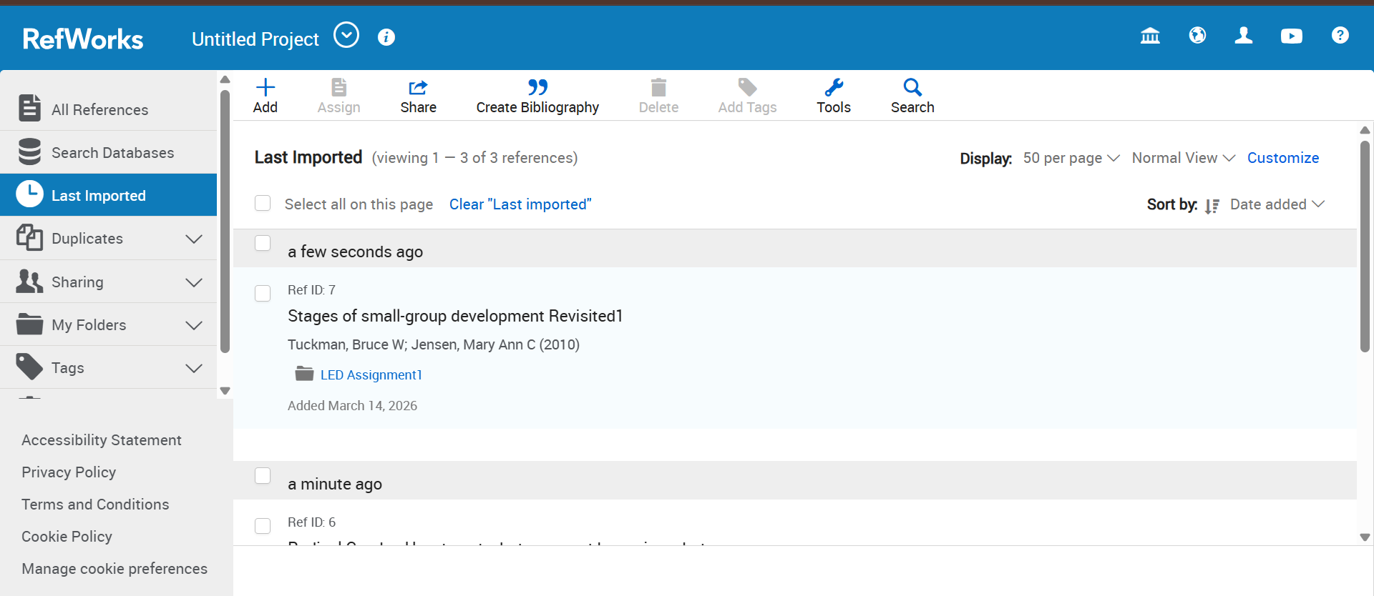here are the all imported sources.

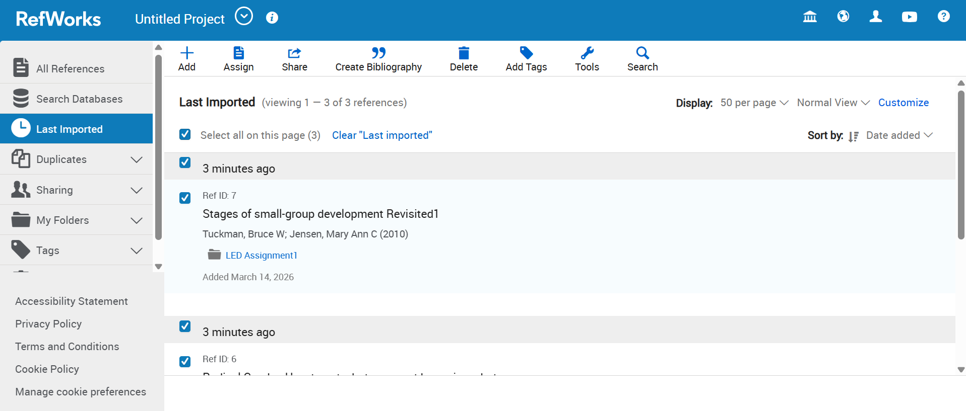To create bibliography select all the sources and click on create bibliography.

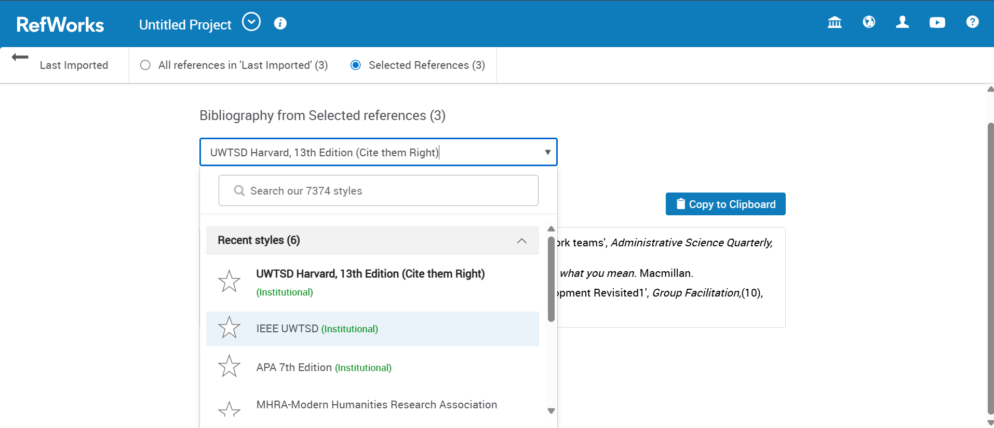I need to create bibliography and select IEEE UWTSD.

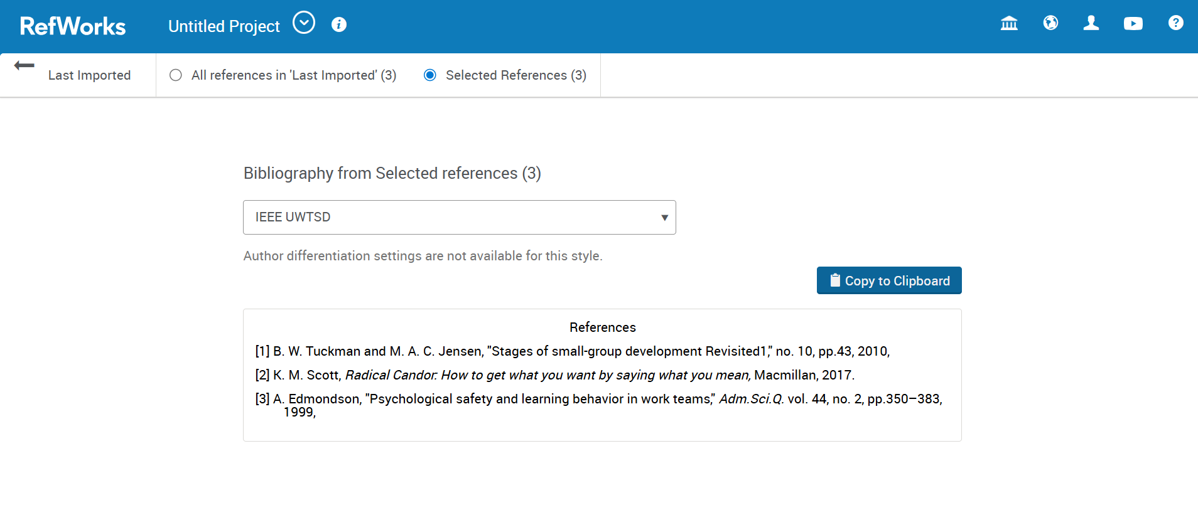Than copy on clipboard.
Now I have to connect Refworks and MS Word. To do this create add-ins.
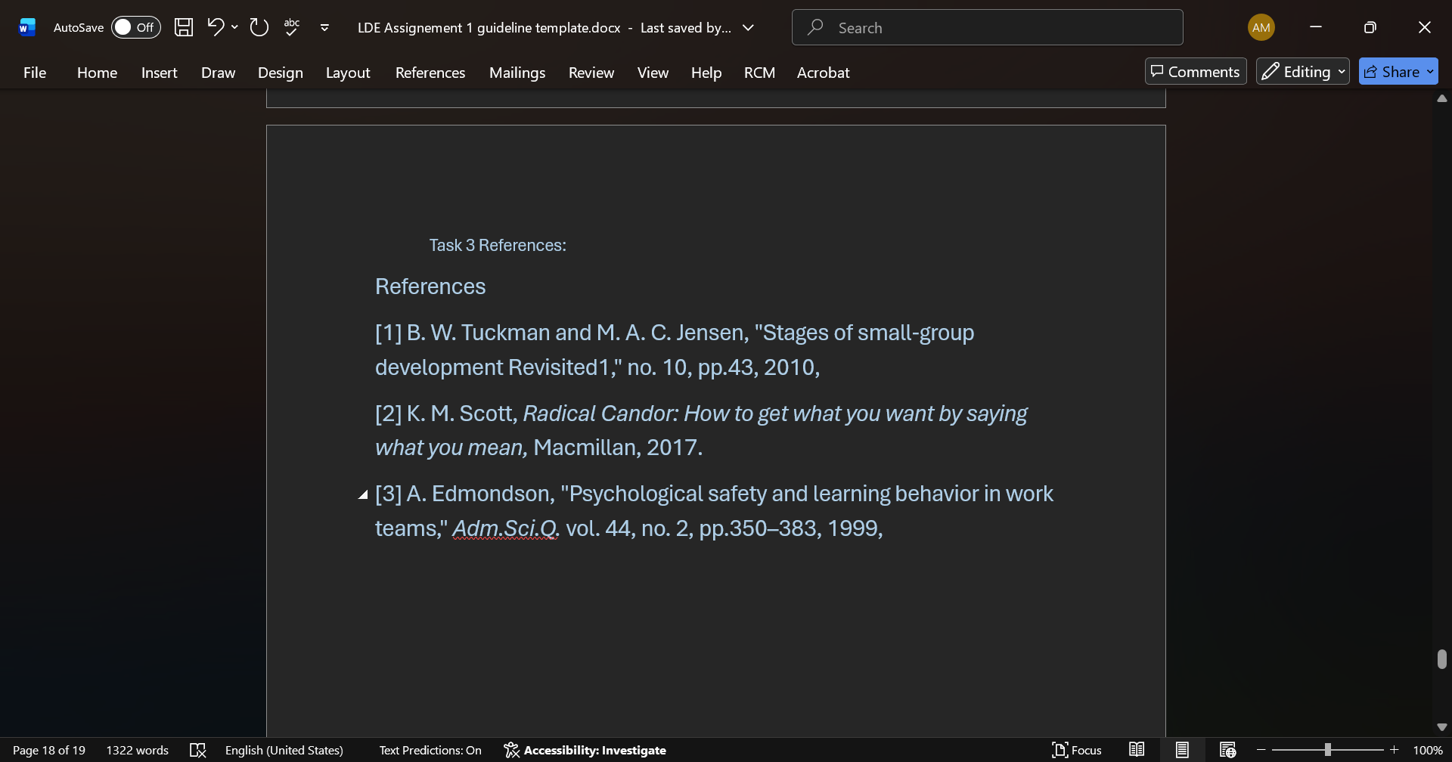Paste on the task 3 reference.

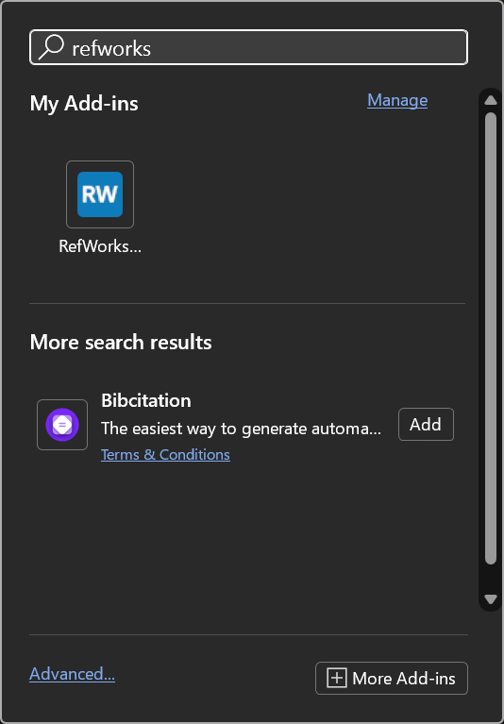 Search on task bar for RefWorks and click on it.
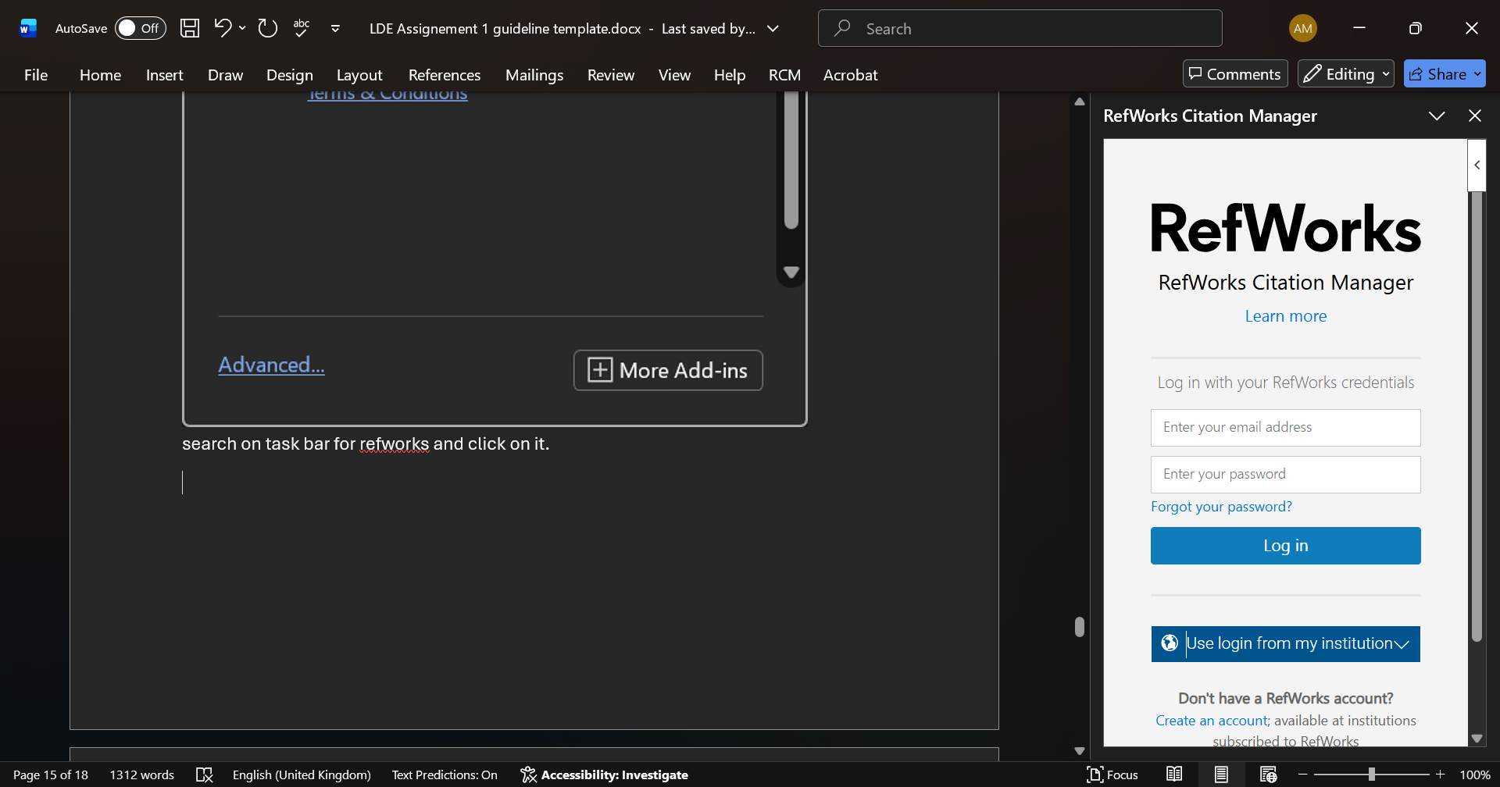Now I need to log in.
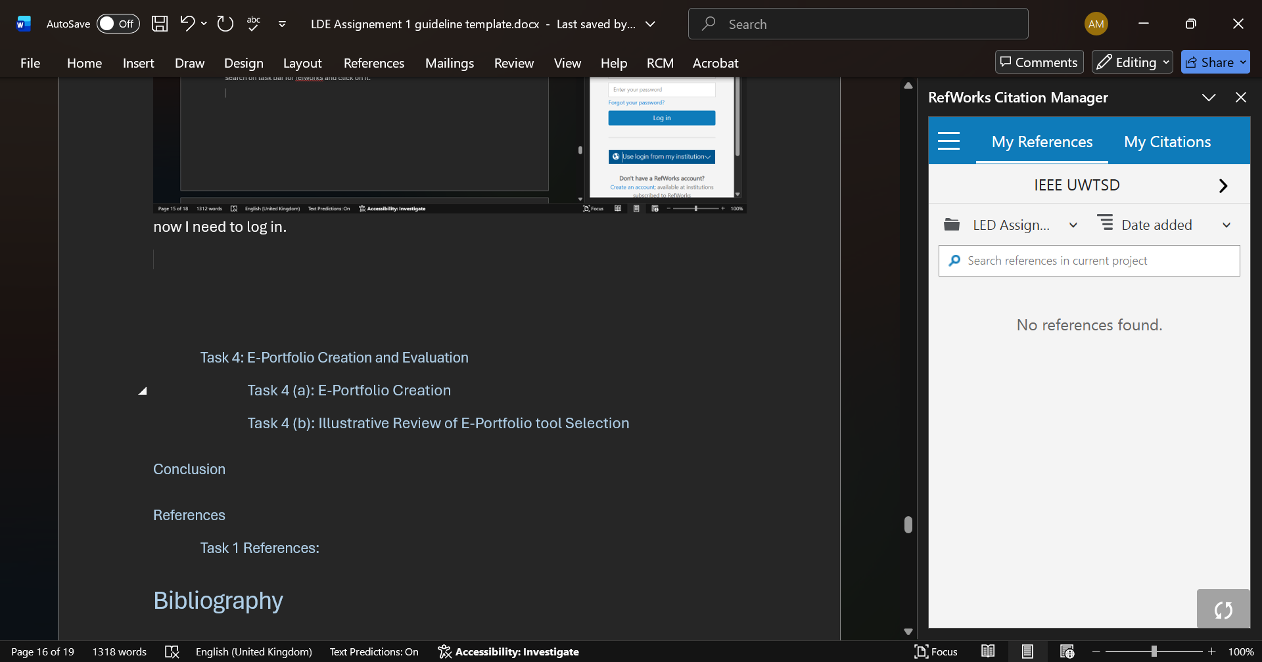Click on my citation.
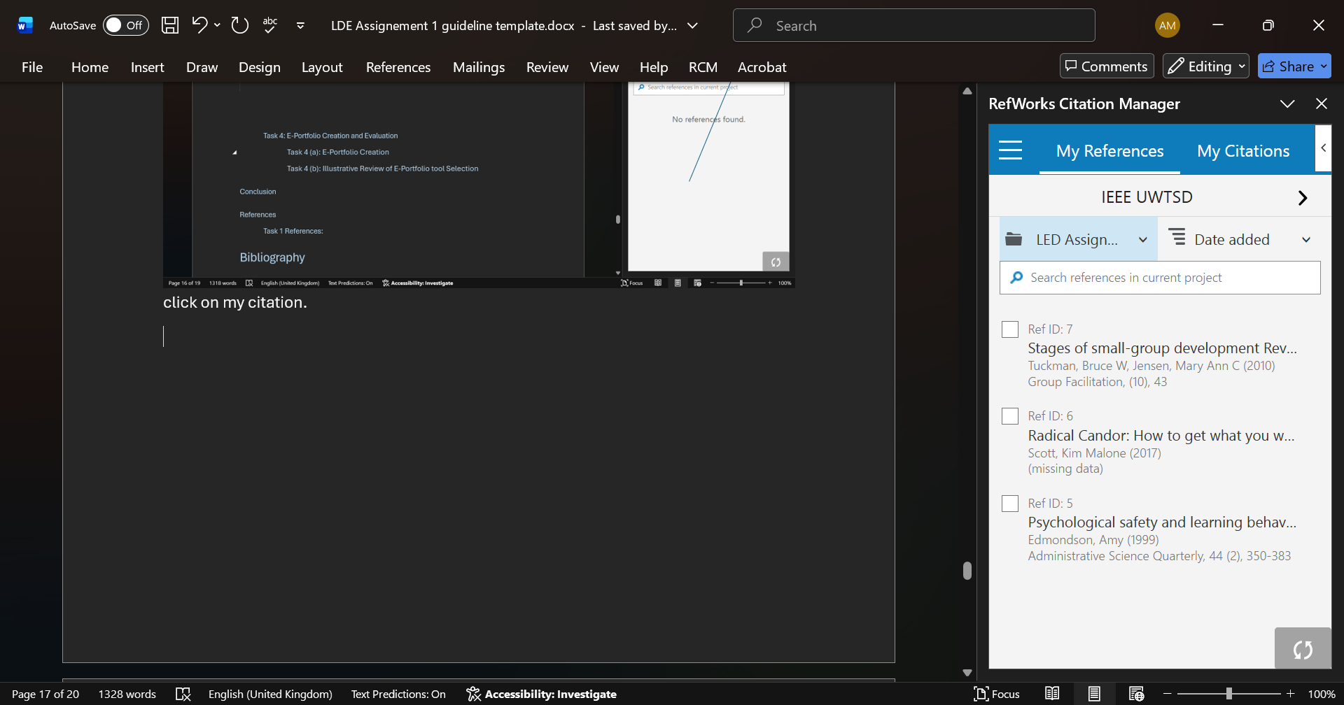Here are the all sources. Now select one by one to reference paragraphs.
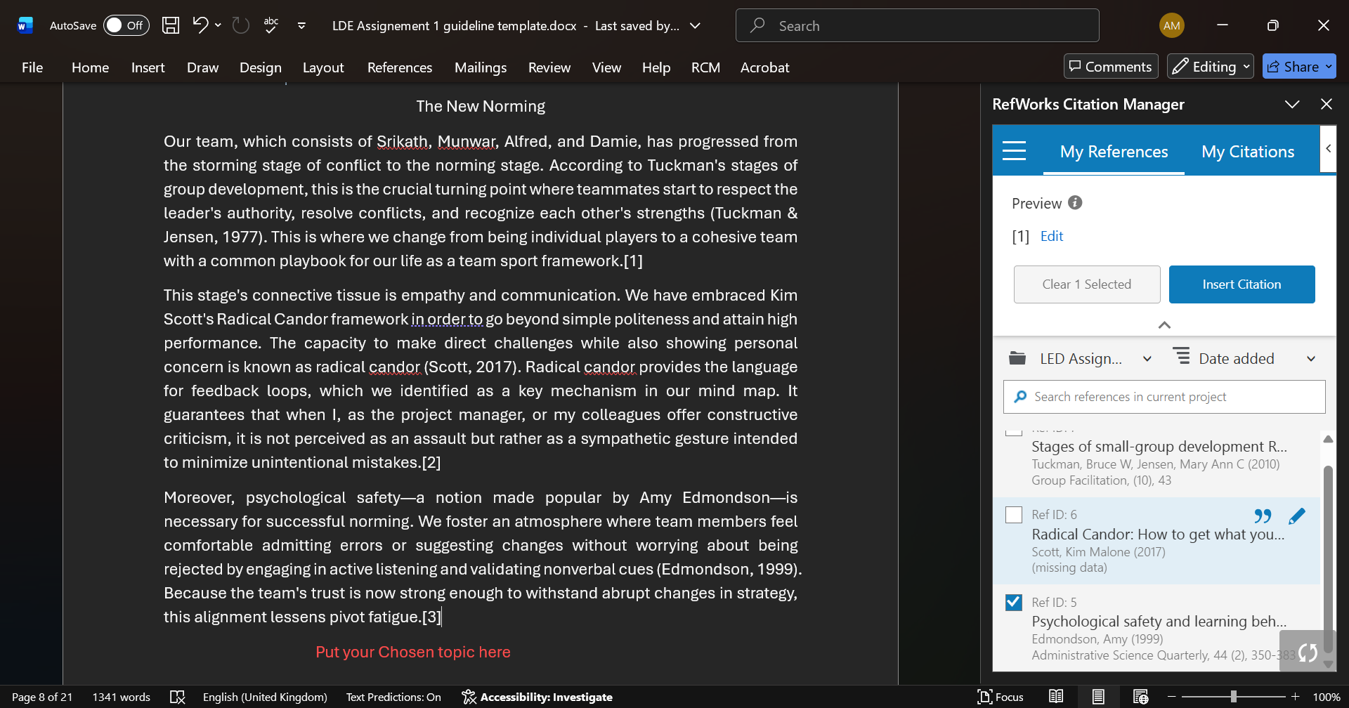After selecting the source click on insert citation, then number comes up end of paragraph.
2n Click on it
Select first

As a result we can see here numbers.

Task 4: E-Portfolio Creation and Evaluation

Task 4 (a): E-Portfolio Creation
Link: https://2532062.wixsite.com/my-site-5

Task 4 (b): Illustrative Review of E-Portfolio tool Selection

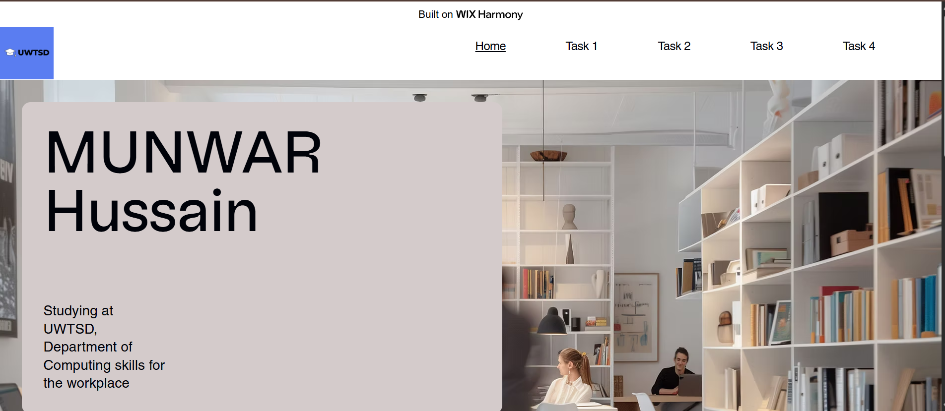
Wix is a very good option for beginners because it is a cloud-based drag and drop website building platform, it is very user friendly, and it is a good source to develop a website for small business and portfolios. On Wix there are more than 800 templates available. And it has very good security and extensive app market. But the main disadvantages are that you cannot change the templates after you have published it, and the platform is locked and only few advanced functions available after you have published the website.

Conclusion
Creating this portfolio has been a challenge in calculating the abilities I should possess in order to be the best in the digital era. I now know that to become a professional is to be flexible as I have been introduced to numerous tasks such as the need to cheque out virtual teamwork hiccups and learn to operate within the digital research tools.

References

Task 1 References:

Bibliography

[1] | K. Whiting, “world economic forum,” World Economic forum, 21 10 2020. [Online]. Available: https://www.weforum.org/stories/2020/10/top-10-work-skills-of-tomorrow-how-long-it-takes-to-learn-them/. [Accessed 15 03 2026].
[2] | AOFIRS, “Association of internet reseach specialists,” Association of internet reseach specialists, 15 11 2022. [Online]. Available: https://aofirs.org/articles/academic-skills-you-need-to-improve/?srsltid=AfmBOoqps96zjDBtL7S6opwXIPyZSUP6TTuV66Y_BQw225mpODQP9tEM. [Accessed 15 03 2026].
[3] | O. Education, “Skills Required for Academic Writing – Get a Complete Guide,” One Education, 09 04 2025. [Online]. Available: https://www.oneeducation.org.uk/skills-required-for-academic-writing/. [Accessed 15 03 2026].
[4] | S. Marketing, “Academy Blog: Prepare Your Career for the Future: Key Skills for Tomorrow's Workplace!,” Made Smarter Innovation, vol. 12, no. 09, p. 1, 2024.
[5] | Marco Dondi, Julia Klier, Frédéric Panier, and Jörg Schubert, “Defining the skills citizens will need in the future world of work,” Mckinsey and company, vol. 12, no. June 25, p. 19, 2021.
[6] | D. Sheikh, “What skills will employers be looking for in the future?,” people managment, 07 July 2021. [Online]. Available: https://www.peoplemanagement.co.uk/article/1741997/what-skills-employers-looking-for-future. [Accessed 17 03 2026].

Task 3 References:

References

[1] S. Morrison-Smith and J. Ruiz, "Challenges and barriers in virtual teams: a literature review," vol. 2, no. 6, pp.1096, 2020,

[2] E. E. Makarius and B. Z. Larson, "Changing the perspective of virtual work: Building virtual intelligence at the individual level," vol. 31, no. 2, pp.159–178, 2017,

[3] L. Handke, P. L. Costa, F. E. Klonek, T. A. O’Neill and S. K. Parker, "Team perceived virtuality: An emergent state perspective," vol. 30, no. 5, pp.624–638, 2021,

[4] E. Glikson and A. W. Woolley, "Human trust in artificial intelligence: Review of empirical research," vol. 14, no. 2, pp.627–660, 2020,

[5] T. U. Daim, et al., "Exploring the communication breakdown in global virtual teams," Int.J.Project Manage. vol. 30, no. 2, pp.199–212, 2012,

