

LOCATION: Swansea | LLEOLIAD: abertawe
LEVEL 5 | LEFEL 5
EXAMINATION PERIOD | CYFNOD ARHOLIADAU
JANUARY 2025 | 2026

MODULE CODE: ACDC5009
Electromagnetic Radiation

TIME: 2 HOURS
answer all questions

Equipment or materials required – Calculator
Adnoddau neu ddefnyddiau sydd eu hangen - Cyfrifiannell

ANSWER ALL QUESTIONS
Question 1 [25 marks]
- A light ray travelling in a medium with a refractive index of 1.75, strikes the surface of a block of glass at an angle of incidence of ${40}^{o}$. The block of glass has a refractive index of 1.5. Calculate the critical angle for total internal reflection at the interface [6 Marks]
Answer:
Angle of incidence $={45}^{o}$
Critical angle $θ_{c}=\sin^{-1}\left(\frac{n_{glass}}{n_{m}}\right)$ [2 Marks]
$θ_{c}=\sin^{-1}\left(\frac{1.5}{1.75}\right)$ [2 Marks]
$θ_{c}={59}^{o}$ [2 Marks]
- Describe Fleming’s Right hand rule. [4 Marks]
Answer:
Fleming’s right hand rule states that, If the thumb, the forefinger and the middle finger are held in such a way that they are mutually perpendicular to each other (makes 90° of angle), then the forefinger points the direction of the field, the thumb points the direction of motion of the conductor and the middle finger points the direction of the induced current (from EMF) [4 Marks]
- A Charge $Q_{1}= -20μC$ is located at P(-6,4,6) and a charge $Q_{2}= 50μC$ is located at R (5,8,-2) in a free space. Find the force exerted on $Q_{2}$ by $Q_{1}$. The distance given are in meters. [15 Marks]
Answer:
${\overline{F}}_{Q_{1}Q_{2}}=\frac{Q_{1}Q_{2}}{4πε_{0}d_{12}^{2}}{\overline{a}}_{12}$
$\overline{P}=-6{\overline{a}}_{x}+4{\overline{a}}_{y}+6{\overline{a}}_{z}$ [1 Mark]
$\overline{R}=5{\overline{a}}_{x}+8-2{\overline{a}}_{z}$ [1 Mark] ${\overline{d}}_{PR}=\overline{R}-\overline{P}=11{\overline{a}}_{x}+4{\overline{a}}_{y}-8{\overline{a}}_{z}$ [1 Mark]
$\left|{\overline{d}}_{PR}\right|=\sqrt{{11}^{2}+4^{2}+{(-8)}^{2}}=14.177$ [2 Marks]
${\overline{a}}_{12}=\frac{{\overline{d}}_{PR}}{\left|{\overline{d}}_{PR}\right|}=\frac{11{\overline{a}}_{x}+4{\overline{a}}_{y}-8{\overline{a}}_{z}}{14.177}=0.776{\overline{a}}_{x}+0.28{\overline{a}}_{y}-0.564{\overline{a}}_{z}$ [2 Marks]
${\overline{F}}_{Q_{1}Q_{2}}=\frac{-20×{10}^{-6}×50×{10}^{-6}}{4π×8.85×{10}^{-12}×{14.177}^{2}}[0.776{\overline{a}}_{x}+0.28{\overline{a}}_{y}-0.564{\overline{a}}_{z}]$ [2 Marks]
${\overline{F}}_{Q_{1}Q_{2}}=-0.0447[0.776{\overline{a}}_{x}+0.28{\overline{a}}_{y}-0.564{\overline{a}}_{z}]$ [2 Marks]
${\overline{F}}_{Q_{1}Q_{2}}=-0.0346{\overline{a}}_{x}-0.0126{\overline{a}}_{y}+00.2522{\overline{a}}_{z}]$ N [2 Marks]
$\left\lceil {\overline{F}}_{Q_{1}Q_{2}}\right\rceil =\sqrt{{(-0.0346)}^{2}+{(-0.0126)}^{2}+{(-0.02522)}^{2}}=44.634mN$ [2 Marks]
Question 2 [25 marks]
- Describe the following terms used in Electromagnetic Radiation with necessary diagram,
- Diffraction, [3 Marks]
- Total Internal Reflection, [3 Marks]
- Scattering [3 Marks]
- Refraction [3 Marks]
Answer:
- Diffraction,
Diffraction is defined as the interference or bending of waves around the corners of an obstacle or through an aperture into the region of geometrical shadow of the obstacle /aperture. The diffracting object or aperture effectively becomes a secondary source of the propagating wave. [2 Marks]
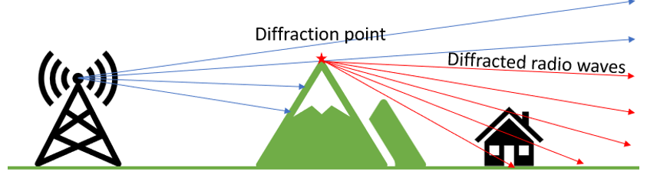 [1 Mark]

- Total Internal Reflection,
Total internal reflection is the phenomenon that involves the reflection of all the incident light off the boundary. [2 Marks]
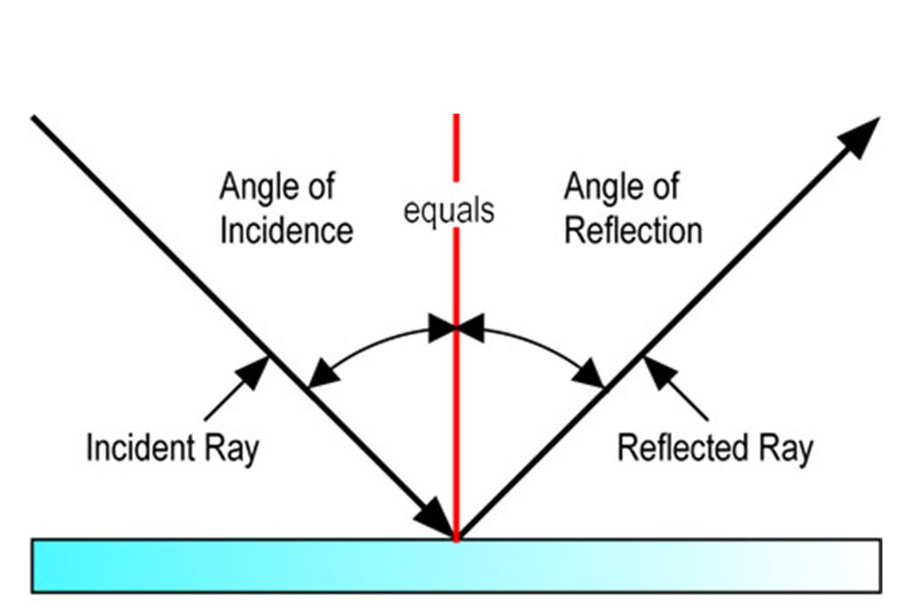 [1 Mark]
- Scattering
Scattering is the process by which a particle in the path of an electromagnetic wave continuously removes energy from the incident wave and re-radiates the energy into the total solid angle centred at the particle. [2 Marks]
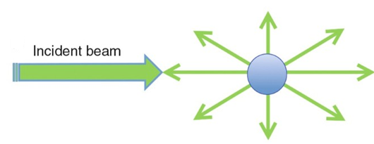 [1 Mark]
- Refraction
Refraction is the change in the direction of a wave passing from one medium to another. Refraction is the bending of light (it also happens with sound, water and other waves) as it passes from one transparent substance into another. [2 Marks] 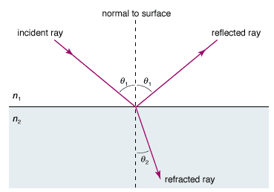 [1 Mark]
- Given the speed of light is $c=3×{10}^{8}m/s$. Calculate the refractive index of the medium if the speed of the light in that medium is $2.5×{10}^{8}m/s$ [5 Marks]
Answer:
$v=2.5×{10}^{8}m/s$
$n=\frac{c}{v}$ [1 Mark]
$n=\frac{{3×10}^{8}}{{2.5×10}^{8}}$ [2 Marks]
$n=1.2$ [2 Marks]
- How does an Electromagnetic wave propagate in free space. [4 Marks]
Answer:
Electromagnetic waves are Self-Propagating in nature. The magnetic and the electric fields come at 90° to each other, and the combined waves move perpendicular to both electric and magnetic oscillating fields occurring during the disturbance. [4 marks]
- Differentiate modulation and demodulation [4 Marks]
Answer:
Modulation:
Modulation is the process of varying one or more properties of a periodic waveform, called the carrier signal, with the message signal that contains information to be transmitted. [2 Marks]
Demodulation:
Demodulation is the process of extracting the original information-bearing signal from a modulated carrier wave. [2 Marks]
Question 3 [25 marks]
- A radar system transmits a signal with a frequency of 2.6GHz. The doppler shift signal has been calculated as 21KHz. Calculate the velocity of the target. [6 Marks]
Answer:
$v=\frac{λf_{Dop}}{2}$ [1 Mark]
$λ=\frac{c}{f}=\frac{3×{10}^{8}}{2.6×{10}^{9}}=0.115m$ [2 Marks]
$v=\frac{λf_{Dop}}{2}=\frac{0.115 ×21×{10}^{3}}{2 }$ [2 Mark]
$v=1211.5m/s$ [1 Mark]
- A continuous wave radar system operates with a speed of light of velocity $3×{10}^{8}m/s$. If the Radar measures a time delay of $4.5×{10}^{-6}seconds$. Calculate the distance to the target. [6 Marks]
Answer:
$∆t=\frac{2R}{c}$
R- distance to the target
$R=\frac{∆t. c}{2}$ [2 Marks]
= $\frac{4.5×{10}^{-6}×3×{10}^{8}}{2}$ [2 Marks]
$R=675m$ [2 Marks]
- An Optic Fiber has a Numerical aperture (NA) of 0.32, and the refractive index of the cladding is 1.40. Calculate the refractive index of the core and the acceptance angle, assuming the light enters the fiber from air. [8 Marks]
Answer:
NA=0.32
$n_{2}=1.40$
Refractive index of air (n)=1
$NA=\sqrt{n_{1}^{2}-n_{2}^{2}}$ [1 Mark]
$0.32=\sqrt{n_{1}^{2}-{1.40}^{2}}$ [1 Mark]
$n_{1}^{}=\sqrt{{1.40}^{2}+{0.32}^{2}}$ [2 Marks]
$n_{2}=1.44$ [1 Mark]
$θ_{a}={Sin}^{-1}\left(\frac{NA}{n}\right)$
$θ_{a}={Sin}^{-1}\left(\frac{0.32}{1}\right)$ [2 Marks]
$θ_{a}={18}^{0}.66$ [1 Mark]
- What is TEM modes Why can they not propagate through a rectangular metal waveguide? [5 Marks]
Answer:
TEM modes are wave propagation modes where both the electric (E) and magnetic (H) field vectors are entirely transverse to the direction of wave propagation. This means there are no longitudinal components of either field in the direction of wave propagation. [2 Marks]
TEM mode propagation in a waveguide structure requires a return path for the current that supports both the electric and magnetic fields transversely. In coaxial cables, the outer and inner conductors provide this path. Rectangular waveguides, which typically consist of a single hollow conductor, lack this mechanism. Rectangular waveguides dues not have two medium for transmission. [3 Marks]
Question 4 [25 marks]
- Define the Doppler Effect. [3 Marks]
Answer:
Doppler effect is defined as the increase (or decrease) in the frequency of sound, light, or other waves as the source and observer move towards (or away from) each other. [3 Marks]
- Describe the working of a Pulse radar, with the aid of a functional Block diagram. [15 Marks]
Answer:
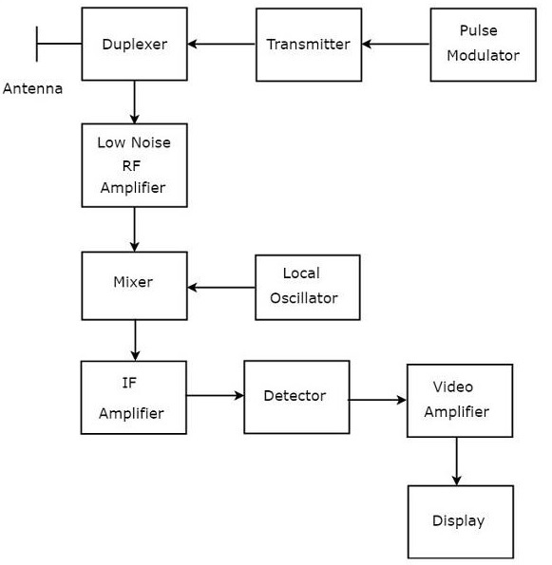
[5 marks]
- Pulse Modulator − It produces a pulse-modulated signal and it is applied to the Transmitter. [1 Mark]
- Transmitter − It transmits the pulse-modulated signal, which is a train of repetitive pulses. [1 Mark]
- Duplexer − It is a microwave switch, which connects the Antenna to both transmitter section and receiver section alternately. Antenna transmits the pulse-modulated signal, when the duplexer connects the Antenna to the transmitter. Similarly, the signal, which is received by Antenna will be given to Low Noise RF Amplifier, when the duplexer connects the Antenna to Low Noise RF Amplifier. [1 Mark]
- Low Noise RF Amplifier − It amplifies the weak RF signal, which is received by Antenna. The output of this amplifier is connected to Mixer. [1 Mark]
- Local Oscillator − It produces a signal having stable frequency. The output of Local Oscillator is connected to Mixer. [1 Mark]
- Mixer − We know that Mixer can produce both sum and difference of the frequencies that are applied to it. Among which, the difference of the frequencies will be of Intermediate Frequency (IF) type. [1 Mark]
- IF Amplifier − IF amplifier amplifies the Intermediate Frequency (IF) signal. The IF amplifier shown in the figure allows only the Intermediate Frequency, which is obtained from Mixer and amplifies it. It improves the Signal to Noise Ratio at output. [1 Mark]
- Detector − It demodulates the signal, which is obtained at the output of the IF Amplifier. [1 Mark]
- Video Amplifier − As the name suggests, it amplifies the video signal, which is obtained at the output of detector. [1 Mark]
- Display − In general, it displays the amplified video signal on CRT screen.
[1 Mark]
- Describe the functionality of a 4 port Magic TEE used in microwave communication shown in figure 1. [7 Marks]

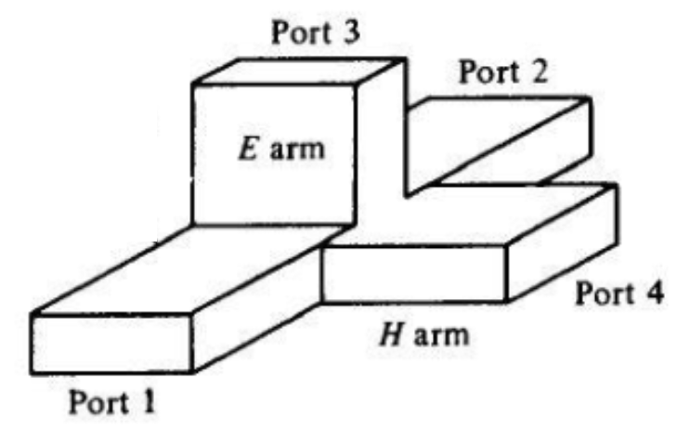
Figure 1: Magic Tee
Answer:
A Magic Tee or Hybrid Tee is a 4 port waveguide tee that is a combination of an E-Plane and H-Plane Waveguide Tee. [1 Mark]
A magic tee has four ports:
- Port 1 - Co-linear
- Port 2 - Co-linear
- Port 3 - Difference Port
- Port 4 - Sum Port [2 Marks]
When two signals of equal magnitude are fed from port 1 and 2, we get a zero at port 3 and the sum of the two signals at port 4.
When a signal is fed through port 4, it gets divided equally between port 1 & 2 and both the outputs are in phase. No output comes from port 3.
When a signal is fed through port 3, we get an output of equal magnitude but opposite phase at port 1 & 2 (the signals are 180 degrees out of phase). Output at port 4 is zero. [4 Marks]

Diwedd/End

