Name | Student Number | Date | Lecturer’s Name | Your score
Ghofran Hallak | 2407309 | 23/10/25 | Caorline | To be filled by the marker  ___/40
You will have 75 minutes to complete this assessment. It is divided into three sections: note-taking, paraphrasing and writing a paragraph.
---------------------------------------------------------------------------------------------------------------------
1. Take diagrammatic notes from the passage below using the space provided:

As a student you've got a lot on your plate - academic work, social life, work commitments, career plans, relationships and finances - sometimes stress can get in the way of this juggling act. When you recognise that you have become overwhelmed with stress, adopt a few strategies to help you manage your triggers more effectively. Those strategies could include exercising; you simply need to get your heart racing, for example by going for a brisk walk or a bike ride. Another suggestion is to try mindfulness, a relaxation technique originating in Buddhism. It is used by clinicians to improve patients' physical and mental health as it can significantly lower stress levels. Thirdly, why not speak to your friends and family - they know you best and care about you the most. What's more, studies suggest that socialising with a friend just once a week can reduce your stress levels and improve your mood as much as therapy or counselling. Simple time management techniques can also help you to feel more relaxed and focused. Try creating a written schedule, breaking your tasks down into manageable chunks, planning accordingly and allocating yourself time every day to relax or socialise. Finally, an obvious but often overlooked solution: get enough sleep, as no one functions at 100% when they're tired.
Adapted from: https://www.prospects.ac.uk/applying-for-university/university-life/5-ways-to-manage-student-stress

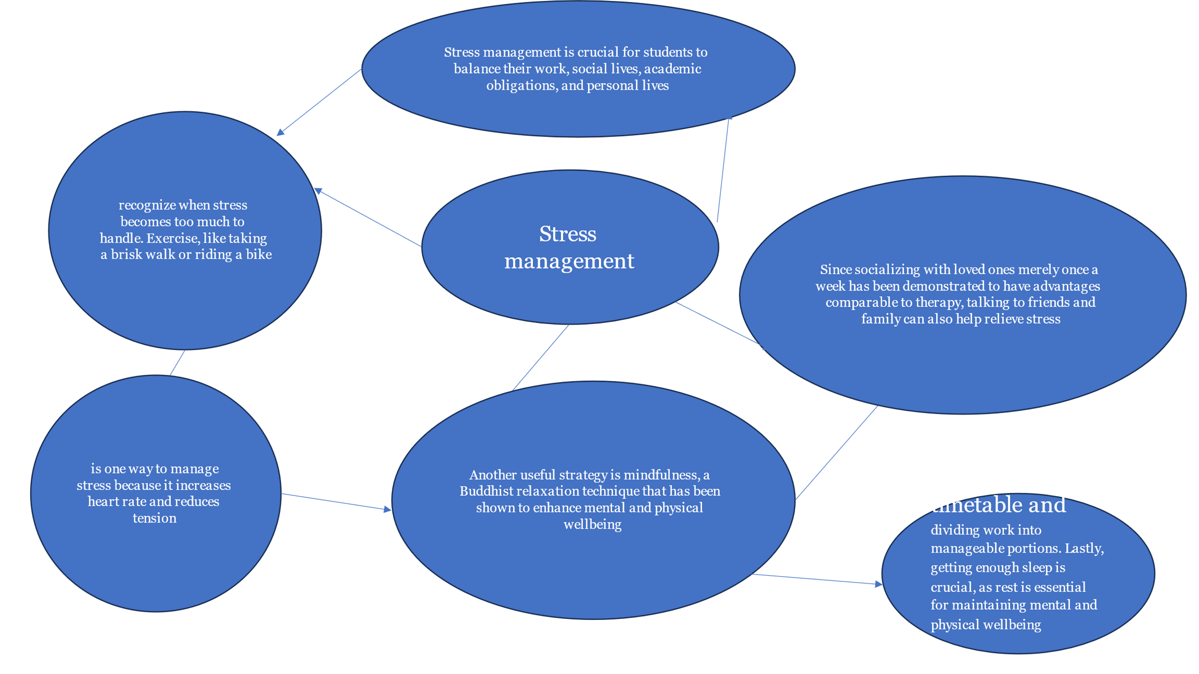

Space for your notes (max 12 marks):

Stress management is crucial for students to balance their work, social lives, academic obligations, and personal lives. The first stage is to recognize when stress becomes too much to handle. Exercise, like taking a brisk walk or riding a bike, is one way to manage stress because it increases heart rate and reduces tension. Another useful strategy is mindfulness, a Buddhist relaxation technique that has been shown to enhance mental and physical wellbeing. Since socializing with loved ones merely once a week has been demonstrated to have advantages comparable to therapy, talking to friends and family can also help relieve stress. You may maintain your attention and relaxation by practicing effective time management, which includes making a documented timetable and dividing work into manageable portions. Lastly, getting enough sleep is crucial, as rest is essential for maintaining mental and physical wellbeing

2. Paraphrase the following sentences (max 3 marks for each, max 12 marks in total):

- Good time management techniques can help you feel more relaxed and focused.

Using efficient time management techniques could help you feel more at ease and concentrated.

- Speaking to your friends and family can significantly lower stress levels.

Stress levels can be considerably reduced by talking to your loved ones.

- University life offers numerous opportunities for personal growth and development.

University life provides many changes for student to grow and develop as individuals.

- Attending lectures regularly is crucial for understanding course material.

Going to lectures regularly is important for grasping the course material.

3. Write a well-structured paragraph (8 sentences) on the following topic:

Strategies for managing a student budget and reducing costs while at university.

Your paragraph must be written in full sentences (no bullet points) and in an academic style.

(max 16 marks in total)

Managing a student budget and reducing costs while at university requires thoughtful planning and strategic decision making. One of the effective approaches is to create a detailed budget that outlines both fixed and variable expenses, it helps students to see and track their spending and identify areas where they can save money. Shopping for textbooks second hand or utilizing digital versions can also significantly reduce academic costs. Additionally, cooking meals at home instead of dining out helps students save money and maintain happier and healthier lifestyle. Public transportation or cycling is often a more economical alternative to owning a car, which can incur expensive maintenance and insurance fees. Students should also make use of student discounts offered by various retailers, services, and entertainment venues, which can lower day to day expenses. Finding free or low-cost recreational activities, such as attending university events or using campus facilities, can provide entertainment without straining the budget. Ultimately, cultivating financial discipline and making informed choices about spending are crucial for maintaining a manageable budget during university life.

