Name: | Mike Wakelyn
Student ID: | 1707800
Module Name: | Introduction to Web Development (ACCA4003)
Tutor Name: | Kemi Ademoye

Assignment: Design and Hand-code a Website Using Web Standards

Submitted on: DATE

Abstract
This report aims to discuss and evaluate the accompanying hand-coded website. Contained within is a site-map, wireframe diagram, screenshots of the completed website, results of code validation testing as well as accessibility testing, a detailed evaluation of the site along with future recommendations and reference and appendices sections at the end.
The assignment was to design and hand-code a website using current web standards and to follow it with a specification report. The HTML and CSS code was to be validated using W3 validation tools and accessibility was to be scored using several relevant tools, such as www.contrastchecker.com and browser extensions such as aXe for Google Chrome.

For more information on the author, please visit the below LinkedIn profile:
www.linkedin.com/in/mikedwakelyn

CONTENTS
Page 2 – Abstract
Page 3 – Contents
Pages 4 to 6 -
- Requirements – Setting out the task
  - Introducing the website
  - Site Map
  - Wireframe/schematic diagram of the homepage
Pages 7 & 8 -
- Implementation – Completed website with validation
  - Completed website - Screenshots
  - Code validation test results – HTML & CSS
Pages 9 to 11 -
- Evaluation
  - WCAG 2.0 accessibility testing
  - Evaluating the completed website
  - Future recommendations
Page 12 -
- References
Page 12 -
- Further reading and sources
Pages 13 to 22 -
- Appendices

- Requirements – Setting out the task
  - Introducing the website
As part of the module entitled Introduction to Web Development delivered by Dr Kemi Ademoye at the University of Wales Trinity Saint David’s Swansea campus, students were tasked with designing and hand coding their own website which could be based on a topic of their choice.
The author of this report, Mike Wakelyn chose to build a site to introduce his family, as this is a topic he knows well and already has a detailed library of media to draw upon. The intention of the website was to provide a brief introduction to the characters of the Wakelyn family along with some photos and videos of fun times had through the years. It is aimed at anyone who visits and wishes to know more about the Wakelyns.
There is a landing page with a site standardised navigation bar which can take a viewer to any page on the site. There is a slideshow banner of family pictures and a ‘Click here to enter’ button which links to the homepage where the navigation bar can be found along with a brief introduction, the authors Twitter feed and Twitter ‘Follow me’ button, a family tree and links with descriptions to the other main pages.
There are three separate main content pages, one for each of the two children and one for a family pet as well as an ‘About Us’ and ‘Contact’ page linked form the navigation bar respectively.

  - Sitemap
Students were required to create a sitemap for their website.
A sitemap is a file where you can list the webpages of your site to tell Google and other search engines about the organisation of your site content.
It can also provide valuable metadata associated with the pages that you list in that sitemap [1].
Below is the sitemap created for Mike Wakelyn’s website.

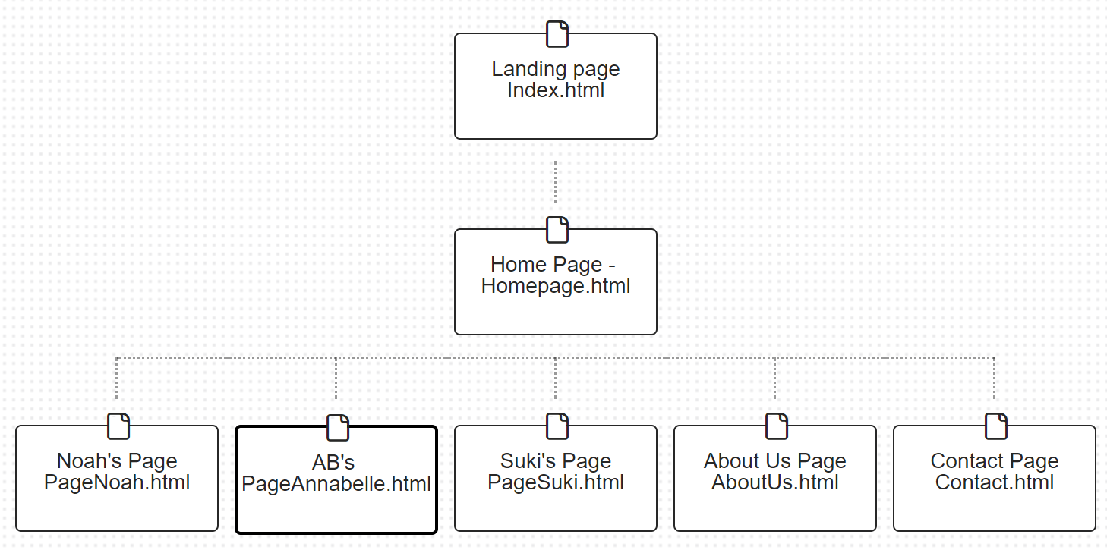

  - Wireframe/schematic diagram of the homepage
As well as a sitemap, students were asked to provide a wireframe diagram that illustrates a grid layout of the main design elements and content sections of the website.
According to WikiPedia.com, a wireframe diagram, ‘also known as a page schematic or screen blueprint, is a visual guide that represents the skeletal framework of a website’ [2].
Below is the website wireframe for Mike Wakelyn’s website.

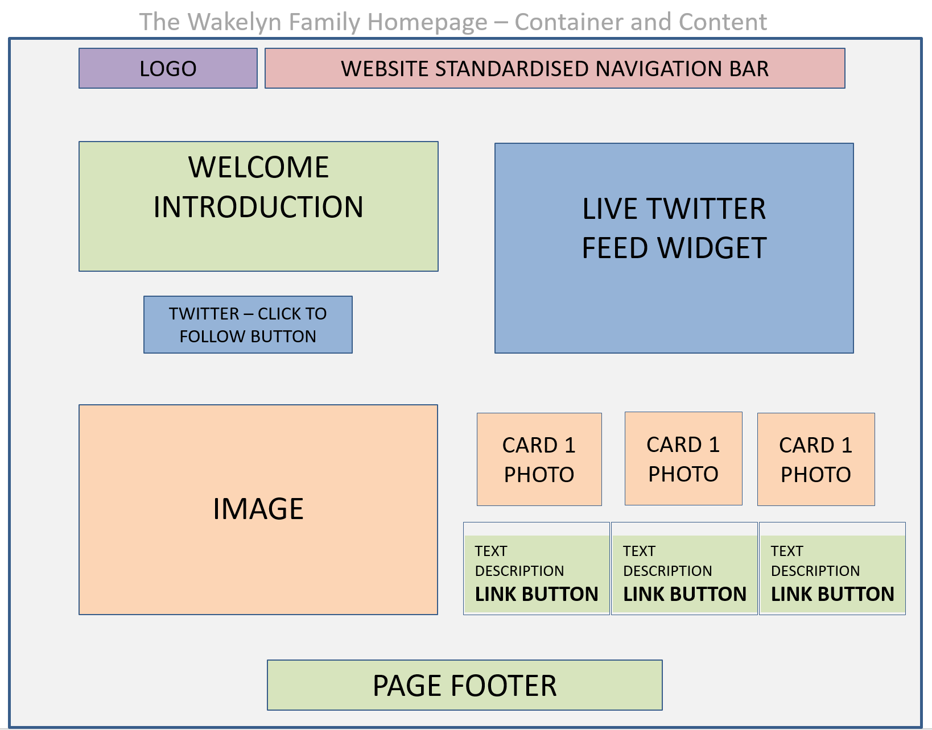

- Implementation – Completed website with validation
As standards recommend and as requested as part of the assignment, the students were required to validate the HTML code of their homepage and CSS code of their CSS style sheets. To do this, Mike Wakelyn used the following links, the results of which can be found in section 2.2.
- HTML5 validation - https://validator.w3.org/
- CSS3 validation - https://jigsaw.w3.org/css-validator/

  - Completed website - screen shots
Screenshots of the website can be found in appendix 1 - 7 respectively.
  - Code validation test results – HTML5 & CSS3
As noted on World Wide Web Consortium (W3C) validation website [3], in 2009 the Web community were asked if there was still strong motivation for code validation. There were many points raised, some of which are briefly summarised below.
- Validation as a debugging tool
While modern web browsers are adept at parsing even the worst HTML coded sites, most web developers know that using standard, interoperable markup and stylesheets, on the other hand, offers a much greater chance of having one's page handled consistently across platforms and user-agents.
- Validation eases maintenance
HTML and CSS are considered globally agreed upon coding styles. Having standardised and validated code ensures maintenance and evolution can be undertaken by both the current and future developers.

- Validation help to teach good practices
Automated checking tools are helpful for beginners and students of web design and aid in identifying mistakes. Some teachers also stress that automated validation tests are a good introduction to broader, more complex quality concepts such as accessibility [3].
Upon completing the design and implementation of the Wakelyn family website, Mike Wakelyn proceeded to the above links in order to validate both his HTML and CSS. The results of which can be found in appendix 8a though to 10b respectively.
Appendix 8a illustrates the results of the CSS validation before any error correction. As can be seen there was one error and it was indicated that a value for “background-color” was invalid for the navigation bar. This was resolved by removing the faulty value along with its code and setting the background colour to “none” in the HTML code. The successful retest can be found in appendix 8b.
Similar to above, the HTML validation test revealed one error which was shown to be a duplicate element ID called “KidsPara”. This was resolved by combining paragraphs and separating with line breaks. The successful re-test can be seen in appendix 9b
Lastly, there were also errors revealed with the “IMG” elements of the HTML code. Appendix 10a shows that there were three empty “alt=”alt desc”” elements. This was simply an oversight by the designer and was easily resolved by entering alternative description that would show in the event of the images not loading. Appendix 10b shows the successful re-test.
There were a few warning left on the re-test, but Mike Wakelyn was satisfied that they would not cause any issues.

- Site Evaluation
Upon completion of any project, evaluation is an important step in understand the projects suitability and success.
  - WCAG 2.0 accessibility testing
According to W3C on their webpage for W3C Content Accessibility Guidelines (WCAG 2.0) [4], there are four key points in their ‘layers of Guidance’. They are Principles, Guidelines, Success Criteria and Sufficient and Advisory Technique. These can be broken down further, more information can be found at https://www.w3.org/TR/WCAG20/

  - Evaluating the completed website
An accessibility check was carried out to ascertain the accessibility score as recommended by WCAG 2.0. From studying the results of the accessibility check on http://contrastchecker.com (appendix 11), it can be seen that the homepage of the Wakelyn family website received the highest score in all test criteria. This means that the site passes the six tests for minimum contrast and enhanced contrast for fonts below 18 points, minimum and enhanced contrast for fonts over 18 points, fully colour compliant for brightness and colour difference as well as for readable text for people with colour blindness.
The website headings have passed the accessibility test with AA, AAA, AA18pt AAA18pt and a PASS on contrast and colour difference. The addition of the <main> tag to all sites aides with navigation as advised by the accessibility tests run via the Google Chrome plug in ‘aXe’ and the background and foreground colours are suitable for compliance with WCAG 2.0 guidelines.
As the forms and all other pages use the same colour scheme, they have all passed the accessibility tests. The issue’s with the images and media however were that the alternative text descriptors were questionable in terms of being useful replacements for people with sight disabilities. These errors were taken in to account and given the limited and known audience of the site, as well as the text descriptors themselves, Mike Wakelyn deemed them sufficient for this project.
As well as using the online checker, the designer used a web plugin for Google Chrome called ‘aXe’. This is a development tool that runs in the web browser and provides easy, open source accessibility testing. Upon running the homepage through aXe, there were 116 violations found of varying degrees of seriousness and 2 reviews.
The reviews were that the colour contrast between the blue links on the Twitter widget and the background of the website were indeterminate. This was down to the widget being provided by Twitter and non0customisable to the designer. As the colours were part of a widget, it appeared that the aXe checker could not determine the contrast and so flagged this as a point to review. Mike Wakelyn felt that to change an entire site colour scheme to benefit a single feature was unreasonable and these points were marked as ‘Not an issue’.
114 of the 116 violations where also down to the colour contrast of the twitter widget. The description read “Insufficient colour contrast – Serious” but was uncontrollable given that the snippet of code used queried a Twitter based service for the colours. As such, these errors were unresolvable.
1 of the violations was owing to the lack of “lang=”xx” in the widgets HTML elements. Again, this was pulled from a Twitter based service that the designer had no control over.
The final violation indicated that the pages do not have a defined landmark and was highlighted as a moderate issue. As mentioned briefly earlier, wrapped the contents of the body of each site in the “<main>” tags resolved this issue.
In conclusion, it is prudent to use multiple means for accessibility testing to gain a broader understanding of the issues involved. The aXe tests revealed more errors and in far greater detail than the test on http://contrastchecker.com. This drew attention to potential issues that Mike Wakelyn, as a fully able bodied person had not foreseen.
  - Future recommendations
In light of the above evaluation some points can be raised in terms of future improvement recommendations.
It can be noted that is it good practice to employ landmarks to all pages from the start which highlights the main content of the page and assists with navigation for keyboard users.
The use of externally provided widgets must also be taken in to account. To combat the review points highlighted from the aXe accessibility it could be considered good practice to select a colour scheme that compliments all features from the website that were planned as part of the wireframe schematic phase of the project.

References

[1] | Google, “Learn About Sitemaps,” Google, [Online]. Available: https://support.google.com/webmasters/answer/156184?hl=en. [Accessed 05 01 2018].
[2] | WikiPedia, “Website Wireframe,” [Online]. Available: https://en.wikipedia.org/wiki/Website_wireframe. [Accessed 05 01 2018].
[3] | W3C - World Wide Web Consortium, “Why Validate?,” [Online]. Available: https://validator.w3.org/docs/why.html. [Accessed 05 01 2018].
[4] | W3C - WCAG 2.0, “Web Content Accessibility Guidelines (WCAG) 2.0 - W3C Recommendation 11 December 2008,” [Online]. Available: https://www.w3.org/TR/WCAG20/. [Accessed 05 01 2018].

- Further reading and sources
- https://cooltext.com/ - Used to generate site logo
- https://www.w3schools.com/bootstrap/bootstrap_grid_stacked_to_horizontal.asp - Used to research bootstrap grid principles
- http://css3buttongenerator.com/ - Used to generate a CSS button which was then manipulated throughout the site by the designer
- https://www.canva.com/design/DACra77UXkY/JwaJqyXqUGR4qRX_L6o_Ng/edit?category=tACFakxKulQ – To create the family tree graphic
- https://publish.twitter.com/# - Generating the Twitter widget
- https://www.hyde-design.co.uk/joomla-bites/80-create-a-css-slideshow-no-javascript-required - Research on different CSS slideshows. Fling-minislide identified and modified from this website
- https://stackoverflow.com/questions/31956221/how-to-disable-auto-play-for-local-video-in-iframe - How to disable autoplay of videos
- https://www.w3schools.com/howto/howto_css_contact_form.asp - Creating a contact form
- https://www.w3.org/TR/WCAG20-TECHS/ARIA11.html - Adding landmarks
- https://www.w3schools.com/bootstrap/bootstrap_navbar.asp - Resource to learn about implementing a bootstrap navigation bar
- Appendices

Appendix 1
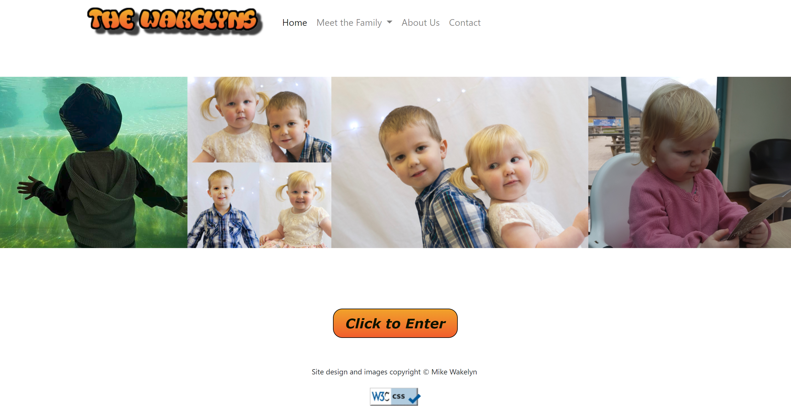

Appendix 2
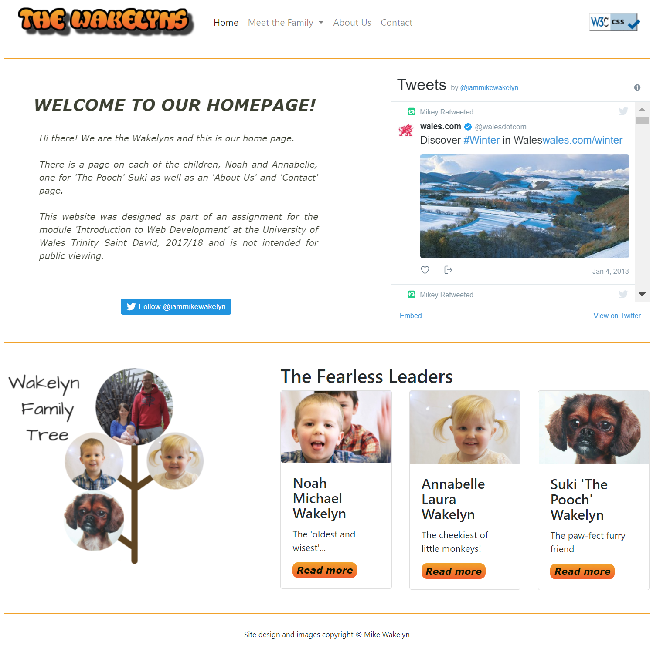

Appendix 3
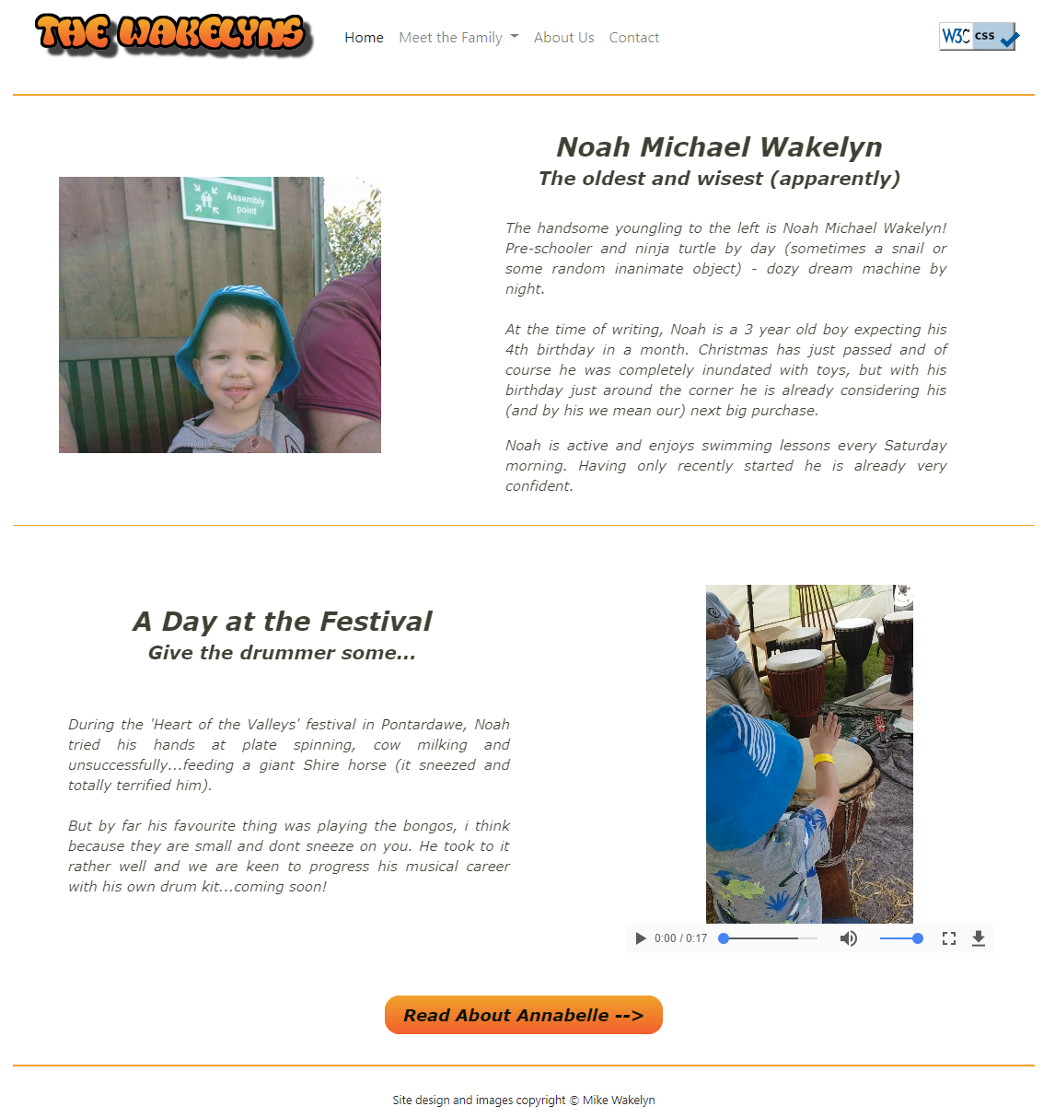

Appendix 4
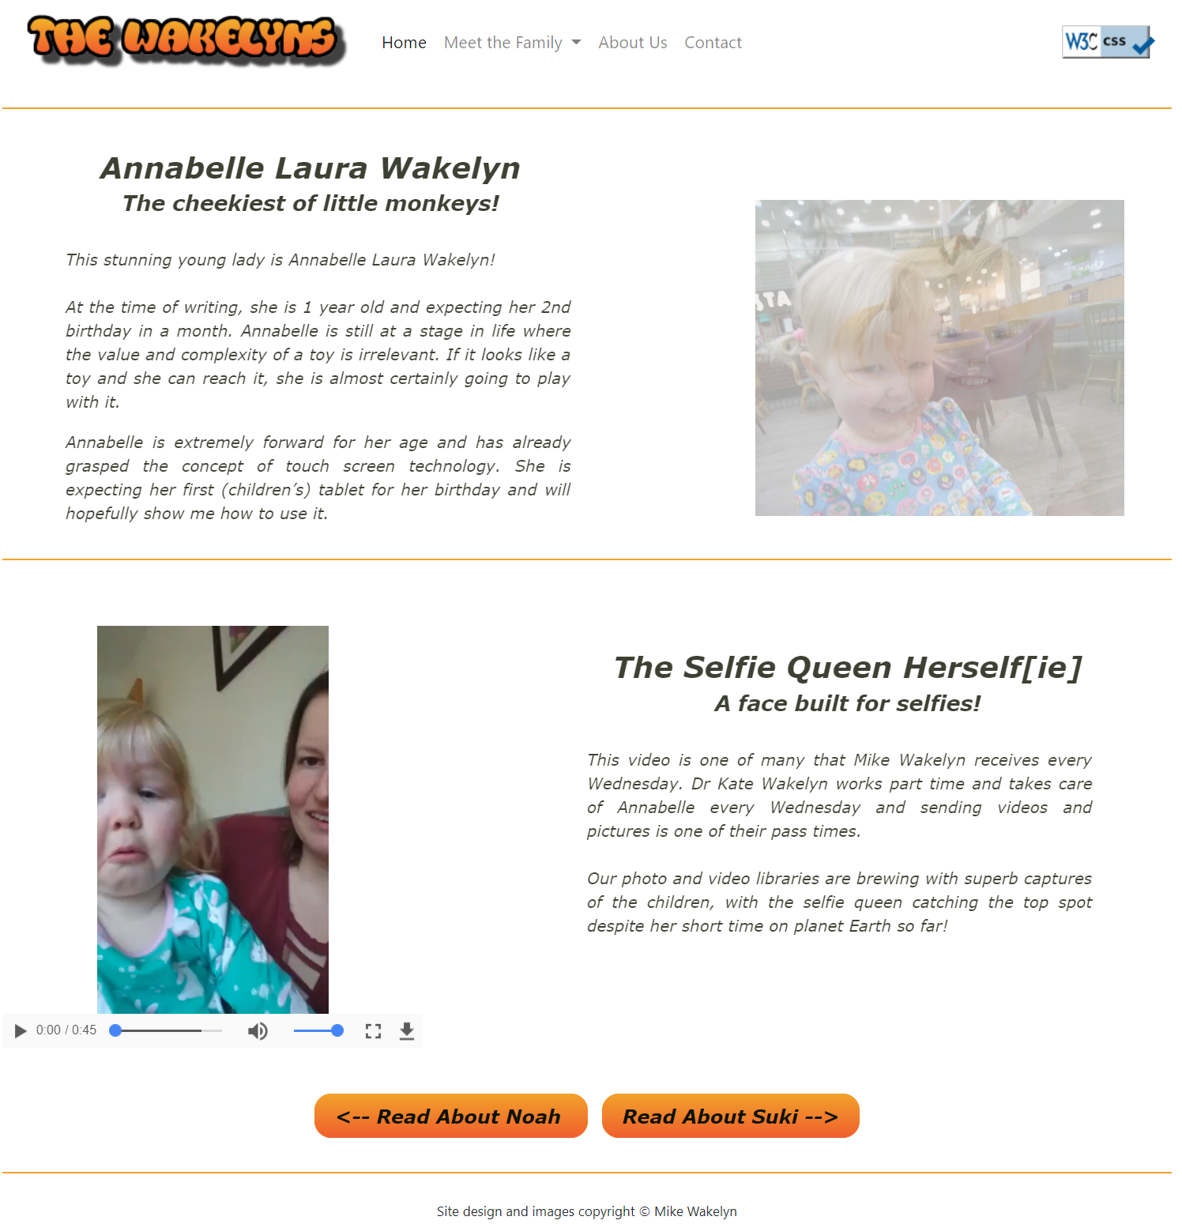

Appendix 5
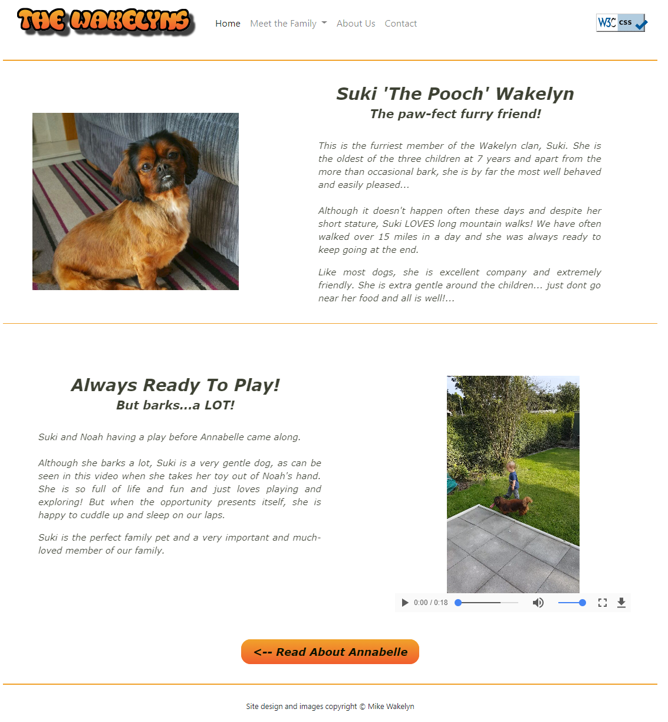

Appendix 6
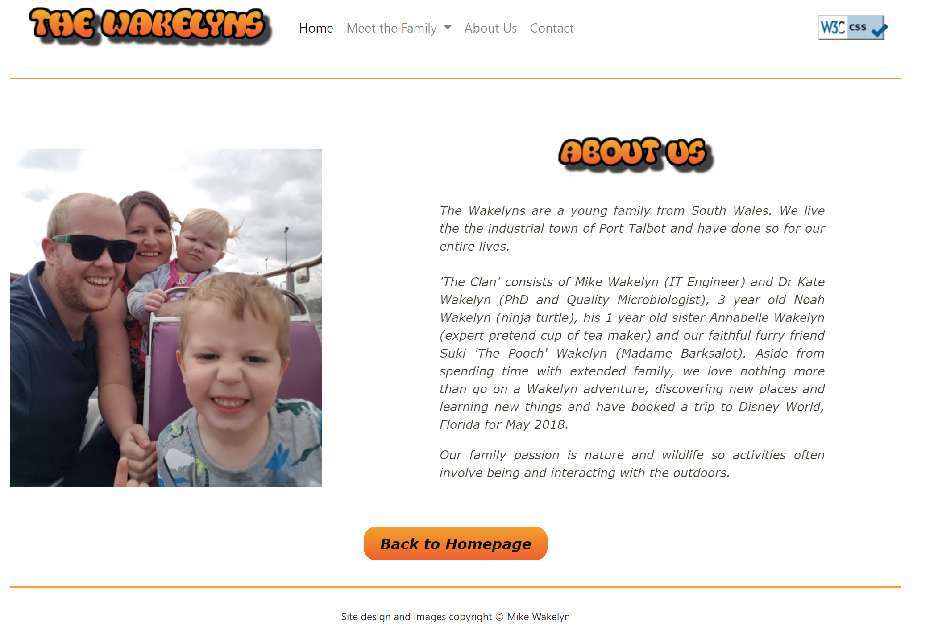
Appendix 7
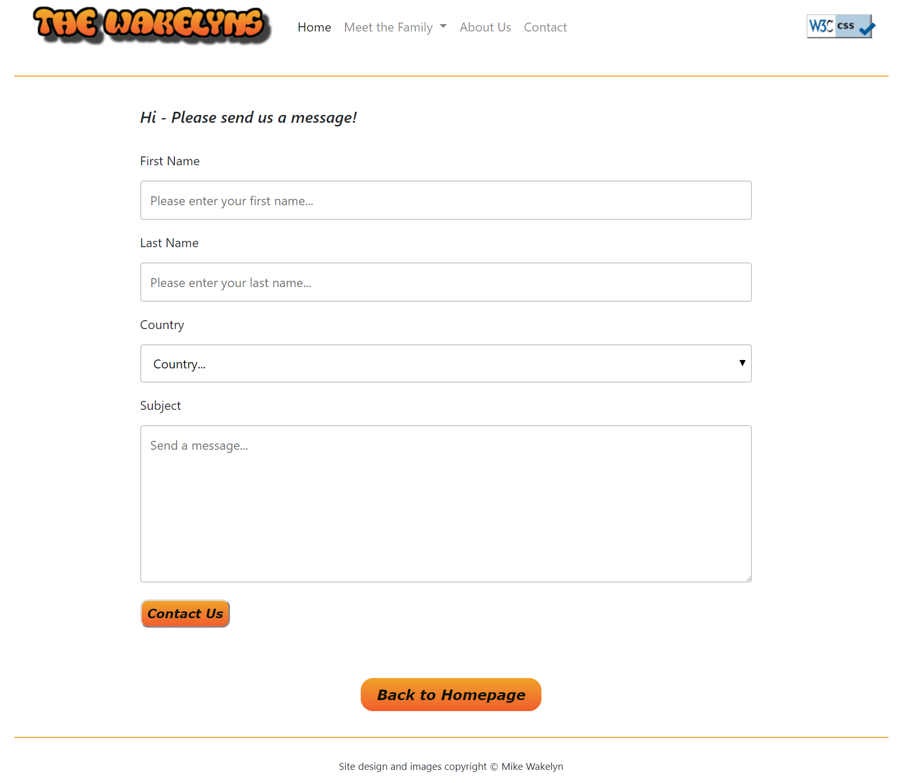
Appendix 8a
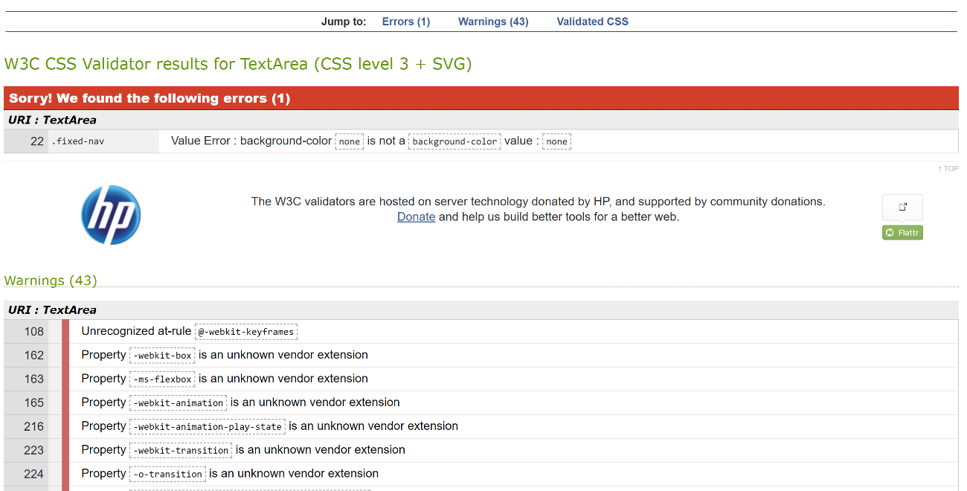

Appendix 8b
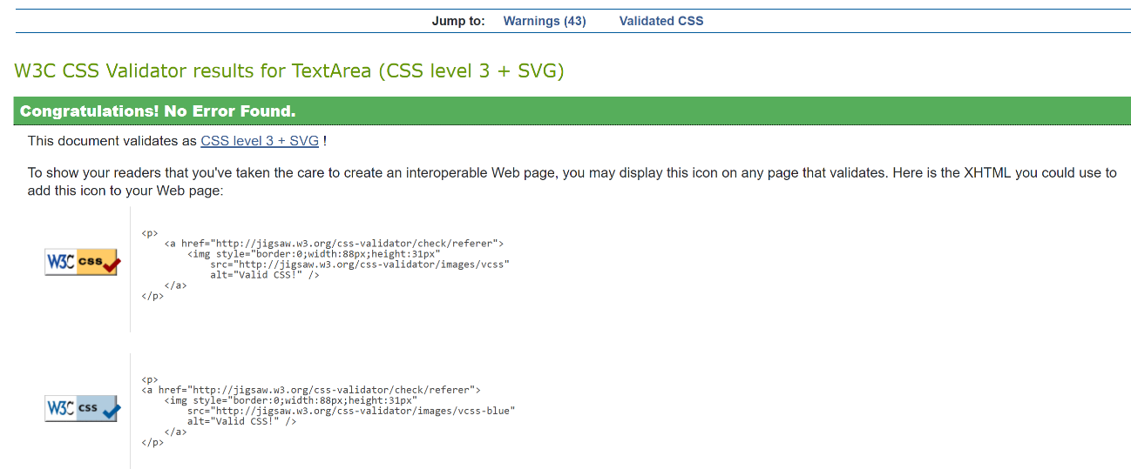

Appendix 9a
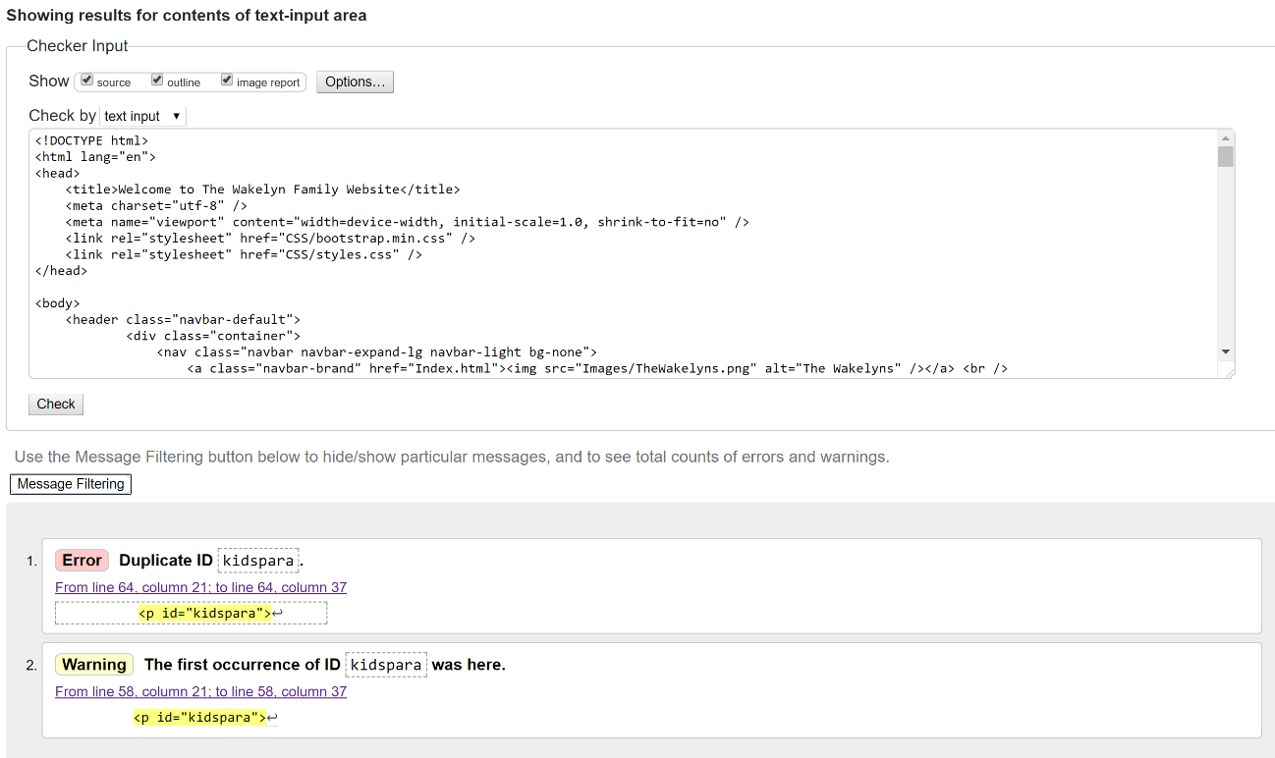

Appendix 9b
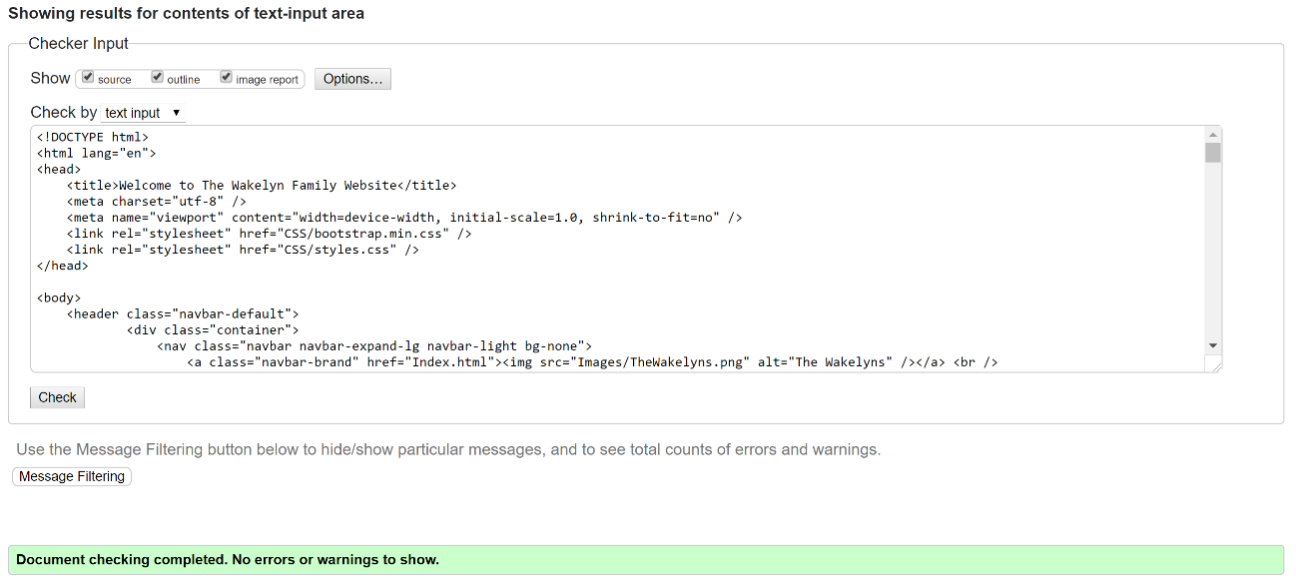

Appendix 10a
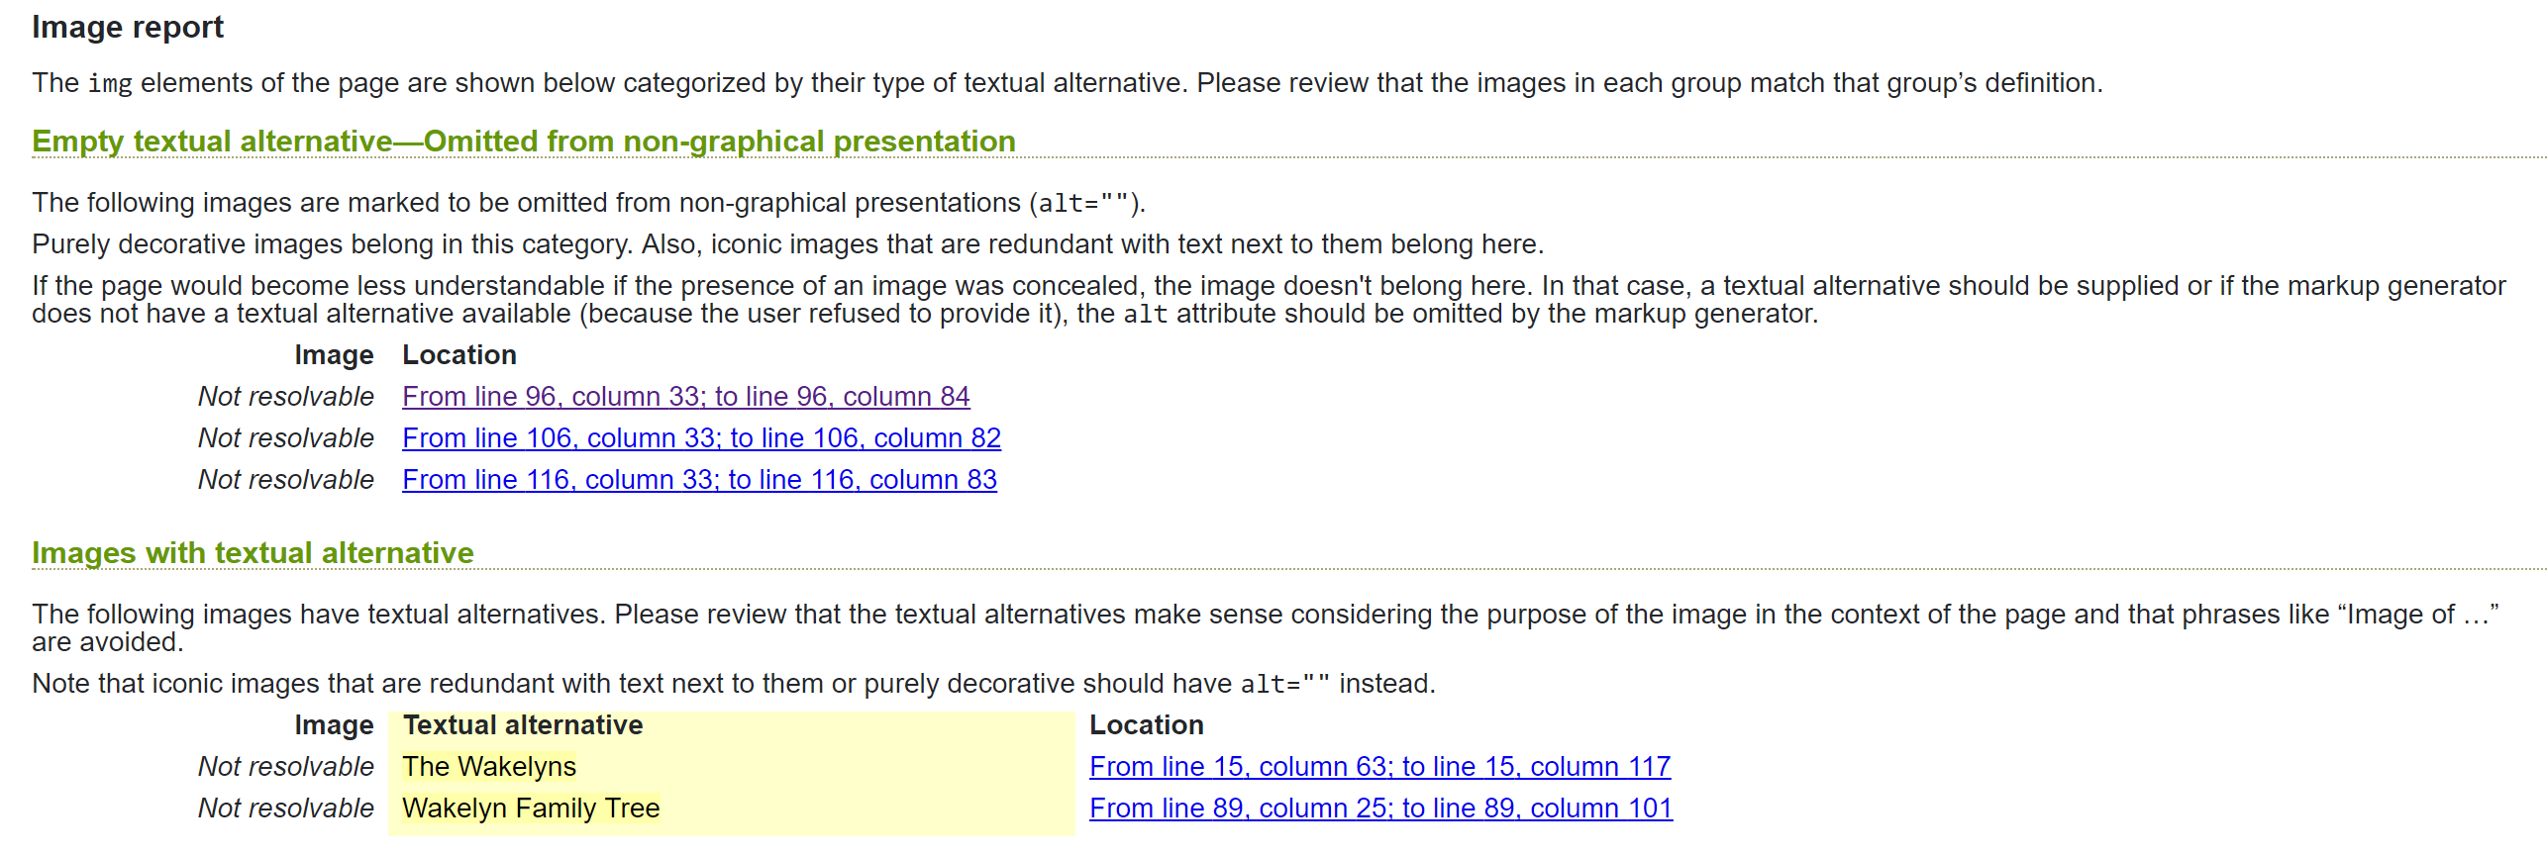

Appendix 10b
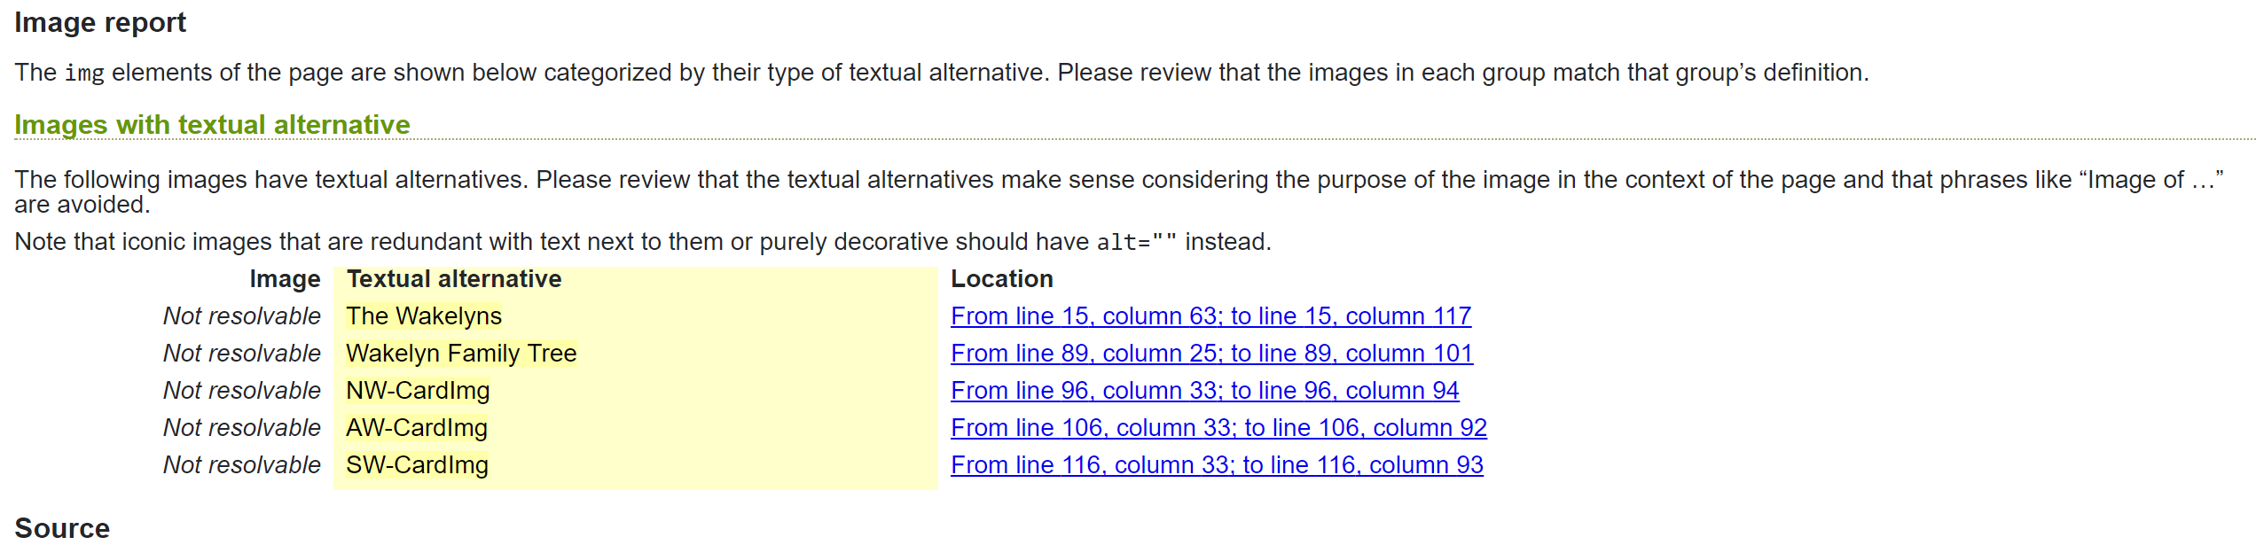

Appendix 11


