Abstract
Today, companies are more and more dependent on information technology, and companies are therefore facing many problems of information security. This paper introduces and compares ISO27001 standard, OCTAVE standard and NIST SP800 standards after survey and analysis of related documents, and understands the respective characteristics of these standards and the process of enterprise risk management. The characteristics of these standards and the process of enterprise risk management were separately presented. Then, this article uses the ISO27001 standard to help the Caribbean Coffee company to establish its information security mechanism based on its security situation. As a result, an information security management system that satisfied the business needs of the company and the requirements of international standards has been established.
1 Introduction
In the era of big data, people's work and life are increasingly dependent on information systems, and the threats to information are becoming more diverse and frequent. How to effectively protect information security has become an important issue of common concern for individuals, enterprises and society. In recent years, the international community has been promoting laws, regulations and policies related to information security. Many organizations are studying and formulating relevant information security standards, such as International Organization for Standardization (ISO), International Telecommunication Union (ITU), and British Standardization Institute (BSI), etc. With the development of globalization and big data technology, information security standards today have formed a global system which based on international standards, regional and national standards are core of the system. This paper introduces and compares the ISO27001 standards, the OCTAVE standards and the NIST SP800 standards based on survey and analysis of the relevant literature. Meanwhile, I get the knowledge of their characteristics and the process of enterprise risk management.
With the popularization of enterprise informatization, information plays a positive role in enterprise management, while it also brings many information security problems. For enterprises, it is necessary to establish a set of mechanisms to achieve the following points. a) Ensure the overall information security of the company, prevent information leakage, protect the company’s intellectual property rights and user rights. b) Ensure the availability, integrity and confidentiality of the information system. c) Prevent and avoid most information security incidents. d) Provide effective measures when information security incidents occur. With the establishment of information security management system standards (ISMS), information security risks can be identified and analyzed. Furthermore, measures can be taken to reduce and maintain the risk to an acceptable level. The establishment of ISMS can not only effectively protect information resources, but also ensure the efficient, orderly, economical and sustainable development of enterprise’s informatization process. This paper uses one of the most famous international standards ISO27001 for information security management, and considers the information security management situation of Caribbean Coffee Company. Three steps have been taken to solve the company’s problem which is the establish of framework, risk assessment, risk control and continuous operation. Finally, an information security management system that satisfied the business needs of the company and the requirements of international standards has been established.

2 Survey of security frameworks
2.1 Analysis of ISO27001
ISO 27001 is an important standard in the field of international information security management. It comes from BS7799 formulated by the British Standards Association. ISO/IEC 27001 defines the basic requirements and methods for the establishment of ISMS. Through this standard, you can select the goals, control and security measures applicable to the organization. ISO27001 can ensure the adequacy and appropriateness of security control measures in an organization. At the same time, it can develop effective control measures to reduce the security risks faced by the organization and protect the information assets of the organization. One of the features of ISO 27001 is that it is applicable to organizations or information systems of all types and sizes, so this risk assessment method has a strong association with organizations. Information systems and databases are considered as valuable information assets for an organization, and their risks can be assessed and then choose appropriate control measures to mitigate the risk.
The ISO27001 standard insists on adopting the PDCA model which is a periodic framework. In this model, each phase is associated with other phases. The transformation of the 4 stages is shown in Figure 1. Firstly, the existing problems and the causes of the problems are identified through the analysis of the current situation in the PLAN stage, and then the risk management measures are implemented according to the scheme. After that, the implementation results will be checked. Finally, the current security scheme will be modified and improved. Specifically, the construction process of ISMS can be divided into the following five stages: (1) Preparation of enterprise background information and related materials. (2) Specify a risk assessment plan to conduct risk assessment and identification. (3) Analyze the risk assessment results and establish an information security management system framework under the standard. (4) Conduct internal and external review and final approval respectively. (5) These processes is continuously repeated and improved during the operation of ISMS. In general, ISO27001 standard adopts process methods to establish, implement, operate, monitor and review ISMS. It continuously improves the organization's information security management level through continuous improvement.
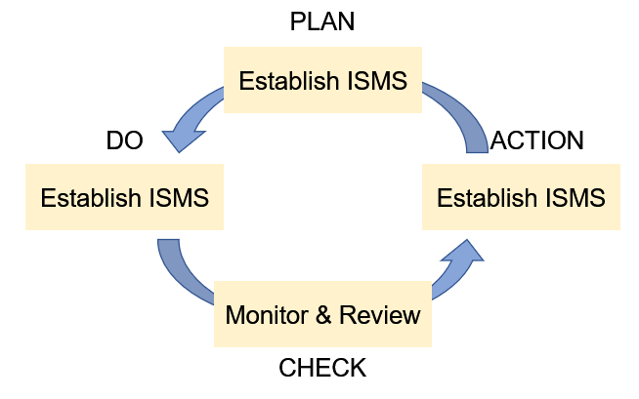
Figure 1. Transformation of 4 stages
2.2 Analysis of OCTAVE
OCTAVE is a systematic and organization-wide method to evaluate information security. It is proposed by researchers at the CERT Center under CMU/SEI. In order to enable the organization staff to fully grasp the information security requirements, a three-stage method is used to study the management issues and technical issues. The goal of the first stage is to establish the organization's general understanding of information security issues. Then, an asset-based configuration threat file will be formed. The second stage will analyze the organization's information infrastructure and find loopholes that lead to unauthorized behavior. In the third stage, protection strategies and plans need to be formulated in accordance with the priority order of risks to solve risks and problems.
The characteristic of OCTAVE is to focus on the organization itself and identify the objects that need to be protected, clarify its risks, and then develop solutions that combine technology and practice. OCTAVE enables companies to sort out complex organizational and technical issues, improve their security status and resolve information security risks. OCTAVE is a " from top to bottom" evaluation process, but the evaluation process it defines is relatively complicated, which is not suitable for some small companies.

2.3 Analysis of SP800
SP800 is a series of guidelines on information security issued by NIST in the United States, and it is the main standard to guide the construction of information security management in the United States. Among these guidelines, SP800-30 is a core report of information security, which describes the process of risk assessment and information security management. Different from ISO27001, SP800-30 believes that the management of information assets should be based on the management of the organization. The organization's risk management process should aim to protect the organization and the organization's ability to fulfill tis missions, not just information assets. SP800-30 provides a complete guide to the risk assessment process, including the key activities to prepare for the risk assessment, the necessary activities to implement the risk assessment, and the methods to maintain the current assessment results. Then apply this process to the risk management framework model proposed in SP800-39.
SP800-39 provides a process method to carry out risk management actions for federal information systems and organizations, proposes a three-level risk management structure. What's more, SP800-39 introduces in detail how the federal government applies the risk management process to the three levels of the risk management structure. The first layer implements the risk framework and provides the environment and background for all risk management activities implemented by the organization. From the perspective of business process, the second layer incorporates information security requirements into the organization's business. The third layer starts from the perspective of the information system, classifies the organization's information system, and assigns security control to the organization's information system. The three-layer structure is shown in Figure 2.
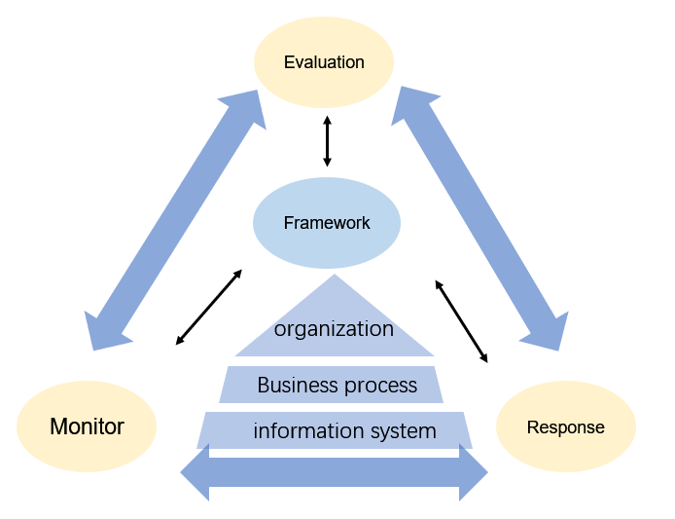
Figure 2. Structure of SP800-39
3 ISMS based on ISO27001
3.1 Analysis of Caribbean Coffee's safety management
Caribbean Coffee is a multinational company which has huge information resources. For the company's computer system is scattered, all of the employees and customers can use their personal devices to access the company's network and resources, which may lead to abuse of authority, user error operation and other problems. That is to say, the confidentiality of personal employee data and customer data cannot be guaranteed, which poses a great threat to the information security of the company. In addition, as there is no unified management, there are many loopholes in the information security of intellectual property rights.
According to the above introduction, the security problems of Caribbean Coffee can be divided into three categories. (1) There is no hierarchical management system to ensure information security, and meanwhile there is no restriction on the resource access rights of different levels of employees and customers. (2) The personnel who manage and use the enterprise information have insufficient safety awareness, and there is no strong safety management policy and publicity to educate them. (3) Failure to provide sufficient human and financial support for information security-related businesses, and the company have no special information security experts to review and supervise the resources of the organization.

3.2 Establishment of ISMS
In order to implement information security management, the first step is to establish an information security management system. Seventeen security domains have been identified according to ISO27001, as shown in Figure 3. Caribbean Coffee can expand on this basis to increase or highlight information security education and training, encryption control, inspection/supervision and auditing, so as to form a complete enterprise information security management system.
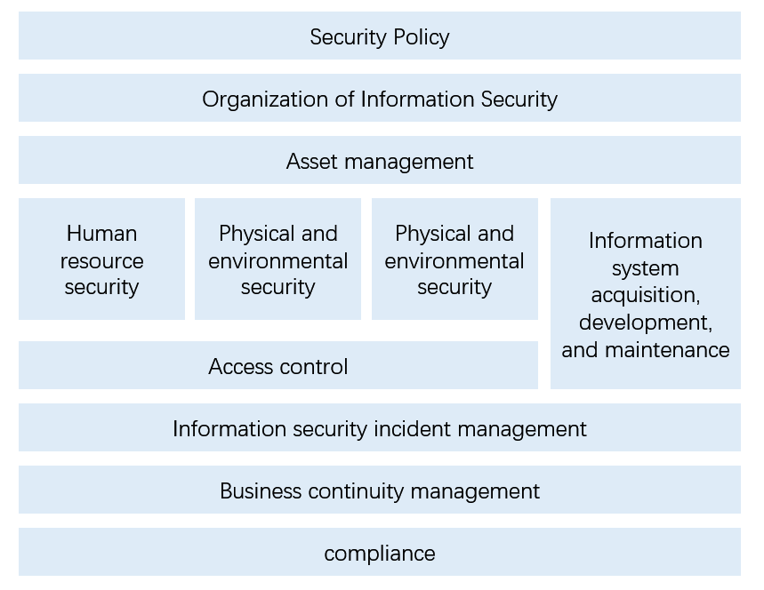
Figure 3. Security domains of ISO27001
Specifically, there are five safety implementation methods as follows. (1) Continuously identify risks, and continuously adopt management and control measures to reduce risks to an acceptable level by the organization. (2) Carry out risk assessment, learn the current risk level of the enterprise in time, and establish an enterprise information security guarantee system based on the results of the risk assessment. (3) The information security technology and information security management are classified into different levels. The information security of the enterprise is regulated by specifying strict level protection methods. (4) Establish an emergency recovery guarantee system to timely control the development of the situation and ensure the property safety of the enterprise in case of information security accidents. (5) Establish a complete operation guarantee mechanism, apply advanced technical means and products, such as anti-virus software, network access control, etc. Furthermore, it is necessary to uniformly supervise the intellectual property rights and other important information of the enterprise.
In addition, two kinds of supervision measures should be taken. (1) Security inspection. A special safety management department should be established to be responsible for implementation and regular inspections. What' more, it is important to discover the hidden dangers in technology, personnel and process of information security in time. These measures are also conducive to improving the safety awareness of Caribbean Coffee employees and ensuring the continued operation of the business. (2) IT audit. The audit is an assurance process for the audit institution to verify whether the information security control measures of the organization are complete. It is a strong supervision mechanism to use the audit mechanism to carry out independent system audit. Firstly, the internal audit department of Caribbean coffee can establish an audit team periodically, train auditors, and then effectively manage the information security audit work carried out in various departments of the company. In addition, it is also possible to hire a third-party audit agency to conduct an external audit on the company.

3.3 Risk Evaluation
According to the risk evaluation requirements of ISO27001, it is implemented through two processes of risk identification and risk evaluation, as shown in Figure 4. In the preparation stage of risk evaluation, we should sort out the asset list based on the business operation process of each department, and then score the value of assets. Then, we will use tool software, manual analysis, penetration testing and other methods to identify the weaknesses of the existing system. In addition, it is necessary to analyze the possible threats to important assets based on work processes and past information security incidents, such as unauthorized disclosure, tampering, and deletion of personal employee data and customer data. Finally, evaluate the acceptable level of each risk and determine the priority treatment level.
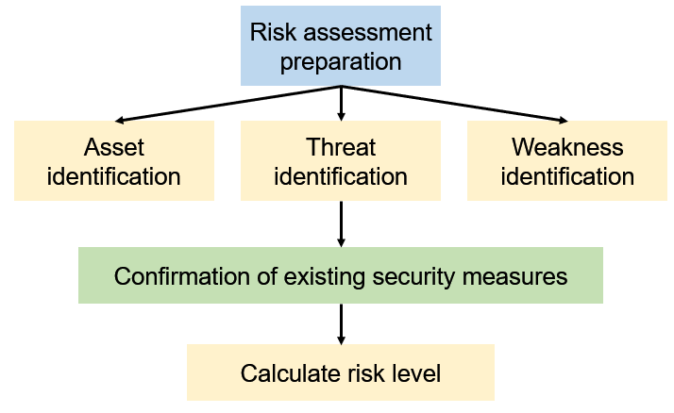
Figure 4. Risk Evaluation Procedure
3.4 Risk control and continuous operation
According to the establishment process requirements of the information security management system, risk control plans need to be formulated. The first step of the risk control plan is to determine the risk level benchmark table, which is the result of comprehensive analysis of the results based on the risk assessment results. The risk level benchmark table identifies two to three risk thresholds and divides the level of risk. For information assets higher than the acceptable risk value, the risk treatment plan shall be formulated according to the identified weak points and threats. The risk treatment plan of each information asset shall be based on the results and suggestions of risk analysis. The new control measures need to be verified by the improvement measures, considering whether they are in compliance with laws and regulations, effectiveness, own safety and reliability, and cost, etc. The implementation purpose of the improvement measures is to reduce the risk value of the corresponding information assets below the acceptable risk value. For asset projects below the acceptable risk value, review is still required to check whether there is a potential threat with high single risk. The risk improvement schedule is shown in Table 1.
Table 1. Examples of improvement plans
Threats | Improvement measures | Vulnerability
Threats | Improvement measures | before | after
network attack | Build fire dam and IDS, Issuance of digital certificates | 5 | 2
monitor, intercept or tamper data | Different user rights, Grading different data | 7 | 3
risk value: 120 |  | residual risk: 30
After implementing a series of risk control measures, the organization's information security management system has been established. In order to ensure the normal operation of the supervision information security management system, it is necessary to regularly implement the audit mechanism to ensure that the control measures are effectively implemented. At the same time, we should develop and expand the content of information security management system to cope with more updated threats. The risk assessment work shall be repeated in accordance with the rules and regular risk assessments are conducted annually. Specifically, perform risk assessment when there are significant changes in the organizational structure; perform risk assessment when the workflow changes, especially the core business process; perform risk assessment when the information security assets increase or decrease; perform risk assessment after major information security incidents or disaster recovery. In this way, the cycle of the entire information security management system can form an effective closed-loop operation.

4 Conclusion
Information security is essential for enterprises. This article has studied and analyzed three popular information security standards. After summarizing and comparing, I understand their characteristics and the process of establishing an information security management system. Based on the method of ISO27001, the information security management system of Caribbean Coffee is established in this paper, which includes four stages: security analysis, security framework establishment, risk evaluation, risk control and continuous operation. According to the PDCA model, ISMS meets the company's security needs. In the future, with the development of big data, more information security issues will arise, and I will learn more about security frameworks.

References
[1] International Organization for Standardization. (2013). ISO/IEC 27001: 2013: Information Technology--Security Techniques--Information Security Management Systems--Requirements. International Organization for Standardization.
[2] Susanto12, H., Almunawar, M. N., & Tuan, Y. C. (2011). Information security management system standards: A comparative study of the big five. International Journal of Electrical Computer Sciences IJECSIJENS, 11(5), 23-29.
[3] Achmadi, D., Suryanto, Y., & Ramli, K. (2018, May). On developing information security management system (isms) framework for iso 27001-based data center. In 2018 International Workshop on Big Data and Information Security (IWBIS) (pp. 149-157). IEEE.
[4] Beckers, K., Heisel, M., Solhaug, B., & Stølen, K. (2014). ISMS-CORAS: A structured method for establishing an ISO 27001 compliant information security management system. In Engineering Secure Future Internet Services and Systems (pp. 315-344). Springer, Cham.
[5] Disterer, G. (2013). ISO/IEC 27000, 27001 and 27002 for information security management.
[6] Alberts, C., Dorofee, A., Stevens, J., & Woody, C. (2003). Introduction to the OCTAVE Approach. Carnegie-Mellon Univ Pittsburgh Pa Software Engineering Inst.
[7] Ross, R., Katzke, S., Johnson, A., Swanson, M., & Stoneburner, G. (2008). NIST SP800-39, managing risk from information systems an organizational perspective. Gaithersberg, MD: NIST, http://csrc. nist. gov/publications/drafts/800-39/SP800-39-spd-sz. pdf.
[8] 徐黎源. (2009). 基于 ISO/IEC27001 体系的中小企业信息安全管理机制研究 [D] (Doctoral dissertation, 宁波大学).
[9] 张乐鑫. (2015). B 公司基于 ISO27000 信息安全管理体系的风险评估和控制 (Master's thesis, 华东理工大学).

