

EXAMINATION SOLUTIONS
(to accompany the examination paper sent to the external examiner
but NOT to be seen by students)

Programme: | BSc Computing (Computer Networks and Cyber Security) | Level: | 6
Module: | ACCA6010
Author: | Kapilan Radhakrishnan | Sem: | Jan 2020

SECTION A

Question number | Answer | Question number | Answer
1  2  3  4  5  6  7  8  9  10  11  12  13  14  15 | c  b  a  b  d  c  b  b  a  c  c  a  d  b  a | 16  17  18  19  20  21  22  23  24  25 | a  c  b  a  b  c  d  a  c  a

SECTION B

Q 1 | Question | Marks
a  b  c  d | Neighbor table  Contains EIGRP neighbor addresses and the interface through which they can be reached.  Topology table  Contains all destinations advertised by neighboring routers.  Advertised or Reported Distance (AD)  Advertised distance (AD), also referred to as the Reported Distance, is the cost between the next-hop router and the destination.  Feasible Distance (FD)  Feasible distance (FD) is the cost between the local router and the next-hop router plus the next-hop router’s AD to the destination network.  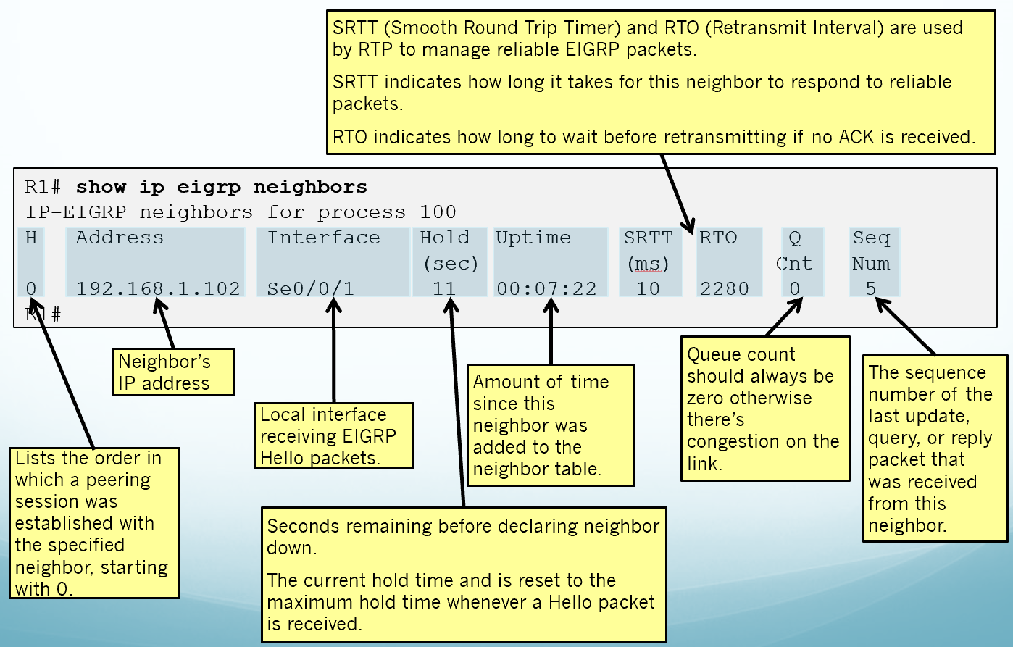  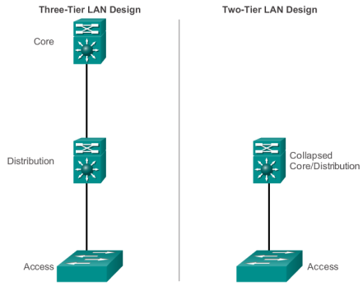  The port density of a switch refers to the number of ports on a single switch.  Forwarding rates define the processing capabilities of a switch by rating how much data the switch can process per second.  Forwarding Rates are an important factor when selecting a switch because if the rate is too low, it will not be able to support full wire-speed communication across all of its switch ports. | 2.5  2.5  2.5  2.5  1 mark each  3 marks  4

Q 2 | Question | Marks
a  b  c | 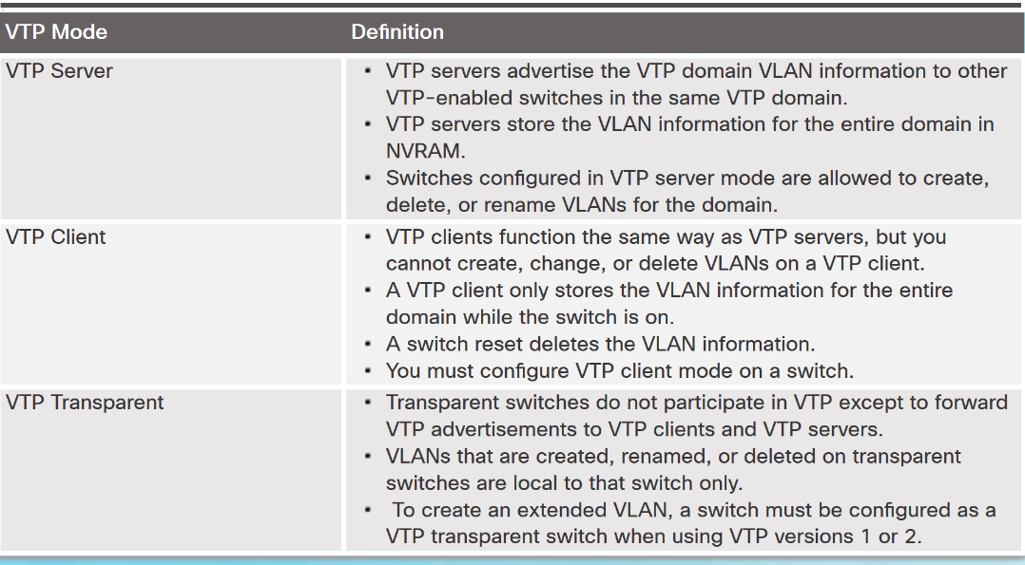  i Steps:  - Elect a root bridge  - Elect the root ports  - Elect the designated and non-designated ports  ii. S1will be elected as root because of lowest priority.  iii: S2 & S3 fa0/1 – root ports  S1 fa0/1 and 0/2 and S2 fa0/2 – designated ports  S3 fa0/2 – non-designated ports  Hello  Database description  Link-state Request  Link-state update  Link-state Acknowledge | 3 each  3  2  6  1 mark each

Q 3 | Question | Marks
a  b  c | EtherChannel Restrictions  - Interface types cannot be mixed. (Fast Ethernet + Gigabit Ethernet cannot be grouped.)  - Provides full-duplex bandwidth up to 800 Mbps (Fast EtherChannel) or 8 Gbps (Gigabit EtherChannel)  - Cisco IOS Switch can support 6 EtherChannels.  - Created between two switches or a server and switch.  - If one side is configured as trunk, the other side must be a trunk within same native VLAN.  - Each EtherChannel has a logical port channel interface and changes to a channel affects its physical interfaces.  - The ability of a network to dynamically recover from the failure of a device acting as a default gateway is known as first-hop redundancy.  - Multiple routers are configured to work together to present the illusion of a single router to the hosts on the LAN.  - By sharing an IP address and a MAC address, two or more routers can act as a single virtual router.  - The IP address of the virtual router is configured as the default gateway for the workstations on a specific IP segment  - When frames are sent from host devices to the default gateway, the hosts use ARP to resolve the MAC address that is associated with the IP address of the default gateway  - A redundancy protocol provides the mechanism for determining which router should take the active role in forwarding traffic. It also determines when the forwarding role must be taken over by a standby router | 10  10 marks  5 marks
  Classful | Classless
  Classful routing protocols do not send subnet mask information in routing updates.  Classful routing protocols cannot support variable-length subnet masks (VLSMs) and classless interdomain routing (CIDR).  Classful routing protocols also create problems in discontiguous networks | Classless routing protocols include subnet mask information in the routing updates.  Classless IPv4 routing protocols (RIPv2, EIGRP, OSPF, and IS-IS) all include the subnet mask information in routing updates.  Classless routing protocols support VLSM and CIDR.

