business review of aston martin utilising their financial statements

Michael Waite - 2134221

Contents
Executive Summary 3
Introduction 4
Use and Limitation of Ratios 5
Ratios Analysis 7
Profitability Ratio 7
Liquidity Ratios 8
Leverage Ratios 8
Activity or Efficiency Ratio 9
Investment Ratio 10
Summary of Findings 11
Conclusion & Recommendations 12
Appendices 13
References 13
Calculation details of all ratios utilised. 14
Profitability Ratio 14
Liquidity Ratio 15
Leverage Ratios 16
Activity or Efficiency Ratio 17
Investment Ratio 18
The Statements 20

Executive Summary
This executive summary encapsulates the key findings and recommendations from an in-depth analysis of the potential £5M joint venture opportunity with Aston Martin. The following insights have been derived from a thorough examination of financial statements, ratio analysis, and a critical evaluation of the financial health of Aston Martin plc.
Financial Performance Overview: Aston Martin's financial performance in 2022 was characterised by a significant loss of £527.7 million, a marked increase from the £189.3 million loss reported in 2021. This downturn raises concerns regarding the company's financial stability and underscores the importance of a cautious approach.
Liquidity and Leverage Assessment: Aston Martin’s liquidity, as indicated by the current ratio of 1.08 in 2022, is modest, necessitating a focus on strengthening short-term liquidity. The debt-to-equity ratio has risen from 0.96in 2021, signifying increased financial leverage that warrants careful debt management.
Profitability Challenges: The analysis of gross margin, operating margin, and net profit margin reveals profitability challenges, with losses recorded in 2022. Addressing these challenges will involve implementing cost control measures and revenue enhancement strategies.
Recommendations:
- Due Diligence: Prior to proceeding with the joint venture, an exhaustive due diligence process is imperative. This should encompass a comprehensive analysis of Aston Martin plc's financials, operational capabilities, market positioning, and the specifics of the joint venture agreement.
- Cost Control: Immediate measures to control costs are essential for restoring profitability. Streamlining operations, renegotiating supplier contracts, and optimising resource allocation are viable strategies.
- Liquidity and Debt Management: Focusing on bolstering short-term liquidity and prudently managing debt levels will enhance financial stability.
- Operational Efficiency: A deeper analysis of efficiency ratios is needed to identify operational inefficiencies and implement improvements.
- Investor Relations: Enhancing communication with investors and rebuilding investor confidence is crucial, especially after a challenging financial year.
Conclusion: In conclusion, while the joint venture opportunity with Aston Martin may hold promise, it must be approached with caution and a commitment to meticulous evaluation. The decision-making process should be guided by a wider understanding of the financial landscape and the broader strategic context.
The journey toward a £5M joint venture with Aston Martin plc is one that requires careful consideration of the risks. To embark on this project, we should consider suitable contractual protections should Aston Martins financial position continue to perform poorly.

Introduction
The report is structured to provide clarity and depth, beginning with a detailed review of financial statements, followed by the calculation and analysis of key financial ratios. We will critically evaluate these ratios, considering the reasons for changes over time and acknowledging the limitations of ratio analysis. Finally, we will conclude with recommendations that consider the key aspects to consider regarding the proposed joint venture opportunity.

Use and Limitation of Ratios
Using financial ratios in financial analysis provides valuable insights into a company's performance and financial health. However, it's essential to understand both their use and limitations to make informed decisions. Here's an overview:

Use of Financial Ratios:
Performance Evaluation: Ratios help evaluate a company's financial performance over time, highlighting trends and areas that need improvement. They are used to assess profitability, liquidity, solvency, and efficiency.
Comparison: Ratios enable companies to compare their financial performance with industry peers, competitors, or benchmarks. This helps identify strengths and weaknesses relative to others in the same industry.
Forecasting: Ratios are often used in financial forecasting. Historical data can inform future projections, helping with budgeting and financial planning.
Risk Assessment: Ratios can help identify financial risks, such as liquidity issues or high debt levels, allowing companies to take corrective actions before problems escalate.
Investor Decision-Making: Investors use ratios to assess the financial health of potential investment targets. They help investors make informed decisions about buying, holding, or selling securities.
(Weetman, 2013)
Limitations of Financial Ratios:
Historical Data: Ratios are based on historical financial statements, which may not reflect current market conditions or future trends. They provide a snapshot of the past but may not predict the future accurately.
Industry Differences: Different industries have varying financial structures and operating norms. Comparing ratios across industries may not be meaningful due to these variations.
Lack of Context: Ratios provide numbers but not the context behind them. A high or low ratio may not tell the full story without understanding the company's unique circumstances.
Manipulation: Companies can manipulate financial statements to improve ratios temporarily. This can mislead stakeholders, emphasising the need for additional due diligence.
No Accounting for Non-Financial Factors: Ratios focus solely on financial data and do not account for non-financial factors like management quality, market dynamics, or industry disruptions.
Incomplete Picture: Ratios provide a limited view of a company's overall health. Other factors like competitive positioning, customer satisfaction, and market trends must also be considered.
Not All Ratios Are Relevant: Some ratios may not be applicable to certain industries or companies. Using irrelevant ratios can lead to misinterpretation.
Ratios Alone Aren't Decisive: Ratios are a part of financial analysis but should not be the sole basis for decision-making. They should be considered alongside qualitative factors and a broader understanding of the business.
(Faello, 2015)
In summary, financial ratios are valuable tools for assessing financial performance and risk, but they have limitations. It's crucial to use them in conjunction with other information, consider the context, and be aware of the inherent constraints when making financial decisions or evaluating a company's financial health.

Ratios Analysis

Profitability Ratio

Margin Ratios
Gross Margin- Aston Martin’s gross profit margin increased from approximately 31.38% in 2021 to 32.62% in 2022. This indicates that the company became more efficient in generating profits from its core business activities. An increasing gross profit margin can be a positive sign, as it suggests that the company may have improved its pricing strategy, cost management, or product mix, resulting in higher profitability at the gross level.
The gross profit margin indicates Aston Martin spends just under 70p direct costs for every £1 in sales. (Marr, 2012). It provides insights into the company's ability to cover its variable costs and contribute to fixed expenses and profits.
Operating Margin - Both in 2022 and 2021, Aston Martin had negative operating profit margins, indicating that the company's core operations were not profitable during those years.
The decrease in operating profit margin from -6.78% in 2021 to -8.53% in 2022 suggests that the company's operating performance deteriorated over this period. Negative operating margins may raise concerns about the company's ability to cover its operating expenses with its revenue.

Return Ratios
Net Profit Margin – Aston Martin’s net profit margin deteriorated from approximately -17.28% in 2021 to -38.2% in 2022. This indicates a larger net loss relative to revenue in 2022 compared to the previous year. The negative net profit margin for both years indicates that the company incurred net losses. This is a concern, as it suggests that the company's expenses, including operating expenses, interest, and taxes, exceeded its revenue. The decrease in net profit margin indicates worsening profitability. (Nariswari & Nugraha, 2020)
Return on Assets (ROA) – Both in 2022 and 2021, Aston Martin had negative ROA, indicating that the company's assets did not generate sufficient earnings to cover expenses. The decrease in ROA from -6.66% in 2021 to -17% in 2022 suggests a worsening in the company's ability to generate earnings relative to its asset base. Negative ROA is a significant concern, as it indicates inefficiency in asset utilisation and a failure to generate profits from investments in assets.
The negative ROA for Aston Martin in both 2022 and 2021 highlights the need for significant improvements in asset utilisation and overall financial performance. Addressing the underlying issues affecting ROA is crucial for the company's long-term sustainability and profitability. (Filatov, 2019)
Return on Equity (ROE) – Both in 2022 and 2021, Aston Martin had negative ROE, indicating that the company incurred losses that exceeded its shareholders' equity. The decrease in ROE from -28.66% in 2021 to -68.31% in 2022 suggests a significant deterioration in the company's ability to generate returns for its shareholders' equity. Negative ROE is another significant concern, as it indicates that the company's losses have eroded shareholders' equity, potentially affecting the company's financial stability.

Liquidity Ratios

Current Ratio - The increase in the Current Ratio from 2021 to 2022 (0.96 to 1.08) indicates an improvement in short-term liquidity, as the company had a higher proportion of current assets relative to current liabilities in 2022. However, it's essential to assess the company's specific working capital needs to determine if this level of liquidity is adequate for its operations and financial obligations. (Mao, 2023)
Overall, the Current Ratio provides a snapshot of a company's liquidity position, and an increase in this ratio is generally viewed positively in terms of short-term financial health.
Quick Ratio/Acid Test Ratio: The Quick Ratio for Aston Martin improved from 131.4% in 2021 to 145.7% in 2022. This indicates an enhancement in the company's short-term liquidity position. A higher ratio suggests a larger proportion of highly liquid assets relative to short-term liabilities in 2022, which is generally a positive sign and the comfortable level of short-term liquidity to meet its immediate financial obligations may provide a sense of security to stakeholders and creditors.
The improvement in the Quick Ratio from 2021 to 2022 indicates that the company may have taken measures to strengthen its liquidity position. This is particularly important given the challenging financial year in 2022, as reflected in the reported losses.
In summary, the improvement in the Quick Ratio for Aston Martin in 2022 is a positive sign for short-term liquidity.
Cash Ratio: The Cash Ratio increased from 46% in 2021 to 56% in 2022. This indicates an improvement in Aston Martin’s ability to cover its short-term liabilities using cash and cash equivalents alone.
Both ratios are significantly below 100%. This suggests that Aston Martin follows a conservative liquidity management strategy, holding a portion of its short-term liabilities in cash and cash equivalents but relying on other highly liquid assets, such as accounts receivable and inventory, to meet its obligations.
The increase in the Liquidity Ratios from 2021 to 2022 is likely a result of Yew Tree Overseas Ltd, Geely International and Mercedes-Benz investment subscribing to £335M of shares offered through a £575M rights issue. This was aiming to provide a “liquidity cushion to underpin and accelerate future capital expenditure”. (Fahy, 2022)

Leverage Ratios
Gearing Ratio – This ratio provides insights into the extent to which non-current liabilities (long-term debt and obligations) contribute to the company's overall capital structure. In 2021, the ratio was 65.9%, indicating that non-current liabilities contributed significantly to the company's capital structure. Comparing this ratio to the 2022 ratio of 62.5%, we can see a slight reduction in the proportion of non-current liabilities in the capital structure. This reduction reflects efforts to manage and optimise the company's long-term obligations.
Debt/Equity Ratio - The Debt/Equity Ratio provides insights into the company's financial risk. A higher Debt/Equity Ratio indicates a higher level of financial leverage, which can increase the company's risk, especially if it faces challenges in servicing its debt obligations. Aston Martin’s Debt/Equity Ratio decreased from 3.3 in 2021 to 3.02 in 2022, which suggests a relative reduction in financial risk in terms of debt utilisation.
Overall, a decreasing Leverage Ratio can be viewed positively as it signifies a reduction in the relative reliance on debt financing, potentially reducing financial risk for the company.
Long Term Debt/Equity Ratio: In 2021, the ratio was approximately 1.89, indicating a significant reliance on long-term debt financing in the company's capital structure. Comparing the 2022 ratio of 1.63, we observe a slight reduction in the ratio. This reduction suggests a potential effort to optimise the capital structure and manage long-term debt obligations. This is reflected in a recent article stating that Aston Martin proposes a £210M placing of new shares to support its balance sheet. (Alliance News, 2023)
Interest Coverage: In 2021, the ratio of approximately -0.65 indicates that Aston Matin's operating profit was not sufficient to cover its interest expenses. This suggests a higher risk of potential difficulties in meeting interest obligations.
Comparing this ratio to the 2022 ratio of approximately -1.00, we observe a further drop in the interest coverage in 2022. Both years show a low ability to cover interest expenses and highlight poor financial stability and high risk associated with high levels of debt.

Activity or Efficiency Ratio
Days Sales Outstanding (DSO) - This DSO figure indicates that, on average, it took Aston Martin approximately 64.92 days to collect payment from its customers after making a sale during the year 2022. In contrast, in 2021, Aston Martin had a DSO of approximately 81.11 days, meaning it took longer to collect payments from customers during that year. This decrease indicates an improvement in accounts receivable efficiency. Aston Martin was able to collect payments from customers more quickly in 2022 compared to the previous year.
That means that the company's credit and collection policies were more effective in 2022, resulting in improved cash flow and liquidity. This is often a positive sign, but it's important to strike a balance. Extremely low DSO can also indicate overly aggressive credit policies that may discourage potential customers.
Inventory Turnover: The ratio of approximately 3.82 indicates that Aston Martin efficiently managed its inventory in 2021, similar to 2022 at 3.85. It sold and replaced its average inventory approximately 3.82 times during the year 2021 and 3.85 during 2022. The relatively consistent inventory turnover ratio between 2021 and 2022 suggests that the company maintained stable inventory management practices over the two years.
Consistently high inventory turnover ratios are generally positive as they indicate that the company is efficiently managing its inventory and that there is a stable demand for its product.
Days Payable Outstanding (DPO): The DPO in 2022 of approximately 346.63 days suggests that Aston Martin takes an average of 346.63 days to pay its suppliers. This indicates that the company tends to delay payments to its suppliers, potentially optimising its cash flow. The DPO in 2021 is relatively consistent with 2022 at 350.14, indicating that the company maintained a similar approach to managing accounts payable over the two years.
Executive Chairman Lawrence Stroll told CNBC that they are targeting to become “sustainably free cash flow positive from 2024” and this may be part of their strategy in achieving that. (Iordache, 2023)

Investment Ratio

Earnings per Ordinary Share (EPS): Both years have negative EPS values, indicating that Aston Martin incurred losses in both 2021 and 2022 with values of -£1.63 and -£0.76 respectively. This suggests that the company's expenses exceeded its revenue during these periods. Although the company continued to experience losses in 2022, the EPS improved compared to 2021. This could be seen as a positive sign, but it's essential to assess whether this improvement is sustainable.
Negative EPS values can be concerning for investors, as they indicate that the company is not generating sufficient profits to cover its expenses and provide returns to shareholders. Many investment analysts regard EPS ratio as a key measure of investment potential. (Atrill, 2012)
Dividend Cover: Since no dividends were declared or paid in the year ended 31 December 2022 or 2021, the dividend cover ratio would be undefined or not applicable. The effect of no dividend however could cause shareholders to sell their holding since they are effectively not getting a return on their investment.
Price per Earnings Ratio: Both years' P/E ratios show that Aston Martin had negative earnings with 2021 at -0.09 and 2022 at -0.44, which can be a concern for investors. It's important for the company to improve its financial performance and return to profitability to attract investor confidence.
Dividend Yield Ratio: Since there is no data on dividend payments (DPS), I am unable to calculate the dividend yield ratio. The decision to not pay dividends was indicated in the report as a strategic move based on financial challenges. Although this can be unattractive to some investors there are others that may prefer companies that do not pay dividends, as it can defer taxable income until they sell their shares. In some cases, capital gains from share price appreciation may be taxed at a lower rate than dividend income.

Summary of Findings

Financial Statements Analysis:
- Balance Sheet: Aston Martin's total assets increased from £2.8425 billion in 2021 to £3.1043 billion in 2022. Non-current assets, including intangible assets and property, plant, and equipment, showed a moderate increase. However, current assets, including inventories and trade receivables, also increased significantly.
- Income Statement: The company reported a substantial operating loss of £141.8 million in 2022, compared to a loss of £76.5 million in 2021. Revenue increased from £1.0953 billion to £1.3815 billion, but expenses, including finance costs, led to a larger loss.
Key Ratios Analysis:
- Profitability Ratios: The company's profitability ratios showed losses in 2022, indicating operational challenges.
- Liquidity Ratios: The current ratio suggests adequate short-term liquidity.
- Leverage Ratios: A high debt to equity ratio indicates significant financial leverage.
- Investor Ratios: The Price-to-Earnings (P/E) ratio was -0.44 in 2022, indicating negative earnings per share.
Analysis of Ratios:
- Profitability Analysis: The company's losses in 2022 raise concerns about its ability to generate profits from its operations.
- Liquidity Analysis: Short-term liquidity appears to be sufficient based on the current ratio.
- Leverage Analysis: The high debt to equity ratio suggests a substantial reliance on debt financing.
- Efficiency Analysis: An improvement in DSO suggest Aston Martin are taking a more aggressive stance in credit collection improving cash flow and liquidity.
- Investor Ratios Analysis: A negative P/E ratio in 2022 indicates a lack of earnings.

Conclusion & Recommendations
Based on the analysis of Aston Martin's financial data and the potential joint venture opportunity with Aston Martin plc, the following conclusions and recommendations are provided:
Conclusion:
- Financial Performance: Aston Martin experienced a challenging financial year in 2022, reporting a substantial loss of £527.7 million compared to a loss of £189.3 million in 2021. This significant increase in losses raises concerns about the company's financial stability.
- Liquidity: The current ratio for 2022 is 1.08, indicating that Aston Martin has relatively modest short-term liquidity. While the company can cover its short-term obligations, it should strive to maintain a more comfortable liquidity position.
- Leverage: The debt-to-equity ratio has increased from 2021 to 2022, suggesting higher financial leverage. The company should carefully manage its debt levels to avoid excessive financial risk.
- Efficiency: Efficiency ratios indicate a more aggressive policy to improve cash flow and liquidity is being followed.
- Profitability: The gross margin, operating margin, and net profit margin analysis indicate challenges in profitability, with losses recorded in 2021 and 2022.
Recommendations:
- In-Depth Due Diligence: Before proceeding with the joint venture opportunity with Aston Martin plc, the business should conduct a comprehensive due diligence process (Nan, et al., 2008). This should include a detailed analysis of Aston Martin's financials, operational capabilities, market positioning, and the specific terms and conditions of the joint venture.
- Cost Control: Aston Martin should implement cost control measures to improve profitability. This may involve streamlining operations, renegotiating supplier contracts, and optimising resource allocation.
- Liquidity Management: Given the current ratio of 1.08, Aston Martin should focus on strengthening its short-term liquidity position. This can be achieved by managing working capital effectively and exploring options for short-term financing if necessary.
- Debt Management: The company should carefully manage its debt levels and consider refinancing options to reduce interest expenses. Reducing financial leverage can enhance long-term financial stability.
- Operational Efficiency: Operational bottlenecks and areas for improvement need to be identified. Implementing efficiency-enhancing strategies can improve overall performance.
- Investor Relations: Aston Martin should work on improving its investor relations by communicating its plans for recovery and growth. Building investor confidence is essential, especially after a challenging financial year.
- Continuous Monitoring: Regularly monitoring financial performance and key ratios to detect early signs of improvement or potential issues. Adjust strategies as needed to align with changing market conditions.

Appendices

References
Alliance News, 2023. Aston Martin proposes £210 million placing of new shares. [Online]
Available at: https://www.ajbell.co.uk/articles/latestnews/263846/aston-martin-proposes-%C2%A3210-million-placing-new-shares
[Accessed 17 9 2023].
Aston Martin Lagonda, 2022. Aston Martin Lagonda Annual Report and Accounts 2022. [Online]
Available at: https://www.astonmartin.com/-/media/corporate/documents/annual-reports/aston_martin_annual_report_2022.pdf?rev=6a462584d1c54890a85a324a2663c3d7&hash=9A3C425CE6101D99D4249E882AA19A4F
[Accessed 14 July 2023].
Atrill, P., 2012. Financial Management for Decision Makers. 6 ed. Harlow: Pearson Education Ltd.
Faello, J., 2015. Understanding the limitations of financial Ratios. Academy of Accounting and Financial Studies journal, 19(3), p. 75.
Fahy, M., 2022. Aston Martin heads further off course. [Online]
Available at: https://www.investorschronicle.co.uk/news/2022/07/29/aston-martin-heads-further-off-course/
[Accessed 17 9 2023].
Filatov, E., 2019. Author’s integrated methods of analysis of the model of return on assets of construction companies. Materials Science and Engineering, 667(1), p. 12024.
Iordache, R., 2023. Aston Martin shares surge 14% on profitability forecast for 2023. [Online]
Available at: https://www.cnbc.com/2023/03/01/aston-martin-shares-surge-on-profitability-forecast-for-2023.html
[Accessed 17 9 2023].
Mao, R., 2023. Verify the Relationship Between a Company’s Earning per Share, Return on Equity, Return on Asset, Sales Growth, Price to Earning Ratio, Current Ratio, Gross Profit Margin, Quick Ratio, Asset Turnover and Its Stock Price. Les Ulis, EDP Sciences.
Marr, B., 2012. Key performance indicators: the 75 measures every manager needs to know. 1st ed. Harlow: Pearson Education Ltd.
Nan, M. J., Kinley, G. & Ficery, K. L., 2008. Merger deal breakers: when operational due diligence exposes risk. Journal of Business Strategy, 29(3), pp. 23-28.
Nariswari, T. N. & Nugraha, N. M., 2020. Profit Growth: Impact of Net Profit Margin, Gross Profit Margin and Total Assets Turnover. International Journal of Finance & Banking Studies, 9(4), pp. 87-96.
Weetman, P., 2013. Financial Accounting - An Introduction. 6 ed. Harlow: Pearson Education Ltd.

Calculation details of all ratios utilised.

Profitability Ratio

These ratios measure overall performance & effectiveness of the business.
Margin Ratios
Gross Profit Margin (%) measures the profitability of a company's core business activities, excluding operating expenses and other non-operating costs. It indicates the efficiency of a company in producing goods or services and is calculated as follows:
Gross Margin % = $\frac{Gross Margin}{Revenue} ×100$
For 2022: (450.7 / 1,381.5) * 100 ≈ 32.62%
For 2021: (343.7 / 1,095.3) * 100 ≈ 31.38%
The gross profit for Aston Martin in 2022 was £450.7 million, compared to £343.7 million in 2021. This reflects the profit left after deducting the cost of sales from revenue.

Operating Margin measures the profitability of a company's core operations. It indicates how efficiently the company manages its expenses relative to its revenue. A higher operating margin is generally more favourable as it suggests that the company is generating a greater profit from each pound of revenue.
Operating Margin % = $\frac{Operating Profit}{Revenue} ×100$
For 2022: (-117.9 / 1,381.5) * 100 ≈ -8.54%
For 2021: (-74.3 / 1,095.3) * 100 ≈ -6.78%

Return Ratios
Net Profit Margin (%) measures the profitability of a company after accounting for all expenses, including operating expenses, interest, taxes, and other non-operating costs. It indicates the efficiency of a company in generating profit from its total revenue and is calculated as follows:
Net Profit % = $\frac{Net Income}{Revenue} ×100$
For 2022: (-527.7 million / 1,381.5 million) * 100 ≈ -38.2%
For 2021: (-189.3 million / 1,095.3 million) * 100 ≈ -17.28%

Return on Assets (ROA) measures a company's efficiency in utilising its assets to generate profit. It indicates how effectively a company's management is deploying its resources to generate earnings and is calculated as follows:
Return on Assets = $\frac{Net Income}{Total Assets} ×100$
For 2022: (-£527.7 million / £3,104.3 million) * 100 ≈ -17%
For 2021: (-£189.3 million / £2,842.5 million) * 100 ≈ -6.66%

Return on Equity (ROE) measures a company's profitability in relation to its shareholders' equity. It indicates how effectively a company is utilising shareholders' investments to generate profit and is calculated as follows:
Return on Equity = $\frac{Net Income}{Sharolder^{'}sEquity} ×100$
For 2022: (-£527.7 million / £772.5 million) * 100 ≈ -68.3%
For 2021: (-£189.3 million / £660.4 million) * 100 ≈ --28.65%

Liquidity Ratio
These ratios measure the business’ ability to meet current obligations.
Current Ratio: This ratio assesses the company's short-term liquidity and can be calculated as the ratio of current assets to current liabilities.
Current Ratio = $\frac{Current Assets}{Current Liabilities}$

For 2022: Current Ratio = £1,125.4 million / £1,041.9 million ≈ 1.08
A current ratio above 1 suggests that the company has sufficient current assets to cover its current liabilities.
For 2021: Current Ratio = £867.9 million / £905.2 million ≈ 0.96
The 2021 ratio below 1 suggests that the company in 2021 had issues with its current assets not covering its current liabilities.
Quick Ratio/Acid Test Ratio: The Acid-Test Ratio, also known as the Quick Ratio, is a liquidity ratio that measures a company's ability to meet its short-term liabilities using its most liquid assets, excluding inventory. It is a more stringent measure of liquidity than the Current Ratio since it excludes the value of inventory, which may not be as easily convertible to cash.
Acid-Test Ratio = $\frac{Current Assets-Inventory}{Current Liabilities}$

For 2022: Acid-Test Ratio = £1,125.4 million - £286.2 million / £1,041.9 million ≈ 0.805
For 2021: Acid-Test Ratio = £867.9 million - £196.8 million / £905.2 million ≈ 0.741

Cash Ratio:
The Cash Ratio is an even more conservative measure of liquidity than the Acid-Test Ratio (Quick Ratio). It focuses solely on the most liquid assets, which are cash and cash equivalents, and excludes both inventory and accounts receivable.
Cash Ratio = $\frac{Cash and Cash Equivalents}{Current Liabilities}$

For 2022: Cash Ratio = £583.3 million / £1,041.9 million ≈ 0.56 or 56%
For 2021: Cash Ratio = £418.9 million / £905.2 million ≈ 0.463 or 46.3%

Leverage Ratios
Gearing Ratio: The gearing ratio represents the proportion of a company's non-current liabilities in relation to the total capital available, which includes both equity and non-current liabilities.
Gearing Ratio = $\frac{Non-Current Liabilities}{Equity+Non-Current Liabilities}$

For 2022: Gearing Ratio = £1289.9 million / £772.5 million + £1289.9 million ≈ 0.625 or 62.5%
For 2021: Gearing Ratio = £1276.9 million / £660.4 million + £1276.9 million ≈ 0.659 or 65.9%

Debt/Equity Ratio: The Debt-to-Equity Ratio, measures the extent to which a company is financed by debt relative to shareholders' equity.
D/E Ratio = $\frac{Total Liabilities}{Shareholders Equity}$

For 2022: D/E Ratio = £2,331.8 million / £772.5 million ≈ 3.02
For 2021: D/E Ratio = £2,182.1 million / £660.4 million ≈ 3.30
A higher D/E Ratio for 2022 indicates a higher proportion of debt financing relative to shareholders' equity.

Long Term Debt/Equity Ratio: The Long-Term Debt to Equity Ratio is a financial metric that assesses the proportion of a company's long-term debt in comparison to its shareholders' equity. This ratio is essential in evaluating the extent to which a company relies on debt financing to fund its operations and investments.
Long Term Debt/Equity Ratio = $\frac{Long Term Debt}{Shareholders Equity}$
For 2022: Long Term Debt/Equity Ratio = £1,257.6 million / £772.5 million ≈ 1.63
For 2021: Long Term Debt/Equity Ratio = £1,247.3 million / £660.4 million ≈ 1.89

Interest Coverage: Interest Coverage Ratio, also known as the Times Interest Earned (TIE) ratio, is a financial metric that assesses a company's ability to meet its interest obligations on outstanding debt. It measures the company's capacity to cover its interest expenses using its operating income. A higher interest coverage ratio indicates better financial health and a lower risk of defaulting on debt.
Interest Coverage = $\frac{Operating Profit}{Interest Charge}$
Where Operating profit = Earnings Before Interest and Taxes (EBIT)
For 2022: Interest Coverage = -£141.8 million / £141.2 million ≈ -1.00
For 2021: Interest Coverage = -£76.5 million / £118 million ≈ -0.65

Activity or Efficiency Ratio
These ratios reflect the business’ efficiency in utilising the assets
Days Sales Outstanding (DSO): DSO is a measure of how efficiently a company manages its accounts receivable. A lower DSO indicates that the company collects payments more quickly, which can improve cash flow.
Days Sales Outstanding = $\frac{Trade and other receivables}{Average Revenue per Day}$
Where Average Revenue per Day = $\frac{Average Revenue}{365}$
For 2022: DSO = (£245.7 million / £1,381.5 million) * 365 ≈ 64.92 days
For 2021: DSO = (£243.4 million / £1,095.3 million) * 365 ≈ 81.11 days
A lower DSO is generally preferred, as it means the company collects payments more quickly, improving its cash flow.

Inventory Turnover: Inventory turnover is a financial ratio that measures how efficiently a company manages its inventory by assessing how many times it sells and replaces its average inventory during a specific period.
Inventory Turnover = $\frac{Cost of Goods Sold (COGS)}{Average Inventory/Stock}$
COGS represents the direct costs associated with the production of goods that were sold during the period = £930.8 million
Average Inventory 2022 = (£286.2 million + £196.8 million)/2 = £241.5 million
For 2022: Inventory Turnover = (£930.8 million / £241.5 million) ≈ 3.85
For 2021: Inventory Turnover = (£751.6 million / £196.8 million) ≈ 3.82

Days Payable Outstanding (DPO): Days Payable Outstanding (DPO) is a financial ratio that measures the average number of days it takes a company to pay its suppliers or accounts payable. It assesses how efficiently a company manages its accounts payable and its ability to optimise cash flow by delaying payments while maintaining good supplier relationships.
Days Payable Outstanding (DPO) = $\frac{Trade and other payables}{Average COGS per day}$
Where Average COGS per day = $\frac{Annual COGS}{365}$
For 2022: Days Payable Outstanding (DPO) = (£876.3 million / £930.8 million) ≈ 343.63
For 2021: Days Payable Outstanding (DPO) = (£721 million / £751.6 million) ≈ 350.14

Investment Ratio

Earnings Per Ordinary Share: measures a company's profitability and indicates how much profit is attributable to each outstanding ordinary share.
Earnings per Ordinary Share (EPS) = $\frac{Net Income (Profit after Tax)}{No of Shares}$
For 2022: EPS = (-£528.6 million / 698,757,075 shares) ≈ -£0.76 per share
For 2021: EPS = (-£191.6 million / 116,459,513 shares) ≈ -£1.63 per share

Dividend Cover: The dividend cover ratio is typically used to assess the sustainability of dividend payments in relation to earnings. In cases where no dividends are paid, the ratio is not meaningful.
Dividend Cover = $\frac{Net Income (Profit after Tax)}{Dividend Proposed and Paid}$

Price per Earnings Ratio: The Price-to-Earnings (P/E) ratio is a common valuation metric used to assess a company's stock price relative to its earnings.
Price per Earnings Ratio = $\frac{Market Value per Share}{EPS}$
For 2022: Price per Earnings Ratio = 333.8p / -£0.76) ≈ -0.44
For 2021: Price per Earnings Ratio = 154.05p / -£1.65) ≈ -0.09

Dividend Yield Ratio: The Dividend Yield is a metric that shows the return on investment for a companies’ shares. Without a dividend payment this cannot be calculated.
Dividend Yield Ratio = $\frac{Dividend per Share}{Market Value per Share}$

The Statements
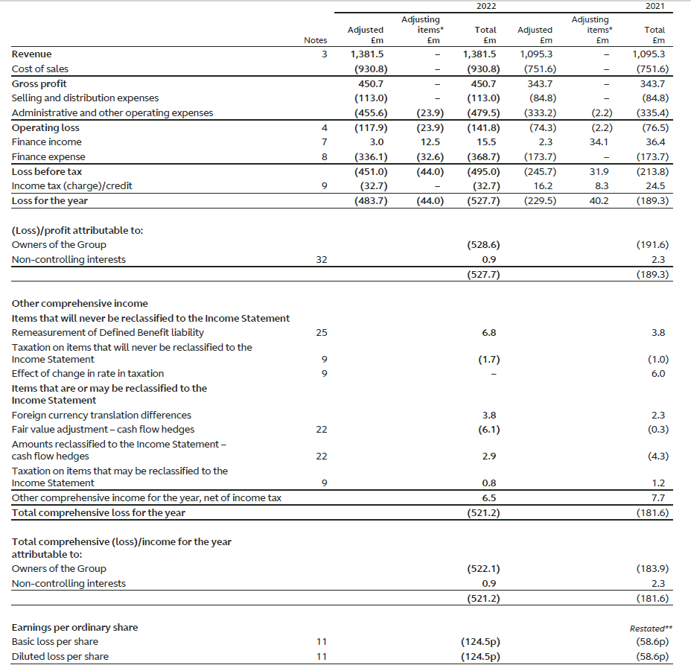
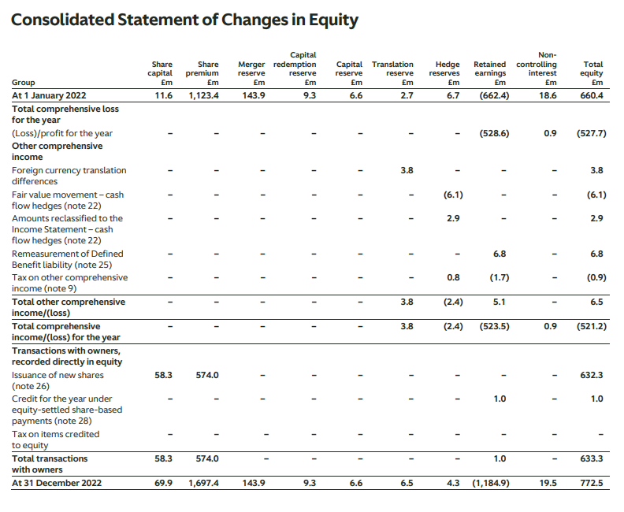
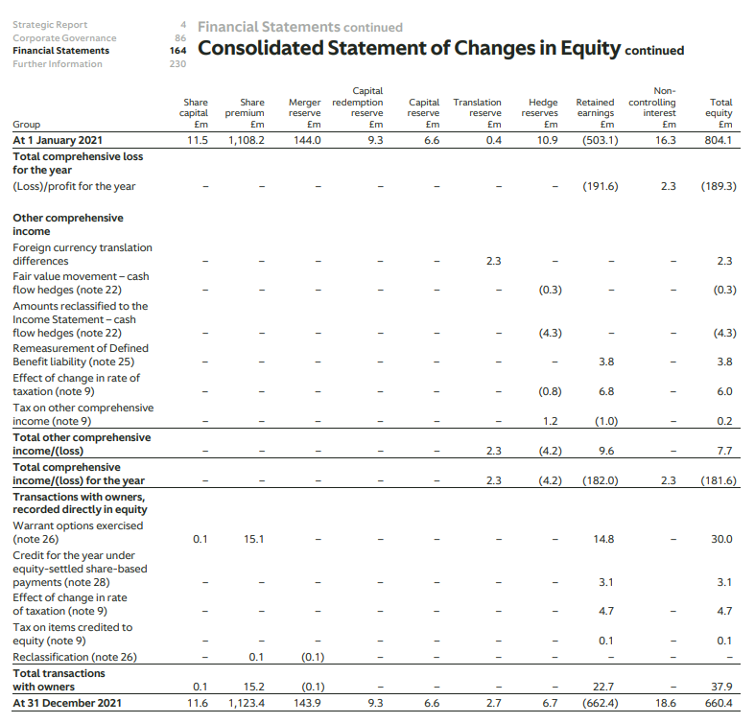
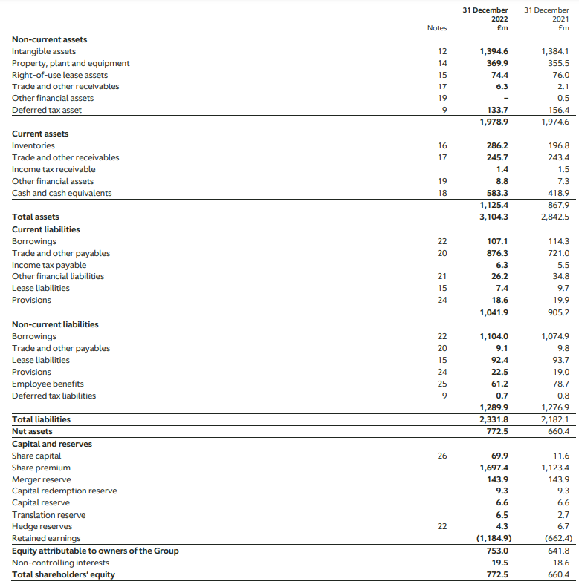
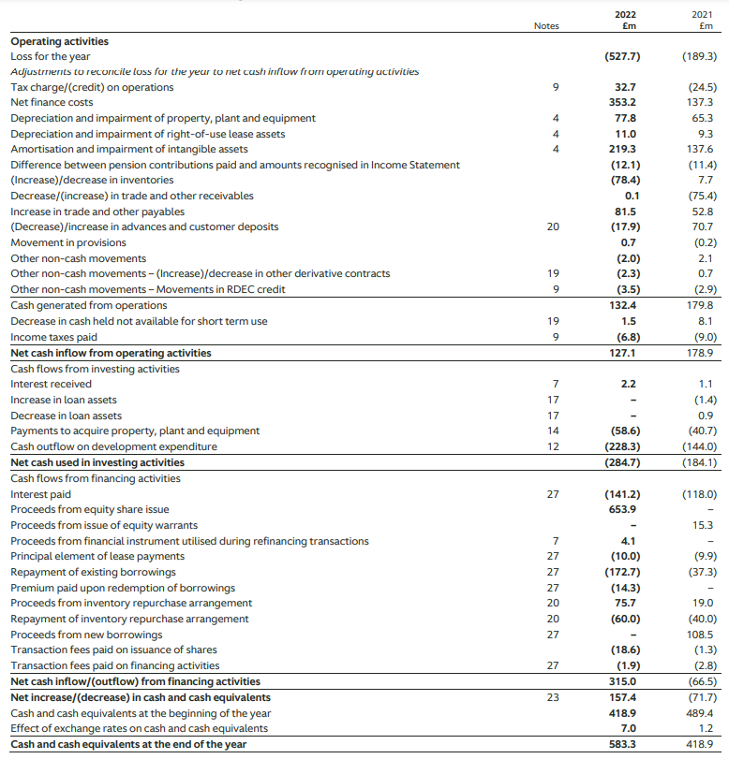
(Aston Martin Lagonda, 2022)

