MODULE NAME:

UNIVERSITY OF WALES TRINITY ST DAVID LONDON CAMPUS
PSYCHOLOGY FOR HEALTH AND SOCIAL CARE

MODULE CODE:
BMHP4003

ASSIGNMENT TITLE: APPLYING PSYCHOLOGICAL PERSPECTIVES IN HEALTH AND SOCIAL CARE

MODULE LEADER: DIYA GANGULY

STUDENT NAME: MARIS GARUBA

STUDENT NUMBER: 1910039

Contents
INTRODUCTION 2
ADOLESCENCE 2
LIFESPAN PSYCHOLOGICAL THEORIES AND THEIR RELATIONSHIP WITH ADOLESCENCE 4
JEAN PIAGET’S COGNITIVE DEVELOPMENT THEORY 4
ERIC ERICKSON PSYCHOSOCIAL THEORY 6
HUMAN COGNITION EMOTIONS AND BEHAVIOUR PATTERNS OF ADOLESCENCE 8
RESEARCHES 9
CONCLUSION 9
REFERENCES 9

INTRODUCTION
The aim of this assessment is to produce an academic essay on the basis of theoretical perspectives in relation to developmental psychology. Relevant research studies will be carried out to signify the role of psychological perspectives as related to Health and Social Care. Developmental psychology refers to changes that occur continuously across the lifespan from childhood to adulthood and are influenced by factors ranging from biological to environmental (Pitts and Phillips, 2017) This study focuses on human growth and the changes such as physical, cognitive, social, intellectual personality and emotional occurrence across the lifespan.
Human development occurs in several stages such as prenatal development, infancy, toddlerhood, childhood, adolescence, early childhood, middle adulthood and late adulthood. For this essay, the focus will be on adolescent stage of development.

ADOLESCENCE
The term adolescent is known as Adolescere in Latin, which translates as to grow up. Adolescence is the time period of development in which several changes occurs in an individual that turns him or she into an adult .It is marked by physical, mental, emotional and psychological changes. The age ranges from thirteen to nineteen which is also referred to as the teen age. Adolescence starts at the onset of puberty and stops when the adolescent transitions into adulthood. During this time the individuals form their personal and social identities. Their reasoning skills are developed and they explore new adventures and figure out what they want you become in life. Several limits are tested, they become autonomous/independent, awareness of self and they tend to experiment with drugs.
Among the life stages, adolescence is the most prolonged transition stage in which an adolescent is neither a child nor an adult. Besides, they are faced with the challenges of unpreparedness of parents and other social institutions for the assumption of adult responsibility. In the past, adolescence has been seen as a stage of stress and storm, and the daunting challenges experienced in adjusting to adulthood and its responsibilities are perceived as normal experiences for all adolescents. However, the daunting challenges, stress, and storms that the adolescents' experience is neither inevitable nor universal. Some of the notable problems displayed in this stage of development include conflicts with parents, mood disruption, and risky behaviours
During the early stage of adolescence, children grow more quickly and various body changes occur such as hair growth under the arm and genitals, female breast development, and enlargement of male testicles. These changes often begin early in girls than boys.
A notable psychological transformation at the adolescent stage of development include development of reproductive organs, with boys beginning to experience a break in their voices as it becomes low and hoarse, development of acne, while girls experience menstruation periods. Girls begin to experience breast development and enlargement, and drastic growth and development of body shape, like widening of the waist and weight gain. Adolescents are challenged to gain independence, especially by attempting to find their identity and expression of who they are in society (Bee, 2017). As they attempt to blend into society, they delve into different roles and responsibilities, facilitating self-identity amongst them. Many teens become interested in sexual and romantic relationships. Some would begin to question their sexual identity, which is often a stressful time without the support of peers or family. This time is often characterised with self-stimulation or masturbation. Most adolescents at this stage engage in more arguments with their parents as they fight to gain more independence. Less time is spent with family and more time is spent outside the home with friends. They are more particular about their appearance and there is increase in peer pressure. Although adolescents are able to think abstractly at this stage and give consideration to the bigger picture, they often lack the ability to apply it to the present moment

LIFESPAN PSYCHOLOGICAL THEORIES AND THEIR RELATIONSHIP WITH ADOLESCENCE
There are several psychological theories which are commonly used in association with different life stage developments as individuals’ transition from childhood to adulthood. These theories play critical roles in explaining why people exhibit particular behaviours at different developmental stages. The psychological theories include Jean Piaget’s Cognitive Developmental Theory, Eric Erickson’s Psychological Theory, and Kohlberg’s Moral Development Theory. However, this essay will be focused on Piaget's cognitive developmental theory and Eric Erickson's psychological theory and establishes how these psychological theories are applicable in the adolescent life stage.

JEAN PIAGET’S COGNITIVE DEVELOPMENT THEORY
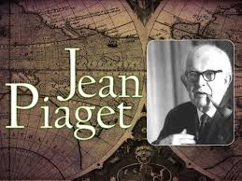
Jean Piaget was a Swiss theorist who developed his cognitive theory on the basis that children gain knowledge by exploration and manipulation of the world around them. Jean Piaget’s cognitive developmental theory focuses on cognition and cognitive development as one develops and transitions from childhood through adolescence to adulthood. The theory explores the cognitive system's ability to develop through various stages of development (Burgess et al., 2017). This theory looks at what brings about the shift in how we think and reason as we transition from one stage to another However, adolescents are capable of dealing with new ideas. Piaget's cognitive development theory facilitates the development of egocentrism among adolescents, making them explore and understand real-life situations.
Adolescents tend to engage in various transformations, which facilitate critical thinking when confronted by different challenges. The theory argues that cognitive development occurs in different stages, with the first stage involving sensory-motor, which starts functioning at birth when the infant cannot think. They rely on their five senses. This stage is often from 0-2 years. At this stage of cognitive development, children can only think of the immediate things they are doing now and not what is in front of them. The second stage of cognitive development occurs at the age of 2 years and is known as pre-operational (Burgess et al., 2017). Here, children begin to develop symbolic thinking abilities. However, they are still incapable of arguing and reasoning logically.
The third and fourth stages are the concrete operational and formal operations, respectively. The latter stage occurs at the age of 6 or 7 years and is characterized by logic but limited thinking and reasoning. However, the former occurs at the age of 11 or 12 years and is characterized by logical thinking and application of abstract ideas. Piaget argued that cognitive development is most dominant among adolescents because it initiates the continuous creation and application of abstract knowledge, including its assimilation and interpretation.
However there are various criticisms to Piaget’s theory of cognitive development. Firstly, kids often acquire these skills sooner than Piaget stated timeline. It is evident that children develop various skills at various timeline which are not as specific as Piaget stated. External factors were not taken into considerations.
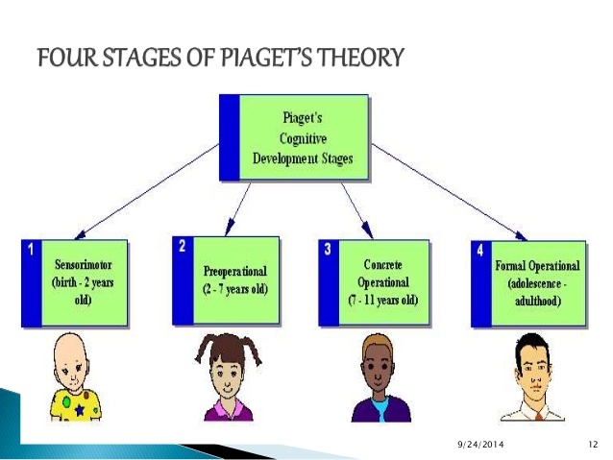

ERIC ERICKSON PSYCHOSOCIAL THEORY
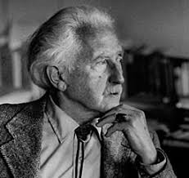ERIC ERICKSON (1902-1994)
On the other hand, Eric Erickson (1902-1994) psychosocial theory emphasizes how personality development occurs in human beings. He was a stage theorist who modified Freud’s psychosexual development theory to psychosocial theory. According to the theory, people experience personality development throughout their lifespan. Eric Erickson identified eight psychosocial crises that every individual undergoes throughout the lifespan. These include trust versus mistrust, autonomy versus shame, initiative versus guilt, industry versus inferiority, identity versus role confusion, intimacy versus isolation, generativity versus stagnation, and ego integrity versus despair.

However, he singled out identity versus role confusion stage to be associated with adolescence life stage. According to Eric Erickson, this is the fifth stage of psychosocial development and occurs from 12 to 18 years. During this stage, adolescents are coupled with the challenge of personal and self-identity search through intense assessment and exploration of personal goals, beliefs, and values.
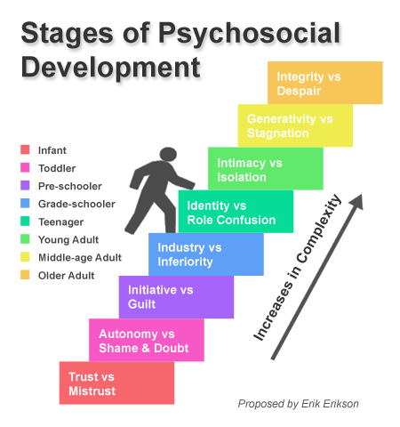
Adolescence marks a very important stage of human growth and development as one transition from childhood to adulthood. Children become more autonomous and start to focus on future aspects such as families, relationships, careers, among others. At this stage, children begin to acquire a sense of responsibility, which they might assume. Furthermore, adolescents start to re-examine their identity to know who they are in society. According to Erickson, the sexual and occupational identities are experienced at this particular stage. Moreover, there is significant body change at the adolescence stage. According to Erickson, adolescents may, at some point, feel ashamed of their bodies as they transition into adulthood. This stage also marks the beginning suicidal thoughts.
Failure to develop a sense of identity during this period leads to role confusion in the future, as many will confess not knowing what to do at a particular time. An adolescent's ability to successfully transition from one stage to another is primarily dependent on the ability to have a strong sense of identity and ability to commit to personal values and beliefs when faced with challenges or ideologies of other people.

HUMAN COGNITION EMOTIONS AND BEHAVIOUR PATTERNS OF ADOLESCENCE
Human cognition primarily focuses on the growth and development of adolescent’s ability to logically reason and think. It often occurs between the ages of 12 to 18 years. Based on these considerations, adolescents can compare or debate different ideas and perspectives with others. Jean Piaget believes that adolescents use trial and error to tackle problems, and is able to form abstract and egocentric thoughts and he termed this the formal operational stage. While Erickson referred to this stage as identity vs confusion. Adolescents tend to be egocentric and they desire to feel and be treated as important in their peer groups. They tend to pull away from their parents and the relationship between the parent-child plays a vital role at this stage. Having healthy and warm parents’ leads to positive outcome with good grades and less trouble at school. But an unsupportive parent –child relationship gives rise to a negative outcome with fear of rejection and less confident.
Emotional reactions often dominate adolescence as most adolescents are confronted with a series of the decision-making process as well as rapid social, physical, and psychological development. Although people often associate adolescence with negative emotions, there are various positive emotions associated with this stage. These include satisfaction, surprise, happiness, concern, gratitude, expectations, and admiration. However, some of the negative emotions in this stage include sadness, anger, fear, bitterness, jealousy, anxiety, guilt, and shame.

RESEARCHES
There has been some recent researches carried out in the UK in relation to health and social care as it affects individuals. Layard and Dunn (2009) survey of 14-16 year olds, found and reported that of the 8,000 individuals surveyed, most stated that in order to have good and fulfilled life, most preferred to have good teachers and also have control of their learning.
In 2007, Morris et al, suggested and made a proposition that parents had a major influence in the emotional dispositions of children using three mechanisms: observation of parents’ emotions, parenting practices and emotional climate of the family.

CONCLUSION
In conclusion, adolescence is the stage of development that has some important physical, emotional and psychological milestones which the theorists, Jean Piaget and Erickson researched on.

REFERENCES
Baltes, P.B., Staudinger, U.M., and Lindenberger, U., 2017. Lifespan psychology: Theory and application to intellectual functioning. Annual review of psychology,
Bee, H.L., 2017. Lifespan development. New York, NY: HarperCollins Publishers.
Burgess, D., Van Ryn, M., Dovidio, J., and Saha, S., 2017. Reducing racial bias among health care providers: Lessons from social-cognitive psychology. Journal of general internal medicine, 22(6), pp.882-887.
Pitts, M., and Phillips, K. eds., 2017. The psychology of health: an introduction. Psychology Press.
https://www.silverridgerecovery.com/blog/2018/april/lifespan-developmental-psychology-addiction-and-/
Layard, R., and Dunn, J. (2009). A Good Childhood: Searching for Values in a Competitive Age. London: Penguin Books.
Rees, G., Goswami, H., Pople, L., Bradshaw, J., Keung, A., and Main, G. (2012). The Good Childhood Report 2012: A summary of our findings. London: The Children's Society.

