Louise Puresevic – 2005324
BMSK6007
Retention of staff within Cwm Taf UHB

The pressures for healthcare providers continue to grow. Down to finances and tighter budgets, GP waiting times, A&E queues, continuing increase of patients and how we treat them including appointment and surgical waiting times and access to care. However, one of the biggest areas of crisis in the NHS is the staffing pressures. This assignment focuses on the current staff crisis that we face today, the pressures facing the NHS in Wales, in particular within Cwm Taf UHB Trust.
In 2020, the unprecedented arrival of the Covid-19 pandemic brought worldwide changes in our everyday lives. The NHS was then cast many more problems.
A profession that was already under crippling pressures swifty escalated to a service that despite cash boosts was still having to negotiate rising A&E numbers, not only with regular casualty cases but also with Covid-19 patients, resulting in lack of bed space and the increase of waiting times. The increase in patient numbers resulted in the building of additional treatment space in the form of field hospitals. And what of the workforce? The aim of this assignment is to study the effect on staff within Cwm Taf UHB and the impact on staff turnover.
The entire experience of the NHS should be one that is easy and straight forward. Cwm Taf UHB serves over 450,000 living across the three county boroughs of Rhondda Cynon Taf, Merthyr Tydfil and Bridgend. It provides health services consisting of primary care, community services, mental health and acute hospital care. By 2036 it is predicted that 1 in 4 people will be aged 65 or over (CTMUHB, 2022). This is usually a critical age bracket of those requiring medical care. Many aspects of the service are to offer care to patients, guidance for visitors and encouragement for its staff. The care of the staff looking after these patients should be a critical point also.
The launch of the organisation’s values, attitudes and behaviours programme by the Health Board on World Values Day on October 15th 2020, looked to offer a positive opportunity to its employees, as well as the patients and service users across the board. To encourage a difference in the way the service was run and the treatment of staff and service users, to build a service that it can be proud of. The encouragement of implementing these values across the board and its staff members offers the opportunity for the trust to look at how they can improve the service, offering patient care to a higher standard, making the best decisions and supporting one another within the workplace. There are many ways to focus on patient engagement, offering training and skills opportunities to staff to be able to present a first-class service.
The Cwm Taf UHB organisational values (CTMUHB, 2022) give staff the best opportunity to offer these three key points:
“We listen, learn and improve” – showing enthusiasm, looking forward to working and learning.
“We treat everyone with respect” – Patient care is top priority. But so is staff advocacy, treat others the same way you would want to be treated.
“We all work together as one team” - with effective leadership from senior levels and good partnership teamwork.
These values encourage the workforce to work together, make change happen, improve and show initiative to progress.
Identifying the staffing issues in the locality of Cwm Taf UHB alone, this assignment focuses on how the staff have coped with the impact of working conditions, studying these facts in relation to the wider aspect of the NHS on a national scale.
Since the Covid-19 pandemic, there has been an increase of staff absence, mostly relating to sickness. Much of this is long term sickness, depression and burnout. Statistics 12 months ago for the year to September 2021 showed a record high in its sickness rate, as shown in Appendix A (Sherwood, 2022). Slowly rising over the previous 3 years or so, but an increase was noticeable since the start of the Covid-19 pandemic. This example shows how going back to this time last year, we can see that numbers had increased for the trust, in particular the Welsh Ambulance Service, followed by Swansea Bay and Cwm Taf Morgannwg. Cwm Taf Morgannwg can be seen to have a significant rise in the percentage of sickness that the same time in 2020.
Following the annual survey of staff in the NHS, the Chief Executive of the NHS Confederation, Matthew Taylor (Taylor, 2022) said in response to the published results that overall findings were not a surprise, especially following the unprecedented pressures that the NHS and its workforce had faced over recent time, in particular the timescale of the Covid-19 pandemic.
Mr Taylor explained that “The fall in staff morale is a real cause for concern, in the numbers of staff who are considering leaving the workforce which has risen to just under a third (31%) since last year. There has also been a noticeable drop in the number of staff recommending the NHS as a place to work”.
This is a particularly important statement that has a significant impact on future workforce. Mr Taylor also stated that “There are also significant areas of concern especially around the health and well-being of staff. The NHS leaders are very aware that more can be done in this area
Cwm Taf UHB has a workforce of nearly 12,000 making it one of the largest employers across South Wales, though overall, there is a relentless demand being placed on staff, with staffing vacancies now standing at 110,000 on the whole. These chronic shortages will get worse before they get better. The usual reports of not having enough staff available in most departments across the trust is an unfortunate but very common factor. This is likely to lead to pressures such as staff becoming overworked, patients demand the same treatments, but the work cannot be completed in the same professional way due to changes in timings, the service being offered and overtime becoming a regular event.
This assignment aims to study the levels of absence within the Cwm Taf UHB trust, in particular The Princess of Wales Hospital in Bridgend. It will focus on how issues can be addressed by sourcing solutions and implementing a structured workplace plan to encourage a better understanding in staff requirements and support mechanisms to benefit the workplace and offer a service that can function more effectively.

References
https://ctmuhb.nhs.wales/about-us/ (2022). Accessed16 September 2022.
ttps://ctmuhb.nhs.wales/jobs/ (2022). Accessed 22 September 2022.
https://gov.wales/sickness-absence-nhs-july-september-2021 (Last updated 16 February 2022). Accessed 17 September 2022.
https://www.nhsconfed.org/news/fall-staff-morale-real-cause-concern. (30 March 2022). Accessed 18 September 2022.

Appendices
Appendix A – NHS Wales sickness statistics 2020 – 2021

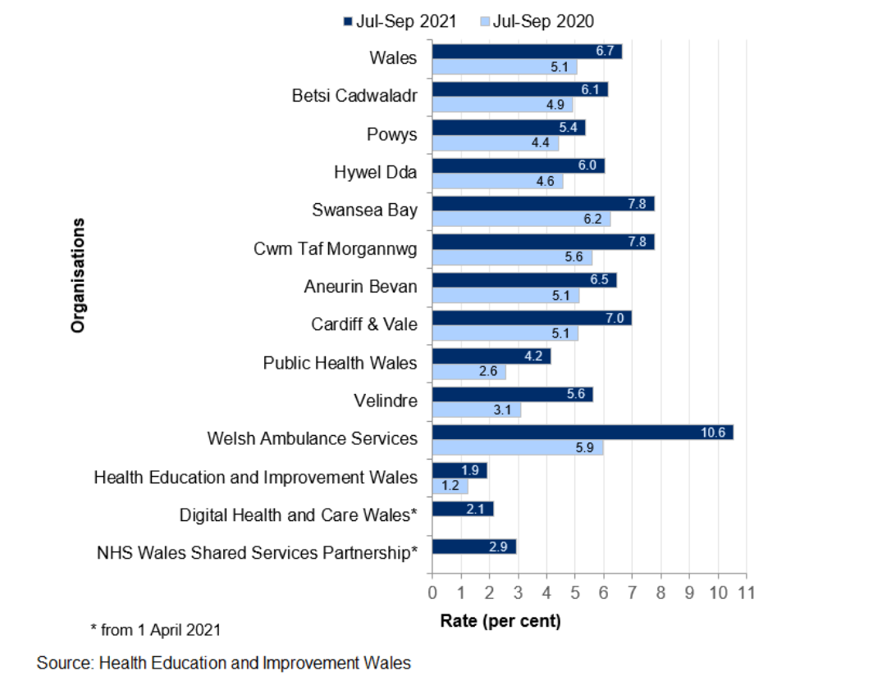
(Sherwood, 2022)

