Jo Edwards (2117195)

An analysis of Aston Martin Lagonda Global Holdings PLC company performance during financial years 2020 and 2021, based on financial metrics for said years, available publicly in the annual reports; and compiled to inform potential collaboration related investment .
s
Report: Collaboration with Aston Martin Lagonda
A Risk Management Assessment

Contents
Introduction. 2
Aston Martin Lagonda background 2
Assumptions 2
Objective 2
Financial Ratios 3
Ratio analysis 3
Financial Ratios 3
Liquidity 3
Leverage 4
Activity 4
Profitability 5
Limitations of financial ratios 5
Aston Martin Lagonda financial ratios for year-end 31st Dec 2020, 31st Dec 2021 6
Ratio trends 2020-21 9
Ratio Trend Analysis Summary 9
AML Ratio comparison with the Automotive sector (US based manufacturers). 10
AML, Structure, Stock price History and significant events 12
Sector financial ratio comparison AML and PORSCHE AUTOMOBIL HOLDING 13
Performance and Market View 14
Conclusion 16
Cons. 16
Pros. 16
Recommendations. 16
Bibliography 17
AML Financial ratio calculations 20

Introduction.

Aston Martin Lagonda background
“Aston Martin Lagonda Global Holdings PLC is an English manufacturer of luxury sports cars and grand tourers. Its predecessor was founded in 1913 by Lionel Martin and Robert Bamford. Steered from 1947 by David Brown, it became associated with expensive grand touring cars in the 1950s and 1960s, and with the fictional character James Bond following his use of a DB5 model in the 1964 film Goldfinger. Their sports cars are regarded as a British cultural icon.[3] Aston Martin has held a Royal Warrant as purveyor of motorcars to the Prince of Wales since 1982,[4] and has over 160 car dealerships in 53 countries, making it a global automobile brand.[5] The company is traded at the London Stock Exchange and is a constituent of the FTSE 250 Index.[6] In 2003 it received the Queen's Award for Enterprise for outstanding contribution to international trade.[7] The company has survived seven bankruptcies throughout its history.[8] “ (Wikipedia Contributors, 2019)

Assumptions
Company ABC is specialist car service provider exploring working with Aston Martin Lagonda (ASTON MARTIN LAGONDA GLOBAL HOLDINGS PLC), to enable the collaboration, Company ABC will be required to invest £5m.
The collaboration could be manufacturing parts, parts supply, or automotive retail, any of which activity would require a significant investment from Company ABC.

Objective
The purpose of the financial analysis is to determine the financial health and predict future performance of Aston Martin Lagonda Global Holdings PLC (AML) based on the publicly available financial statements for years ending 31st December 2021 and 31st December 2022 and present a risk analysis to the board of ABC in respect of the proposed investment of £5M, the risk is analysed solely on the merits of the AML’s financial robustness and future viability as measured or projected from the financial statements. The differences, as calculated by a range of standard financial ratios, between the two will be discussed and relevance to the business health in a number of categories examined, including a limited comparison to those financial ratios considered average or indicative of the automotive industry in general.

Financial Ratios

Ratio analysis
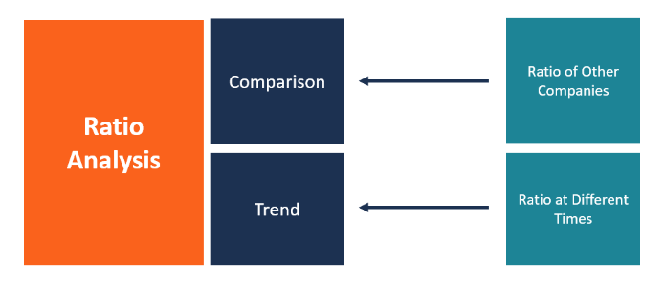
Fig. 1 From (CFI Team, 2022b)
Ratio analysis assists in rapid comparisons of the chronological trends for a company within each ratio category and further compares the financial health and sector specific performance, or potentially for investors seeking opportunities, where the company is positioned within a broad spectrum of investment opportunities.
Trendline analysis helps predict future performance and may also be examined in context of changing market drivers, demand, or geopolitical state changes.

Financial Ratios
Financial Ratios are generally considered in respect to four categories.

Liquidity
Liquidity ratios are calculated by placing the current liabilities of the company in denominator and dividing the liquid assets. A ratio of less than 1 would suggest the company was unable to meet its current liabilities. Ratios greater than 1 suggests the company is able to meet its current financial bills and the larger the ratio, the greater the ability to satisfy liabilities with ease.
Three main liquidity ratios are normally considered;
- Current ratio is the quickest and broadest test, readily available from the financial statements.
- Quick ratio is a stricter test, and considers cash, accounts receivable and any marketable securities assets.
- Cash ratio further ignores the accounts receivable element of the quick ratio assets (the customer may not pay or be slow to pay and hence the immediacy of the asset is not assured) and represents the strictest liquid test, one of immediate or near immediate ability to meet demands for settlement of short-term liabilities.
From an investors point of view, a liquidity ratio of at 1 is desirable, 2 or three preferable, however a significantly higher liquidity ratio may flag improper levels of cash holdings or other highly liquid assets, surplus cash or assets which could and should be if appropriate, be used to grow value in the company for the benefit of the shareholders.

Leverage
Leverage ratios indicate how the business is financed by examining the level of company debt against cashflow, balance sheet or income statement accounts and specify the level of utilisation of debt employed in company operations.
Gearing ratio (also known as Debt/Asset ratio) effectively define the level of long-term debt in relation to the company assets, it is generally accepted that a ratio of less than 50% is within the ‘safe zone’.
Debt/Equity ratio in contrast to Gearing ratio considers the total debt (including short term debt) in respect of the total equity of the company and reflect the degree of reliance of the company on borrowing or equity financing for its operations, in other words reflecting the company’s capital structure. High Debt /Equity is desirable (up to a certain level) as it demonstrates the serviceability of the company debt obligations. Too high a D/E may result in increased cost of borrowing and lead to difficulty in servicing debt.
Long Term Debt/Equity ratio determines how much leverage a company is holding. High LTD/E points to high debt in the financial structure of the company and indicates a financial risk.
Interest coverage is simply an indicator of how easily a company can service the interest payments on its debt. The calculation takes the earnings before interest and tax (EBIT) and divides it by interest expense within accounting period.

Activity
Days Sales Outstanding (DSO) measures how quickly customers pay for the company’s good or services, averaged in days in a particular accounting period. Every business would prefer a low DSO to enable cash flow and reduce working capital borrowing and associated interest.
Days Payable Outstanding (DPO) in contrast to DSO, measures how quickly the company responds to a supplier invoicing, again measured average days in any accounting period. DPO has benefits and adverse effects for the company and supplier, respectively. Benefits include retention of capital, thereby reducing demand for working capital borrowing, the benefits increasing as DSO increases, on the flip side a higher DSO than sector norm spotlights the ‘bad citizen’, in some sectors this is offset by high competition to become suppliers to the company due to the rewards of being so. The supplier however experiences the negative effects of a high DSO relationship with the company, and the cashflow / potential additional financing burden that entails.
Inventory Turnover is a measure of cost of product or cost of inventory sold in a given accounting period relative to the average stock held in inventory for that period. Sector averages do vary, complexity of product, discount in inventory volume purchase and seasonality in buyer trends may all have an effect on the level of acceptable inventory turnover ratio for any particular sector.

Profitability
Gross Profit Margin is the percentage of sales revenue after deduction of the cost of sales. Simply it is how much profit the company makes after meeting the Cost of Goods Sold (COGS). At a higher-level Gross
Operating Margin or return on sales is the revenue residual after deducting operational expenses. Operating Margins further deduct operating costs form the Gross Profit Margin.
Net Profit Margin is the percentage of profit after deducting all company expenses or costs from total revenue and dividing that (net profit) by the total revenue, expressed as a percentage.
Return on Assets is an indicator of the efficiency of a company operations or management in utilisation of its available assets, to realise profit for each unit of asset.

Limitations of financial ratios
A number of caveats exist when interpreting financial ratios in respect of company financial stability, performance or potential.
- Ratios are based on figures in disclosed figures from accounts, therefore can be subject to approximations, errors, and deviations in practices in accounts preparations.
- Ratios rely on comparability, preparation methodologies which differ between companies in considering treatment of key final amounts, such as valuation of inventory, asset depreciation and useful life.
- Inflation may or may not be utilised in the accounting for current asset values, and may rather be based on historical values, such as cost at time of purchase or not reflective of future (expected) product revenue versus current revenue.
- Differences in size, geolocation, diversity of products and desirability of product are a few examples of how even within a given sector, ratios may not reflect a true picture of a company’s financial performance.
- Published ratios may depend on slightly differing approaches to determining the elements that comprise the numerator and denominator, potentially skewing the ratio for comparative consideration.

Aston Martin Lagonda financial ratios for year-end 31st Dec 2020, 31st Dec 2021
 |  |  |  |  |  | at 31 December 2021 £m | at 31 December 2020 £m
LIQUIDITY RATIOS | 1 | Current Ratio | = | Current Assets | u | 0.96 | 1.10
 |  |  |  | Current Liabilities
LIQUIDITY RATIOS | 2 | Cash Ratio | = | Current Assets (Cash & Obligation) | u | 0.46 | 0.61
 |  |  |  | Current Liabilities
LIQUIDITY RATIOS | 3 | Quick Ratio | = | Current Assets (Cash, Obligation and Account Receivables) | u | 0.74 | 0.84
 |  |  |  | Current Liabilities
LIQUIDITY RATIOS | 4 | Net Working Capital Ratio | = | Current Assets - Current Liabilities (Net Working Capital) | u | -0.01 | 0.03
 |  |  |  | Total Assets
LEVERAGE RATIOS | 5 | Debt Ratio | = | Total Liabilities | u | 330.42% | 247.57%
 |  |  |  | Total Equity
LEVERAGE RATIOS | 6 | Long Term Debt to Equity Ratio | = | Total Debts (Long Term Liabilities) | u | 193.35% | 147.05%
 |  |  |  | Total Equity
LEVERAGE RATIOS | 7 | Equity Ratio | = | Total Equity | u | 23.23% | 28.77%
 |  |  |  | Total Assets
LEVERAGE RATIOS | 8 | Interest Coverage Ratio | = | Earning Before Interest and Taxes | u | 181.19% | 566.22%
 |  |  |  | Interest Payments
 | 9 | Gearing Ratio |  | Noncurrent liabilities | u | 65.91% | 59.52%
 |  |  |  | equity + noncurrent liabilities
ACTIVITY RATIOS | 10 | Working Capital Turnover | = | Sales Revenue | u | -29.36 | 7.53
 |  |  |  | Current Assets - Current Liabilities
ACTIVITY RATIOS | 11 | Inventory Turnover | = | CoGS | u | 3.72 | 2.45
 |  |  |  | 2 period Inventory avearge
ACTIVITY RATIOS | 12 | Assets Turnover | = | Sales Revenue | u | 0.39 | 0.22
ACTIVITY RATIOS | 12 | Assets Turnover |  | Total Assets
ACTIVITY RATIOS | 13 | Receivable Turnover | = | Sales Revenue | u | 5.57 | 2.95
ACTIVITY RATIOS | 13 | Receivable Turnover |  | Inventory
 | 14 | DSO | = | Trade and other receivables | u | 81.11 | 106.14
 |  |  |  | Av Revenue per Day
 | 15 | DPO |  | Trade and other payables | u | 350.14 | 422.01
 |  |  |  | Av. COGs per Day
PROFITABILITY RATIOS | 16 | Net Profit Margin | = | Net Profit | u | -17.28% | -67.10%
PROFITABILITY RATIOS | 16 | Net Profit Margin |  | Sales Revenue
PROFITABILITY RATIOS | 17 | Gross Profit Margin | = | Gross Profit | u | 31.38% | 18.16%
PROFITABILITY RATIOS | 17 | Gross Profit Margin |  | Sales Revenue
PROFITABILITY RATIOS | 18 | Operating Margin | = | Gross Profit after Expenses | u | -6.98% | -52.76%
PROFITABILITY RATIOS | 18 | Operating Margin |  | Sales Revenue
PROFITABILITY RATIOS | 19 | Return on Assets (ROA) | = | Net Profit | u | -6.66% | -14.69%
PROFITABILITY RATIOS | 19 | Return on Assets (ROA) |  | Total Assets
PROFITABILITY RATIOS | 20 | Return on Equity (ROE) | = | Net Profit | u | -28.66% | -51.05%
PROFITABILITY RATIOS | 20 | Return on Equity (ROE) |  | Total Equity
PROFITABILITY RATIOS | 21 | Basic Earning Power Ratio | = | Gross Profit after Expenses | u | -2.69% | -11.55%
PROFITABILITY RATIOS | 21 | Basic Earning Power Ratio |  | Total Assets
INVESTOR RATIOS | 22 | EPS (in GDP pence) | = | Net Profit | u | -543 | -165.9
INVESTOR RATIOS | 22 | EPS (in GDP pence) |  | Total common shares outstanding |  | (from Financial Statements)
INVESTOR RATIOS | 23 | Dividend Cover | = | Net Profit | u | 0.00 | 0.00
INVESTOR RATIOS | 23 | Dividend Cover |  | Dividend proposed and paid
INVESTOR RATIOS | 24 | Price per earnings | = | Market Value per share | u | 0.00 | 0.00
INVESTOR RATIOS | 24 | Price per earnings |  | EPS
INVESTOR RATIOS | 25 | Dividend Yield Ratio | = | Dividend per share | u | 0.00 | 0.00
INVESTOR RATIOS | 25 | Dividend Yield Ratio |  | Market Value per share
INVESTOR RATIOS |  |  |  | AML has not paid dividends since floating 2018

Ratio trends 2020-21
Liquidity ratios show at a base level AML has significantly less liquidity in 2021 than in 2020, all of the ratios reduce by at least 10%, the Current Ratio and Quick Ratio falling below the accepted safe zone of >1.
Leverage Ratios indicate substantial jumps in indebtedness in 2021 against 2020. Immediate and long-term debt exposure both rose by about approx. 30% over 2021 levels. Equity Ratio decreased by over 5 percentage points showing a decrease in shareholder value. Interest Coverage Ratio plummeted by just short of 400% points flagging a drop in headroom to service borrowing, albeit still above the absolute minimum 100% ratio safe level. Gearing Ratio increased by approx. 10%.
Activity Ratios, both DSO and DPO reduced indicating AML had improved both paying suppliers and recovering payments however the DPO appears extreme. Inventory Turnover increased by approx. 90% indicating more efficient turnover of goods in 2021 against 2020. Both Asset Turnover and Receivable Turnover did increase in 2021 showing the return on the invested capital generated significantly more than the previous year.
Profitability Ratios, an improvement was seen in Net Profit, Gross Profit and Operating Margins although the company remains unprofitable in both 2020 and less in 2021, as interpreted through the calculation of the Profitability Ratios.

Ratio Trend Analysis Summary
- Liquidity deteriorated from 2020 to end of 2021.
- Leverage ratios worsened, demonstrated an increase in exposure to debt risk
- Activity ratios show increased inventory turnover so increase in production savings or stock management. Positive trends in DSO and DPO show better payment strategies for both suppliers and customers although the metrics remain arguably poor.
- Profitability ratios collectively improved although it is noted the company is not in profit by 2021 and has not been in profit in recent trading history (at least since 2018 market floatation), the trend is in an upwards direction.

AML Ratio comparison with the Automotive sector (US based manufacturers).

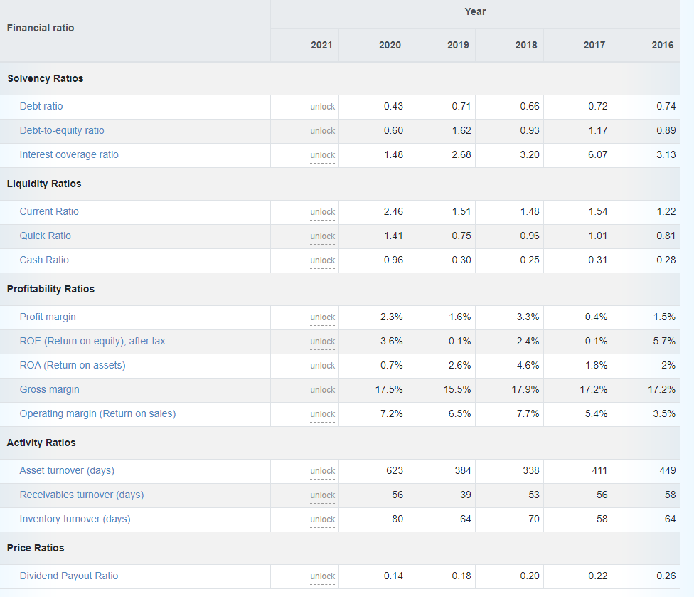
Fig. 2 from (Ready Ratios, 2022)

While Fig. 2 ratios (for general automotive manufacturing) sector were not accessible for 2021, a clear comparison between US based Automotive manufacturing companies and AML can be drawn.
(it is noted Fig.2 average ratios are for the US automotive general sector, and AML is a niche luxury car manufacturer selling mainly in the UK and North America, , however the large sample allows a valid sector comparison)

 | AML 2020 | Average US Auto 2020 | Performance
Liquidity ratios
Quick | 0.84 | 1.41 | -
Current | 1.10 | 2.46 | -
Cash | 0.61 | 0.96 | -
Solvency Ratios
Debt Ratio | 2.47 | 0.43 | -
D/E Ratio | 1.47 | 0.6 | -
Interest Coverage | 5.66 | 1.48 | +
Profitability Ratios
Profit margin | -0.067 | 0.023 | -
Gross Margin | 0.18 | 0.175 | =
Operating Margin | -0.053 | 0.072 | -
ROE | -0.74 | -0.036 | -
ROA | -0.167 | -0.007 | -
Table 1
Table 1 and Chart 1 illustrate AML underperforms in most if not all of the financial ratios against the general US automotive sector in the year 2020.

Chart 1

AML, Structure, Stock price History and significant events

AML is a holding company incorporated July 2018 and is a non-trading business (as defined by SIC 74990)
The Aston Martin company has had a turbulent history experiencing bankruptcy on seven occasions (News, 2018).
Prior to FTSE250 London Market flotation in 2018, private equity managed AML following Ford Motor Company divesting their 70% controlling shareholding (Jones, 2007).
While the company’s press releases are bullish, the market analysts and investors are often less so, as seen in chart 2; as recently as Sept. 2022 the share price plummeted from approx. 500p to 220p compounding an already painful steady drop from the annual high of 902.60 p per share.
Market intelligence projects that the company will not be in profit by 2024, continuing its loss-making track record as may be seen in charts 3 and 4. Although this is a marked turnaround from 2020.
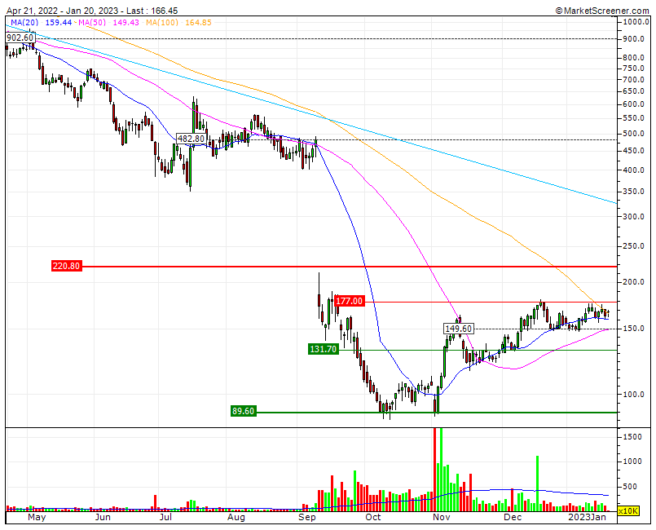
Chart 2 From (MarketScreener, 2023b)

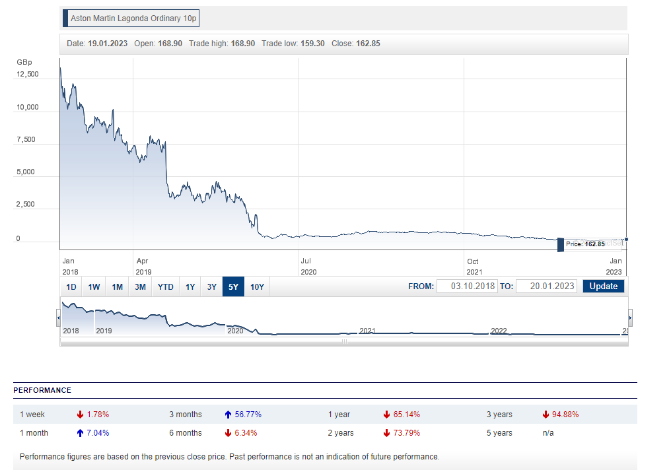
Chart 3 From (Hargreaves Lansdown, 2023b)

Sector financial ratio comparison AML and PORSCHE AUTOMOBIL HOLDING
Whilst it is acknowledged PAH is a magnitude of order larger than AML, a quick comparison highlights the contrast between two luxury automotive manufacturers and sales businesses, both with decades of trading and quite differing trading histories. Notably liquidity is very favourable for PAH and below safe for AML and profitability ratios indicate the reality of lack of dividend opportunity, actual or forecast, for AML versus PAH ‘s healthy position.
 | AML 2021 | PORSCHE AUTOMOBIL HOLDING 2021 | AML v PAH Performance
Liquidity ratios
Quick | 0.84 | 6.3 | -
Current | 1.10 | 6.3  as declared in (TradingView, 2023a) | -
Profitability Ratios
ROE | -0.268 | 0.1168 | -
ROA | -0.068 | 0.1157 | -

Chart 4 from (TradingView, 2023c) & (TradingView, 2023a)

Performance and Market View
AML’s company history, narrowly avoiding insolvency repeatedly does infer creditors may have suffer a reduced premium on outstanding amounts. The rapid growth in production and sales AML is striving for requires significant investment and borrowing, the D/E ratio increased significantly from a less than ideal 247% to 330% over 2021, indicating a jump in debt burden. AML do not have a profit-making history therefore its safe to assume for a company as a whole over the Aston Martin lifetime, investors and lenders have suffered losses as AML phoenixed through the decades. More recently FTSE250 have not been favourable with AML trading at 167p on 20 Jan 2023, less than 20% of the 2022 high, and even the current share price is a bounce from the Sept 2022 90% plummet. The 2018 FTSE250 floatation price was approx. 19GDP. Chart 5 does explain the share price contraction as both the total common share outstanding increasing by a factor of 3 from float to H1’20 with current common share outstanding reaching in excess of 6 times that number issued at the 2018 floatation (TradingView, 2023b).
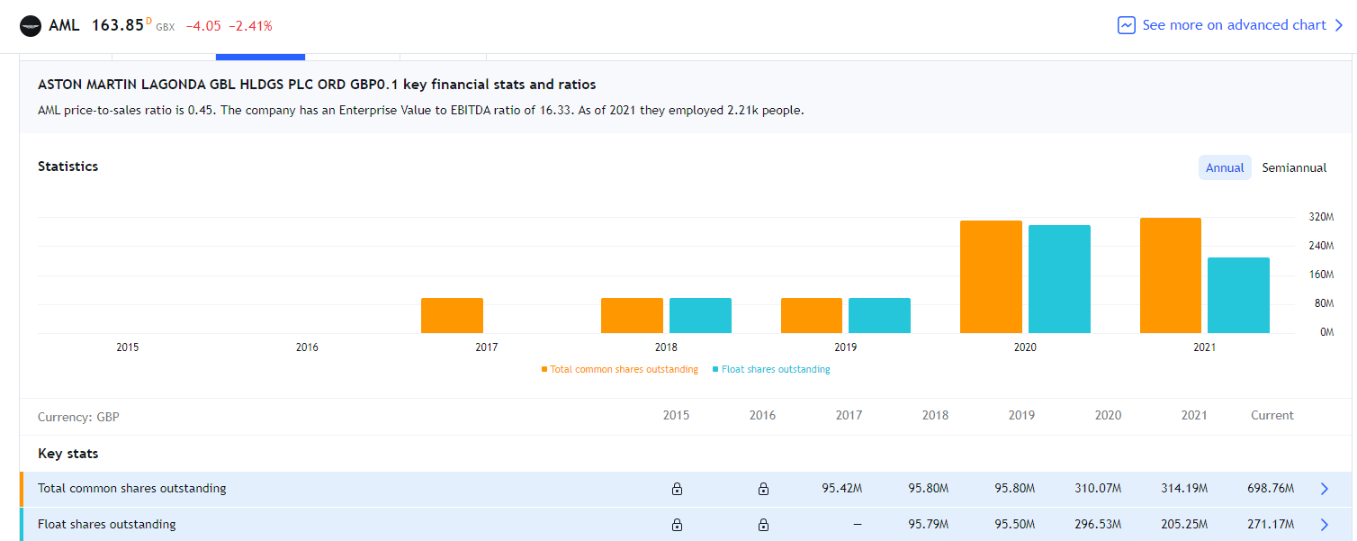
From (TradingView, 2023a)

Market intelligence projects that the company will not be in profit by 2024, continuing its loss-making track record as may be seen in charts 6 and 7. Although there is a marked turnaround from the dip experienced in 2020, at least in part attributable to the effects of the Covid19 pandemic and associated global economic downturn.
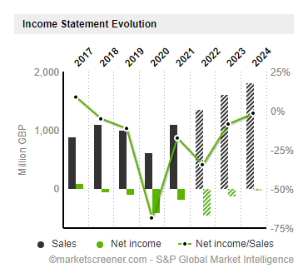
Chart 6 AML From (MarketScreener, 2023a)
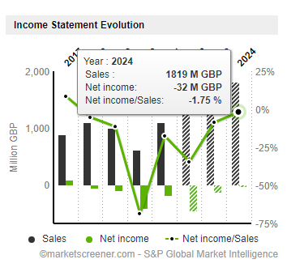
Chart 7 AML From (MarketScreener, 2023a)

Conclusion

Cons.
- Under performance against industry sector financial ratios
- Poor profitability ratios (not in profit and not projected to be)
- High gearing
- Liquidity ratios mainly below safe zone
- Poor debt ratios
- Poor DPO
- Very recent avoidance of insolvency /bankruptcy 2018
- Most likely buoyed by strong brand value.
- Most significant interest coverage ratio high in 2020 but dropping sharply in 2021 by approx. 60% of 2020 levels

Pros.
- AML appear to be striving to stag a siegnificant recovery.
- Acceptable interest coverage.
- Prestigious brand for ABC to be associated with.

Recommendations.
It is not recommended that Company ABC invest 5M GDP in a venture with AML.
The perceived risks presented include low expectancy of acceptable payment terms being met, exposure to AML’s financial stability as demonstrated in the financial ratios, not least the D/E ratio, and AML’s turbulent history of near solvency events.

Bibliography

Ahmed, D. (2022). Top Automotive Industry Financial Metrics. [online] Oak Business Consultant. Available at: https://oakbusinessconsultant.com/automotive-industry-financial-metrics/.
CFI Team (2022a). Liquidity Ratio. [online] Corporate Finance Institute. Available at: https://corporatefinanceinstitute.com/resources/accounting/liquidity-ratio/.
CFI Team (2022b). Ratio Analysis. [online] Corporate Finance Institute. Available at: https://corporatefinanceinstitute.com/resources/accounting/ratio-analysis/.
Compare the Difference Between Similar Terms. (n.d.). Difference Between Gearing and Leverage. [online] Available at: https://www.differencebetween.com/difference-between-gearing-and-vs-leverage/.
find-and-update.company-information.service.gov.uk. (n.d.). ASTON MARTIN LAGONDA GLOBAL HOLDINGS PLC overview - Find and update company information - GOV.UK. [online] Available at: https://find-and-update.company-information.service.gov.uk/company/11488166 [Accessed 19 Jan. 2023].
find-and-update.company-information.service.gov.uk. (n.d.). ASTON MARTIN LAGONDA GROUP LIMITED filing history - Find and update company information - GOV.UK. [online] Available at: https://find-and-update.company-information.service.gov.uk/company/01559668/filing-history [Accessed 19 Jan. 2023].
find-and-update.company-information.service.gov.uk. (n.d.). ASTON MARTIN LAGONDA LIMITED filing history - Find and update company information - GOV.UK. [online] Available at: https://find-and-update.company-information.service.gov.uk/company/01199255/filing-history.
Hargreaves Lansdown. (2023a). Aston Martin Lagonda (AML) Ordinary 10p Statements & Reports. [online] Available at: https://www.hl.co.uk/shares/shares-search-results/a/aston-martin-lagonda-ord-10p/financial-statements-and-reports.
Hargreaves Lansdown. (2023b). Interactive share charts for Aston Martin Lagonda (AML) Ordinary 10p. [online] Available at: https://www.hl.co.uk/shares/shares-search-results/a/aston-martin-lagonda-ord-10p/share-charts [Accessed 23 Jan. 2023].
Hopkins, J. (2022). Aston Martin Lagonda gets target price and estimates cut by Deutsche Bank. [online] Proactiveinvestors UK. Available at: https://www.proactiveinvestors.co.uk/companies/news/997321/aston-martin-lagonda-gets-target-price-and-estimates-cut-by-deutsche-bank-997321.html [Accessed 19 Jan. 2023].
https://amsc-prod-cd.azureedge.net/-/media/corporate/documents/annual-reports/aston-martin-lagonda-global-holdings-plc-annual-report-2021.pdf?rev=28bd14cf04634b888d914b32a783f2bf&hash=08BCE7B57DD899A69FEC934CF8F3D24E. (n.d.). ASTON MARTIN LAGONDA ANNUAL REPORT AND ACCOUNTS 2021.
Jones, M. (2007). Ford to sell Aston Martin in $925 mln deal. Reuters. [online] 12 Mar. Available at: https://www.reuters.com/article/us-ford-astonmartin-statement/ford-to-sell-aston-martin-in-925-mln-deal-idUSWNAS371820070312.
MarketScreener (2022). Aston Martin Lagonda Appoints Andreas Bareis as Regional President for Continental Europe | MarketScreener. [online] www.marketscreener.com. Available at: https://www.marketscreener.com/quote/stock/ASTON-MARTIN-LAGONDA-GLOB-46472778/news/Aston-Martin-Lagonda-Appoints-Andreas-Bareis-as-Regional-President-for-Continental-Europe-42535106/ [Accessed 20 Jan. 2023].
MarketScreener (2023a). ASTON MARTIN LAGONDA GLOBAL HOLDINGS PLC : Shareholders Board Members Managers and Company Profile | GB00BN7CG237 | MarketScreener. [online] www.marketscreener.com. Available at: https://www.marketscreener.com/quote/stock/ASTON-MARTIN-LAGONDA-GLOB-46472778/company/.
MarketScreener (2023b). ASTON MARTIN LAGONDA GLOBAL HOLDINGS PLC : Technical Analysis Chart | AML | GB00BN7CG237 | MarketScreener. [online] www.marketscreener.com. Available at: https://www.marketscreener.com/quote/stock/ASTON-MARTIN-LAGONDA-GLOB-46472778/charts/# [Accessed 20 Jan. 2023].
Mclaney, E.J. and Atrill, P. (2016). Accounting and finance : an introduction. 8th ed. Harlow: Pearson.
News, A.B.C. (2018). British automaker Aston Martin has survived 7 bankruptcies. Now it wants you to invest in it. [online] ABC News. Available at: https://abcnews.go.com/Business/british-automaker-aston-martin-survived-bankruptcies-now-invest/story?id=58417290.
October 12, S. |, Valuation, 2020 | C., Ratio, F. and IRS (2020). Company Valuation: Financial Ratios By Industry | Eqvistra. [online] Eqvista. Available at: https://eqvista.com/company-valuation-financial-ratios-by-industry/.
Ready Ratios (2022). Motor Vehicles and Passenger Car Bodies: industry financial ratios benchmarking. [online] www.readyratios.com. Available at: https://www.readyratios.com/sec/industry/3711/.
TradingView. (2023a). ASTON MARTIN LAGONDA GBL HLDGS PLC ORD GBP0.1 Key Stats and Ratios – LSE:AML. [online] Available at: https://www.tradingview.com/symbols/LSE-AML/financials-statistics-and-ratios/ [Accessed 23 Jan. 2023].
TradingView. (2023b). ASTON MARTIN LAGONDA GBL HLDGS PLC ORD GBP0.1 Key Stats and Ratios – LSE:AML. [online] Available at: https://www.tradingview.com/symbols/LSE-AML/financials-statistics-and-ratios/?selected=total_shares_outstanding [Accessed 23 Jan. 2023].
TradingView. (2023c). PORSCHE AUTOMOBIL HOLDING SE NON VTG PRF NPV Key Stats and Ratios – LSIN:0JHU. [online] Available at: https://www.tradingview.com/symbols/LSIN-0JHU/financials-statistics-and-ratios/?selected=price_earnings [Accessed 23 Jan. 2023].
Wikipedia Contributors (2019). Aston Martin. [online] Wikipedia. Available at: https://en.wikipedia.org/wiki/Aston_Martin.
Your Article Library. (2015). 5 Limitations of Financial Ratios. [online] Available at: https://www.yourarticlelibrary.com/accounting/financial-statements/5-limitations-of-financial-ratios/53045#:~:text=5%20Limitations%20of%20Financial%20Ratios%201%20%281%29%20Ratios.

AML Financial ratio calculations

Please double click the spreadsheet window to open and browse calculations.

