

ESSAY
Programme: BA (Hons) Business Management
Module: Global business Environment
Module code: LCBB4016
Assessment tittle: Component 2 Coursework: Essay
Lectures Name:
Student Name & number: Grace, 2330971

TABLE OF CONTENTS OF GLOBALISATION AND MAJOR FORCES SHAPING THE GLOBAL BUSINESS.
- Introduction………………………………………………………………………………3
- Body:
  - Globalisation's Dual Impact………………………………………………….4,5
  - Analysis of Global Forces…………………………………………………....6,7

- Strategic Recommendations…………………………………………………………….8

- Conclusion………………………………………………………………………………….8

- Reference list……………………………………………………………………………….9

INTRODUCTION
Globalisation refers the increasing interconnections of national economies, making easer the free movement of products, investment, technology and jobs across borders and cultures, economically facilitated by free trade agreement, which is crucial in foresting international commerce, globalisation allows cooperations to achieve competitive advantages by reducing operating costs, accessing new customers, new consumer markers, and the advantage from removal of trade barriers such as tariffs, and leverage economies of scale, while simultaneously exposing them to complex challenges such as geopolitical uncertainty, cultural diversity, and economic volatility (Hill, 2021). In this report will critically examines the impact of globalisation on Unilever, an organisation based in the UK, as well a multinational example operating in 190 countries which have a diverse portfolio of consumer goods brands, as a globally integrated organisation.
Unilever have a strong vision of how firms engage in international trade and adapt their strategies to different markets and conditions, its operations span both developed and emerging economies, making it particularly relevant for analysing the influence of macroeconomic and microeconomic forces on business strategy. (Unilever, Global sustainability,2025). This study will discuss the dual impact of globalisation on Unilever highlights the opportunities creates in market expansion and innovation, including challenges presents as supply chance, disruptions and regular complexities, it will evaluate the major global forces shaping the company’s operations, including technological advancements, global conflicts, talent management, economic inequality, and cultural diversity. In doing so, relevant business frameworks and economic perspectives will be applied to assess how these factors influence Unilever’s competitiveness and strategic decision-making in the global marketplace. (Akter and Sonia, 2025)
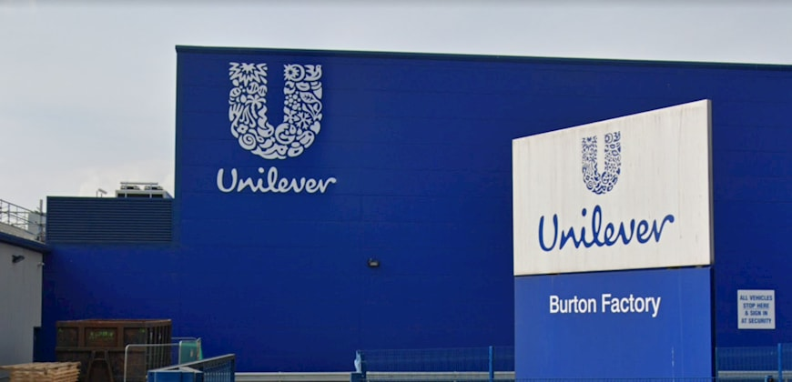

GLOBALISATION DUAL IMPACT
Benefits of globalisation: On Unilever has provide significant advantages, providing the company to expand its operations and strength a competitive position in the global market, the most notable benefits provides access to international markets, allowing Unilever to operate 190 countries reaching a diverse customer base, this global presence enables the company to generate substantial revenues from both developed and emerging economies, particularly in regions such as Asia and Africa where demand for fast-moving consumer goods is rapidly increasing (Unilever, 2023), another key advantage is in the ability to achieve goals as economies of scale, by operating on a global level, the organization from Unilever can produce goods in larger quantities, reducing production cost and improving profitability, allowing the company to invest heavily in research and development, leading to process operating in innovation on its products offerings, as example Dove, and Lipton, global brands which benefits from standardised production processes while still being adapted to local preferences. (Hill, 2021). Globalisation also develop to enhance complex and efficient global supply chains at Unilever, the organisation sources materials from different parts of the world, allowing the reduce cost and increase operational efficiency, this interconnect supply network engage the flexibility and makes possible the products be distributed quickly across multiple markets around the world, Additionally, access to global suppliers supports Unilever’s sustainability initiatives, such as sourcing environmentally responsible materials, Furthermore, globalisation strengthens brand recognition and market power. Unilever’s global brands are recognised worldwide, creating strong customer loyalty and trust. This global brand equity provides a competitive advantage, making it easier for the company to enter new markets and compete with local firms. (Dhawan, E. et al. (2010).33

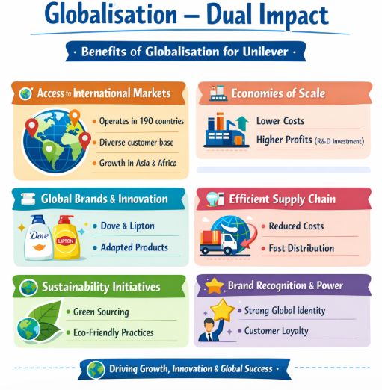

Challenges of Globalisation: Globalisation also brings some impacts challenges despites its advantages, most of the times in management the complexity of operating across multiple international markets, one major challenge at Unilever is supply chain vulnerability, as global organization operates globally exposing the organization to disruption caused by external events such as pandemics , geopolitical conflicts, and trade restrictions. For instance, global crises like COVID-19 and ongoing geopolitical tensions have highlighted the fragility of international supply networks, leading to delays, increased costs, and reduced efficiency. (Pandey, R. et al. 2021), other critical challenge Unilever can face is political and regulatory uncertainty, this can be caused for operating in numerous countries, Unilever must engage to comply with a wide range of legal frameworks, trade policies and regulatory requirements, the political and regulatory normally changes in government policies and tariffs, or trade agreements can significantly impact the company’s operations and profitability, this creates additional complexity and strategic decision making and demands a lot constant monitoring the global political environment. (Doubleday, R. 2004), another challenge is cultural differences this is a significant challenge and play and important role when the organizations operates globally, the consumer preference, the values, and behaviours are complex across regions, so many organizations depends on this facts to be successful, In addition, globalisation increases ethical and sustainability pressures. As a multinational corporation, Unilever faces scrutiny from governments, consumers, and non-governmental organisations regarding issues such as environmental impact, labour practices, and ethical sourcing. Maintaining a positive global reputation requires continuous investment in sustainable practices, which can increase operational costs.

Challenge 1 | Supply Chain Vulnerability: Operating in multiple international markets exposes Unilever to disruptions caused by pandemics, geopolitical conflicts, and trade restrictions. Example: COVID-19 caused delays, increased costs, and reduced efficiency.
Challenge 2 | Political and Regulatory Uncertainty: The company must comply with diverse laws, trade policies, and regulations in different countries. Changes in government policies, tariffs, or trade agreements can impact operations and profitability, requiring constant monitoring.
Challenge 3 | Cultural Differences: Consumer preferences, values, and behaviours vary across regions, requiring adaptation of products and marketing strategies to succeed in different markets.
Challenge 4 | Ethical and Sustainability Pressures: Governments, consumers, and NGOs monitor environmental impact, labour practices, and ethical sourcing. Maintaining a positive global reputation demands continuous investment in sustainable practices, which can increase costs.

(Pandey et al., 2021)

Analysis of Global forces
Globalisation exposes Unilever to a range of external forces that significantly influence its strategic decisions, operational efficiency, and long-term competitiveness. These forces present both opportunities and challenges, requiring the company to continuously adapt within a dynamic global business environment and evaluating the positive and negative global forces affecting Unilever.
Technological as a positive force, is widely recognised as one of the most significant forces driving globalisation and transforming multinational companies like Unilever. Modern digital platforms, data analytics, and digital supply chains enable firms to operate seamlessly across borders and interact with customers worldwide more efficiently. Technology drives innovation, productivity, and competitive advantage, allowing multinational firms like Unilever to develop new products, enhance distribution, and reach consumers directly through digital channels.
- For example, digital adoption helps firms understand consumer behaviour through big data and tailor offerings, accordingly, improving market responsiveness and global reach. Research indicates that digital tools are crucial for managing global supply chains, customer relations, and human resources in multinational companies (Course Hero, 2024).
Market expansion and emerging economies, globalisation allows Unilever to expand into emerging markets, which has been a key strategic focus. Operating in countries with rising middle classes, such as India and countries across Africa, gives Unilever access to large low-income consumer segments and long-term revenue growth opportunities.
- Studies show multinational enterprises benefit from globalization by entering under-saturated markets where demand is growing faster than in mature economies, thereby increasing foreign sales and revenue growth (Kyove et al., 2021).
Supply chain complexity as a negative force, globalisation expands supply chains, which boosts efficiency and cost savings but also increases vulnerability to external shocks. Since multinational firms depend on suppliers across continents, events that disrupt global trade — such as pandemics, political conflicts, or trade restrictions — can significantly affect operations.
- For example, the COVID-19 pandemic highlighted these vulnerabilities when transportation delays and restrictions disrupted global supply chains and increased costs for multinational companies (Deglobalization, 2025).
This structural risk requires Unilever to redesign supply chain strategies, invest in resilience, and sometimes localise production to mitigate global disruptions while balancing cost efficiency.

Cultural diversity opportunities and challenge, operating in diverse cultural environments is central to modern multinational strategy. Cultural diversity can be an advantage when companies succeed in adapting products and marketing strategies to fit local tastes — thereby enhancing acceptance and competitiveness.
- For example, Unilever has often tailored product formats and marketing messaging to local preferences in markets such as Asia and Africa, thereby strengthening brand relevance.
However, cultural differences can also raise challenges. Misinterpretation of cultural norms, inappropriate marketing messages, or poor localisation strategies can alienate consumers and harm brand reputation. This continuous need for cultural adaptation increases operational complexity and costs.
External economic and political forces Global economic and political forces — including trade policy changes, tariff adjustments, and geopolitical tensions — have a profound influence on multinational strategies. Trade liberalisation has historically enabled global firms to expand their footprint and gain more competitive advantage.
Yet, political instability, protectionism, and trade wars disrupt traditional global strategies. Restrictions on trade or sanctions can force companies like Unilever to restructure their operations, delay investments, or even withdraw from certain markets.
- Academic reviews of globalisation conclude that while globalisation broadly expands multinational enterprises, it also introduces economic uncertainties and geopolitical risks that firms must respond to strategically (Kyove et al., 2021).

Highlighting factors Global forces
- Positive influence: Technology enables global reach, market expansion access to new markets, global supply chain cost efficiency, cultural diversity local relevance, economic / political forces trade expansion.
- Negative influence: Technology higher competition, market expansion economic volatility and inequality, cultural diversity high adaptation cost, economic/ political regulatory and geological risk.
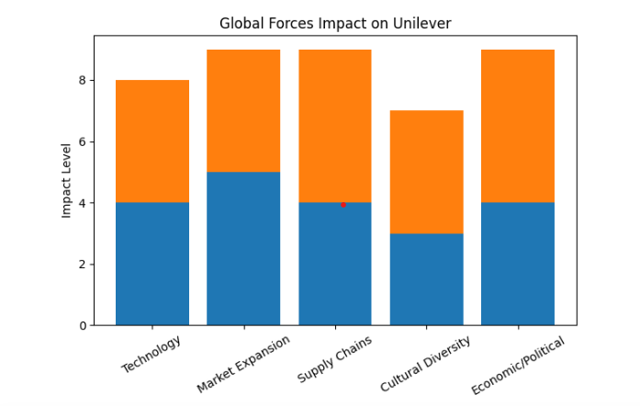
(Global forces Impact on Unilever,2026)
Recommendations
To strengthen Unilever’s global position, the better choice recommends diversifying supply chains and establishing regional manufacturing hubs. This will protect the company from disruptions caused by pandemics, political instability, or trade restrictions (Ivanov, 2021). also suggest implementing a global compliance framework to stay ahead of regulatory changes in different countries, ensuring smooth operations and informed strategic decisions (Cavusgil et al., 2020), embracing digital technologies, such as data analytics and e-commerce platforms, will help Unilever better understand consumer needs, innovate efficiently, and respond rapidly to market changes (Müller et al., 2022). In addition, adapting products and marketing to local cultures while preserving core brand values will strengthen customer loyalty, continuing to prioritise sustainability and ethical sourcing, which not only meets stakeholder expectations but also supports long-term profitability (Kiron et al., 2017). Finally, focusing on emerging markets with local partnerships can unlock growth while managing risks effectively (Khanna & Palepu, 2010).
Conclusion
Globalisation presents both opportunities and challenges for multinational companies like Unilever. By leveraging technological advancements, expanding into emerging markets, adapting to diverse cultural contexts, and maintaining resilient and sustainable supply chains, the company can enhance its competitiveness and operational efficiency in the global marketplace. Strategic responses to political, economic, and regulatory uncertainties are also critical to sustaining long-term growth. Overall, firms that effectively balance global integration with local adaptation are better positioned to capitalise on globalisation while mitigating associated risks (Hill, 2021).

Reference List

- Cavusgil, S.T., Knight, G., Riesenberger, J.R., Rammal, H.G. and Rose, E.L., 2020. International business. 4th ed. Pearson.
- de Mooij, M., 2021. Global marketing and advertising: Understanding cultural paradoxes. 5th ed. Sage.
- Hill, C.W.L., 2021. International business: Competing in the global marketplace. 13th ed. McGraw-Hill Education.
- Ivanov, D., 2021. Supply chain resilience: Theory and practice. Springer.
- Khanna, T. and Palepu, K., 2010. Winning in emerging markets: A road map for strategy and execution. Harvard Business Press.
- Kiron, D., Kruschwitz, N., Haanaes, K. and Velken, I., 2017. Sustainability in the age of disruption. MIT Sloan Management Review, 58(2), pp.1–9.
- Müller, J.M., Kiel, D. and Voigt, K.I., 2022. Impact of digital transformation on global supply chains. International Journal of Production Economics, 243, p.108318.
- Pandey, R., et al., 2021. Challenges of global supply chain management in multinational corporations. International Journal of Logistics Management, 32(1), pp.55–72.
- Unilever, 2023. Annual report 2023: Global operations and performance. [online] Available at: https://www.unilever.com/investor-relations [Accessed 24 March 2026].
- Unilever, 2025. Global sustainability strategy. [online] Available at: https://www.unilever.com/sustainable-living/ [Accessed 24 March 2026].

