
PROGRAMME: MSC PUBLIC HEALTH AND SOCIAL CARE IN PRACTICE
MODULE: SOCIAL EPIDEMIOLOGY AND PUBLIC HEALTH DEVELOPMENT
MODULE CODE: LCHS7000
ASSIGNMENT TITLE: COMPONENT 2 ANALYTICAL REPORT
TASK 1: TOPIC: ETHNICITY AND HEALTH INEQUALITIES
TARGET GROUP: BLACK WOMEN
TASK 2: TOPIC: NON-COMMUNICABLE DISEASE: TYPE 2 DIABETES MELLITUS (T2DM)
TARGET POPULATION: ADULTS AGED 18 YEARS AND OVER LIVING IN THE LONDON BOROUGH OF TOWER HAMLETS, LONDON
Student name: Saxena seema
Student id: 2542707
Lecturer Muhammad Aliyu

Executive Summary
Monitoring of inequalities, complications, prevalence and incidence can point to groups at risk and inform specific prevention actions. Combining early risk identification, culturally appropriate nutrition education, support for physical activity and weight management should be performed. In task 1 of the report, it is clear that socio economic and cultural factors are responsible for the ethnic and health inequalities for the black women. Task 2 highlighted that there is the strong link between social economic inequalities and the burden of diabetes.

Table of Contents
Task 1: Social Epidemiological Analysis 1
Introduction 1
Contextual background and underlying factors 1
3 diseases/illness 1
3 social issues 1
National Response to reduce health inequalities in the chosen group 1
Organisations that support the group 1
Conclusion 1
Task 2: Epidemiological Analysis 1
Introduction 1
Main Body 1
1. Public Health Measures in Tower Hamlets 1
2. Key Determinants and Risk Factors 1
3. Health Needs Assessment and Epidemiological Evidence 1
4. Monitoring systems available for Adults aged 18 years and over living in the London Borough of Tower Hamlets, London 1
5. Planning and using epidemiology 1
6. Designing health intervention programme and evaluating the impact 1
7. Epidemiological approach’s strengths and weaknesses 1
Conclusion 1
References 1
Task 1 1
Task 2 1

Task 1: Social Epidemiological Analysis
Topic: Ethnicity and health inequalities
Target group: Black women

Introduction
Black women in the UK are individuals who are identified as Black Caribbean, Black African and other black ethnic backgrounds. The population might experience health inequalities because ethnicity intersects with socio-economic deprivation, discrimination, racism and unequal accessibility to appropriate healthcare, which influences overall health outcomes and maternity experience throughout pregnancy and after childbirth (NHS England, 2026). Black women disproportionately face higher maternal mortality alongside inequality in chronic conditions, mental health and maternity care experience (MBRRACE-UK, 2025). Understanding the intersecting determinants is important to develop equitable health initiatives.

Contextual background and underlying factors

3 diseases/illness

Higher rate of perinatal mental illness
Black mothers in England are more than twice as likely as White mothers to be hospitalised for perinatal mental illness. Black women between 2020 and 2023 represented 12% of admissions for puerperal mental disorder despite accounting for about 5% of deliveries (Thomas, 2024). Racism, poverty, traumatic maternity experiences, and challenging accessibility for culturally appropriate mental health services increase vulnerability.

Higher prevalence of maternal obesity
Obesity increases pregnancy risk, including diabetes, hypertension and thrombosis. In 2023 and 2024, 36.3% of black women were recorded as living with obesity in early pregnancy compared to 26.2% of women in overall England (OHID, 2024). Prevention should combine physical activity support, accessible nutrition with non-stigmatising and culturally appropriate preconception and antenatal services.

Greater risk of sickle cell disease and related complications
Sickle cell disease disproportionately impacts people of black Caribbean heritage and black African people. There are approximately 15000 people across England living with sickle cell disease, and around 250 new cases annually are being recorded (NHS England, 2025). Pregnancy requires specialist monitoring because sickle cell complications impact infective health and overall mental health.

3 social issues

Discrimination in maternity care and racism
Racial discrimination remains a major determinant. 28% of Black women in the Five X More 2025 survey have reported experiencing racial discrimination during maternity care (Mahase, 2025). Additionally, in the survey, 54% also reported issues with healthcare professionals (Mahase, 2025). The experience discourages women from raising concerns and undermines trust. Mandatory accountability mechanisms, anti-racism training and meaningful involvement of black women in service as a result are required.

Financial disadvantage and poverty
Economic disadvantage is responsible for compounding maternity inequality. 39% of people between 2021 and 2024 from black households were living in low income after housing costs compared with 18% of people in white households (GOV.UK, 2025). Transport and the ability to attend appointments, and restricted financial insecurity or lack of healthy food choices increase maternity inequality.
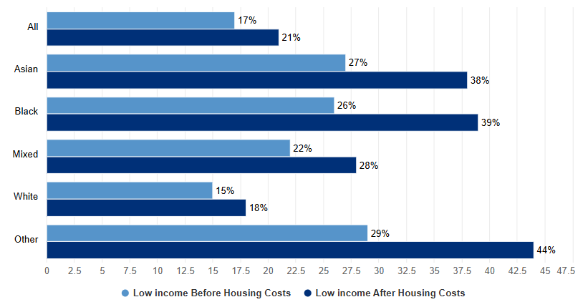
Figure 1: Households living with low income
(Source: GOV.UK, 2025)

Overcrowding and housing insecurity
Housing conditions can impact stress, mental well-being, and accessibility to a healthy living environment. 16% of Black African households were overcrowded in the 3 years to 2 March 2023 compared to 3% of households overall in England (GOV.UK, 2025). Overcrowding can make pregnancy and postnatal recovery more difficult and increases stress.
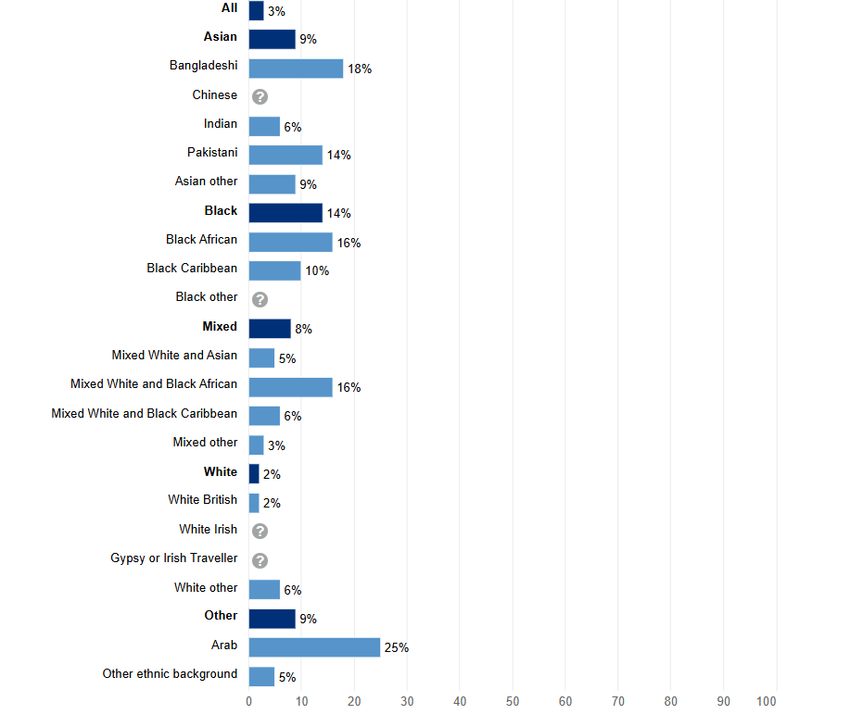
Figure 2: Overcrowded householder
(Source: GOV.UK, 2025)

National Response to reduce health inequalities in the chosen group
- Maternity Disparity Task Force
The Government of the UK established the Maternity Disparity Task Force in 2022 for addressing poor maternity outcomes among women living in deprived areas and ethnic minority women. The government in 2024 reported that the task force was developing targeted free pregnancy resources for ethnic minority groups and was also responsible for investing in research for maternity disparity. £50 million was allocated through NIHR for research into health inequality, including maternity disparity (DHSC, 2022). The objective of the task force includes improving maternity care access and preconception care and reducing neonatal death while addressing wider social determinants of health (GOV.UK, 2024). The task force also brings together NHS professionals, government, voluntary sector organisations and mothers to create a cooperative mechanism while incorporating lived experience of women into policy.
- NHS Core20PLUS and maternity continuity care
Core20PLUS of NHS England identifies maternity as one of the five clinical priorities to reduce Health Care inequality. It specifically calls for continuity of care for Asian, black and minority ethnic women and also women living in the most deprived communities (NHS England, 2026). The maternity delivery plan of NHS England also requires local systems for analysing maternity outcomes and collecting data according to population group so that inequality can be identified and adequate services can be changed (Thomas, 2024). 37 of 42 local maternity and neonatal systems by March 2024 had published equality and equity action plans demonstrating National implementation of the approach (NHS England, 2025). Continuity means that the women will be able to receive care from a more consistent group of midwives, potentially improving trust, communication and early recognition of complications.
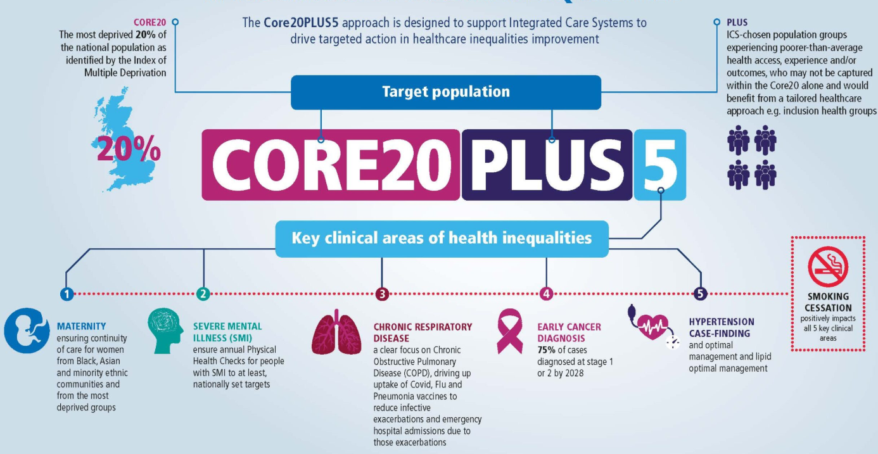
Figure 3: Reducing healthcare inequality
(Source: NHS England, 2026)

Organisations that support the group
Five X More is a UK organisation specifically focused on improving maternity experience and the maternal health outcome for black women. The stated mission of the organisation is to support, empower and advocate for black women to enable them to receive equitable, respectful and high-quality care during pregnancy and beyond (Five X More, 2026). The wider role of the organisation is important because it combines research, community advocacy, policy campaigning and healthcare professional engagement rather than only providing individual support. One of the major contributions of the organisation is the black maternity experience report 2025, which collected evidence from more than 1100 black and black mixed Heritage women who had accessed the maternity service between 2021 and 2025 (Five X More, 2025). The research highlighted continuing problems with communication, social discrimination, women feeling that there concerned is not adequately addressed and pain management.

Conclusion
Black women in the UK experience persistent and significant health and equality issues, particularly in maternal health. Perinatal mental health difficulties, higher maternal mortality and conditions like sickle cell disease show important health disparities, while poverty, racism and housing inequality further increase vulnerability. National initiatives, including Core20PLUS and the maternity disparity task force, focus on addressing the inequalities through targeted Health Care improvement. Organisations like Five X More additionally improve Research and advocacy.

Task 2: Epidemiological Analysis

Introduction
Definition of the Health Problem and Its Reported Social, Cultural and Health Consequence
Type 2 Diabetes Mellitus (T2DM) is a chronic metabolic condition which consists of insulin resistance as well as impaired regulation of the glucose in the body. Unlike type 1 diabetes, which is an autoimmune problem, T2DM develops gradually and is very strongly associated with obesity, poor diet, sedentary lifestyle, as well as genetic preposition (Nanda et al. 2022). Socially, it reduces the overall quality of life, increases the cost of healthcare and disproportionately impacts the communities which are deprived. Culturally, it is more prevalent among the South Asian as well as Black ethnic groups who face high risk because of their genetic, dietary as well as social economic conditions.
Levels of the Incidence/Prevalence Demonstrating Severity of the Health Issue
On the global level, diabetes impact more than 537 million as of 2021 people of age group around 20 to 75 years with 90% of the cases of type 2 diabetes (Huang et al. 2025). In UK, about 4.6 million people live with diabetes and someone is diagnosed with diabetes every two minutes. In Tower Hamlets, London, this disease prevail, the largest, and the number of people with diabetes are highest here (Diabetes UK, 2026). The local data show that 16,900 diagnosed cases with thousands more and diagnosed are from this region. The borough ranks third highest in London for the age, standardised prevalence as well as 67% of the people with diabetes live in the most deprived regions (Tower Hamlets Council, 2026).
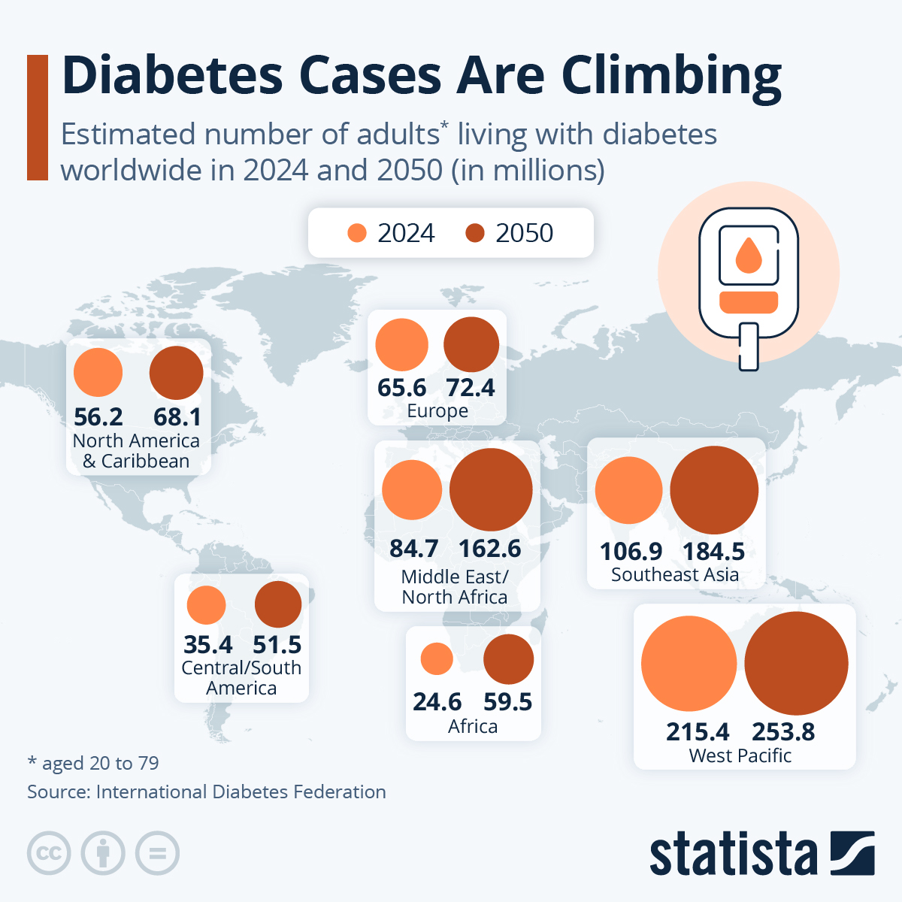
Figure 4: Global Diabetes Prevalence
(Source: Statista, 2023)

Main Body

1. Public Health Measures in Tower Hamlets
Prevention
The Tower Hamlets has implemented a targeted prevention program in order to reduce the risk factors associated with T2DM. The NHS Diabetes Prevention Program (NDPP) offers the lifestyle interventions that focus upon diet, physical activity as well as weight management (NHS, 2026). On the local level, Tower Hamlets council runs different community initiatives like healthy borough schemes which provides culturally tailored nutrition workshops for the South Asian and Bangladeshi communities because this group has higher genetic susceptibility to diabetes.
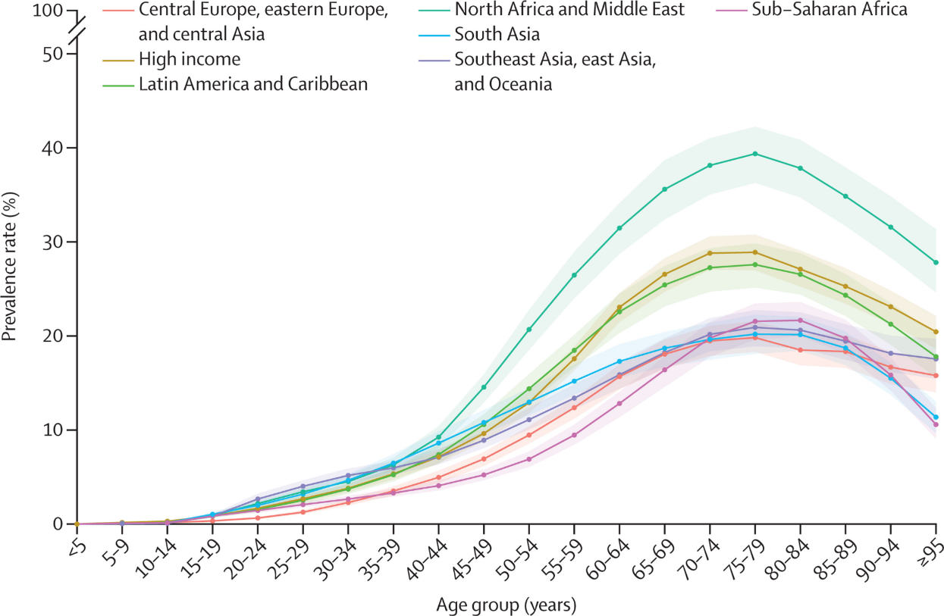
Figure 5: Diabetes Prevalence among Black and South Asian People
(Source: The Lancet, 2023)
Protection
The protective measures consist of systematic screening along with the early diagnosis. The GP practises in Tower Hamlets risk stratification tools in order to identify the individuals with high risk, especially those who are aged around 40–74 years, using NHS Health Check Program (NHS, 2026). The protection also extends to the clinic management where the structured patterns of diagnosis ensure regular HBA1C monitoring, retinal screening, as well as risk assessment of cardiovascular diseases
Promotion
The health promotion campaigns focus upon rising the awareness as well as empowering the communities. The Tower Hamlets partners with the charities like Diabetes UK in order to deliver the culturally sensitive outreach, which consists of multilingual resources as well as the community champions (Diabetes UK, 2026). The public campaigns showcase the importance of physical activity, healthy eating along with the routine screening.

2. Key Determinants and Risk Factors
Biological determinants consist of the age and genetics. Although, T2DM is more common in the older adults, but the recent data show the rising diagnosis among the younger population of 40 years or below. The ethnic background is also important because the South Asian and black populations have 2 to 4 time’s higher risk in comparison to the white people (Orazumbekova et al. 2023).
The lifestyle factors like obesity, poor diet along with the physical in activity are another major contributor. In the Tower Hamlets, 27% of the people are obese and the childhood obesity rates are also very high in London (Tower Hamlets Council, 2026). The diets are consisting of high refined carbohydrates as well as low physical activities leads to more insulin resistance.
The socioeconomic determinants further a very crucial role. The Tower Hamlets is one of the most deprived boroughs in London with 67% of the people with diabetes living in the most deprived groups (Tower Hamlets Council, 2026). The poverty crowded housing along with the limited access to healthy food options increases the vulnerability of the people further.
The cultural factors also shape up the overall risk as the traditional diets, Limited health literacy along with the stigma around chronic illness can directly reduce the diagnosis and management.
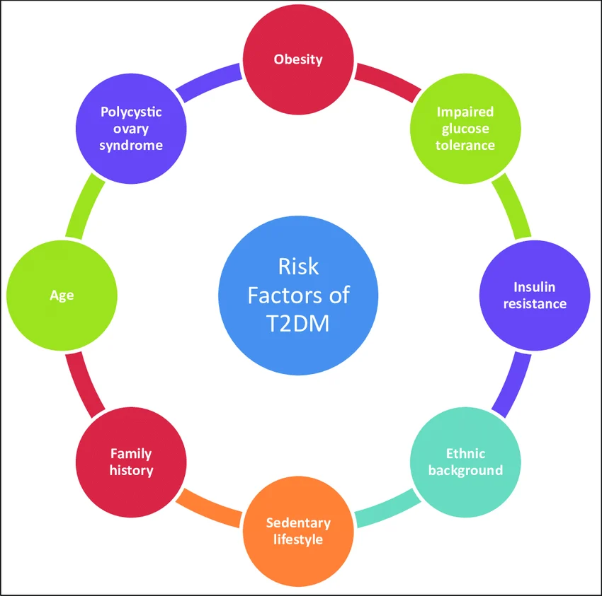
Figure 6: Risk Factors of T2DM
(Source: Syed Sameer et al. 2026)

3. Health Needs Assessment and Epidemiological Evidence
Tower Hamlets has a substantial burden of 23719 people (6.12% of the registered population) recorded with diabetes in 2024 and 2025 (PCND, 2026). It highlights the significant need for early diagnosis, prevention and effective long-term management among adults. Local evidence highlights a lack of equality in diabetes care, as only 50.1% of the population on the Tower Hamlets diabetes register had HbA1c below 59 mmol/mol (Tower Hamlets Together, 2024). Thus, preventing complications and improving glycaemic control are major local health needs.

4. Monitoring systems available for adults aged 18 years and over living in the London Borough of Tower Hamlets, London
Several systems monitor T2DM at the local level. The Quality and Outcomes Framework QOF records diagnosed diabetes through GP practices. Tower Hamlets in 2024 and 2025 recorded 23719 people with diabetes, enabling primary care and prevalence performance monitoring (PCND, 2026). The national diabetes audit provides ICB and practice-level information on treatment targets and processes, including blood pressure, cholesterol monitoring and hba1c (NHS England, 2026). Additionally, Fingertips enables comparison of diabetes indicators between England and local authorities (OHID, 2026). Collectively, each monitoring system focuses on different attributes to deal with T2DM for adults in Tower Hamlets.

5. Planning and using epidemiology
Public Health Impact
Type 2 Diabetes Mellitus (T2DM) is a major health issue in adults in Tower Hamlets. Epidemiological assessment based on prevalence, incidence, admission and mortality data can assist in determining the magnitude and geographic spread of the disease. Glycemic control is necessary to reduce morbidity and mortality of T2DM (Butayeva et al. 2023). Consider extra care should be taken for age, deprivation and obesity as well as ethnicity as these factors could be contributing to unequally distributed disease burden.
Short-Term Consequences
In the short-term, T2DM not managed optimally can lead to hyperglycaemia, fatigue and impaired quality of life, higher use of primary-care services, higher rates of emergency admissions and higher health-care costs. Epidemiological surveillance may be used to identify those groups with poorer glycaemic control and guide the provision of specific interventions.
Long-Term Consequences
As the disease is chronic, T2DM also puts individuals at risk for cardiovascular disease, kidney disease, neuropathy, retinopathy, and lower-limb complications. The long-term effects of diabetes include damage to large and small blood vessels, which can lead to heart attack and stroke, and problems with the kidneys, eyes, feet and nerves (Betterhealth, 2024). This evidence can help to inform specific diabetes health promotion activities, early diagnosis, diabetes weight management and improving diabetes management in Tower Hamlets.

6. Designing health intervention programme and evaluating the impact
Intervention Design
Vulnerable adults should be identified by NHS Health Checks and primary care HbA1c checks, and then referred to the healthier “NHS Diabetes Prevention Programme” (National Health Service, 2026). The programme offers weight, physical activity and nutrition style guidance and support in a personalised way and delivered either face-to-face or digitally.
Evaluation of Impact
Benefits should also be analysed by age, ethnicity and deprivation to see if high-risk groups benefit from such measures. Based on Manchester University’s NHS diabetes prevention scheme, completing it reduces someone’s chance of developing Type 2 diabetes by 37%, with participants achieving an average weight loss of 3.3kg (National Health Service, 2025).
Expected Outcomes
- Complications and healthcare needs in the future should be lowered by reducing diabetes incidence, improving glycaemic control and healthier weight.
- Participation, drop-out, access, sustainability should also be taken into account when evaluating which will show weaknesses in implementation.

7. Epidemiological approach’s strengths and weaknesses
Strengths
The epidemiological approach has been used to inform an understanding of T2DM in adults in Tower Hamlets, based on measurement of prevalence, incidence, mortality and patterns of risk factors. Having routinely collected NHS and OHID data allows for comparison across age, ethnicity and deprivation levels; assisting priority groups and recognising inequalities. UK healthcare is free, publicly funded via the NHS, and over 98% of the population is registered to general practices (Ravindrarajah et al. 2023). For example, epidemiological evidence can help inform prevention as the NHS Diabetes Prevention Programme. Overall, the approach also facilitates planning of interventions based on evidence.
Weaknesses
Routine epidemiological data cannot be accurate and it can miss undiagnosed cases of diabetes and it may also show variation in the way diabetes is recorded and coded across different health settings. Respiratory syncytial virus (RSV) is an important cause of severe respiratory illness in older adults and adults with respiratory or cardiovascular comorbidities (Rozenbaum et al. 2023). Due to confounding, observational studies can reveal associations between obesity, ethnicity and T2DM, although in itself it cannot prove causality. Population statistics can also mask variation among the different groups within Tower Hamlets' various communities. Thus, it is important to consider epidemiological data in conjunction with qualitative evidence and the context of the local community for the purpose of ensuring the appropriateness, equity and responsiveness of interventions.

Conclusion
The epidemiological analysis suggests that Type 2 Diabetes Mellitus (T2DM) is a significant public health problem for adults in Tower Hamlets and is related to obesity, ethnicity, deprivation and lifestyle. However, caution must be used in interpreting the results, due to under diagnoses or factors that confounded and restricted their utilisation in routine data. In conclusion, the early detection and culturally responsive prevention efforts should be enhanced, alongside weight management and equitable access to diabetes services, in Tower Hamlets to alleviate acute and chronic health inequities.

References

Task 1
DHSC (2022) Maternity Disparities Taskforce: terms of reference. Available at: https://www.gov.uk/government/news/new-taskforce-to-level-up-maternity-care-and-tackle-disparities(Accessed: 8 August 2026).
GOV.UK (2025) Overcrowded households. Available at: https://www.ethnicity-facts-figures.service.gov.uk/housing/housing-conditions/overcrowded-households/latest (Accessed: 8 August 2026).
GOV.UK (2025) People in low income households. Available at: https://www.ethnicity-facts-figures.service.gov.uk/work-pay-and-benefits/pay-and-income/people-in-low-income-households/latest/ (Accessed: 8 August 2026).
Mahase, E. (2025) ‘Maternity care: One in four black women report experiencing racial discrimination’, BMJ, 390, r1544. Available at: https://www.bmj.com/content/390/bmj.r1544.full(Accessed: 8 August 2026).
NHS England (2025) Review of progress in 2023/24: delivering the equality objectives and meeting the wider equality requirements. Available at: https://www.england.nhs.uk/long-read/review-of-progress-23-24-delivering-the-equality-objectives-and-meeting-the-wider-equality-requirements (Accessed: 8 August 2026).
NHS England (2025) Revolutionary gene-editing therapy for sickle cell offers hope of a cure for NHS patients. Available at: https://www.england.nhs.uk/2025/01/revolutionary-gene-editing-therapy-for-sickle-cell (Accessed: 8 August 2026).
NHS England (2026) Core20PLUS5 – an approach to reducing healthcare inequalities. Available at: https://www.england.nhs.uk/about/equality/equality-hub/national-healthcare-inequalities-improvement-programme/core20plus5 (Accessed: 8 August 2026).
Five X More (2025) Black Maternity Experiences Report 2025. Available at: https://fivexmore.org/embargoed-report(Accessed: 8 August 2026).
Five X More (2026) Five X More: Black maternal health. Available at: https://fivexmore.org/embargoed-report (Accessed: 8 August 2026).
Thomas, T. (2024) Black mothers twice as likely as white mothers to be hospitalised with perinatal mental illness. Available at: https://www.theguardian.com/world/article/2024/may/06/black-mothers-twice-likely-white-hospitalised-perinatal-mental-illness(Accessed: 8 August 2026).
GOV.UK (2024) Inclusive Britain second update report – May 2024. Available at: https://www.gov.uk/government/publications/inclusive-britain-update-report/inclusive-britain-second-update-report-may-2024 (Accessed: 8 August 2026).
OHID (2024) Child and maternal health profiles: December 2024 update. Available at: https://www.gov.uk/government/statistics/child-and-maternal-health-profiles-december-2024-update/child-and-maternal-health-profiles-december-2024-update-statistical-commentary(Accessed: 8 August 2026).

Task 2
Betterhealth, (2024), Diabetes - long-term effects. Available at: https://www.betterhealth.vic.gov.au/health/conditionsandtreatments/diabetes-long-term-effects (Accessed: 08 August 2026)
Butayeva, J., Ratan, Z.A., Downie, S. and Hosseinzadeh, H., (2023). ‘The impact of health literacy interventions on glycemic control and self‐management outcomes among type 2 diabetes mellitus: A systematic review’. Journal of diabetes, 15(9), pp.724-735. Available at: https://onlinelibrary.wiley.com/doi/pdfdirect/10.1111/1753-0407.13436 (Accessed: 8 August 2026).
Diabetes UK (2026) How many people in the UK have diabetes? Available at: https://www.diabetes.org.uk/about-us/about-the-charity/our-strategy/statistics (Accessed: 8 August 2026).
Huang, Q., Li, Y., Yu, M., Lv, Z., Lu, F., Xu, N., Zhang, Q., Shen, J., Zhu, J. and Jiang, H. (2025) ‘Global burden and risk factors of type 2 diabetes mellitus from 1990 to 2021, with forecasts to 2050’. Frontiers in Endocrinology (Lausanne), 16, 1538143. Available at: https://doi.org/10.3389/fendo.2025.1538143 (Accessed: 8 August 2026).
Nanda, M., Sharma, R., Mubarik, S., Aashima, A. and Zhang, K. (2022) ‘Type-2 diabetes mellitus (T2DM): spatial-temporal patterns of incidence, mortality and attributable risk factors from 1990 to 2019 among 21 world regions’. Endocrine, 77(3), pp. 444–454. Available at: https://doi.org/10.1007/s12020-022-03125-5 (Accessed: 8 August 2026).
National Health Service, (2025), NHS diabetes prevention scheme helps one million people. Available at: https://www.england.nhs.uk/2025/12/nhs-diabetes-prevention-scheme-helps-one-million-people/ (Accessed: 08 August 2026)
National Health Service, (2026), NHS Diabetes Prevention Programme (NHS DPP). Available at: https://www.england.nhs.uk/diabetes/diabetes-prevention/ (Accessed: 08 August 2026)
NHS (2026) NHS Health Check. Available at: http://www.nhs.uk/tests-and-treatments/nhs-health-check/ (Accessed: 8 August 2026).
NHS England (2026) National Diabetes Audit Core Report 1: Care Processes and Treatment Targets 2024-25. Available at: https://digital.nhs.uk/data-and-information/publications/statistical/national-diabetes-audit/report-1-cp-and-tt-data-release-2024-25/nda-report-1-cp-and-tt-data-release-2024-25(Accessed: 8 August 2026).
NHS England (2026) NHS Diabetes Prevention Programme (NHS DPP). Available at: https://www.england.nhs.uk/diabetes/diabetes-prevention/ (Accessed: 8 August 2026).
OHID (2026) Diabetes: Fingertips Public Health Profiles. Available at: https://fingertips.phe.org.uk/diabetes-ft (Accessed: 8 August 2026).
Orazumbekova, B., Hamdani, T., Hodgson, S., Samuel, M., Stow, D., Spreckley, M., Finer, S., Siddiqui, M.K. and Mathur, R. (2025) ‘Evidence of ethnic variations in the relationships between routinely recorded clinical factors and T2D: a systematic review and meta-analysis’. International Journal of Obesity (London), 49(10), pp. 1929–1945. Available at: https://doi.org/10.1038/s41366-025-01848-9 (Accessed: 8 August 2026).
PCND (2026) Quality and Outcomes Framework: Tower Hamlets, 2024-25. Available at: https://pcnd.info/tower-hamlets/data-library/qof(Accessed: 8 August 2026).
Ravindrarajah, R., Sutton, M., Reeves, D., Cotterill, S., Mcmanus, E., Meacock, R., Whittaker, W., Soiland-Reyes, C., Heller, S., Bower, P. and Kontopantelis, E., (2023). ‘Referral to the NHS Diabetes Prevention Programme and conversion from nondiabetic hyperglycaemia to type 2 diabetes mellitus in England: a matched cohort analysis’. PLoS medicine, 20(2), p.e1004177. Available at: https://journals.plos.org/plosmedicine/article/file?id=10.1371/journal.pmed.1004177&type=printable (Accessed: 8 August 2026).
Rozenbaum, M.H., Begier, E., Kurosky, S.K., Whelan, J., Bem, D., Pouwels, K.B., Postma, M. and Bont, L., (2023). ‘Incidence of respiratory syncytial virus infection in older adults: limitations of current data’. Infectious diseases and therapy, 12(6), pp.1487-1504. Available at: https://link.springer.com/content/pdf/10.1007/s40121-023-00802-4.pdf (Accessed: 8 August 2026).
Statista (2023) Share of adults with diabetes worldwide, by region. Statista. Available at: https://www.statista.com/chart/23491/share-of-adults-with-diabetes-world-region/ (Accessed: 8 August 2026).
Syed Sameer, A., Mujeeb Zafar, B. and Saniya, N. (2026) Pathophysiology of diabetes: An overview. Diabetes mellitus is a chronic heterogeneous metabolic disorder with complex pathogenesis. Available at: https://www.researchgate.net/publication/345718453_Pathophysiology_of_diabetes_An_overview (Accessed: 8 August 2026).
The Lancet (2023) Global, regional, and national burden of diabetes from 1990 to 2021, with projections of prevalence to 2050: a systematic analysis for the Global Burden of Disease Study 2021. The Lancet, 402(10397), pp. 203–234. Available at: https://www.thelancet.com/journals/lancet/article/PIIS0140-6736%2823%2901301-6/fulltext (Accessed: 8 August 2026).
Tower Hamlets Council (2026) Child healthy weight action plan. London: Tower Hamlets Council. Available at: https://www.towerhamlets.gov.uk/Documents/Children-and-families-services/Child-healthy-weight-action-plan.pdf (Accessed: 8 August 2026).
Tower Hamlets Council (2026) Living with Type 2 Diabetes. Appendix 1. London: Tower Hamlets Council. Available at: https://democracy.towerhamlets.gov.uk/documents/s154120/Appendix%201%20Living%20with%20Type%202%20Diabetes.pdf (Accessed: 8 August 2026).
Tower Hamlets Together (2024) Tower Hamlets Together Board: Population Health – Stroke, Diabetes and Mental Health. Available at: https://northeastlondon.icb.nhs.uk/wp-content/uploads/2023/03/1-February-2024-Tower-Hamlets-Together-Board-meeting-paper-pack-final-w.pdf (Accessed: 8 August 2026).

