Workshop Skills/Learning in the Digital Era
Workshop Skills Logbook Hand-in
Joshua Ofosu Asare
2111739
BEng Embedded Electronic Systems

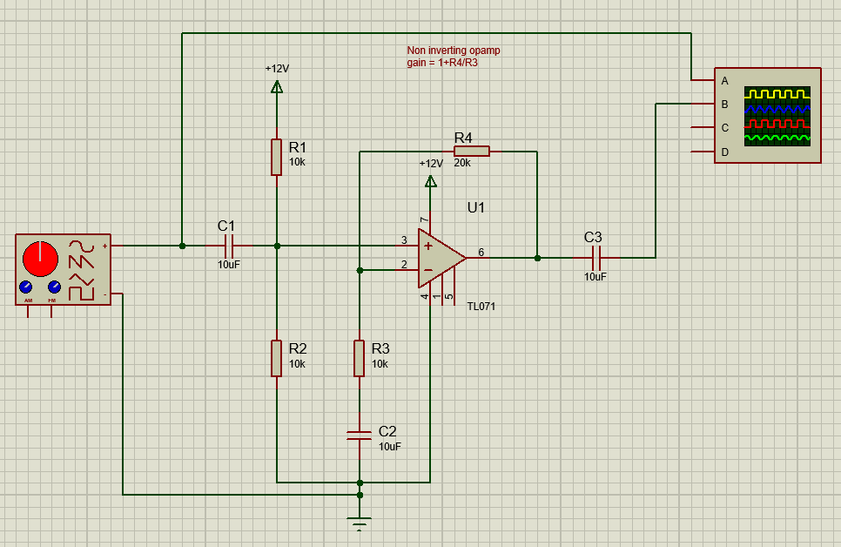
Figure 1: A screenshot of the circuit in proteus
The figure above shows the circuit as created in Proteus.
The circuit board was tested on a breadboard by attaching the function generator signal to the input of the circuit and CH1 of the oscilloscope to the same point. The output was connected to CH2 of the oscilloscope.
To assemble the PCB, a soldering iron, fume extractor and unleaded solder were used. To solder each of the connections, the components with just two pins were inserted into each hole and bend so they would not fall out when the PCB was inverted to solder from beneath.

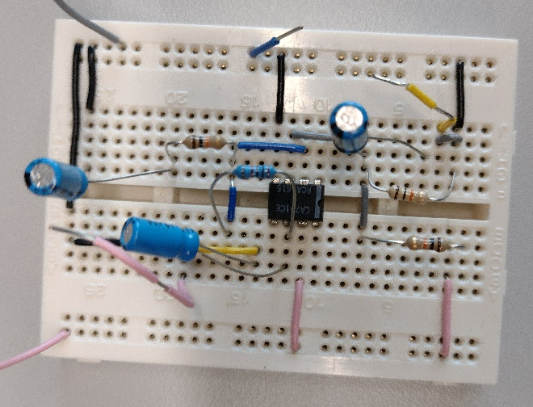
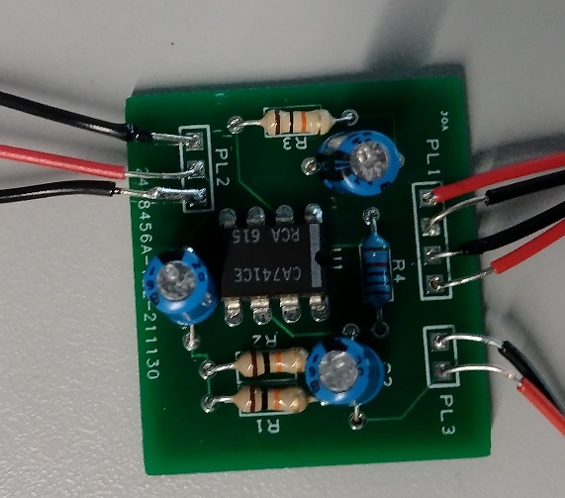

LM741 – Proteus Simulation
Frequency (Hz) |  | Output Voltage (mV) | Frequency (Hz) |  | Output Voltage (mV)
100 |  | 300 | 200 |  | 300
500 |  | 300 | 1K |  | 300
2K |  | 300 | 5K |  | 300
10K |  | 300 | 20K |  | 300
50K |  | 300 | 100K |  | 288.75
200K |  | 245 | 500K |  | 115

Max Value = 300 * 0.707 = 212.50mV
-3dB point is 212.50mV at 250kHz
Input voltage = 100mV, Gain = 3
Gain Bandwidth Product = 750kHz
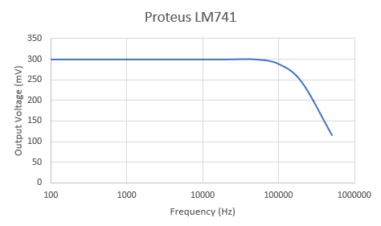

TL071 – Proteus Simulation
Frequency (Hz) |  | Output Voltage (mV) | Frequency (Hz) |  | Output Voltage (mV)
100 |  | 300 | 200 |  | 300
500 |  | 300 | 1K |  | 300
2K |  | 300 | 5K |  | 300
10K |  | 300 | 20K |  | 300
50K |  | 300 | 100K |  | 298.75
200K |  | 292.50 | 500K |  | 267.50
1M |  | 210 | 2M |  | 130

Max Value = 300 * 0.707 = 212.50mV
-3dB point is 212.50mV at 980kHz
Input voltage = 100mV, Gain = 3
Gain Bandwidth Product = 2940kHz
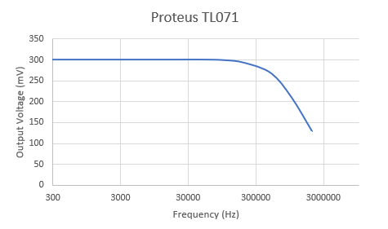

Breadboard CA741C - Practical
Frequency (Hz) |  | Output Voltage (mV) | Frequency (Hz) |  | Output Voltage (mV)
100 |  | 600 | 200 |  | 600
500 |  | 600 | 1K |  | 600
2K |  | 600 | 5K |  | 600
10K |  | 600 | 20K |  | 600
50K |  | 600 | 100K |  | 380
200K |  | 292.50 | 500K |  | 267.50
1M |  | 210 | 2M |  | 130

Max Value = 600 * 0.707 = 424.30mV
-3dB point is 424.30mV at 86.66kHz
Input voltage = 200mV, Gain = 3
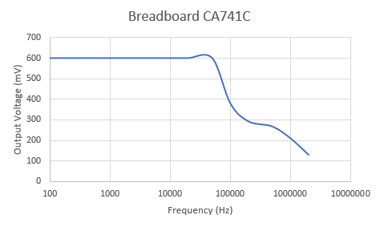
Gain Bandwidth Product = 259.98kHz

PCB CA741C - Practical
Frequency (Hz) |  | Output Voltage (mV) | Frequency (Hz) |  | Output Voltage (mV)
100 |  | 600 | 200 |  | 600
500 |  | 600 | 1K |  | 600
2K |  | 600 | 5K |  | 600
10K |  | 600 | 20K |  | 600
50K |  | 572 | 100K |  | 348
200K |  | 180

Max Value = 600 * 0.707 = 424.30mV
-3dB point is 424.3 mV at 79.8KHz
Input voltage = 200mV, Gain = 3
Gain Bandwidth Product = 239.4kHz


