Improving Supply Chain Performance
vale | Damian.thomas@vale.com
Procurment and supply chain management
Damian Thomas
2023

Summary.
This report has focused on any supply chain if it had an international component involved as stated in the brief. This led to considerable thought being put into the product to use, however, working in a nickel refinery allowed for easy access to the information needed on the nickel oxide used. It was then separated into two separate sections, the FMEA (Failure Mode and Effect Analysis) and the six steps that could be taken to make the supply chain more resilient.
As mentioned previously, the first part of the report focussed on the FMEA of the nickel oxide supply chain. It was split into five sections which are:
- Vessel.
- UK Problems.
- Problems with Containers.
- Covid.
- Bad Weather.
These areas are all key components in the supply chain which can be very problematic for the delivery of nickel oxide. These five main areas were then split up into the individual problems that affect each of the main headings.
The second part of the report looks at the six steps that could be taken to improve the resilience of the supply chain. The six steps have been listed below:
- Focus on the logistics of the supply chain.
- Gain customer perspective on the product.
- Closely manage contracts.
- Meaningful Key Performance Indicators.
- See if any alternate routes can be used.
- Have more safety stock at the Clydach Refinery.

Contents
Summary. ii
Table of Figures and Tables. 1
Introduction. 2
FMEA Analysis. 3
Vale Nickel Oxide FMEA. 4
Improvements. 9
Step One. 9
Step Two. 9
Step Three. 10
Step Four. 10
Step Five. 11
Step Six. 11
Conclusion. 12
References 13
Appendices 14
Appendix 1 14

Table of Figures and Tables.
Figure 1 - Example of FMEA (Forrest, 2010) 3
Table 1 – FMEA Table. 7
Table 2 – FMEA Value Breakdown. 8

Introduction.
This report will look at the supply chain of raw materials within Vale Clydach. The main import for the refinery is nickel oxide obtained from multiple locations, including mines owned by Vale in Canada. The brief states that the supply chain must be an international supply chain which is why Vale has been chosen.
An FMEA (Failure Mode and Effect Analysis) will be conducted on the supply chain to understand the current state of the supply chain. The report will also include a risk assessment for the supply chain and the potential threats that could affect the supply chain.
The second section will look at six steps that could be used to improve the supply chain and make it more resilient to potential future threats. These steps will be evaluated to understand if they are beneficial to the company or if they cause further problems to the supply chain.
Finally, there will be a conclusion to summarise the results of the FMEA and the six steps, giving an overall perspective on the supply chain.

FMEA Analysis.
FMEA is an abbreviation for Failure Mode and Effect Analysis. It is a tool widely used in industry. Institute for Healthcare Improvement (2023) defines the FMEA as:
“a systematic, proactive method for evaluating a process to identify where and how it might fail and to assess the relative impact of different failures, in order to identify the parts of the process that are most in need of change”
Institute for Healthcare Improvement (2023)
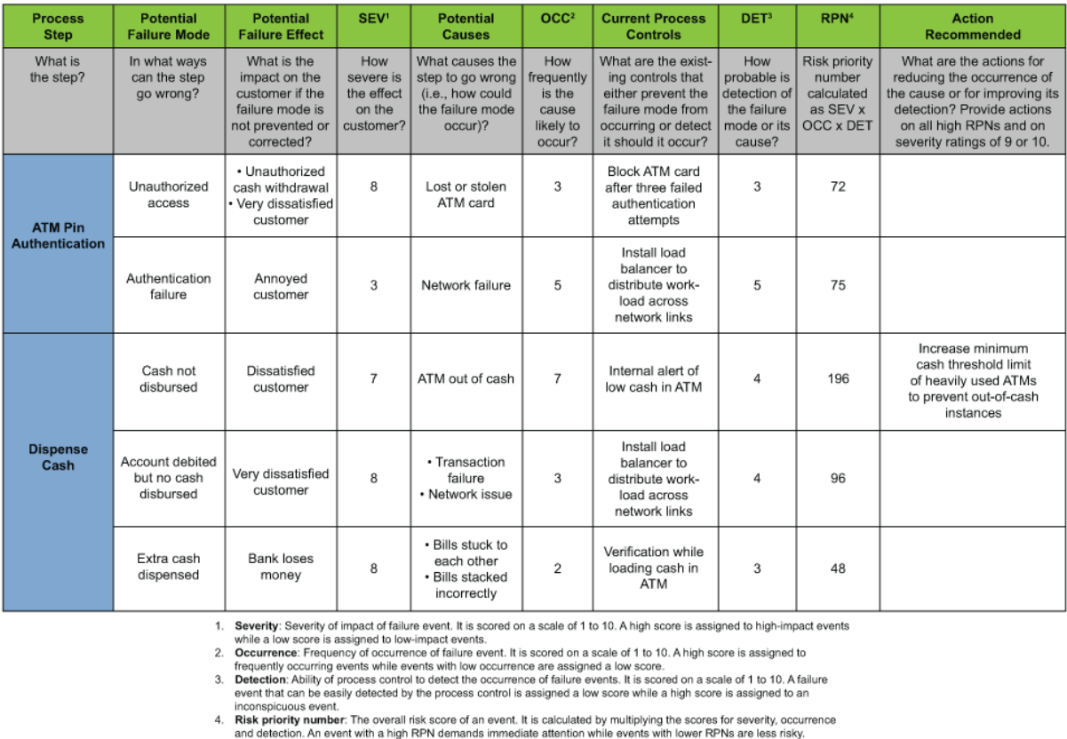
Often, when conducting an FMEA, a table format is used to list the ways in which a failure may occur. It is then given a score to determine the severity, should that failure happen. Another score is given for how often it is likely to occur and for the detection of the failure. Once the three values have been attained, they are multiplied together to obtain the RPN (Risk Priority Number). Below is an example FMEA provided by Forrest (2010)
Figure 1 - Example of FMEA (Forrest, 2010)
It should be noted that a key is provided below to identify the criteria of the scoring the importance of each category. Figure 1 also does not contain a revised scoring after a recommended action has been provided. This is important as the new score identifies the new RPN value. In the FMEA constructed for the Vale supply chain process, this will be added where it is applicable.

Vale Nickel Oxide FMEA.
Shipment of Nickel Oxide to Clydach Nickel Refinery.
Process Step | Potential Failure Mode | Potential Failure Effects | Sev. | Potential Causes | Occ. | Current Process Controls | Det. | RPN | Action Recommended | New Severity | New Occurrence | New Detection | New RPN
Vessel | Vessel Cancellations to put ships back into rotation on shipping routes | Additional time delay and costs in holding the containers in the shipyard ready for departure. | 8 | Possible changes in conditions or delivery schedules. | 3 | Notification on any schedule changes. | 3 | 72 | No Further Action Required. | 8 | 3 | 3 | 72
Vessel | Vessel Space is difficult to obtain | Shipments were delayed as many vessels cannot carry the containers to their desired location. | 7 | Backlog of containers reduces the amount of available space. | 4 | No current controls. | 5 | 140 | Additional vessels to carry more containers or to look for potential other routes. | 4 | 4 | 6 | 96
Vessel | Missing connecting vessel | Delays are caused in the containers reaching the UK ports. | 7 | Due to other delays in the supply chain, connecting Vessels can sometimes be missed. | 4 | No current controls. | 7 | 196 | Have a second source of supply. | 4 | 4 | 6 | 96

UK | UK Port Congestion | A large backlog of containers means that there is delay of the materials reaching the final location on time. It also increases costs due to holding fees. | 8 | Backlog from Covid and Strikes on the ports. | 7 | Governmental action for the striking work party. | 4 | 224 | Once the action has been taken by the government, the number of strikes will reduce. | 8 | 2 | 4 | 64
UK | Train delays | Late delivery from ports to Cardiff. | 7 | Recent Strikes with train companies. Bad Weather at Port causing unloading delays | 8 | No local actions can be made, only action can be taken by the government. | 5 | 280 | Once the action has been taken by the government, the number of strikes will reduce. | 8 | 2 | 4 | 64
UK | UK Roads and Transport | Limited haulage companies able to deliver the materials to the refinery. | 7 | Prices of haulage companies are normally very expensive. | 7 | No current controls. | 7 | 343 | Use additional Haulage companies to improve delivery to the refinery. | 4 | 4 | 5 | 80

Containers | 20' Containers Availability | Limited number of containers available to have on the transport vessel. | 8 | Containers may not be offloaded quickly enough to keep up with demand. | 6 | No current controls. | 8 | 384 | Late fees on containers would incentivise faster offload. | 6 | 4 | 5 | 120
Containers | Nickel Oxide Containers are very heavy | The containers are often left in port if the vessel is low on space as they are much heavier than other containers. | 6 | Dock workers prioritise the lighter containers. | 4 | Have the heavier items at the bottom of the loading. | 10 | 240 | No Further Action can be made. | 6 | 4 | 10 | 240
Containers | Container cost has increased since Covid | During covid, containers increased to as high as £11,000 from £5,000/£6,000. | 8 | Extra costs due to Freight companies looking to maximise profits by not offering availability at lower rates | 7 | Additional amounts are added on to the delivery costs. | 8 | 448 | Costs are gradually coming back down to the previous amount. | 4 | 4 | 4 | 64

Covid | Delays due to Covid 19 | Restrictions due to covid meant that the delivery of items from certain areas had to be thoroughly cleaned and inspected to make sure the virus was spread as little as possible. | 7 | Covid regulations. | 6 | Covid is becoming a less frequent occurrence and is having less effect on the UK side of the chain compared to two years ago. | 10 | 420 | As the vaccine has been widely distributed, the effects of Covid are not as major as they previously were. | 7 | 4 | 3 | 84
Covid | Time taken for Nickel Oxide to reach the refinery changed from 50/54 days to 90 days during Covid | Some areas are still having delays due to covid restrictions causing major delivery issues. | 8 | Covid regulations in certain countries, Shortage of Vessel space and connecting vessels | 6 | Country will shut down ports, Freight companies have no vessel space and put-up costs to maximise profit | 10 | 480 | As the vaccine has been widely distributed, the effects of Covid are not as major as they previously were. | 7 | 4 | 3 | 84
Bad Weather | Bad weather making travel slower, ports being unable to offload containers | Vessels will travel slower in bad weather; Docks will not unload containers | 10 | Bad weather and travel conditions. | 7 | Forecasting weather before making extended journeys. | 8 | 560 | Forecasting the potential conditions and risks gives better visibility. | 10 | 4 | 3 | 120
Table 1 – FMEA Table.
Severity |  |  | Occurrence |  |  | Detection
1 | No threat to life or supply. |  | 1 | Won't occur. |  | 1 | Easily detected
2 | Little to no chance Injury or slight delays in shipment. |  | 2 | Little to no chance of an occurrence. |  | 2 | Highly likely to be detected.
3 | Highly unlikely to injure or cause delays. |  | 3 | Highly unlikely to happen. |  | 3 | Likely to be detected.
4 | Unlikely to cause injury or delays to shipment. |  | 4 | Unlikely to happen. |  | 4 | Better than average chance of detection.
5 | Reportable incident causing delays or injury. |  | 5 | Less than average chance of an incident occurring. |  | 5 | Moderate chance of detection.
6 | Likely to cause delays in shipping or injury. |  | 6 | Moderate chance of an occurrence. |  | 6 | Less than average chance of detection.
7 | Highly likely to cause delays in shipment or injury. |  | 7 | Better than average chance of an incident occurring. |  | 7 | Unlikely to be detected.
8 | Injury requiring medical attention or incident causing an effect on the supply. |  | 8 | Likely to happen. |  | 8 | Highly unlikely to be detected.
9 | Injury requiring extensive first aid or incident causing serious delays. |  | 9 | Highly likely to happen. |  | 9 | Little to no chance of a detection.
10 | Life threatening or cancellation to the supply of materials. |  | 10 | Will occur |  | 10 | Cannot be detected
Table 2 – FMEA Value Breakdown.
Above is a scale for each of the three factors involved in the RPN. Each number is directly related to the consequences should the potential failure mode occur. This should aid better understanding of the effects if left untreated.

Improvements.
This section will look at six steps which could be used to improve the resilience of the supply chain for nickel oxide used at Vale. These steps should strive to improve the supply chain and to reduce any delays that affect the customer.

Step One.
Poirier & Reiter (1996) list eight different considerations when re-engineering the supply chain. Each of these individually have their own merits however, the most suitable within Vale is “Placing new emphasis on the logistics function”. By focussing on the logistics, it ensures that the product gets to its desired location on time and would minimise the inherent costs accossiated with the logistics function.
This would develop the resilience, as the money saved from re-engineering the logistics side of the supply chain could be invested in other areas such as the transportation of raw materials or into the manufacturing of the products.

Step Two.
Bowersox, et al. (2013) take an overview of the entire supply chain from the supplier perspective all the way through to the customers perspective. This creates an understanding for the whole process. One of the areas they highlight is the management of customer relationships. As the Clydach refinery is the final step of the nickel oxide supply chain, the customer relationships need to be one of the most important factors and to be nurtured as much as possible. Bowersox, et al. (2013) go on to say
“The foundation of logistics commitment is to provide customer service in a cost-effective manner”.
Bowersox, et al. (2013)
Step two means that Vale should consider the product from the customer perspective and make any changes necessary to ensure they are satisfied. This would improve the resilience, as the demand for the product can be better predicted and the customers are more likely to return to the same source of supply, if they have had a positive experience with the distributor.

Step Three.
Weele (2014) splits the supply chain into three distinct areas. These areas are:
- Core Concepts.
- Strategy and Planning.
- Implementation.
In the case of Vale, core concepts is the area of importance in order to review the contract management. Weele (2014) goes on to list several problems that can come from the contract management section, including insufficient decision making, payment problems and contract management.
The contract management refers to large businesses such as Vale which is a multinational company. To make the contract management more resilient, a professional should review the current contract held by both companies and see where either side is failing in their duties. This could then lead to fines for any discrepancies, creating an incentive for both sides to ensure that the work is completed to a good standard.

Step Four.
Nuthall (2009) focuses on the performance measures in the book “Dynamic Supply Chain Alignment”. She explains that performance measures give an overview on what has happened within an organisation and between organisations and help to drive change. This is essential when making a supply chain more resilient as it improves over time.
While performance measures are important within an organisation, they must be a meaningful measure. They must contain relevant targets to be achived by the organisation. Within Vale, this could be tied into the contracts held by the transportation company, to have payment within a few days of receipt of the goods and the amount could depend on whether they have hit the targets. The targets could be something simple, such as, if the shipment was delivered to port on the agreed date and time.

Step Five.
Step five is to consider alternative routes for the journey of the nickel oxide. As shown in Appendix 1, there is a limitation on transport routes available to be utilised by Vale, restricting the amount of nickel oxide that can be obtained as there are only two main sources. During covid, there were further problems with the transnational shipment of goods into the UK, due to the spread of covid throughout the world. BBC (2022) stated that the “Ships are also having to wait longer than expected at port to load and unload”. This had a direct impact on the journey duration, with the receipt of nickel oxide at the Clydach nickel refinery being longer than before.
As covid now has less of an impact on the shipment of goods compared to the past three years, the waiting times at docks should also decrease. However, Vale should also find an alternative supply route as a contingency, should any large delays present themselves. This would alleviate the pressure of supply, however it would likely increase the cost, as another shipping route could double the costs of shipment if both were to be used at the same time.

Step Six.
AccountingTools.com (2023) explains safety stock as an
“Excess inventory that acts as a buffer between forecasted and actual demand levels”.
AccountingTools.com (2023)
This essentially means that safety stock is inventory that the company store on top of what is sold, to ensure that all demands can be met. This reduces the amount of stock out and improves perception of the company for customers. In the case of Vale, there is only a small amount of safety stock held to meet demands which has caused problems previously, as the demand of a customer was almost not met, however, enough was produced and found to satisfy the purchase.
If Vale were to increase the amount of safety stock held at the Clydach refinery, the resilience would increase as the company would not be as dependent on deliveries being on time and would allow the satisfaction of all purchase requests from customers.

Conclusion.
This report has investigated two areas regarding procurement and supply chain of a company. The report focuses on the supply of nickel oxide to the Clydach nickel refinery. It also contains a visual representation of the supply chain from the mines abroad until it reaches the nickel refinery. This is shown in appendix one to help better understand the journey undertaken.
The first part of the report focused on conducting a Failure Mode and Effect Analysis (FMEA) on the supply of nickel oxide to the Clydach nickel refinery. It considered many different steps in the process, including the shipping of nickel oxide to site. The purpose of the FMEA is to highlight any potential failures associated with certain areas of supply chain. Most supply chains only consider the initial risk and just provide one RPN (Risk Priority Number), however, the FMEA used in this report considered the RPN after a mitigation has been implemented to reduce the risk or remove it completely. This gives a more accurate representation of the risks involved and a better understanding of them.
The second part of the report looked at the six steps that could be used to improve the resilience of the supply chain. These six steps highlighted in the report are:
- Greater focus on the logistics function of the supply chain.
- Consider the product from the customer’s perspective.
- Manage contracts effectively.
- Use meaningful performance measures.
- Consider alternative routes.
- Keep additional safety stock at the Clydach refinery.
By considering these six steps, the supply chain can be improved upon and made more resilient.

References
AccountingTools.com, 2023. Safety stock definition. [Online]
Available at: https://www.accountingtools.com/articles/safety-stock
[Accessed 26 April 2023].
BBC, 2022. Warning shipping delay problems to continue this year. [Online]
Available at: https://www.bbc.co.uk/news/business-60131947
[Accessed 25 April 2023].
Bowersox, D. J., Closs, D. J., Cooper, M. B. & Bowersox, J. C., 2013. Supply Chain Logistics Management. Fourth ed. s.l.:McGraw-Hill.
Forrest, G., 2010. FMEA (Failure Mode and Effects Analysis) Quick Guide. [Online]
Available at: https://www.isixsigma.com/uncategorized/fmea-quick-guide/
[Accessed 11 April 2023].
Institute for Healthcare Improvement, 2023. Failure Modes and Effects Analysis (FMEA) Tool. [Online]
Available at: https://www.ihi.org/resources/Pages/Tools/FailureModesandEffectsAnalysisTool.aspx#:~:text=Failure%20Modes%20and%20Effects%20Analysis%20(FMEA)%20is%20a%20systematic%2C,most%20in%20need%20of%20change.
[Accessed 11 April 2023].
Nuthall, L., 2009. Performance Measurement: Shaping Supply Chain Subculture. In: Dynamic Supply Chain Alignment. s.l.:Gower, pp. 207-220.
Poirier, C. & Reiter, S. E., 1996. Supply Chain Optimisation: Building the Strongest Total Business Network. First ed. s.l.:Berrett-Koehler Publishers, Inc..
Weele, A. J. v., 2014. Purchasing and Supply Chain Management. Sixth ed. s.l.:Cengage Learning.

Appendices

Appendix 1

Sea journey-cargo vessels.
Canada
Southampton
Cardiff
Clydach Refinery
Matsusaka, Japan
Malaysia
Singapore
Europe
London Gateway
Southampton
Rail.
Preferred Hauler FIL

Sea journey-cargo vessels.
Sea journey-cargo vessels.

Rail.
Sea journey-cargo vessels.

Sea journey-cargo vessels.
Sea journey-cargo vessels.

