EMPLOYABILITY AND PERSONAL DEVELOPMENT ASSIGNMENT
Analysis of Field Sales Manager and Territory Sales Manager Roles
Student Name: Iulian-Marian Dinu
Student Number: 2518291
Module Code and Title: LCLM4005
Lecturer: Inderjit Grewal
Assignment Title: Employability Skills, Self-Assessment and Personal Development

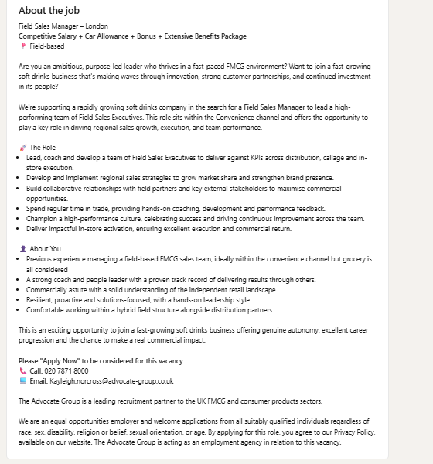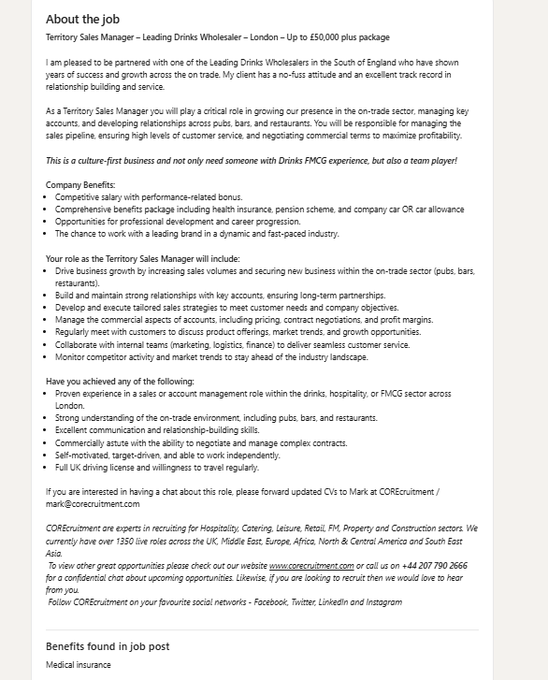

Task 1 – Select Job Adverts and Identify Key Skills
The two selected job adverts are for a Field Sales Manager in London at a fast-growing soft drinks/FMCG business and a Territory Sales Manager for a leading drinks wholesaler in London. Although the organisations use different routes to market, both adverts identify a similar set of commercial, interpersonal and leadership skills.
The first advert emphasizes leading a field sales team, coaching and developing Field Sales Executives, delivering KPIs, managing distribution and improving in-store execution. It also requires regional sales strategy, customer relationship management, trade activity and the ability to identify commercial opportunities. Knowledge of the convenience channel, grocery and the wider FMCG environment is important. The second advert focuses more on the on-trade sector, including pubs, bars and restaurants. Its requirements include sales growth, new business development, key account management, sales pipeline management, negotiation, pricing, contracts and profit margins. It also highlights communication, relationship-building, self-motivation and knowledge of the drinks and hospitality market.
The main common skills across both adverts are sales development, territory management, customer relationship management, communication, commercial awareness, negotiation, new business acquisition, target achievement and knowledge of the drinks/FMCG market. Both positions require independence, resilience and the ability to identify opportunities and convert them into profitable business. Leadership is especially important in the Field Sales Manager role, while the Territory Sales Manager role emphasizes managing customers and commercial performance.
One key skill I could use in my future employment is customer relationship management. In a field-based sales position, building relationships involves understanding the customer's needs, providing appropriate solutions, following up consistently and creating opportunities for repeat business. My previous experience has shown that customers are more likely to engage when a salesperson understands their business and provides practical support rather than simply presenting a product.
In a future Field Sales Manager or Territory Sales Manager role, I would use this skill by segmenting customers by potential, planning regular visits, recording opportunities in CRM systems and agreeing clear follow-up actions. I would also use customer feedback to identify gaps in distribution, pricing, product range or promotional activity. This approach would help me develop long-term partnerships while contributing directly to sales growth, customer retention and KPI achievement.

Task 2 – Self-Assessment
SWOT Summary
Strengths | Weaknesses
Relevant FMCG and drinks experience; new business development; approximately 200 new customers; communication; relationship-building; adaptability; independent field work. | Formal people management; advanced sales-data analysis; strategic negotiation; commercial planning for larger-scale management roles.
Opportunities | Threats
Progression into Territory/Field Sales Management; leadership training; Excel and CRM development; mentoring; stronger use of measurable achievements. | Competition for management roles; changing FMCG conditions; margin pressure; changing customer behaviour; risk of skills becoming outdated; balancing work, study and development.
My SWOT self-assessment reflects the requirements of two selected job adverts and draws on my professional experience in FMCG, beverages, foodservice, and hospitality.
Strengths
A key strength is my practical sales experience across multiple sectors. I have worked in brand activation, business development, and field sales, which has given me insight into customer purchasing decisions. At Aqua Carpatica UK, I gained expertise in beverage brands, activation, and customer engagement. At Brakes UK, I focused on acquiring customers in hospitality, including restaurants, pubs, hotels, education, and care. This experience aligns with the second job advert, demonstrating my knowledge of the on-trade environment and the importance of prospecting, relationship management, and commercial discussions.
New business development is another strength. At Dot Dot Creative Ltd, I secured approximately 200 new customers across convenience stores, coffee shops, supermarkets, and sushi businesses within six months. This demonstrates my ability to prospect, engage diverse customers, present products, and convert opportunities. It also highlights my resilience, as field sales requires persistence and consistent effort.
Communication and relationship-building are also strengths. Sales performance relies on understanding customers, clearly explaining value, and maintaining professional relationships. My experience engaging with buyers and business owners has made me comfortable communicating with various decision-makers. I am also experienced working independently in the field, meeting both adverts' expectations for self-motivation and responsibility.
Adaptability is another strength. Transitioning between beverages, foodservice, and FMCG has required me to learn new products, customer needs, and sales processes. This flexibility will support my adjustment to a new territory or organization.
Weaknesses
Formal people management is a key development area. While I have experience with customers, territory management, and supporting commercial activity, the Field Sales Manager role requires coaching and developing a team against KPIs. I aim to strengthen my ability to conduct structured one-to-one meetings, provide performance feedback, delegate effectively, and support underperforming team members.
Advanced sales data analysis is another area for development. I understand sales performance and commercial targets, but I want to build confidence in using data to identify trends, measure territory performance, and make strategic recommendations. Enhancing my skills in Excel, CRM reporting, and dashboards will support more evidence-based decision-making.
I also seek to further develop strategic negotiation and commercial planning skills. While I have negotiated with customers and presented products, more senior roles require complex discussions on pricing, margins, contracts, promotions, and profitability. Strengthening these skills will help me transition from individual sales performance to broader commercial management.
Opportunities: The drinks and FMCG sector offers strong opportunities for career progression, as field sales experience can lead to roles such as Territory Sales Manager, Area Sales Manager, National Account Manager, or Sales Manager. The two adverts indicate that employers value candidates who combine sales execution with leadership and commercial acumen. My sector experience provides a solid foundation for advancement.
Professional development is another opportunity. I can leverage online courses, employer training, mentoring, and practical projects to improve people management, Excel, CRM analytics, and negotiation skills. Seeking feedback from experienced managers and using performance reviews will help identify specific areas for improvement.
There is also an opportunity to strengthen my professional profile by documenting measurable achievements. Instead of describing myself solely as an experienced salesperson, I can demonstrate impact through new accounts won, revenue generated, customer retention, distribution growth, and territory performance. This approach will make my CV and interviews more evidence-based.
Threats: Competition for management-level sales positions is a significant threat, as many candidates have direct experience managing large teams and national accounts. The evolving FMCG environment also presents challenges, including margin pressure, shifting consumer behaviour, and increased brand competition. Employers increasingly seek sales managers who can demonstrate commercial value, not just activity.
Another threat is relying too heavily on existing experience. Sales methods, CRM systems, data tools, and customer expectations are continually evolving. Without ongoing development, my experience may become less distinctive. Additionally, balancing work, study, and professional development can pose time-management challenges.
Overall, this SWOT analysis demonstrates a strong foundation for employability in drinks and FMCG sales. My priority is to progress from an experienced field salesperson to a well-rounded commercial leader. By enhancing people management, data analysis, negotiation, and strategic planning skills, I can meet the requirements of senior positions and expand my long-term career opportunities.

Task 3: Employment Goals and Personal Development Plan
My aim in the short term is to move into a Territory Sales Manager or Field Sales Manager role in the drinks or fast-moving consumer goods (FMCG) industry, so that I can put into practice my experience in field sales and business development while at the same time developing my leadership and commercial management skills. During the following 6 to 12 months, I plan to improve my abilities in management, data analysis, and negotiation, and will monitor my progress by referring to specific and measurable work achievements.
My aim is to eventually become an Area Sales Manager or a senior commercial sales leader, taking responsibility for a wider territory or a team and helping to shape regional growth strategies. This is in keeping with my desire to move from working on individual customer acquisitions to taking on positions which focus on leadership, strategic planning, and more extensive commercial duties.
The three areas that I want to focus on in my personal development plan are the following: I intend to improve my abilities in people management between six and twelve months by taking a leadership or coaching course that is widely acknowledged, asking an experienced manager to act as my mentor, and offering to coach my colleagues. My progress will be evaluated based on feedback as well as on the actual improvements seen in the way I delegate and in the effectiveness of my coaching.
Second, over the next six months I intend to increase my proficiency in Excel, CRM reporting, and sales data analysis by taking an intermediate or advanced Excel course and by practicing the creation of sales dashboards using realistic territory data. My progress will be judged by my ability to analyse key performance indicators (KPIs), spot trends, and make clear commercial recommendations.
Third, over the coming 12 months I will improve my negotiation and commercial planning abilities by attending negotiation training and keeping records of examples of my dealings with customers, our pricing discussions, and the commercial results achieved. Success will be judged by feedback, greater confidence, and tangible improvements in sales or margins. The steps I am taking cover the weaknesses noted in my SWOT analysis and serve as evidence of my active preparation for moving into a management position.
Personal Development Plan Overview
Development area | Actions | Timeline / Resources | Measure of progress
People management | Leadership/coaching course; mentoring; coach colleagues. | 6–12 months; course + manager/mentor feedback. | Feedback, delegation and coaching evidence.
Data analysis | Advanced Excel; CRM reporting; build sales dashboards. | Within 6 months; online course + practice data. | Analyse KPIs and present recommendations.
Negotiation | Negotiation training; record customer/commercial outcomes. | Within 12 months; training + workplace practice. | Feedback, confidence and measurable sales/margin outcomes.

