Eco-Insulate UK Senior Management Report: Reward Management
- Reward principles (AC1.1) (390 Words)
Eco-Insulates reward management must be strategically aligned with our business strategy, encompassing relevant policies, philosophies, and practices that recognise employee contributions and reinforce organisational goals. When designed effectively, reward systems play a critical role in shaping a positive organisational culture, promoting desired behaviours, plus pivotal in developing individual and organisational performance (Chown, 2023).
Despite working in different sectors, B&Q and GSK have successfully aligned business and reward strategies to enhance culture and performance. Eco-Insulate must also align its reward principles with strategic goals and core values to support a positive work environment, improve performance management, and improve overall business effectiveness (Armstrong, 2010).
Figure 1: A Reward System (Armstrong 2014,p.364)
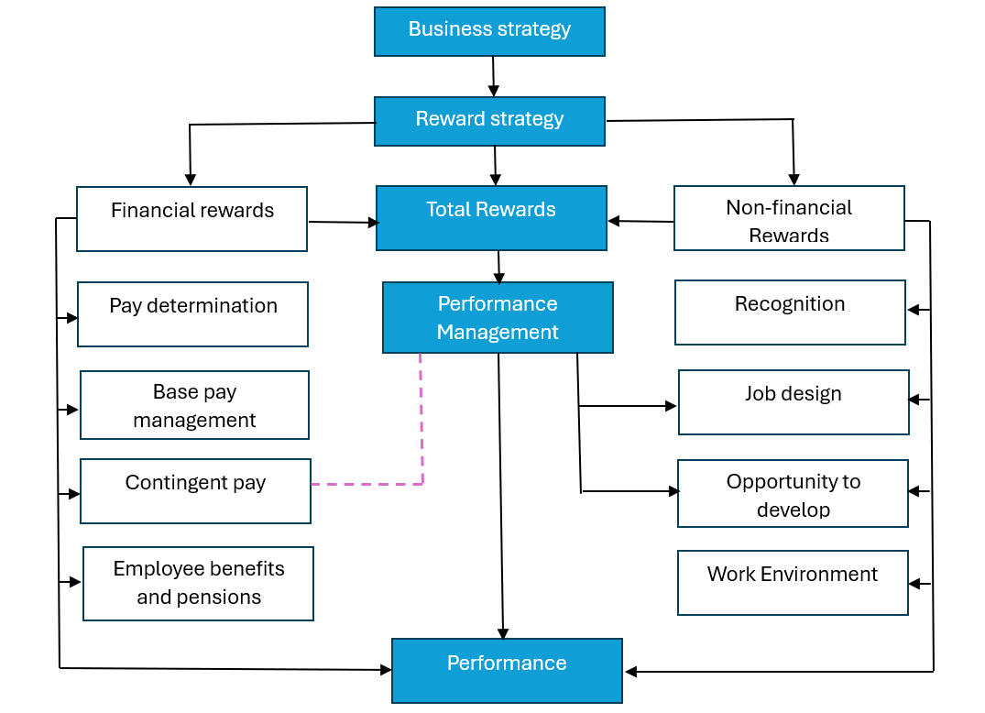
Organisations with established reward strategies are 1.5 times more likely to keep high performers, 1.6 times more likely to meet current talent needs, and 3.1 times more likely to maximise return on reward investment (Bradley and Gilmartin, 2024).
Effective reward systems must be transparent, competitive, consistently applied, and aligned with performance expectations to build trust and credibility (CIPD, 2025a). They should support ‘good work’ by promoting job security, development opportunities, and inclusivity. Eco-Insulate provides only basic statutory benefits, with no formal incentives and secretive senior-level schemes. This places us at a disadvantage compared to competitors, undermining our culture and performance potential (Young and Tong, 2025).
To address this, a comprehensive Total Reward strategy is essential. Integrating both extrinsic (transactional) rewards including pay, bonuses, and benefits, plus intrinsic (relational) rewards, including recognition, personal development, and meaningful work. These influence Eco-Insulates organisational culture and drive performance management by enhancing motivation, engagement, and goal alignment (Armstrong, 2010).
Figure 2: The Elements of Total Rewards (Armstrong 2010,p.42)
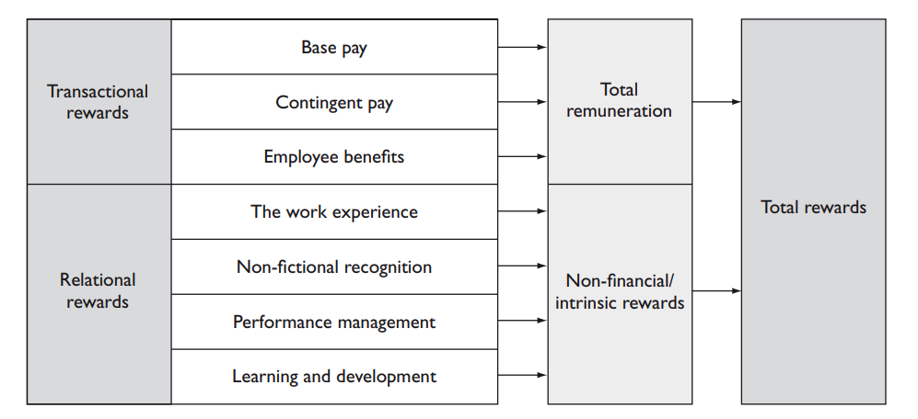
While financial compensation is still a key motivator in job selection, non-financial factors including job security, flexibility, personal growth, respect, and a positive work environment play a crucial role in retention and engagement (Taylor, 2014; Rees and Tymon, 2016).
A successful Total Reward system must be supported by clear performance metrics, achievable goals, and effective oversight, therefore critical to our performance management system. Otherwise, it risks being seen as unfair and demotivating (Gupta and Shaw, 1998).
Communication, complexity, and adapting to changing employee expectations are still ongoing challenges (CIPD, 2025a; Lupton, 2015). Over half of existing reward strategies do not meet the needs of remote workers (Churchill, 2020).
The principles of reward including pay, benefits, recognition, development, and performance management will significantly strengthen engagement, increase productivity, and foster a high-performance, innovative culture at Eco-Insulate (Armstrong, 2010).

- Extrinsic and intrinsic rewards (AC1.2) (394 Words)
Extrinsic and intrinsic rewards contribute to individual motivation and sustained productivity. They have differing approaches, however both are essential for talent attraction, retention and reinforcing performance expectations at Eco-Insulate. Extrinsic rewards including pay, bonuses, promotions, and benefits address employees' fundamental needs, including financial security and stability, aligning with the lower levels of Maslow’s hierarchy of needs (Zalenski and Raspa, 2006).
Pay is still the fundamental extrinsic reward, directly linked to job roles and market rates. Bonuses, particularly performance-related, offer short-term incentives that drive output and competitive behaviour. Benefits including health-cover, pensions, and paid leave enhance the overall employee value proposition and support overall employee wellbeing, contributing to loyalty and retention. While these rewards can significantly boost employee contribution, particularly in goal-oriented environments, their long-term effectiveness depends on strategic alignment (CIPD, 2025b).
Over-reliance on extrinsic rewards risks undermining intrinsic motivation if not balanced appropriately. Currently, Eco-Insulate lacks structured performance-based incentives. Introducing performance-related pay (PRP), grounded in Expectancy theory, can enhance motivation linking effort to clear, achievable goals. However, it assumes financial reward is always the primary driver. Line managers will play a pivotal role in effectively implementing and managing these schemes (Armstrong, 2010).
Intrinsic rewards including recognition, autonomy, purpose, and personal growth are critical to sustained performance and employee engagement. Autonomy empowers ownership and creativity. Purpose connects individual roles to organisational impact. Opportunities for development address higher-level psychological needs, including esteem and self-actualisation (Kaur, 2013).
These rewards, derived from the nature of work itself, are more enduring and support long-term job satisfaction and commitment. Job design that incorporates meaningfulness increases intrinsic motivation. Autonomy, competence, and relatedness as recognised in Self-Determination Theory are essential for sustained contribution and performance (Deci, Olafsen and Ryan, 2017).
Fairness in reward distribution is vital. Inequity perceptions, particularly with existing secret Eco-Insulate schemes will lead to dissatisfaction and demotivation. Transparency is essential. Clarity on who receives what and why, ensures equity and builds trust (Rees and Tymon, 2016).
While many organisations prioritise extrinsic incentives, a balanced, integrated approach is essential (Woodhams and Perkins, 2022). A Total Reward strategy combining both extrinsic and intrinsic elements will optimise individual contribution and deliver sustained organisational performance. Eco-Insulate must include all relevant components and recognise the different interrelationships and dynamic factors in creating a total rewards framework to build a high-performance, engaged workforce to enable a sustainable and successful business (Armstrong 2010; Cotton, 2018).

- Grade and pay structures (AC2.1) (431 Words)
Pay and grade structures are essential, non-discriminatory frameworks within basic pay systems, designed to manage compensation, ensure fairness, and support business strategy. Adopting an appropriate structure is essential for Eco-Insulate to support transparent, equitable, and strategically aligned remuneration practices (Perkins, White and Jones, 2016).
While smaller organisations may manage pay informally on a case-by-case basis, these approaches often lack scalability, transparency, and strategic alignment. Over two-thirds of UK employers now implement structured pay frameworks, with over 80% reviewing them regularly to ensure fairness. However, fewer than one-third feedback findings to employees (CIPD, 2024a; Unison, 2023a).
Structures can be classified as informal or formal. Informal structures include individual job or salary ranges, spot rates, and individual pay arrangements. Spot rates are common in specialist sectors including the electrical industry, where the Joint Industry Board (JIB) sets hourly rates and standardised benefits across roles and all business sizes (JIB, 2025a; JIB, 2025b). While these reflect market national rates, supporting recruitment and retention, they often lack transparency, progression methods, or represent the local labour-market. However, job grades could enable pay progression based on performance, competence, or contribution, around a fixed mid-point salary (Unison, 2023a).
In contrast formal pay structures offer a systematic hierarchy of grades based on job complexity, responsibility, and competencies. Each grade is linked to a defined salary range, enabling progression based on tenure, performance, or skill.
Figure 3: Types of pay structures (Armstrong 2015,p.180)
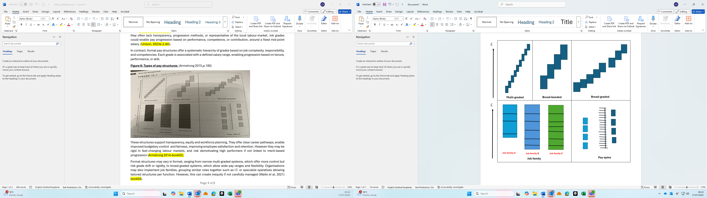
These structures support transparency, equity, and workforce planning. They offer clear career pathways, enable improved budgetary control and fairness, improving employee satisfaction and retention. However, they can be rigid in fast-changing labour markets, and risk demotivating high performers if not linked to merit-based progression (Armstrong, 2014).
Formal structures may vary in format, ranging from narrow multi-graded systems, which offer more control but risk grade drift or rigidity, to broad-graded systems, allowing wide pay ranges and flexibility. Organisations may also implement job families, grouping similar roles together like I.T. or specialist operatives allowing tailored structures per function. However, this can create inequity if not carefully managed (Waite et al., 2021).
Popular in the public sector, pay spines include numerous incremental points, usually rewarding tenure. Administratively simple and equitable, they lack performance recognition and can lead to increased costs in low staff-turnover environments (Armstrong, 2015).
Eco-Insulate must select a structure aligned with its organisational culture, working practices, and strategic objectives. The chosen system should provide flexibility, fairness, and deliver our business needs (Armstrong, 2014). With salary transparency increasing by 49% in the UK since 2019, adopting a formal structure may highlight pay discrepancies, increase trust, reduce administrative costs, and support effective positive change (King, 2025; Kirby, 2025).

- Contingent rewards (AC2.2) (372 Words)
Contingent rewards are linked to specific goals or performance metrics. They are a critical component of all performance management systems. Used by 70% of employers, they are based on variables including performance, skill, competence, or contribution. Their influence on individual, team, and organisational performance is significant when well-designed, clearly assessed, and strategically aligned to Eco-Insulates requirements (Woodhams and Perkins, 2022).
Figure 4: Types of variable pay (Perkins, White and Jones 2016,p.187)
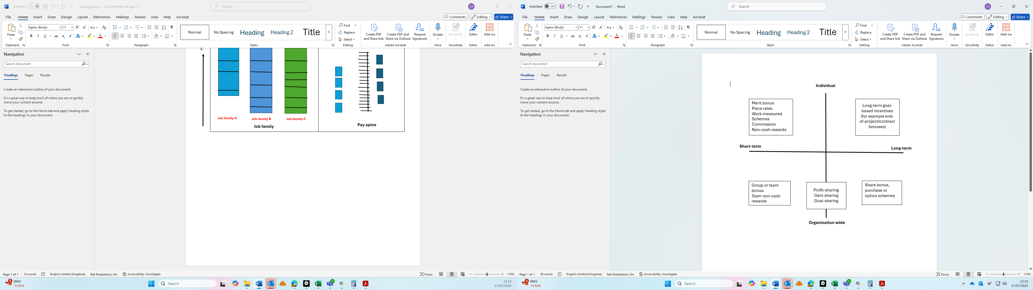
At the individual level, merit bonuses and commission can enhance motivation, focus, and productivity. These rewards increase employee effort through anticipated tangible recognition. Effectiveness is based upon realistic goal-setting, otherwise it leads to demotivation or unethical behaviour (Armstrong, 2010). While PRP is popular, poorly implemented schemes may demotivate average performers if perceived as inequitable (CIPD, 2024a).
Eco-Insulate only implies measured daywork, shop-floor piece-rate can boost individual output, but requires strict quality control and clear performance criteria. Additionally, non-cash incentives including gifts maybe more appropriate in financially difficult periods (Lupton, 2015).
Skill-related reward is offered for new skills acquisition and maybe more relevant for our shopfloor. Competency-related requires a definition of what ‘competency’ is, evidencing it, with a full assessment, ensuring its ongoing relevance, all of which increases complexity.
Figure 5: Competency-related pay (Armstrong 2010,p.187)
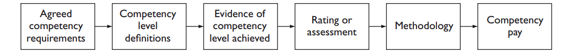
Team level contingent rewards increase collaboration and create a shared purpose when aligned with team objectives. Group, shift or contract completion bonuses when aligned with team objectives, encourage joint effort and enhance overall performance. However, they must be designed to prevent unfairness perceptions due to unequal contributions. Group tensions or unhealthy competition can be mitigated through fairness, transparency, and clear accountability structures (Taylor, 2010; Armstrong, 2014).
Organisation-wide contingent rewards, including profit-sharing or employee ownership, align employee interests with Eco-Insulates goals, reinforcing a high-performance culture. While their motivational impact may vary (Ogbonnaya, Daniels and Nielsen, 2017), these schemes promote long-term engagement and trust. Gain-sharing, though complex and used by only 13% of companies, links cost-saving or productivity improvements directly to financial rewards, reinforcing innovation and shared success to drive overall business performance (CIPD, 2024b; Taylor, 2014).
Contingent rewards can significantly influence Eco-Insulates performance at all levels when strategically aligned and appropriately managed. However, without fairness, clarity, consistent oversight, and effective line-management, they risk undermining morale, encouraging bad behaviours. This could damage our planned Eco-Insulate cultural and productivity improvement initiatives (Crawshaw, Budhwer, and Davies, 2017).

- Benefits (AC2.3) (416 Words)
Benefits are non-wage compensation forming a vital part of total rewards, which Eco-Insulate can use to positively influence employee attraction, retention, motivation, well-being, and overall organisational performance. This is especially relevant given current concerns around staff turnover, company culture, and performance (CIPD, 2025c; Armstrong, 2014).
Their merits will depend on identifying employee needs and aligning initiatives with Eco-Insulates priorities and values. The top three benefits are healthcare, paid time off, and pensions (Haan and Bottorff, 2024).
Health and well-being benefits depending on budget include medical, dental, vision, and wellness programs. These support higher productivity, reduce absenteeism, improve resilience and loyalty. Improving morale and reducing short and long-term ill-health consequences and costs while enhancing Eco-Insulates reputation in the talent market. Offering such benefits aligns with our vision to invest in people, driving performance and engagement (Cowler, 2024) .
Work-life balance rewards including flexible working, paid leave, and family-friendly policies all promote well-being, reduce burnout, and enhance job satisfaction. These improve retention, productivity, and organisational commitment. Addressing employees’ practical needs concentrates their focus and engagement. 35% of working parents are seeking new employment for relevant improved terms and with most businesses now offering flexible working, work-life provisions are essential for our labour market competitiveness (Cotton et al., 2022; Dawson, 2025). Such rewards reinforce our commitment to a healthy, motivated workforce and strengthens our employer brand.
Pension and insurance benefits hold particular value for older employees, providing future financial security. Therefore, Eco-Insulate could use this information when deciding what benefits would be best suited to our employees. In the public sector, where base pay is often lower, high pension contributions are a key attraction, increasing loyalty and reducing turnover (Davies, 2025).
Figure 6: Employee perceptions of the value of their pension contribution over their career (Lupton, 2015,p.26)
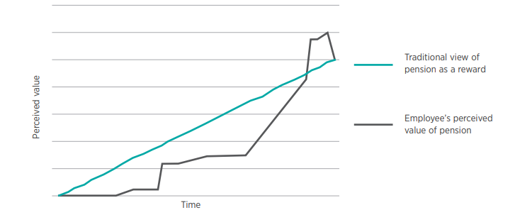
Critical illness or death-in-service coverage removes financial anxiety, again improving employees’ focus and productivity. As 25% of employees report money worries affecting job performance, financial well-being schemes including early pay access apps or interest-free loans can further enhance workforce stability (Cotton, 2022; Mohdzaini, 2022).
Flexible benefits, only used by 24% of employers, allow personalisation. This increases individual satisfaction, engagement, and retention, illustrating Eco-Insulates responsiveness and further strengthens our branding. However, they are expensive and complex requiring careful planning and resources. Half of employees would accept reduced pay in exchange for tailored benefits, illustrating its potential, if they can be effectively implemented (Woodhams and Perkins, 2022; Howlett, 2019b; People Management, 2022a).
Despite their costs, benefits can enhance ‘quality of working life’, reinforcing Eco-Insulates corporate social responsibility and supporting recruitment, retention, inclusion, and long-term organisational success (IDR, 2023; Dawson, 2025).

- Recognition (AC2.4) (389 Words)
Recognition schemes are a critical part of total rewards, offering both financial and non-financial incentives to motivate and retain. Financial rewards including pay increases and bonuses are tangible and effective in boosting short-term performance and motivation. Also, vouchers and gifts serve as additional financial tools, contributing to employee engagement when integrated into a broader reward strategy (Cotton, Gifford, and Young, 2022).
Beyond monetary incentives, non-financial recognition plays a vital role in creating a high-performance culture. These schemes can be formal or informal, public or private, individual or team-based, top-down or peer-to-peer. While formats differ, each offers its own benefits when aligned with Eco-Insulate goals and workforce requirements. Formal schemes include 'Employee of the Month' awards or long-service recognitions. Formal recognition provides visible, structured acknowledgment, reinforcing Eco-Insulates goals and enhancing employee self-esteem, job satisfaction, and a sense of purpose. Their impact depends on consistency, transparency, and avoiding bureaucratic or superficial implementation (Waite et al., 2021).
Informal recognition includes verbal praise or thank-you notes, often delivered by line-managers through real-time praise or development support, offers immediacy and authenticity. It reinforces desirable behaviours and builds a culture of everyday recognition, fostering stronger manager-employee relationships and improved wellbeing. This aligns individual contributions with core values, which is key to sustainable performance improvements (Armstrong, 2010).
Recognition preferences vary among individuals. Some may value private acknowledgments over public displays. Tailoring recognition methods to suit employee preferences ensures inclusivity and avoids alienating those uncomfortable with public attention. Equally important is employee voice creation. By allowing employees to participate in decision-making and provide feedback, organisations demonstrate respect and recognition, reducing attrition and increasing engagement (Crawshaw, Budhwer, and Davies, 2017).
Peer-to-peer recognition decentralise recognition, empowering employees to appreciate one another’s contributions. This promotes collaboration, inclusivity, and internal networking. It enhances team cohesion and builds a collective sense of achievement, which supports individual motivation and strengthens organisational culture. As 59% of employees globally report low motivation in conjunction with our own experience with high staff turnover and a negative culture, such schemes are essential for engagement and performance (Personio, 2025).
Recognition scheme success depends on fairness, relevance, and organisational values alignment. Tokenistic or biased schemes will damage morale and trust. Recognition strategies must be carefully designed, consistently implemented, and tailored to workforce needs to support Eco-Insulates long-term goals, ideology, and in creating a new positive organisational culture (CIPD, 2022).

- Business Context (AC3.1) (387 Words)
Operating in a global marketplace, Eco-Insulates reward strategy is shaped by a complex mix of international, national, and organisational factors. As a medium-sized business operating across diverse specialist markets, Eco-Insulate must operate within various legal, cultural, and economic influences that determine pay. Internationally, cultural expectations and labour regulations will impact reward policies. International trade changes, exchange rates, global events, and logistical disruptions directly affect supply costs and consequently, Eco-Insulates available reward budget (Hooker, 2024).
Nationally, UK legislation regarding minimum and equal pay, demographic changes, and regional skill shortages all impact reward priorities (Woodhams and Perkins, 2022). There are several other external and internal factors influencing Eco-Insulates reward decisions.
Figure 7: Factors affecting pay levels (Armstrong, 2010,p.232)
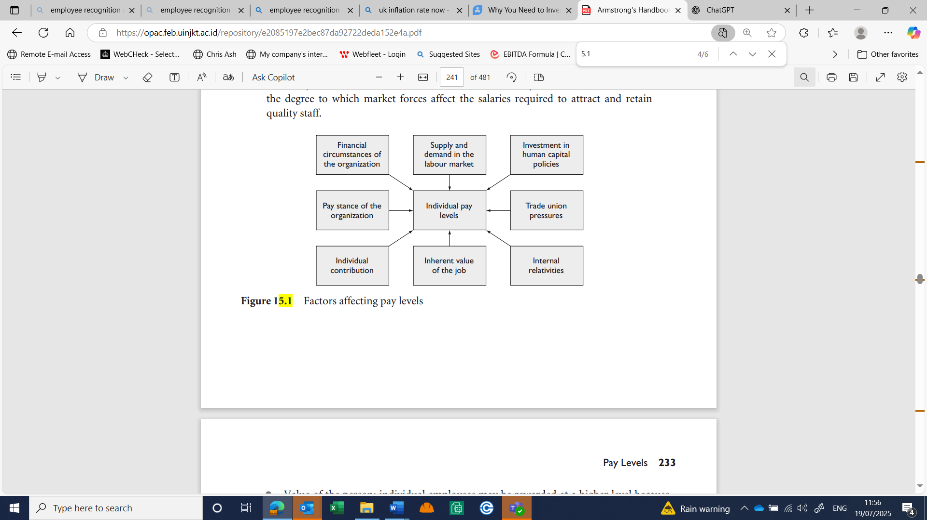
Political and legal developments including recent UK government potential reforms that will extend workers’ rights, also higher minimum wage and employer National Insurance contributions have increased Eco-Insulates cost base. Also, the cost-of-living crisis has exaggerated these challenges directly affecting our reward budget (CIPD, 2025d). 36% of UK employers are finding it difficult to fill vacancies, increasing talent competition, driving up wages. (Cockett, 2024; Paydata, 2025)
In May 2025, median pay grew by 5.8%. There were considerable industry differences, 7.5% in food service against 3.5% in insurance. These emphasise the need for sector-specific pay strategies. Benchmarking competitors pay in our sector becomes essential in staff retention (ONS, 2025a).
Eco-Insulates ability to fund rewards is directly linked to our finances and sales performance. During economic downturns, non-monetary recognition and development opportunities gain increased importance. The business type and whether its operating in the public or private sector will also impact decisions. Trade unions influence further shapes reward (Cotton et al., 2024; Perkins, White and Jones, 2016).
Internally, Eco-Insulate business strategy, leadership approach, and organisational culture drive reward decisions. Leadership priorities whether focusing on cost control, innovation, customer service or performance will dictate incentive type. Industry norms also influence whether rewards are output-driven or behaviour-based. Our workforce demographic will require a tailored reward approach. Possibly younger employees value career progression and flexibility, while older staff may prioritise financial security through pensions or insurance (Armstrong, 2014).
Eco-Insulates reward strategy must remain agile and responsive to numerous external and internal pressures. Strategic alignment with business objectives, compliance with regulatory frameworks, and an understanding of our specific workforce needs are all essential to maintaining a competitive and effective reward environment (Woodhams and Perkins, 2022).

- Benchmarking (AC3.2) (395 Words)
For Eco-Insulate, the most appropriate way to collect and measure benchmarking data is through a structured, cyclical approach combining internal and external sources to ensure accuracy, consistency, and relevance (Anand and Kodali, 2008).
Figure 8: Benchmarking cycle (Jetmarova 2011,p.80)
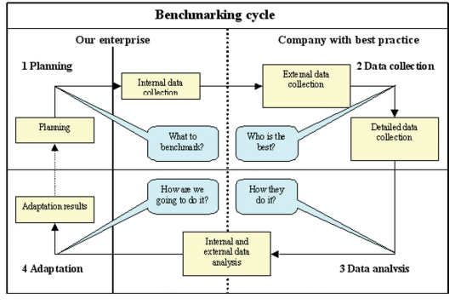
Effective benchmarking begins internally, with a detailed analysis of current remuneration packages and role details. Key sources include payroll records, appraisals, job descriptions, and surveys. Certain sources can be subjective, outdated and not fully comprehensive. Integrating multiple quantitative and qualitative data types provides a more balanced and robust approach. Internal analysis forms the basis for meaningful external comparisons and ensures internal equity. Senior management commitment is essential to support data collection, maintain confidentiality, allocate resources, and ensure data accuracy. Additionally providing evidence-based training for the benchmarking team. Without this foundation, external benchmarking may lead to misaligned or ineffective Eco-Insulate strategies (Jetmarova, 2011; Farrand, 2023).
Industry compensation surveys are a key quantitative benchmarking source, offering data on pay levels by job function, or skillset. The JIB publishes a transparent national market rate for all businesses to compare (JIB, 2025b). Eco-Insulate must consider variations in role content, responsibilities, and accountability, as direct like-for-like role comparisons are often limited. Reward strategies must align with Eco-Insulates broader business objectives rather than just copying competitors’ rates, to avoid overpayment and misaligned company rewards. Combining information with additional relevant sources including job evaluations would enable improved benchmarking (Davies, 2025; Farrand, 2023).
Professional networks and associations, including CIPD, offer qualitative insights into emerging trends, people practices, and innovative reward strategies. With a reliance on voluntary feedback and focus on more generalised areas, they are possibly best suited for identifying trends rather than precise benchmarking metrics. Nevertheless, it offers important strategic decision-making guidance (CIPD, 2025e). Alternative benchmarking sources, which are key to data validity and reliability include recruitment advertisements, which may offer general data on current pay, though its reliability is inconsistent. Specialist third-party HR consultancies can offer more tailored benchmarking, including role-specific and regional insights, however at a cost (IDR, 2023; Woodhams and Perkins, 2022)
Government and public databases, including ONS, OECD, GOV.UK and the Bank of England offer valuable macro-level analysis. The ONS conduct eight-two UK business surveys annually, distributing 1.4 million questionnaires, providing essential economic data for government monitoring, market analysis, academic research, and business benchmarking. While extensive, they may only offer limited information for Eco-Insulate company-specific highly specialised roles (ONS 2025c; Perkins, White, and Jones, 2016).

- Job Evaluation (AC3.3) (414 Words)
Job evaluation provides a structured approach for determining relative role worth within Eco-Insulate. This ensures internal equity, supports reward structures, and aligns with market pricing. Although market benchmarking is common, maintaining internal fairness within organisations remains a concern (Armstrong and Brown, 2018).
Job evaluation can apply organisation-wide or to specific groups and involves either analytical or non-analytical approaches (CIPD, 2025e). Before initiating job evaluations, Eco-Insulate must consider the purpose, evaluation framework, and responsibilities of those involved.
Figure 9: ACAS Pre-Job Evaluation . (ACAS 2014,p.4)
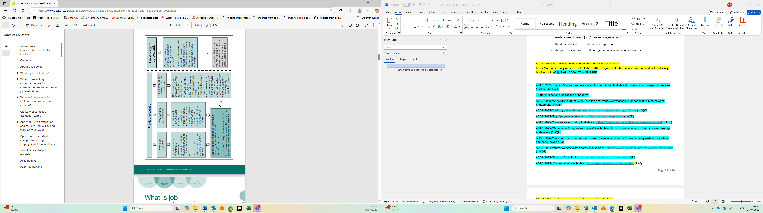
Unison offers resources to support this process, including checklists, case studies and training. This helps to address informal and formal bias by identifying unconscious personal beliefs that influence assumptions and ensure they are excluded from the job evaluation framework, maintaining the integrity of the process (Unison, 2023b).
Non-analytical job evaluation methods, including job ranking or classification, assess roles as a whole, often lacking objective criteria. Commonly used in academic or the public sector, roles are placed in a hierarchy or grouped based on complexity. This can be simple and cost-effective but are subjective and prone to inconsistency. Accurate matches within Eco-Insulate can be difficult to achieve. These approaches provide no legal defence in equal pay claims because of their lack of transparency and detailed evaluation criteria (Suff and Reilly, 2006; Woodhams and Perkins, 2022).
Analytical approaches deconstruct jobs into key components for evaluation, promoting fairness and objectivity. The popular point-factor method assesses roles against pre-defined factors including skills, responsibilities, working conditions and effort, assigning weighted scores that create an overall value. Commonly used within corporates, this method is systematic, transparent, and difficult to manipulate but is time-consuming and resource intensive. Competency-based evaluation measures roles against the behaviours and competencies required for effective performance. While this aligns well within dynamic high technology environments, it demands clearly defined competencies, which can be challenging to express (ACAS, 2014; Armstrong, 2014).
Analytical methods can be complex, bureaucratic, and costly. They may incorrectly suggest exactness. Nevertheless, they provide equal pay claims defence and build equitable pay systems (Suff and Reilly, 2006).
Figure 10: Comparison of analytical and non-analytical approaches to job valuation. (Crawshaw, Budhwer, and Davies 2017,p.261)

Critical to job evaluation validity are evaluators consistency and objectivity. Standardisation through clear definitions and training is essential. Increasingly, computer-based systems are used to improve consistency and reporting, though these may reduce transparency and employee involvement (Taylor, 2014).
While job evaluation can be resource-intensive, it offers considerable benefits. It enables Eco-Insulate to fully understand what our employees do, supports job design improvements, enhances communication, promotes transparency and equity which are the foundation for a fairer and more positive working environment (ACAS, 2014).

- Reward legal requirements (AC3.4) (454 Words)
Legislation plays a vital role in forming Eco-Insulates reward strategy, ensuring fairness, compliance, and competitiveness. Legal requirements do more than set minimum standards, they actively influence how pay and benefits are structured, set budgetary priorities, informs market-positioning, and builds our much-needed long-term workforce engagement and retention (Waite et al., 2021).
The Employment Rights Act 1996 ensures employees receive written terms outlining pay, while protecting against discrimination or unlawful deductions. Additionally, the National Minimum Wage Act 1998 sets legally enforceable minimum pay rates, reviewed annually. For Eco-Insulate, this sets a baseline for reward budgets and then influences pay for positions with greater accountabilities or performance requirements, particularly with increased employee expectations (Daniels, 2022).
Figure 11: Table on the Current National Minimum Wage Rates (ACAS 2025a)
Wage band | Current rate (from 1 April 2025)
Age 21 or over (National Living Wage) | £12.21
Age 18 to 20 | £10.00
Under 18 | £7.55
Apprentice | £7.55

Many organisations voluntarily pay the UK Living Rate currently at £12.60 to remain competitive (IDR, 2025).
The Social Security Contributions and Benefits Act 1992 requires employers to provide Statutory Sick Pay for eligible employees. Reinforcing Eco-Insulates responsibility in providing financial security as part of our rewards package during illness. These legal obligations influence both base pay and how Eco-Insulate designs its broader benefits including all paid time off aspects. Not only to ensure entry-compliance, but further paid time off benchmarking as a key reward component is needed to improve our talent attraction and retention issues (Lewis, 2015; ACAS, 2025b).
The Working Time Regulations 1998 mandates 5.6 weeks paid leave. Eco-Insulate only provides this statutory 28 day minimum, below the UK average of 34 days. While compliant, this limits our competitiveness. Increasing leave entitlement improves employee wellbeing, work-life balance, and has several associated business benefits improving productivity and culture(Daniels, 2022; Moss, 2024).
The Equality Act 2010 significantly affects reward strategy by prohibiting discrimination in all pay-related decisions, including base pay, bonuses, and promotion opportunities. Equal pay for equal work is not only a legal requirement but also a driver of internal equity, compelling Eco-Insulate to run transparent and compliant reward practices (Lewis, Sargeant and Schwab, 2011; Kidner, 2019).
250+ employee businesses have mandatory pay-gap reporting requirements for gender since 2017 and CEO since 2018. While this increases our administration demands, they actively inform our equitable reward practices (CIPD, 2024c). However, 17% of qualifying employers did not report their gender pay gaps in 2023, though 2024/25 saw one of the largest annual pay gap reductions from 11.8% to 11.2% (Jackson, 2025). Only 28% of CIPD surveyed employers reviewed ethnicity pay gaps (Cotton et al., 2024). The Equality (Race and Disability) Bill may extend reporting to include ethnicity and disability, though reporting in these areas is still challenging due to data limitations and disclosure sensitivities (CIPD, 2025f). Nevertheless, increased transparency will positively drive reward fairness, reputational credibility and competitiveness which all help to address our current psychological, cultural and retention issues at Eco-Insulate (Wilmott, 2020).

