“I know of no case study in history that describes an organization that has been managed out of a crisis. Every single one of them was led.”
George J. Flynn (Foreword: Leaders Eat Last, p. xi)
The concept of leadership and exactly what constitutes an effective and productive leader has been a focus of studies since the early part of the 20th century (Northouse, 2026). Indeed, throughout history, we can observe public recognition of great leaders who were noted as possessing certain characteristics which contributed to their success. In healthcare, historically, leaders were invariably male, dominant, imperious and intransigent, which gave rise to widely accepted dictatorial hierarchies within the medical setting (Kumar and Khiljee, 2016). In the modern NHS it has become widely accepted that such an unyielding, hierarchical structure is not only outdated (Bouttell, 2025) but the resultant inability to challenge has led to serious incidents and avoidable deaths, such as that involving Elaine Bromily in 2005 (Bidwai, Beument and Mercer, 2015).
Today the NHS is popularly referred to as being ‘in crisis’. Budgets are pinched, staff under pressure and public demand on services higher than ever before (Department of Health and Social Care, 2025). Now more than ever, positive and progressive leadership is needed to rally a tired and disenfranchised workforce and bring about real change.
This essay seeks to critically examine contemporary leadership theories, models and concepts and provide reflection on both my experience of leadership and knowledge of the same, gained by wider reading. I will conclude with an analysis of the relevance of each of the theories discussed, specifically in relation to their use within the Welsh Ambulance Service NHS University Trust (WAST).
I joined WAST in 2014 after a fifteen-year teaching career. I quickly progressed from Ambulance Technician to Paramedic and accepted a leadership role as Senior Paramedic in November 2025. During this time, I have worked with a variety of different managers, who adopted various styles of leadership – some intentionally and some seemingly spontaneous or involuntary. Since my appointment to a leadership role, I have become acutely aware of my own approach and the need to adapt this, in order to facilitate effective communication and engagement in the staff for whom I hold responsibility.
Perhaps one of the oldest beliefs regarding leadership is that leaders have certain traits which allow them to be successful in their role. The belief that ‘Great Leaders are born not made’ was the central belief to Carlyle’s Great Man Theory of the 19th century, which persisted well into the 20th century. The idea that potential leaders can be identified by certain characteristics, be that confidence, charisma or intelligence is a common concept even today (Northouse 2016) which, from observation, prevails within the ambulance service. Frequently promoted from within (Hirvikallio et.al), in my experience, staff within WAST are often headhunted for management and leadership roles, seemingly in accordance with certain personality traits. Conversely some appear to be disregarded without consideration, for similar reason.
The idea that leadership traits were inherent and could not be learned or developed, gave rise to models which identified specific traits that leaders must possess. These initially included physical qualities such as weight and height, in addition to supposedly innate characteristics including self-confidence, integrity and ambition (Budrhaja 2026). Stogdill (1948) conducted the first of two reviews of the literature on leadership available at the time and concluded that there is no single set of characteristics that are possessed by every leader and moreover, that possession of leadership traits does not automatically result in an individual’s progression to a leadership position (Irby et.al, 2013, Northouse 2016). Disparity pertaining to the concept and meaning of trait, whether it be inherent characteristics possessed by individuals or perceived attributes as observed by followers, gives rise to an enduring dichotomy between theorists (Day and Zaccaro from Koppes et.al, 2007).
On my journey to become Senior Paramedic (SP) I was asked repeatedly if I would consider applying for the role. It would be reasonable to suspect, that those asking saw traits in me that they thought would be beneficial. When examining leadership traits and characteristics as defined by leading researchers over the years (Northouse 2016), one characteristic commonly referred to is that of extraversion or self-confidence. Many other listed characteristics are of a similar theme (See fig below) but interestingly, it was my lack of self-confidence and abundance of self-doubt, that prevented me applying for the role of SP for many years.
Figure 1:
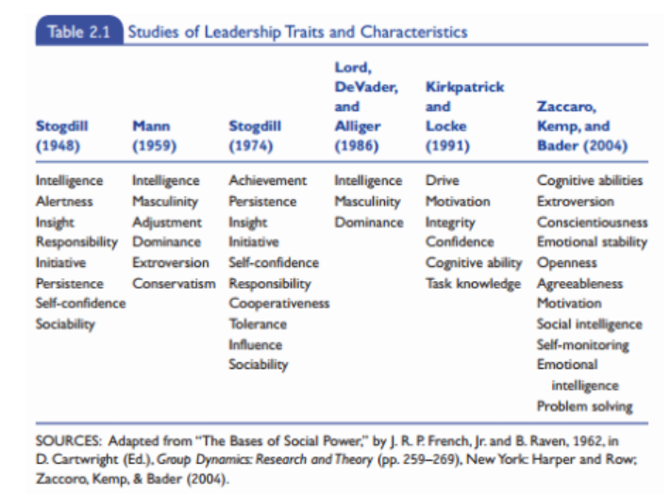
From Northouse 2016. Page??
In summary, trait theory sought to identify the characteristics that make individuals effective leaders. However, despite extensive research and debate no single universally accepted set of traits has ever been established (Benmira and Agboola 2020). Nevertheless, elements of trait theory seem to remain influential. Many people continue to associate effective leadership with particular personal attributes and characteristics and Benmira and Agboola further suggest, that modern psychometric tests seek to identify personality traits associated with suitability for specific roles within employment, positing that psychometric assessments are firmly grounded in trait theory.
The idea of authentic leadership emerged in the early 2000’s, probably as some have claimed, as a counter to some of the less ethical leadership styles experienced and observed around the turn of the millennium (Einola and Alvesson 2021). At this time, executive behaviour came under the spotlight for numerous corporate scandals which in turn exposed an environment of aggressive and often unethical practice, led by overconfident, directorial leaders (George 2007). George believed that leaders were frequently selected for the wrong attributes and felt that preferable attributes should be associated with personal values such as empathy, self-awareness and self-reflection indicating a strong moral compass. Since its inception, the idea of authentic leadership has seen the development of other models, significantly those of Kernis (2003) Ilies et. al. (2005) and Walumbwa et. al. (2008). Although, widely considered as moralistic, fair and transparent, authentic leadership models have also had their fair share of criticism. (Northouse 2016)
A central debate concerning Authentic Leadership Theory (ALT) is the notion of authenticity itself. Einola and Alvesson (2021) accept that authenticity can augment both performance and success but urge caution in using it to excess. Many corporate decisions must be made despite one’s genuine misgivings and to be uncompromisingly authentic in this environment, may reflect negativity on one’s professionalism. There is a risk that true authenticity, the ability to ‘be yourself’ in an honest and uncompromised style, invites vulnerability and exposure which may be difficult to ameliorate in the professional world (Einola and Alvesson 2021). Consider the paramedic who aspires to a leadership role, but who has developed a reputation as a joker or entertainer. Without curbing this part of their nature, they may be unlikely to be taken seriously either by senior management or by staff on their team. Nonetheless, Gardner and Karam (2021) see no issue with this scenario and argue that to lead influentially with self-awareness encapsulates the principle of ALT without conflict.
Further criticism of ALT relates to this dichotomy between personal authenticity and professional identity. As a new leader/manager in WAST I do feel I adopt a different persona than before, feeling the weight of the ‘senior’ role and concomitant expectations of staff. Personal standards come under scrutiny, whether that be uniform standards, knowledge or conduct, despite one’s idiosyncrasies.
Adopting a leadership persona is not always easy and is known to come with its own difficulties. Einola and Alvesson (2021) oppose the concept of authentic leadership as a theory, questioning how the inward gaze of authenticity can be successfully married with the outward gaze of leadership. They develop this argument by suggesting that attempts to become and be seen as authentic, introduce a conscious effort which is the antithesis of authenticity itself. Gino et al (2020) augments this idea by describing the heightened stress and personal toll of inauthenticity when associated with catering, whereby an individual moulds their responses and professional demeanour to fit what they believe to be the corporate expectation.
I can appreciate the stress of adapting one’s persona to fit, albeit the opposite scenario to that suggested by Gino et al. As an introspective, often cautious and rule-driven person, in my first few years at WAST I found it difficult to find my place amongst my mostly extroverted, gregarious colleagues. My need to be liked and accepted, often resulted in a conscious exaggeration of my personality, portraying a far more confident and sociable front than my natural default. Now in a leadership position as SP, my current role feels more comfortable to wear and allows me to be far more authentic in my personality, given that I must set an example both clinically and personally. I am naturally a rule follower who holds myself to high standards and the role of SP allows me to be authentic in that, without feeling awkward.
Ibarra (2015) examines the difficulty of combining the task of openly demonstrating one’s genuine self, with that of leading and managing staff effectively. She concludes that efforts to remain ‘true’ to one’s authentic self have the potential to prevent growth. Leadership development, Ibarra contends, involves learning from others and combining their best practices into an authentic personal style. Thus, personal growth can take place, whilst remaining true to beliefs and values.
More recently, studies in the field of leadership have begun to look at the need for self-analysis and reflection, in those that seek to lead effectively. At the forefront of this is the idea of emotional intelligence (EI), originally developed from the idea of social intelligence by Salovey and Mayer (1990), to explain how introspection and self-awareness can exponentially enhance leadership skills and qualities (Northouse 2016).
Goleman (2000) believes that self-awareness and the ability to self-regulate one’s personal emotions are skills that all effective leaders should possess and hone (Allen et.al 2016). Goleman expounded the difference between IQ and EI, claiming that whilst IQ was a relatively static quotient, EI can be learned and developed throughout life.
Goleman’s approach was further supported by Shankman and Allen’s (2012) Emotionally Intelligent Leadership model. This sought to combine EI and leadership through self, others and context, with the focus on others highlighting the importance of followership. The deliberate inclusion of others within this model, points towards the emerging importance of the notion of followership. Indeed, the footnote to that particular heading reads; “Being aware of your relationship with others and the role they play in the leadership process”
Allen et. at (2012)
Since commencing a leadership role, my altered relationship with colleagues has been a personal concern. Many of the staff I am now leading, led me by the hand as a newly qualified technician and mentored me through my training and early years as a paramedic. The irony is, that I now sit alongside them as a ‘senior’ and discuss both positive and negative aspects of their practice. Navigating this change of dynamic has weighed on me heavily, but crucially I have come to realise that it may not have been an easy process for some of them too. Often in Emergency Medical Services, the transition from front-line to leadership role is perceived as challenging and, in some cases, poorly received by former peers (Hirvikallio et. al 2026).
There remains much debate regarding how much influence EI plays in leadership success (Northouse 2016) and the validity of EI as a concept (Spector 2005). Locke (2005) separates intelligence from emotions and believes EI to be a form of rationality and the ability to regulate emotions. This, he states, has nothing to do with intelligence but is simply a collection of learned skills and introspection. Locke vehemently defends the traditional definition of intelligence against what he appears to perceive as a diluted, ‘easy to access’ intellect for all-comers. Nonetheless, supporters of EI as a scientific theory, propose that the ability to recognise emotion in both oneself and others and carefully regulate appropriate interactions, requires a level of intelligence that can be measured against traditional concepts of intellect (Askanasy and Daus, 2005).
As the debate continues, it seems to me to be reductive to question the value of self-awareness and emotional regulation, purely on the basis they fail to meet the conventional definitions of intelligence. Academic objections appear to mirror the historical tendency to undervalue so-called soft skills, despite substantial evidence demonstrating their contribution to workplace performance and leadership effectiveness. (Heckman & Kautz, 2012). In my opinion, qualities such as self-awareness, empathy and introspection are valuable and important leadership competencies.
Greenleaf (date?) recounts the story of Herman Hesse’s Journey to the East. Famously, he precises the tale of a band of explorers on a mythical journey and their servant Leo. When Leo goes missing and the group disintegrate, they realise that it was Leo, the servant, who was holding them all together, leading the group from within. (Greenleaf, 1970. Northouse 2026).
Although fanciful, the idea of servant leadership which developed from this early premise, has garnered great interest. From the title of Simon Sinek’s book Leaders Eat Last (2024), to the wealth of research carried out by scholars such as Hale and Fields (2007), Ehrhart (2004), Spears (2010) and Walumbwa et.al, (2010), the characteristics and traits of the servant leader are widely discussed (Northouse (2026).
As a service driven organisation, leaders within WAST could be anticipated to naturally default to this style. However, in my experience service pressures, financial constraints and operations targets, often result in the primary focus being elsewhere, away from the hypothetical band of explorers. Had Leo been constrained by budgets, boundaries and other such corporate constraints, it is possible the explorers would have looked on him less favourably.
Greenleaf (1970) asserts that effective leaders are servants first;
“Leo was actually the leader all of the time, but he was servant first because that was what he was, deep down inside.”
From personal experience, leaders and managers within the Welsh Ambulance Service NHS University Trust (WAST) are often promoted internally, having progressed from entry-level positions. This would suggest that such leaders possess a desire to improve the lives of others, having begun their career as front-line, patient-facing clinicians. It would not be unreasonable then, to expect them to continue this altruistic path as leaders, but it would seem not to be so straightforward. Kline (2019) cites the findings of the Francis Report (2013) which pointed to institutional norms within the NHS standing as barriers to holistic leadership styles. Once in a leadership position, the pressure to meet targets and inability to change operational systems appears to preclude more synergistic relationships with staff. Anderson (2009) identifies this incongruity between the organisational expectations of managers to prioritise corporate priorities, and the desire of servant-leaders to focus on their followers thus relegating operational concerns to second place.
Nonetheless, as a senior paramedic working closely with front-line staff, there are elements of servant leadership which strongly align with my values and are within my gift to effect. Andersen (2009) asserts that servant leaders have the desire to help people develop and flourish, and I certainly aspire to fulfil this, particularly when working alongside newly qualified clinicians.
Within the NHS, much focus and investment have been devoted to leadership development in recent decades (Martin and Learmonth 2012). From 1983, following the publication of the Griffiths Report, management within the NHS has evolved to align closely with that in the corporate world, with the introduction of executive boards and layers of management (Khumar and Khiljee 2016). Alongside this contemporary approach came a need to develop and educate leaders and managers, highlighted in the NHS Next Stage Review (2008). More recently, the Healthcare Leadership Model (HLM) was developed in 2013 by the NHS Leadership Academy, to develop leadership skills amongst health and care staff and mangers. This replaced the previous NHS Leadership Framework following criticism that it was overly simplistic (Boutell 2026) and has recently been superseded by the NHS Leadership and Management Code (2026).
The evolution of these three models of leadership in healthcare, demonstrate a pattern of an initial simple design, a shift towards greater complexity and finally a move back to a simpler framework (See figures 1, 2 and 3).

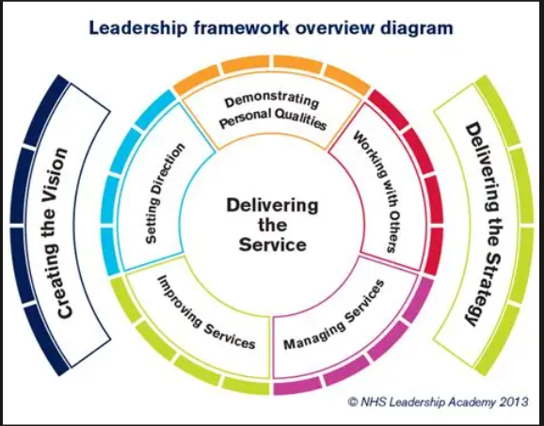
NHS Leadership Framework (20??)

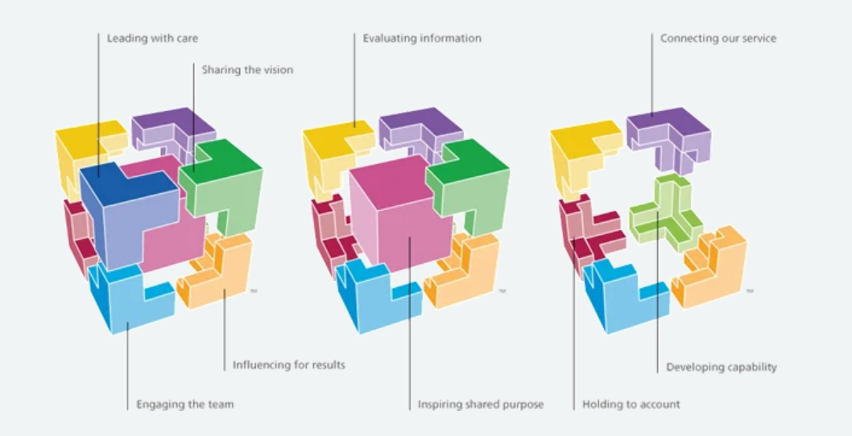
Healthcare Leadership Model (2013)

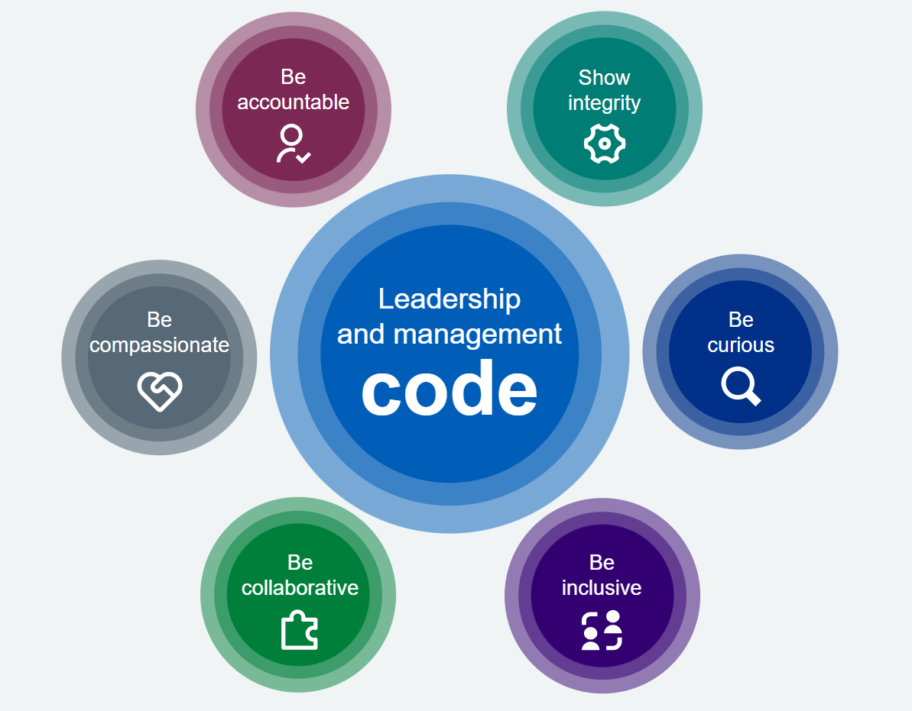
NHS Leadership and Management Code (2026)

Notably, none of these models relies solely on one single leadership style or theory. Yu et al (2024) attribute this to the unique challenges faced by the healthcare sector and a resultant need to employ a range of leadership styles to address diverse issues such as staff disengagement, low moral, operational and financial pressures and the drive to improve quality of care. Nicol (2012) however, identifies an emphasis on EI within the NHS leadership framework, with the concept of demonstrating personal qualities appearing foremost. Indeed, this can also be observed in the two subsequent models, with personal qualities such as compassion, accountability, integrity and care being emphasised. Conversly, Boutell (2015) postulates that the NHS utilises three main leadership styles; transformational, democratic and distributed leadership, to facilitate an adaptive system of leadership able to respond to the many different and complex challenges outlined previously by Yu et al.

Distributed leadership is described as a model in which leadership practice is shared, with responsibility shifting from individuals to a collaborative team, which may exist vertically or horizontally within an organisation. Whilst this is typically seen in many school settings (Harris 2013) the horizontal approach can also be observed within WAST, whereby clinical and operational leadership is delineated.
WAST’s own model of leadership behaviours is currently illustrated in the Our WAST Way model, which cites three guiding principles of leadership (see figure 4)

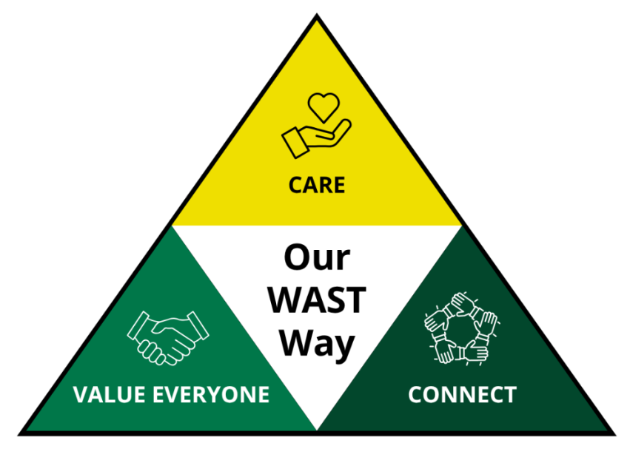
Our WAST Way 2026
As with the previous NHS models, Our WAST Way initially appears to place emotional intelligence at its core, with the triptych components of care, connect and value everyone. However, the design team behind the model, Real World Group, maintain that the theory of collective leadership lies at its heart. The term collective leadership is often used interchangeably with distributed leadership, but academically they remain separate concepts (Goksoy 2016). The underlying principle of collective leadership is that leadership is not solely the responsibly of a nominated group, but is a shared responsibility involving the unified and cooperative actions of a larger group of invested people (Lungeanu et al 2023). This aligns with the corporate belief that WAST is a people led organisation where everyone has the potential and ability to lead (WAST reference).
Although a range of leadership theories have been explored, the evidence for their practical implementation and perceived usefulness within WAST remain anecdotal rather than empirically measured. Historically, a reliance on trait theory to identify potential leaders appears to have prevailed, where individuals were approached and encouraged to apply when positions were advertised. Kahneman (2011) explains how this approach, using system 1 thinking, can lead to a recruitment bias, which in turn may stall the development of leadership progression. Historically, there has been a notable lack of formal leadership training within ambulance services, with newly appointed leaders learning on the job (Alhafi et al 2026). More recently however, WAST has actively provided leadership programs, such as the PGCert in conjunction with University of Wales Trinity St Davids and the Level 5 in Leadership and Management with the Institute of Leadership and Management, to educate and broaden the knowledge of appointees. Nevertheless, the innate human reliance on identifying desirable attributes in potential leaders continues to be a powerful influence.
Authentic leadership and Servant leadership have been proved to have positive effects of staff wellbeing and are well supported within ambulance trusts, with staff reporting affinity to behaviours such as openness, integrity and empathy (Alhafi, Peasey et al 2026). Pennington (2025) believes that character is the single most important factor is effective leadership and further asserts that the ability to connect with staff is more important than charisma in determining influence.
In its report on leadership in paramedicine, NHS England (2023) notes that,
“As paramedic practice is developed further, it will be important to acknowledge organisational leadership differs to on scene command control.”
Recent organisational changes within my locality have intentionally shifted leadership and management practice from a predominantly hierarchical, command-and-control model to a more supportive and staff-centred approach. The integration of principles associated with Authentic Leadership, Servant Leadership and Emotional Intelligence has been transformative for the local staff teams, which in turn is beginning to foster greater trust, openness and staff engagement, supporting both individual wellbeing and collective organisational performance.
In conclusion, and as Karpowicz (2026) argues, despite the development of numerous leadership theories and frameworks, the challenge of leading organisations remains as complex as ever. While the many models which have been developed offer valuable insights, effective leadership cannot be reduced to one approach alone. Consistent with the work of Pennington (2025), Karpowicz suggests that successful and engaging leadership is achieved through a combination of characteristics, styles and skills adapted to the demands of different contexts and situations.
The WAST model emphasises role-dependent behaviours, while also encouraging leadership responsibility at every level of the organisation. This aligns closely with the conclusions of both Karpowicz and Pennington, who advocate for an integrated approach to leadership embedded across organisations. By fostering a shared vision and a common understanding of leadership responsibilities, organisations such as WAST, are better positioned to navigate change, drive improvement and achieve the positive cultural and operational transformation that has often proved difficult to realise.

In this component, I intend to critically reflect on the development of my personal leadership styles and behaviour, using credible tools including management and leadership style assessments and critical reflection. I will also examine my interpersonal skills, attempt to determine how these affect workplace relationships and will use these findings to produce a personal development plan.
One of my earliest primary school reports notes my “ability to organise anything that moves”. I have never been sure whether this statement was complimentary although I cannot deny its accuracy. Over the years I have made an effort to tone down this aspect of my personality, but Mr Fitzgerald appears to have possessed prescient foresight, as I progressed initially into a career in teaching. The effort to tone down what some may refer to as leadership potential, resulted from the opinion of my peers who regarded it more as being bossy and somewhat domineering. As someone who has always had a need to be liked and accepted, this aspect of my personality was troubling.
Raised in the 1970’s with a father in the police, I had a strong sense of what was right and an equally strong fear of doing wrong. At the age of 11 having jumped a red light on my bike, I was stopped by one of Dad’s colleagues in a police car and told off. The fear of Dad finding out stayed with me for weeks. My parents had high expectations and each school report was followed by a detailed analysis in the kitchen. Looking back, I wonder whether it was their fear of failure that was projected onto me.
As an adult, many of these traits remain with me. I still have an innate need to be liked and accepted and I worry about letting people down or being badly thought of. I continue to have high expectations of myself which sometimes leads me to have unrealistic goals and often results in procrastination. This in turn promotes stress, anxiety and feelings of failure. Over the years I have become increasingly aware of these behaviours, especially since moving into a leadership role within WAST. Having previously regarded many of these personal characteristics as faults, I can now see that they can be redefined as strengths that simply require a little management and development
When I was asked to complete the Insights Report for this course, I was initially intrigued. Years ago whilst working in the outdoor industry I had completed the Belbin assessment and came out squarely as a Teamworker. However, this was at a point in my life where fitting in was still of paramount importance and my answers probably reflected that; there was no identification of any leadership skills or tendencies. Therefore, when completing the Insights Report I resolved to be as honest as possible, without overthinking or trying to fit a mould.
When the report was returned, I was perturbed. There seemed to be many facets of behaviour that I couldn’t recognise in myself. From the statement that “Roles that require empathy and sympathy may not suit her” to “She may appear dismissive of decisions made on ‘gut-feel’ rather than objective analysis” within the opening paragraphs, I initially could only see the negatives and pronouncements that I felt did not apply to me. A few days later however, I indignantly showed the report to my husband to read, who in turn nodded his acquiescence throughout. Having understood that not every statement would necessarily apply, I was able to read it again less defensively and with significantly more introspection.
Coming from a professional background in Physical Education (P.E) and coaching, my default style has previously been quite didactic and command oriented. This recognised style of teaching is one within a spectrum used in P.E and often lends itself to initial skill acquisition, before a progression to other styles such as reciprocal and guided discovery (Mosston and Ashworth 2008). However, understandably this ‘do as I say’ style of leadership is generally poorly received within my current role. At the core of my values as a Senior Paramedic, is my belief in clinical excellence and the determination to propagate this amongst my team. Yet, I am aware that my success in achieving this is dependent on the engagement of my team, which may be positively or negatively affected by my style of leadership.
After ten months as a Senior Paramedic (SP), I am beginning to feel confident in the role and would like to think I am becoming a good leader. Becoming, because even in the last few months I can acknowledge the progression and development of my leadership skills.
Reflective practice is a widely used tool to facilitate professional development. The art of reflection is described by Johns (2022) as being “…a process of self-enquiry towards self-realisation”. The link between considered and honest reflection and effective change in practice is well documented (Kinsella 2010) and the process has been adopted by professional bodies within healthcare, such as the Health and Care Professions Council (HCPC), as a means to provide evidence of Continuing Personal Development (CPD).
Within this essay I intend to include two examples of reflection which have allowed me to consider and develop my styles and skills of leadership. These reflections will be structured using Rolfe et al.’s (2001) reflective model. I have chosen this framework because I find the simple three-stage approach (What? So what? Now what?) provides sufficient guidance while remaining less prescriptive than other reflective models.
The first reflection explores a situation that arose in the very first few weeks of my new appointment as an SP and explores how my emotions, presumptions and bias have the potential to negatively impact how I approach and deal with difficult situations and staff interactions. As with all professional reflections, anonymity will be upheld and any identifying information removed.
What?
A few weeks after my appointment I had scheduled my first set of clinical ride-outs, the first of which was with my previous shift partner. A week before this shift I was emailed by the Operations Manager to let me know that my ex-partner had requested a ride-out with another SP, rather than with me. The request had been put to their line manager during their Personal Annual Development Review (PADR). This request had been formalised and put in an email to me, the Locality Manager (LM) and another SP.
So What?
My immediate feeling was one of embarrassment, followed quickly by an indignant anger. I emailed back stating that I felt no special allowance to select a different SP should be made as it would set a precedent. Staff are generally not afforded the luxury of choosing who they work with or are managed by, and I saw no reason why this should be permitted in this circumstance. I then contacted the LM and outlined what had transpired, reiterating my thoughts. The LM asked if there was any reason my colleague may have requested this, whether we had encountered difficulties in the past and what our working relationship had been like over the years. I recalled one incident about 3 years previously where we had exchanged words but explained that this had been resolved and there had been no issues that I was aware of since. I understood we had a good working relationship; shifts were always good natured and there was no bad feeling between us as far as I was aware. I could not explain why this request had been made and was hurt and puzzled by it.
Meanwhile, I internalised and over-analysed every conversation and encounter I could recall, concluded my colleague must hate me, would never accept me in a leadership position and would negatively influence the whole team. I foresaw a slew of similar requests not to work with me resulting in professional isolation and an impact on my ability to carry out my new role effectively.
I had no reply to my email and continued to ruminate. I didn’t sleep well the night before the arranged shift and felt apprehensive and unsettled on my journey to work. However, on arrival, I was received warmly and we subsequently had a productive and enjoyable day.
Now What?
Landry (2019) determines that effective leadership and emotional intelligence are inextricably linked. Like many others, she posits that leaders who are aware of and regulate their own emotions, alongside understanding those of their team, are more likely to be successful. In the example above, I was aware of my own emotions, but initially unable to consider those of my crewmate, absorbed as I was by my own personal feelings of hurt, self-doubt and inadequacy. Cherniss and Goleman (2001) expand on this point, stating that leaders must understand and acknowledge their own emotions first, before being able to effectively manage the emotions of others. Failure to regulate my emotions in this instance, resulted in a hastily sent, particularly blunt and abrupt email which could easily have further damaged already fragile relations. My Insights report notes that I can be “overly critical and blunt” which I accept as a character trait. Having recognised this, I am now able to pause and consider how my communication, both written and verbal, may be received by others.
Of particular use in my Insights Report is the section on communication. This notes that I may “appear somewhat cool and aloof” to those who don’t know me well. My opposite type is identified as “the Inspirer, Jung’s “Extraverted Feeling” type” and interestingly my colleague appears to fit this mould. Mullins (2019) notes that personality clashes such as this are frequently the root cause of work stress and disaffection and in retrospect, I can acknowledge how this clash may have impacted on the breakdown of communication.
The previous incident I referred to involving this colleague, stemmed from their repeated disagreement with, and challenge to, almost every decision that required clinical judgement or consideration. At the time, they were very newly qualified. However, the repeated disagreements regarding clinical and operational decisions created ongoing professional tension and made collaborative decision-making increasingly challenging. Consequently, I found myself adopting a more autocratic and directive leadership style in an attempt to maintain clarity and progress. Reflecting on this now, I recognise that while this approach achieved short-term outcomes, it may not have fostered the most effective working relationship or supported the development of mutual trust and understanding. To continue managing in this manner could potentially isolate me from the colleagues I am employed to support and impede effective communication.
My Insights report is clear that when dealing with my opposite type, I “should not criticise and condemn” and “should not neglect to offer praise and recognition when it is due”. It is also noted that many Inspirers “tend to misjudge the abilities of self and others” and “often leap to conclusions without all of the information”. I clearly remember feeling my experience and clinical knowledge were often doubted or dismissed and suspected my colleague considered me outdated, regarding their recent university acquired knowledge as superior. With hindsight, understanding of this colleague’s personality type would have allowed me to depersonalise much of this behaviour and seek to work more collaboratively, adapting my own behaviours and approach accordingly. My understanding of the situation now, compels me to think about and communicate with this colleague in a very different way. I recognise the importance of taking time to build rapport, offer praise and encouragement and involve them in decision-making by presenting options and seeking their views, rather than simply telling them what we should do.
Only since embarking on this course and exploring my personal attributes and traits alongside theories of leadership, have I been able to effectively process and evaluate this relationship with clarity and objectivity. This newly acquired understanding has allowed me to acknowledge where my behaviours had an impact and compelled me to consider how adapting my responses and emotions can result in more positive and meaningful interactions. Going forward, giving greater consideration to the different personalities and perspectives of those I work alongside, while continuing to develop my own knowledge and understanding, will help me lead more effectively and achieve better outcomes for my teams.
In order to further develop as a leader, I have explored my leadership styles, preferences and behaviours through the completion of several leadership questionnaires and self-assessment tools. This has provided valuable insight into my strengths, areas for development and the ways in which my leadership approach may affect and influence others. Reflecting on the results has helped me gain a greater understanding of my natural leadership tendencies and identify opportunities to adapt my style to better meet the needs of different individuals and situations.

The Insights Discovery Model is similar in design to that of the Myers-Briggs Type Indicator, which I also completed many years ago. Both tools have their roots in the work of Carl Jung, specifically his theory of psychological preferences. Whilst Insights presents findings through four colour energies, Myers-Briggs presents them through four letters. My Myers-Briggs result, approximately 20 years ago, was ISTJ (Introversion, Sensing, Thinking, Judging) indicating the following;

“Quiet, serious, earns success by being thorough and dependable. Practical, matter of fact, realistic and responsible. Decides logically what should be done and works toward it steadily, regardless of distractions. Takes pleasure in making everything orderly and organised – their work, their home, their life. Values traditions and loyalty.”
Myers & Briggs Foundation

In comparison, my more recent Insights report attributed the colour energies Blue, Green, Red, Yellow as indicated below (Figure ??). This result drew similarities to the older Myers-Briggs results; a predilection for structure and organisation alongside a practical and realistic approach to tasks and problem solving, a conscientious and duty focused attitude to work and a propensity to be a rule follower with high standards and expectations.
As previously alluded to, I was initially quite aggrieved with the results from my Insights report and felt that the warmer, caring aspects of my personality had been somewhat hidden. On reflection however I can appreciate that this is true of how I present in the workplace; my methodical, quality-driven self often dominates rather than that of my softer, caring side.

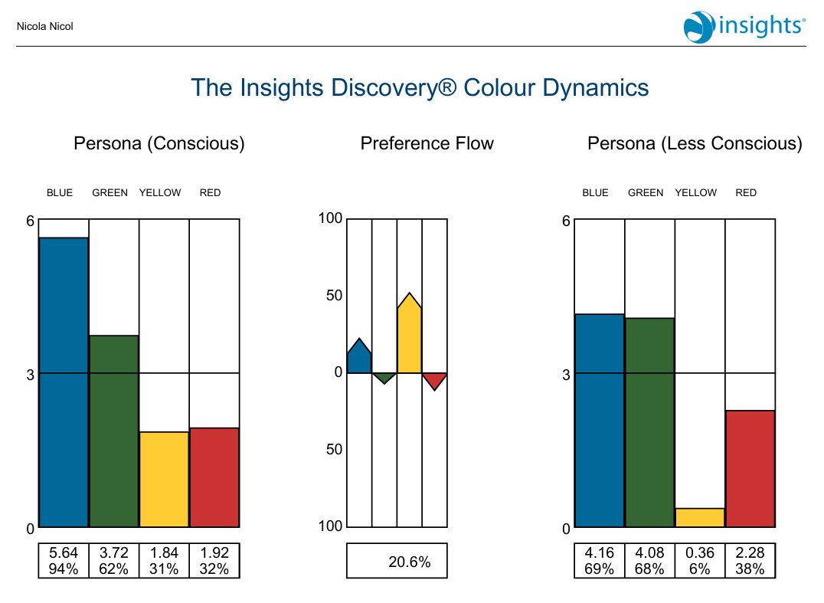
Interestingly, whilst my Conscious Persona demonstrates a clear preference for Cool Blue, my Less Conscious Persona shows an almost equal balance between Cool Blue and Earth Green. This has to some extent allayed my fears, whilst also making me more conscious of my tendency to conceal the more supportive, gentler aspects of my personality at work. Conversely a reversal of this can be seen between Fiery Red and Sunshine Yellow, which are almost equal in my Conscious Persona, but in my Less Conscious Persona, Fiery Red is far more dominant. This indicates that some of my more assertive characteristics are more controlled at work. As a senior clinician operating in the pre-hospital environment, there are many reasons for me to project Cool Blue qualities, such as attention to detail and a focus on standards and evidence-based practice. However, in order to develop effective and supportive relationships with the staff I oversee, it is important to allow them to access my compassion, empathy and understanding.

Exploring my management and leadership styles….

What?
One of my tasks as SP is to conduct a monthly medicines audit. This is rotated around the vehicles of the stations for which I am responsible and involves checking for out of date stock, ensuring all medicines are stored correctly, in the right places and in the right amounts. Concurrently, every station is responsible for its own monthly drugs check, this is usually performed at the beginning of the month.

One station in my locality had been sorely neglected for many years. Until very recently, the staff were operating out of a single room, on old vehicles, with no cleaning facilities. This situation had led to an eroding of standards, a feeling of being undervalued and a general disengagement with management.

Three months after my appointment, I was scheduled to perform a medicines audit on one of their vehicles. I had been anticipating this and had been contemplating some of the issues that I thought might arise. I was aware, from previously working on these vehicles, that medications were not being stored in the standard fashion. Over the years an accepted norm had been adopted, where many medications were stored in drawers and pockets counter to Trust guidance. I also knew that drugs were frequently overstocked and that monthly checks did not take place on a regular basis. This gave me cause for concern on many levels. In my now senior clinical position, I could not let this situation continue. My responsibility to the Trust to maintain and uphold clinical standards forms the primary focus of my role. However many of the staff remained close friends as well as colleagues and I found myself caught between the responsibilities of my new role and the dynamics of my personal relationships.

So What?
Previously, I would have approached this situation in the following manner. I would have carried out the audit without any prior warning or announcement and upon identifying issues, would likely have spent a considerable amount of time personally reorganising the stock into the correct locations and quantities. Following this, I would have sent a direct and somewhat terse email to staff, advising them that an audit had been completed and that the standard and organisation of medication storage fell significantly below the expected standard. I would have attached a copy of the medicines storage plan and instructed staff that this must be adhered to in future.
My Insights reports suggests that I “may be highly critical of carelessness or lack of discipline in others. She will find it beneficial to consciously seek out others’ views”. Consideration of this led me to reflect on my default approach and contemplate a better way of addressing the problem.
I recognised that my modus operandi largely focused on correcting the immediate problem rather than engaging and involving those concerned. Whilst the issue may have been resolved in the short term, it is unlikely that this would have encouraged ownership or cultural change. Professor Michael West, a concept of compassionate leadership (2017) emphasises the importance of engaging staff, listening to their perspectives and creating an environment where individuals feel valued and empowered to contribute to improvement.
Having reflected and spent time considering how I should approach the situation, I came up with the following plan. Firstly, to engage with staff prior to carrying out the audit, explaining that it was a requirement of my role and further seeking to make staff cognisant of why drugs should be stored according to Trust guidance. I again considered sending an email to the entire staff team, but having considered other ways of eliciting staff engagement, eventually decided to approach a single member of the staff team personally.
This particular member of staff was popular, influential and had been a member of the team for many years. They had mentored me as newly qualified paramedic and were experienced and well regarded within the locality. I explained my dilemma and asked for their help in putting things right. Together we formulated an action plan, whereby the weekend crew would reorganise the drugs on the vehicle and notify me of any stock issues. Thereafter I could carry out the audit, passing the vehicle, and the team member I had approached would notify the rest of the crew on station that this would be a regular event.
Since this point, drug storage and compliance with vehicle stocking guidelines have remained of a good standard.
Now What?
I was delighted with how I had resolved this situation. Rather than achieving a short-term solution and leaving my team feeling chastised and resentful, positive changes were made and crucially have been maintained over time. This reinforced my growing realisation that engaging staff and working collaboratively with my teams to identify solutions, can be far more effective than a didactive approach.
Moving forward, this experience has empowered me to consider a far more collaborative way of working with both teams and individuals, involving them in problem solving and decision making and considering the delegation of tasks to encourage ownership and engagement. This is an example of collective leadership, rather than an autocratic, top down, command style of leadership, which has been proved to facilitate improvement in healthcare standards across the world (West 2017).

Chapter 2: where the NHS is today (2025) .
Engagement insight report: 10 Year Health Plan for England (2025) .
Professor Michael West: Leadership in today's NHS (2017) Directed by Anonymous .
Authentic Leadership_ Building An Organization That Thrives - Bill George.
Case Study_ Strengthening Collective Leadership at the Welsh Ambulance Services University NHS Trust - Real World Group.
Free Leadership Masterclass See how to lead a team that actually performs → Articles / Beyond Hierarchies: How the NHS Leadership Model Is Reshaping Healthcare Management Leadership Theories & Models Beyond Hierarchies: How the NHS Leadership Model Is Reshaping Healthcare Management.
Great Man Theory.
Hawthorne Studies_Radical Criticism.
Healthcare Leadership Model – Leadership Academy.
Improving clinical leadership and management in the NHS - Nicol.
Make people your greatest asset, not your biggest frustration It's all in our new book -now on.
Mullins_Hawthorne Experiments 1.
Myers & Briggs FoundationAvailable at: https://www.myersbriggs.org/my-mbti-personality-type/the-16-mbti-personality-types/.
The_real_Hawthorne_effect.
What is Wrong with NHS Leadership Development.
Alhafi, Y., Peasey, R., Bowles, K. and Perraton, L. (2026) An exploration of leadership attributes in paramedicine: A scoping review Elsevier BV.
Benmira, S. and Agboola, M. (2021) Evolution of leadership theory BMJ.
Bidwai, A., Beament, T. and Mercer, S. (2015) Hierarchy in critical airway management Wiley.
Brown, K.M. 'Trait theory' Emerald Publishing Limited, pp. 897–898.
Budhraja, J. (2026) Trait Theory of Leadership - Advantages and its Limitations.
Einola, K. and Alvesson, M. (2021) The perils of authentic leadership theory SAGE Publications.
George, B. 'True north: Discover your authentic leadership'True north. John Wiley & Sons, Incorporated, .
Goksoy, S. (2016) Analysis of the Relationship between Shared Leadership and Distributed Leadership Ani Publishing and Consulting Company.
Heckman, J.J. and Kautz, T. (2012) Hard evidence on soft skills Elsevier BV.
Hirvikallio, J., Hackman, P., Haaranen, A. and Kvist, T. (2026) Leadership in emergency medical services: An integrative literature review Elsevier BV.
Johns, C. (2022) Becoming a reflective practitioner. Sixth edition edn. Wiley.
Jung, C.G., Adler, G. and Hull, R.F.C. (1971) Collected Works of C.G. Jung, Vol. 6, Psychological Types. Course Book edn. Princeton University Press.
Kahneman, D. (2011) Thinking, fast and slow. 1. ed. edn. Farrar, Straus and Giroux.
Kumar, R.D.C. and Khiljee, N. (2016) Leadership in healthcare Elsevier BV.
Landry, L. (2019) Why Emotional Intelligence Is Important in Leadership. Harvard Business School Online. Available at: https://online.hbs.edu/blog/post/emotional-intelligence-in-leadership.
Landry, L. (2019) Why Emotional Intelligence Is Important in Leadership.
Lungeanu, A., Dechurch, L. and Contractor, N. (2023) Collective Leadership SAGE Publications, Inc.
Martin, G.P. and Learmonth, M. (2012) A critical account of the rise and spread of ‘leadership’: The case of UK healthcare Elsevier BV.
Mccambridge, J., Witton, J. and Elbourne, D.R. (2013) Systematic review of the Hawthorne effect: New concepts are needed to study research participation effects Elsevier BV.
Mid Staffordshire, N. (2013) Report of the Mid Staffordshire NHS foundation trust public inquiry. Stationery Office.
Mosston, M.a.A., Sara (2008) Teaching Physical Education. 1st online Edition (6th Edition) edn. The Spectrum Institute for Teaching and Learning.
Mullins, L.J. (2019) Organisational behaviour in the workplace. Twelfth edition edn. Pearson.
Northouse, P. (2026) Leadership: Theory and Practice. 10th Edition edn. SAGE.
Oswald, D. Handling the Hawthorne effect: The challenges surrounding a participant observer.
Rebecca Newton Building Trust, engagement and motivation as a leader: the power of authenticity London School of Economics and Political Science.
Rolfe, G., Freshwater, D. and Jasper, M. (2001) Critical reflection for nursing and the helping professions : a user's guide. Palgrave Macmillan.
Sedgwick, P. and Greenwood, N. (2015) Understanding the Hawthorne effect BMJ.
Simon Sinek (2024) Leaders Eat Last. Penguin Books.
Wu, Y., Awang, S.R., Ahmad, T. and You, C. (2024) A systematic review of leadership styles in healthcare sector: Insights and future directions Elsevier BV.

