
Applied Leadership and Management Outreach
Module Assignment Submission
Student Name: | Winta Omer
Student Number:
Module No: | BMSK4014
Module Title: | Problem Solving and Decision Making

Statement of Confirmation of Authenticity
By the act of making this submission, the student declares that this is the work of the student named above. The work has not, in whole or in part, been knowingly presented elsewhere for assessment, or where assessment has been built on a previous assessment, this has been identified. Where materials have been used from other sources it has been properly acknowledged. If this statement is untrue, the student acknowledges that an assessment offence has been committed.
Attention is drawn to the plagiarism and unfair practice policies of UWTSD.

Table of Contents
Define a complex problem in the workplace, including its scope and impact . 3
Analyse information on the identified problem, to help inform the decision making process . 3
Propose a range of alternative solutions to the problem 4
Using a decision making technique, evaluate a range of solutions to identify the most appropriate option 4
Develop a detailed plan for implementing the solution 5
Communicate the plan to relevant stakeholders 6
Assess appropriate monitoring and review techniques to ensure successful implementation of solution 6
References 7
Appendix 1 8

Define a complex problem in the workplace, including its scope and impact

The event decoration business is a complex industry that experiences seasonal fluctuations. These fluctuations can pose significant challenges and create problems for businesses in this sector. Seasonal changes pose a challenge for businesses in the event decoration industry. The nature of this industry means that demand for event decorations varies depending on the time of year. Businesses in this sector must understand and effectively manage these fluctuations to maintain profitability and sustainability.
One of the difficulties caused by changes is the uneven distribution of work throughout the year. Event decoration companies experience a surge in demand during peak seasons, such as holidays, weddings, and other special occasions. However, during quieter periods, there is a decline in business activity. This creates an imbalance in workload distribution. It can lead to instability.
Another issue related to changes is managing the workforce. During peak seasons, businesses often require staff to meet the increased demand. Hiring workers can be a solution, but it comes with challenges, such as quickly training new employees and ensuring they deliver quality work. On the other hand, retaining employees becomes more challenging during quieter periods as they may seek more stable employment opportunities elsewhere.
Furthermore, seasonal changes impact cash flow management within event decoration businesses; during peak seasons, when demand is high, companies must invest in inventory and supplies to meet customer requirements. However, when sales decline significantly during seasons, these investments can become quite burdensome as revenue decreases while fixed costs stay the same.
Moreover, pricing strategies tend to get more intricate when there are fluctuations. Companies must find a way to maximise profits during peak seasons while staying competitive. It is essential to strike a balance because setting prices high might discourage potential customers, but putting them too low may not adequately cover expenses.

Scope and Impact
Smithson and Stenning (2006) emphasise that comprehending the scope and impact of complex problems is essential for effective policymaking. Complex issues entail interconnected factors, resisting simple solutions. The scope encompasses dimensions, sectors, and stakeholders affected. Impact spans economic, social, and environmental realms – from productivity shifts to social inequality and resource depletion (Smithson & Stenning, 2006).
The event decoration industry faces a challenge with seasonal changes, affecting many people involved and having wide-ranging consequences. This essay explores this issue's scope and impact, highlighting those affected and how they are impacted.

There are shifts in demand throughout the year in the event decoration business due to different occasions and seasons. Weddings, holidays, and corporate events create a peak season with the need for event decorations. Conversely, the demand decreases significantly during off-peak times like winter or particular weekdays.
This issue affects stakeholders within the event decoration business. Firstly, employees working in these businesses face challenges related to job security and stable income. They may experience periods of being overworked during peak seasons. Face uncertainty when work becomes scarce during off-peak periods. These fluctuations can lead to stress and anxiety among employees.
Secondly, businesses themselves are impacted by these fluctuations. They must manage their resources and workforce to meet changing demands while maintaining profitability. Hiring staff during peak seasons can strain budgets, while keeping employees during off-peak times may need to be more economically feasible.
Moreover, clients who seek event decorations also feel the effects of these fluctuations. When there is demand and insufficient supply, clients might experience higher prices because businesses compete for customers. On the other hand, during slow periods when there is little demand for event decorations, clients may have fewer choices, and it could be difficult for them to find available services.
This issue impacts the people directly involved and affects industries like catering services or venue providers who depend on events for their business. Seasonal changes can disrupt their income and overall stability.

Analyse information on the identified problem to help inform the decision-making process

Brainstorm
Brainstorming is used in the workplace to come up with solutions for complex problems. It involves bringing a group of individuals to collaborate and share their thoughts, ideas and experiences. This process fosters creativity and open-mindedness and encourages the exploration of perspectives. A critical factor in brainstorming is creating an environment where judgment aside and open communication and idea sharing are promoted. Additionally, effective facilitation plays a role in ensuring participation, maintaining focus, and encouraging active involvement from all participants (Smith, J., 2021).
The event decoration industry experiences fluctuations throughout the year due to changes. These fluctuations present challenges in the workplace that require planning and strategising to overcome. Understanding these challenges is vital for event decoration businesses to thrive and succeed.

Seasonal Fluctuations in Event Decoration Business: Brainstorming Session
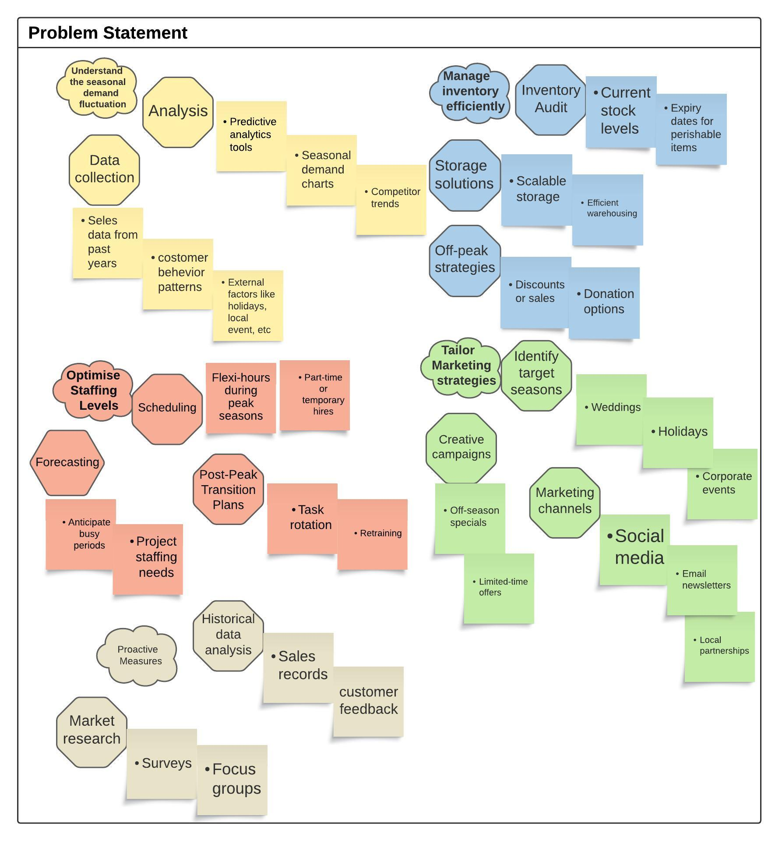

One of the complexities event decoration businesses face is managing staffing levels during peak seasons. During periods like holidays or wedding seasons, there is an increase in demand for event decorations. This necessitates hiring staff to meet customer needs. However, once the peak season ends, demand can decline, leading to overstaffing and increased costs. Balancing staffing levels becomes a task that requires forecasting and scheduling.
Another challenge related to fluctuations is inventory management. Event decoration companies must have various products to cater to themes and preferences. However, sometimes, these items end up not being used during periods. Can tie up valuable resources. It is essential to have strategies for managing inventory to minimise waste while ensuring availability during times.
In addition, marketing efforts should be tailored based on trends. Promoting events during off-peak seasons can be challenging because customers may have yet to plan or be interested in organising events at those times. By running marketing campaigns highlighting unique benefits or incentives, it is possible to generate interest and bookings even during slower periods. To tackle these challenges, event decoration businesses should conduct market research on upcoming trends and analyse historical data on customer behaviour patterns throughout different seasons. This information can guide decision-making processes regarding staffing levels, inventory management and marketing strategies.

Mind maps
Mind maps play a role in navigating the complex challenges that are often faced in today's dynamic work environment. These visual aids, as introduced by Buzan and Buzan (2010), serve as tools for stimulating creativity by allowing employees to view problems from a broader perspective and discover innovative solutions. Moreover, the collaborative nature of mind maps fosters open communication. Encourages innovation within teams. What makes mind maps more valuable is their adaptability, as they can easily incorporate new information that emerges during the problem-solving process (Buzan & Buzan, 2010).

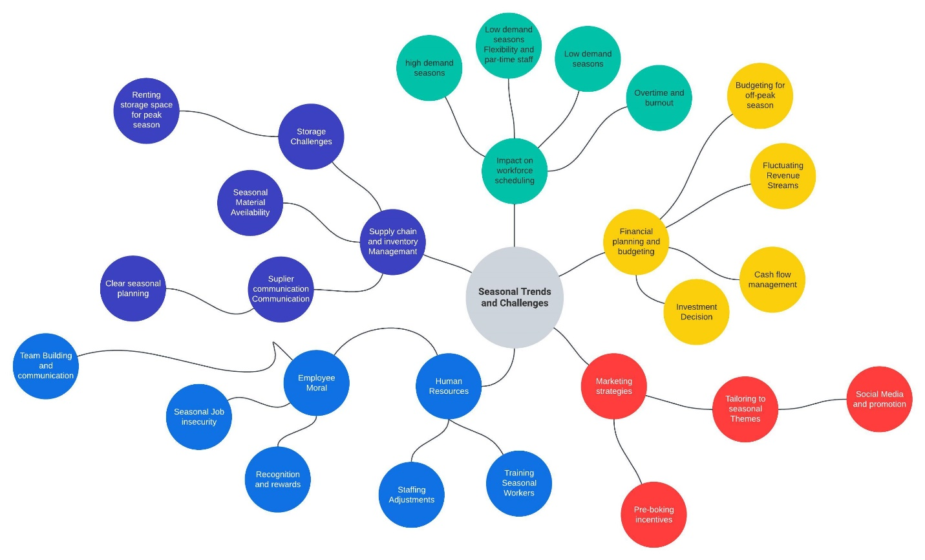

One aspect that needs attention in this field is the matter of staffing. Event decoration businesses often face a surge in demand during peak seasons like holidays or weddings. To meet customer needs, they have to hire personnel. However, finding qualified and dependable employees can be challenging, which stresses the existing staff.

Another area to consider is inventory management. Seasonal variations often result in demands for specific decorations or themes. Businesses must carefully handle their inventory to ensure they have stock during busy periods while avoiding excess inventory during slower seasons. Poor management of inventory can result in lost sales or wastage of resources.

Furthermore, effective marketing and promotion strategies are crucial for managing fluctuations. Businesses must develop tactics that attract customers during peak seasons and maintain their presence during periods. This may involve targeted advertising campaigns, engagement on social media platforms or collaborations with other businesses.

Lastly, financial planning holds importance as well. Seasonal fluctuations can have an impact on cash flow and profitability. Businesses must plan their budgets meticulously for both slow periods to cover expenses and sustain profitability throughout the year.

In summary, dealing with variations in the event decoration industry poses complex challenges that require thorough consideration and strategic planning.
Successfully navigating these challenges requires attention to staffing, inventory management, marketing and financial planning.

The 5 Whys analysis, as introduced by Toyoda and Shook (2009), cultivates an ethos of continuous improvement within an organisation. It galvanises employees to challenge prevailing processes and systems, fostering an environment conducive to innovation and creativity. By consistently using this technique, enterprises can pinpoint reoccurring issues and institute enduring solutions that proactively avert similar challenges in the future.

The 5 Whys analysis delves deeper into the possible causes of seasonal fluctuations in the event decoration business.
Problem: Seasonal Fluctuations in Event Decoration Business
1. Why are there seasonal fluctuations in the event decoration business?
- Because demand for event decoration services varies throughout the year.
2. Why does the demand for event decoration services vary throughout the year?
- Because events are often scheduled around holidays and special occasions.
3. Why are events mostly scheduled around holidays and special occasions?
- Because clients want to celebrate during festive seasons and align events with cultural practices.
4. Why do clients prefer celebrating during festive seasons and cultural practices?
- Because these times hold sentimental value and create a more memorable experience.
5. Why do sentimental value and memorable experiences lead to seasonal fluctuations?
- Because clients are more willing to invest in event decorations when emotions and traditions are involved, resulting in concentrated demand during specific times.
In this 5 Whys analysis, we have reached a potential root cause: holidays and special occasions' emotional and cultural significance drive higher demand for event decoration services during those times, causing seasonal fluctuations in the business. Addressing this root cause could involve.
- promoting events during non-traditional seasons,
- Diversifying services to cater to broader needs or
- Providing incentives for off-peak bookings to even out the demand throughout the year.

The event decoration business faces complex problems due to seasonal fluctuations, which impact various aspects of the company, from staffing and inventory management to cash flow and marketing. Using the Ishikawa (Fishbone) analysis, we can identify the possible causes of these problems.

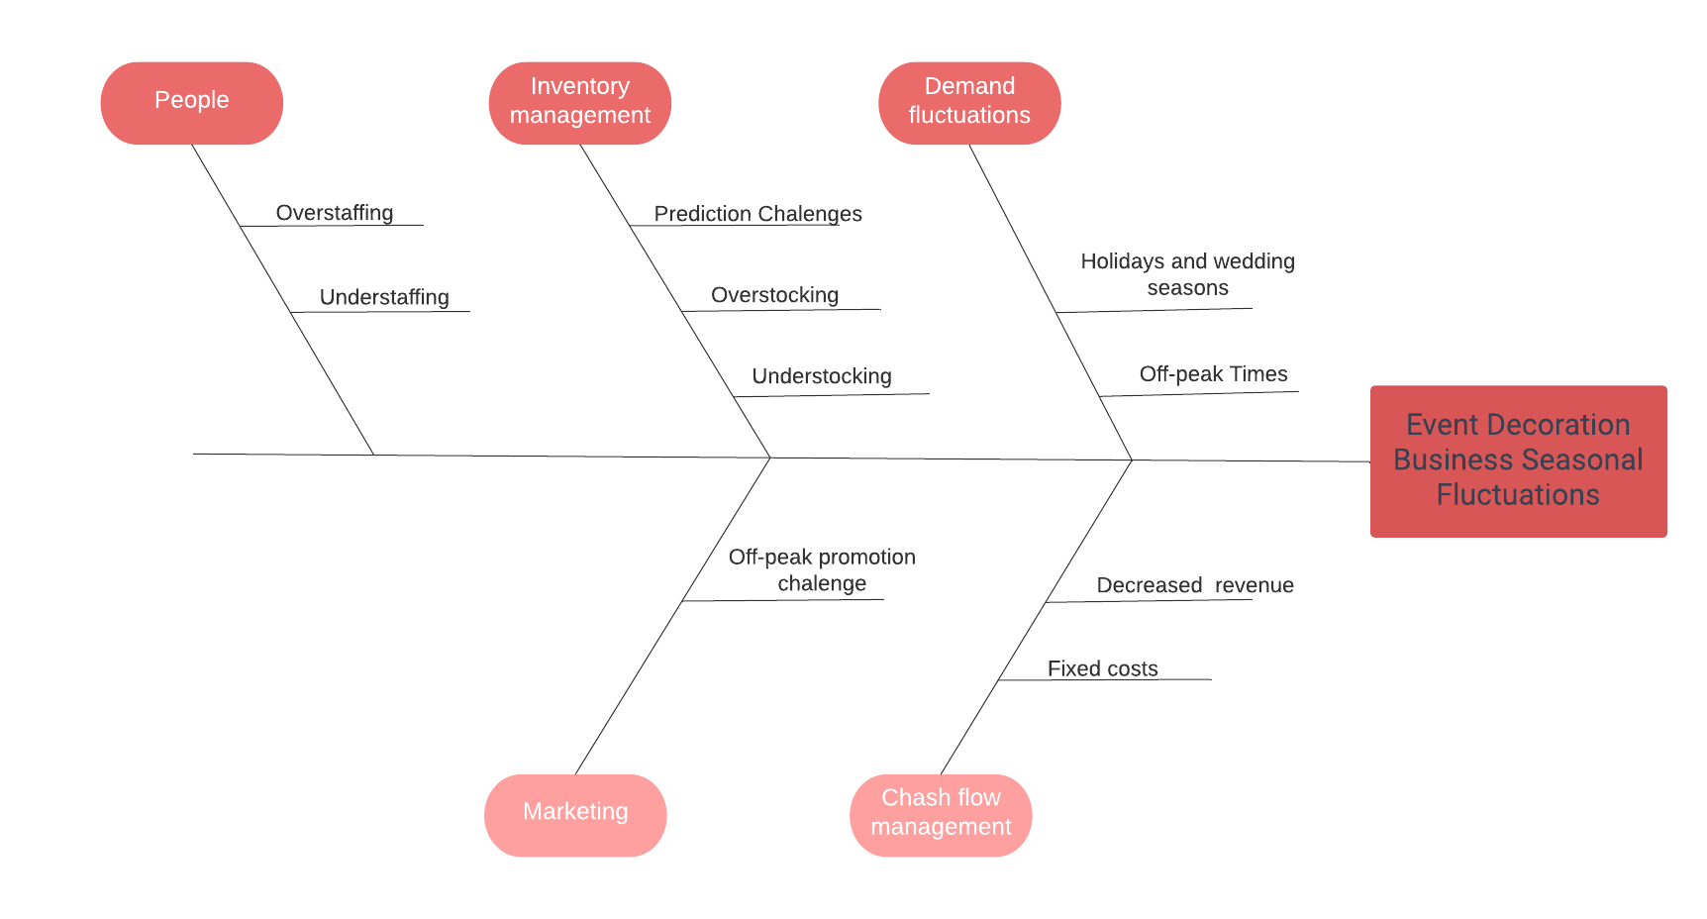

Ishikawa (Fishbone) Analysis
Problem Statement: Complex Problems in the Event Decoration Business due to Seasonal Fluctuations
- Demand Fluctuations
  - Holidays and Wedding Seasons: High demand increases workload and staffing requirements.
  - Off-Peak Times: Low demand resulting in overstaffing, increased costs, and underutilisation of inventory.
- Inventory Management
  - Prediction Challenges: Difficulty in predicting popular items for specific seasons.
  - Overstocking: Tying up valuable resources and increasing storage costs.
  - Understocking: Missing opportunities and leading to customer dissatisfaction.
- Cash Flow Management
  - Decreased Revenue: During slow periods, revenue decreases while expenses remain relatively constant or increase.
  - Fixed Costs: Expenses like rent and salaries remain constant, putting pressure on cash reserves.
- Staffing
  - Overstaffing: Increased costs and reduced profitability during slow periods.
  - Understaffing: Poor service quality and customer dissatisfaction during peak seasons.
- Marketing
  - Off-Peak Promotion Challenges: Difficulty in promoting events during off-peak seasons as customers may have yet to make immediate plans or interest in organising events.

Analysis
- Demand Fluctuations: The demand for event decorations is highly seasonal, with peak seasons usually around holidays and weddings. This fluctuation in demand leads to challenges in managing staffing levels, as there is a need for additional staff during peak seasons and a reduction in staff during off-peak times.
- Inventory Management: Managing inventory is a significant challenge as it is difficult to predict the popularity of different items during various seasons. Overstocking increases storage costs and tied-up capital while understocking leads to missed opportunities and customer dissatisfaction.
- Cash Flow Management: Cash flow is impacted by the seasonal nature of the business. During off-peak periods, revenue decreases while fixed costs such as rent and salaries remain constant, putting pressure on cash reserves.
- Staffing: Balancing staffing levels is a delicate task. Overstaffing during off-peak periods increases costs and reduced profitability while understaffing during peak seasons results in poor service quality and customer dissatisfaction.
- Marketing: Promoting events during off-peak seasons is challenging as customers may not have immediate plans or interest in organising events. Creative marketing campaigns are necessary to generate interest and bookings during slower periods.

Propose a range of alternative solutions to the problem

Step 1: List the Alternative Solutions
- Diversify Services: Expanding into other related services like party planning or corporate events.
- Implement Inventory Tracking: Utilize an efficient system to track sales trends and predict future demand.
- Secure Line of Credit: To better manage cash flow during off-peak seasons.
- Flexible Payment Terms with Suppliers: Establishing agreements with suppliers for more fluid payment schedules.
- Offer Discounts During Off-Peak Seasons: To boost revenue during slow months.
- Freelancer and Part-Time Employee Relations: To manage staffing flexibly.
- Social Media and Cross-Promotion: To maintain brand visibility and attract customers.

Step 2: List the Criteria for Evaluation
- Cost-Effectiveness
- Revenue Generation Potential
- Feasibility
- Customer Satisfaction Impact
- Ease of Implementation

Step 3: Assign Weights to the Criteria (on a scale of 1 to 5, where five is the most important)
- Cost-Effectiveness: 5
- Revenue Generation Potential: 4
- Feasibility: 3
- Customer Satisfaction Impact: 2
- Ease of Implementation: 1

Step 4: Evaluate Each Alternative Against the Criteria (on a scale of 1 to 5)

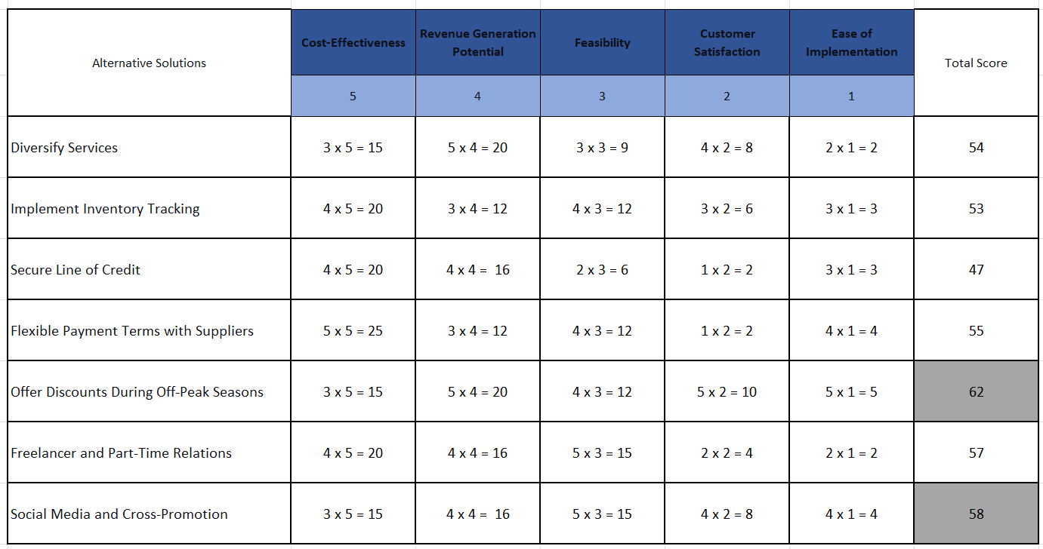

Step 5: Select the Best Alternative
Based on the total scores, "Offer Discounts During Off-Peak Seasons" is the best alternative solution with a score of 62, followed by "Social Media and Cross-Promotion Strategies", with a score of 58.

Using a decision-making technique, evaluate a range of solutions to identify the most appropriate option
In the event decoration industry, some challenges arise due to changes. A decision-making technique called grid analysis can be used to tackle this. This method involves assessing solutions against predetermined criteria and assigning scores accordingly. Two potential solutions were examined; "Providing Discounts in Slow Seasons" and "Implementing Social Media and Cross Promotion Strategies."

1. "Providing Discounts in Slow Seasons": This approach aims to lower prices for event decorations during quieter periods, incentivising customers to book events and take advantage of the reduced costs. It can generate revenue and maintain a stream of business throughout the year.

2. "Implementing Social Media and Promotion Strategies" involves utilising platforms like Facebook, Instagram and Twitter while collaborating with related businesses such as wedding planners or caterers to increase visibility and attract customers.

The grid analysis assessed these solutions based on cost-effectiveness, customer satisfaction and long-term sustainability. The results indicated that "Providing Discounts, in Slow Seasons" scored 62, making it the suitable option as it is likely to generate revenue, attract customers and ensure a business flow throughout the year.
However, "Utilizing Social Media and Cross Promotion Techniques" received a score of 58, suggesting that it is also a method but slightly less effective than the option in this situation.

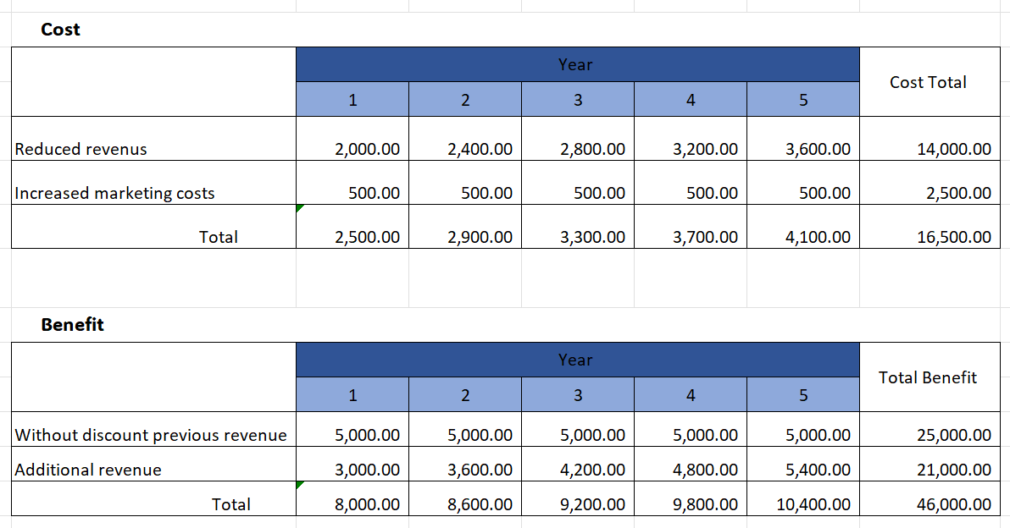

- The "Reduced Revenue" cost is calculated as the revenue foregone due to the discounts. For example, in Year 1, 10 events are discounted by £200 each, resulting in £2,000 reduced revenue. Two more events are booked each subsequent year, increasing the reduced revenue by £400 each year.
- The "Increased Marketing Costs" are assumed constant at £500 annually.
- The "Increased Business" benefit is calculated as the additional revenue from booking extra events due to the discount. For example, in Year 1, 10 events generated £3,000 additional revenue. Two more events are booked each subsequent year, increasing the additional revenue by £600 yearly.
- The "Net Benefit" is calculated as the "Increased Business" minus the "Total Costs".

The option of "Offering Discounts During Off-Peak Seasons" is the best because it consistently provides a positive net benefit each year, increasing over time, which indicates a scalable and profitable strategy. It also helps attract and retain customers, contributes to the business's financial stability, and gives a competitive edge over rivals, which are crucial for long-term business success.

Develop a detailed plan for implementing the solution.

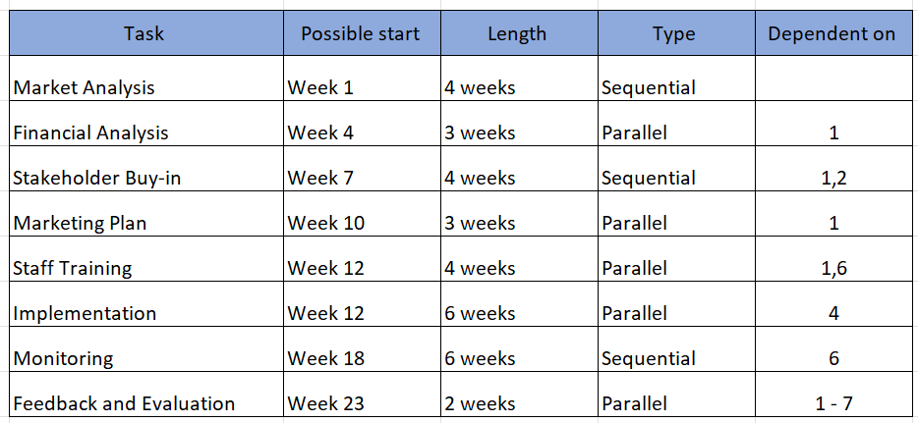

Market Analysis (Weeks 1 - 4): The first step involves analysing the market to determine the discount rate and identify specific, off-peak periods. This entails examining sales data, studying competitor offerings, and analysing customer demand patterns.

Financial Analysis (Weeks 4 - 6): Alongside the market analysis, it is crucial to assess the impact of the proposed discount on the company's finances. This entails evaluating the costs of offering the discount and estimating revenue growth.

Stakeholder Engagement (Weeks 7 - 10): Once both market and financial analyses are completed, engaging stakeholders such as management, marketing, and sales teams is vital. This involves presenting them with the analyses and proposed plan while addressing any concerns they may have.

Marketing Strategy (Weeks 10 - 12): Develop a marketing strategy to promote the discounted offer. This includes determining which marketing channels to utilise (e.g., social media, email, print), creating marketing materials, like advertisements, flyers and emails, and planning when and where to execute these promotional efforts.
Staff Training (Weeks 12 - 15): Before implementing the discounted offer, it is crucial to train the sales and customer service teams regarding the specifics of the discount and how to communicate it with customers effectively. This will entail developing training materials, conducting training sessions, and addressing any inquiries or concerns from the staff.

Implementation (Weeks 12 - 17): Execute the discounted offer by our marketing plan. This will involve updating our company's website, distributing marketing materials, and ensuring the sales and customer service teams are well-informed.

Monitoring (Weeks 18 - 23): Once the discounted offer has been implemented, it is essential to monitor its impact. This includes tracking metrics such as bookings, customer inquiries, website traffic and engagement on social media platforms.

Feedback and Evaluation (Weeks 23 - 24): After the discount offer ends, gather customer and staff feedback to evaluate its success. This will entail analysing the metrics tracked during monitoring, conducting surveys or interviews with customers and staff members, and comparing results against initial goals and projections.

Communicate the plan to relevant stakeholders.
The stakeholders would include
- senior management, who oversee strategic decisions;
- marketing teams responsible for promoting the discount;
- sales teams who will be selling the discounted services and
- customer service staff who will handle inquiries and bookings.
These stakeholders want to be kept informed because each plays a role in successfully implementing the discount strategy. However, a planned communication approach is crucial to keep stakeholders informed and involved in executing a discount strategy during off-peak seasons successfully. These stakeholders include management, marketing, sales and customer service. The communication plan begins with a written proposal and presentation that outlines the strategy's objectives, rationale and expected outcomes. Updates will follow this through weekly status emails and monthly progress meetings. To gather input, feedback will be sought through email surveys and open discussions during meetings throughout the implementation and at its conclusion. The project manager will take charge of coordinating all communication efforts, while the marketing, sales and customer service teams will provide updates on their areas of responsibility. By implementing this approach to communication, all stakeholders will be well-informed, aligned with the strategic goals, and actively engaged throughout its execution.

Assess appropriate monitoring and review techniques to ensure the successful implementation of the solution.

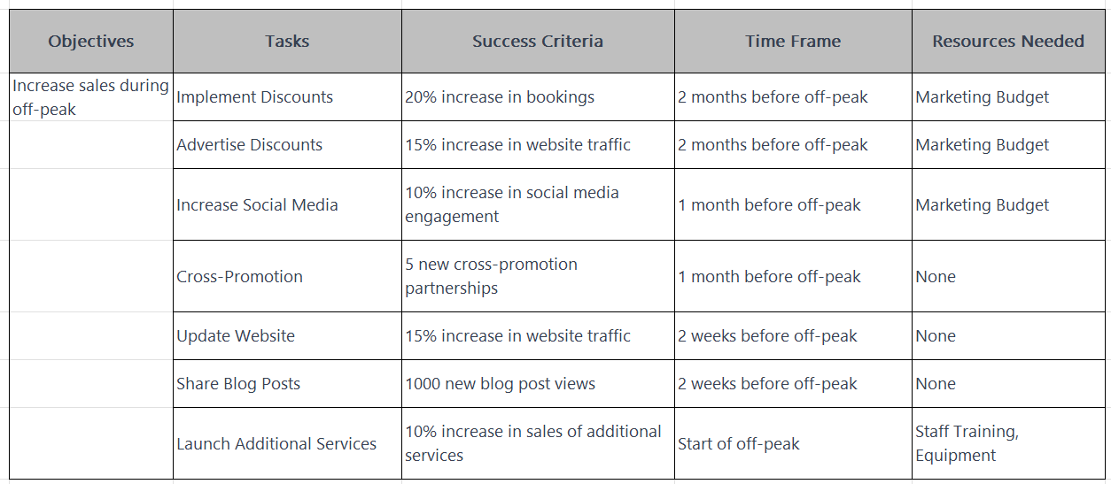

With this plan, we aim to make the best of our slow season by getting more bookings, increasing our online presence, and offering new services. We will measure our success with clear indicators like increased bookings and website visits, and we will need resources like a marketing budget and staff training to make it all happen.
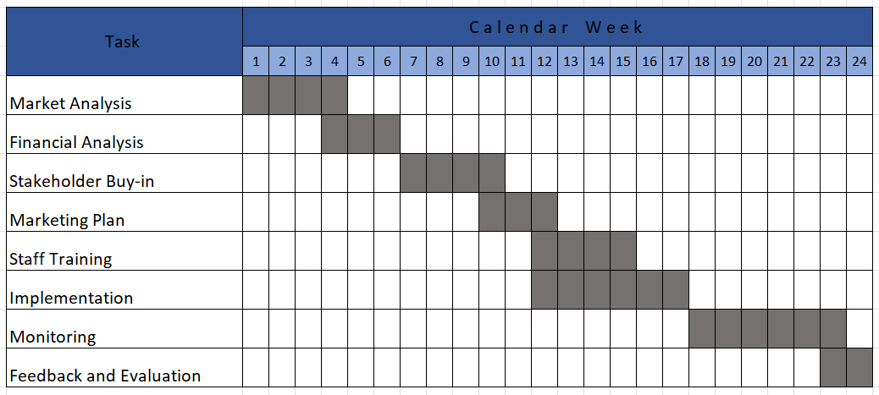
By utilizing the Gantt chart to oversee and evaluate the progress of the execution of the solution, we can guarantee that the project remains on schedule, promptly identify and tackle any obstacles that arise, and ultimately achieve an implementation of the solution.
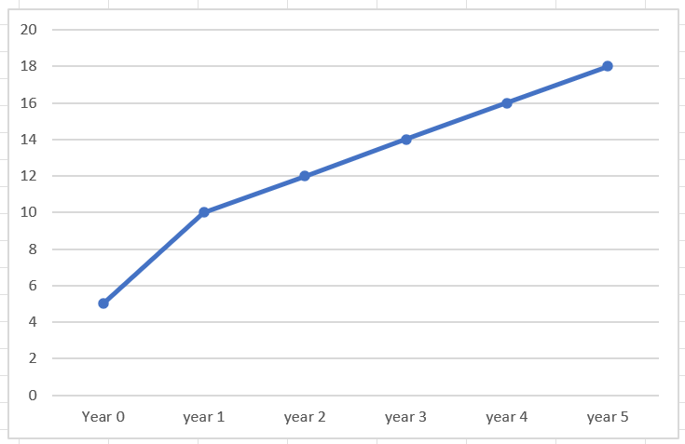
The chart depicting the trend indicates a rise in the number of bookings throughout five years. It begins with ten bookings in Year 1. Then, it consistently grows by two bookings yearly, resulting in 18 by Year 5. The chart visually illustrates this trend, simplifying the business's growth pattern. This positive progression implies that the current strategies are likely effective and can be utilised for predicting business performance.

References

Smithson, R., & Stenning, A. C. (2006). The scope and impact of complexity science in public policy: Implications for knowledge management and organizational change. International Journal of Public Administration, 29(9-10), 817-839. DOI: 10.1080/01900690600801917

Toyoda, S., & Shook, J. (2009). Toyota Production System: Beyond Large-Scale Production (Vol. 4). CRC Press.

Smith, J. (2021). The power of brainstorming: How group collaboration can lead to breakthroughs. Journal of Business Innovation Research, 5(2), 45-58.

Buzan, T., & Buzan, B. (2010). The mind map book: Unlock your creativity, boost your memory & change your life (2nd ed.). Pearson Education Limited.

Appendix 1

