24/07/2026
University of Wales Trinity Saint David
Campus lonon
Assessment 1
Research, build, and deploy a Virtualised Enterprise network
Module: Network Operating Systems and Services
Module code: ACCA5023
Student name: Maksim Zanev
Student ID: 2436811

Lecture name: MD Sadeque Imam Shaikh
Table of Contents
Introduction 2
Task 1 3
1 (a): Research on Hypervisor: 3
1 (b): Research on IP Addressing: 3
1 (c): Research on Routing: 4
1 (d): Research on Network Services: 5
Task 2 7
2.1. Choose your Hypervisor: 7
2.2. Download and Setup: 7
2.3. Configure IP Addressing: 8
2.4. Test and Troubleshoot: 18
2.5. Network Configuration: 23
Task 3 28
3.1. Reflect on the following: 28
3.1.1. Write a Technical reflection covering network deployment and testing: 28
3.1.2. Write your Personal Reflection: 29
Conclusion 30
References 30

Introduction
Modern multinational organisations depend on reliable and secure network infrastructures to support communication, resource sharing and centralised administration across different geographical locations. This report examines the proposed virtualised enterprise network for NOSSLONDON2026, which operates in Birmingham and London. The network environment combines Windows Server 2022, Windows 10 and Debian-based systems, creating a heterogeneous infrastructure that requires appropriate virtualisation, addressing and routing decisions. The research critically considers hypervisor architectures, IP addressing, routing approaches and essential network services. These areas are evaluated in relation to the current topology and its planned expansion, with particular consideration given to scalability, security, efficient resource utilisation and future network management requirements.

Task 1

1 (a): Research on Hypervisor:
Virtualisation architecture has a direct influence on performance, security and scalability. Type 1 hypervisors operate directly on physical hardware, which reduces dependency on a general-purpose host operating system and provides stronger resource control. This architecture is commonly associated with enterprise platforms because virtual machines are managed closer to the hardware layer. In contrast, Type 2 hypervisors operate as applications within an existing operating system. Although this introduces additional overhead, their simpler installation and hardware accessibility make them suitable for development, education and smaller virtual environments [1].
For the NOSSLONDON2026 topology, the selection of a hypervisor should reflect both the current deployment and the enhanced network planned for Coursework 2. A Type 1 solution could provide stronger scalability and isolation for production use; however, it may require dedicated hardware and more complex administration. A Type 2 hypervisor such as VirtualBox provides sufficient compatibility to host Windows Server 2022, Windows 10 and Debian systems on one physical workstation.
Therefore, VirtualBox is suitable for the proposed coursework environment because it balances hardware availability, operating system compatibility and virtual network configuration. Nevertheless, a Type 1 hypervisor would be more appropriate if NOSSLONDON2026 expanded the infrastructure into a production environment with higher availability and stronger isolation requirements[2].

1 (b): Research on IP Addressing:
Effective IP addressing is fundamental to the performance and manageability of an enterprise network because data packets require logical source and destination addresses to travel between devices. When a destination exists outside the local subnet, traffic is forwarded to a default gateway and routed towards the appropriate network. Therefore, the addressing scheme influences not only connectivity but also routing, troubleshooting and future network expansion.
IPv4 uses a 32-bit addressing structure represented in dotted-decimal format, such as 172.16.1.10. Although IPv4 remains widely used, its limited address space has encouraged techniques such as Network Address Translation. IPv6 uses 128-bit hexadecimal addressing and provides a significantly larger address space. However, migration to IPv6 may increase administrative complexity where legacy systems require dual-stack configurations[3].
Subnetting improves address utilisation by dividing a larger network into smaller logical networks. In the NOSSLONDON2026 topology, Birmingham and London require separate subnets because they represent different network locations. The /24 networks shown in the original topology provide simple administration but allocate significantly more addresses than the current number of devices requires.
A Variable Length Subnet Mask addressing scheme would provide greater efficiency by allocating subnet sizes according to actual host requirements. For example, smaller LAN subnets could use /28, while the point-to-point connection between the servers could use /30. This approach reduces address waste and creates a more structured and scalable addressing design[4].

1 (c): Research on Routing:
Routing is essential when devices located in separate IP networks need to exchange data. Routers and routing-capable systems examine the destination IP address of a packet and use routing tables to determine an appropriate forwarding path. The effectiveness of routing therefore depends on accurate network information and the selected method of maintaining routes.
Static routing requires an administrator to manually configure network paths. This provides predictable traffic forwarding, minimal protocol overhead and direct administrative control. However, static routes become increasingly difficult to maintain when a network expands. Dynamic routing protocols, such as Open Shortest Path First, automatically exchange routing information and can adapt when network paths change. This improves scalability and resilience but introduces additional configuration and processing requirements[5].
For the current NOSSLONDON2026 topology, static routing is the more appropriate approach. The network contains Birmingham and London LANs connected through a point-to-point network between the Windows and Debian servers. The small number of networks means that manually configured routes can provide the required connectivity without introducing a dynamic routing protocol.
The enhanced topology must also consider the Debian Server's role as a DHCP Relay. DHCP discovery traffic initially relies on broadcasts, which are not normally forwarded between routed networks. The relay therefore enables DHCP communication between the London network and the central DHCP service. If NOSSLONDON2026 later expanded to multiple locations and redundant routes, a dynamic protocol such as OSPF would become a more scalable solution[6].

1 (d): Research on Network Services:
Enterprise network services should operate as an integrated infrastructure rather than as isolated technologies. In the enhanced NOSSLONDON2026 topology, VPN, DHCP, Active Directory Domain Services and Certificate Authority services contribute to connectivity, centralised administration and security.
Active Directory Domain Services provides centralised identity and access management, allowing users and computers to be managed within a domain environment. This simplifies administration and policy enforcement, although dependence on central domain infrastructure requires appropriate security and recovery planning. DHCP complements this environment by automatically distributing network configuration, reducing manual addressing errors. A DHCP Relay is particularly relevant to the London subnet because it can forward DHCP communication across the routed network to a central DHCP server.
A Virtual Private Network can protect communication between Birmingham and London when traffic crosses an untrusted network. A site-to-site VPN would therefore provide encrypted inter-site connectivity and reduce the risk of traffic interception. However, VPN security depends on appropriate authentication and cryptographic configuration[7].
Certificate Authorities establish cryptographic trust by issuing and managing digital certificates. Certificates can support secure authentication and encrypted network services, but compromise of the CA could affect the trust of the entire infrastructure. Consequently, private key protection and certificate lifecycle management are essential.
Together, these services create a centralised architecture in which DHCP provides configuration, AD DS manages identity, VPN technology protects communication and certificate services establish digital trust[8].

Task 2

2.1. Choose your Hypervisor:
Oracle VirtualBox was selected as the hypervisor for this project because it supports Windows Server 2022, Windows 10 and Debian virtual machines within the same environment. As a Type 2 hypervisor, it provides sufficient functionality for educational purposes while allowing flexible virtual networking, snapshots and hardware configuration. The platform offers an efficient environment for deploying and testing the enterprise network before implementation in a production environment.

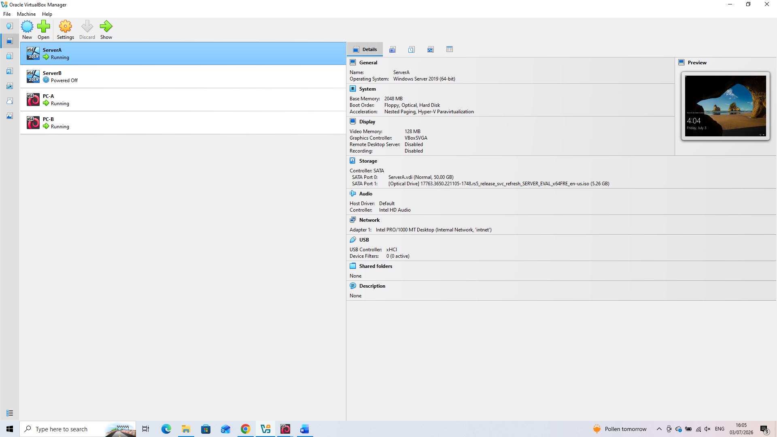

2.2. Download and Setup:
The required installation media for Windows Server 2019, Windows 10 were downloaded before creating the virtual machines. Using official ISO images ensures system integrity and compatibility throughout the deployment process.
Windows Server 2019 was successfully installed and booted into Server Manager. This confirms that the operating system was correctly deployed and ready for further network configuration.

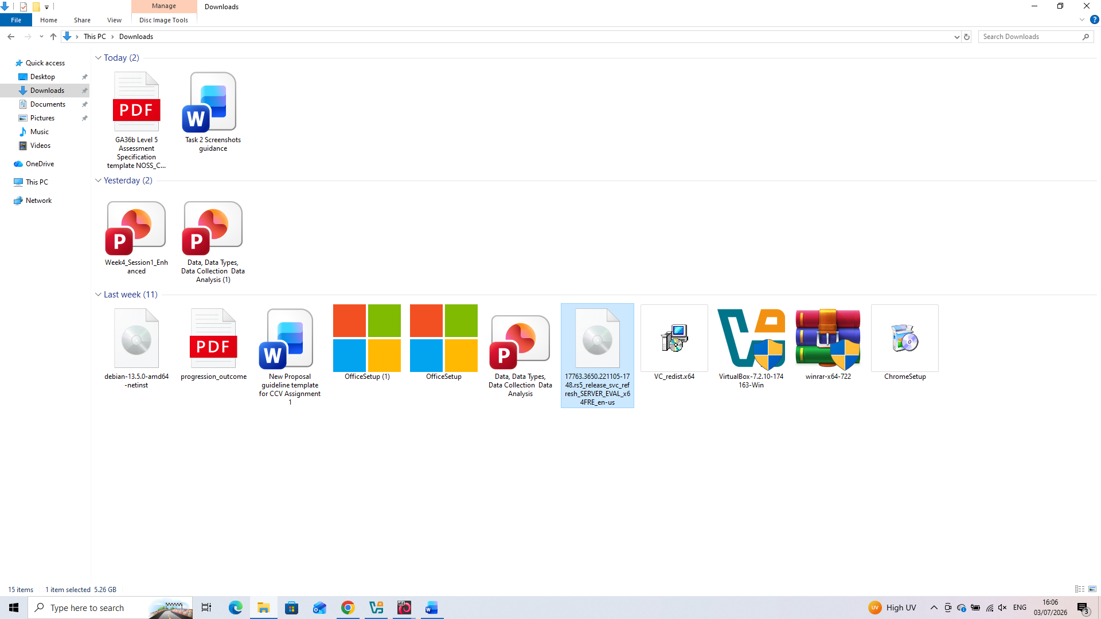

2.3. Configure IP Addressing:

From the Local Server section in Server Manager, the Ethernet Properties window was accessed by selecting the Ethernet link. This allowed the network adapter settings to be configured for the virtual enterprise environment.

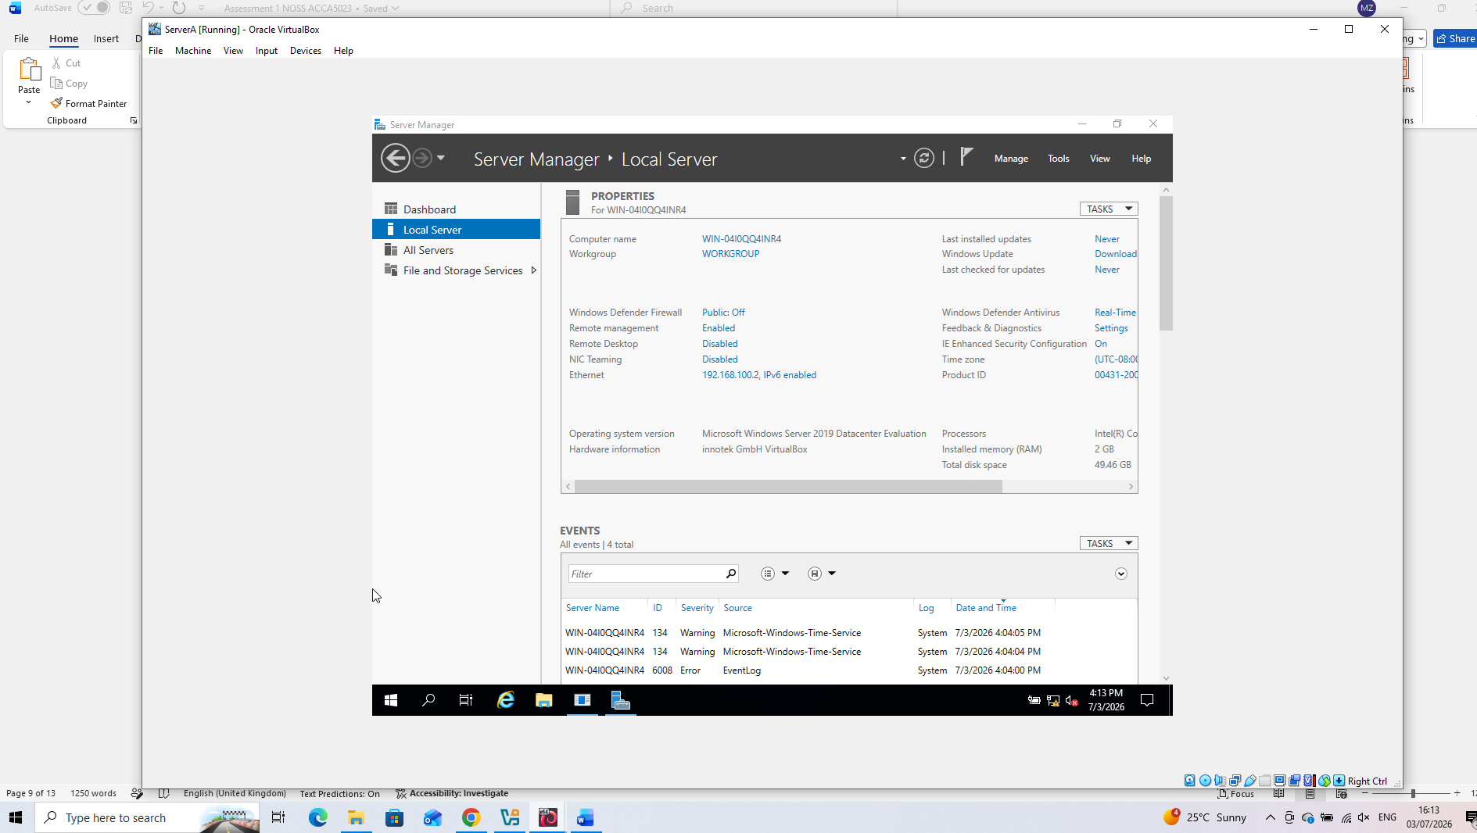
Server A Machine
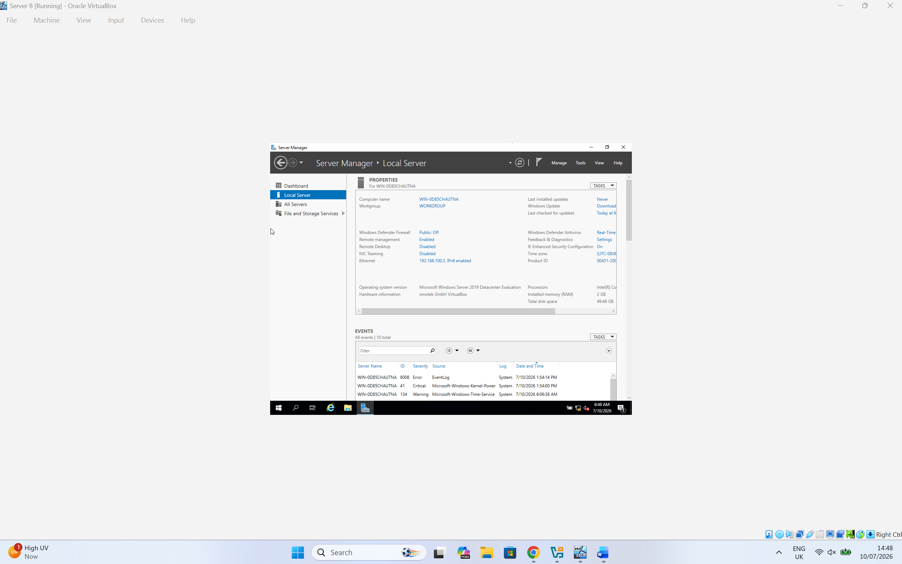
Server B Machine

The network adapter was right-clicked to open the context menu, and the Properties option was selected. This provided access to the adapter configuration settings required for the next stage of the network setup.

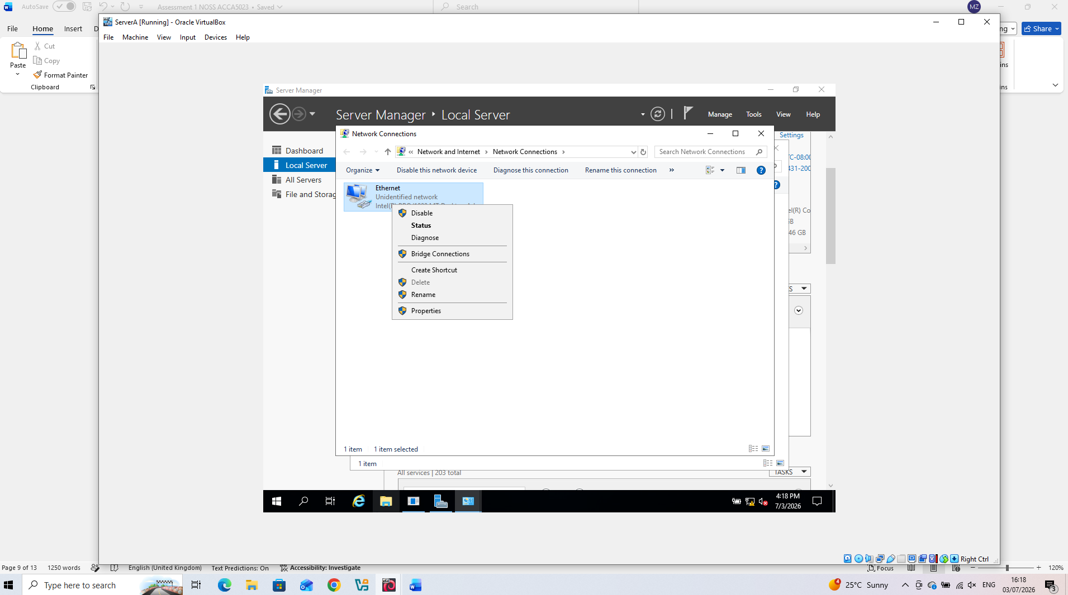
Server A Machine
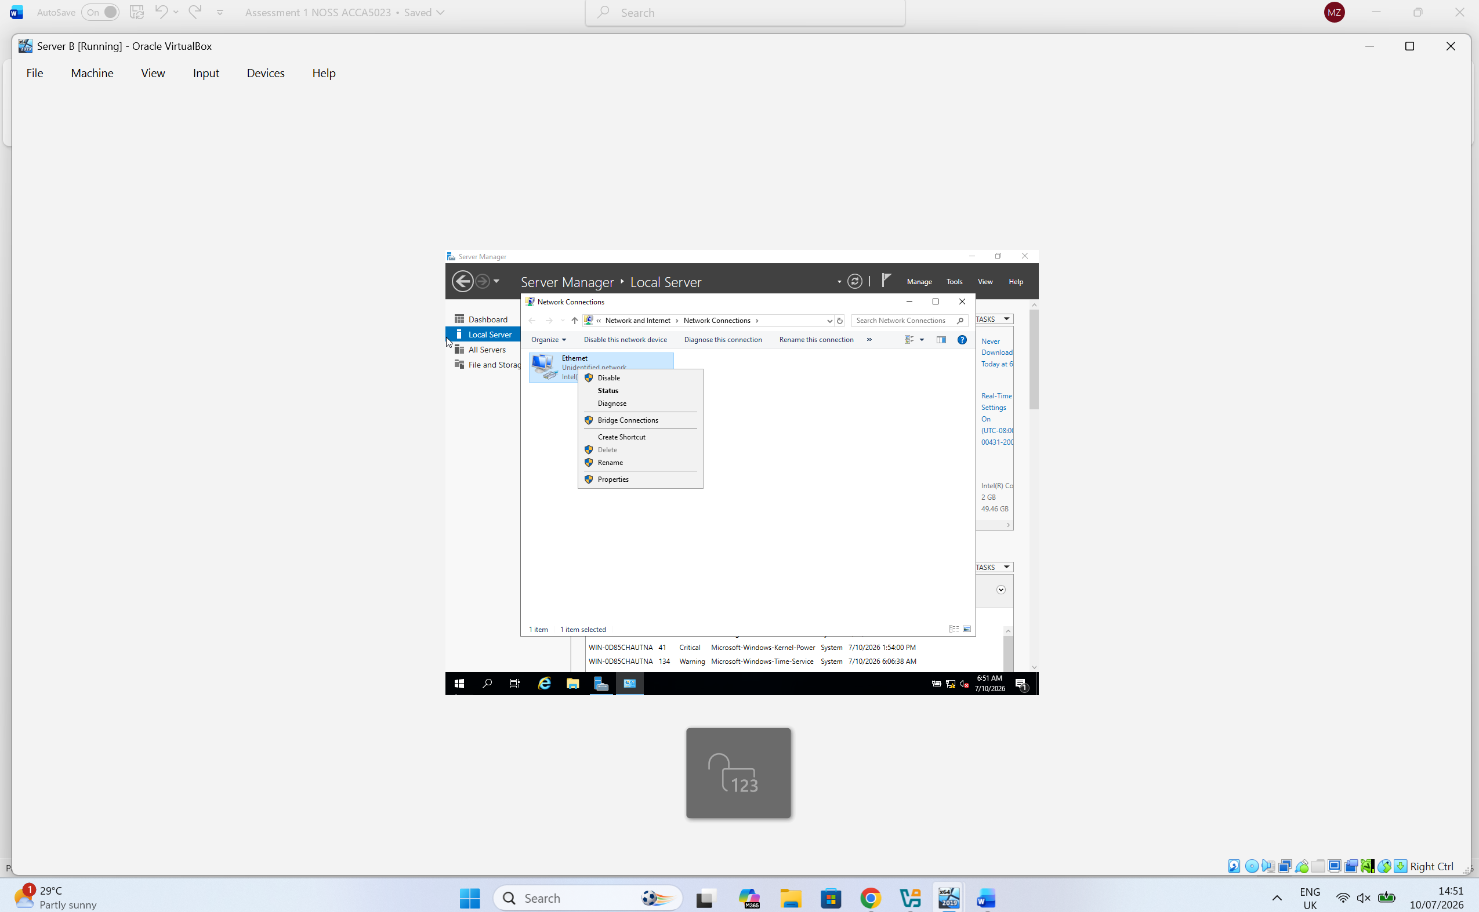
Server B Machine

Internet Protocol Version 4 (TCP/IPv4) was selected from the Ethernet Properties window to configure the IP address settings.

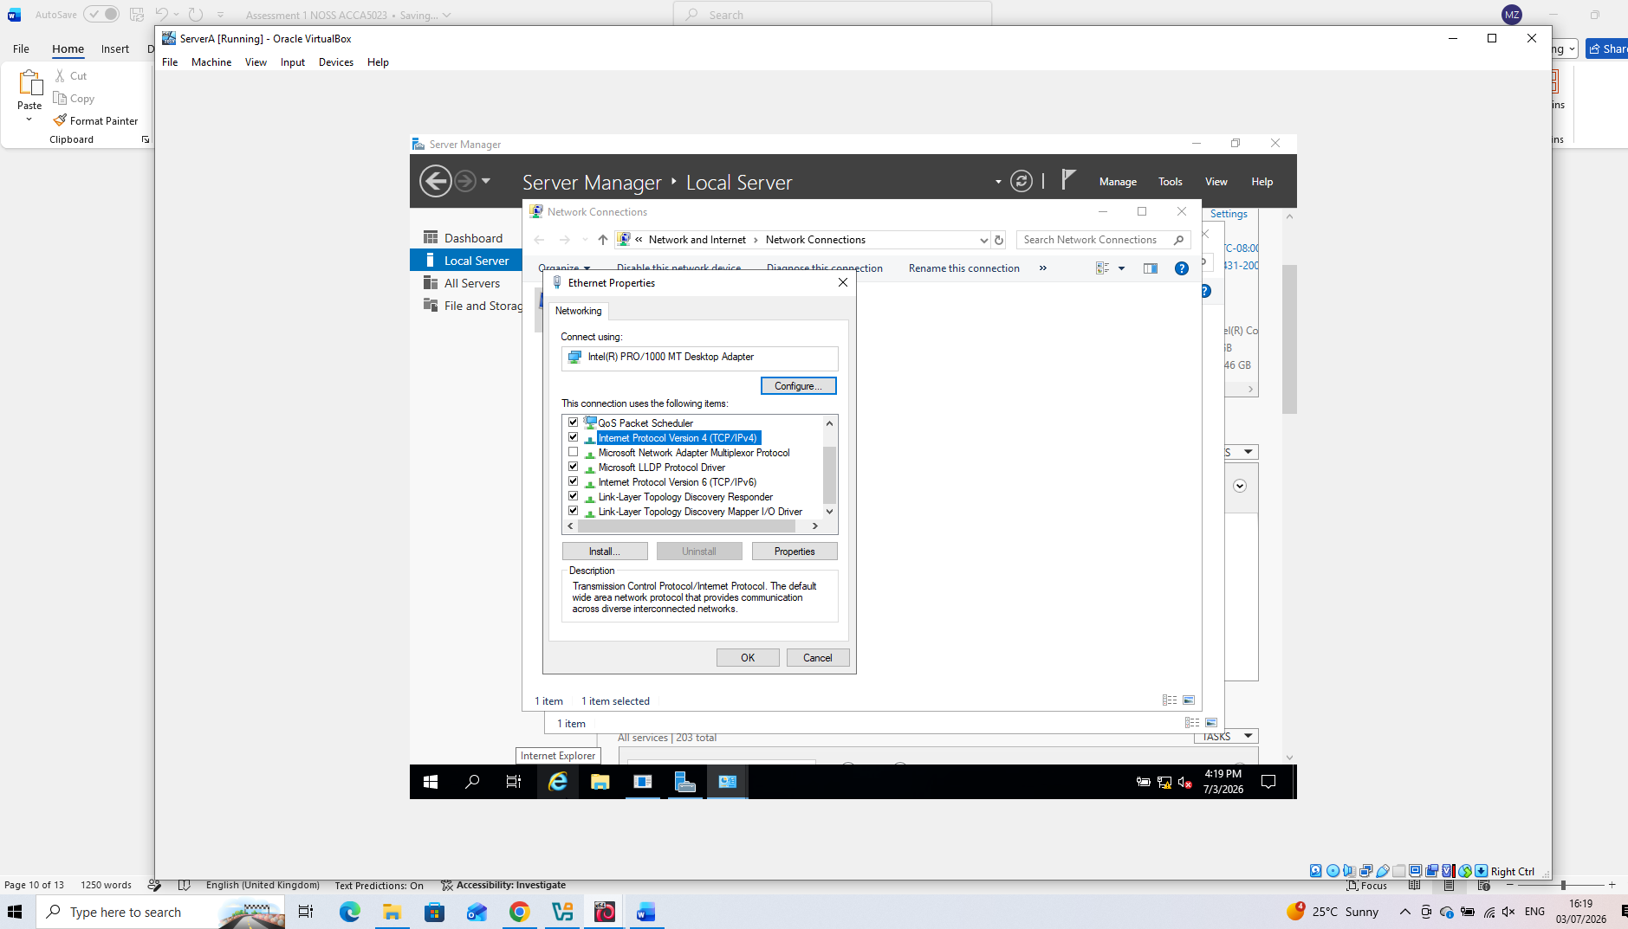
Server A Machine

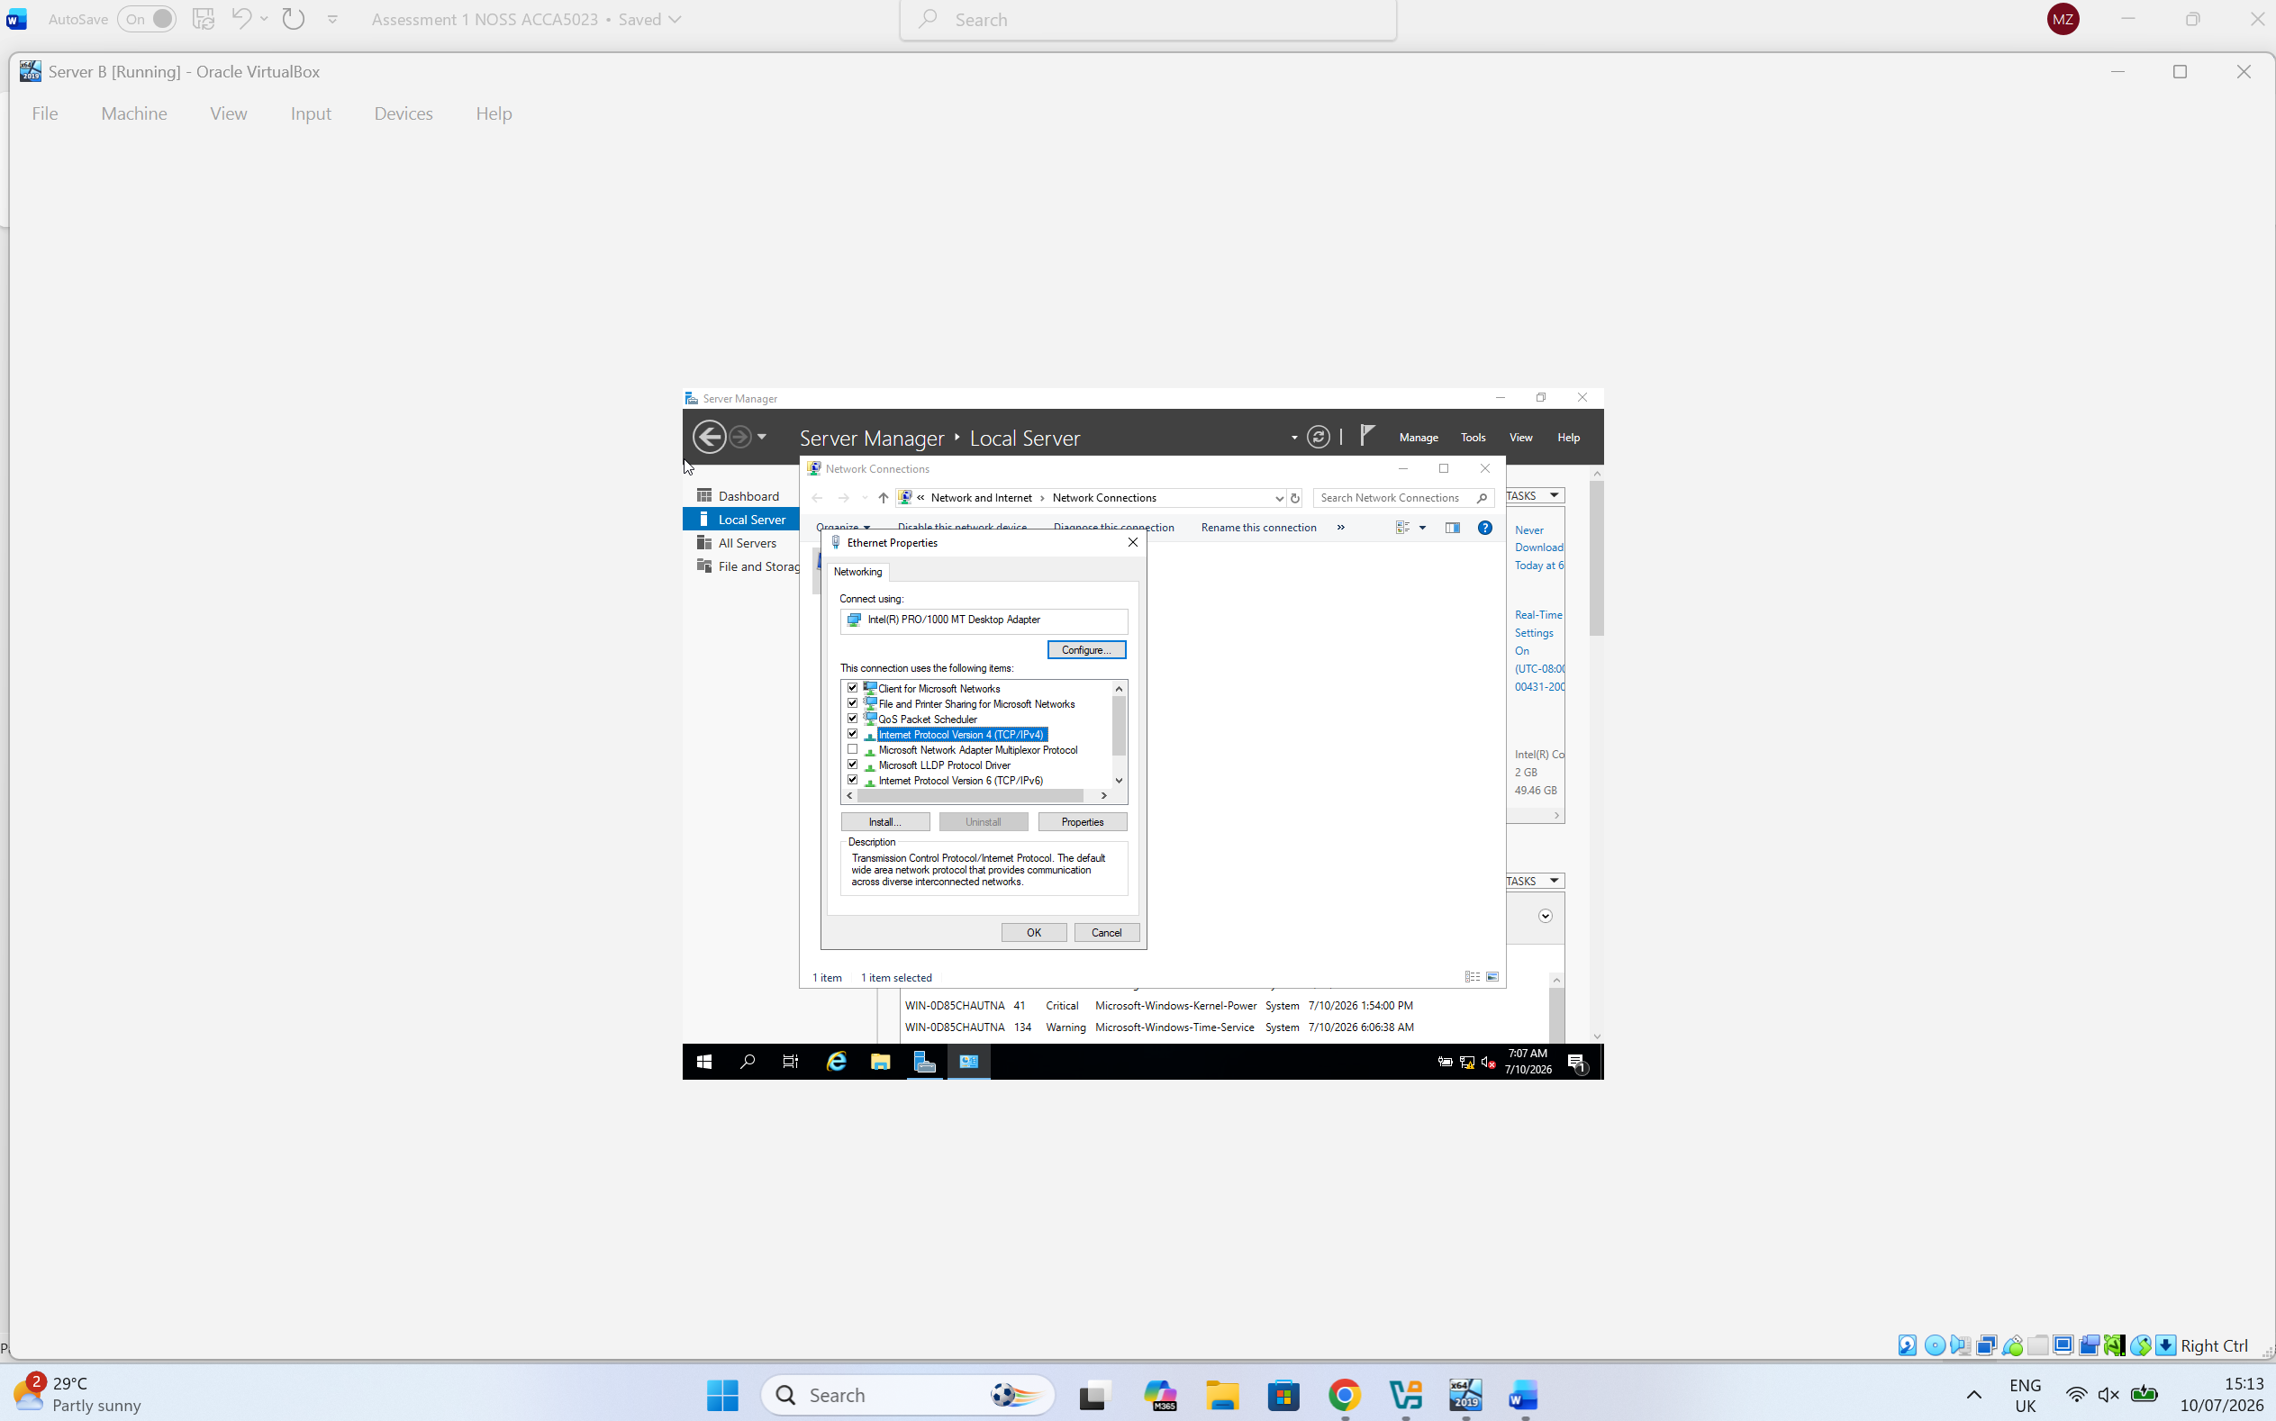
Server B Machine

The "Use the following IP address" option was selected, and the static IP address and subnet mask were entered according to the proposed network addressing scheme.
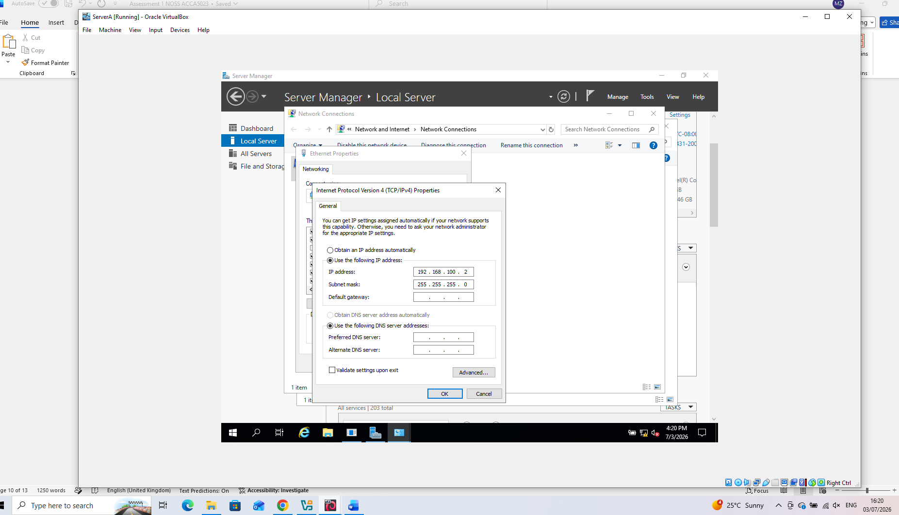Server A was configured with the static IP address 192.168.100.2 and the subnet mask 255.255.255.0 as defined in the proposed network addressing scheme.

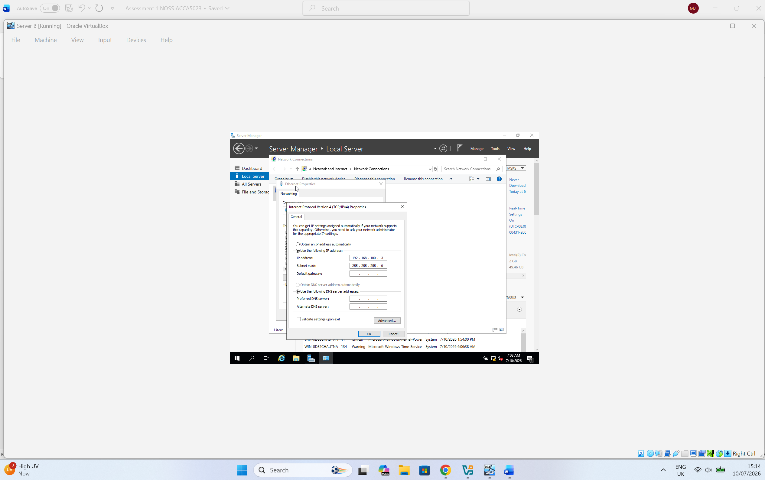
Server B was configured with the static IP address 192.168.100.3 and the subnet mask 255.255.255.0 as defined in the proposed network addressing scheme.

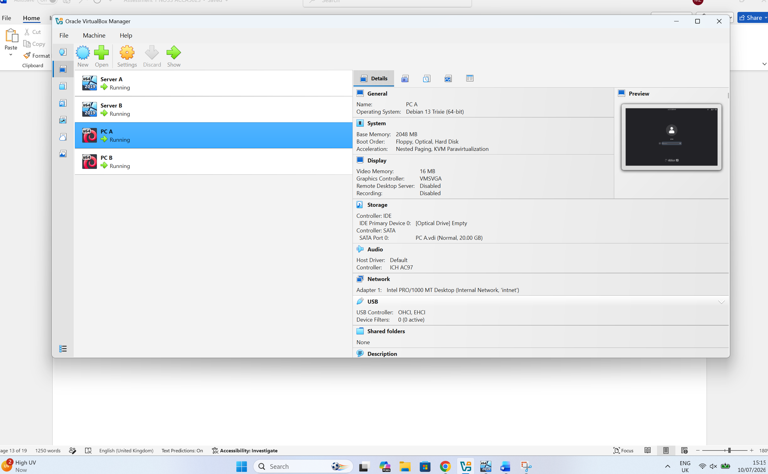
The required installation media for Debian were downloaded before creating the virtual machines. Using official ISO images ensures system integrity and compatibility throughout the deployment process.

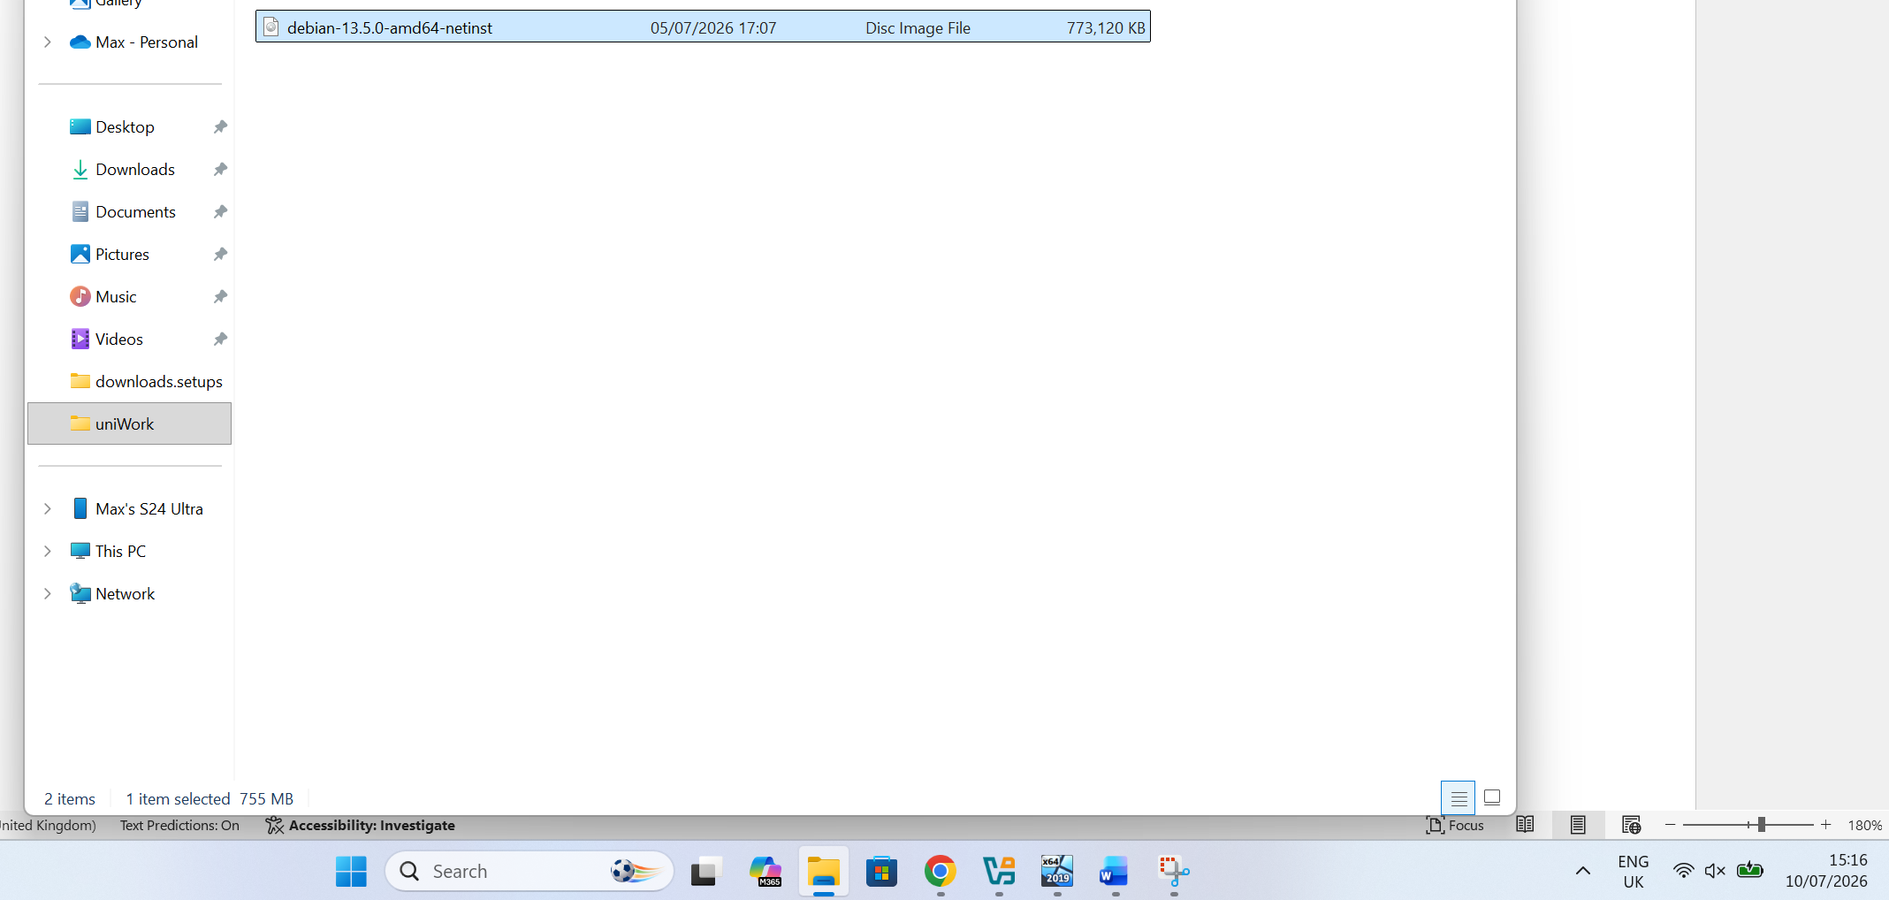

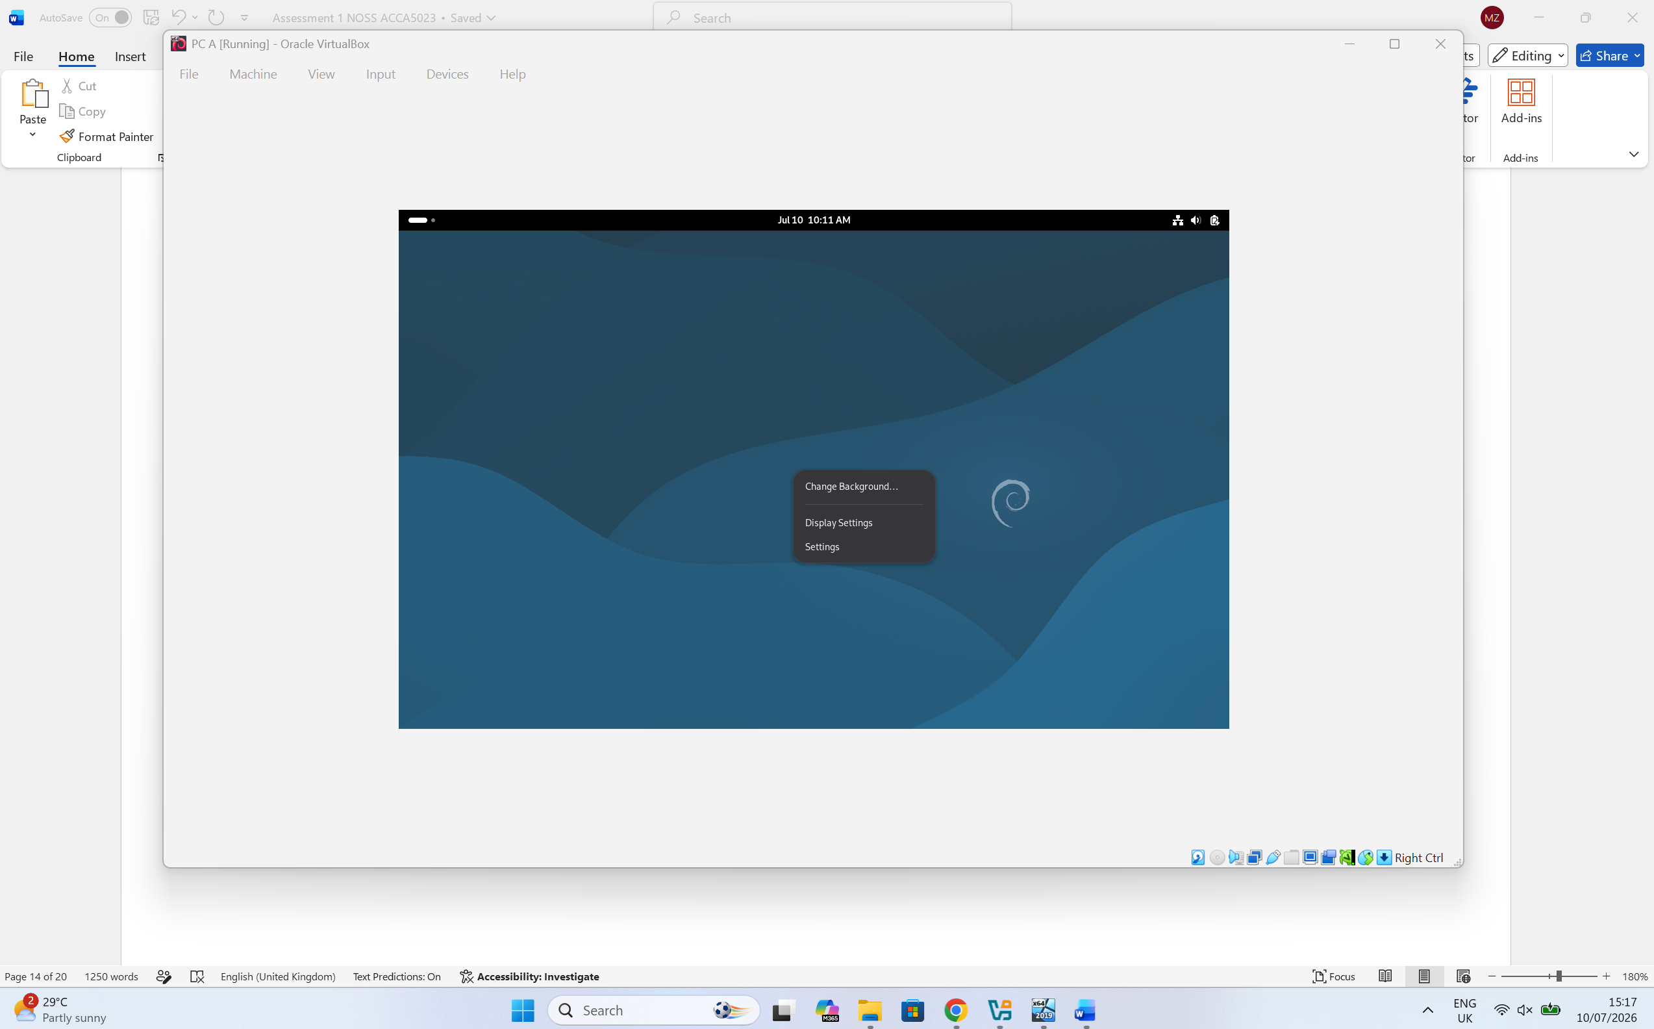
PC A - The Settings option was selected from the context menu by right-clicking the virtual machine. This provides access to the virtual machine configuration options.

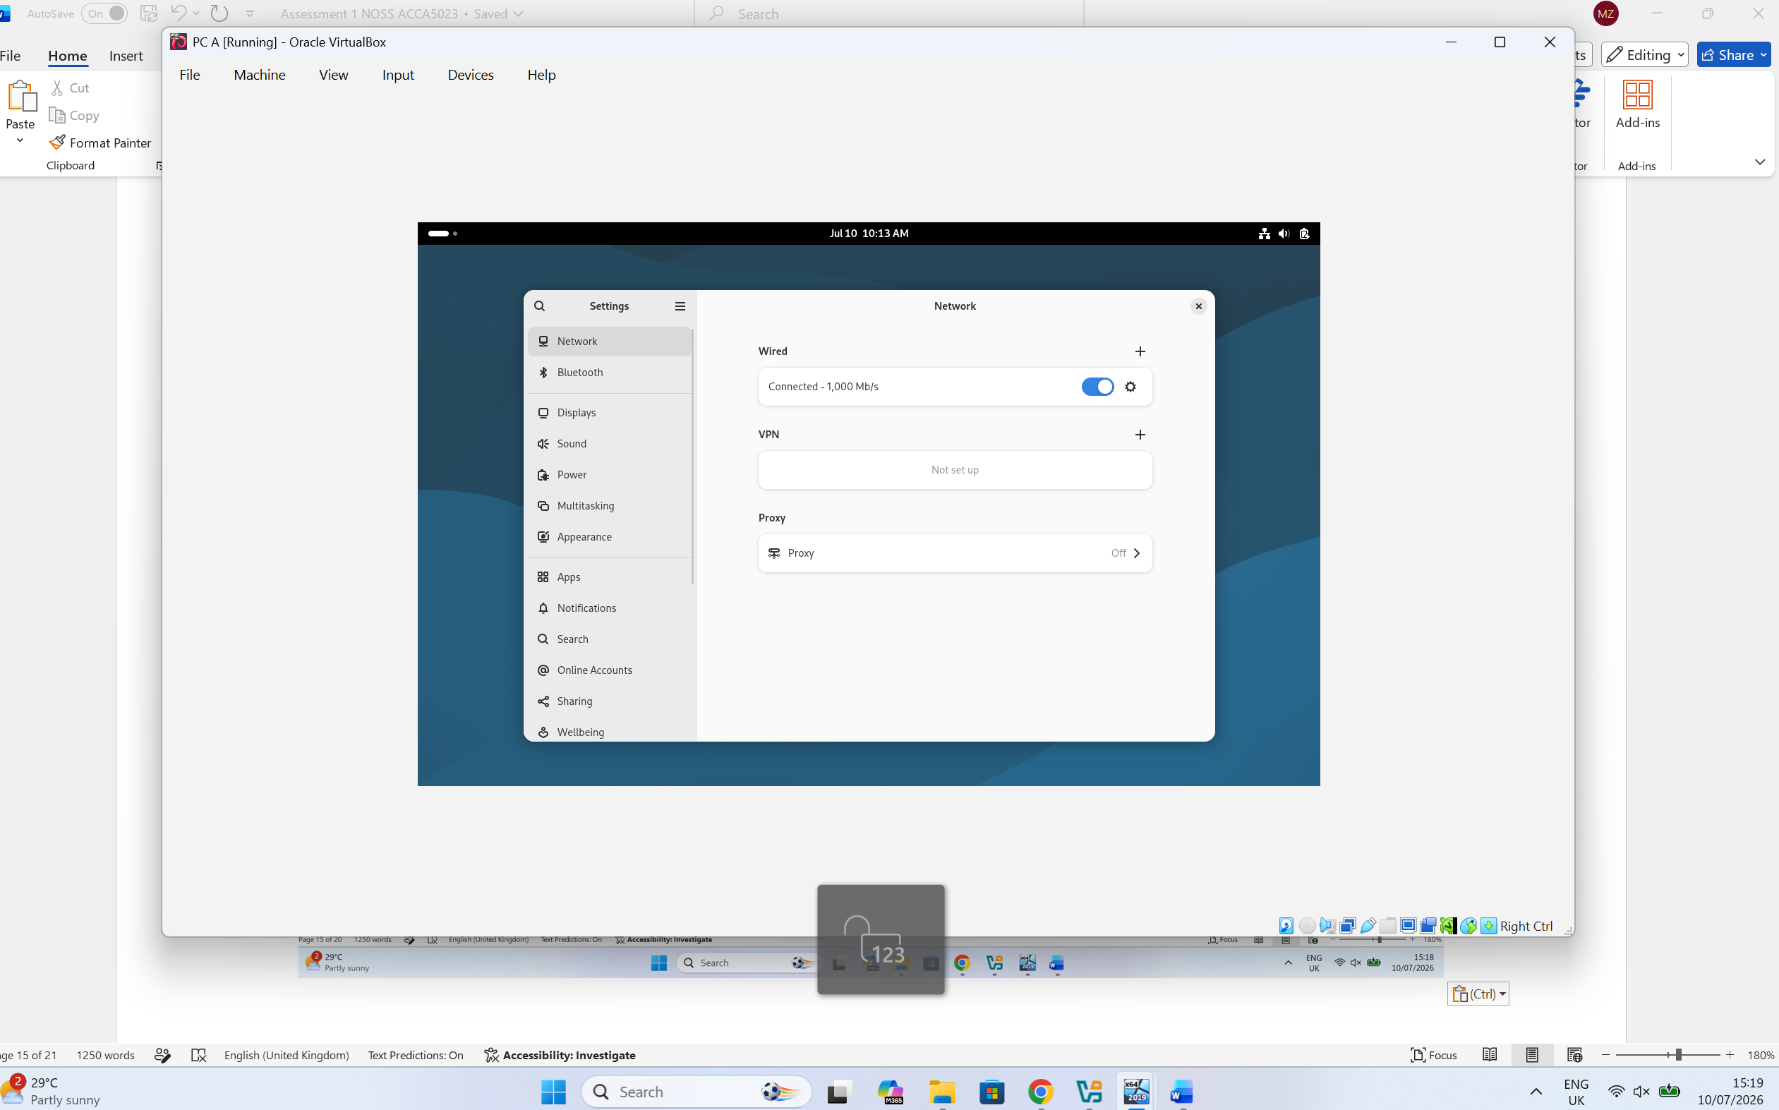
PC A - From the Network menu, the settings icon beside the wired network connection was selected to access the IP configuration menu. This allowed the network interface to be configured with the required static IP settings.
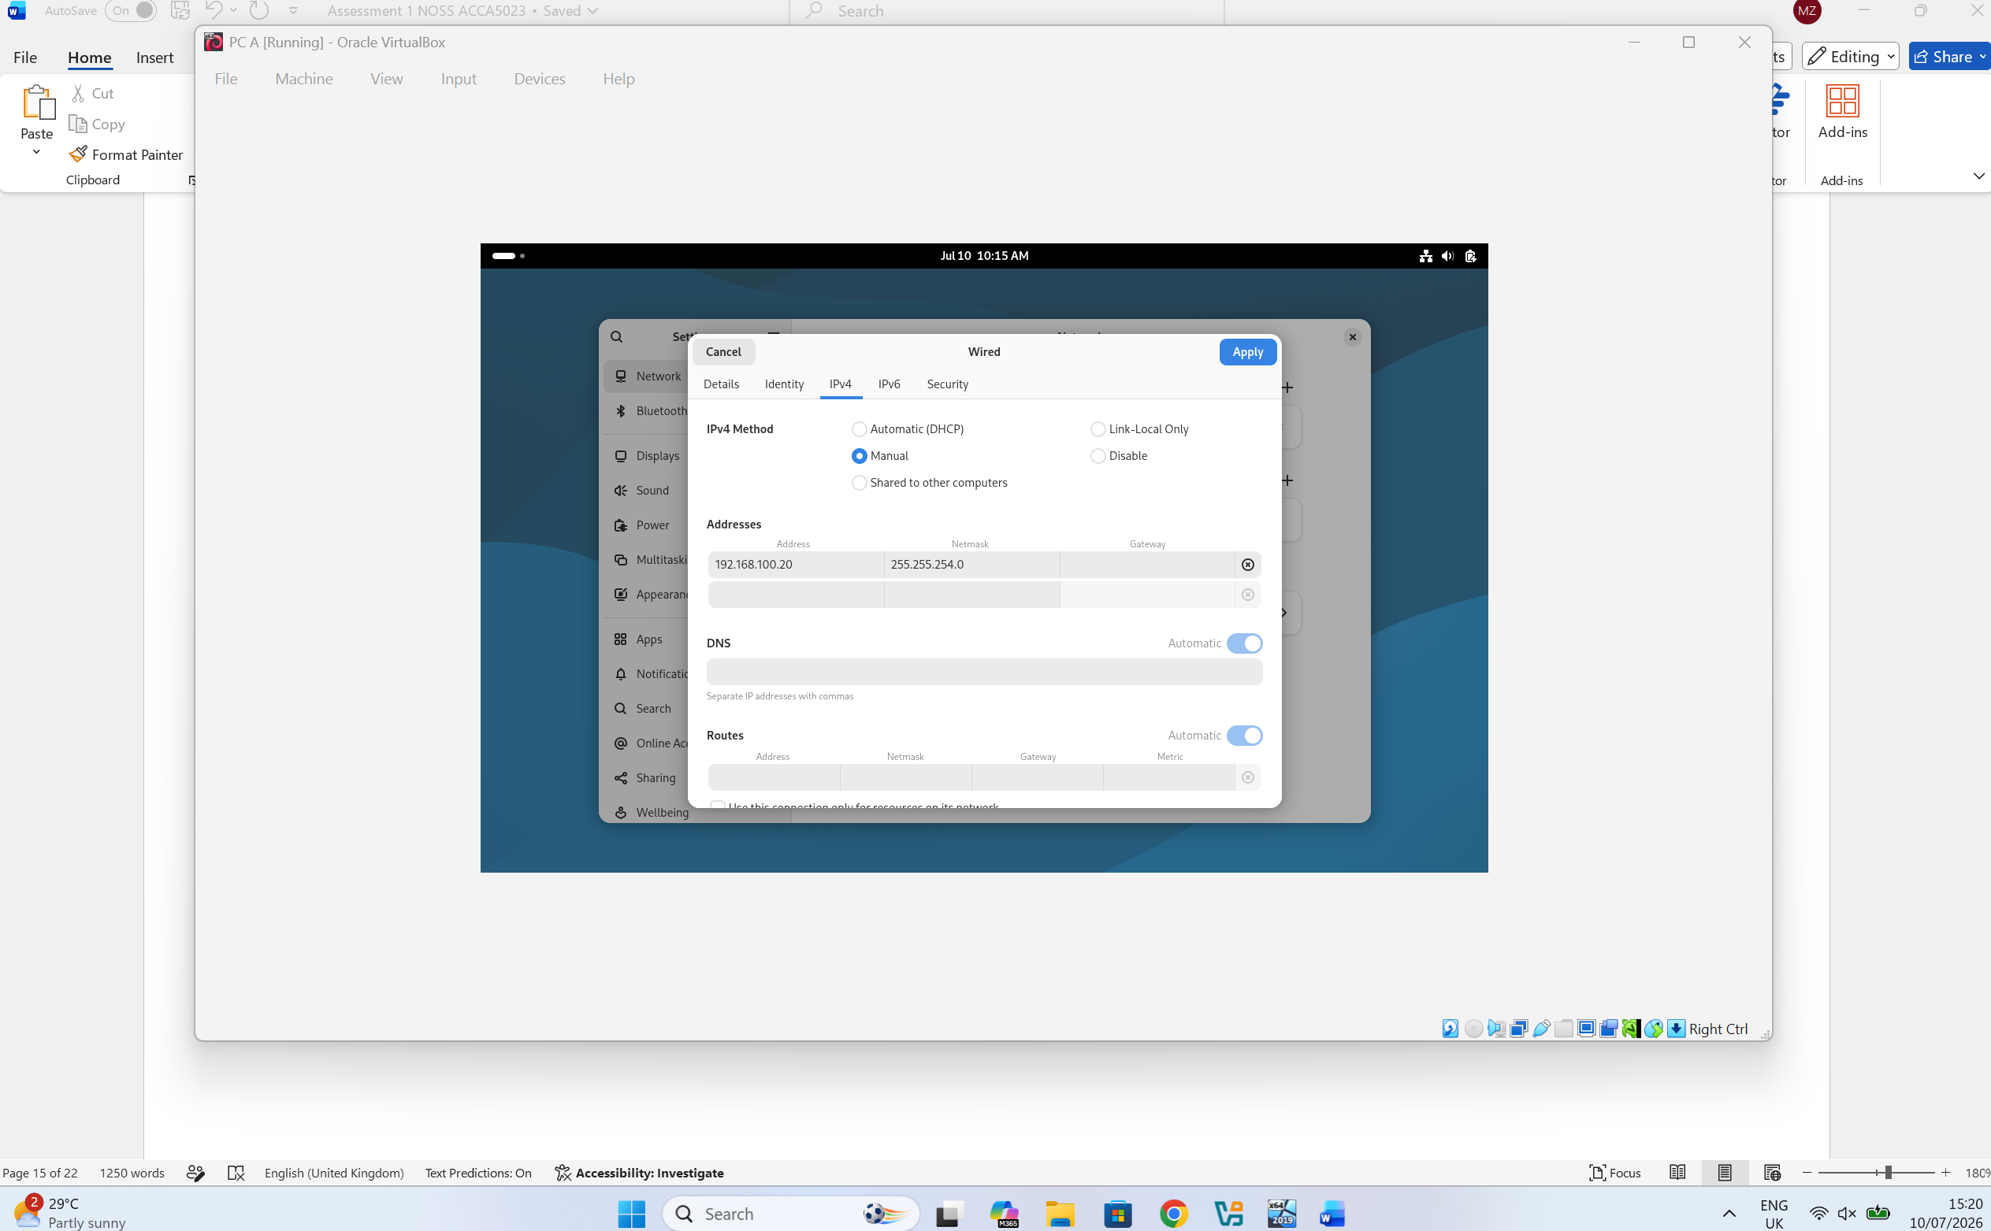
PC A - In the IPv4 settings, the Manual option was selected to assign a static IP configuration. For PC A, the IP address was configured as 192.168.100.20 with the subnet mask 255.255.254.0, ensuring reliable communication within the enterprise network.

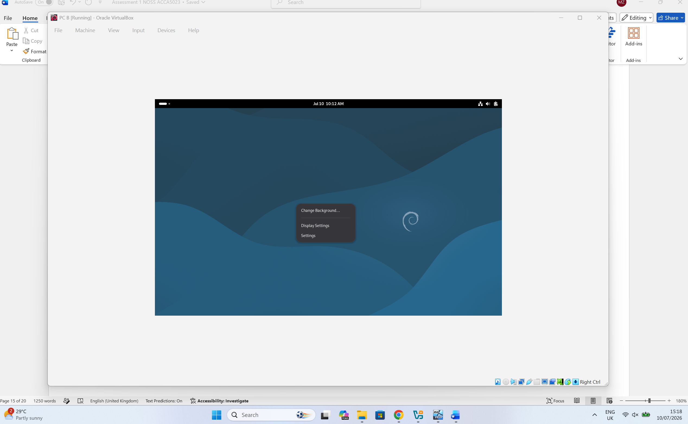
PC B - The Settings option was selected from the context menu by right-clicking the virtual machine. This provides access to the virtual machine configuration options.

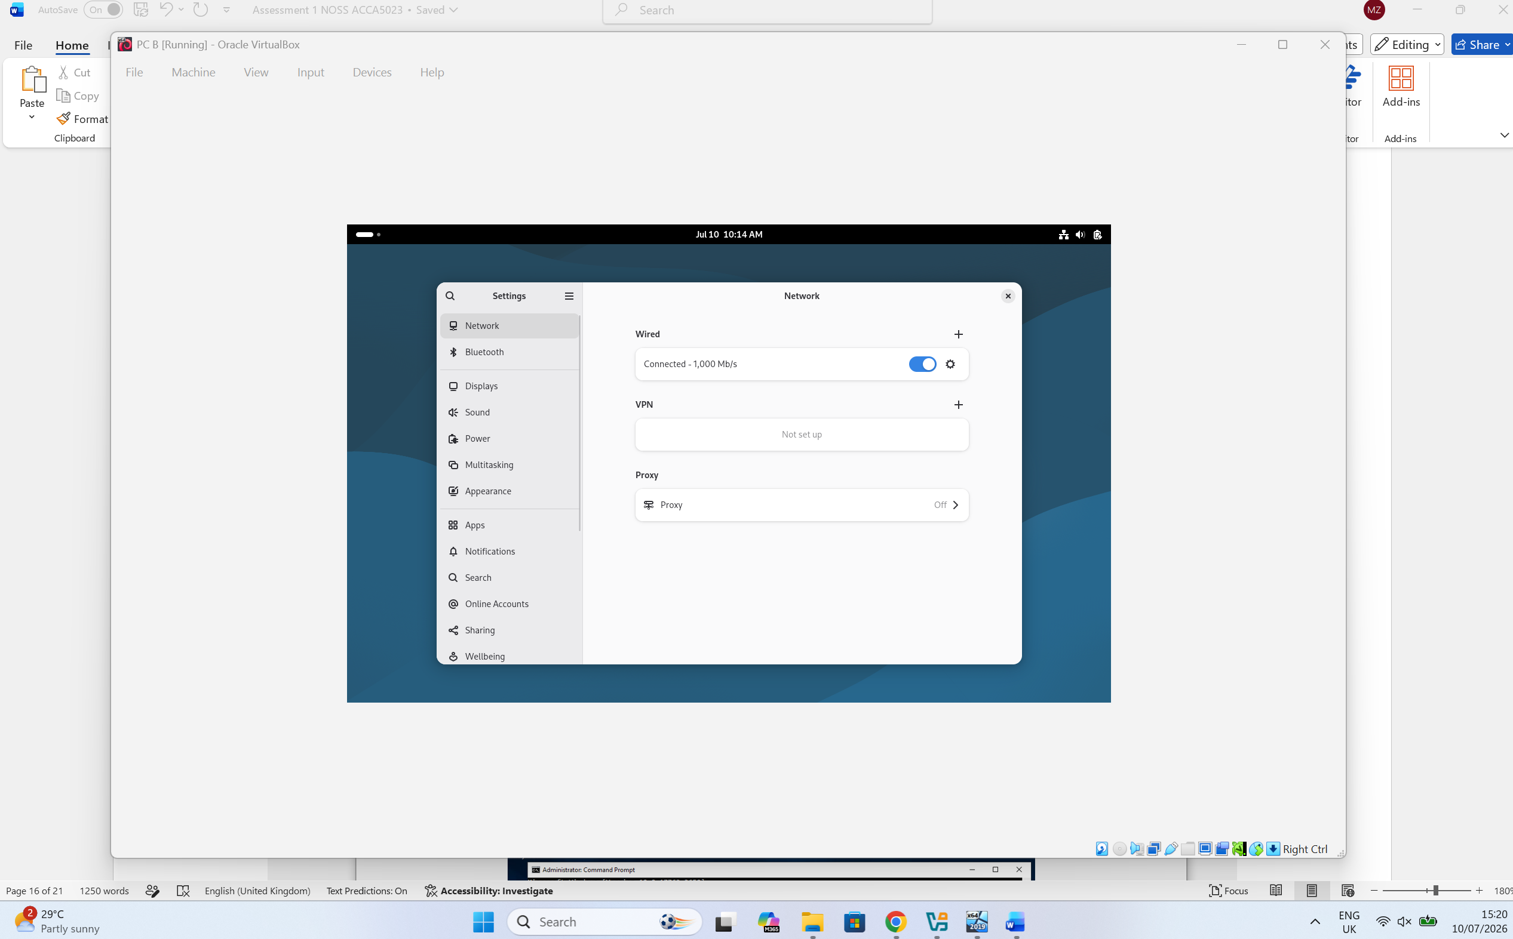
PC B - From the Network menu, the settings icon beside the wired network connection was selected to access the IP configuration menu. This allowed the network interface to be configured with the required static IP settings.

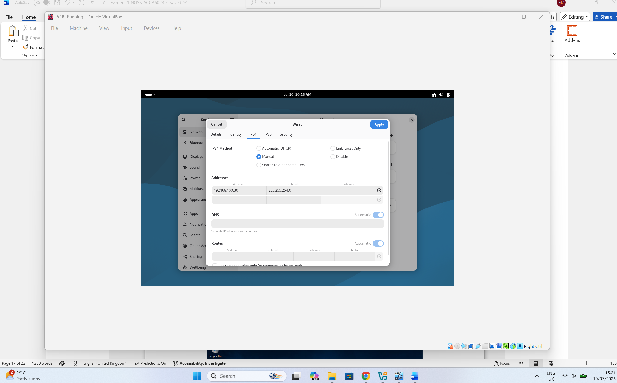
PC B - In the IPv4 settings, the Manual option was selected to assign a static IP configuration. For PC A, the IP address was configured as 192.168.100.30 with the subnet mask 255.255.254.0, ensuring reliable communication within the enterprise network.

2.4. Test and Troubleshoot:
After assigning the IP address and subnet mask, the Command Prompt was used to verify the network configuration. The ipconfig command confirmed that the correct IP address, subnet mask and default gateway had been successfully configured.
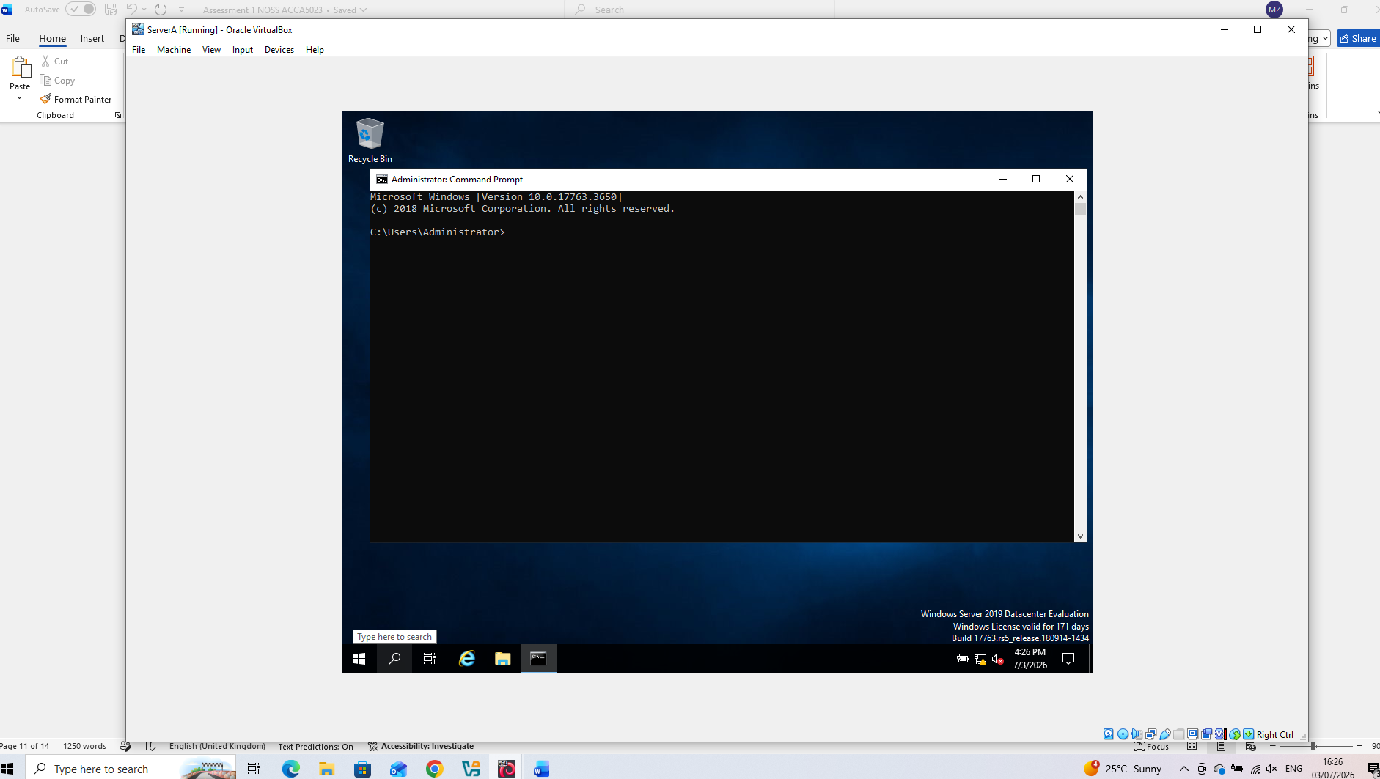
The Command Prompt was opened to verify the network configuration and perform connectivity tests.
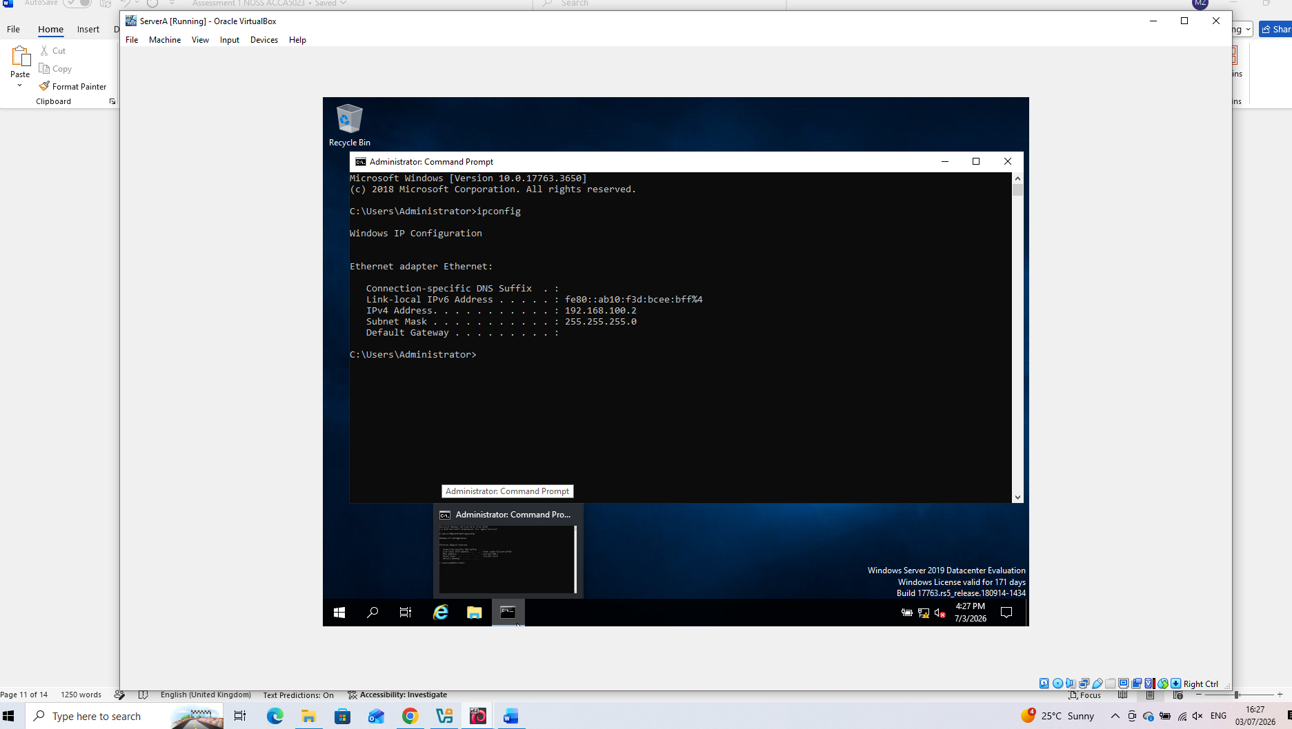
Server A - Using the >ipconfig command, the current network configuration was displayed. The results confirmed that the IP address and subnet mask were correctly configured, ensuring that the device was properly connected to the enterprise network.
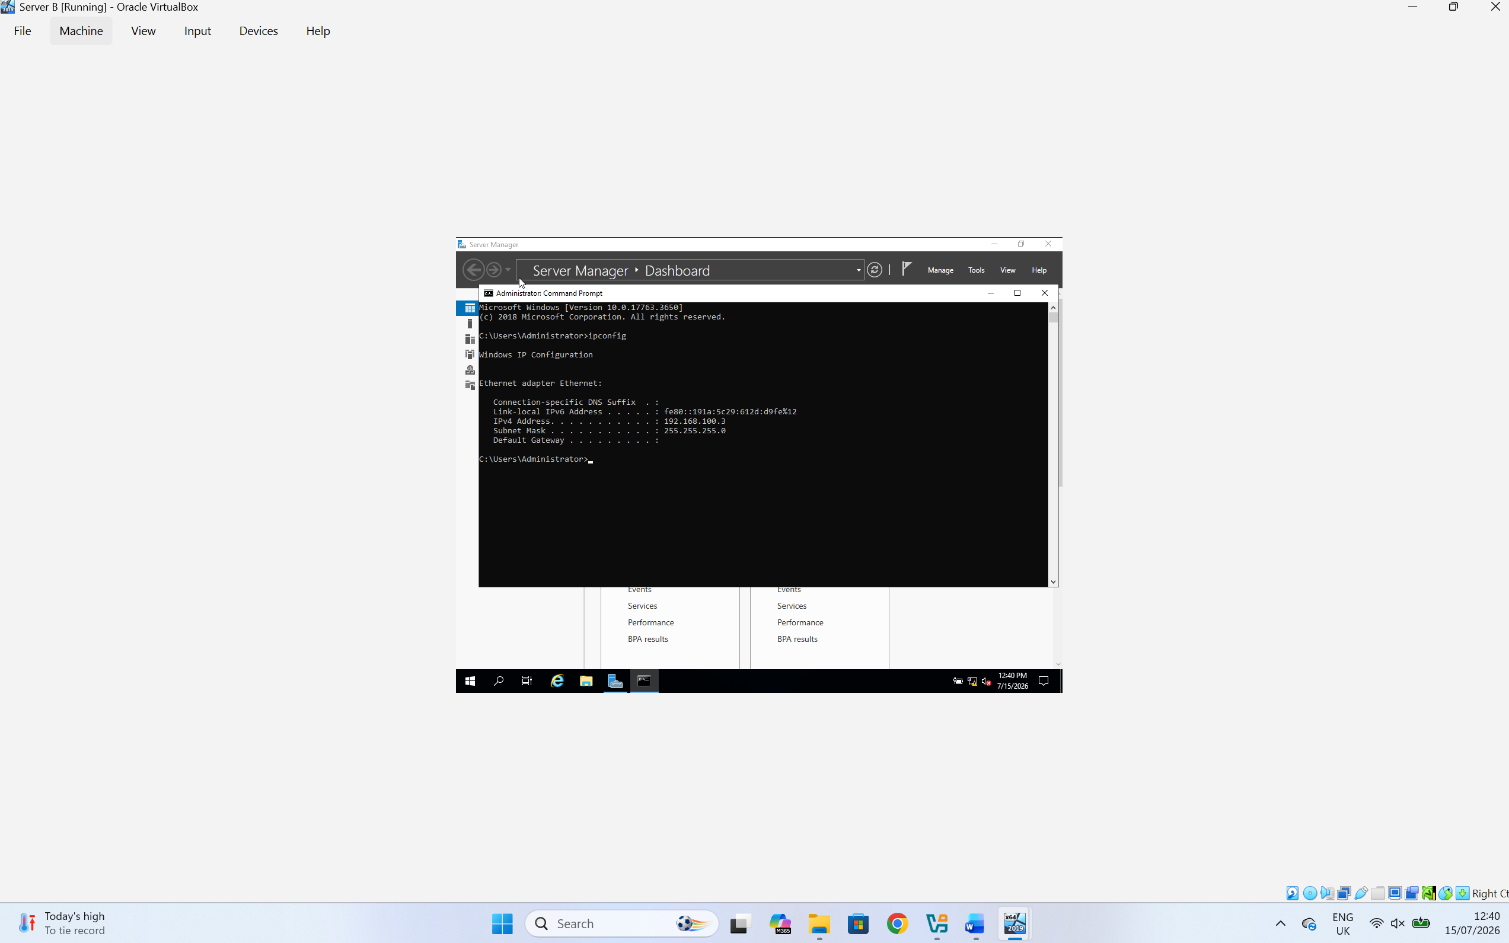
Server B - Using the >ipconfig command, the current network configuration was displayed. The results confirmed that the IP address and subnet mask were correctly configured, ensuring that the device was properly connected to the enterprise network.

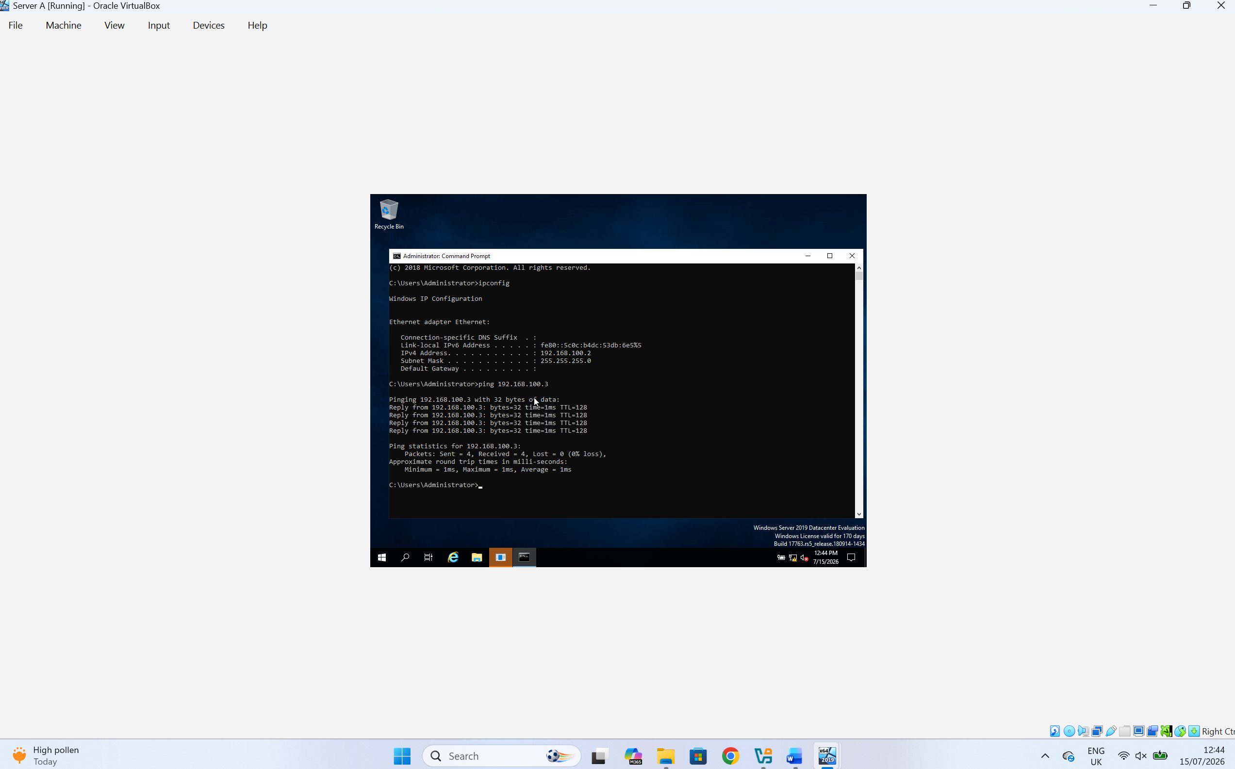
The >ping command was executed on Server A to test connectivity with Server B. The successful responses confirmed that both servers were able to communicate across the network and that the IP configuration and routing were correctly configured.
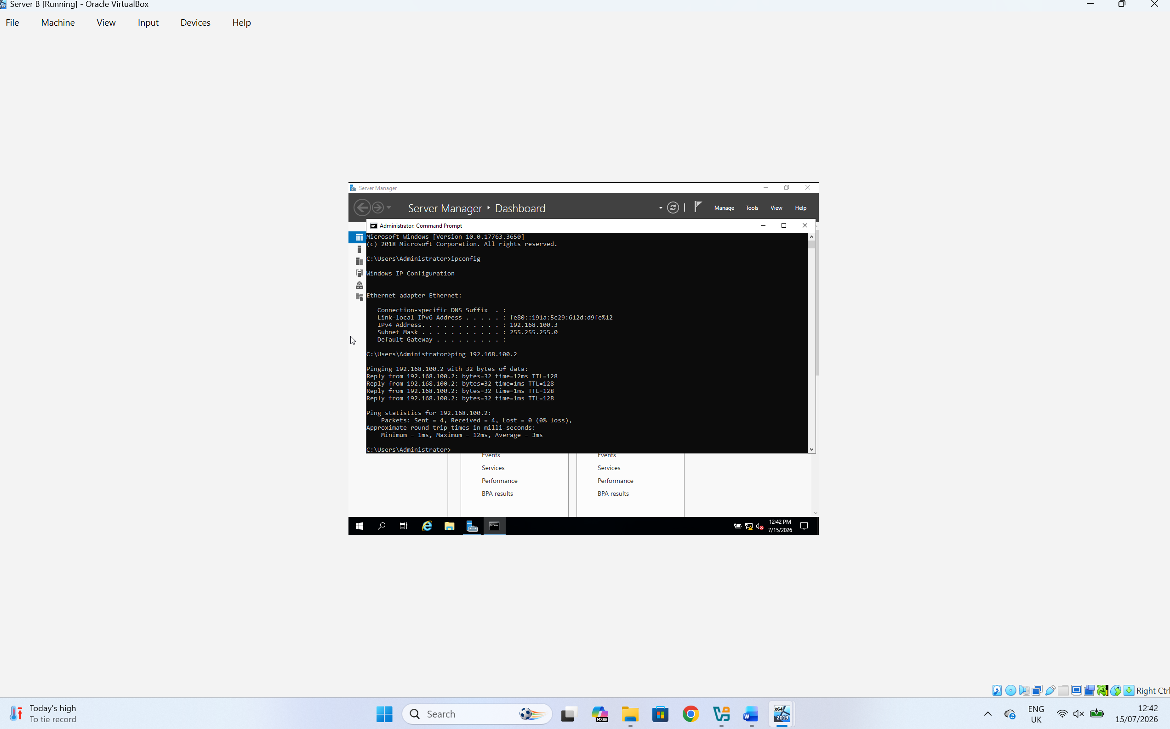
The >ping command was executed on Server B to test connectivity with Server A. The successful responses confirmed that both servers were able to communicate across the network and that the IP configuration and routing were correctly configured.
For the Debian virtual machine, the Terminal was used to verify the network configuration. Commands such as >ip addr were used to confirm the assigned IP address and subnet mask, while the >ping command was used to test network connectivity with the other devices in the enterprise network.

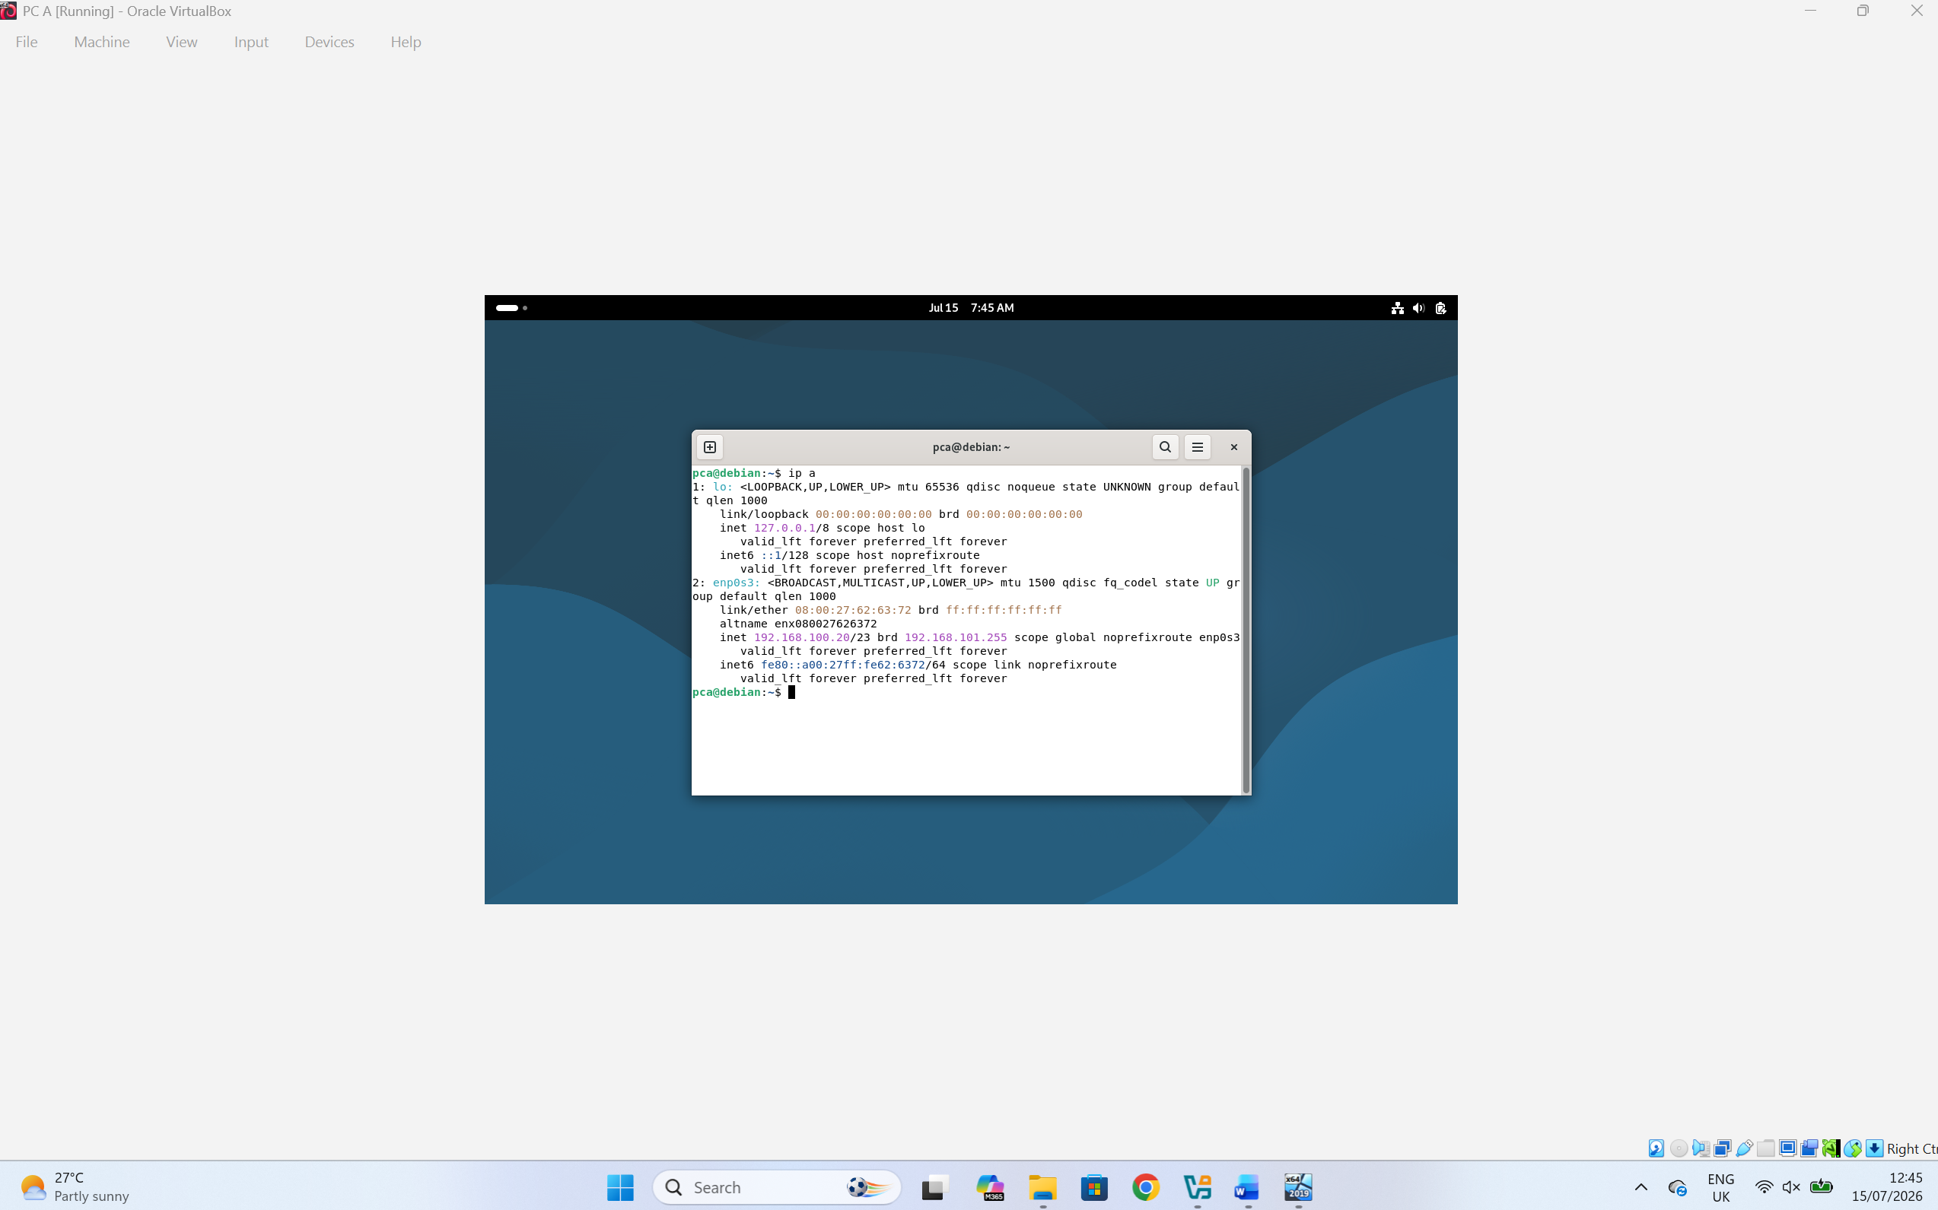
PC A - The >ip a command was used to display the current network configuration. The output confirmed that the IP address and subnet mask matched the values configured during the previous network setup, verifying that the Debian system had been correctly configured.
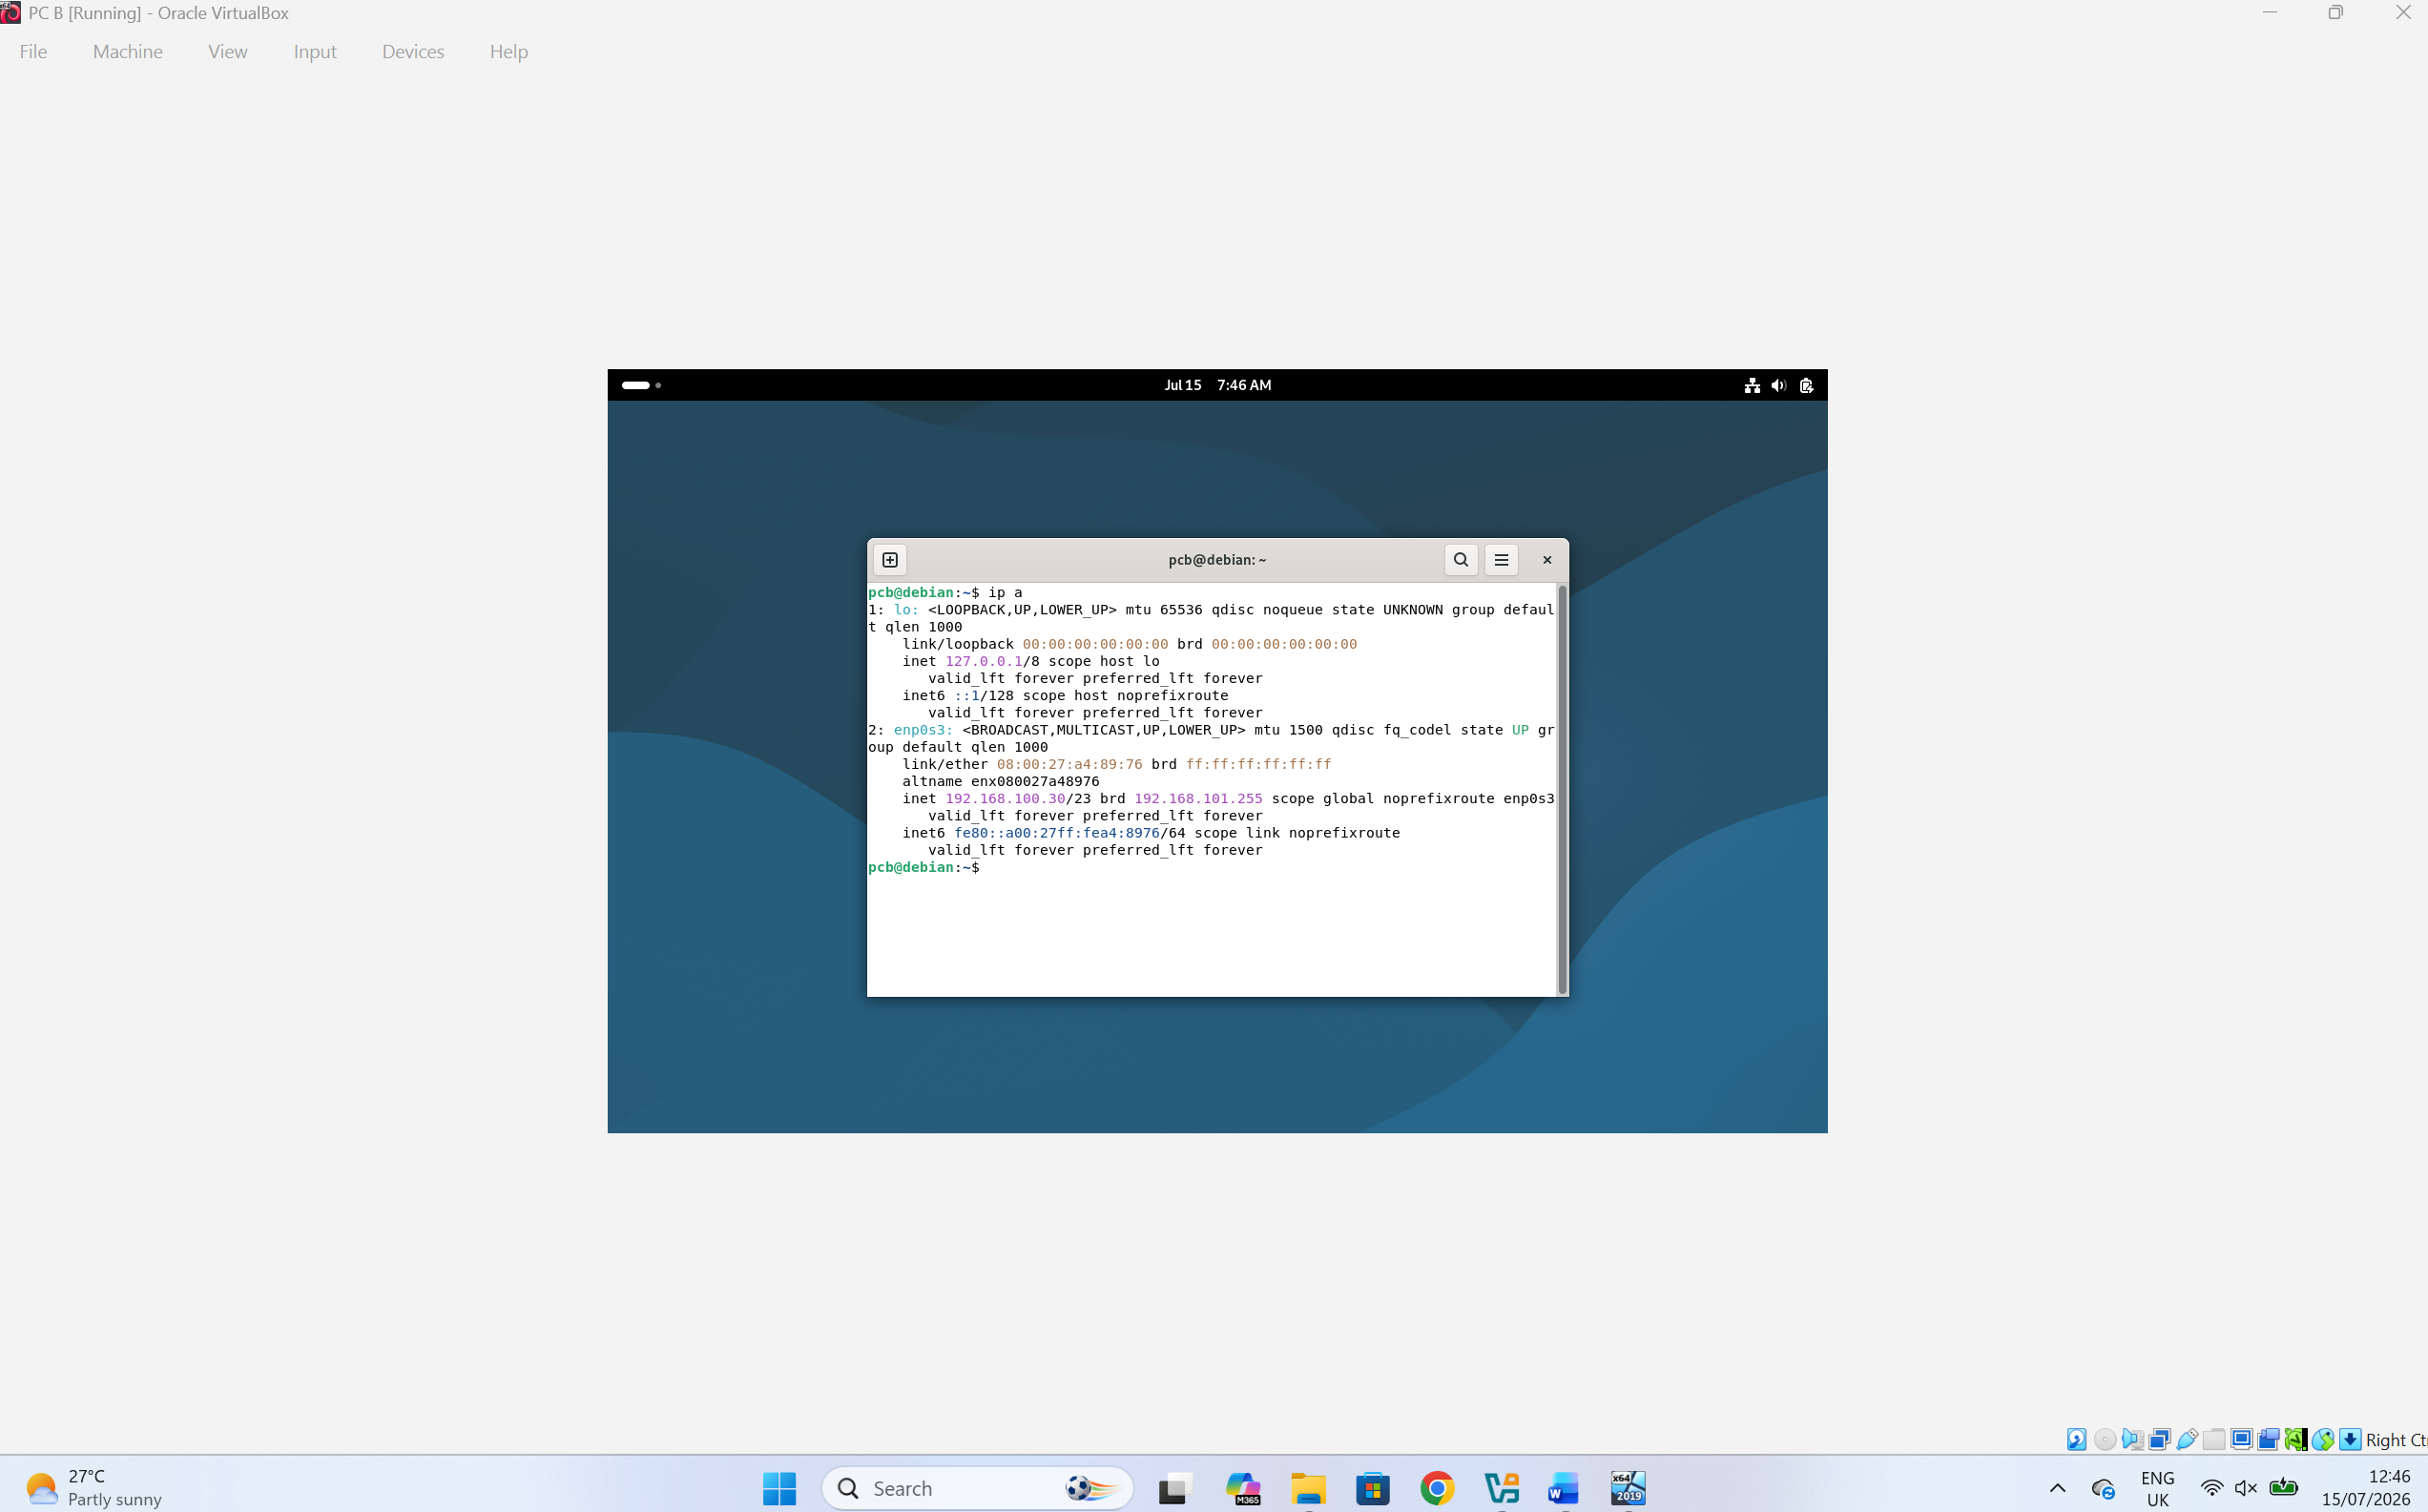
PC B - The >ip a command was used to display the current network configuration. The output confirmed that the IP address and subnet mask matched the values configured during the previous network setup, verifying that the Debian system had been correctly configured.

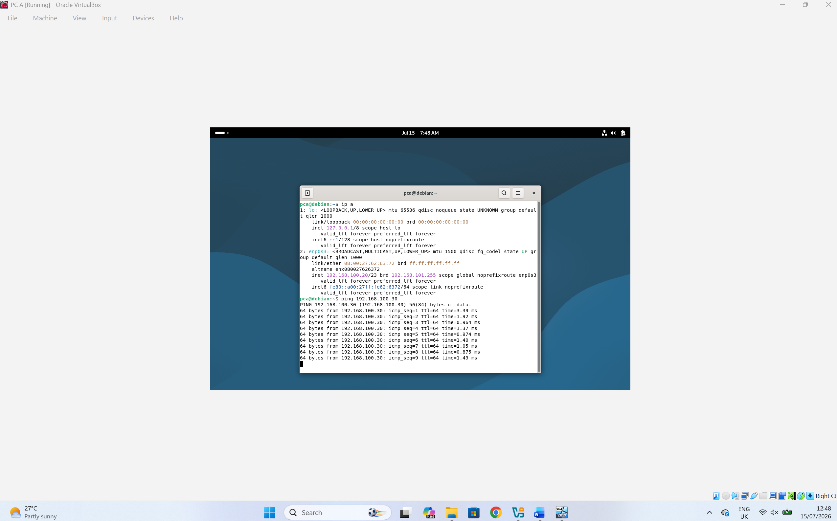
The ping command was used to test connectivity between PC A and PC B. The successful replies confirmed that both devices were able to communicate with each other, indicating that the IP configuration and network connectivity were correctly configured.

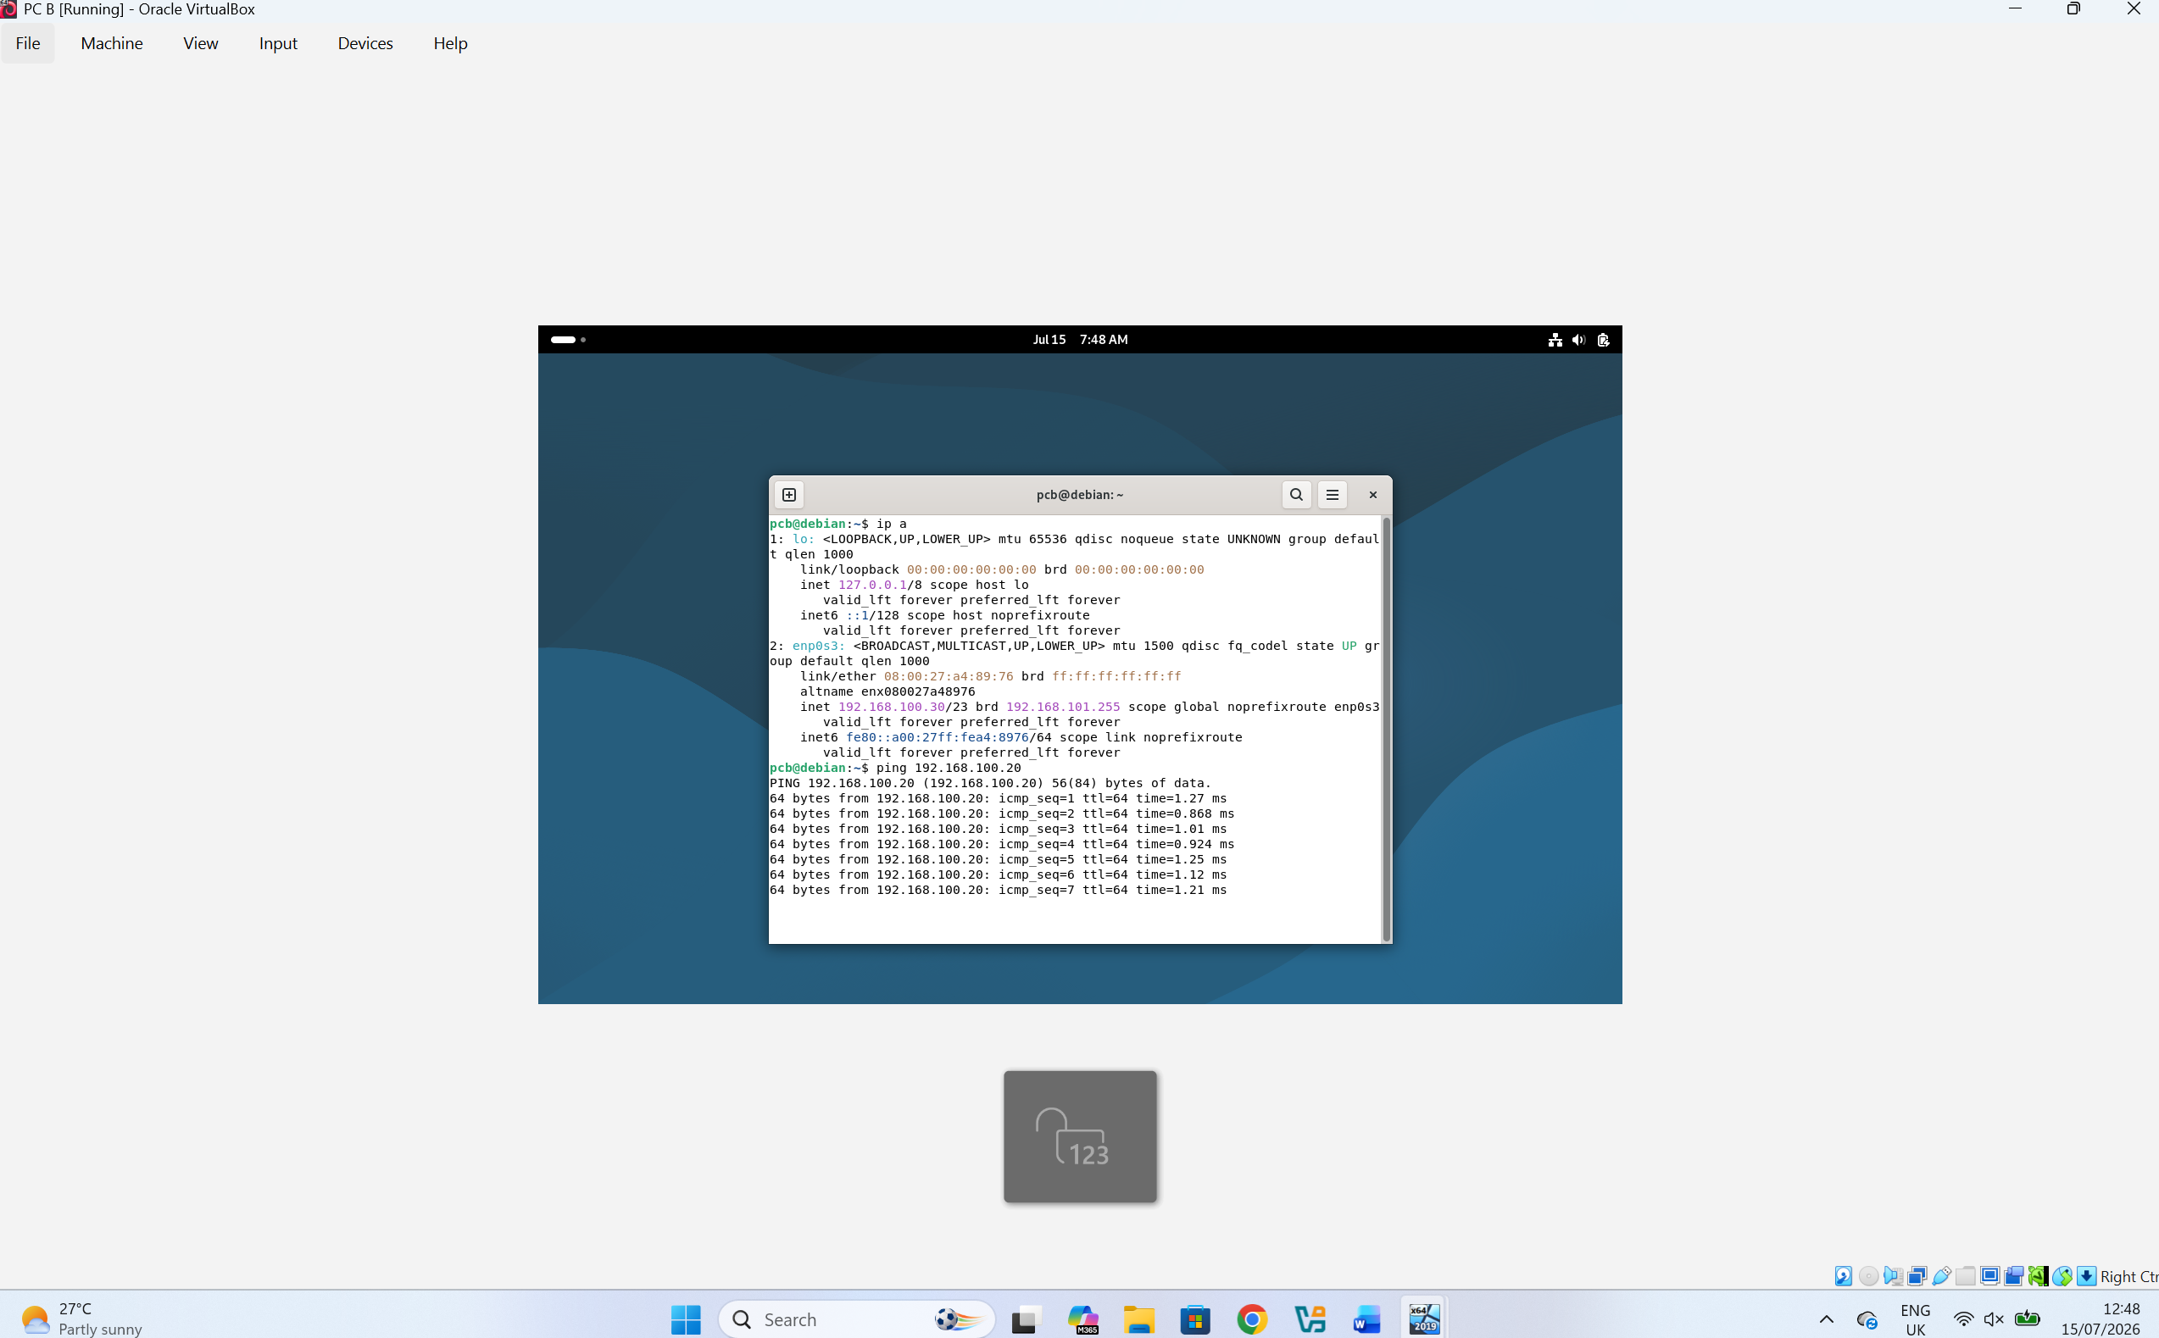
The ping command was used to test connectivity between PC B and PC A. The successful replies confirmed that both devices were able to communicate with each other, indicating that the IP configuration and network connectivity were correctly configured.

2.5. Network Configuration:
To configure the network settings, the Machine menu was selected from the top menu bar, followed by the Settings option. This opened the virtual machine configuration window, where the network adapters could be configured according to the proposed enterprise network topology.

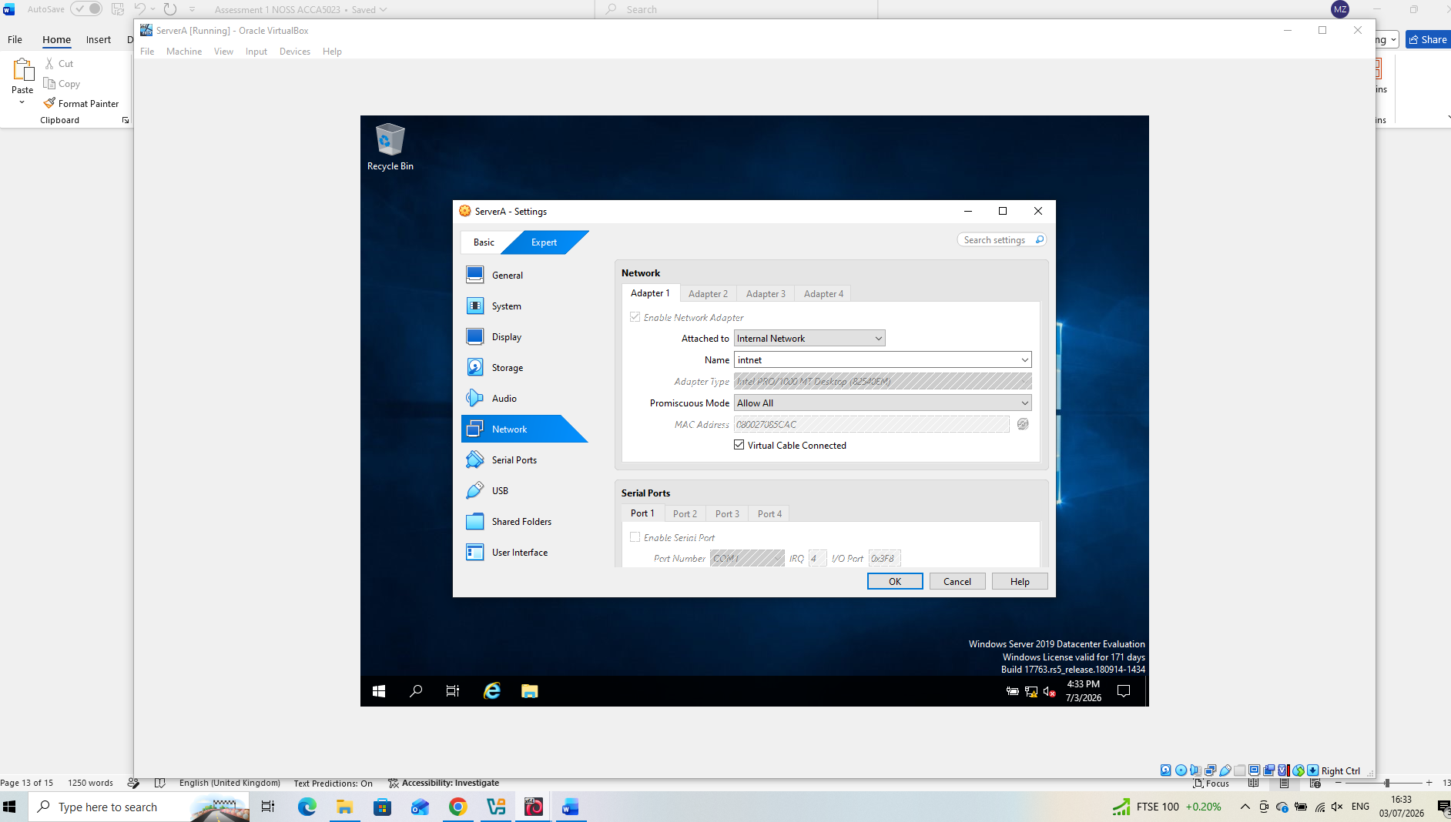
Server A - In the Network tab, Attached to was set to Internal Network, and Promiscuous Mode was configured to Allow All. The configuration was saved by selecting OK, completing the network setup for the virtual machine.

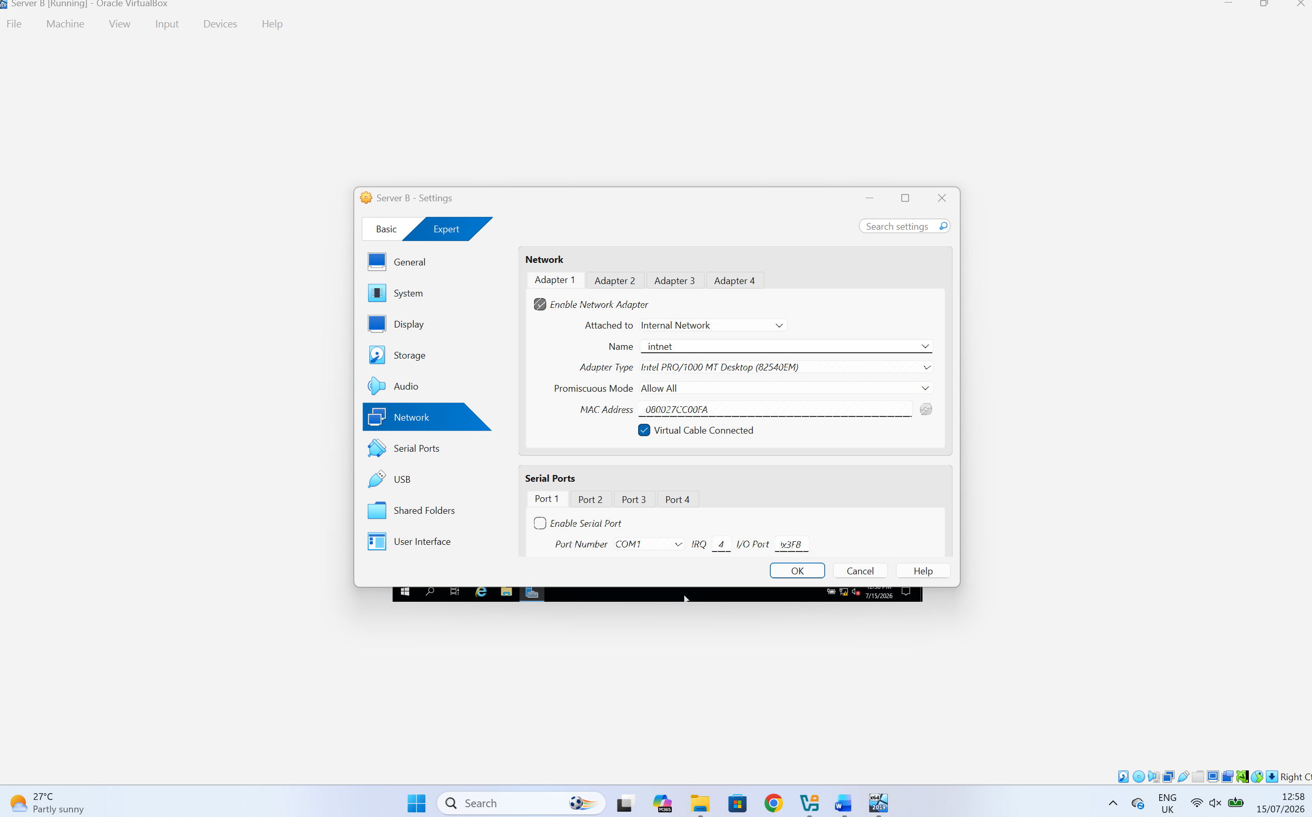
Server B - In the Network tab, Attached to was set to Internal Network, and Promiscuous Mode was configured to Allow All. The configuration was saved by selecting OK, completing the network setup for the virtual machine.

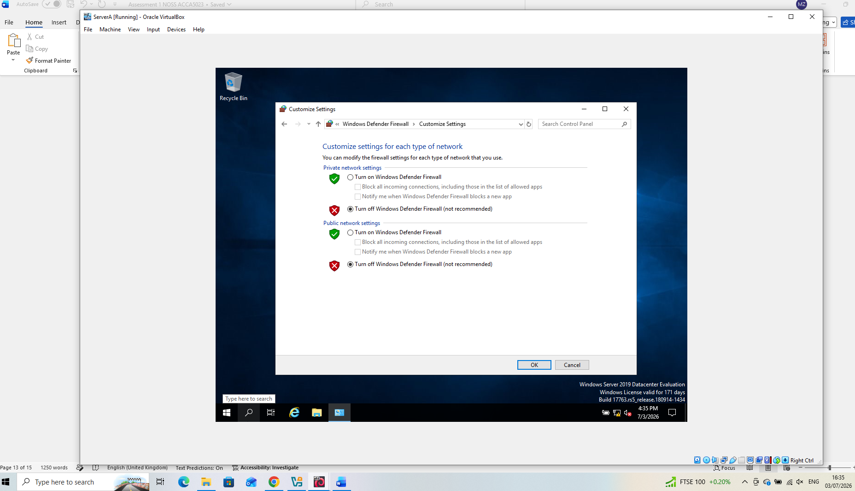
Server A - From the Windows Defender Firewall settings in the Control Panel, the firewall was temporarily disabled for both the Private and Public network profiles. This was done in the isolated virtual lab environment to prevent the firewall from blocking connectivity tests between the virtual machines.

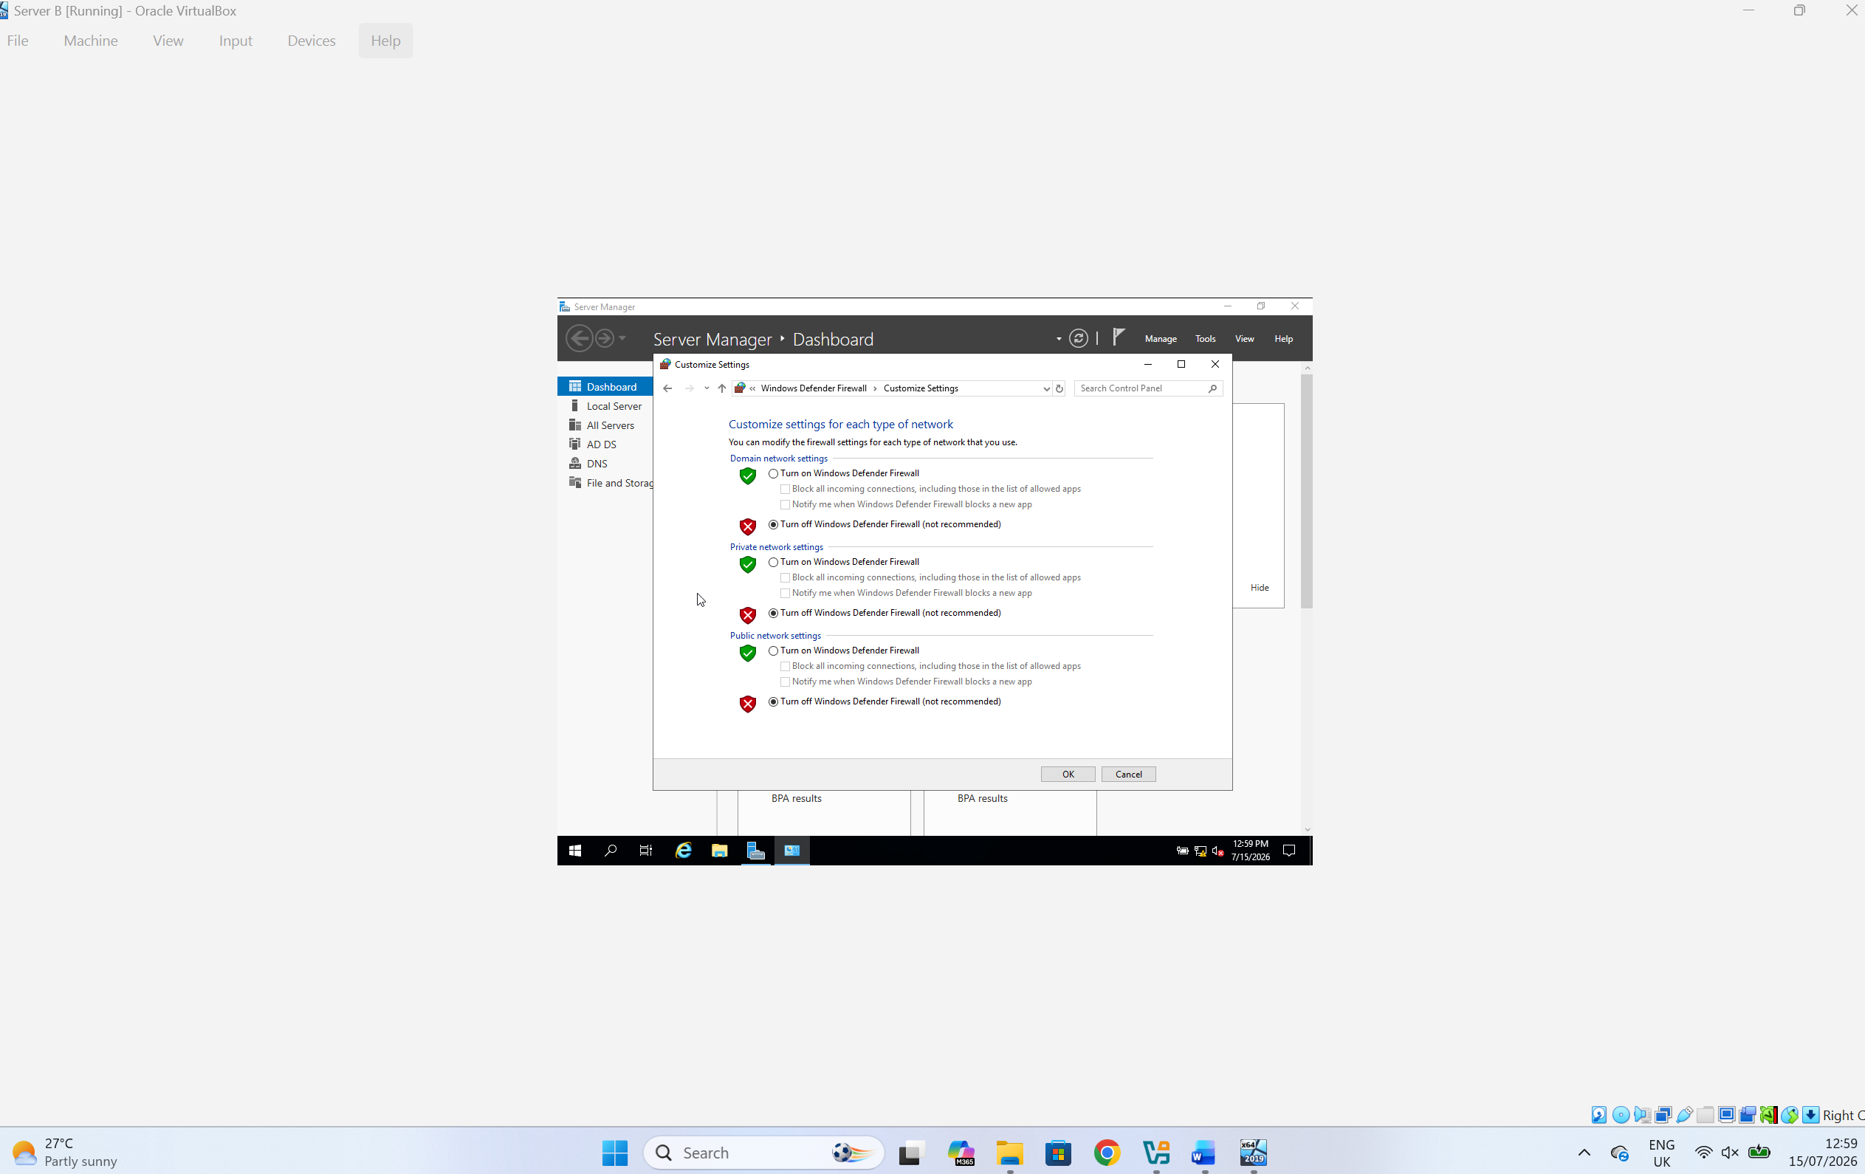
Server B - From the Windows Defender Firewall settings in the Control Panel, the firewall was temporarily disabled for both the Private and Public network profiles. This was done in the isolated virtual lab environment to prevent the firewall from blocking connectivity tests between the virtual machines.

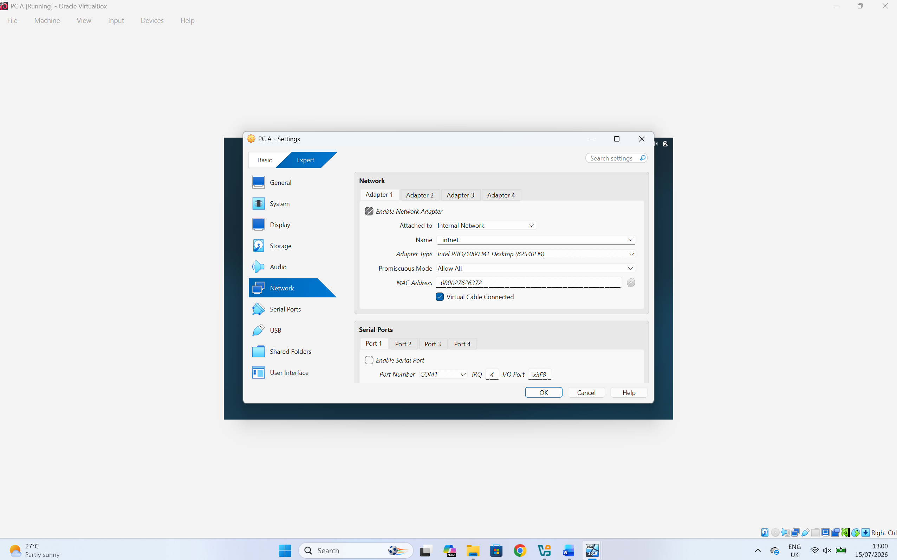
PC A - In the Network tab, Attached to was set to Internal Network, and Promiscuous Mode was configured to Allow All. The configuration was saved by selecting OK, completing the network setup for the virtual machine.

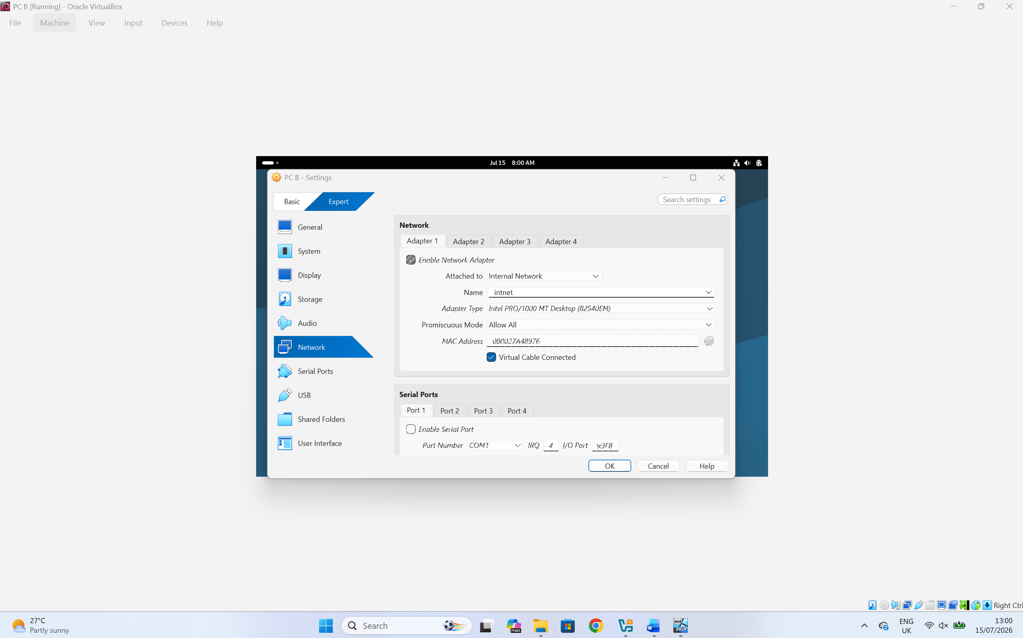
PC B - In the Network tab, Attached to was set to Internal Network, and Promiscuous Mode was configured to Allow All. The configuration was saved by selecting OK, completing the network setup for the virtual machine.

Task 3

3.1. Reflect on the following:
The following reflections evaluate the technical aspects of the network deployment and the knowledge and practical skills developed during the completion of this assessment.

3.1.1. Write a Technical reflection covering network deployment and testing:
The deployment of the virtual enterprise network successfully demonstrated the process of building and testing a heterogeneous network environment using Oracle VirtualBox. Windows Server 2019, Windows 10 and Debian virtual machines were configured according to the proposed network topology. Static IPv4 addressing was implemented to provide consistent network identification and ensure reliable communication between all devices.
Throughout the deployment process, the virtual network adapters were configured using the Internal Network option, allowing secure communication within the isolated virtual environment. The Windows Defender Firewall was temporarily disabled during testing to prevent connectivity issues while verifying the network configuration. Network settings were validated using the ipconfig command on Windows systems and the ip a command on Debian systems. Connectivity testing was then performed using the ping command, which confirmed successful communication between Server A, Server B, PC A and PC B.

3.1.2. Write your Personal Reflection:
This assessment has significantly improved my understanding of enterprise networking and virtualisation technologies. Before completing the practical tasks, I understood the theoretical concepts of IP addressing, routing and network services, but configuring the virtual environment provided valuable practical experience. Building the network from the beginning allowed me to understand how different operating systems communicate within the same enterprise infrastructure.
During the deployment, I developed greater confidence in configuring network adapters, assigning static IP addresses and troubleshooting connectivity problems using diagnostic tools such as ipconfig, ip a and ping. Testing the communication between the virtual machines also reinforced the importance of accurate network planning and systematic verification.
Overall, this project strengthened both my technical knowledge and practical skills in network administration. The experience gained from deploying and testing a virtual enterprise network has prepared me for more advanced networking tasks and will be valuable for future academic projects and professional development within the field of information technology.

Conclusion
This assessment successfully examined the research, deployment and testing of a virtualised enterprise network for the proposed NOSSLONDON2026 environment. The research demonstrated the importance of selecting an appropriate hypervisor, designing an efficient IP addressing scheme, implementing suitable routing methods and integrating essential network services such as Active Directory Domain Services, DHCP, VPN and Certificate Authority services.
The practical deployment confirmed that Oracle VirtualBox provides a suitable platform for creating and managing a virtual enterprise network in an educational environment. Windows Server 2019, Windows 10 and Debian virtual machines were successfully configured using static IPv4 addressing and an isolated internal network. Network connectivity was verified using standard diagnostic tools, confirming successful communication between all configured devices.
Overall, the project demonstrated the importance of careful planning, accurate configuration and systematic testing when deploying enterprise network infrastructures. The knowledge and practical experience gained throughout this assessment have strengthened my understanding of virtualisation technologies, network configuration and troubleshooting, providing a solid foundation for future study and professional practice in network administration and enterprise networking.

References
[1] B. Ðorđević, V. Timčenko, S. Savić and N. Davidović, "Comparing Hypervisor Virtualization Performance with the Example of Citrix Hypervisor (XenServer) and Microsoft Hyper-V," 2020 19th International Symposium INFOTEH-JAHORINA (INFOTEH), East Sarajevo, Bosnia and Herzegovina, 2020, pp. 1-6, doi: 10.1109/INFOTEH48170.2020.9066288. keywords: {Virtual machine monitors;Virtual machining;Virtualization;Hardware;Microsoft Windows;Servers;Microsoft Hyper-V;Citrix XenServer;Windows Server;virtual machine},
[2] S. G. Soriga and M. Barbulescu, "A comparison of the performance and scalability of Xen and KVM hypervisors," 2013 RoEduNet International Conference 12th Edition: Networking in Education and Research, Iasi, Romania, 2013, pp. 1-6, doi: 10.1109/RoEduNet.2013.6714189. keywords: {Virtual machine monitors;Linux;Virtualization;Virtual machining;Kernel;Hardware;Benchmark testing;server virtualization;hypervizor;Xen;KVM;benchmark},
[3] Timothy Rooney, "IP Addressing," in IP Address Management: Principles and Practice , IEEE, 2011, pp.1-2, doi: 10.1002/9780470880654.part1.
[4] G. Dai, "Design and implementation on a things management protocol for internet of things," Proceedings of the 32nd Chinese Control Conference, Xi'an, China, 2013, pp. 7361-7364. keywords: {Protocols;Internet;Bit error rate;Computer architecture;Decoding;Industries;Wireless sensor networks;Internet of Things;Architecture;Protocol;Things Management Protocol},
[5] J. Janitor, F. Jakab and K. Kniewald, "Visual Learning Tools for Teaching/Learning Computer Networks: Cisco Networking Academy and Packet Tracer," 2010 Sixth International Conference on Networking and Services, Cancun, Mexico, 2010, pp. 351-355, doi: 10.1109/ICNS.2010.55. keywords: {Education;Computer networks;Computational modeling;Computer simulation;Electronic mail;Laboratories;Protocols;Application software;Facial animation;Wire;Packet Tracer;Cisco Networking Academy;Visual Learning;Emerging Teaching Methods;Animation;Simulation;Teaching},
[6] C. Wijaya, "Performance Analysis of Dynamic Routing Protocol EIGRP and OSPF in IPv4 and IPv6 Network," 2011 First International Conference on Informatics and Computational Intelligence, Bandung, Indonesia, 2011, pp. 355-360, doi: 10.1109/ICI.2011.64. keywords: {Routing protocols;Routing;Network topology;Logic gates;Measurement;Vectors;routing;ospf;eigrp;dynamic routing protocol;ipv4;ipv6;cisco;network routing}
[7] Jordan Krause, Mastering Windows Server 2019: The complete guide for system administrators to install, manage, and deploy new capabilities with Windows Server 2019 , Packt Publishing, 2021.
[8] H. -h. E, M. -n. Song, J. -d. Song, Y. Li and Z. -j. Ren, "The Research of Service Network Based on Complex Network," 2010 International Conference on Service Sciences, Hangzhou, China, 2010, pp. 203-207, doi: 10.1109/ICSS.2010.41. keywords: {Complex networks;Ecosystems;Application software;Computer networks;Web services;Distributed computing;Computer science;Telecommunication computing;Network topology;Quality management;service network;complex network;service composition;network clustering;service engineering},

