University of Wales Trinity Saint David
School of Engineering
Designing a race car rear wing: Structural Design
Viktoria Berces
1908705
BEng (Hons) Mechanical and manufacturing Engineering
15/10/2023
Structural & Fluid Analysis
ACMA 6010

Table of Contents

1. Introduction 3
2. Finite element analysis 4
3. CFRP rear wing model 6
4. Optimization of CFRP rear wing model 10
5. The simulation and experimental results 13
6. Related Formula 1 standards and regulations 15
7. Conclusion 16
8. Appendices 17
Appendix A 17
Appendix B 18
Appendix C 19
List of figures 20
References 21

Introduction

The objective of this thesis is to provide an exposition on Finite Element Analysis (FEA) and discuss its potential future advancements. Moreover, it aims to develop a model structure for a Carbon Fiber Reinforced Polymer (CFRP) rear wing and optimize it based on the determined force, ensuring the minimal mass and meeting the displacement requirements, while considering the constraints of production. Additionally, the proposed procedure for conducting the simulation and experiment on the rear wing, along with the analysis of the resultant data, will be discussed.

Finite element analysis

The purpose of finite element analysis is to numerically solve complicated and complex differential equations that cannot be solved analytically. During finite element analysis, the complex space will be broken down into small elements, which can be expressed with simple equations. By applying this technique, it is possible to predict how the analysed object behaves within the predefined criteria. Its application is now widespread.

As Liu et al (2022) notes the history of finite element analysis can be traced back to the 1940s and is attributed to engineer Hrennikof. His work "Solution of problems of elasticity by the framework method" was published in the Journal of Applied Mechanics, in which he split the domain into a mesh. This can be considered the birth of finite element analysis; it revolutionized the way engineers approach and solve complex structural and mechanical problems.

In the 1950s, engineers developed the early finite element analysis theories to solve real-world problems. Also in these years, the so-called Matrix Stiffness Method was developed, which is the earliest form of today's infinite element method.
The best-known pioneers include Clough, Argyris, Zienkiewicz, Irons, Gallager, among others.

Therefore, finite element analysis plays an important role in advanced engineering and continues to develop today.
As IEEE Innovation at work (2023) states, one of the biggest advantages of finite element analysis is that it allows the use of complex geometry forms. This is essential when dealing with real-world engineering problems, such as the design of aircraft components, medical devices or architectural structures. Real-world scenarios can be replicated by applying different boundary conditions.
Its flexibility makes it possible to produce fewer physical prototypes, which reduces the material and time required for the prototype, thus the costs incurred during the design.
It predicts with a high degree of accuracy how certain materials and structures will react to different loads and conditions.
In addition, it is well suited for time-dependent simulations, for example how the structure of the car deforms during a collision.
Finite element analysis visualizes the various parameters specified during the analysis (displacement, strain etc) and how they change. In this way, the behaviour and deformation of the material and structure can be better understood, and possible weaknesses that can lead to failure can be more easily identified.

As Structural Numerical Research Center (2023) notes, by combining finite element analysis with artificial intelligence (AI) and machine learning (ML), accuracy and efficiency can be increased even more. Since AI and ML can learn from previous simulations, it can automate mesh generation by learning from previous failures. As a result, the results will be even more accurate, and the simulation preparation time can be reduced.
So-called surrogate modelling, these are machine learning models that can predict the behaviour of the structure without performing a full FEA simulation.
Once trained, the surrogate model can make predictions for new input parameter sets without the need for running time-consuming FEA simulations.

Cloud computing is also becoming more and more common, the advantage of which is that it can be accessed from anywhere in the world with an Internet connection, so it is possible to collaborate in real time. Multiple users can work on the same simulation, and it is also possible to share data and feedback.
In summary, the future of FEA lies in its integration with emerging technologies such as AI and ML. Its use will continue to be fundamental to engineers in various industries, helping them design, analyse and optimize products and systems more efficiently and effectively.

CFRP rear wing model

The model used for the simulation with the design studio was the previously specified steel base rear wing model.
The model used has a uniformly distributed load, so the force applied to the wing is evenly distributed on its surface and has a constant intensity. The load in this case is 5263 N, each grid of the model received a load of 1 Newton.

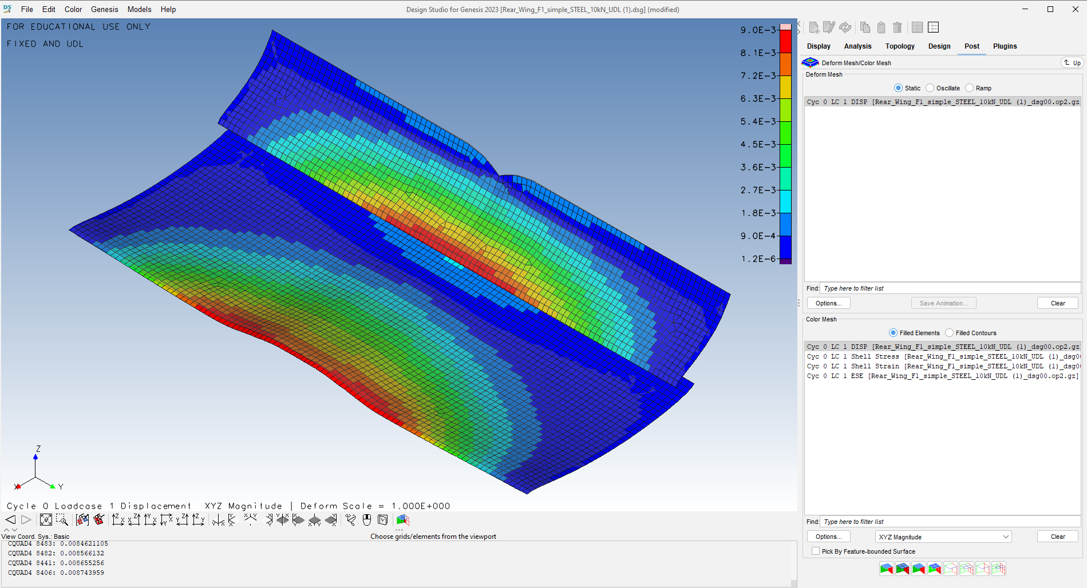
Figure 1 - Steel base structure displacement

The analysis has determined that the displacement of the steel-based wing is 9 mm, this result means that, under the applied load conditions, the wing has deflected by 9 millimetres from its original position as it shown in Figure 1 – Steel base structure displacement. Also, the weight of the steel structure is 7.53 kg.
The following parameters were used during the preparation of the unidirectional CFRP model.

Young's Modulus in the longitudinal direction (E_1): 132 GPa
Young's Modulus in the lateral direction (E_2): 10.8 GPa
Poisson's Ratio (Nu_12): 0.24
Inplane Shear Modulus (G_12): 5.65 GPa
Transverse Shear Modulus (1-Z plane) (G_1z): 5.65 GPa
Transverse Shear Modulus (2-Z plane) (G_2z): 5.65 GPa
Mass Density (Rho): 1540 kg/m3
Allowable longitudinal stress in tension (Xt): 1513 MPa
Allowable longitudinal stress in compression (Xc): 1000 MPa
Allowable transverse stress in tension (Yt): 43.4 MPa
Allowable transverse stress in compression (Yc): 43.4 MPa
Allowable in-plane shear stress (S): 43.4 MPa

Furthermore, the model consists of 5 layers, and each layer contains 5 plies, the thickness of which is 0.1 mm.
The orientation of the fibres in each layer of the composite as follows:

First Layer: Fibers oriented at -90°
Second Layer: Fibers oriented at -45°
Third Layer: Fibers oriented at 0°
Fourth Layer: Fibers oriented at 45°
Fifth Layer: Fibers oriented at 90°

The arrangement of the layers in this way and 5 plies per layer resulted in a reduction in weight, but an increase in displacement, as shown in Figure 2 – CFRP base structure displacement - below.

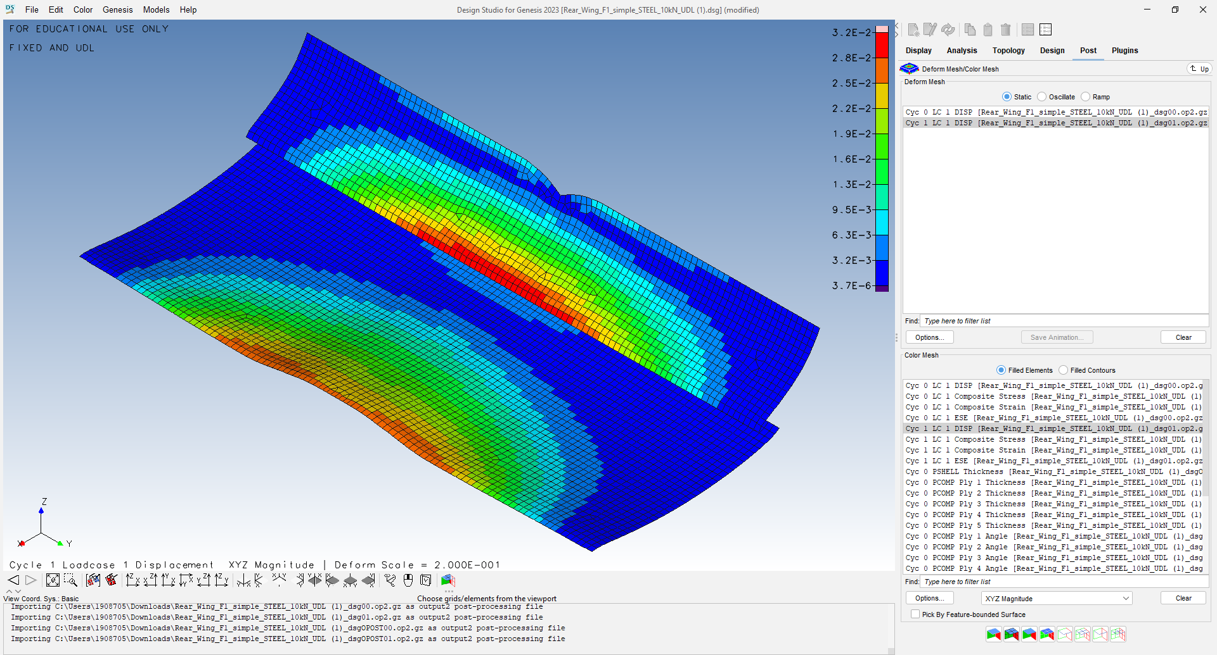
Figure 2 - CFRP base structure displacement

The rear wing's displacement measured 32 mm; a magnitude significantly larger than the displacement of a steel-based wing.
However, the mass decreased from 7.53 kg to 1.88 kg.
The goal was optimizing the model with the objective of minimizing mass while satisfying displacement constraints problem. The aim was to minimize the mass of the CFRP model while ensuring that the maximum displacement does not exceed 9 mm.

Due to noncompliance of the model with the prescribed displacement limits, it was necessary to modify the plies, thereby enabling a deviation from the requirement of strictly adhering to 5 plies within a single layer.
The model defined in this way is shown in Figure 3 – Optimised CFRP structure, uniformly distributed load - below. It can be stated that the displacement has decreased to 8.5 mm, which already meets the displacement regulations. Furthermore, there was an increase in the mass of the wing, reaching 3.24 kg, due to alterations in the number of plies per layer.

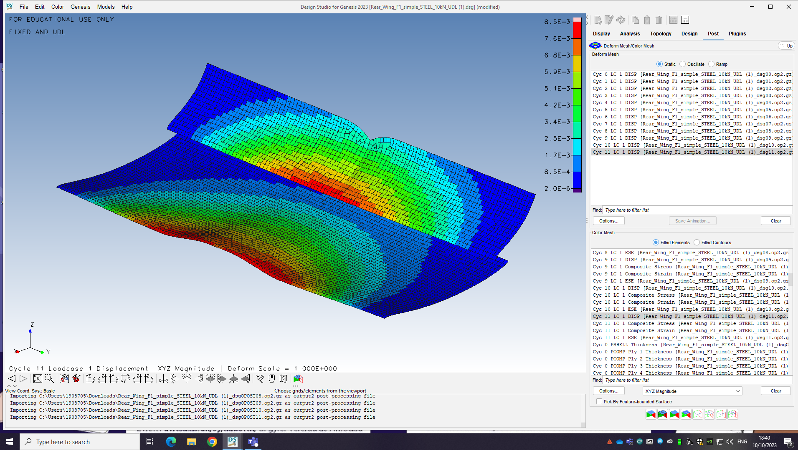
Figure 3 - Optimised CFRP structure, uniformly distributed load

In the case of determining the ply, it was important to set discrete data because the production processes can only produce entire plies, so partial or fractional plies cannot be manufactured.

Optimization of CFRP rear wing model

Glenn research Center (2023) notes, downforce is created as a result of Newton's third law, which states that for every action there is an equal and opposite reaction. In the case of a racing car, it directs the air upwards as it moves forward. According to Newton's third law, the air exerts a downward force on the car as a counter force.

As Racecar engineering (2023) states when designing the rear wing of a racing car, consideration of aerodynamics is crucial. The shape and design of the wing is important as it helps create a pressure difference between the upper and lower surfaces of the wing. This pressure difference causes the air to move from the high pressure area (the top of the aerofoil) to the lower pressure area. This airflow generates downforce, which increases the car's traction and stability, especially at high speeds and when cornering. A well-designed rear wing can significantly improve the performance and handling of a racing car.

According to Szczygieł (2022), the Formula 1 regulations stipulate that the rear wing must resist a horizontal force of 500 N, and the displacement of the wing must not exceed 7 mm.
Based on this, the objective, constraint, and design variations elements were defined.
The objective was still to achieve the smallest mass, while the limit became the maximum displacement of 7 mm. Changing the number of plies per layer made it possible to achieve better optimization results.
The air flow passes through the gap between the two aerofoils, which improves downforce. Turbulence will arise behind the rear wing. The upper surface of the rear wing is under high pressure, while the airflow on the lower surface of the wing accelerates and the pressure decreases. All this causes a suction effect on the lower side of the wing, which increases the high pressure on the upper part of the wing, and this generates the downforce.
Based on the aforementioned observations, it was assumed that the force would not be distributed in a straight proportion and with the same intensity on the rear wing, i.e., it would not be a uniformly distributed load.
The load would primarily affect the front part of the upper surface of the two aerofoils.
Based on the above findings, the model shown in Figure 4 – Optimised CFRP structure, 500 N load - below was determined.
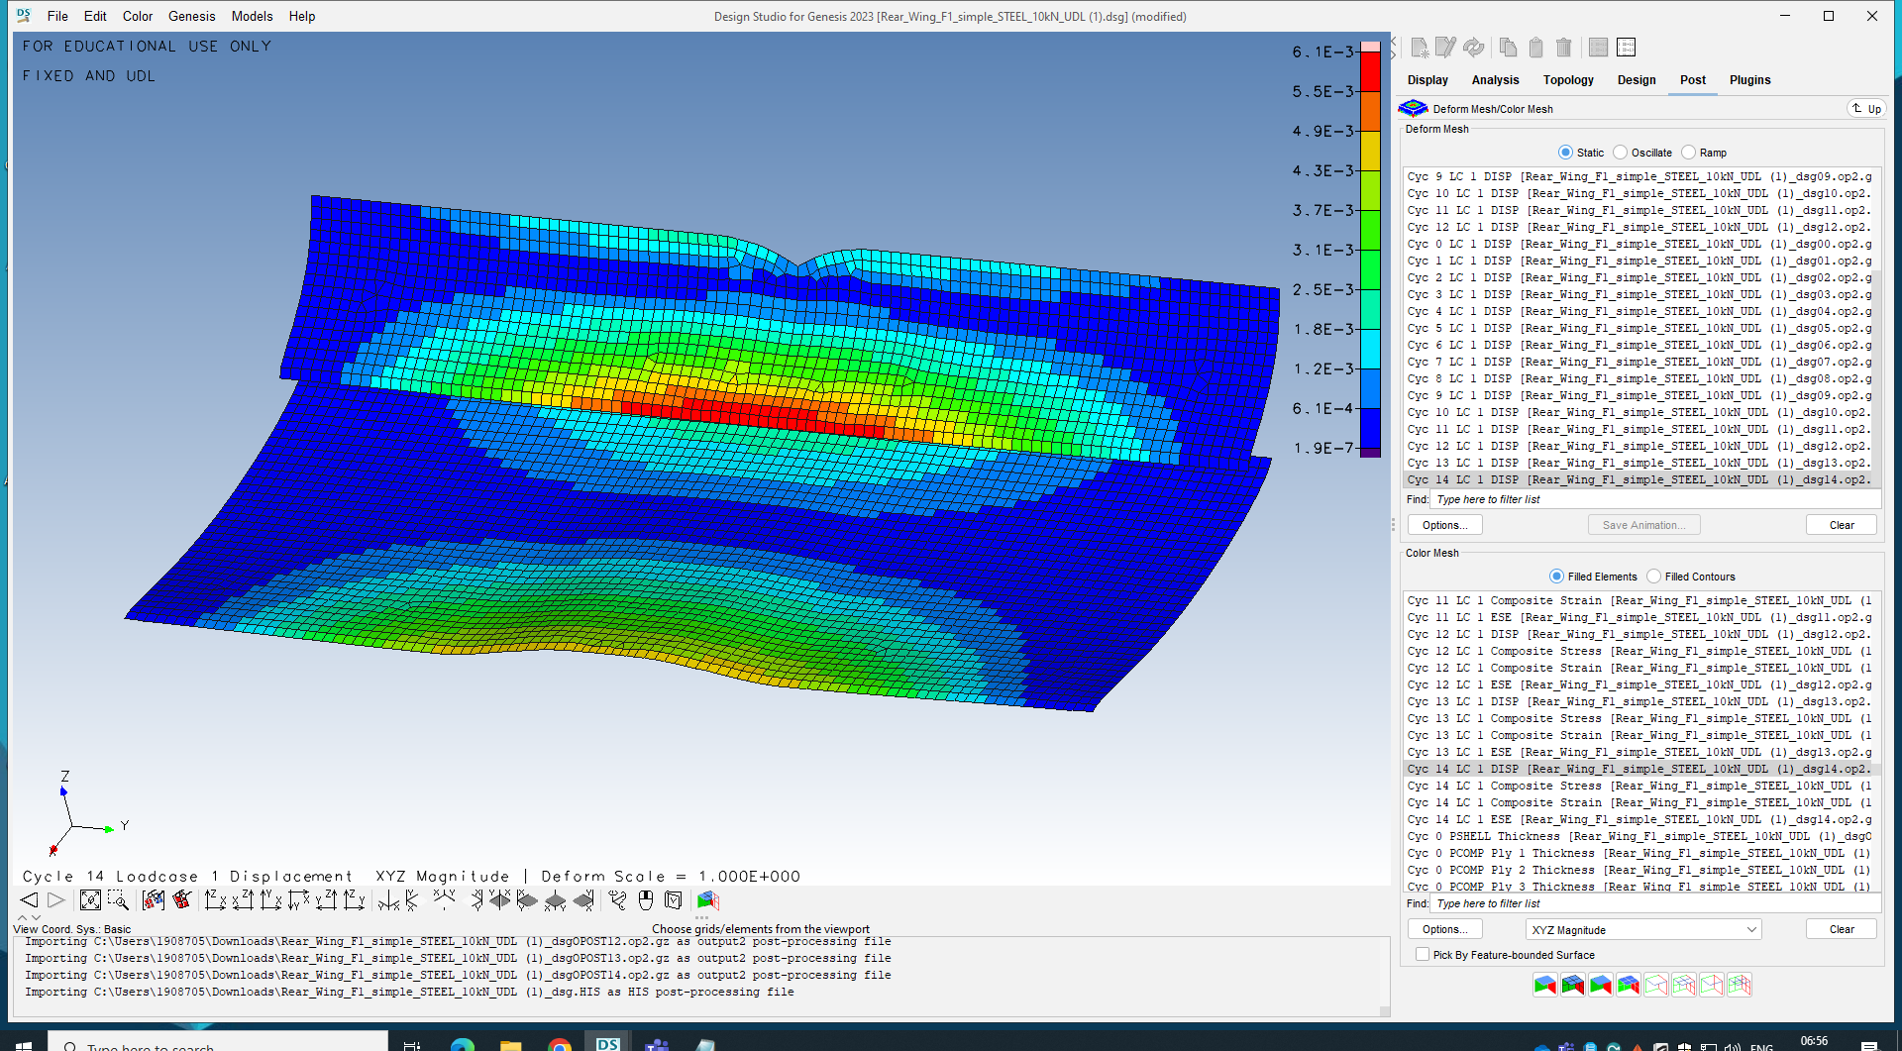
Figure 4 - Optimised CFRP structure, 500 N load

In accordance with the model's design, the stipulated force of 500 N was concentrated within the previously mentioned region which resulted in a displacement of 6.1 mm (Appendix A – Figure 6 - Optimised CFRP structure, 500 N load share). Consequently, the smallest weight attained was 2.48 kg. The weight and displacement of the rear wing also experienced changes by modifying the number of plies per layer.
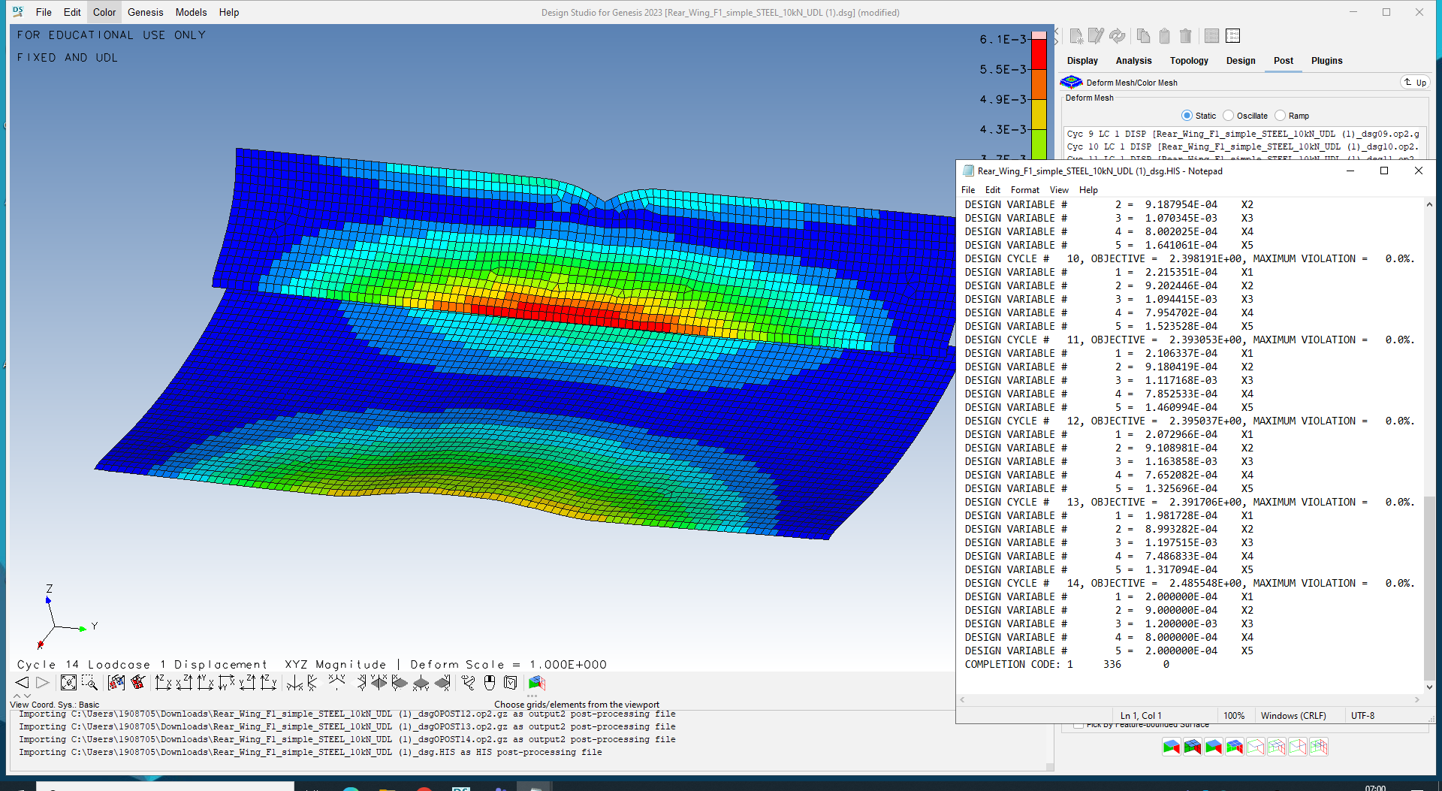
Figure 5 - Optimised CFRP structure, 500 N load - HIS

From Figure 5 – Optimised CFRP structure, 500 N - HIS, it was evident that the first layer positioned at -90 degrees consisted of 2 plies. Similarly, the second layer at -45 degrees comprised 9 plies. The third layer, located at 0 degrees, was composed of 12 plies. The fourth layer at +45 degrees consisted of 8 plies, and the fifth layer at +90 degrees had 2 plies.
14 cycles were required to achieve the optimal result. Figure 7 in Appendix B shows how the objective, i.e., the mass and the maximum constraint violation changed during the 14 cycles.

The simulation and experimental results

During the development of the rear wing, it is important to understand how it behaves under the specified conditions. The Formula 1 rear wing is exposed to particularly high stress, in order to accurately understand the behaviour, it is necessary to create and test a prototype. Simulations and models help to understand the behaviour of the rear wing but cannot fully replicate the complex interactions that take place during the actual, real-world process.
The simulation results can be validated by creating a physical prototype. Understanding the results can provide an opportunity to make improvements.

The utilization of a wind tunnel serves as the most appropriate approach for conducting experiments on the model. To effectively assess this, it is recommended to employ a scaled down version of the original model at a 60% reduction.
When making a prototype, it is important that it resembles the wing as closely as possible. The majority of 60% scale Formula 1 models typically comprise of 3D printed components attached to an aluminium framework, whereas the genuine model is made from carbon fibres. All possible factors affecting the wing's behaviour must be considered.

Opting for a closed system wind tunnel is the most favourable choice as it sustains the usage of the same air, thereby preserving its kinetic energy and necessitating less energy for operation.
However, a potential drawback arises from the recirculation of the same air within the system, which may result in an increase in temperature due to friction with the walls. Consequently, the air experiences a reduction in density, potentially impacting the Reynolds number.
When utilizing a scale model, it is crucial to carefully adjust the Reynolds number, as the transition from laminar to turbulent flow in the scale model occurs in a more remote region compared to the full-scale model.
For testing a Formula 1 car in a wind tunnel, the most suitable technique involves utilizing a moving belt, commonly referred to as a "moving belt method," where the belt moves at the identical speed as the air.
In real-world scenarios, there is no boundary layer when a vehicle is in motion on the road. Therefore, it is necessary to eliminate the boundary layer during wind tunnel testing to obtain accurate results.
If the air, which moves more slowly, is sucked in at the right speed before it reaches the belt, then the boundary layer can be eliminated.
As Byjjn (2019) states that, during the wind tunnel experiment, surface pressure sensors are placed on the model, which are located exactly where they would be located on the car, and the results obtained in this way can be compared with those obtained during CFD. Pressure tapping is a small hole on the surface that is connected to the pressure transducer by a plastic tube.
Ludis Analytics (2023) also notes that one of the bases of data collection is the visualization of air flow. One of these techniques can be the use of the aforementioned pressure sensors, as well as the use of smoke or flow visualization paint.
The collected data is then analysed using advanced software and computational models.
As soon as the data collected by the scale model is verified, the full scale model can be manufactured using the verified design to perform track based testing.

Related Formula 1 standards and regulations

The rules for Formula 1 races and the technical regulations for racing cars are defined by the governing body, the Federation Internationale de I'Automobile, (FIA).
The FIA aims to ensure safe racing and to create regulations that ensure the safety of competitors, all within the framework of fair racing.
The technical regulations for the rear wing include its dimensions and shape. To ensure fairness, the FIA sets limits on the maximum width, height, and chord length of the rear wing. It also specifies the allowable angle of attack. These regulations aim to strike a balance between downforce and drag, enabling teams to discover the ideal configuration for achieving speed and stability.
The FIA ensures compliance with the rules through regular inspections and regularly reviews and updates the rules to allow teams to develop, both in terms of design and performance.

Conclusion

In summary, this thesis focused on developing a model for a Carbon Fiber Reinforced Polymer (CFRP) rear wing and optimizing it to meet force, mass, and displacement requirements while considering production constraints.
It was determined during optimization, that altering the number of plies per layer of CFRP leads to variations in displacement and mass. Additionally, the displacement is influenced by the pressure distribution on the rear wing.
The thesis also discussed the proposed procedure for simulating and experimenting on the rear wing, as well as analysed the resulting data and it established that is crucial to conduct model testing and compare the simulation outcomes to facilitate the model's further advancement.

Appendices

Appendix A

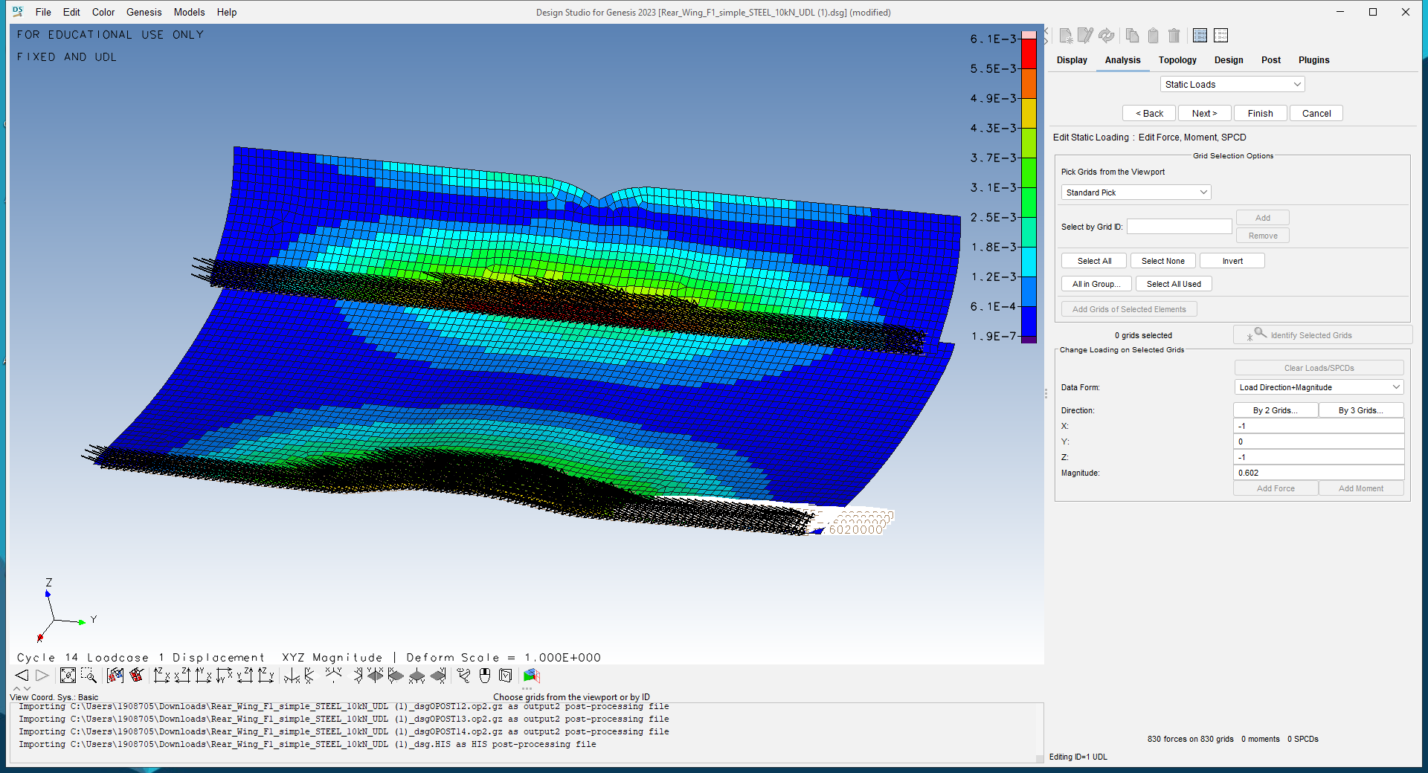
Figure 6 - Optimised CFRP structure, 500 N load share

Appendix B

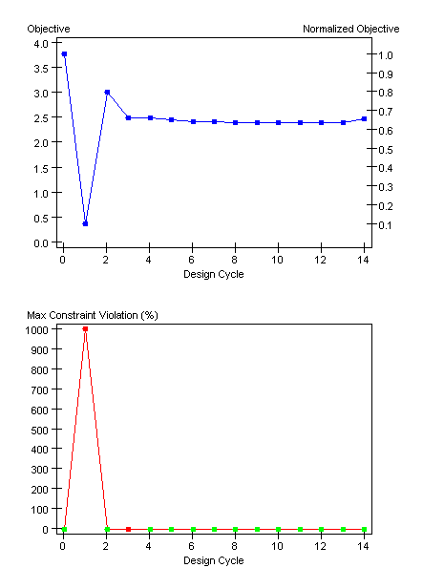
Figure 7 - Optimised CFRP structure, 500 N load- design history

Appendix C

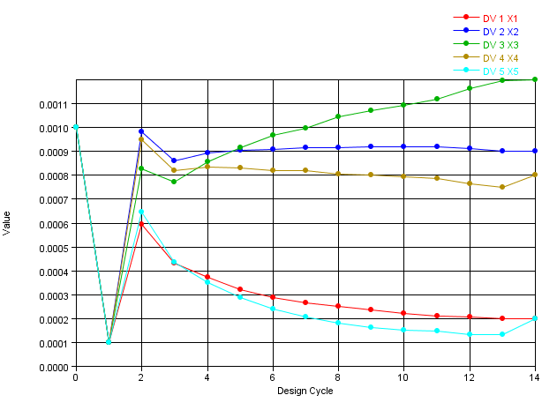
Figure 8 - Optimised CFRP structure, 500 N load - layer thickness

List of figures

Figure 1 - Steel base structure displacement 6
Figure 2 - CFRP base structure displacement 8
Figure 3 - Optimised CFRP structure, uniformly distributed load 9
Figure 4 - Optimised CFRP structure, 500 N load 11
Figure 5 - Optimised CFRP structure, 500 N load - HIS 12
Figure 6 - Optimised CFRP structure, 500 N load share 17
Figure 7 - Optimised CFRP structure, 500 N load- design history 18
Figure 8 - Optimised CFRP structure, 500 N load - layer thickness 19

References

- Abdullah, S. et al. (2008) ‘A review of Finite Element Analysis Approaches in Durability Assessment of Automotive Components’, Journal of Applied Sciences 8 (12), pp.2192-2201. Available at: https://www.researchgate.net/profile/Prof-Dr-Md-Mustafizur-Rahman/publication/46029315_A_Review_on_Finite_Element_Analysis_Approaches_in_Durability_Assessment_of_Automotive_Components/links/0912f50a9ebfb9a03a000000/A-Review-on-Finite-Element-Analysis-Approaches-in-Durability-Assessment-of-Automotive-Components.pdf (Accessed: 22/08/2023)
- FEA (2023) Academy History of Finite Element Method. Available at: https://www.fea-academy.com/index.php/component/content/article/27-blog/fea-generalities/73-fem-history?Itemid=101 (Accessed: 30/09/2023)
- Byjjn and Vyssion (2019) Measuring aerodynamics at the track. Available at: https://www.f1technical.net/features/21963 (Accessed: 14/10/2023)
- Glenn Research Center (2023) Newton’s laws of motion. Available at: https://www1.grc.nasa.gov/beginners-guide-to-aeronautics/newtons-laws-of-motion/ (Accessed: 08/10/2023)
- Hutton, D. V. (2004) Fundamentals of finite element analysis. 1st edn. New York: McGraw-Hill
- IEEE Innovation at work (2023) Advantages of the Finite Element Method. Available at: https://innovationatwork.ieee.org/the-advantages-of-fem/ (Accessed: 30/09/2023)
- Ivan A, et al. (2012) Finite Element Analysis Applications in Failure Analysis: Case Studies. Finite Element Analysis - Applications in Mechanical Engineering. InTech. DOI: 10.5772/51024
- Liu, W. K., Li, S. and Park, H. S. (2022) Eighty Years of the Finite Element Method: Birth, Evolution, and Future. Available at: https://link.springer.com/article/10.1007/s11831-022-09740-9 (Accessed: 30/09/2023)
- Ludis Analytics (2023) Slicing the Wind: Deciphering the Role of Aerodynamics in Formula 1. Available at: https://www.linkedin.com/pulse/slicing-wind-deciphering-role-aerodynamics-formula-1-ludisanalytics/ (Accessed: 14/10/2023)
- Noble, J. (2020) FIA assessing F1 rear wing flexibility test changes. Available at: https://www.autosport.com/f1/news/fia-assessing-f1-rear-wing-flexibility-test-changes-4981060/4981060/ (Accessed: 08/10/2023)
- Racecar engineering (2023) Diffusers. Available at: https://racecar-engineering.telegraph.co.uk/tech-explained/diffusers-engineering-basics-aerodynamics/ (Accessed: 08/10/2023)
- Structural Numerical Research Center (2023) Future of Finite Element Analysis. Available at: https://numericalarchive.com/2023/03/30/future-of-finite-element-analysis/#:~:text=In%20FEA%2C%20AI%20and%20ML,and%20cost%20required%20for%20simulations. (Accessed: 30/09/2023)
- Szczygieł, Sz. (2022) Design and strength analysis of the rear wing of a Formula 1 car. Available at: https://www.linkedin.com/pulse/design-strength-analysis-rear-wing-formula-1-car-szymon-szczygie%C5%82/ (Accessed: 08/10/2023)

