Kristian Crawford

1919795

Digital Degree Apprenticeship

Changemakers: Creativity and Value Creation

ACCA5033

24th June 2023

Table Of Contents

Front Cover Page 1

Table of Contents Page 2

Web Site Address Page 3

Web Site Screenshots Page 3 – 5

Participation Evidence Page 6 – 12

Participation Screenshots Page 13 – 15

Web site address :
https://tion267.wixsite.com/myportfolio

Web Site Screen Shots:

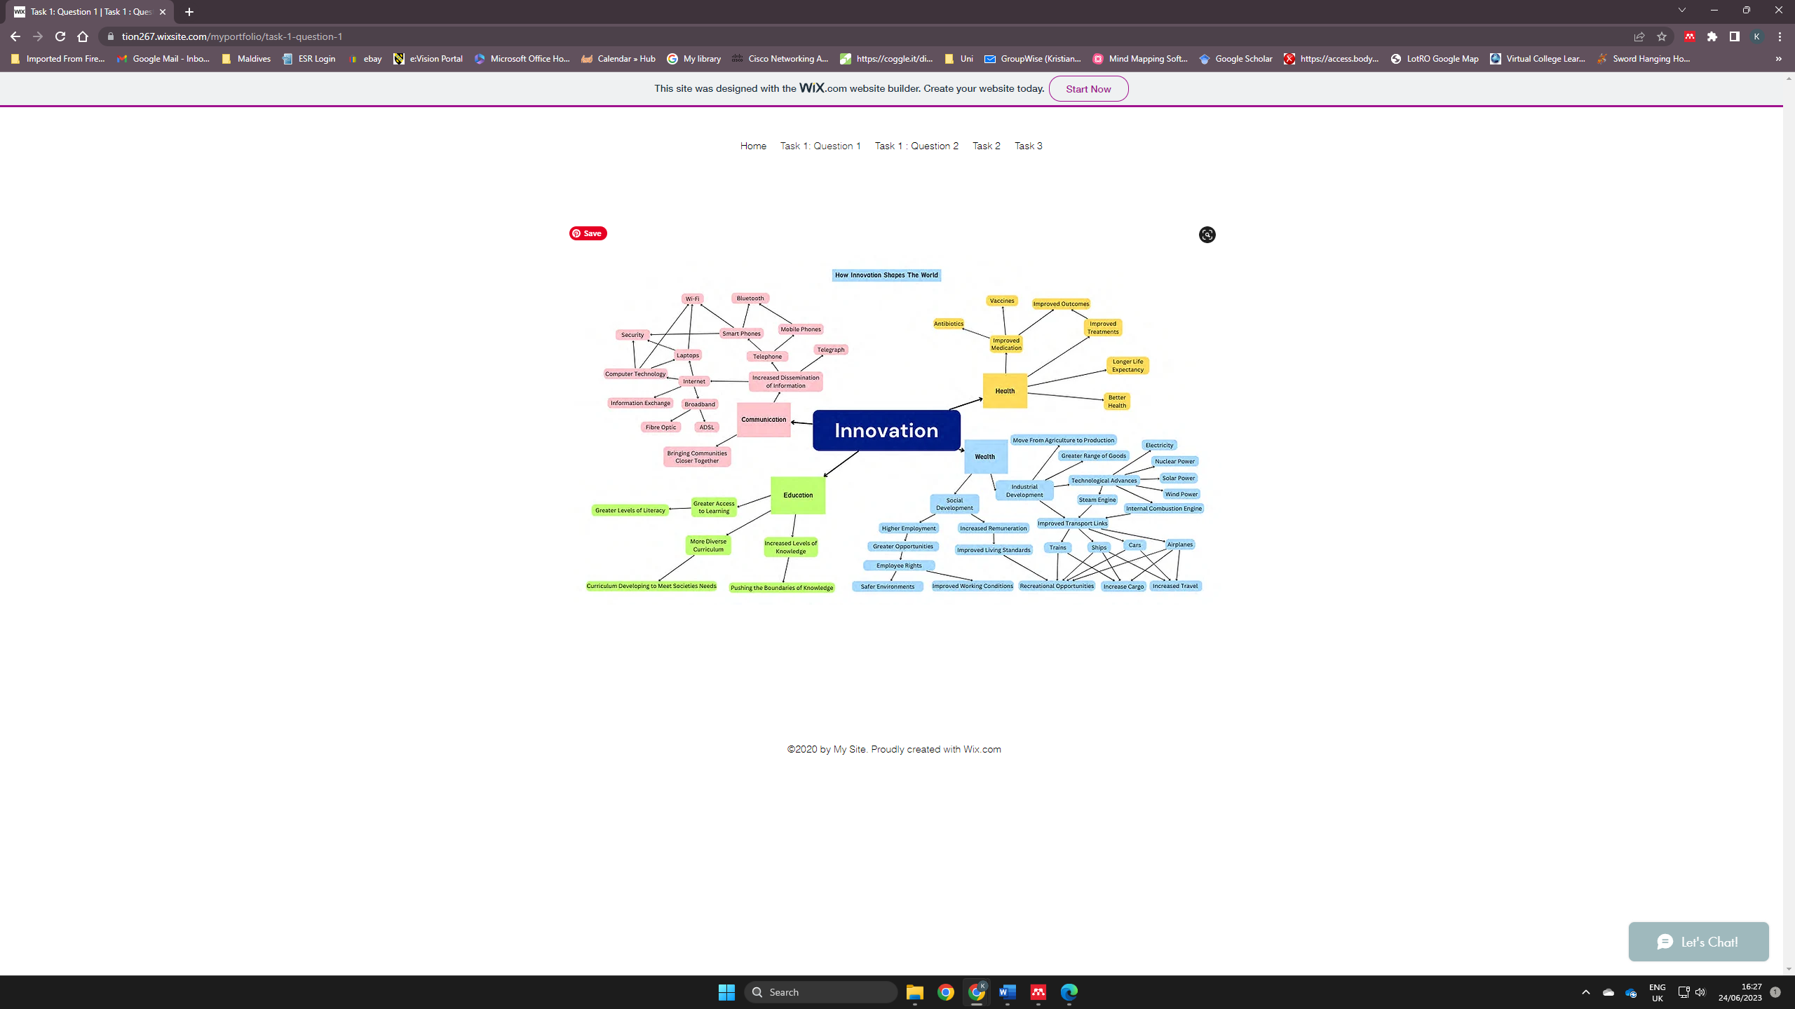
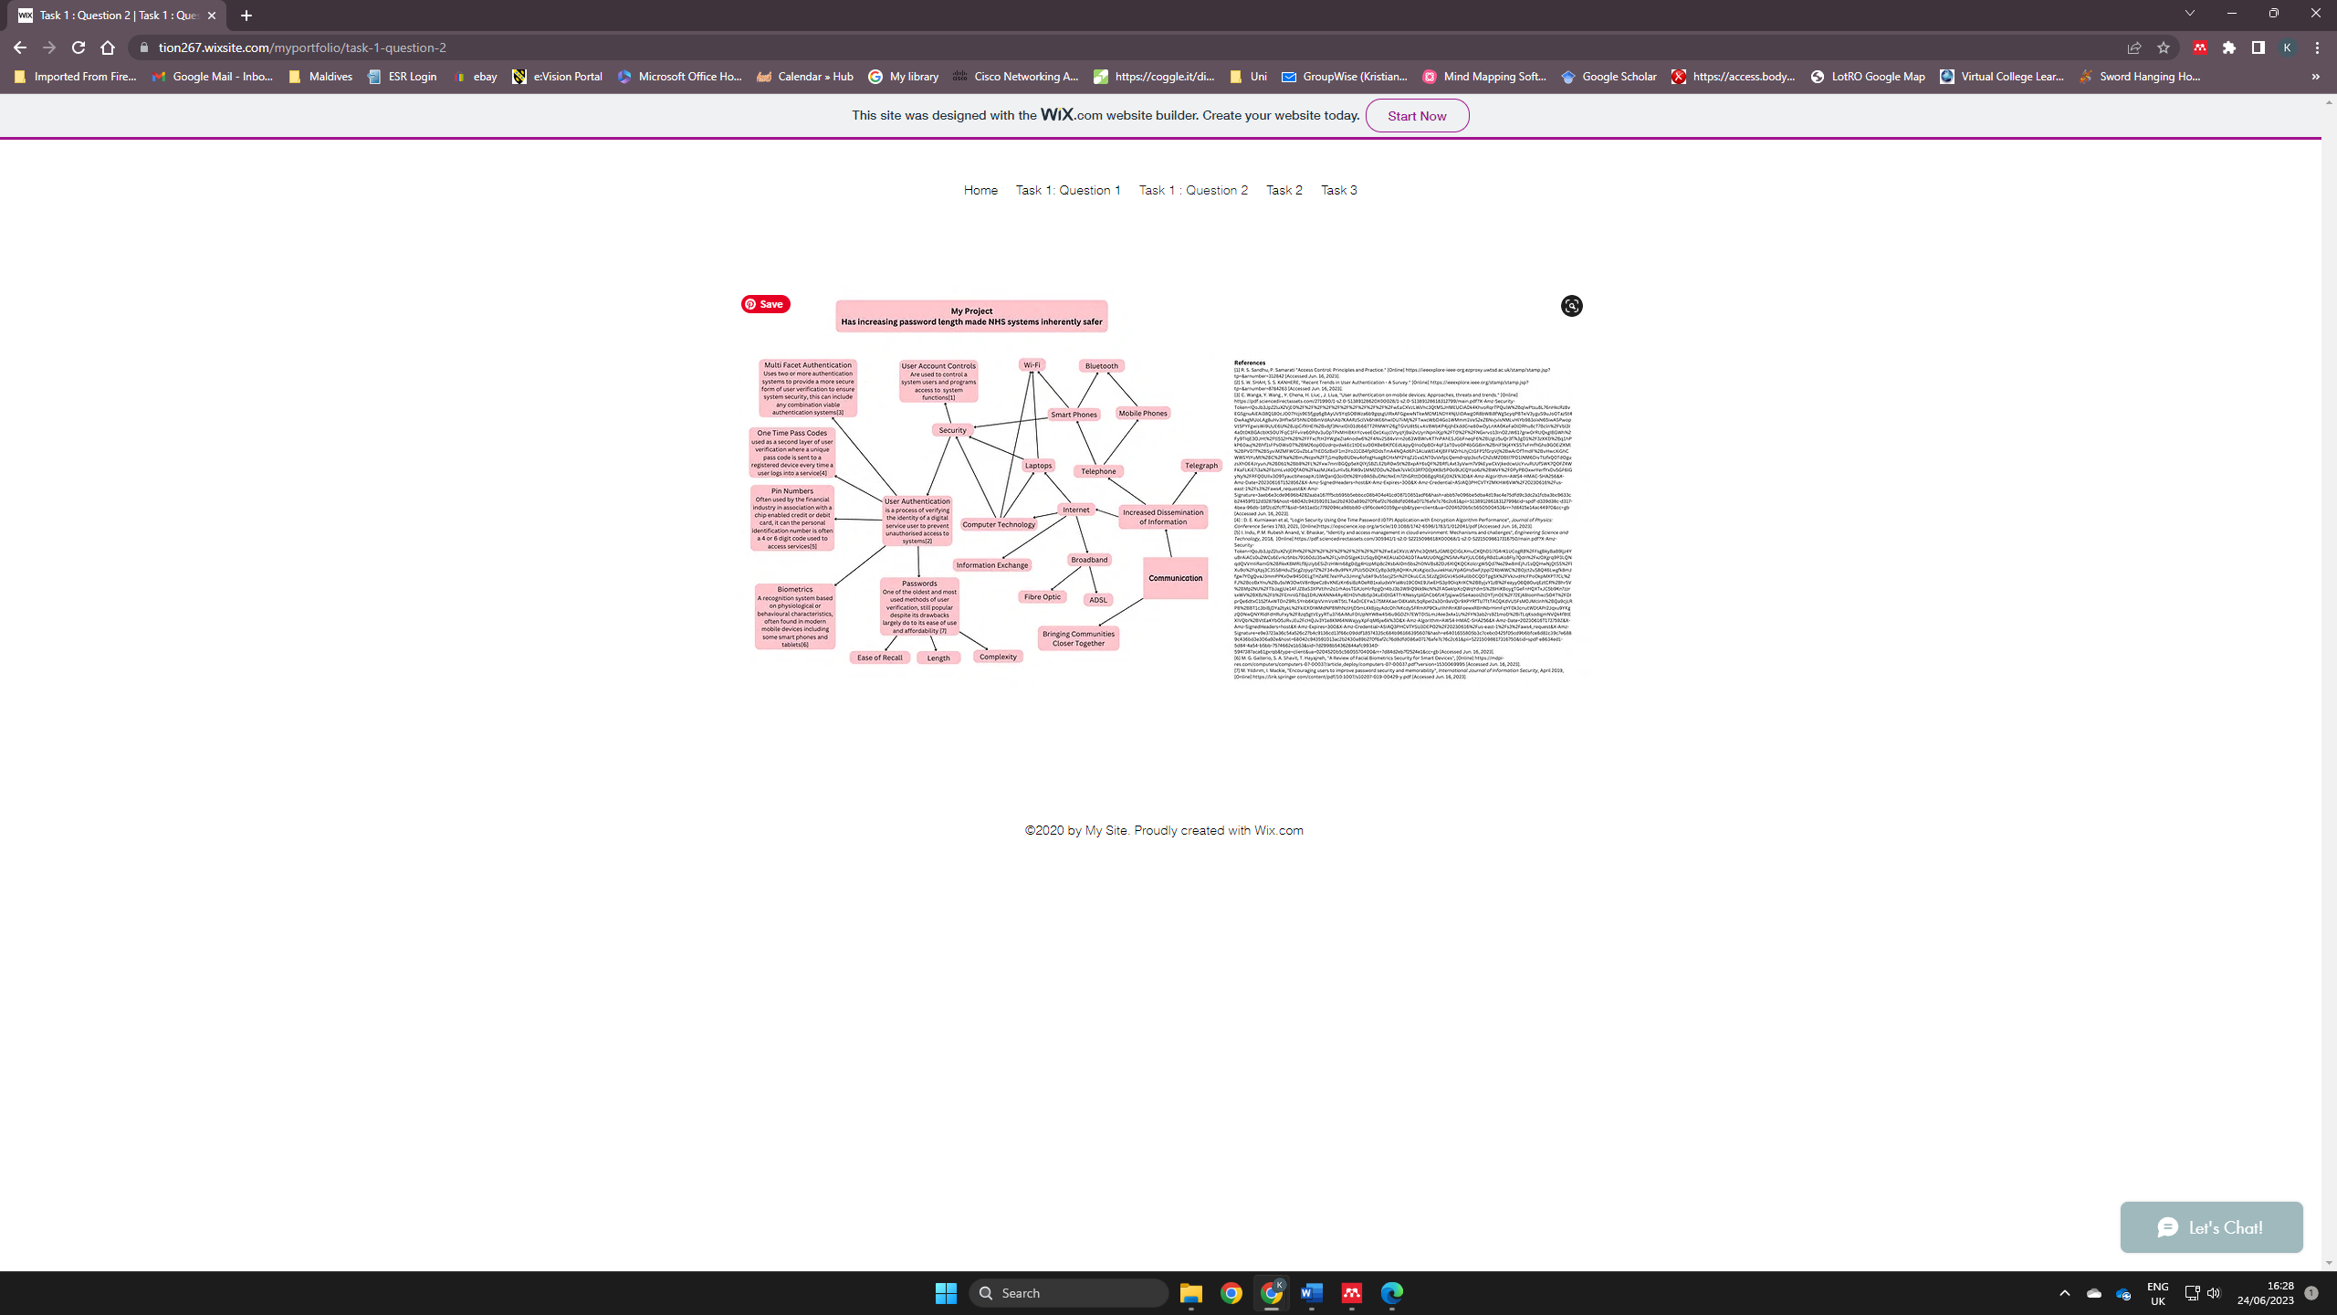

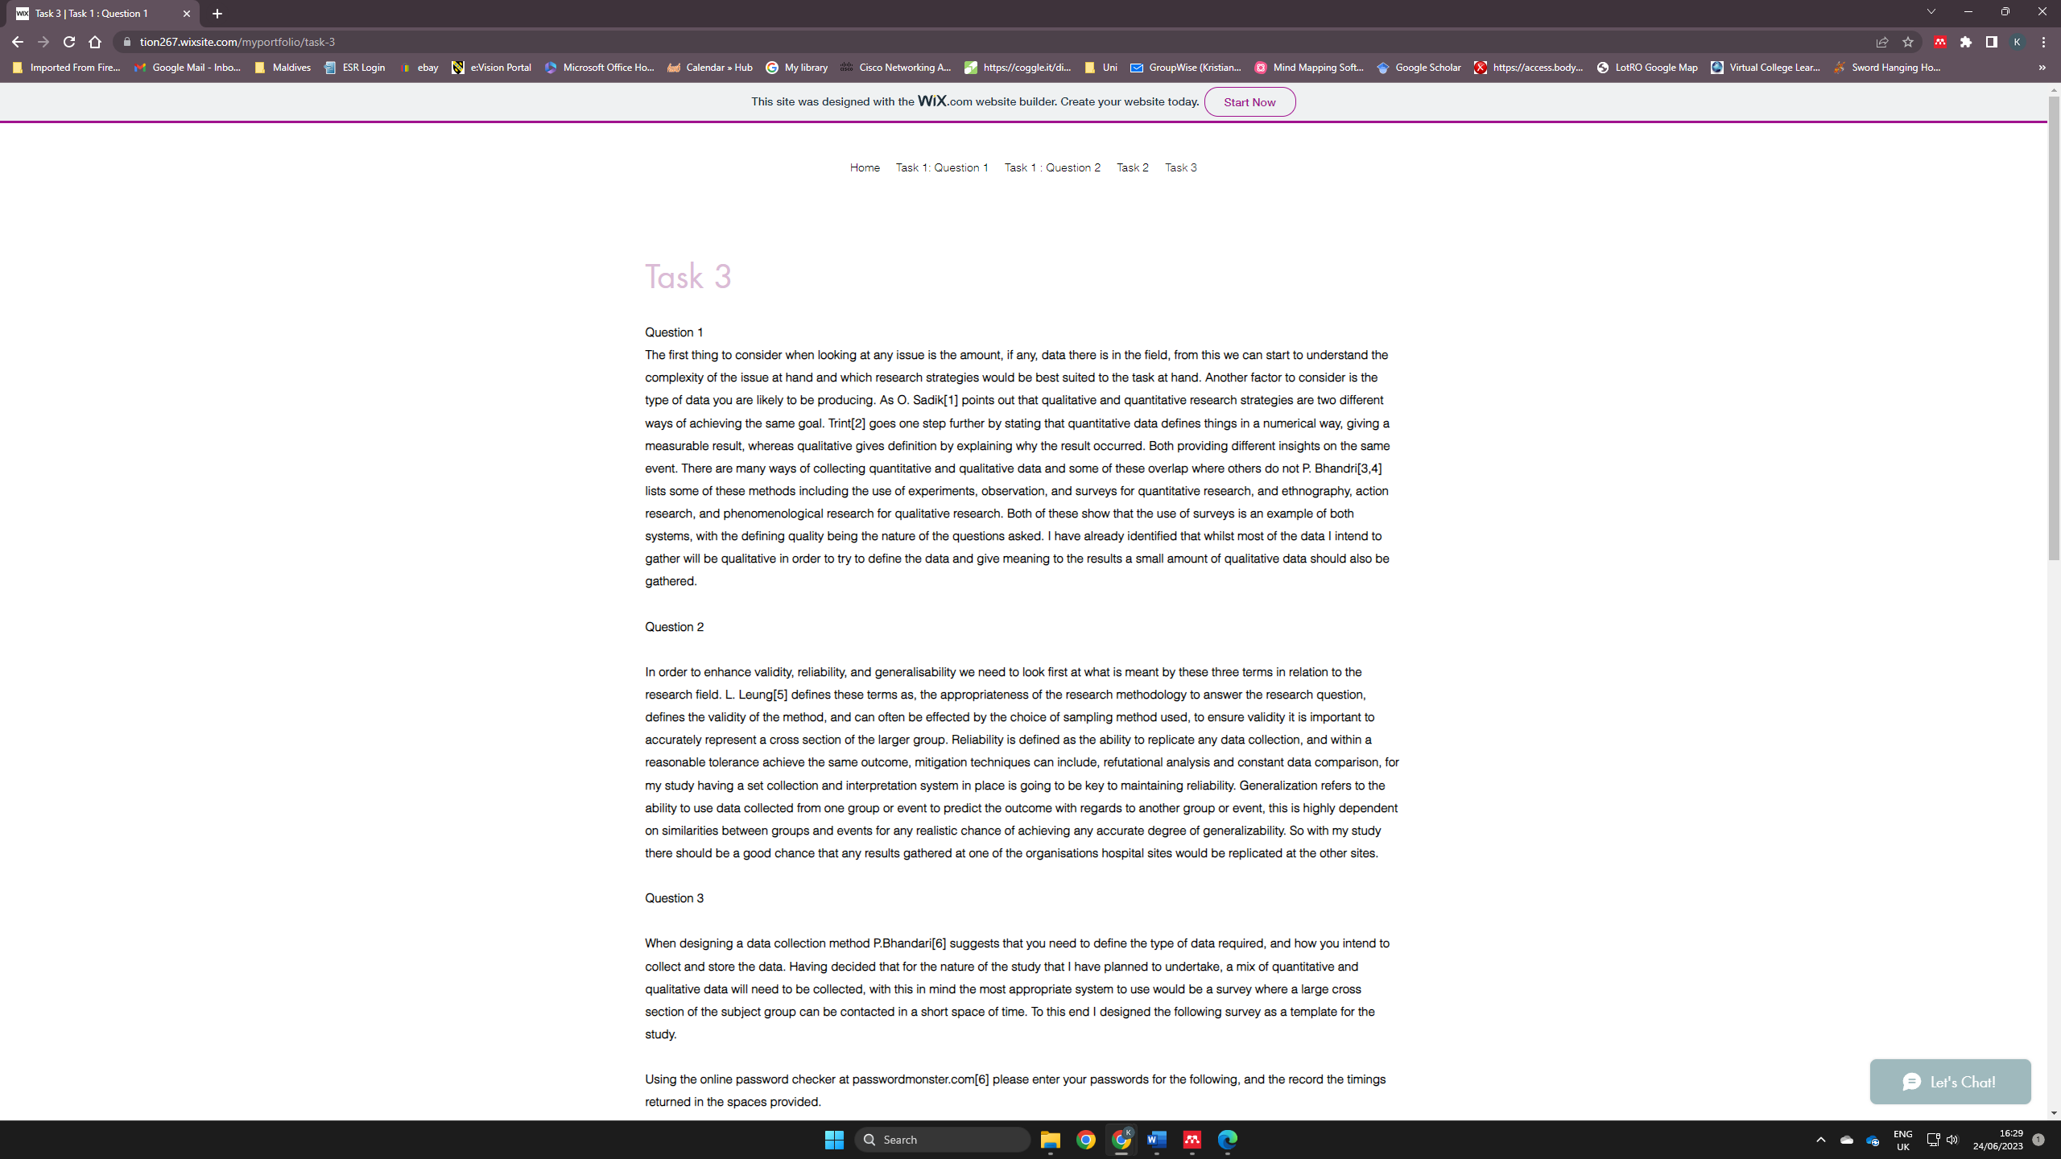
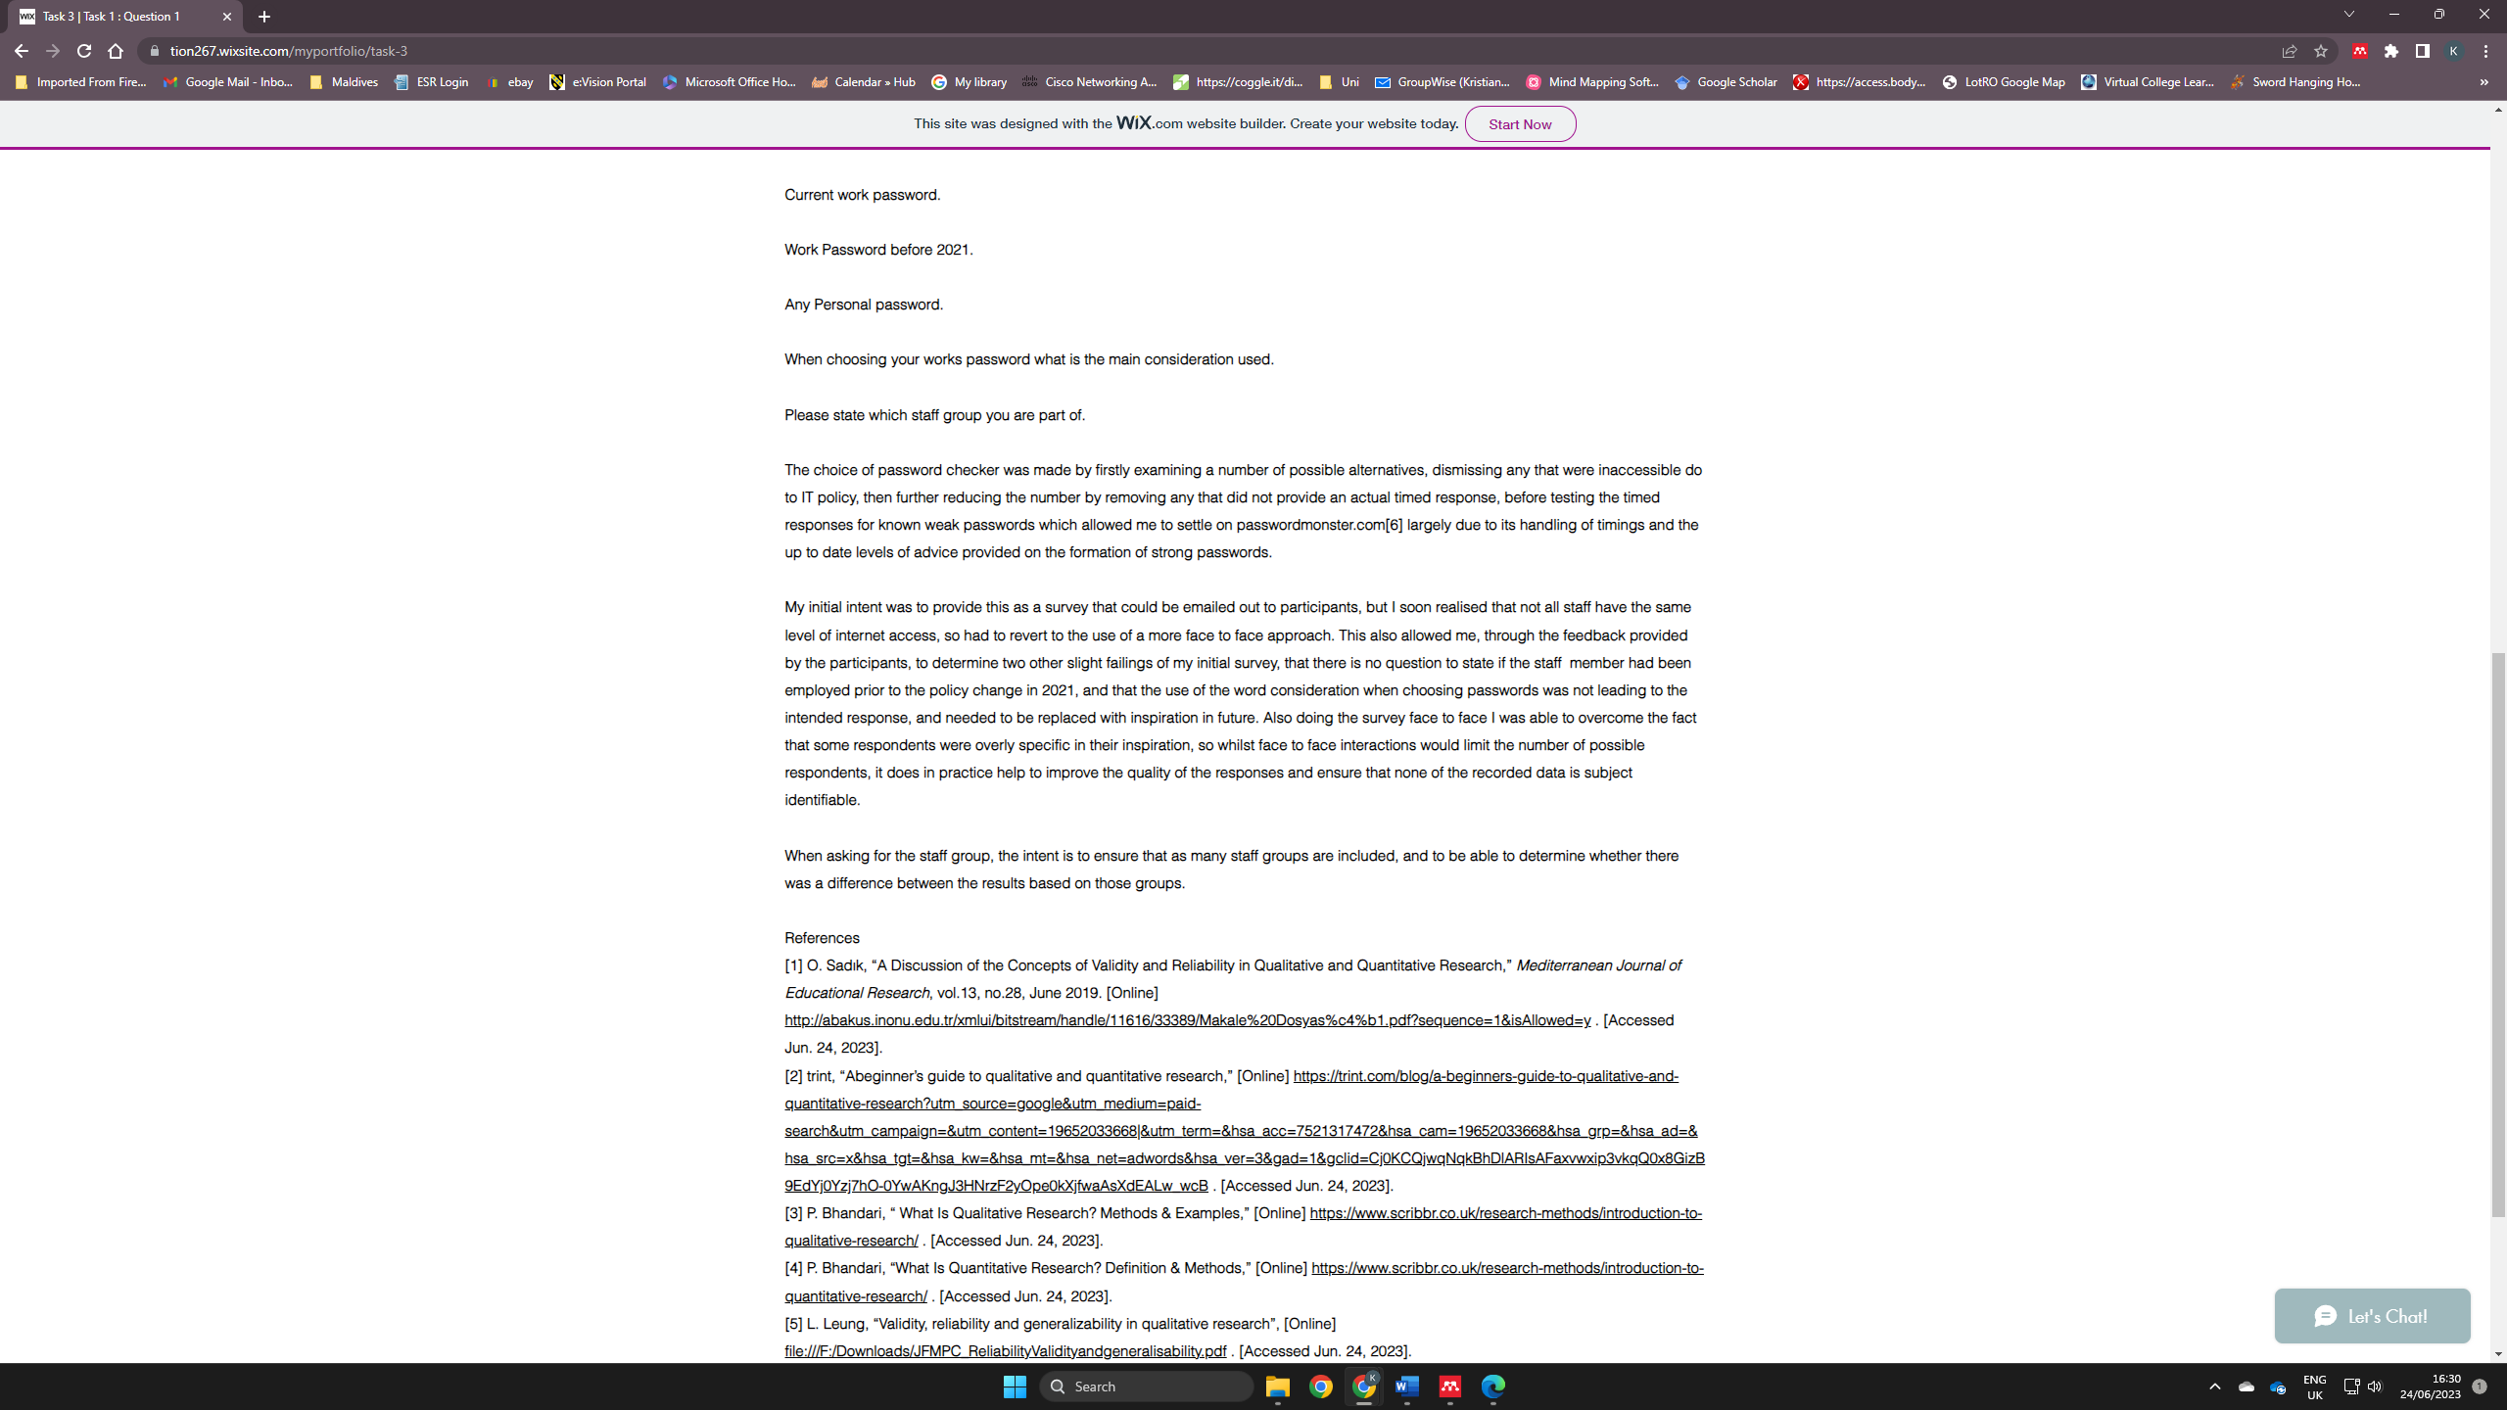

Unit 1 Participation Evidence

Things that were not around 10 years ago
Electronic home assistants, Amazon Echo.
Alibaba
Restaurant deliveries
High quality phone cameras
Smart watches

Innovation changes everything
Formation of Language
Ability to Control Fire
Development of agriculture – and then the plough
Sailboats for exploration
Paper and Printing technology
Alphabet
Modern number systems
Democracy
Scientific method
Steam, and internal combustion engines.
Modern Car and airplanes
Vaccination

Vaccinations
Improve general health, extend life span and give greater opportunity for individuals and groups to develop knowledge and skills which can improve the world in other ways, and generally make a greater contribution to society as a whole.

Technologies changing the world
6 technologies identified by the World Economic Forum
Computing Capabilities – wearable technology in some ways faster than the fastest computer of the mid 80’s
Big Data – Every time you interact with technology leaves a photoprint that can be analysed and monetised.
Digital Health - Using health data to measure effectiveness of treatments to improve future outcomes.
The Digitisation of Matter – The use of 3D printers to produce custom items for use in every aspect of life.
The Internet of Things – The growing trend of every day objects that connect to the internet from smart speakers to smart security and smart watches, how far will this trend go.
Blockchain – The backbone behind digital currencies such as Bitcoin, the use of digital currency is still quite low but set to increase dramatically over the coming years.

World Economic Forum
IOT - With the increase of devices added to the internet, and local networks, and an increase in these being more simplified devices with limited room for security settings to be modified, with the addition of these being wi-fi enabled. These devices will impact on both networking in general and maintaining the security of networks.

The Importance of Creativity
Just recently I decided it was time for a major PC upgrade, where I picked all of the parts I required and then proceeded to build the system, some of the areas where a little bit of creativity was required was in the wiring, for anyone who has ever built a computer you will know that keeping the wiring in as tidy a bundle as possible to prevent restricted air flow to key components is always a challenge, fortunately the case I chose aided with this, but it also had glass panels on the front and side so required some creative thinking to keep all the visible wiring as tidy as possible. Having achieved this I was left feeling very proud of the job done, so much so that I am very happy to show others what I achieved.

Defining creativity
I do not really consider myself to be overly creative, even though by application of a semi logical approach to issues I am able top produce on most occasions solutions which I am usually able to defend under scrutiny, or adapt if a persuasive comment is applied to the solution which would make me consider its validity. But to a fairly large degree very few of these creative solutions actually lead to the creation of anything tangible.
Having watched the additional content on the dive deeper section has made it clearer that you can be creative without creating something tangible, a new way of thinking can indeed be creative.

Creativity
Past experience.
There have been many instances of times where I have been discouraged from doing things, I was always led to believe that I was not smart enough to go to university, and yet thanks to a wonderful woman who is now my wife I have been encouraged to push the envelope to see what I am capable of, and so far this is me attending university.
On a slightly more traditional note, many years ago I developed an interest in photography, and despite being told over the years that it was only a hobby and not worth the effort, I have produced a number of shots that I remain very proud of, and whilst they may not be the greatest photographs ever produced, that does not diminish my sense of achievement at being able to produce them.
Importance of creativity
All sectors come across issues from time to time and whilst most can be overcome by the application of the standard systems of operation, occasionally a problem arises which does not fit the standard pattern, and requires a new level of thinking in order to overcome, so every so often the ability to think outside the box is hugely important, as this can then lead to new solutions being accepted as a standard way forward as it improves the way we work.

The Importance of Creativity
Just recently I decided it was time for a major PC upgrade, where I picked all of the parts I required and then proceeded to build the system, some of the areas where a little bit of creativity was required was in the wiring, for anyone who has ever built a computer you will know that keeping the wiring in as tidy a bundle as possible to prevent restricted air flow to key components is always a challenge, fortunately the case I chose aided with this, but it also had glass panels on the front and side so required some creative thinking to keep all the visible wiring as tidy as possible. Having achieved this I was left feeling very proud of the job done, so much so that I am very happy to show others what I achieved.

Unit 2 Participation Evidence
Research strategy.

The main part of my strategy would probably fit the second option where I would formulate an approach to the research based on my personal observations, formulate a theory based upon those observations then carry out research to support the working theory, but with one eye on any literature that could undo the theory.

Reflexion
The predominant method of research in my subjects I would expect to be more quantitative in nature as networking tends to be a more numbers driven field where results can be easily quantified and measured, on the Cybersecurity side, still much of it can be measured using quantitative methods, but as user interaction, and the effects of cybercrime can also have a very personal effect which cannot always be as easily quantified, the use of a more qualitative method may be more appropriate.
Subjects that may be more reliant on qualitative research would be those surrounding the arts or psychology where the subjective view of the subject cannot be easily measured in a quantitative way.

Forum Post
Mixed Method Research is it Applicable
Given the nature of the intended research, in that it will attempt to analyse whether a change in a given system of work has had an effect on the efficiency of the effected system, and that a quantitative value can be applied easily to the measuring of any differences, then essentially a mixed approach would be unnecessary, but should a difference in performance have occurred then its possible that qualitative data may lead to a greater understanding of the results. But in the first case I would say that the quantitative approach would probably be sufficient to simply measuring if there is a meaningful difference.

Forum Post
Dealing with the Hawthorn effect when gathering data
The primary measure for dealing with the hawthorn effect for my study is that I intend to base the study around the an easily quantifiable set of data, which looks at the strength of passwords used by users, measurable with many easily available tools, which quantify how long a password would take to crack. With this type of data as there is no observational data being gathered the hawthorn effect can be minimalized.

Reflection
Analyse and evaluate data collection method.
The type of collection
Due to the nature of the research the type of data will be mostly quantitative data relating to how long password cracking tools would take to crack the passwords provided (current, last used under previous system, and one home), so to ensure data security I would be asking the participant to enter the required passwords and then record the response time given. As a follow up I would simply ask what main factor decided on the choice of current workplace password.
Size of sample
To ensure the most reliable data set I would ideally be looking at getting as many staff across multiple departments to get a fair spread of participants to ensure the most even, and accurate spread of results
Data collection method
For this research the most effective method for data collection would have to be a largely limited answer survey, as most of the data required would be numerical, also as many of the staff groups in the organisation do not access the IT systems on a regular basis, a face to face approach to the survey may be most appropriate rather than emailing the survey out, though a mixed approach may work, face to face is more likely to guarantee participation, but will also be most time consuming.

Reflection
Torrance Test
Uses for a Brick
Building things
Door stop
Comedic prop
Descriptive Term
Weight (Paper weight)
Step
Counterweight
Space Filler
Reflection
The Scamper Approach
Combine - Current Phone Cameras, where camera technology has been added to mobile telephones to create a usable alternative to stand alone cameras.
Combine - Newer High End Cameras, where technology mostly used in mobile phones, such as wi-fi and Bluetooth have been added to extend normal functionality and improve connectivity for image transfer.
Put – Super glue war originally designed as a military field dressing, but has now become one of the most used all purpose glues on the planet.

Reflection
Divergent Thinker
One of the most important divergent thinkers of the modern computing era would have to be Alan Turing, who has been credited as being one of the fathers of modern computing, and without his unique way of approaching the issue of developing computer technology we at the very least would have taken much longer to get where we are today.

Reflection
Gawain’s Problem
Gawain is only looking at making a good first impression, he is not looking at the overall implications of his actions beyond that point. He has not looked at the fact that the suit is going to be a difficult burden on their family finances, or that there may be alternatives that could possibly provide the same results at a lower cost, or that the benefit derived would be for a single event, as he is unlikely to need the suit again.

Forum Post
The 4 W’s
For my project proposal I intend top look at the implementation of the new password policy within my organisation and its effect on overall system security. So my 4 W's are

Who is effected - All of the staff with PC access

What is the problem - Does the new system increase overall system security

Where does it happen - At every computer and network enabled device

Why does it matter - If the system does not improve security then was it worth implementing, it makes the system less secure then what needs to be done to address the issues identified.

Reflect
Oscar Wild
I would assume that Oscar Wilds statement is used to say that a cynical person would simply examine all things they come in to contact in a simple monetaristic way, that is everything can be reduced to its financial value. So they know the price of things but care little for the actual value, which cannot be measured in terms of price only, sentimental or emotional values cannot be easily quantified as the by and large can only be measured against the feelings of the individual.

Reflection
Organising
When it comes to my household documents I have a filing cabinet in one of the spare bedrooms referred to as the office, this is also where my computer lives, and as I tend to be pretty organised in the layout of my filing cabinet so things are easy to find, and have a set place. As for getting messed up by others, there is only me and my wife and she is far tidier than I am so not really an issue. Abetter example would be my storage hard drive which over the years has been increasingly filled with files, many of which are now obsolete and should be discarded. But I rarely find any real time to achieve the spring clean that the drive needs and deserves.

Refection
Value Frameworks
For my intended project either of these approaches would work but for my mind the closer connection would be with Makiguchi’s approach, as the project seeks to identify the effectiveness of the new password system on the overall security of the trusts digital systems, in a time when health records are becoming increasingly digitised. Therefore, there are three possible outcomes, an improvement in the systems security, no overall change, or a deterioration in security. Identifying any of these would then lead to either a reassurance for all concerned that either the systems are at least as safe as they were before the change, or would give us potential reasons for any deterioration allowing us to plan to correct any issues.

Participation Screenshots




